
24 Mayıs 2021

From the Baran Tursun International Foundation for Disarmament, Right to Life, Freedom, Democracy, Peace and Solidarity

Submission to the UN CEDAW
For the Pre-Session and Prior to Adoption of the List of Issues
81 (Virtual PSWG) Pre-Sessional Working Group
05 July 2021 - 09 July 2021

Turkey

Contact address: Mehmet Tursun, President of Baran Tursun Foundation
e-mail: mehmettursun100@gmail.com
GSM: +905334404579
Turkey Izmir

Report of Violations of Right to Life as a Result of Disproportionate Use of Force by Law Enforcement Officials

THEY DIDN’T HAVE TO DIE

Reporters
Dr. Günal Kurşun
Mehmet Tursun

Izmir-2021

This report was created and maintained with the financial support of the European
Union provided under Etkiniz EU Programme. Its contents are the sole responsibility of
Baran Tursun Foundation and do not necessarily reflect the views of the European Union.

“Report of Violations of Right to Life as a Result of Disproportionate Use of Force by Law Enforcement Officials – They Didn’t Have to Die” was prepared in Turkish and English by expert reporters Dr. Günal Kurşun and Mehmet Tursun, who were assigned with the financial support provided to Baran Tursun Foundation by the ETKINIZ EU Programme to ensure access to national and international human rights mechanisms.

RIGHT TO LIFE VIOLATIONS IN TURKEY

With the Law No. 5681 dated 02.06.2007, some amendments were made in Law of Police Powers (LPP) No. 2559 for reasons such as “a very rapid increase in terrorism, complaints and crime rates”. The legal basis for the power “to stop and ask for identification”, which was regulated in the “Regulation on Judiciary and Prevention Searches” (RJPS) dated 01.06.2005, was created especially with the Article 16 titled “Use of Force and Weapon”. There was an unlawful use of power before that date.
Concepts such as “reasonable doubt, foresight and discretion” were reformulated with some amendments made in the Law No. 6638, which entered into force on 27.03.2015 with the name “Law Amending the Law of Police Powers, Gendarmerie Organization, Duties and Powers Law and Some Other Laws” and known by the public as Internal Security Law.
Due to lack of adequate training for law Enforcement Officials regarding abstract concepts such as reasonable doubt, foresight and discretion, more than 400 cases that, in fact, should have been processed according to the Law of Misdemeanors have resulted in death as a result of the fact that each law enforcement officer attributes a meaning to the Article 16 of the LPP, which regulates the authorization to use weapons by law Enforcement Officials, and therefore each law enforcement officer takes an action according to this, despite a regulation was made on the reasons, subjects and purposes of stopping and asking for identification, the form, duration and form of the procedure.

In cases that resulted in the deaths of civilians, including children and women, the right to life of the suspects was abolished although there was no attack and violence against the police, no armed conflict with the police, no response to the government’s influence and actions with weapons, and no violence and rape that endanger the life and property of others.

As a result of these severe violations of rights, serious perceptions have emerged in the society that law Enforcement Officials can at any time use violence, shoot with a gun, and kill anyone who continues his in daily life or opposes the Law of Misdemeanors.
The society has a strong perception both about the violations of the right to life and that the disproportionate force exerted by the police against the awareness of claiming rights and social reflexes in the society goes unpunished. The fact that administrative mechanisms ignore the obligation of law Enforcement Officials to comply with the “proportionality and necessity” criteria of international human rights law, and the perception of protecting and guarding the criminal created by the statements of bureaucrats in executive positions play an important role in the formation of these perceptions.
Extrajudicial Killings and Summary Executions of Women by the Law Enforcement

Extrajudicial and summary executions in Turkey manifest themselves in a wide range of ways from killing people for not obeying a stop warning to deaths in peaceful demonstrations and detention. As a result of abstract and unfulfilled concepts such as “foresight”, “reasonable doubt” and “appreciation” left to the police officers’ margin of appreciation and perception of the law, the right to life of more than 400 civilians, who do not threaten life, do not use violence against the police, and who must be treated according to the Law on Misdemeanours, have been violated.

The police, who use lethal force, consider it a legal duty to commit the murder by exceeding their legal powers and to punish the suspect with death with the decision given at that moment, instead of including the suspect in the judicial process and leaving the punishment to the judiciary. This situation is determined as the most important source of the problem.

The police, charged with protecting life, trained and equipped to do so, have used their lethal weapon as a "first choice" in hundreds of cases, instead of "last choice" according to international criteria approved by the United Nations.

As the table below shows, the police executed a total of 404 people, including 93 children, 70 women and 240 adult men, without including them in any judicial proceedings.

Extrajudicial Killings and Summary Executions (Total)
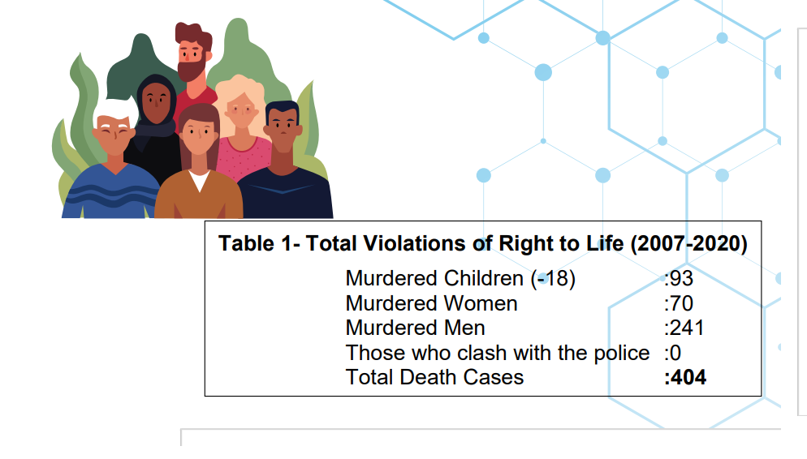

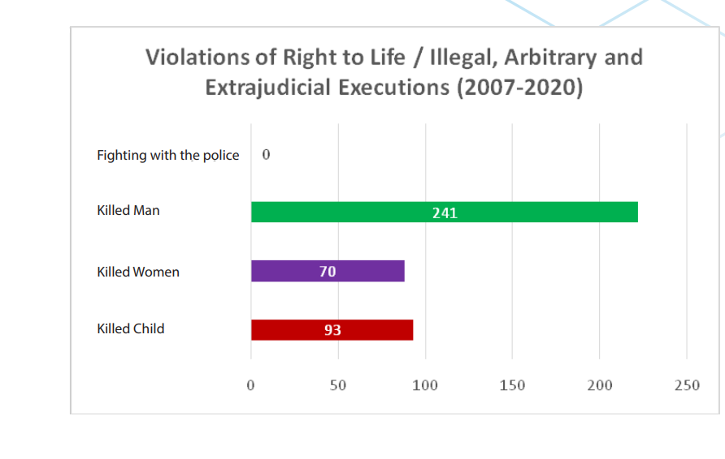

List of extrajudicial and summary execution of women cases in Turkey from 2007 to 2019
 | Name | Age | Date of incident | Place of Incident | Cause of dealth
1 | M.Ü | 23 | 26.05.2019 | Diyarbakır | Police officer shot and killed his colleague
2 | H.Ş | 22 | 10.01.2019 | İzmir | Police officer killed a transgender person during solicitation of sex in her flat
3 | E.K | 38 | 25.06.2018 | Kocaeli | Intimate partner killing
4 | Ü.Y | 28 | 14.00.201 | Antalya | Police killed his own colleague
5 | A.C | 4 | 28.12.2017 | Diyarbakır | Run over by a speeding police vehicle
6 | E.S | 21 | 17.12.2017 | Sakarya | Run over by armoured police vehicle
7 | F.B | 7 | 21.10.2017 | Siirt | Run over by armoured police vehicle
8 | G.Y | 55 | 19.10.2017 | Bitlis | Run over by armoured police vehicle
9 | R.M | 29 | 19.06.2017 | Diyarbakır | Run over by armoured police vehicle
10 | P.H | 85 | 15.06.2017 | Diyarbakır | Run over by armoured police vehicle
11 | F.E | 54 | 24.05.2017 | Hatay | Police officer killed his mother
12 | B.D | 7 | 09.02.2017 | Mardin | Run over by armoured police vehicle
13 | N.Ö | 73 | 06.09.2016 | Tunceli | Run over by armoured police vehicle
14 | Z.C | 7 | 19.05.2016 | Istanbul | Shot by police
15 | P.G. | 28 | 15.05.2016 | Istanbul | Shot by police
16 | G.Ç | 45 | 29.04.2016 | Istanbul | Killed by her policeman husband
17 | T.Ç | 18 | 29.04.2016 | Istanbul | Shot by police
18 | H.E | 55 | 24.04.2016 | Diyarbakır | Run over by armoured police vehicle
19 | S.Ç | 17 | 05.04.2016 | Diyarbakır | Shot by police
20 | G.A | 59 | 19.02.2016 | Mardin | Run over by armoured police vehicle
21 | S.Ç | 33 | 20.01.2016 | Antalya | Shot by police
22 | N.S | 17 | 07.01.2016 | Sirnak | Shot by police
23 | M.İ | 3 month old | 25.12.2015 | Sirnak | Shot by police - special operations
24 | A.K | 55 | 23.12.2015 | Sirnak | Shot by police in public demonstrations
25 | A.A | 46 | 22.12.2015 | Sirnak | Shot by police in public demonstrations
26 | T.İ | 57 | 21.12.2015 | Sirnak | Shot by police - special operations
27 | B.Y | 0 | 20.12.2015 | Sirnak | Shot by police in public demonstrations
28 | Z.Y | 45 | 20.12.2015 | Sirnak | Shot by police in public demonstrations
29 | E.G | 39 | 20.12.2015 | Mardin | Shot by police in public demonstrations
30 | A.B | 40 | 19.12.2015 | Sirnak | Shot by police
31 | H.Ş | 30 | 17.12.2015 | Sirnak | Shot by police in public demonstrations
32 | F.A | 56 | 07.12.2015 | Mardin | Shot dead on the grounds of not obeying the stop warning/curfew of the police
33 | H.Ş | 31 | 2015 | Kocaeli | Familial dispute
34 | D.K | 20 | 03.12.2015 | Istanbul | Shot by police
35 | S.A | 10 | 02.12.2015 | Sirnak | Shot dead on the grounds of not obeying the stop warning/curfew of the police
36 | N.K | 45 | 19.11.2015 | Mardin | Shot dead on the grounds of not obeying the stop warning/curfew of the police
37 | F.Y | 20 | 11.11.2015 | Sirnak | Killed as a result of the gas canister used by the police.
38 | D.D | 25 | 25.10.2015 | Istanbul | Shot by police in her house
39 | H.Ş | 12 | 10.10.2015 | Diyarbakır | Shot by police - special operations
40 | R.K | 20 | 04.10.2015 | Diyarbakır | Shot by police
41 | S.A | 10 | 09.09.2015 | Sirnak | Shot dead on the grounds of not obeying the stop warning/curfew of the police
42 | Z.T | 17 | 07.09.2015 | Sirnak | Shot by police - special operations
43 | C.Ç | 10 | 07.09.2015 | Sirnak | Shot by police - special operations
44 | A.G | 32 | 05.09.2015 | Tunceli | Shot by police in public demonstrations
45 | G.M | 38 | 28.08.2015 | Manisa | Intimate partner killing
46 | G.T | 72 | 17.08.2015 | İzmir | Run over by a speeding police vehicle
47 | G.Ö | 31 | 25.07.2015 | Istanbul | Shot by police
48 | A.Ş | 75 | 17.06.2015 | Bursa | Shot by police
49 | S.U | 42 | 17.06.2015 | Bursa | Shot by police
50 | F.Z | 21 | 10.11.2014 | Trabzon | Shot by police
51 | Ş.Ö | Unknown | 01.07.2014 | Ankara | Shot by police
52 | N.A | Unknown | 01.07.2014 | Ankara | Shot by police
53 | B.T | Unknown | 01.07.2014 | Ankara | Shot by police
54 | A.U | 70 | 03.11.2013 | Karaman | Run over by a speeding police vehicle
55 | A.K | 72 | 27.10.2013 | Hakkari | Run over by a speeding police vehicle
56 | Z.M | 23 | 27.09.2013 | Elazig | Shot by police
57 | M.K | 32 | 04.10.2012 | Antalya | Shot by police
58 | Y.AKPAN | Unknown | 20.11.2011 | Ankara | Shot by police
59 | K.Ö | Unknown | 14.09.2011 | Adana | Shot by police
60 | Y.Ç | 23 | 20.11.2011 | Istanbul | Shot by police
61 | T.K | 21 | 17.03.2011 | Tunceli | Intimate partner killing
62 | Ç.Ş | 20 | 11.11.2010 | İzmir | Shot by police
63 | S.Y | 29 | 27.07.2010 | Istanbul | Shot by police
64 | M.A | 8 | 29.04.2009 | Van | Run over by armoured police vehicle
65 | Ö.K | 13 | 19.10.2009 | Kutahya | Killed as a result of the gas canister used by the police.
66 | N.B | 32 | 2008 | Antalya | Shot by police
67 | V. S | 22 | 2008 | Kocaeli | Died in detention at the police station
68 | K.M | 38 | 08.12.2007 | Ankara | Shot by police
69 | Y.N | Unknown | 22.10.2007 | Malatya | Shot dead on the grounds of not obeying the stop warning/curfew of the police
70 | N.B | 35 | 03.08.2007 | Antalya | Shot dead on the grounds of not obeying the stop warning/curfew of the police

These details reflect the category of women who lost their lives in the Report of Violations of the Right to Life as a result of the Disproportionate Use of Force by Law Enforcement

ETKINIZ EU Programme 2020/DS386

