Comments on the Fourth Periodic Report Submitted by Hong Kong, China under the Convention on the Elimination of all Forms of Discrimination Against Women
International Women’s League
Vivian S.Y Tsui - Chairwoman
HKSAR, China
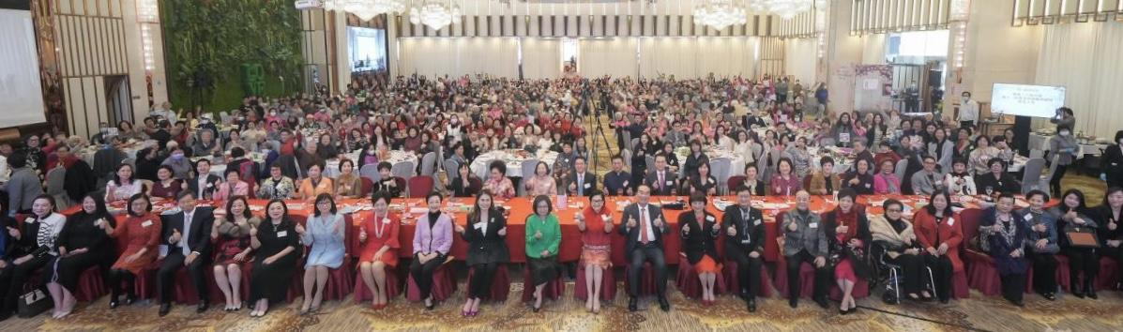


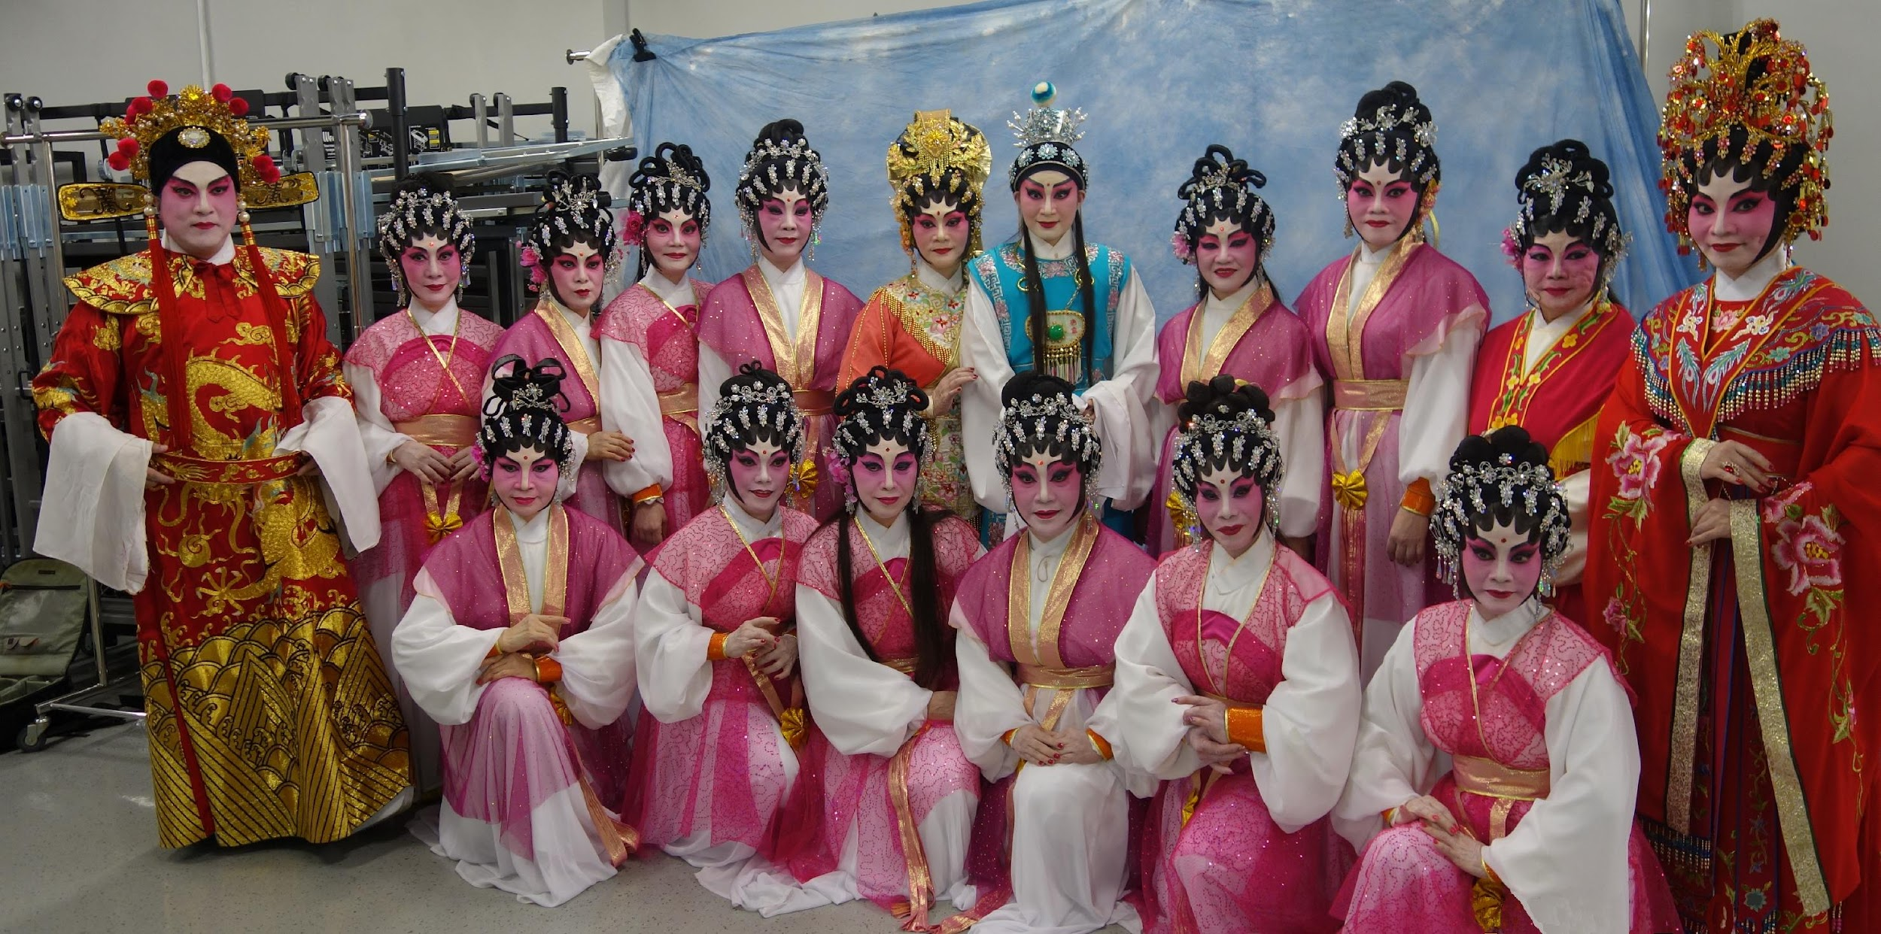

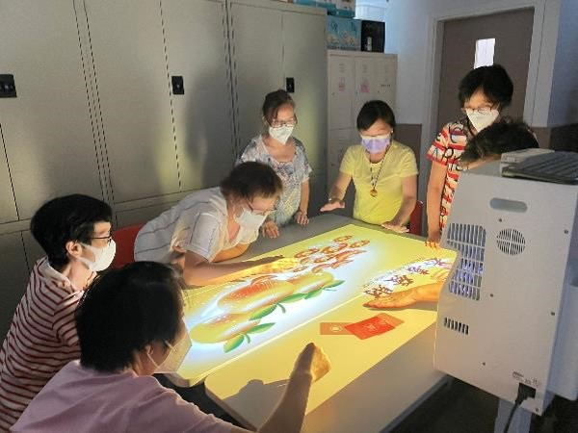


International Women’s League, HKSAR, China

The International Women's League Limited (IWL) was founded and established by Mrs. TSUI Yu Mui-hing in 1986. The IWL is a non-profit and non-political organization. Its main objectives are to unite women from all walks of life, to improve and protect the lawful rights of women and to liaise with women organizations all over the world, whilst encouraging them to take an active interest in Hong Kong affairs and public welfare.

It is committed to protecting the well-being of vulnerable groups of women, imparting traditional Chinese culture and cultivating young people's values whilst developing their potential and promoting social stability and progress.

The current president of IWL is Mrs. Josephine M.W Pang MH, and the chairwoman of the board is Ms. Vivian S.Y Tsui.

Members of the IWL come from various socio-economic backgrounds, occupations, and races in Hong Kong. Amongst members are business women, professionals, workers and housewives as well as those who are enthusiastic about women's development and advancement. IWL strives for the well-being of all women by providing professional social services from children to the elderly.

IWL launched the International Women's League Neighbourhood Elderly Centre (IWL NEC) that provides elderly carer support, counseling services, dementia specific support, physical therapy, occupational therapy, medical knowledge education, mental health care and technology education for elderly. It also holds an annual large-scale cultural and artistic activities for the elderly and a Respect Conference to expand the social circle of the elderly.

IWL holds diverse women's activities, such as exchange and study tours to various countries, classes in song and dance, cultural performances such as Cantonese opera, and hosting mainland visiting women's organizations. In addition, youth activities and cross generational services are organized, such as visiting elders, volunteer training, and exchange seminars to cultivate positive values among young people.

We write to comment on several issues in relation to the HKSAR, China to facilitate the Committee’s consideration of its fourth periodic report

Through nearly 40 years of effort, the IWL encourages women to participate in social services, promotes women's development, enhances women's status, provides professional and diverse services for the elderly and creates a friendly elder care community. IWL has also established a youth volunteer team to teach and promote the rights of girls and traditional Chinese culture, such as Cantonese opera and etiquette.

During the pandemic, IWL assisted citizens in epidemic prevention and control. In the early stages of the epidemic in 2020, the chairpersons, vice chairpersons, and members of the management committee leveraged their respective networks, actively searching for pandemic prevention materials from domestic and international sources. IWL established street stations for the distribution of masks, PPEs and hand sanitizer.

With the support from the HKSAR welfare department, IWL also applied new technologies to expand its services into online services. In 2021, IWL held periodic Zoom activities, including home elderly care skills teaching classes, presidium songs playing, home treatment seminars, and anti-fraud awareness. Members of the Legislative Council and doctors were also invited to share their knowledge and advice on the various pandemic related topics via online platforms. Other presentations included helping the elderly to improve their use and understanding of smartphone applications.

In 2022, IWL received support from various charitable funds to purchase smartphones and mobile network cards as gifts to elderly women who were still using traditional phones, facilitating their access to online information, whilst purchasing and disseminating pandemic home kits to help them overcome difficult times.

During the pandemic IWL took measures to arrange employees to work from home, while incorporating flexible working hours in order to prevent the spread of COVID.

On Hong Kong women

Since 1997, Hong Kong women made commendable efforts towards Hong Kong's prosperity and stability.
Women of Hong Kong are generally independent, financially autonomous, assertive, and focused. There is a local saying that women are “holding up half the sky”. Hong Kong women generally receive good education, and are avid promoters of self reliance and mutual support. Women’s development has come a long way and it is demonstrated by the solid increase in numbers of women in professional fields and management positions.

Gender mainstreaming
Gender mainstreaming was established as a major global strategy for the promotion of gender equality in the Beijing Platform for Action at the Fourth United Nations World Conference on Women in Beijing in 1995.
In 2002, the Women's Commission developed a Gender Mainstreaming Checklist to assist government officers in implementing gender mainstreaming. Since then, with the advice and support of the Commission, the Government started to promote gender mainstreaming in bureaux and departments.

Starting from 1 April 2015, the HKSAR government required all bureaux and departments to refer to the Gender Mainstreaming Checklist¹ and apply gender mainstreaming when formulating major government policies and initiatives.

In 2016, HKSAR government implemented a pilot scheme to encourage non-governmental organizations in the social welfare sector to refer to the Checklist and apply gender mainstreaming when formulating policies and programmes. The HKSAR government is committed to creating a friendly environment for women through a series of supportive policies, such as promoting a working environment that supports breastfeeding. Starting from December 11, 2020, Hong Kong has extended the statutory maternity leave from 10 weeks to 14 weeks, and each employee can receive a salary subsidy for the additional 4 weeks of maternity leave, with a maximum limit of HKD80,000 HKD. This subsidy can be fully refunded from the government to the employer.

Family-friendly employment practices
As the largest employer in Hong Kong, the HKSAR government has been committed to promoting family-friendly employment practices². Since 2006 this has included implementing a five-day work week and flexible work arrangements, enabling employees to achieve a balance between work and family life, which has led many enterprises to follow suit.

- Women’s Commission’s website:
https://www.women.gov.hk/en/enabling_envir/gender_mainstreaming/checklist.html
- HKSAR government’s web site:
https://www.gov.hk/tc/residents/employment/recruitment/familyfriendly.htm

In March 2016, the Hong Kong Stock Exchange¹ required listed companies to disclose the following policies: salary and dismissal, recruitment and promotion, working hours, equal opportunities for holidays, diversification, anti-discrimination and other benefits, and encouraged listed companies to combat discrimination and pay attention to working hours.

The relevant measures promoted by the Labour Department in recent years include flexible working hours, five-day work week, home office, part-time work options and medical security, childcare services, stress or emotional counseling services and other life support for employees.

Since 2011, the Family Council and the Home Affairs Bureau have also held the " the Family-Friendly Employers Award Scheme "² every two years to commend enterprises and institutions that attach importance to family friendly spirit; HKSAR also encourage more employers to implement family friendly employment measures. The Labour Department launched the Good Employers Charter 2020, which features the theme of “Family-friendly Good Employer”.

Employers are encouraged to empathically consider the family roles of their employees and adopt family-friendly employment practices which help the employees to balance responsibilities from work and family. In 2022, the Equal Opportunities Commission indicated 17% of employers stating implementation of family friendly measures within the company.
- HKEX’s web site:
https://cn-rules.hkex.com.hk/%E8%A6%8F%E5%89%87%E6%89%8B%E5%86%8A/%E9%99%84%E9%8C%84-%E4%BA%8C%E5%8D%81%E4%B8%83-%E7%92%B0%E5%A2%83%E3%80%81%E7%A4%BE%E6%9C%83%E5%8F%8A%E7%AE%A1%E6%B2%BB%E5%A0%B1%E5%91%8A%E6%8C%87%E5%BC%95
- The Family Council and the Home Affairs Bureau’s website:
https://www.familycouncil.gov.hk/en/Employment/award_schemes.html

Gender Development Index (GDI)
As a woman, I think women’s well-being in Hong Kong has improved impressively. The Gender Development Index (GDI)¹ is a comprehensive indicator created by the United Nations Development Programme (UNDP) to measure the development results of a country or region in the fields of health, education and economy, reflecting the degree of gender equality. Hong Kong continues to rise annually in the GDI, from 33rd in 1995 to 22nd in 2007, reaching the world ranking as 8th as of 2021 - along with countries such as Iceland.

Education
Analysis on education has shown educational participation and outcomes are the areas that have achieved the greatest gender parity in Hong Kong during the last decade. Compared to 2010, the number of women with tertiary education increased by 47.6% in 2020. In the 2021/22 academic year, 52.0% of women attended higher education courses funded by the University Grants Committee of HK². The proportion of research postgraduates who are women is 61.8%. With respect to educational outcomes, more women study arts and humanities (70.6%), education (72.6%), nursing (65.87%) and social sciences (62.54%). Moreover, not only have girls continued to excel in languages, the gender gap in science and mathematics has narrowed. More and more women are taking courses in engineering departments that were once male dominated. In the 2020/21 academic year, for example, 50.1% of medical students were women.

- UNDP’s website, https://hdr.undp.org/data-center/documentation-and-downloads and
https://hdr.undp.org/sites/default/files/publications/additional-files/2022-09/HDR21_22_SourceData.xlsx
- Women Commission’s website: https://www.women.gov.hk/tc/publications/statistics.html

Leaderships and Workforce
The improvement of education and the introduction of the concept of feminism have also enabled some Hong Kong women to play a leading role through their own efforts. Women in all walks of life in Hong Kong have made significant contributions to social development. In governance, Ms. Carrie Lam became the first female Chief Executive in 2017, and among the 26 current principal officials of the government, 6 are women, accounting for nearly a quarter of the cabinet, which is highest to date. Among the 18 permanent secretaries, the highest echelons of the civil service, more than 60% of them are females. Women now account for 36% of the non-official members of government-appointed advisory and statutory bodies, which is 10% higher than 20 years ago. The Chief Executive John Lee Ka-chiu of HKSAR announced in his 2023 Policy Address that HKSAR Government will set up a Women Empowerment Fund of $100 million (each year $20 million) in this 2023's Budget to promote women's development further, and to support women in balancing job and family commitments. The HKSAR Government has all along been committed to promoting women's development and providing them with support, and will continue to work with members of the community, making ways for Hong Kong women to unleash their full potential in different roles of the community and live a happy life.

Hong Kong has achieved a number of firsts over the past few years. In 1997, Ms Leung Ai Si became the first female Secretary for Justice in the legal profession. In 2018, the first female judge was appointed to the Court of Final Appeal. Also in 2018, we welcomed the first female chairperson of the Hong Kong Stock Exchange. In the banking sector, the HK CEO of international banks like Citi, HSBC and Standard Chartered are all women. According to HKEX¹, the percentage of directorships held by women in listed issuers increased from 8.9% in 2009, 14.6% in 2020 to 16.6% in 2023. Hong Kong is definitely not short of women leaders. These examples all reflect that the socio-economic status of women in Hong Kong has indeed improved compared to the past.
- https://www.hkex.com.hk/chi/BoardDiversity/index_c.htm
With the international community’s support, we will continue to compel change, and hope that the voice of women is heard, and heeded, in Hong Kong.
In terms of workforce, with the transformation of Hong Kong's economy, the demand for white-collar workers has been increasing since the 1980s. Both men and women have abundant employment opportunities. For many years, the government and non-profit women's organizations, such as IWL, have been committed to extending maternity leave, providing baby care rooms, and encouraging breastfeeding. Over this time the female labour force participation rate has risen to about 50%. Half of our solicitors and public accountants are female, and 37% of managerial positions are now held by women. The participation rate of women in the workforce is lower than that of men, but it still has increased, gradually from 48.2% in 2010 to 50.5% in 2019, and decreasing to 49.6% in 2020. This reflects the influence of traditional Chinese ideology during the epidemic; women need to take care of their families and take care of household chores. During the epidemic, to facilitate stay-at-home studying for their children, many women needed to leave their work positions to spend more time in the household.

On political participation, the main channel for women's political participation in Hong Kong is the Legislative Council. Both men and women have the right to vote and run in the Hong Kong Special Administrative Region, which is guaranteed by the Basic Law. Starting from 2021, more women have the chance to enter the Legislative Council under the new electoral system (including geographical constituencies, functional constituencies, and electoral affairs commission) with the rise of total number LegCo Members from 70 to 90. From 2000 to 2021, the number of female LegCo Members increased from 11 (16.7%) to 18 (18.9%). There are many women candidates in the Legislative Council election, and it is evident that they are more able to attract female voters, which also reflects Hong Kong's openness towards women's political participation.

Hong Kong National Security Law (NSL) on Civil Space
The Hong Kong National Security Law, officially the Law of the People’s Republic of China on Safeguarding National Security in the Hong Kong Special Administrative Region, was passed on 30 June, 2020. Critics have said that the passing of this law would cause negative impacts on the economy, freedom, and rights. However, we have not seen such violations of women’s rights, we do not think Hong Kong’s women political rights, as protected by Article 7 of CEDAW, have been unreasonable affected. In fact, we see trade union activists, journalists, lawyers, civil society actors, who are most often women, living and continuing their lives freely and as usual in Hong Kong.

On contrary, I believe the implementation of NSL has brought clarity and social stability to HKSAR. Providing the business environment for capital and business activities to thrive in Hong Kong.

Equal rights of men and women
Women's rights in Hong Kong are protected by many laws, and the government is committed to eliminating discrimination against women and promoting women's rights, so that Hong Kong can move towards true equality between men and women. Promoting gender equality in 1949 was a fundamental national policy of China, which was applicable to Hong Kong after 1997. In 1996, the United Nations Convention on the Elimination of All Forms of Discrimination against Women and the Gender Discrimination Ordinance came into effect in Hong Kong. The Gender Discrimination Ordinance criminalizes discrimination based on gender (whether male or female), marital status, and pregnancy, and covers seven public areas including employment, education, provision of goods, services, and facilities. The Ordinance also prohibits sexual harassment of men or women. After 1997, the Basic Law protected the rights and freedoms enjoyed by women. In 2001, the government established a Women's Commission, which played a key role in formulating long-term goals and strategies, and was committed to promoting women's self-improvement and fully demonstrating their strengths. The Gender Discrimination (Amendment) Bill of 2020 protects persons in common workplaces from sexual harassment and protects women who breastfeed from harassment.

Conclusion

While women’s status has gradually improved, I have confidence and great trust that HKSAR government and local NGOs will not rest on their laurels, and continue to promote and support women’s development.

