CEDAW BRAZILIAN ALTERNATIVE REPORT
HRE AND YOUTH

Joint submission sent as a civil society report to the
88th Session (13 May 2024 - 31 May 2024) of the
Committee on the Elimination of All Forms of Discrimination against Women (CEDAW)

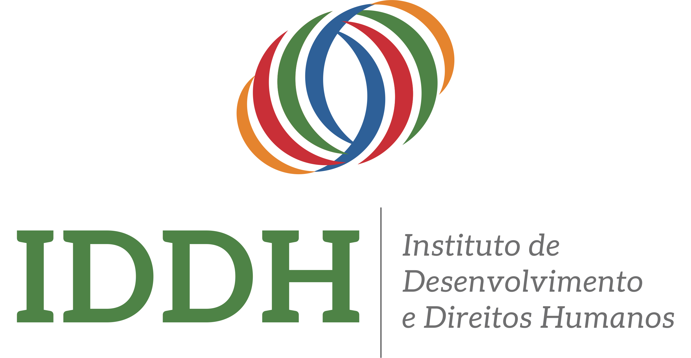

Co-sponsors:

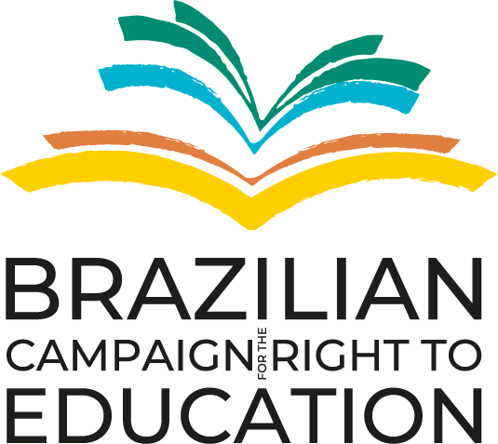

Contact: Institute for Development and Human Rights - IDDH
www.iddh.org.br - April 2024

INTRODUCTION

- The Institute for Development and Human Rights (IDDH) is a Brazilian civil society organization that, for 20 years, has sought to strengthen civic space in Brazil and Latin America through human rights education and articulation with civil society organizations to influence international human rights systems. It operates with: a) Training and Research (courses, workshops and materials), and, b) Articulation and Advocacy (Platforms for articulation and information on advocacy, such as the International Advocacy Network (RAI) and its Youth division (RAIJ). Find out more about IDDH through its digital platforms: iddh.org.br, Educar DH, IndexDH.org.br.
- Seeking to follow our mission, implement the 4th phase of the United Nations World Program for Human Rights Education (WPHRE - A/RES/66/137, 2011) and achieve SDGs 4 (Quality Education), 5 (Gender Equality) and 16 (Peace, Justice and Strong Institutions), IDDH established a Youth Program focused on strengthening the civic participation of young human rights defenders in international human rights forums.
- The Youth Program at IDDH began in 2020, in which young volunteers instruct and articulate human rights education to other young people, aiming at greater participation of this group in the human rights scenario.
- With the aim of making the opinion of Brazilian children at the CEDAW, the Youth Program at IDDH developed this report to encompass the evaluations and recommendations of adolescents about Human Rights Education in Brazil, focusing on Article 29 of the Convention on the Rights of the Child (Article that most encompasses HRE) and General Comment n.1 of the Children's Rights Committee. However, IDDH also included a section in the questionnaire devoted to analyzing the gender inequality issues in Brazil's education system, according to Article 10 of the Convention on the Elimination of all forms of Discrimination Against Women. For this report, only the questions and answers from the gender inequality section are shown and analyzed.

METHODOLOGY

- The Youth Program works with Human Rights Education because it believes it is an essential component of the Right to Education and a driver of human rights values and the society we aspire to be.
- This report resulted from a public consultation conducted by interns from the Youth Program at IDDH, who studied the Convention on the Rights of the Child, General Comment No. 1 from the Committee on the Rights of the Child and Article 10 from the CEDAW. Seeking to understand the experiences of adolescents with HRE directly, they developed a questionnaire focusing on article 29 of the Convention, divided into subsections of the article and the section about gender equality. The survey was launched on December 11, 2023, and ran until February 18, 2024, reaching all 5 regions of Brazil. Despite the limited number of participants, it facilitated an understanding of the national landscape concerning the subject. In total, there were 23 research participants from 8 of the 27 states in Brazil.
- We also emphasize that we recognize the limitations indicated by this data, as it represents a small sample and was originally collected for another purpose. This means that we are aware that we are presenting only a snapshot of the questions, highlighting those that are most relevant to the topics of gender-based violence and human rights education (HRE) in schools. Therefore, racial, regional, and other important markers for understanding violence against women in Brazil will not be extensively considered here. It is essential to highlight that IDDH, as a network to encourage HRE, also used the form for data collection and pedagogical purposes, concisely instructing respondents on subjects such as the UN, the 17 Sustainable Development Goals and the Universal Declaration of Human Rights. Considering all this extremely important information gathered by the youth interns of IDDH, we made this report for CEDAW, considering that the Committee should also consider the rights of girls and children in HRE.
- It is worth noting that for scale graphs from 0 to 10, the value 0 represents the least ideal situation, while the value 10 represents the most ideal scenario for the question context.

DEVELOPMENT: BRAZIL’S SCENARIO

During the last few years under Bolsonaro’s presidency, Brazil faced a severe deficiency in public policies addressing the needs of girls and women. The 2023 Spotlight Report (which monitors the implementation of the 2030 Agenda of Sustainable Development in Brazil) points to an alarming scenario. Target 5.1 has regressed over four years, with no official data on the indicator and governmental leniency towards gender-based violence and direct promotion of violations against the rights of women and girls by governmental bodies. This is based on philosophical conceptions of women's submission to men within the family and religious perspectives.
Despite civil society's efforts to monitor it, target 5.2 has been regressing since the first edition of the 2023 Spotlight Report, with no official data production on the indicators that address this commitment and in the face of the impact of patriarchal racism and misogyny on women's lives. In 2022, the number of women over 16 years old who reported experiencing some form of violence or aggression in the past 12 months increased by 4.5% compared to the previous year, according to the Brazilian Forum of Public Security: 18.6 million reports (28.9%), the highest rate since the survey began in 2018. There were almost 51 thousand cases of physical, psychological, and/or sexual violence against women per day. Most of them are Black (65.6%), young (30.3% between 16 and 24 years old), and are more likely to be verbally abused. Furthermore, black women are at higher risk of suffering from severe physical violence. According to research “Visible and Invisible: The Victimization of Women in Brazil” made by Datafolha, while 6.3% of black women say they have been victims of beatings, 3.6% of white women have suffered this type of attack, showcasing that black women are still being targeted in cases of gender-caused abuse cases.
As highlighted in Plan Internacional "Por Ser Menina Report”, the perception of girls about the street environment is that boys are safer, more carefree and live in this space with greater freedom and parental authorization. Girls, on the other hand, carry a constant insecurity, concern and fear related to their image, body, physical security and rights. These are barriers that mean that girls have fewer opportunities than boys, that they live with prejudices and judgments for being girls, and that end up hampering their development until adulthood.
In addition to the context of government-led lethality that stimulates the possession of individual weapons, there is a context of intense political culture which, on the other hand, reaffirms male ownership of women’s and girls’ bodies, which is why the domestic environment, is revealed as one of the most risky sites for women and girls. Moreover, within the judicial and law enforcement context, a reduction and/or stagnation in the network of care and services and protection for women victims of domestic sexual violence have culminated in the slowness of the judicial process.
Regarding education, Brazil faces a problematic scenario. According to the Brazilian Institute of Geography and Statistics (IBGE), In 2023, the illiteracy rate among women aged 15 and over was 5.2%, while among men it was 5.7%. Girls from the poorest households or living in fragile or humanitarian settings are not benefiting from the expansion in education, while the girls who are in school are struggling to secure the quality education they need to compete in a rapidly changing workforce where digital and transferable skills, like critical thinking and confidence, are indispensable.
Unfortunately, the panorama is that no matter where a girl lives, she is at risk of encountering violence in every space – in the classroom, home and community. And the types of violence she will come into contact with have become increasingly complex with the rise of technology. Considering this Brazilian scenario, the research conducted by interns from the Youth Program at IDDH portrays a critical overview regarding the rights of girls and women, especially in the school environment.

PUBLIC CONSULTATION RESULTS

- Firstly, it is important to highlight who the respondents of the forms were. Out of the 23 respondents, 13 of them (56.5%) considered themselves as cis men, 9 other participants were cis women (39.1%), and one participant chose not to inform their gender, as seen below:
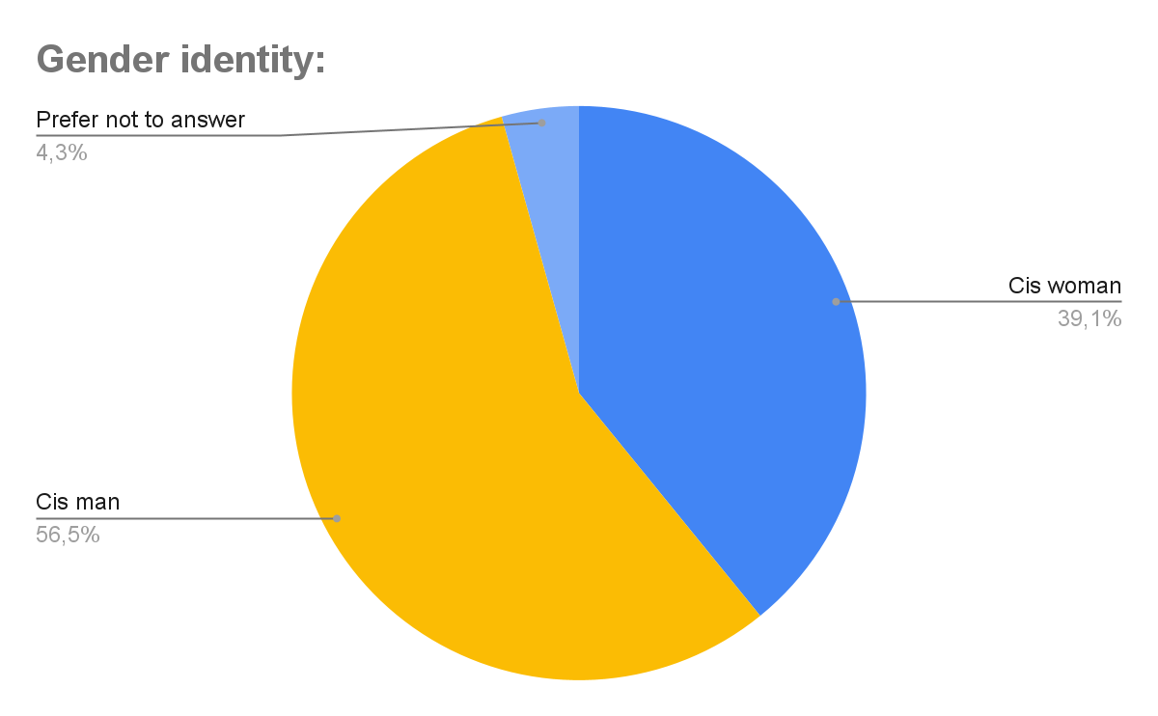

- Moreover, before the questions were shown in the forms, a brief and straightforward introduction to gender equality was added to contextualize children who might not have been familiar with the topic. It contained a summary of the achievements of the women's rights movement in addressing gender inequality and an overview of the challenges that girls and women continue to face today in educational and professional environments, in addition to the mention of SDG 5.
- Regarding the answers found, when asked if they have ever felt in danger while at school due to their gender, 8.7% of children answered that they frequently feel threatened because of their gender, while another 8.7% said that they experienced this instance but not constantly.
- In general, the majority of respondents stated that they had never felt in danger because of their gender. However, it is essential to highlight that individuals who responded that they have already felt at risk prefer not to inform their gender or identify as cis women.
- Moreover, almost 50% of the respondents, most of whom identify as cis women, stated that opportunities are different for men and women. Another 8% still determine whether the opportunities are the same, while the other 42% (of which 80% identify as men) stated that they did not see significant discrepancies regarding opportunities. It is essential to highlight that most respondents based their answers on the school environment.
- Furthermore, just over half of the children stated that they already feel socially pressured to do certain things because of their gender, regardless of how they identify. Again, at the school level, the majority considered that the school doesn’t address gender equality adequately and that phrases discriminating against individuals based on gender are common, as shown in the graphs below:

Graph 1: Distribution of children's perception of how often their schools comment on gender equality
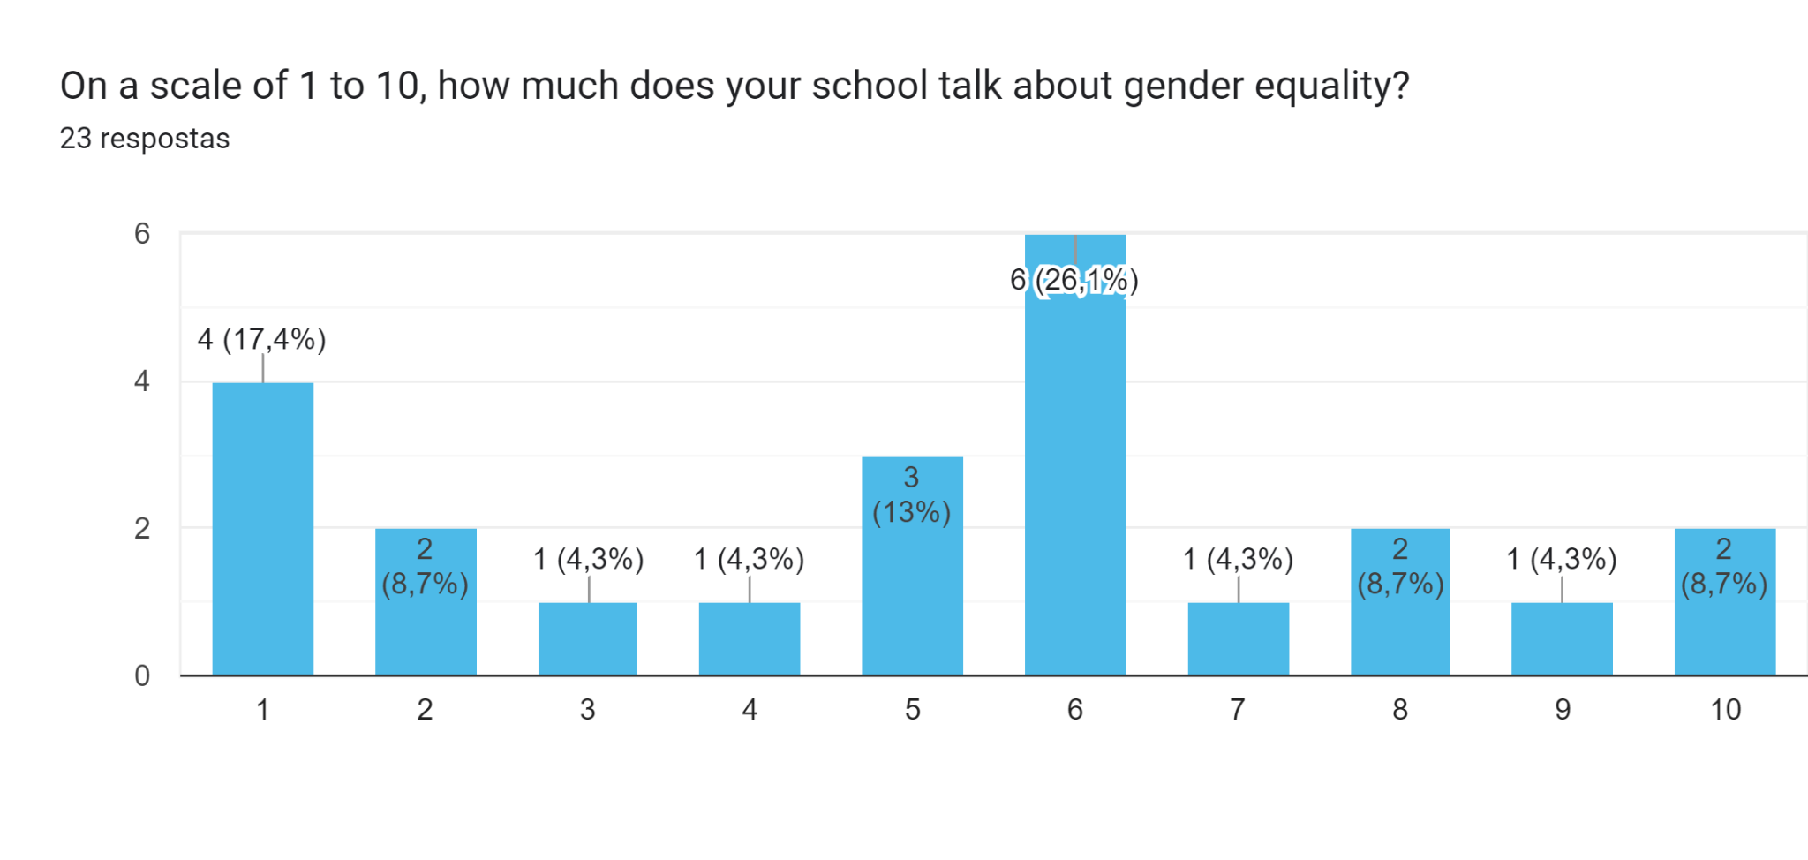

Graph 2: Distribution of children's perception of how often they observe discriminatory and prejudiced verbal behaviors regarding gender
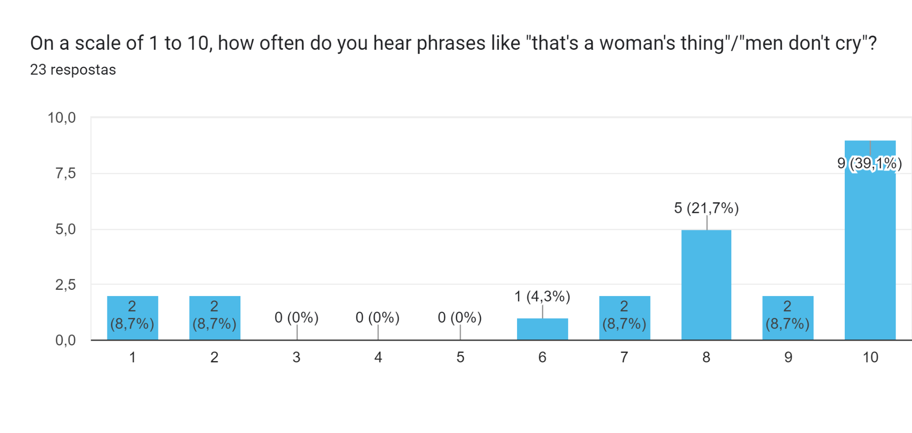
Henceforth, it is possible to consider that many children still suffer social pressures caused by gender roles, forcing them to act under expectations. Furthermore, there are a number of individuals who prefer not to disclose their gender and women who feel uncomfortable and unsafe because of their gender, impacting their well-being. Lastly, most respondents recognize a significant difference in the opportunities provided for different genders, highlighting the importance of continued education and information to mitigate this gap.

RECOMMENDATIONS:

Considering all that has been stated, we would like to suggest to CEDAW to recommend the Brazilian state the following:

- Make concerted efforts to include appropriate indicators and metrics for assessing compliance with the Convention, focusing on ensuring gender equality, especially taking into account children and young women, as well as the LGBTQIAPN+ community, and the racial marker of Afro-descendant women, which is determinant for fighting gender-based violence in Brazil;

- Prioritize efforts to include human rights education with a focus on combating all forms of discrimination and gender-based violence, including psychological and sexual violence within educational environments.

- Ensure actions aimed at implementing existing international and national parameters regarding human rights education (HRE), combating all forms of discrimination and gender-based violence, including the current phase of the World Programme on HRE and Learning; the National HRE Plan, SDGs 4 and 5.

According to Brazilian legislation, children are people under 12 years of age and adolescents those between 12 and 18 years of age (Art. 2 of the Child and Adolescent Statute (Law No. 8,069, of July 13, 1990). In turn, young people are people between 15 and 29 years old (Art. 1, § 1 of the Youth Statute, Law No. 12,852, of August 5, 2013). At the UN, the Convention on the Rights of the Child considers children people even 18 years old (Convention on the Rights of the Child) and young people between 15 and 24 years old (UN General Secretariat). Considering these classification variations, this report consulted children/adolescents between 15 and 17 years) and was prepared/coordinated by young adults (18 years old) from the Youth Program at IDDH). The intention is to be as inclusive as possible given the different classifications. There will only be no focus on children, since IDDH does not develop courses and methodologies specific to this age group in its leadership training.
PLAN INTERNACIONAL. Por Ser Menina. Available on: https://plan.org.br/wp-content/uploads/2021/11/relatorio-por-ser-menina-final.pdf
IBGE <https://agenciadenoticias.ibge.gov.br/agencia-noticias/2012-agencia-de-noticias/noticias/39530-proporcao-de-jovens-de-6-a-14-anos-no-ensino-fundamental-cai-pelo-terceiro-ano>
GT Agenda 2030. <https://gtagenda2030.org.br/relatorio-luz/relatorio-luz-do-desenvolvimento-sustentavel-no-brasil-2023/>.
COLETIVO RPU BRASIL. Relatório 2022 Igualdade de não-discriminação de gênero. <plataformarpu.org.br/publicacoes>.
PLAN INTERNATIONAL. A New era for Girls. Avaliable on <https://plan-international.org/publications/a-new-era-for-girls/>
GELEDES. Visível e Invisível: A Vitimização de Mulheres no Brasil. Available on:https://www.geledes.org.br/mulheres-negras-sofrem-mais-violencia-que-brancas-diz-pesquisa/?gad_source=1&gclid=CjwKCAjwt-OwBhBnEiwAgwzrUvmBy6AX32rmyATdj-ynQwkGZ-jLq7QgAERiNPAf2ho0FNovTmrL9BoCA1YQAvD_BwE

