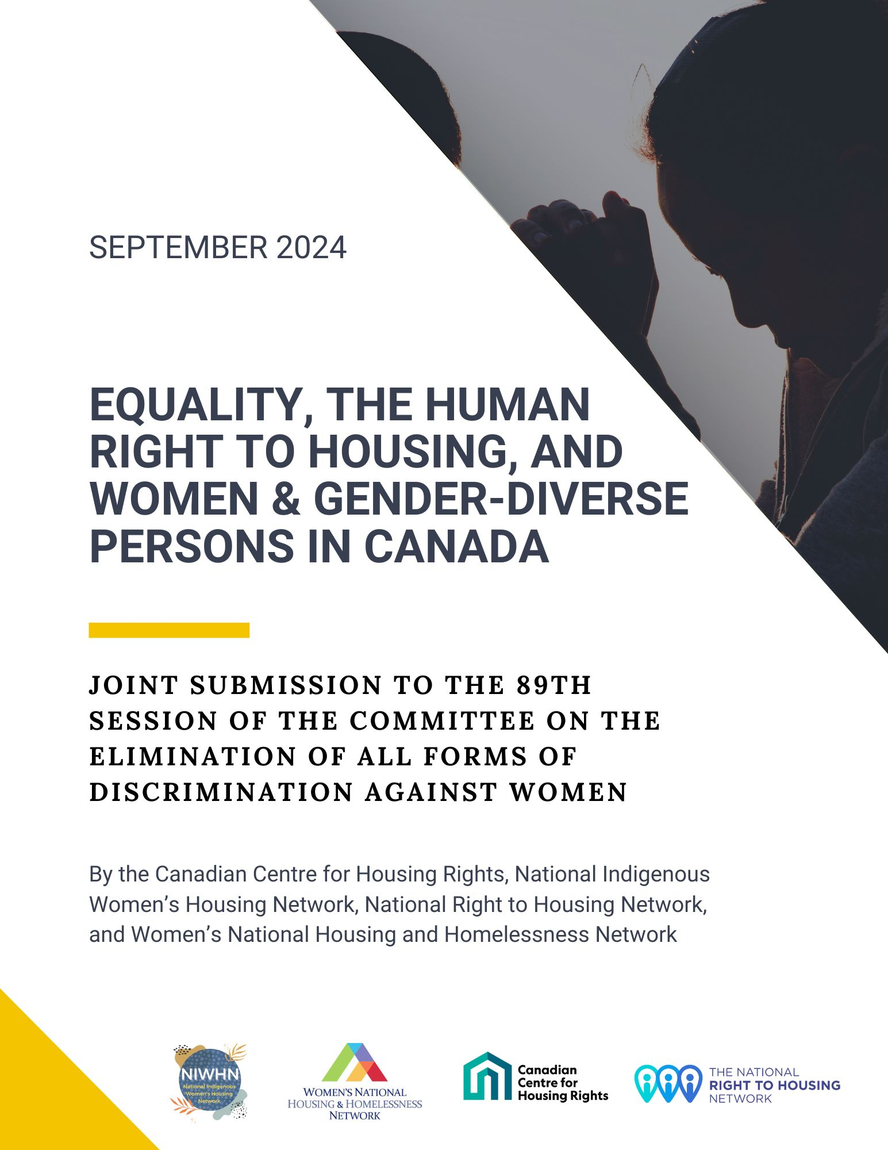
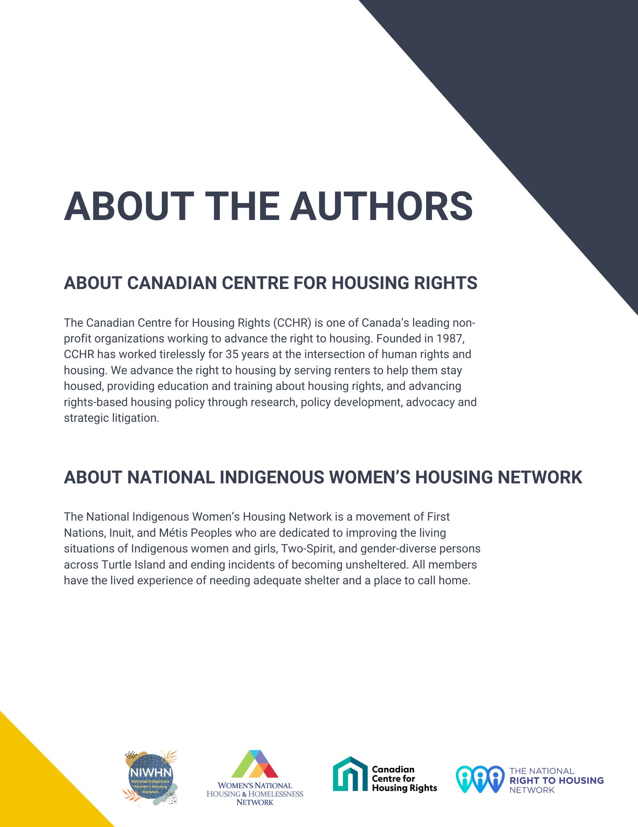
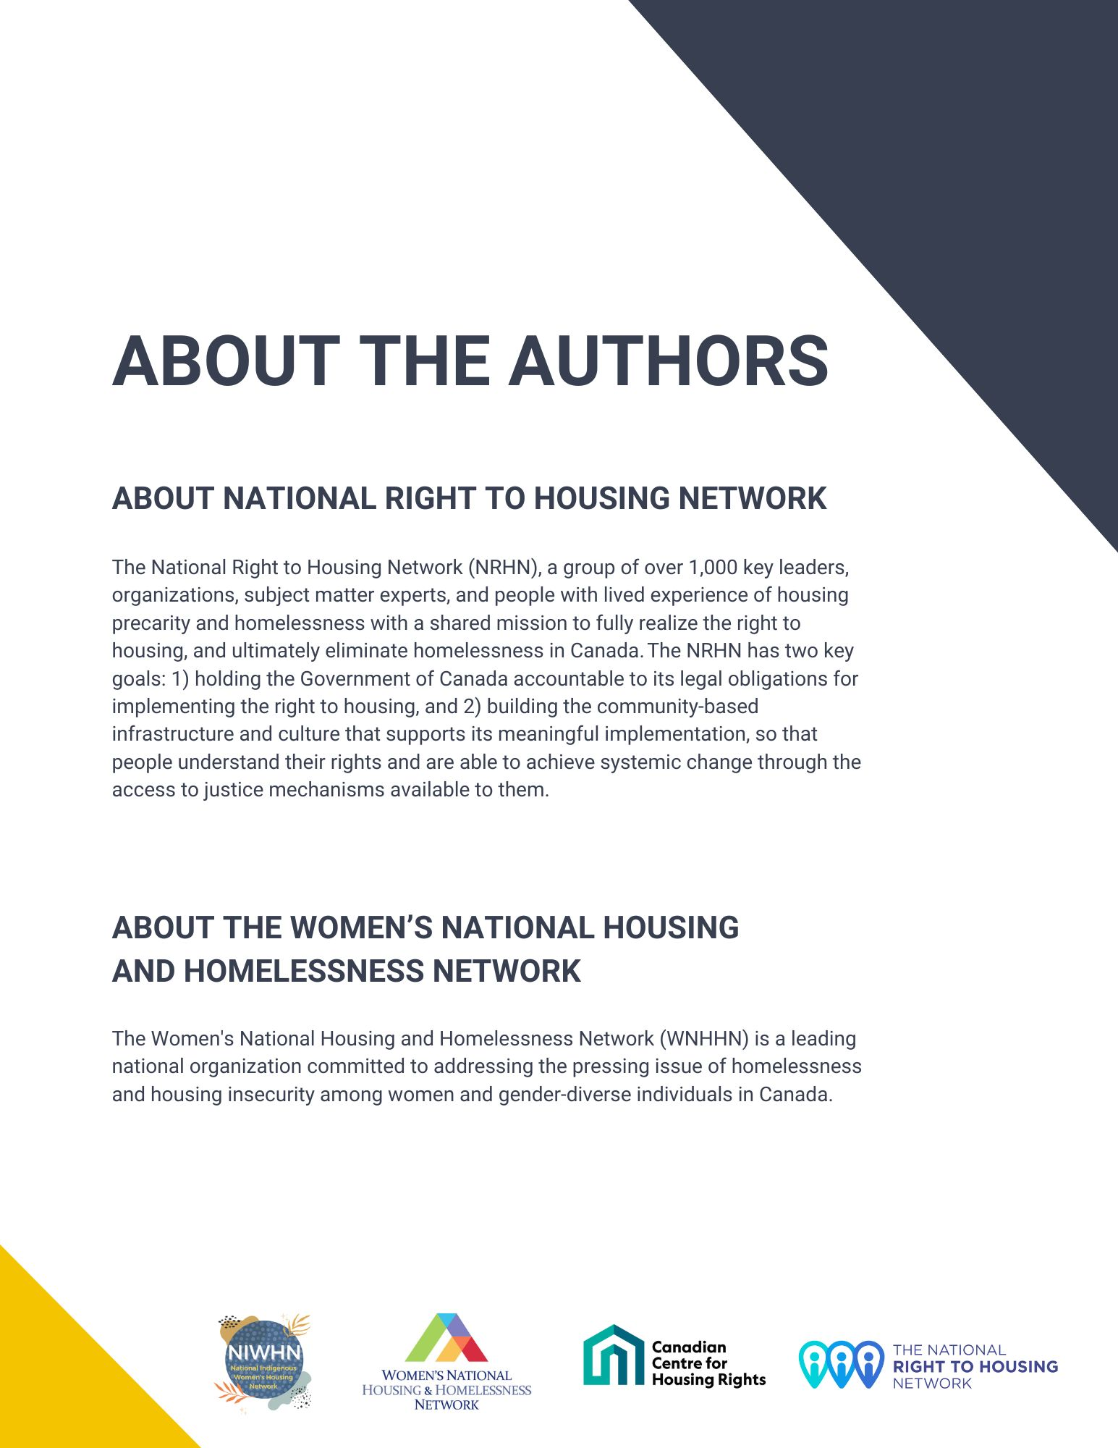
Contents

A. Introduction 4
B. Canada’s housing and homelessness crisis as experienced by Indigenous women and 2-Spirit persons – Articles 2, 3, 11 and 14 4
C. Economic empowerment of women – Articles 2, 3, 11 and 14 10
i. Impact of the COVID-19 Pandemic 11
ii. Canada’s Response to the Housing and Homelessness Crisis in Law, Policy, and Programs 12
a) National Housing Strategy Act Accountability Mechanisms 12
b) Federal Policies and Programs 14
iii. Feminization of Poverty and Experiences of Homelessness 18

Introduction
- The Canadian Centre for Housing Rights, National Indigenous Women’s Housing Network, National Right to Housing Network, and Women’s National Housing and Homelessness Network submit this brief in advance of the 89th Session of the UN Committee on the Elimination of All Forms of Discrimination Against Women (CEDAW Committee).

Canada’s housing and homelessness crisis as experienced by Indigenous women and 2-Spirit persons – Articles 2, 3, 11 and 14
- Women and gender-diverse people, and particularly Indigenous women, girls, Two-Spirit, and gender-diverse people, are experiencing some of the most egregious right to housing violations across Canada. While recognizing the gendered violence and exploitation created as a result of housing policy failures is critical, it is also important to acknowledge that the current housing landscape does not exist in a vacuum. As recognized in Homeless on Homelands, a human rights claim submitted by the National Indigenous Women’s Housing Network:
“At the core of the matter is dispossession from lands Indigenous women, girls, and gender-diverse people have called home since time immemorial. Colonial conceptualizations of land, ownership and housing as commodities that are bought, sold and are subject to financial speculation disrupt the relationship of mutuality and reciprocity that is inherent to Indigenous relationship with land. It commodifies land and positions housing development as a tool of extracting wealth and profits. Current [housing crises and ongoing financialization of housing] in Canada deeply relies on disruption and elimination of Indigenous ways of knowing and living.”
- In its 2016 Concluding Observations, the CEDAW Committee noted the State party’s commitment to fully implementing the United Nations Declaration on the Rights of Indigenous Peoples (2007). It also raised concern with Canada’s lack of “a coherent plan or strategy to improve the socioeconomic conditions of Indigenous communities, in particular Indigenous women, in order to combat the root cause of their vulnerability to violence, and about the lack of measures to break the circle of distrust between the authorities and Indigenous communities.”

- Similarly, the CEDAW Committee noted concern in 2016 that, “Indigenous women continue to suffer from multiple forms of discrimination, in particular with regard to their access to employment, housing, education and health care, and continue to live in poverty in the State party, as reflected by high poverty rates, poor health, inadequate housing, lack of access to safe water and low school-completion rates” (emphasis added).

- The lack of coordinated action to improve the socio-economic conditions of Indigenous women and 2-Sprirt persons has not improved since the CEDAW Committee issued this recommendation. The most pressing evidence of this can be gathered from the Canadian government’s response to the Calls to Justice from the Missing and Murdered Indigenous Women and Girls (MMIWG) Inquiry Report. Of the 231 Calls to Justice, only two have been completed, while half have not even started yet. These calls represent critical actions and steps, identified by Indigenous communities across Canada, to ensure the realization and enjoyment of Indigenous women’s human rights and their inherent rights. The Calls to Justice particularly point to the critical urgency of investments in housing, with important emphasis on culturally appropriate supportive housing models, led by and for Indigenous women and gender-diverse people.

- In 2020, the Canadian government committed $724 million over 5 years as part of a comprehensive Violence Prevention Strategy to build new transitional housing/second stage shelters serving Indigenous communities, and to provide operational funding to existing shelters. This funding aimed to play a critical role in getting essential gender-based violence (GBV) response services to communities that were previously not served by any such service. Yet, as of May 2023, the funding was largely unspent, with only $4.38 million dispersed to four projects. While new shelters are anticipated to be developed over this year and next, this demonstrates the slowness of the government’s response in the face of an urgent crisis that continues to create extreme vulnerabilities and loss of life among Indigenous women and gender-diverse people.

- In its 2022 budget, the Canadian government earmarked $4.3 billion over seven years to address the housing crisis impacting First Nations, Métis and Inuit communities. This included $2.4 billion over five years to support First Nations housing on reserves, $565 million over five years to support housing in Self-Governing and Modern Treaty Holder First Nations communities, $845 million over seven years to support housing in Inuit communities, and $190 million over seven years for housing in Métis communities. It continues to remain unclear how these investments specifically aim to benefit First Nations, Inuit and Métis women and gender-diverse people and lift them out of housing insecurity. As noted in the report by Les Femme Michif Otipemisiwak “it is not explicitly stated what steps are taken to incorporate a gendered lens in addressing the needs of Métis women and girls” when it comes to affordable housing investment by the federal government.

- The government’s 2022 budget also announced $300 million to address the critical need for safe and affordable urban, rural and northern Indigenous housing projects. The 2023 budget committed an additional $4 billion over seven years starting in 2024-25 for the implementation of the Urban, Rural and Northern (URN) Indigenous Housing Strategy. Many noted that these investments fall significantly short of what is actually needed to address the crisis, which spans across the country, from remote communities in the North, to on-reserve and off-reserve communities. More critically, there is a lack of clarity around how the investments are set to benefit women and gender-diverse people and no information on intersectional, gender-responsive monitoring and measuring mechanisms that would track how funds are spent to alleviate the most vulnerable out of housing need.

- The government’s 2024 budget announced $4 billion over seven years for the URN Indigenous Housing Strategy. While this investment was welcomed by advocates, it is yet to be operationalized and falls short of the need. Based on the report from the National Housing Council, a $3 billion investment per year is required to close the gap on existing housing needs for Indigenous communities in URN regions.

- As critical as it is that these funds be disseminated through an Indigenous-led delivery partner, it is equally critical that the federal government and its delivery partner adopt a gender-responsive dissemination strategy and establish mechanisms to monitor and track how these funds are being allocated, as well as their impact on reducing homelessness and housing need for Indigenous women and gender-diverse people and their families. It is critical that these monitoring mechanisms are accountable to marginalized Indigenous women, gender-diverse people, and 2SLGBTQQIA+ people themselves, and the organizations and groups they choose to represent them.

- Like other federal investments in housing, investments in Indigenous housing are not accompanied with any coherent strategies, plans or mechanisms to ensure that housing developed or operated as a result of these investments benefits Indigenous women, girls, Two-Spirit and gender-diverse individuals. Data is often also unclear around distinct impacts on First Nations, Inuit and Métis women and gender-diverse people, and how investments alleviate them from poverty and housing insecurity through addressing their unique needs.

- There is also a lack of disaggregated data that captures the scale and depth of First Nations, Inuit and Métis experiences with housing insecurity, and homelessness continues to be a barrier to distinctions-based policy that addresses unique concerns of the women and gender-diverse people from diverse Indigenous communities. As noted in the report from Les Femmes Michif Otipemisiwak, particularly in regards to Métis women and gender-diverse people, “There does exist some disaggregated data on some of the root causes that lead to homelessness (e.g., health, education, employment), however the experiences and stories of Indigenous peoples, in the context of homelessness, are not universal. Data must not homogenize their experiences as the Métis population, particularly Métis women and girls, have unique experiences and distinct needs.”

- Indigenous women and gender-diverse people continue to be disproportionately impacted by egregious housing insecurity, shaped by socio-economic factors like poverty and access to health and education. Compared to non-Indigenous women, Indigenous women are more likely to be in core-housing need, with single-mother led households particularly over-represented in this demographic. The Pan-Canadian Women’s Housing and Homelessness Survey further noted that Indigenous women and gender-diverse people were also more likely to report experiences of eviction and discrimination from landlords. The survey also reported that Indigenous women were more likely to experience homelessness at younger ages, with one in four Indigenous survey participants reporting their first experience of homelessness before the age of 16.

- In June 2022, the National Indigenous Women’s Housing Network launched a historic human rights claim, Homeless on Homelands: Upholding Housing as a Human Right for Indigenous Women, Girls, Two-Spirit, and Gender-diverse People. The claim, submitted to the Federal Housing Advocate, recognized the National Housing Strategy Act (NHSA) as a critical instrument that can be utilized to challenge colonial policies and mechanisms that attempt to displace Indigenous women, girls, Two-Spirit, and gender-diverse people from “their proper power and place.”

- This human rights claim articulated four key violations to the housing rights of Indigenous women, girls, Two-Spirit and gender-diverse people across Canada.
  - Violation 1: Lack of Action on the Calls to Justice from the Inquiry into Missing and Murdered Indigenous Women and Girls Report and Calls to Action from the Truth Reconciliation Commission Report
  - Violation 2: Failure to Provide Safe, Adequate and Culturally-Appropriate Housing, on Our Own Terms
  - Violation 3: Interjurisdictional Neglect, Multiple Systems Failure, and Institutional Betrayal
  - Violation 4: Security of Tenure under NHS and Secure Indigenous Land Tenure

- Submitted together with the Women’s National Housing and Homelessness Network, The Crisis Ends with Us: Request for a Review into the Systemic Denial of the Equal Right to Housing of Women and Gender-Diverse People in Canada, the claims were reviewed and collectively referred by the Federal Housing Advocate to the National Housing Council, requesting a national Review Panel on Government’s Failure to Prevent Homelessness for Women and Gender-Diverse People. The national review panel is set to be a historic first-of-its-kind process, recognizing homelessness impacting women and gender-diverse people as a critical human rights issue in Canada.

- RECOMMENDATIONS

- Echoing Concluding Observations from CEDAW’s 2016 review of Canada, develop a specific and integrated plan for addressing the particular socioeconomic conditions affecting Indigenous women, both on and off reserves, including poverty, poor health, inadequate housing, low school-completion rates, low employment rates, low income and high rates of gender-based violence, and take effective and proactive measures, including campaigns to raise awareness within Indigenous communities about women’s human rights and to combat patriarchal attitudes and gender stereotypes.

- Revise the definition of chronic homelessness in the National Housing Strategy to better reflect gendered experiences of housing need and homelessness, including hidden homelessness and homelessness amongst Indigenous women, girls, Two-Spirit, and gender-diverse people.

- Provide adequate and consistent funding to an Urban, Rural and Northern Indigenous housing strategy that is co-developed with Indigenous communities and applies an intersectional gendered lens.

- Recognize Indigenous women’s and gender-diverse people’s right to self-determination through creating resources and capacity for housing designed by Indigenous peoples, built by Indigenous peoples, applying biophilic design, and environmentally friendly materials.

Economic empowerment of women – Articles 2, 3, 11 and 14
- Women and gender-diverse people across Canada experience disproportionate levels of housing need and barriers to adequate housing. Of the 1.7 million people experiencing core housing need, 28 per cent are women-led households. Moreover, a greater proportion of women-led, lone-parent family households are in core housing need (27 per cent) compared to men-led households (16 per cent), and more women-led households live in subsidized housing (44.1 per cent) than men-led households (40.5 per cent).

- Women’s housing need is further interconnected with experiences of GBV, with GBV constituting a leading cause of homelessness among Canadian families, particularly women-led households. Women account for 79 per cent of people experiencing GBV, and survivors are four times more likely to face housing insecurity. As a result, 75 per cent ￼ However, it is important to note that currently available data severely underestimates the scale of women’s homelessness and housing need, due in part to the hidden nature of women’s homelessness.

- Several factors perpetuate women’s homelessness and housing need and create barriers for access to adequate housing, including discrimination in the housing market and emergency shelter systems, lack of affordable and appropriate long-term housing options, underfunded and overwhelmed emergency shelter systems, and gaps in emergency services for women and gender-diverse people, which prevent those fleeing violence from regaining housing stability.

- A national survey on women’s housing and homelessness revealed that women’s experiences of discrimination in housing are widespread, particularly among 2SLGBTQQIA+ people, Indigenous people, racialized people, people with disabilities, people receiving social assistance, and other equity-deserving groups. Eighty per cent of respondents reported experiencing at least one form of discrimination from a landlord or property manager, with most respondents experiencing multiple forms of discrimination. Nearly 16 per cent of respondents reported that they were forced to move out of their last home because of discrimination or harassment. Moreover, over 70 per cent of respondents reported living in unsuitable housing conditions, and 37 per cent reported experiencing an eviction, many of whom did not have access to legal support at the time they were evicted.

- Across Canadian shelter systems, there are very few women-specific emergency shelter beds. Sixty-five per cent of all shelter beds are open to all genders (40 per cent) or designated for men only, compared to nine per cent dedicated specifically for women. There are close to three times the amount of emergency shelter beds available to men (4,628) compared to women (1,687) across the country, while some jurisdictions – such as Yukon – report having no women-specific emergency homeless shelters.

Impact of the COVID-19 Pandemic
- Women’s housing need and precarity were further exacerbated by the COVID-19 pandemic, as women were disproportionately affected by job loss and other economic factors, in addition to experiencing greater risks of eviction and increased rates of GBV. For its part, Canada failed to implement specific policies or programs to address these urgent needs, undermining women’s right to housing.

- More than 20,000 women left the workforce between February and October 2020, while about 68,000 men joined the workforce during that time period. While women make up just under half of all workers, they accounted for nearly two-thirds of all job losses during the pandemic and 70 per cent of all job losses among workers aged 25 to 54. The pandemic highlighted that women are more often employed in marginal jobs, tend to make less money than men for doing the same jobs, and are more likely to work part-time jobs and in sectors that were negatively impacted by the pandemic. Women are also more likely to work minimum wage jobs, and as such, are less likely to have financial savings.

- The loss of jobs and incomes contributed to an arrears and eviction crisis. Due to pandemic-related job losses and the lack of savings, women across the country bore the brunt of the pandemic and were forced to choose between paying rent or paying for other life necessities. Due to rising rents, emergency pandemic income supports were not sufficient to protect women-led households from eviction due to rental arrears. As a result, women experienced greater housing precarity and risk of homelessness due to the inability to pay rent, both during and beyond the pandemic.

Canada’s Response to the Housing and Homelessness Crisis in Law, Policy, and Programs

National Housing Strategy Act Accountability Mechanisms
- The National Housing Strategy Act (NHSA) is federal legislation that was adopted by the federal government in 2019. The NHSA recognizes the right to housing as “a fundamental human right affirmed in international law.” It states that “housing is essential to the inherent dignity and well-being of the person,” and commits the federal government to “further the progressive realization of the right to adequate housing as recognized in the International Covenant on Economic, Social and Cultural Rights.”

- The NHSA also requires the government to adopt and maintain a rights-based National Housing Strategy to support the progressive realization of the right to housing. The Strategy must include national goals, timelines and desired outcomes, focus on improving housing outcomes for persons in greatest need, and provide for participatory processes to ensure the ongoing inclusion and engagement of civil society, stakeholders, vulnerable groups, and persons with lived experience of housing need, as well as those with lived experience of homelessness. A National Housing Strategy was presented by the government in 2017 (two years prior to the passing of the NHSA), but to date has not been updated to reflect the right to housing as reflected in the International Covenant on Economic, Social and Cultural Rights (ICESCR) and required by the NHSA.

- The NHSA also requires the appointment of:
- A Federal Housing Advocate who receives and reviews submissions on systemic issues and submits findings and recommendations to the Minister of Housing;
- A National Housing Council to advise the Minister on changes needed to the National Housing Strategy; and
- A Review Panel of three members, appointed by and from the National Housing Council, to hold participatory hearings into systemic issues referred to by the Federal Housing Advocate and submits opinions and recommended measures to the federal government.

- The NHSA was the result of years of civil society advocacy and urging from UN treaty bodies and successive Special Rapporteurs on the Right to Adequate Housing. It should be noted that the legislation as first introduced by the Government of Canada failed to provide for meaningful accountability or hearings into systemic violations of the right to housing. However, after interventions from civil society and by the UN Special Rapporteur on the Right to Adequate Housing, amendments were introduced to ensure access to hearings, reviews by the independent Advocate, findings and recommendations requiring a response from the government. These innovative mechanisms for access to justice outside of the court system are seen internationally as an important initiative that may be applied in other countries. The mechanisms address systemic issues that are often neglected when courts adjudicate individual claims. However, they rely on adequate support for rights claimants and good faith engagement by governments.

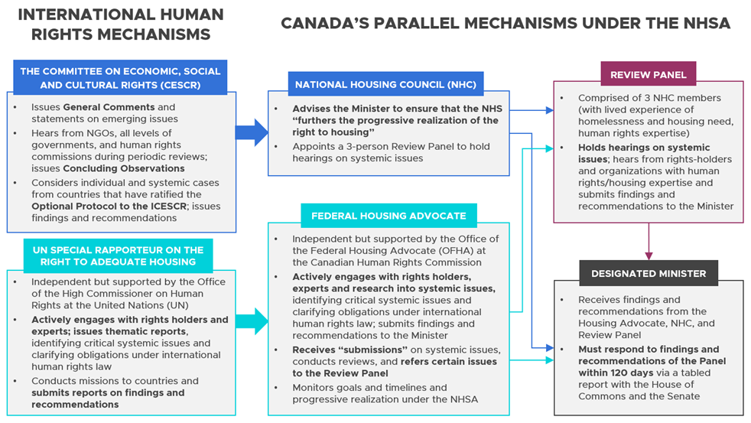

- Through the first Review Panel, which examined the financialization of purpose-built rental housing, and the Federal Housing Advocate’s first review, which examined homeless encampments in 2023, right holders in Canada participated in unprecedented accountability mechanisms committed to identifying and remedying systemic violations of the right to housing.

- While civil society engagement was one of the strongest components of the Review Panel on financialization, the noticeable absence of key government departments and elected officials from all levels of government represents a critical weak link in the review panel process. Importantly, participation from the Canada Mortgage and Housing Corporation (CMHC), Economic and Social Development Canada (ESDC), Women and Gender Equality Canada (WAGE), and Housing, Infrastructure and Communities Canada (HICC) can help future Review Panels to create more informed recommendations that narrow in on remedying structural gaps, barriers and challenges to eliminate violations of the right to housing of women and gender-diverse people in greatest need.

- Ultimately, the strength of the recommendations generated from these processes is the biggest test of the processes’ ability to drive the progressive realization of housing as a human right. With reports from the first Review Panel released, rights holders are voicing concerns that the recommendations fall short of presenting housing solutions that would address the urgency and direness of the crisis.

Federal Policies and Programs
- In 2017, the federal government launched Canada’s first National Housing Strategy, followed by the aforementioned 2019 NHSA, recognizing the progressive realization of the human right to adequate housing. The 2017 Strategy committed 25 per cent of investments to women and girls, but since then, governments have made few efforts to monitor or measure if this target is being met. In addition, homelessness programs under the strategy do not reflect gendered experiences of homelessness, such as hidden homelessness.

- The Government of Canada has not yet adopted a strategy to prevent and end homelessness amongst women and gender-diverse persons in Canada. The existing federal commitment to end chronic homelessness by 2030 does not specify how this target will be reached for women and gender-diverse persons, especially given that chronic homelessness is commonly hidden for this population (e.g., chronic situations of abuse, couch-surfing, and/or relying on dangerous survival strategies to pay rent, such as trading sex for payment). As has been documented extensively elsewhere, current data collection methods (e.g., Point in Time Counts, Street Needs Assessments, By-Name Lists) are largely unable to capture experiences of hidden homelessness. As a result, these gendered experiences are inadvertently invisibilized, making it difficult to track progress towards the elimination of homelessness amongst women and gender-diverse people.

- In the Canadian context, governments tend to focus on addressing visible homelessness, often in the form of rough sleeping (or ‘unsheltered homelessness’), with investments and programs targeting people experiencing chronic homelessness. Reaching Home, Canada’s current homelessness strategy, and its predecessor, the Homelessness Partnering Strategy, prioritize addressing chronic homelessness in its programs. In its 2020 Speech from the Throne, the federal government committed to ending chronic homelessness in Canada. However, the definition of chronic homelessness used in Reaching Home fails to account for the often-hidden forms of homelessness that women, girls, women-led families, and gender-diverse persons experience. These include conditions such as:
  - “Remaining in an abusive relationship in order to maintain housing.
  - Living in inadequate or dangerous housing in order to keep the family together or maintain custody over one’s children.
  - Engaging in survival sex in order to access housing.
  - Couchsurfing with family, friends, or strangers in order to avoid shelters, or because shelter services and affordable housing are unavailable or unsafe.”

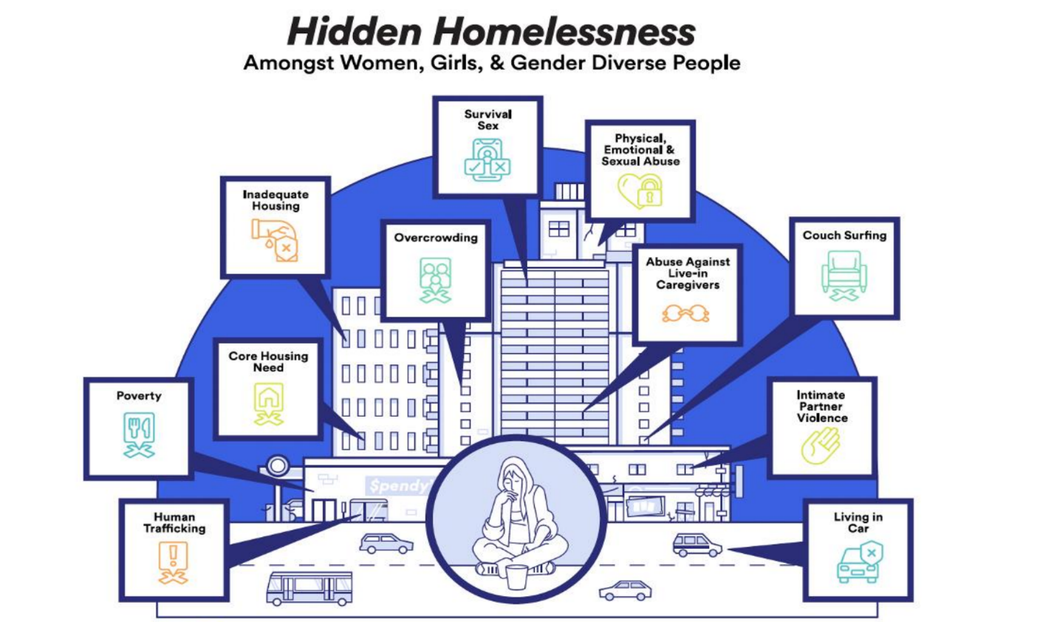Figure 1: Hidden Homelessness Amongst Women, Girls and Gender-Diverse People.
- This failure to capture the unique experiences of women and gender-diverse persons within federal definitions of homelessness and chronic homelessness likely contributes to gender-based inequities in funding, and contributes to severe gaps in supports, services, and emergency housing. Further, it means that women and gender-diverse people may not be considered candidates for “priority housing lists” and Housing First programs because the ways in which they experience chronic homelessness are often distinct (e.g., multiple years trapped in a violent home vs. chronic shelter users). As such, the effect of the current definition of chronic homelessness contravenes the obligation that governments guarantee substantive equality and non-discrimination in the area of housing.

- Under the NHSA and international human rights law, the Government of Canada is required to establish human rights-based targets, timelines, outcomes, and indicators regarding the immediate elimination of homelessness and the progressive realization of the right to housing. While the federal government committed to eliminate chronic homelessness by 2030, it has failed to set many other targets (e.g., timeline for the elimination of children’s homelessness). Similarly, while the federal government has committed to allocating “33 per cent of the Strategy’s investments, with a minimum of 25 per cent towards serving the unique needs of women and their children,” it remains unclear how this 33 per cent (let alone 25 per cent) has been achieved with respect to homelessness specifically. In CMHC’s 2020 progress report on the National Housing Strategy, gender-specific outcomes were noted for only one program – the National Co-Investment Fund – which does not address homelessness. More broadly, much reporting to date on the impact of the National Housing Strategy has taken the form of reporting on dollars spent rather than outcomes, such as the number of individuals and families lifted out of core housing need and homelessness.

- Critically for this review, in 2016, the CEDAW Committee recommended that Canada, “[e]nsure that the national poverty reduction strategy and the national housing strategy protect the rights of all women, with a focus on the most disadvantaged and vulnerable groups, by integrating a human rights-based and gender-based approach.”

- The federal government’s 2024 budget (and updated National Housing Strategy, now known as Canada’s Housing Plan) does include some measures to address Canada's housing crisis, which, though incremental, are welcome commitments. This includes a Tenant Protection Fund to empower tenants’ rights organizations, a Renters’ Bill of Rights, funding for non-market housing (i.e., $1.5 million for a Rental Protection Fund), and increased investment in Canada’s homelessness strategy (including human rights and Housing First responses to encampments). More recently, the government launched the long-awaited Co-operative Housing Development Program, and is expected to launch the Urban, Rural and Northern Indigenous Housing Strategy soon. However, recent funding announcements did not include any gender or human rights-based targets, goals, or data collection, despite the Strategy’s commitment to ensuring 25 per cent of investments reach women and girls.

- While there is reason to celebrate these federal investments, they pale in comparison to investments in the private housing sector, such as the additional $15 billion allocated to the Apartment Construction Loan Program in Budget 2024. Additionally, while the Renters’ Bill of Rights presents the opportunity for federal leadership to establish minimum standards of renter protections across the country over the long-term, Canada's rent control measures remain inconsistent and fragmented at the provincial and territorial level. Housing advocates across Canada have noted that without sharp gender-based and human-rights focused implementation, monitoring, and tracking mechanisms, Budget 2024 measures will fall short of addressing the housing needs of women and gender-diverse people in greatest need.

- RECOMMENDATIONS

- Commend the government of Canada on the passing and implementation of the National Housing Strategy Act. With a second review panel on the Government’s Failure to Eliminate Homelessness for Women and Gender-Diverse People fast approaching, it is critical that the shortcomings of the review panel process are recognized and adequately corrected – including the need for government to appear in front of panel members. Identifying systemic violations to the right to housing for women and gender-diverse people would require the review panel to narrow in on structural challenges like feminization of poverty, multiple forms of gender-based violence (GBV), marginalization rooted in racism and ableism and harms created through state and colonial institutions.

- Ensure gender-based equity in funding under Canada’s Housing Plan and prioritize investments in affordable housing that address the deep poverty experienced by women and gender-diverse people. This includes greater investment in the Affordable Housing Fund and Co-operative Housing Program and increasing access to these programs by women-led and women-focused organizations, non-profits, and housing providers.

- Develop a robust monitoring system to ensure that funding under Canada’s Housing Plan goes towards women, girls and gender-diverse people in greatest need.

- Establish a gender-responsive budgeting processes to address differing impacts on the housing experiences of women and gender-diverse persons to ensure compliance with the “maximum available resources” and “all appropriate means” standards. This includes recognizing the distinctive and urgent obligation to protect the right to life of Indigenous women, girls and gender-diverse people in accordance with the Calls to Justice from the MMIWG Inquiry Report.

- Invest in more social housing for low-income households, which are disproportionately women-led.

- Invest in more permanent supportive housing options for women and gender-diverse people experiencing homelessness and fleeing GBV.

- Ensure that the development of recently announced new protections for tenants, such as the Tenant Protection Fund and the Renters’ Bill of Rights, is informed by structural barriers faced by women and gender-diverse people, leading to national standards on rent and vacancy control.

Feminization of Poverty and Experiences of Homelessness
- The feminization of poverty has been well-documented in Canada, with data indicating women often survive on lower incomes, are overrepresented in minimum-wage and part-time jobs, assume disproportionate responsibilities for housework and childcare, and their employment and income is more likely to be interrupted in the event of pregnancy and/or child rearing. Income inequality is particularly evident for Indigenous and racialized women, with research indicating that racialized women in Canada earn only 55.6 per cent of the income earned by non-racialized men. This gendered economic inequality, in the context of overheated housing markets, means many women and their children are forced to remain in situations of violence and/or inadequate housing. Research demonstrates women will remain in abusive situations for years because they cannot afford any other housing in their community, or available housing does not meet their children’s needs (e.g., proximity to transportation, schools), and/or they fear for their children’s safety in the care of their partners. Mothers who do leave situations of intimate partner violence with their children often experience housing need and profound systemic challenges in accessing supports and regaining housing stability.

- Single mothers face overwhelming structural challenges to accessing safe, affordable, and adequate housing in Canada. As noted above, women-led, lone-parent family households are more likely to be in core housing need than men-led households (27 per cent vs. 16 per cent), and that single mothers experience greater levels of poverty than other demographic groups. Canadian Census of Population (2016) data indicates that “lone-parent households, particularly lone-parent households led by women, are far more likely to be in core housing need than other family types,” with research showing “36 per cent of those in lone-parent families were in core housing need, a far higher rate than couples without children (5 per cent) and couples with children (8per cent).” Housing need and homelessness is often heightened for women and children experiencing multiple forms of marginalization, particularly Indigenous women, girls, Two-Spirit, and gender-diverse people. For example, the rate of shelter use for Indigenous children (ages 0-15) is 9.2 times higher than for non-Indigenous children, and research consistently shows that Indigenous mothers face unique burdens to regaining housing stability, such as racist and discriminatory treatment by landlords.

- The combination of poverty, violence, and inadequate housing creates the conditions for child welfare involvement – including because poverty and housing conditions are frequently conflated with neglect in child welfare investigations. Housing instability is frequently perceived as an indicator of adverse parenting behaviours, specifically neglect, resulting in apprehension of children.

- Studies indicate that children and youth with experiences of child welfare involvement are at greater risk of becoming homeless as young people, and that losing custody of one’s child is a traumatic crisis that can precipitate homelessness for some women. Child welfare involvement has been linked to lifelong experiences of eviction, and studies indicate child and youth experiences of housing instability and violence are predictive of adult homelessness, parent child separation, and violent victimization. This suggests that chronic homelessness, adult homelessness, and intergenerational homelessness are linked to experiences of homelessness during childhood and youth, which are often inseparable from mothers’ experiences of inadequate housing.

- In 2023, advocates welcomed the design of the Canada Disability Benefit Act (CDBA), which aims to provide income support for persons with disabilities. The CDBA states that, in setting the amount of the benefit, the Governor in Council must take into consideration:
  - the Official Poverty Line as defined in section 2 of the Poverty Reduction Act;
  - the additional costs associated with living with a disability;
  - the challenges faced by those living with a disability in earning an income from work;
  - the intersectional needs of disadvantaged individuals and groups; and
  - Canada’s international human rights obligations.

- The Disability Benefit amount ($2,400 per year), set in the 2024 federal budget, bears no reasonable relationship to the criteria outlined above. Under the previous Canada Assistance Plan Act, governments were obligated to set social assistance rates at an amount that considers the basic requirements of a household. The Supreme Court of Canada clarified that considering basic requirements did not dictate a precise amount, but it required the provision of assistance “that is compatible, or consistent, with an individual's basic requirements.”

- This is particularly pressing for women and gender-diverse people, as research shows that over 75 per cent of women and gender-diverse people experiencing housing insecurity report some form of disability. The current Disability Benefit amount will not be able to lift women and gender-diverse people with a disability out of housing insecurity or homelessness. The benefit amount does not reflect the official poverty line and does not align with international human rights law requirements related to the right to adequate housing and to live independently with dignity in the community.
RECOMMENDATIONS
- Strengthen income supports to address the depth of poverty experienced by women and gender-diverse people and their families.

- Increase the amount of the Canada Disability Benefit to an amount that is consistent with CDBA, which requires that the benefit be set at an amount that is consistent with the poverty line and with the requirements of the right to adequate housing and to live independently with dignity in the community under international human rights law.

National Indigenous Women’s Housing Network (2022). “Homeless on Homelands: Upholding Housing as Human Right for Indigenous Women, Girls, Two-Spirit and Gender-Diverse People.” https://womenshomelessness.ca/wp-content/uploads/Indigenous-Housing-Claim-June-15-2022.pdf
CEDAW Committee, Concluding Observations to Canada (2016).
Ibid.
CBC News (5 June 2023). “A report card on the MMIWG inquiry’s calls for justice.” https://www.cbc.ca/newsinteractives/features/cfj-report-cards/cfj1
Olivia Stefanovich (8 May 2023), “Ottawa announces $103M for Indigenous women’s shelters,” https://www.cbc.ca/news/politics/indigenous-womens-shelters-103-million-1.6836034#:~:text=The%20funding%20comes,according%20to%20CMHC.
Women of the Métis Nation, “An Examination of Métis Women’s and 2SLGBTAAIA+ Folks’ Housing Needs and Experiences,” https://metiswomen.org/wp-content/uploads/2021/06/Housing-Literature-Review-converted.pdf at p. 6
CMHC, “Urban Rural, and Norther Indigenous Housing Strategy,” https://www.cmhc-schl.gc.ca/professionals/project-funding-and-mortgage-financing/funding-programs/indigenous/urban-rural-northern-indigenous-housing-strategy
The Canadian Press (27 May 2023), “Indigenous groups hope for infrastructure dollars and economic development in budget,” https://www.cbc.ca/news/indigenous/indigenous-federal-budget-asks-1.6792785#:~:text=Ahead%20of%20the,reserve%20housing%20needs
Native Women’s Association of Canada, “Canada’s MMIWG2s National Action Plan – Annual Scorecard,” https://nwac.ca/assets-knowledge-centre/FEDERAL_ANNUAL_SCORECARD_ACTIONPLAN_2022_2022-06-03-132116_mfnq.pdf
National Housing Council (31 March 2022), “Report and recommendations to the Minister of Housing, Diversity, and Inclusion on Urban, Rural, and Northern Indigenous Housing,” https://cms.nhc-cnl.ca/media/PDFs/report-recommendations-minister-housing-diversity-inclusion-urban-rural-nih-en.pdf
Women of the Métis Nation, “An Examination of Métis Women’s and 2SLGBTAAIA+ Folks’ Housing Needs and Experiences,” https://metiswomen.org/wp-content/uploads/2021/06/Housing-Literature-Review-converted.pdf, p. 14
Statistics Canada (4 April 2023), “Housing experiences and measures of health and well-being among First Nations people living off reserve, Métis and Inuit: findings from the 2018 Canadian Housing Survey,” https://www150.statcan.gc.ca/n1/pub/41-20-0002/412000022023001-eng.htm
Schwan, K., Vaccaro, M., Reid, L., Ali, N., & Baig, K. (2021). “The Pan-Canadian Women’s Housing & Homelessness Survey,” https://womenshomelessness.ca/wp-content/uploads/EN-Pan-Canadian-Womens-Housing-Homelessness-Survey-FINAL-28-Sept-2021.pdf (Pan-Canadian Women’s Housing & Homelessness Survey)
Women’s National Housing and Homelessness Network (2022), “Human Rights Claims,” https://womenshomelessness.ca/humanrightsclaims/
Schwan, K., Versteegh, A., Perri, M., Caplan, R., Baig, K., Dej, E., Jenkinson, J., Brais, H., Eiboff, F., & Pahlevan Chaleshtari, T. (2020). The State of Women’s Housing Need & Homelessness in Canada: A Literature Review. Hache, A., Nelson, A., Kratochvil, E., & Malenfant, J. (Eds), https://womenshomelessness.ca/wp-content/uploads/State-of-Womens-Homelessness-Literature-Review.pdf (State of Women’s Housing Need & Homelessness)
Krystle Maki (August 2017), “Housing, Homelessness, and Violence Against Women,” https://endvaw.ca/wp-content/uploads/2017/09/Housing-Homelessness-and-VAW-Discussion-Paper-Aug-2017.pdf
Marta Burczycka, (12 December 2019) “Section 2: Police-reported intimate partner violence in Canada, 2018,” https://www150.statcan.gc.ca/n1/pub/85-002-x/2019001/article/00018/02-eng.htm
State of Women’s Housing Need & Homelessness, Supra, note 15.
Schwan, K., Versteegh, A., Perri, M., Caplan, R., Baig, K., Dej, E., Jenkinson, J., Brais, H., Eiboff, F., & Pahlevan Chaleshtari, T. (2020). The State of Women’s Housing Need & Homelessness in Canada: Key Findings. Hache, A., Nelson, A., Kratochvil, E., & Malenfant, J. (Eds). https://womenshomelessness.ca/wp-content/uploads/Key-Findings-State-of-Womens-Homelessness.pdf
State of Women’s Housing Need & Homelessness, Supra, note 15.
Pan-Canadian Women’s Housing & Homelessness Survey, Supra, note 15.
Infrastructure Canada (05 December 2023), “Homeless Shelter Capacity in Canada from 2016 to 2022, infrastructure Canada,” https://doi.org/10.25318/1410035301-eng
Centre for Equality Rights in Accommodation (CCHR) (July 2021), “ Communication to United Nations Commission on the Status of Women - Setbacks in realizing Women’s Right to Housing in Canada,” https://housingrightscanada.com/wp-content/uploads/2022/08/CERA-CSWSubmission-July2021-final.pdf
Ibid.
Ibid.
National Housing Strategy Act S.C. 2019, c. 29, s. 313, Assented to 2019-06-21.
Ibid.
Farha L. & Perucca J (2024), ”National Housing Council’s Missed Opportunity”. https://www.hilltimes.com/story/2024/06/10/national-housing-councils-missed-opportunity/424530/
Centre for Equality Rights in Accommodation (2021). ” Setbacks in Realizing Women’s Right to Housing in Canada”. https://housingrightscanada.com/wp-content/uploads/2022/08/CERA-CSWSubmission-July2021-final.pdf
Women’s National Housing and Homelessness Network (June 2022), “The Crisis Ends with Us: Request for a Review into the Systemic Denial of the Equal Right to Housing of Women and Gender-Diverse People in Canada,” https://womenshomelessness.ca/wp-content/uploads/WNHHN-Housing-Claim-14-June-2022.pdf (Crisis Ends with Us)
Crisis Ends with Us, Supra, note 30.
Crisis Ends with Us, Supra, note 30.
Crisis Ends with Us, Supra, note 30.
Baig & Seccia (2024). WNHHN welcomes ambitious Budget 2024, calls for urgency to meet gender-based targets. https://womenshomelessness.ca/budget2024/
Women’s National Housing and Homelessness Network et al (2023). ”An Intersectional Housing Agenda for Canada.” https://womenshomelessness.ca/wp-content/uploads/An-Intersectional-Feminist-Housing-Agenda.pdf
Crisis Ends with Us, Supra, note 30.
Ibid.
Ibid.
Ibid.
https://womenshomelessness.ca/wp-content/uploads/Pre-Budget-Submission_WNHHN_NIWHN_Aug-2024.pdf

