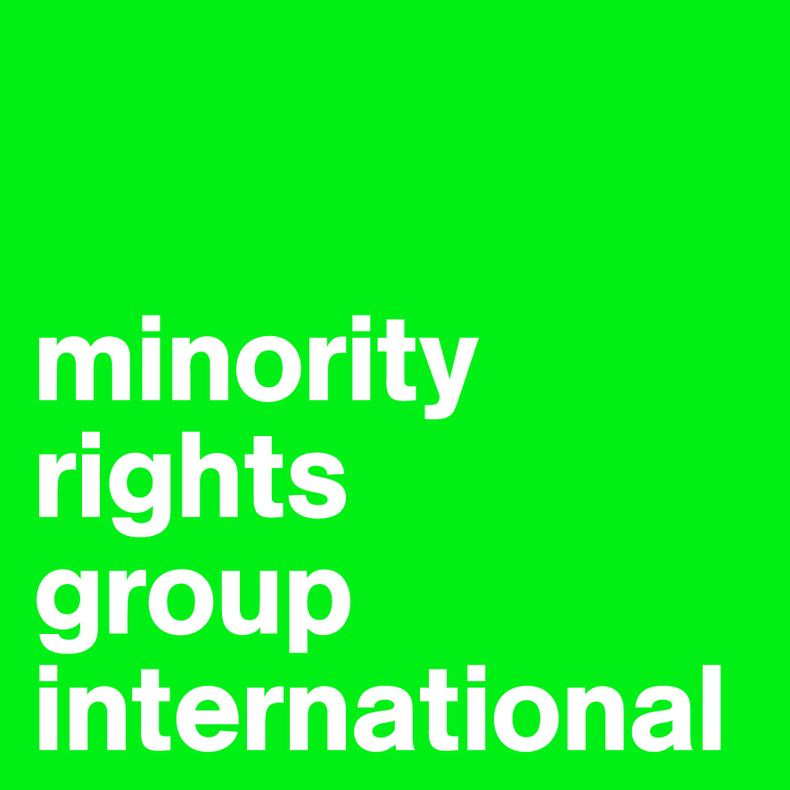

Submission to the Committee on the Elimination of Racial Discrimination
By Minority Rights Group International

List of Issues prior to reporting

BOTSWANA

95th Session, 23 April – 11 May 2018

54 Commercial Street, London E1 6LT, United Kingdom
Tel. +44 20 7422 4200, Fax +44 20 7422 4201, www.minorityrights.org
Some of the racial discrimination that exists in Botswana is statutory restrictions and exclusions on the basis of ethnic origins, limiting recognition, and failing to place minority tribes on equal footing with the tribes previously known as the 8 major tribes; this contrary to Article 1 of the International Convention on the Elimination of All Forms of Racial Discrimination.

As part of the legacy of the Protectorate Regime, and until 2008, Botswana statutorily maintained that there are 8 major tribes, being the Bangwato, Bakgatla, Batawana, Bakwena, Bangwaketse, Balete and Barolong. The Chieftainship Act specifically placed the chiefs of these tribes as Paramount Chiefs, according the chiefs of other tribes subsidiary positions. The Constitution confirmed and entrenched this position at sections 77, 78 and 79, when it provided that the chiefs of the 8 major tribes had seats as of right, to Ntlo Ya Dikgosi (House of Chiefs), where as other chiefs were elected to their seats. This position advised the misconstruction that Botswana is predominantly a Tswana nation.

Following various actions by some of the minority tribes, and in particular, the High Court case of the Wayeyi Chief (as he then was), Shikati Kamanakao, against the government, the Constitution was amended. Further, the Chieftainship Act was repealed and replaced instead by the Bogosi Act of 2008.

The decision by the Court in the Kamanakao case was that all laws which had a discriminatory effect against the Wayeyi (and by extension, other tribes which were not part of the 8tribes considered ‘major tribes’) were to be revised. Further hereto, the Government made representations to the African Commission on Human and Peoples’ Rights that it would make efforts to recognize the Wayeyi chief. The latter was done, although it was done arbitrarily and for a short term of only 5 years, without the revision of statute.

There are still laws and absences of laws, which are discriminatory, on the basis of ethnic origin, viewing the 8 major tribes as superior to all other tribes, and which contradict the Bogosi Act, which was enacted in efforts to eliminate discretionary recognition. These are herein discussed.

The Tribal Territories Act Cap 32:02 (1933)

The Tribal Territories Act defines itself as “An Act to define boundaries of the Tribal Territories.” The Act proceeds to outline the boundaries of 7 of the 8 Tswana tribes, being the boundaries of the Bamangwato, Batawana, Bakgatla, Bakwena, Bangwaketse, Bamalete, Batlokwa. It is trite that the tribes in Botswana extend far beyond the 8 Tswana tribes. To assume therefore that the only tribal territories that exist are those that belong to the 7 tribes is to subjugate the rights the other 37 tribes in the country have.
The areas referred to as tribal territories have come to be known as districts, however, still retain the names of the Tswana tribes, disregarding the other tribes which have tribal areas within the said district and tribal territory. The Bogosi Act recognizes defines tribal areas in section 2 on Interpretation. “Tribal area means the area inhabited by a tribe, whether within or outside of a tribal territory”. This notwithstanding, the Bogosi Act states that a tribal territory is any territory defined as such in the Tribal Territories Act. This effectively confers supremacy both culturally and territorially on the Tswana chiefs. This is an obvious exclusion of the non-Tswana chiefs from territorial control.

Sections 77,78, and 79 of the Constitution

The Constitution of Botswana, being the supreme law of the country cannot be amended by a mere Court Order. It is the most paramount statute in the land, regulating various factors, and from which all laws derive. In the Constitution, there exist provisions for the Establishment and Composition of the Ntlo Ya Dikgosi (House of Chiefs). Botswana, having a dual legal system, recognizes civil and customary laws. The Ntlo Ya Dikgosi plays an advisory role to parliament on matters pertaining to culture, custom, tradition. It is therefore imperative that all tribes be represented in the Ntlo Ya Dikgosi for them to be said to enjoy equal political participation.

Section 77 of the Constitution however provides for the constitution of the Ntlo Ya Dikgosi as follows:
- Barolong Farms in the Southern District,
- Chobe in the North West District,
- Ga Malete in the South East District,
- Ga Mmangwato in the Central District,
- Ghanzi District,
- Goo Tawana in the North West District,
- Kgalagadi District,
- Kgatleng District
- Kweneng District,
- Ngwaketse in the Southern District,
- North East District, and
- Tlokweng in the South East District;

It is noteworthy that in addition to the 8 tswana tribes, addition of 4 tribes has been made. At section 78 however, on Designation and selection of members of Ntlo Ya Dikgosi the same Constitution states as follows:

- Except for the areas of Ghanzi, Chobe, Kgalagadi and North East, the Members for the areas referred to in section 77(1)(a) shall be designated to the Ntlo ya Dikgosi according to the established norms and practices of those areas.
- The Members for the Ghanzi, Chobe, Kgalagadi and North-East areas referred to in section 77(1)(a) shall be selected, from their own number, to the Ntlo ya Dikgosi by persons for the time being performing the functions of the office of Kgosi within each of those areas.

Effectively therefore the seats as of right remain with only the 8 Tswana tribes, reinforcing the supremacy of the same.

Further, section 77 extends the earlier referenced tribal territories to include Borolong, the 8th Tswana tribe, not included in the Tribal Territories Act.

The representation of the other tribes is superficial and unequal to that of the Tswana tribes. This has a discriminatory effect, and closes out the non-Tswana tribes from impactful political participation, in addition to delineating the tribal areas of these other tribes to the Tswana tribes.

Schedule to the Bogosi Act Cap 41:01 (2008)

The Bogosi Act is statutory re-enactment with amendments, the provisions relating to Bogosi and matters incidental thereto. The Act, which effectively repeals the Chieftainship Act (Section 29), provides for recognition of tribes and kgosis. These provisions appear at sections 3 and 5 respectively. From a reading of the Act, the intention is to do away with the supremecy of the Tswana chiefs over the non-Tswana tribes. To this effect, section 30 of, the Chieftainship Act having been repealed, the Act provides that “any person who immediately before the commencement of this act was Kgosi shall continue to hold sucg office as if he or she had been so designated, appointed and recognized under this Act.” Effectively, once a Kgosi has been accorded recognition in terms of section 5 of the Bogosi Act, they are in equal standing with the kgosis recognized in terms of section 30.

However, in the Bogosi (Prescribed rate of Salary) Order, provisions for salaries for chiefs, and headmen are made, to the exclusion of the non-Tswana chiefs; and where the Ghanzi, Northern Kgalagadi, Southern Kgalagadi, and Tati tribal leaders are considered, they are referred to as headmen, and are designated amounts far less than those for the chiefs. It is assumed, by the schedule that the only chiefs are those of the 8 Tswana tribes, and that all other tribal leaders are headmen and are thereby entitled to far lesser salaries.

The Bogosi Act did away with the language of the Chieftainship Act, including the reference to tribal leaders, of Kgosi as Chief, and the reference of Kgosana as Headman. This is a clear indication that the schedule is misplaced. In addition, however, the salaries allocated the Tswana Kgosis are far exceed those of the Kgosis of the other tribes. The salary provisions are therefore discriminatory.

Failure by government to provide for Universal Recognition of all tribes and their Kgosis and/or tribal leaders

Although the Bogosi Act largely provides solutions to limitations of discrimination with regards to recognition, it also highlights the assumed supremacy of the Tswana tribes. The Tswana tribes were accorded recognition, historically, by the Protectorate Regime. The basis of this recognition is insignificant now, in a time where it is understood that the Tswana tribes are in fact not more sovereign than other tribes. These tribes and their Kgosis however, are accorded default recognition at section 30 of the Bogosi Act, whereas the other tribes have to seek permission for recognition from the Minister. It is clear that the Ministerial position is a political position and not one allocated necessarily out of expertise in a certain area of practice.

Section 3 which provides for the recognition of tribes provides as follows:
“(1) The Minister, after consulting a tribal community in its Kgotla, may recognise that tribal community as a tribe.
(2) In deciding whether a tribal community shall be recognised as a tribe, the Minister shall take into account the history, origins, and organisational structure of the community, and any other relevant matters.”
The last part of section 3 (2) leaves the criteria for the recognition of a tribe to the Minister. A Kgosi cannot be recognized before a tribe is recognized, as they can only be recognized as Kgosi of the particular tribe, as provided by section 5, which states as follows,

“(1) Subject to the provisions of this Part and of section 22, no person shall hold or assume the Bogosi of any tribe or exercise or perform any of the powers or duties pertaining thereto unless he or she has been recognised as Kgosi of such tribe under the provisions of this Act.
(2) Subject to the provisions of section 9, no person shall be recognised as Kgosi of any tribe unless he or she has been designated as the rightful successor thereto in accordance with section 6.”
In terms of section 30 of the Act, the Kgosis who were Kgosis before the enactment o the Act shall be considered Kgosi. The basis for this is not stated. It is therefore undoubtable that the section is discriminatory, and that the most appropriate cause of action is the universal recognistion of all tribes, instead of subjecting other tribes to considerations that the Tswana tribes are not subjected to, in order to attain recognition.

