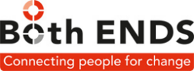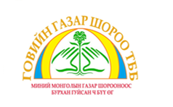

SHADOW REPORT
for
CEDAW Committee Review
MONGOLIA CEDAW REPORT SILENT ON IMPACT OF MINING, FOREIGN DIRECT INVESTMENT, AND INTERNATIONAL FINANCIAL INSTITUTIONS
ON WOMEN’S HEALTH

June 15, 2020
Executive Summary
This shadow report is intended to inform the review of the State Party’s obligations under CEDAW bringing to the attention of the Secretariat issues that have not been raised in earlier CSOs reports.
The shift from a female employment intensive agricultural (livestock) and light industry economy to that of a male workforce dominated mineral extraction sector had major impacts termed as “shock therapy” measures. This was carried out without social, gender and health impacts assessments. Government of Mongolia continues to resist to carry out health impacts assessment when making agreements and issuing mining licenses for 30 years (+60-year extension right) for mega mining projects to TNCs. The GoM to date does not require assessments of health, including reproductive health, safety and security risks and impacts of mining on women and girls.
We warrant attention to the gender impacts at national level of an economy that is highly dependent on Foreign Direct Investment (FDI) for one sector: the mining sector. Dependence on a single market and price fluctuations in mineral markets with its bust and boom cycles result in the Mongolian government’s dependence on IMF bailout loans that come with explicit conditionalities. The neoliberal economic policy framework that gears all sectors to support mining, including health sector, has consequences for women’s health and the gendered access to and availability of health services. We do this by showing the state of public health facilities and those private health care facilities financed by IFIs investments.
Mongolia has undergone a series of structural adjustments since the 1990s to decrease it public sector and open its economy to global finance. This was exacerbated by the introduction of austerity measures that particularly target women who now carry the burden of low paid jobs and\or unpaid care work with separate and specific needs for certain public services and disproportionately work in the public sector.
When structural adjustments began, women enjoyed a higher measure of equality and education than many other Asian countries. Transition has eroded women’s previous status, economic security, levels of reproductive health, and participation in public life. “[W]omen have less influence in policy-making bodies and forums than they had before transition. One impact of transition has been to increase their workloads, particularly for nomadic and rural women. Women have benefited less than men in the acquisition of assets from privatisation and this has affected their power to raise credit and loans for micro-economic enterprises and self-employment, resulting in fewer opportunities (2000:49).”
The WBG initiated legal reform of mining sector as early as 1992, 1995 while environmental impact assessment law (EIA) was supported only in 2012 after major social shocks from health impact of cyanide spills, mercury and other chemicals used in mining operations have become frequent. Herders living around Oyu Tolgoi, South Gobi Sands in Khanbogd and Gurvantes and AREVA uranium mine in Ulaanbadrakh have felt negative social, cultural, health and gender impacts and raised them in national and international fora through partner NGOs. The public outcry of mining affected communities regarding deadly health impacts has resulted in an inadequate reaction from GoM which negates, ignores any evidence brought to them and resists cooperation on assessing, documenting and mitigating negative mining impacts. This is the first submission on health impacts, particularly reproductive health impacts on women to CEDAW on behalf of herder communities affected by mining in the Gobi Desert region in Mongolia.

Macroeconomic policies and Investment Agreements
Strongly driven by diplomatic pressure and loan conditionalities provided by the IMF, World Bank and ADB, the development trajectory set out was limited to a singular focus on mining and its support sectors. IMF data from 2017 shows that mining revenues account for 90% of Mongolian exports. Mongolia’s flagship copper-gold mine Oyu Tolgoi has attracted most FDI and is projected to account for 30% of Mongolia’s GDP. The negotiation process of its Investment Agreement (IA) is a clear example of resource diplomacy that involved a number of diplomatic missions in addition to the two mining companies involved Ivanhoe Mines (Turquoise Hills Resources) and Rio Tinto.
The dependence on mining has forced Mongolia into legislative acquiescence to corporate interests and accepting ISDS clauses that curb its democratic policy making space. The consequences are regressive taxation, increasing debt and dependency on IMF loans, and potential arbitration against environmental and social regulation. The impact on the public budget has gendered consequences which we will identify in more detail below.
The Oyu Tolgoi Project itself, with a producing open pit and an underground mine under construction has been socially and environmental controversial from the start. The Environmental Impact Assessments are outdated (2012) and does not have a gender impact analysis. Its Environment and Social Action plan of 2015 does not have a gender impact analysis either, nor do any of the audits. Implementation of a megaproject always has gendered impacts (loss of land, loss of livelihood, loss of biodiversity, damage to social and cultural heritage sites and natural resources). The impact of mining has direct health and safety consequences for women and girls.
With regard to CEDAW Articles 7, 8, 10, 11, 12, 13 and 14 and the UN High Level Panel on Women’s Economic Empowerment establishing in 2017 that “Macroeconomic policies are crucial enablers of gender equality because they shape the overall economic environment for women’s economic empowerment” we want to focus attention to the Mongolian economy that has become highly dependent on Foreign Direct Investment in primarily the mining sector.

The fiscal stabilization and arbitration clauses in the Oyu Tolgoi IA, driven by international investment treaties and taxation agreements, safeguard corporate profits and give companies the possibility to threaten governments with arbitration as Rio Tinto has done February 2020 un response to an additional tax bill of US$ 155 million.. This is still far less than the US$ 230 million tax that the company avoided by using tax havens. Such arbitration is not only costly and unlikely to rule in favour with Mongolian’s public interests, it prevents the state to legislate in their people’s public interest. Investment protection constrains the Mongolian government in reregulating tax legislation or social and environmental regulation.

Oyu Tolgoi’s too-large-to-fail financing structure is led by public IFIs such as the IFC and the EBRD. Mongolia’s share in the Project of 34% was acquired through a loan with corporate majority shareholder and project manager Rio Tinto, to be paid off with the dividends resulting from the mine. In sum, the project has created national debt, is generating disappointing if not negative income, and has left the government hand-tied. The incentives Mongolia offered to foreign investors foreclose the necessary policy space to harness investment to serve sustainable development and advance gender equality.

Public Revenue losses and subsequent reduced spending due to tax avoidance and tax regressive policies undermine gender equality programs. Emphasized recently by the UN Independent Expert on Foreign Debt and Human Rights in his 2018 report to the General Assembly, women’s rights are especially at risk when tax revenues diminish, and governments scale back spending on essential services. Taxes are needed to strengthen public services such health, elderly and childcare, services where women’s work is overrepresented and much of it is under paid.

“Women in mining-affected communities further lose livelihoods, homes, and food and water sources because of mining’s environmental destruction. It is unacceptable that governments -- duty-bound to uphold peoples’ interests and well-being -- collect so little from mining corporations that exploit resources while passing on the greater burden of revenue-raising unto the backs of women and the working poor through inequitable taxes such as VAT.”
We recommend that:
- All future investment agreements should exclude fiscal holidays, stabilisation and ISDS clauses;
- All large-scale projects should include a gender and health impact analysis by an independent expert before approval.
We support the recommendations by ActionAid:
- "The IMF and GoM should contribute towards the creation of an enabling macroeconomic environment for women's rights by adopting an evidence-based comprehensive approach to defining, identifying and addressing how its taxation and wider policy advice impacts upon different groups of women.
- Minimise and mitigate the regressive impacts of indirect taxes such as VAT and taxes on the informal economy, and commit to pursuing a progressive, gender-just approach to tax that effectively redistributes wealth and contributes to the achievement of women’s rights by taxing those with the most ability to pay”.

In 2017, the IMF disbursed its 6th bail out loan since 1990 which increased Mongolia’s external debt to US$11.2 billion, twice its GDP. The conditionalities of the loan include budget reforms that involve austerity measures such as wage freezes and a personal income tax increase. The most controversial conditionality in the 2017 programme was the reduction of universal child care support to targeting only the 60% poorest households. These programs are directly influenced by corporate mining interest, shown by IMF postponement of the loan already agreed upon by both parties in response to Rio Tinto complaint with unfavourable banking legislation. The loan was disbursed when Mongolia retracted the legislation three days later.

Recalling CEDAW’s recognition in its Preamble that “the eradication of…interference in the internal affairs of States is essential to the full enjoyment of the rights of men and women,” we extend this principle to IFIs and IMF as well.

The 2019 analysis of IMF and gender equality by the BrettonWoods project explains how “almost every macroeconomic policy the IMF regularly prescribes carry harmful gendered impacts, including labour flexibilisation, privatisation, regressive taxation, trade liberalisation and targeting social protection and pensions…[T]hese myriads impacts also do not function in isolation, but rather interact and compound one another, meaning understanding the cumulative gendered impacts of an entire reform programme is really required to inform policy.”

We recommend a concerted effort by resource rich states such as Mongolia to demand action from the International Financial Institutions, in particular the World Bank, the IMF, IFC, ADB and EBRD to stop conditioning states to strip their public checks and balances.

MINING AND HEALTH

Maternal and child health in communities affected by mining
The earliest mining impact of mining on human health issues came about in late 1990s related to Gold 1 Program of Mongolia. It has caused severe impacts on human health never recognized by Government of Mongolia (GoM) as such. Regardless of the fact that there was no prior health impact assessment or post-project scientific research on impacts and efforts to prevent or mitigate damages, the GoM has embarked on Gold 2 project in 2018 in the same Zaamar soum area as the Gold 1 project. The district of Ulaanbadrakh in Dornogobi affected by uranium exploration and production is the next most visible case of local community suffering from exposure to mining impacts on livestock and human health involving claims of offspring and infants born with congenital malformations and deformities. The same inaction on part of responsible authorities, including Ministry of Health to assess, research and mitigate the impacts is resulting in social uproar brewing in across Mongolia in mining affected communities.
Our report will bring concerns of communities in Khanbogd affected by Oyu Tolgoi copper-gold mine and Gurvantes affected by 6 coal mines. Both are settlements of Umnugobi aimag located in the Gobi Desert region. The concerns have been collected using a community survey questionnaire designed by the community activists.
Research into the impact of mining on women and in particular on women’s health has been extensively documented and include concerns with access and quality of water, health concerns related to mining such pollution, deteriorated air quality due to dusts and limited health facilities. While there is abundant scientific evidence on mining impact on women’s health, the by GoM’s unwillingness to assess and protect the health situation in mining affected communities. Women themselves applied a community survey to see if what they see and feel individually is shared by other members of community.

In both soums (districts), community activists attempted to reach out to at least 100 members of their nomadic and semi-nomadic communities with a short health survey. In Gurvantes the survey has used a printed questionnaire which then was sent to Ulaanbaatar for manual data entry. In Khanbogd a web-based survey application was used to collect data. The goal of the survey was to see if community members agree with the observation that there are more and new health problems since mining operations began in their communities. NOTE: the fully collected and analyzed survey report and English translation will be available soon. The paper survey in Ulaanbadrakh will take longer as travel and door to door visits, manual data entry and processing require time.
One respondent’s comment reflects the general sentiment that we hear in these communities: “I have lived here all my life. In recent years the mining operations and influx of more people have brought crimes and illnesses we have not had before. Simply adding hospitals or police capacity without analysing the root causes is not going to solve the problem”.
We present a chart from each soum showing responses on health issues. The data below are indicative and are the result of a first analysis but as such, they do show a clear pattern. We will provide more detail and further analysis of this data when we update the report.
In Khanbogd (Chart 1) respondents listed impact on reproductive health, general health and relationships of family members as top three negative impacts (yellow column). 60 percent of respondents in Khanbogd were women and 80.19 percent were respondents of reproductive age group. In late May a paper survey was initiated but due to problems of travel and more accessibility via internet a mobile phone survey was carried out in June over period of one week covering 100 respondents from the OT affected community. The survey in Khanbogd contained 18 health specific questions which took on average 3.6 minutes to respond and thus was possible to be collected via a mobile application.
Gurvantes respondents’ overwhelming majority (over 79%) agreed that the health conditions listed are new and or increasing today. 63.92 percent of respondents in Gurvantes were women and 45.56 percent of reproductive age group. In Gurvantes a paper survey was carried out in April over a period of one month and covered representatives of five Baghs (smallest settlements) affected by different mines and\or mine infrastructure with a purpose to see difference in impacts covering issues on environmental and health impacts, resettlement and potential impacts on livelihoods.

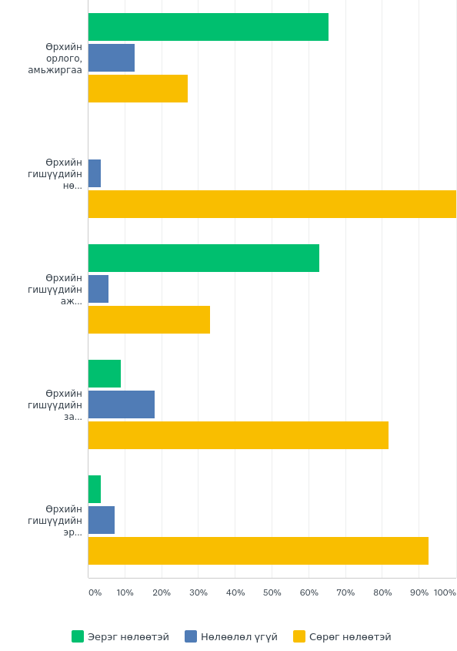
Chart 1. Khanbogd respondents’ answers to mining impact on families: green Positive; blue – No impact and yellow – Negative impact.

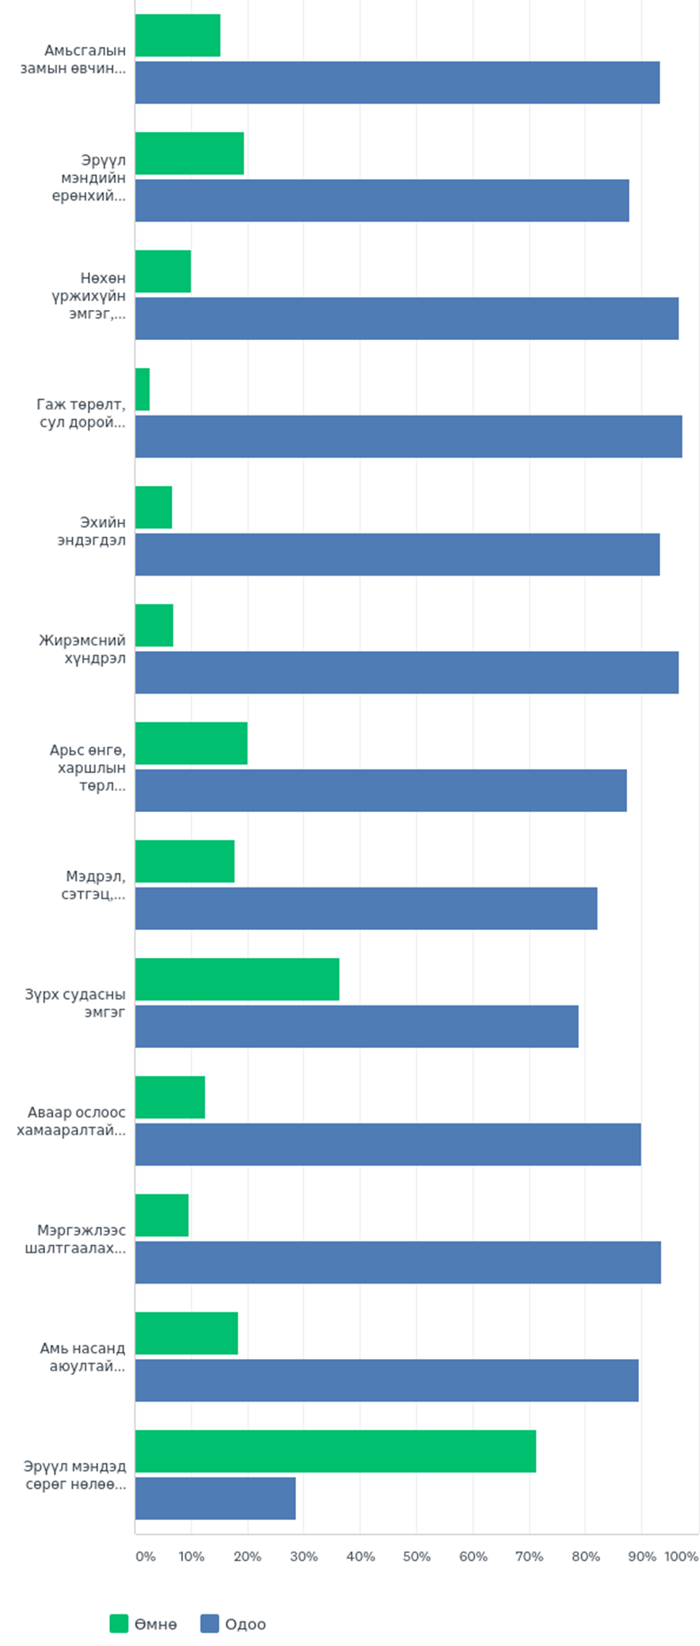
Chart 2. Gurvantes responses to question “Which of these conditions existed before and which are increasing today?” shows agreement that health has deteriorated since mining operations came to their community. Green – before and Blue – today.
Lack of will to enforce national and international commitments on health impact assessments
The Law on Environmental Impact Assessment (2012) includes a provision on health impact assessment for high risk projects but it has not been enforced to date. Non-conformance with the CEDAW Article 12 on ensuring that any policy decisions, development programs assesses potential impacts on women’s health, especially reproductive health has never been brought up in any of previous reports, and the Law on Environmental Impact Assessment (2012) does not include specific measures for assessing gender impact of high-risk projects and the particular risks faced by women and girls.
Non-disclosure of health hazard information
In addition to not disclosing existing information in the country on health impacts by mining operations, coal induced air pollution in urban centers, other toxic emissions and spills, the GoM resists use of empirical and scientific evidence of mining impact on human health available worldwide until it has produced its own scientific data. In 2016, UNICEF published a report on impacts of air pollution induced by thermal coal use on maternal and child health in Mongolia, particularly Ulaanbaatar. No comprehensive action was taken until late 2018 early 2019 costing many lives and health damages that triggered a Mom’s & Dads Against Smog movement that staged series of demonstration in the central square demanding GoM to act. Non-disclosure of information is by far the most disabling factor preventing population from making informed decisions to protect their health. GoM does not use existing scientific evidence of negative impacts caused by gold, coal and uranium mining available worldwide to inform, educate and prevent damage to the health of its population, especially women’s reproductive health.
Mongolia’s tenth regular report to the 76th CEDAW section entitled “Progress made to implement the National Maternal, Child and Reproductive Health Program 2017-2021 and information on results of its monitoring” is silent on the increasing rate of what is termed in the national health statistics as “congenital malformations, deformations and chromosomal abnormalities. According to these statistics the rate of congenital malformations, deformations and chromosomal abnormalities has doubled from 3.8 in 1999 to 7.9 in 2003. The rates steadily increased to reach 16.6 for 0-1-year age group in infant mortality statistics in 2018. This is second largest (16.6%) death cause after “certain (or unspecified) conditions originating in perinatal period” (55.3%).
Maternal and child health data by soums appears only in 2018 compilation of statistical data. The data on medical facilities, human resources and health care services by soum looks very detailed and appears to be complete as opposed to data on maternal and child mortality by aimag and soums. Data for aimags and soums with large scale mining such as Dornogobi or Umnugobi appear to be especially problematic on mortality and morbidity data.
Based on General recommendation No. 24: Article 12 of the Convention (women and health) PARA 9: …State parties must report on their health legislation, plans and policies for women with reliable data disaggregated by sex on the incidence and severity of diseases and conditions hazardous to women’s health…” and “demonstrate that health legislation, plans and policies are based on scientific and ethical research and assessment of the health status and needs of women…”

We recommend:

-the GoM to carry out health impacts assessments, with gender disaggregated data, by independent entities in mining affected areas, in particular in Ulaanbadrakh (Dornogobi) , Khanbogd and Gurvantes (Umnugobi) where affected communities have not been able to receive adequate response to their claims of impacts on their health by hazardous mining operations.

-develop and implement gender sensitive standards for compensation for damages caused by mining and affiliated businesses to the local community members due to negative impact on health.

-institute a public health warning and/or information services on toxicity and potential impacts of minerals, chemicals and other hazardous materials on human and animal health.

PRIVATIZATION OF HEALTH SECTOR
The Extractive industry, especially the large transnational corporations, demand investment friendly environment which includes adequate quality services for them and their employees. In Mongolia this has resulted in such health care providers like SOS Medica International, Intermed Mongolia (now UFIH) and similar private health service supported by IFIs to serve the well-paid clients of mining and its supply chain and infrastructure sectors.

IFIs financing is not available to support and develop the public health service facilities concentrating more on technical assistance on governance, standardization etc. preparing private health care development. Mongolia’s universal health care system is crumbling while private health service is blooming at the cost of taxpayers supported by IFIs. This report will not go into discussion on whether private clinics are accessible, affordable and provide more efficient services to communities impacted by mining or general vulnerable population in the country.

Mongolia is a small nation of little over 3.2 million population. Increasing the size of its population has been a controversial policy priority pursued by all governments, including current ruling political forces. Increasing population is seen in national plans as way to increase workforce and way to larger markets mentioned in just about every development donor report analysing development opportunities for Mongolia - all resulting in various small incentives promised to young women for child-bearing. However, there is little to nothing done to protect reproductive health of young women and men employed in mining sector and those living in communities affected by mining operations nationwide.
The big Maternal and Child Health Centre was built by Russians in socialist era and still is the only center that has technical capacity to address problems in maternal and child health and maintains universal access to all citizens of Mongolia regardless of residence registration, social status and/or economic capability. On April 18, 2020 a young musician posted photos of the Center on FB that got the attention of media yet again to the desperate conditions of public health facilities which supposed to protect the health of the country’s future generations.
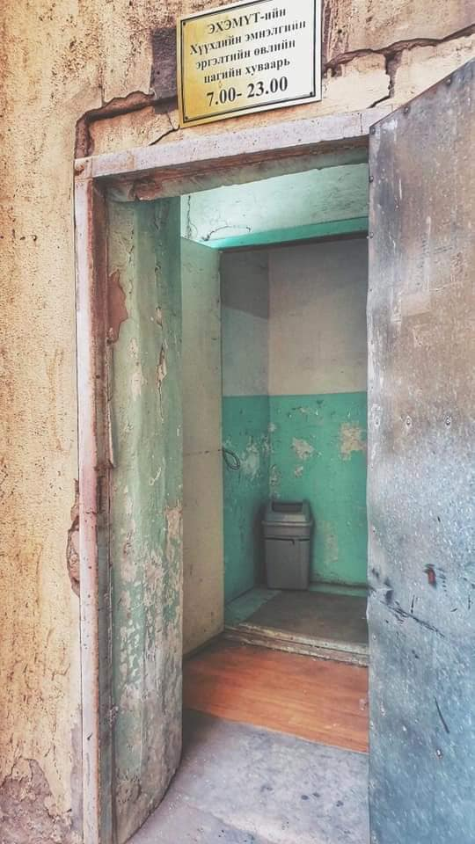
Photo 1. National Center for Maternal and Child Health, entrance to the Children’s Inpatient Hospital for visitors. One the Center’s FB page one can see a nicely cleaned up photo taken from afar.
All public health facilities face the need to hospitalize serious case during flu season overburdening its carrying capacity.
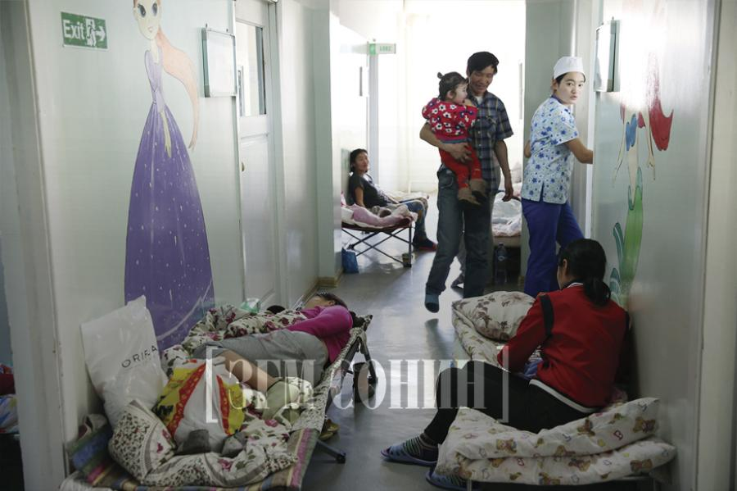
Photo 2. Mothers with young children on the floor in corridors has been an issue for at least one decade. This photo is part of an article published in Government News in January 2020.

SOS Medica Mongolia – one of the first private health service that was supported by diplomatic and IFIs efforts in early 2000s as large mining corporations started operations in Mongolia. SOS Medica Mongolia has several branches in the rich districts of Ulaanbaatar and clearly has no mandate or obligation to protect the health of communities affected by mining operations. SOS Medica’s evacuation service is not available to pregnant herder women needing emergency intervention available only in the capital city. Women in serious health conditions have to travel to Ulaanbaatar by car from Gurvantes, Khanbogd or Ulaanbadrakh from 500 – 780 km one way.
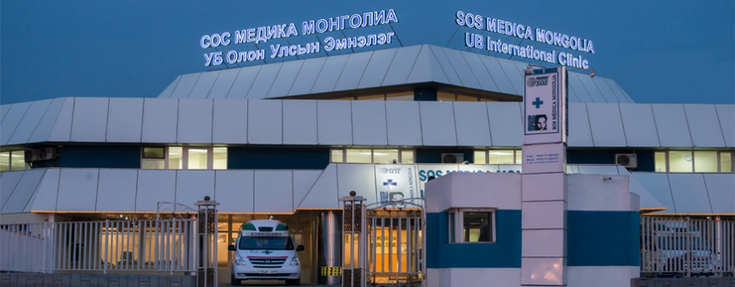
Photo 2. SOS Medica Mongolia - main facility.

Their clients are as listed below:
- Mining and Energy
- Embassies
- International schools
- Non-governmental organizations
- International banks and financial institutions

Intermed Mongolia or United Family Intermed Hospital (UFIH) an International Financial Corporation (IFC) financed private health facility owned by large businesses MCS Group which has mining and energy operations; Energy Resource (EBRD financed) coal miner and Shunkhlai Group – oil and gas company and servicing yet again large businesses and population which can afford or desperate enough to put all resources to get a decent diagnostic service.
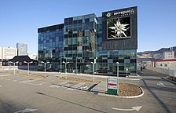

Based on existing research evidence that private health sector is not accessible to overwhelming majority of rural communities affected by mining operations and recommendations of the UN Independent Expert on Debt:

We recommend that

-IFIs to provide grants for improving public health care facilities, especially the Maternal and Child Health Center and build such centers in provincial centers.

-“IFIs provide grants only, not loans, to ensure food security and social services in low-income countries. Doing so would contribute to preventing malnutrition and reducing poverty.

-GoM institutes a regulation whereby private hospitals provide health services at public health care cost and rates during flu epidemic seasons and health pandemic situation.

Robinson, B. and Solongo, A. (2000) The Gender Dimension of Economic Transition in Mongolia. In F. Nixson, B. Suvd, P. Luvsandorj, B. Walters (eds). The Mongolian Economy:A Manual of Applied Economics for a Country in Transition. Edward Elgar Publishing Ltd. 2000. pp. 231-255.
Ibid p. 323
IMF 2017, pg. 16: https://www.imf.org/en/Publications/CR/Issues/2017/05/31/Mongolia-2017-Article-IV-Consultation-and-Requestfor-an-Extended-Arrangement-Under-the-44954 (December 7, 2018).
https://www.somo.nl/undermining-mongolia/ (June 10, 2020)
UN High Level Panel on Women’s Economic Empowerment, Taking action for transformational change on women’s economic empowerment, 2017, p. 3.
https://www.somo.nl/riotinto-taxschemes-mongolia/ (June 10, 2020)
UN Independent Expert on Foreign Debt, Impacts of economic reforms and austerity measures on women’s human rights, OHCHR, A/73/179, 2018.
https://apmdd.org/campaigns/global-public-finance/tax-justice/women-make-noise-for-tax-justice, (May 13, 2020).
For a clear method of a gender impact analysis for extractive industries see https://oxfamilibrary.openrepository.com/bitstream/handle/10546/620776/bp-gender-extractives-corporate-agenda-010516-en.pdf?sequence=1&isAllowed=y. (June 10, 2020)
ActionAid 2018, Short-Changed: How the IMF's Tax Policies Are Failing Women. https://actionaid.org/sites/default/files/short-changed_final.pdf (June 10, 2020).
International Monetary Fund website, 2017, at https://www.imf.org/en/News/Articles/2017/05/24/17193-imf-executiveboard-approves-financial-arrangement-for-mongolia, see also Bloomberg, 2017, at https://www.bloomberg.com/news/articles/2017-02-19/imf-to-loan-mongolia-440-million-as-part-of-5-5b-bailout (June 12, 2017).
Mongol bank, Mongolia’s Gross External Debt Position at https://www.mongolbank.mn/eng/liststatistic.aspx?id=4_3; Financial Times, Mongolia: living from loan to loan, September 12, 2016 at https://www.ft.com/content/4055d944-78cd-11e6-a0c6-39e2633162d5; Focus Economics at https://www.focus-economics.com/country-indicator/mongolia/externaldebt; https://www.gfmag.com/global-data/country-data/mongolia-gdp-country-report (August 2017).
For a discussion on IMF conditionality, and for Mongolia in particular, see Brunswijck, G. (2018) Unhealthy Conditions, https://eurodad.org/files/pdf/1546978.pdf (December 17 2018).
Bloomberg, 19 April 2017, at https://www.bloomberg.com/news/articles/2017-04-19/mongolia-clears-hurdles-needed-for-5-billion-imf-led-bailout (August 8, 2017).
https://www.developmentpathways.co.uk/blog/mongolia-kyrgyzsg-child-benefits/ and https://www.brettonwoodsproject.org/2018/03/pro-poor-anti-poor-world-bank-imfs-approach-social-protection/
Edwards, T. May 5, 2017, https://www.reuters.com/article/us-mongolia-imf/mongolia-annuls-forex-regulation-to-pave-way-forimf-bailout-idUSKBN1810TF (December 17, 2018.)
BrettonWoods Project 2019, at https://www.brettonwoodsproject.org/2019/02/the-imf-and-gender-equality-operationalising-change/, p.8
https://ikon.mn/n/1din (June10, 2020)
Jenkins, Katie (2014) Women, mining and development: An emerging research agenda. The Extractive Industries and Society 1: 329–339 , https://www.oxfam.org.au/wp-content/uploads/2011/11/OAus-TunnelVisionWomenMining-1102.pdf and http://apwld.org/wp-content/uploads/2018/10/Women-and-Mining-in-Asia1.pdf
Mobile communication quality in Ulaanbadrakh is too slow to use the web-based survey. Paper surveys need to be sent, collected and manually entered which will delay final outcome by at least a month.
https://www.unicef.org/mongolia/media/911/file/Agaariin_bohirdol_report_mn.pdf
http://www.mglnews.mn/content/read/69702/Ard-irged-utaanii-esreg-jagsaj-baina.htm
https://www.chd.mohs.mn/images/pdf/sma/uzuulelt/EnglishM2003.pdf (conveniently the earliest data on this cause of death is dated 1999 oe after completion of Gold 1 Program)
https://www.chd.mohs.mn/2019/sariin%20medee/2018eng.pdf page 186
https://www.chd.mohs.mn/2019/sariin%20medee/2018eng.pdf pp 146-154
Ibid.p 143-144
http://www.sosmedica.mn/page_list/about_us
https://www.intermed.mn/eng/
https://news.zindaa.mn/372m
https://www.ehemut.mn/index.php/news/timelist
https://zgm.mn/%D0%B8%D1%87%D0%BC%D1%8D%D1%8D%D1%80-%D0%BC%D0%BE%D0%BD%D0%B3%D0%BE%D0%BB%D1%8B%D0%BD-%D1%85%D2%AF%D2%AF%D1%85%D0%B4%D2%AF%D2%AF%D0%B4-%D1%88%D0%B0%D0%BB%D0%B0%D0%BD-%D0%B4%D1%8D%D1%8D%D1%80-%D1%8D%D0%BC%D1%87%D0%BB%D2%AF%D2%AF%D0%BB%D0%B6-%D0%B1%D0%B0%D0%B9%D0%BD%D0%B0/
http://www.sosmedica.mn/page_list/about_us
Zuckerman, E. 2018, A Guide to Women’s Rights and Environmental Justice Advocacy on International Financial Institutions, at https://www.bothends.org/en/Whats-new/Publicaties/A-Guide-to-Womens-Rights-and-Environmental-Justice-Advocacy-on-International-Financial-Institutions/ (June 10, 2020).

