

Written statement to the Committee on the Rights of the Child

On the 10th April 2024, the European Parliament adopted the European Pact on Asylum and Migration (EPAM), a set of interrelated legal acts (nine Regulations and one Directive) that address a homogenisation of the Common European Asylum System (CEAS).
Although all the texts are now part of the EU law following their publication in the Official Journal of the European Union (OJEU), and will be directly applicable in Spain, Member States have until 12 December 2024 to submit their national implementation plans.
In these implementation plans, states will have the opportunity to take appropriate measures to protect children, as despite the repeated invocations in the Convention on the Rights of the Child (CRC), there are concerns about provisions that could contravene the Convention, limit children’s rights and seriously affect their well-being. These include:
- The mere fact that the European Pact articulates differentiated regimes for third country national or stateless children as compared to children who are nationals of Member States is a violation of the right to non-discrimination in Art. 2 of the CRC
- The legal fiction of non-entry (art. 54 Reg. (UE) 2024/1348) jeopardises the application of all the rights set out in the Convention to all children under the jurisdiction of a Member State (Art. 2 of the CRC).
- Failure to expressly state that family unity should not be broken, but to state that it shall be maintained ‘as far as possible (art. 45 Reg. (UE) 2024/1348), violates the right of the child not to be separated from his or her family (art. 9 CRC).
- The lack of provision for legal aid for children during the age determination procedure; allowing a single representative to be in charge of 30 unaccompanied children at the same time (art. 23.10 Reg. (UE) 2024/1348); or the omission of the right of access to courts recognised in other international treaties (Art. 6.1 European Convention on Human Rights), are not in accordance with the principle of the best interests of the child (art. 3 CRC).
- The use of a ‘proportionate level of coercion’ to comply with the obligation to provide biometric data during the screening (art. 14 Reg. (UE) 2024/1358) violates the protection of Art. 19 of the CRC against the disproportionate use of force.
- Allowing the possibility of internment (immigration detention) of children (art. 13 de la Dir. (UE) 2024/1346), could compromise the prohibition of arbitrary depravation of liberty of children (art. 37 de la CRC).
- The possibility of being able to adopt the internal protection measure in the unaccompanied child's country of origin (art. 8 Reg. (UE) 2024/1347) could strongly compromise the principle of non-refoulement, as well as the right of Art. 6 of CRC the if the measure would endanger the child’s life, survival or development.
The Spanish State, and the other Member States of the European Union, have the margin to adapt the provisions of the Pact in such a way as to the rights of children recognised in the UN Convention on the Rights of the Child (UNCRC). However, failure to take appropriate measures to implement the Pact would also violate Art. 4 of the CRC which obliges Member States to take all legislative, administrative and other measures to implement the rights recognised in the Convention, as well as Art. 22 of the CRC which protects the right of children who are refugees or who are seeking refugee status to receive appropriate protection and humanitarian assistance for the enjoyment of all the rights provided for in the Convention itself and in the international instruments ratified by each State.
Finally, it is essential to point out that, although Spain and the Member States of the European Union have ratified the United Nations Convention on the Rights of the Child of 20 November 1989 (CRC), the European Union is not a signatory to the Convention. It would therefore be desirable for the Committee to urge the Spanish authorities to promote the necessary initiatives to ensure that the EU expressly adheres to the content of the Convention on the Rights of the Child, thus allowing the use of the different mechanisms contained in the Convention itself and its protocols for the defence of children's rights.

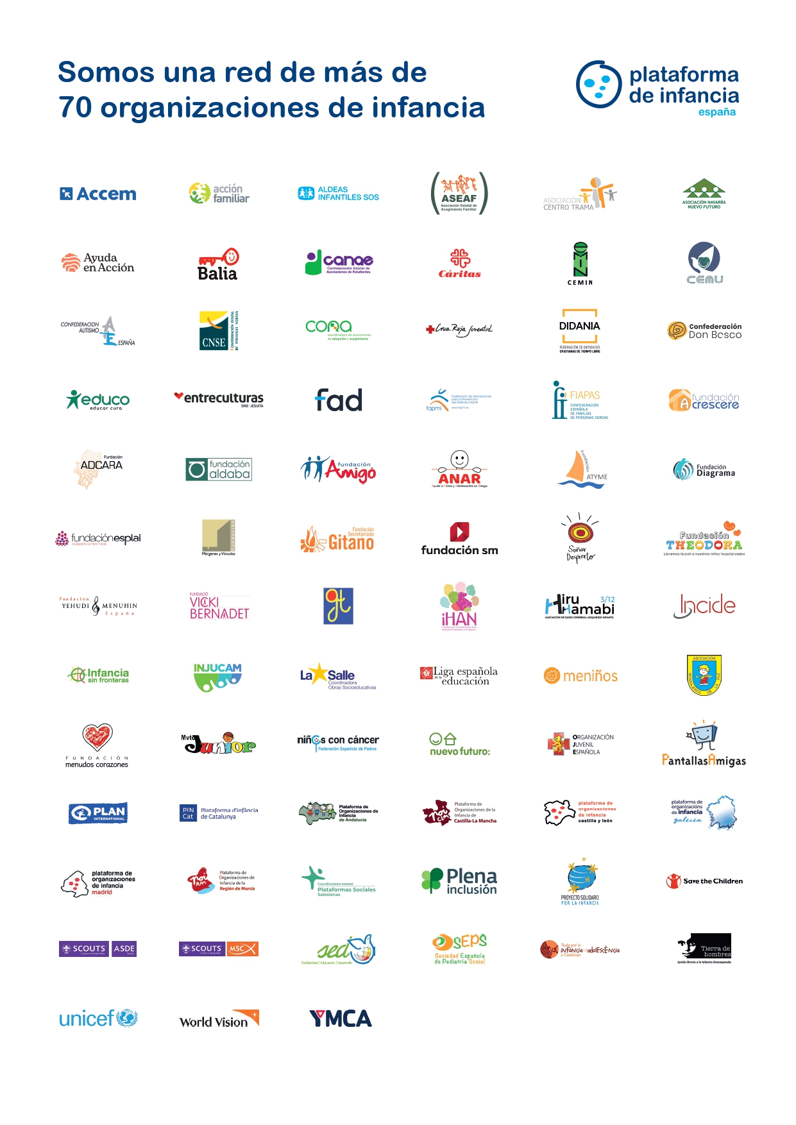



SOMOS UNA RED DE MÁD DE 70
ORGANIZACIONES DE INFANCIA
Nuestra misión es proteger, promover y defender los derechos de niños, niñas y adolescentes conforme a la Convención sobre los Derechos del Niño de Naciones Unidas.

Nuestra visión es alcanzar el pleno cumplimiento de los derechos de niños, niñas y adolescentes, integrando el esfuerzo de las organizaciones de infancia y de todos los agentes sociales.

.

Financia



