Joint Submission for the List of Issues Prior to Reporting
to the UN Committee on the Elimination of Discrimination Against Women
77th Pre -Sessional Working Group (2 to 6 March 2020)

Contact Information
German Alliance for Choice
Lützelbergstr. 10
35457 Lollar
mail: gafc1@web.de

Authors
The present report was developed by Marion Böker, Christiane von Rauch, Anke Valeria Neufeld, Stephanie Schlitt, Heike Spohr and Ines Thonke (in alphabetical order). The expertise of the authors covers human rights, women's rights, women’s rights activism, advocacy, evidence-based medicine, sexual and reproductive health and rights, family planning, public health, gender and international cooperation.

Supporting organizations
The list of all 66 supporting organizations is attached at the end of this document (pp. i – viii).

Introduction
This report is submitted by the German Alliance for Choice (GAfC) for the 77th Pre-Sessional Working Group of the UN Committee on the Elimination of Discrimination Against Women (CEDAW), taking place on 2 to 6 March 2020 in advance of the 9th/10th State report of Germany to CEDAW. It examines violations of articles 2, 10 and 12 of the Convention on the Elimination of All Forms of Discrimination Against Women (CEDAW) with respect to
ensuring the unhindered and non-discriminatory access of women*:
- to accurate, evidence-based comprehensive sexual education and to family planning methods,
- to information on abortion providers, methods, and other relevant information, necessary to take informed decisions; and
- to safe abortion services, regardless of their place of residence, income level, educational background, sexual orientation, civil status or any other socio-cultural, physical or economic characteristic; and
ensuring the quality and coverage of services of abortion providers, which require targeted, time bound measures regarding:
- the development and adoption of standard procedures and guidelines for safe abortion;
- the inclusion of abortion in the regular curriculum of gynaecologists and general practitioners, and
- the decriminalization and destigmatization of abortion providers and women* who seek information on and have an abortion.
This report complements reports submitted by the German CEDAW Alliance and the German Women Lawyers‘ Association (djb). The organisations supporting this submission address the Committee to provide updated information and analysis on the critical situation in the area of sexual and reproductive health and rights (SRHR) in Germany, a situation which the German Federal Government must address and redress promptly and comprehensively, in order to prevent a further deterioration and to ensure full implementation of CEDAW in this area.

Art. 2, CEDAW: Protection of the principle of the equality of men and women and access to health rights through the national constitution and legislation

Directly related and relevant:
- CEDAW, General Recommendation No. 28, Para 29-30 emphasises that “the obligation of States parties to pursue their policy [of eliminating discrimination against women], by all appropriate means, is of an immediate nature”. The requirement of Art. 2 of CEDAW is an essential and critical component of a State party’s general legal obligation to implement the Convention” and “to implement the Convention in a general way”;
- CEDAW, General Recommendation No. 35, Para 18 states: “Violations of women’s sexual and reproductive health and rights, such as [...] criminalization of abortion, denial or delay of safe abortion and/or post-abortion care, forced continuation of pregnancy, and abuse and mistreatment of women and girls seeking sexual and reproductive health information, goods and services, are forms of gender-based violence [...]”.
- CESCR, General Comment No. 22, para 33: State parties must take “deliberate, concrete and targeted steps”, “using all appropriate means, particularly including, but not limited to, the adoption of legislative and budgetary measures”, in order to ensure adequate availability, accessibility (physical accessibility, affordability and information accessibility), acceptability and quality of sexual and reproductive health care (paras 12-21).

Decriminalization of abortion information and services
The denial of abortion information and services profoundly affects women’s lives and health and hinders the fulfilment of a range of civil, political, economic, and social rights. Because abortion is a medical service that only women need, access to abortion is a precondition for ensuring gender equality.
Placed in Chapter 16, “Offences against Life” of the Federal Criminal Code, immediately following the sections on “murder” and “killing at the request of the victim”, Section 218, Criminal Code defines abortion as a criminal offence. Those who terminate a pregnancy, including women themselves, are punishable with up to five years (one year in the case of women) of imprisonment or a fine. Abortion is not a criminal act when undertaken under a criminal or medical indication and is not punishable even though a criminal act within the first 12 weeks of pregnancy after mandatory counselling and a three day waiting period, “which the World Health Organization has declared to be medically unnecessary”. Section 219 defines conditions for the counselling and counselling centers. Subsection 219a “Advertising services for abortion” dates to 1933 is a leftover from the Nazis, defined for purposes of racist, inhumane population policies.
From 1972 until the revised legislation in the context of German reunification, abortion in the German Democratic Republic was regulated in the “Law about the Interruption of Pregnancy” by a time limit until the 12th week after last menstruation. Abortion was on request and without mandatory counselling. Costs were covered by medical insurance. The law in place since 1992 represents a de facto retrogression of reproductive rights of women who had lived in the former GDR.
The definition of abortion as a criminal offence against life instead of as a regular reproductive health service, as required under the provisions of several Human Rights Treaties (CEDAW, Art.12, CESCR, Art.12), is increasingly used by anti-abortion activists in Germany to target doctors and women.
Anti-abortion activists particularly resort to Section 219a to target abortion providers who provide information on their office websites about the abortion services they offer in line with the provisions of the law. Section 219a criminalizes those who offer abortion services “for material gain or in a grossly inappropriate manner” and is the only option for anti-abortion activists to criminalize abortion providers. Their objective though is to criminalize abortion as such.

In the statement on the ruling against Dr. K. H. on 12 December 2018 for infringement of Section 219a, the State Court of Giessen stated: “Fundamentalist supporters of the primary protection of unborn life reject the compromise as such, which was found for “cases of pregnancy conflicts” and use the secondary arena of Section 219a Criminal Code, to hunt down doctors who unconsciously or meanwhile consciously infringe the partly misleading provision on the “prohibition of advertisement”, and thus force lawsuits in increasing numbers”

During the last 20 years, there have been hundreds of charges filed against abortion providers. A majority of these cases were turned down by the courts because of definition gaps in the law. Still anti-abortion activists use these cases to publicly defame abortion providers and stigmatize women who decide to abort.

With the legal reform of Section 219a in February 2019, definition gaps were closed. Section 219a, subsection 4 was added, specifying that “subsection (1) No 1 shall not apply when physicians, hospitals or institutions
- point to the fact that they are prepared to perform a termination of pregnancy under the conditions of section 218a (1) to (3), or
- refer to information provided by an insofar responsible Federal or State agency, a recognised counselling center pursuant to the Act on Pregnancies in Conflict Situations or a Medical Association”.

For the first time, it is explicitly punishable for general practitioners, gynaecologists or in general abortion providers, to provide any kind of information on abortion other than the mere fact that they provide the service of abortion. This may constitute a violation of principle of non-retrogression.

Based on the reformed Section 219a, two doctors were sentenced to pay fines. In November 2019, a Berlin court confirmed the final sentence against one of them because of the following sentence on her office homepage: “Part of the services of Ms. Dr. G. is as well medical, anaesthesia-free abortion in protected atmosphere”. On 12 December 2019, in the court case against Dr. H., Giessen for infringement of the reformed Section 219a, the judge and the public prosecutor emphasised the urgency of a revision and reform of sections 218 and 219 due to legal and constitutional inconsistencies.
In February 2019, the government had the opportunity to decriminalize the provision of information by doctors on abortions they provide, in accordance with the law but failed to do so despite evidence provided that maintaining this form of criminalisation runs counter to Germany’s obligations under international human rights law. Whereas before the February 2019 law reform, its stance could be described as an omission, the endorsement of continued criminalisation is an action in contravention of human rights standards and WHO guidelines.
To date these standards and guidelines have played no role in the reasoning of the government or the judiciary in dealing with the subject of women’s human rights as related to access to abortion information and services and women’s sexual and reproductive self-determination. Part of the failure to devise and enforce rights-respecting normative frameworks may be attributed to the insufficient capacity building on these frameworks and their implications for executive and judicial practice. The CEDAW committee recommended since long under Article 2 that the “State party strengthen training provided by the German Judicial Academy and enable judges, prosecutors, and lawyers to directly apply or invoke the Convention and the Optional Protocol thereto in domestic courts.”

Sufficient supply of facilities for performing abortions in all regions of the country
Due to federalism, the implementation of CEDAW in Germany is inconsistent and not coherent. According to Section 13, 2 of the Act on Pregnancies in Conflict Situations (SchKG), the federal states must ensure a sufficient supply of outpatient and inpatient facilities for performing abortions. This is not guaranteed throughout the territory of the State party.
The federal states are responsible for ensuring the provision of abortion care. Still, no monitoring framework exists to document whether and how they do so. The health ministries of many federal states do not have any data and figures concerning the numbers and geographical distribution of doctors providing care, much less comprehensive analysis of the situation of provision of abortion care and improvement strategies. Instead, they refer either to the Federal Medical Associations, the state Medical Associations, the professional associations of gynaecologists or to the hospital associations, who have no legal responsibility for the provision of abortion care.
During the debate on reform of Section 219a, Criminal Code, the Federal Minister for Health announced to finance a 5 Million Euro study on the impacts of abortion on the psychological health of women, despite various studies already carried out in recent years concluding that there is no evidence of emerging negative emotions over 5 years post-abortion. Furthermore, the scientists conclude: “Our findings challenge the rationale for state-mandated counseling protocols on post-abortion emotions and other policies regulating access to abortion premised on emotional harm claims (e.g. waiting periods)”. After consultations with counselling center representatives and scientists, the Federal Minister for Health added a second module with data collection on the coverage of provision of abortion services to the Terms of Reference. The study will start in 2020 and might take up to three years.
The Federal Ministry of Health has not yet defined any measures to improve the precarious lack of medical care regarding abortion in several regions of Germany, despite robust information, made available to the Ministry (see chapter on CEDAW Art.12, p. xxx), infringing severely CEDAW, Art. 2 and CEDAW/C/GC/28 Para 29-30 stipulating that the provision of appropriate means is to be pursued “without delay”.
The states and medical associations are obliged to provide the Federal Statistical Office with names and addresses of the facilities where abortions have been performed or where abortions are to be performed. According to information from the Federal Statistical Office, however, the federal states and chambers only fulfil this obligation very irregularly. The Federal Statistical Office has relevant data at its disposal, due to compulsory reporting requirements of abortion providers, but is not yet authorized to share it due to data protection regulations.
There is therefore no transparency on the regional situations on the part of the Federal states (exceptions are the city states of Hamburg, Berlin, Bremen). However, pregnancy conflict counselling centres have been reporting severe problems with women’s access to abortion care for years, e.g. in Lower Bavaria, Rhineland Palatinate, Northern Hessen, Lower Saxony. From 2003 to 2018, the number of centers (which could be doctors’ office or medical institutions) reporting that they perform abortions has decreased by about 43% (from 2050 to 1.170 reporting centers).
According to the section 13, 2 SchKG the federal states must survey and publish the supply situation regularly, comprehensively, transparently and with verifiable indicators. There must be a clear point of contact at the state level. The Federal Government has not yet undertaken any measures to guarantee that the state-level ministries of health ensure a sufficient supply in terms of quantity and quality and the adequate geographical distribution of outpatient and inpatient abortion services.
Art. 10 (h), CEDAW: Access to specific educational information

Access to educational information on reproductive health and advice on family planning
Directly related and relevant:
- CEDAW, Art. 10 (h) demands state parties to ensure access to specific educational information to help ensure the health and well-being of families, including information and advice on family planning”;
- General Recommendation No. 35, para 30 (i) stipulates that “age-appropriate, evidence-based and scientifically accurate comprehensive sexuality education for girls and boys” shall be ensured”.
Sexual education is an obligatory part of school education in Germany. Each of the 16 federal states is mandated to define its own school curriculum. The Basic Law defines the educational mandate of the federal states (Art. 7, Abs. 1) as in general.
Although the neutrality in terms of religion and cosmovision is no concept explicitly mentioned in the Basic Law, the Federal Constitutional Court can normatively derived it from Art. 3 III, 4 I and 33 III Basic Law, thus guaranteeing that religious instruction shall be given in accordance with the tenets of the religious community concerned, but school education in general shall be neutral as regards normative cosmovision.
This is particularly relevant for sexual education, which is frequently associated with certain normative views. Accordingly, with the uprise of extreme right-wing politics, the “alliance of concerned parents” and its focus on cutting back women*’s reproductive rights, sexual education has been the subject to tense discussion within German society.
The 16 federal states have defined their curriculum on sexual education quite differently, and marked ideological influences can be identified in several states. It is noticeable that pregnancies in conflict situations is mentioned in all curricula. Still, abortion is sometimes not dealt with at all or under clear ideological instead of neutral health care aspects. According to a representative youth study, 41% of girls without and 35% of girls with migrant background, as well as 41% of boys without and 31% with migrant background replied that “abortion had be dealt with in school”.
The guidelines of Bavaria’s curriculum clearly insist that abortion should be seen as wrongdoing. Several states give a prominent role to protection of unborn life in their curricula. These elements haven’t changed since 2004. In 2016 changes were made to include sexual diversity within the curricula. However, this did not have an impact on how abortion is contextualized in the curricula.
The school curricula set a framework, but the concrete content of the lessons is defined by teachers and the material they choose for the class. There is an increasing amount of “educational material” on the internet, which is provided for free to teachers to promote the so called “right to life of the unborn” by (certain) associations like Aktion Lebensrecht für Alle e.V..
Other associations do not just provide material to teachers, but directly run workshops in schools, in which they teach children that a fertilised ovum already has a soul.
Recently, some associations have started to target university students. Pro Life Europe, active in Germany, explains: “There is a particular need for university outreach because it’s in university that many previously pro-life youth become pro-choice and many students get abortions”. They disguise their mission as one for the protection of human rights, a strategy well known from extreme right-wing organizations.
Another form of university student targeting is happening with the rise of the new right-wing party AFD. Under the umbrella of the party, youth and student organizations are formed, which try to delegitimize emancipatory, feminist and human rights-based approaches at universities. Instead, these student organizations promote their own ideology, in which they warn of the “mass murder of the white race” and compare abortion to the holocaust.
Increasingly, and even stronger with the rise of the AfD, religious fundamentalists, right-wing extremists and anti-feminists join forces and invest a lot of money and efforts in financing e.g. the distribution of plastic embryos in schools, strategically well-planned actions in universities to address students and form “ambassadors for life” and counselling services with a clear objective to influence against abortion (e.g. Pro Femina e.V.).

Art. 12, CEDAW: Women*’s Right to Health
Directly related and relevant :
- ESCR: E/C.12/GC/22,para 13 addresses the duty of the State party to ensure availability of “a wide range of contraceptive methods”, which shall be “accessible, affordable and available throughout the territory of the State to all women and girls” (CEDAW/C/DEU/CO/7-8, para 38);
- CESCR: E/C.12/GC/22,para 18 stresses that “[a]ll individuals and groups, including adolescents and youth, have the right to evidence-based information on all aspects of sexual and reproductive health, including [...] safe abortion and post abortion care”, stresses that “such information must be provided in a manner consistent with the needs of the individual and the community, taking into consideration, for example, age, gender, language ability, educational level, disability, sexual orientation, gender identity and intersex status” (para 19), and clarifies that “retrogressive measures”, such as the “imposition of barriers to information, goods and services relating to sexual and reproductive health” is to be avoided (para 20);
- In CEDAW/C/DEU/CO/7-8, para 38 (b) the CEDAW recommends to “ensure access to safe abortion without subjecting women to mandatory counselling and a three-day waiting period”, repeating recommendations provided before.
- CESCR: E/C.12/GC/22, para 13 on CESCR, Art. 10 on the right to sexual and reproductive health, stipulates that “[e]nsuring the availability of trained medical and professional personnel and skilled providers who are trained to perform the full range of sexual and reproductive health care services is a critical component of ensuring availability”.

The above mentioned four topics related to women*s right to:
- non-discriminatory access to contraception,
- unhindered access to evidence-based information (on abortion and abortion providers),
- voluntary access to unbiased counselling instead of mandatory counselling and waiting period, and
- the guarantee of adequate quality of medical reproductive health care particularly regarding abortion
will be addressed in this chapter, outlining the respective violations in present Germany. Eventually, these violations in combination with the criminalization of abortion and abortion providers have caused the deficient, precarious and constantly deteriorating situation of health care coverage with regard to access to abortion in general, described in the final part of this chapter.

Non-discriminatory access to contraception
In Germany, the financing of contraception is considered a private matter. According to Section 24a Social Code (SGB V), insured persons are entitled to medical advice on questions of contraception, the necessary examination and the prescription of contraceptives paid through the statutory health insurance system. However, a claim to cost coverage for contraceptives exists only for insured persons up to 22 years of age. The standard rates for social benefits do not take into account the costs of contraception. This has a disproportionate and gender-specific effect on women* of reproductive age. Current studies document a clear correlation between low income and inability to sustain contraceptive use consistently. According to these studies, women* under 35 years of age who receive social benefits, use insecure contraception more often. Women* also state that in the past they have more frequently given up contraception for cost reasons. The comparison with all women* (all incomes, no state support) shows that women* receiving social benefits were more likely to become pregnant unintentionally and more likely to terminate a pregnancy. Studies show that if the cost of contraception is covered, women* opt to use more cost-intensive contraceptive methods with longer and greater effectiveness. Access to and choice of a contraceptive is restricted for women* with low income, women receiving social benefits and female students.
In recent years nationwide, numerous regional support models for financing contraception have been implemented because of a perceived need for action. But cost coverage for contraception is a postcode lottery, depending on one’s place of residence. Programmes at the discretion of local or regional authorities may be terminated, leaving beneficiaries without cost coverage. Regulatory practice also shows a wide range of variation with regard to the application and purchase procedure, the type and scope of services, the groups of persons entitled and the contraceptive methods covered. As a result, these regulations have so far been inconsistent and confusing and, moreover, are often not made public. This excludes particularly women* with difficult access to information (without internet access, with language problems), or e.g. women* that do not fit into heteronormative systems of public administration. Individuals have no legal entitlement to cost coverage claimable against the state.
Individuals’ lack of contraceptive access has a discriminatory and restrictive impact on family planning, social participation, and life planning, results in health risks, particularly the risk of unintended pregnancy, and can be a pathway to poverty and unequal and limited access to a number of rights, especially for women*.
Particularly minority women*, female asylum seekers and refugees and other marginalised women* are affected.

Unhindered access to evidence-based information
The content and consequences of reformed Section 219a, Criminal Code, have been described in the chapter referring to CEDAW Art. 2. The legal reform of February 2019 has led to increased barriers for women* to access abortion information and increases directly the barriers for women*s access to abortion as such.
The legal provision of Section 219a, that does not allow doctors, who perform abortions, to provide information on these services they carry out (e.g. methods used, individual treatment details, time limits), together with a general stigmatization of abortion undermines the provision of evidence-based, as well as clinic- or doctor- specific medical information on abortion services while biased, value-driven and factually incorrect information provided by anti-abortion activists and religious fundamentalists thrives unchecked.
These are increasingly using the legal conditions set in Section 219a, in order to keep women* with unintended pregnancies from abortion. In 2019, “large-scale advertisements” for a pseudo counselling service for pregnant women*, provided by Pro Femina, appeared on busses in Giessen, where Dr. H. is working. Pro Femina e.V., an organisation headed by a radical anti-abortion activist with proven connexions to the extreme right in Europe, operates “counselling centers” not licensed to issue women with the certificates they require to access abortion services in various other cities and a hotline. Since several years, the anti-abortion movement in Germany, as well as abroad, covers its anti-abortion fight behind an alleged pro-woman strategy. Their anti-abortion counselling and information centers present their services in disguise. Research of independent journalists revealed that the way to an abortion provider might be closed when biased counselling leads to a “sufficient” time delay for the woman*’s pregnancy to have progressed beyond the legal time limit - which is one of the objectives.
Another form of harassment is the so-called “sidewalk counselling”, vigils or the “40 days pro life” by radical anti-abortion activists who loiter in front of clinics, doctors’ practices and counselling centers with photoshopped pictures of babies in utero, exerting pressure on both women and their companions who search help, information and consultation about abortion and, by law, are required to access it in these places. Harassment also affects doctors and their medical assistants or consultants.
Due to the limitations set by reformed Section 219a, women face major obstacles when they are looking for information on abortion providers. The only official, nationwide way to find a provider is the newly installed list of abortion providers of the Federal Medical Association or the Federal Agency for Health Education (BZgA). Factors including the increasing harassment by anti-abortions activists and doctors’ own opposition to the fact that information provision remains criminalized are known to contribute to the fact that many doctors refuse consent to be listed and this list is nowhere close to providing women seeking abortion services with the information they need.
Information about abortion is provided in state recognised counselling centers and they are allowed to share addresses of providers. As the state often does not provide information, the existing lists are often not up-dated and do not reflect the decrease of numbers of abortion providers (reasons are listed below). The quality of information provided depends on the research results of the counselling centers and can vary substantially. The individual states are responsible for the implementation of the Act on Pregnancies in Conflict Situations, and define its interpretation. In Bavaria, counselling centres are not allowed to pass on doctors’ addresses. Consequently, women living in Bavaria, have no official possibility at all to get information on addresses of abortion providers officially. Nationwide, some of the counselling institutions of the catholic church are known not to provide this information.
Women* with limited access to the internet, limited IT skills, and/or limited knowledge of the German language are even more disadvantaged in finding the required information in time.
For some women*, having to scout for information about where they can obtain an abortion, results in delays that risk (or potentially even result in) their passing the legal time limit of 12 weeks gestation. For all women*, access to information is rendered an extremely cumbersome and stigmatizing process. This outcome is the intended result of the 2019 law reform which could have led - but did not lead to the decriminalization of information provision by doctors.

Voluntary access to unbiased counselling instead of mandatory counselling and waiting period
According to Section 218a, subsection (1), and Section 219, Criminal Code, women* who want to abort have to undergo mandatory counselling and a three day waiting period, which, apart from being medically unnecessary, constitute a serious obstacle for women*’s access to safe abortion services and must therefore be removed.
It exposes women*, being already in a situation of distress, to further psychological pressure. By law, the counselling is to “be guided by efforts to encourage the woman to continue the pregnancy”. Compulsory and biased counselling counteracts the principle for counselling to be voluntary and open-ended. For women considering to terminate pregnancy the counselling requirement and 3-days waiting period means an intermediate step within the short time period between the detection of pregnancy and the deadline for abortion after 12th weeks. Particularly affected are women* for whom access to a decreasing number of officially recognised counselling centers and abortion providers may be disproportionately cumbersome, such as women* living in rural areas, women with limited access to (digital) information or limited mobility, migrant women with difficulties to access information and non-emergency health care, and female refugees (some pregnant after rape or having been forced to prostitution).
For them - as for other women* - lack of information, time and money for the complicated procedure of mandatory counselling, the waiting period and the search for an abortion provider nearby can pose significant obstacles.

Guarantee of adequate quality of medical reproductive health care
A precondition for guaranteeing that women* have access to quality medical reproductive health services, particularly regarding abortion, is the existence and application of standard procedures and guidelines for safe abortion, which requires their integration into the curriculum of gynaecologists and general practitioners. According to CESCR General Comment No. 22, para 13) “[e]nsuring the availability of trained medical and professional personnel and skilled providers who are trained to perform the full range of sexual and reproductive health‑care services is a critical component of ensuring availability”.
The stigmatisation of abortion care remains prevalent in medical education at university in Germany, although abortion is one of the most common surgical procedures in gynaecology. Germany's commission for the state examination in human medicine expressly demands that this topic be dealt with in the course of studies such as medical, legal and ethical aspects of abortion. Nevertheless, this topic is not adequately covered.
There are currently no quality standards of the German Society for Gynaecology and Obstetrics (DGGG), for example medical guidelines or other systematically developed, scientifically based and practice-oriented recommendations on abortion methods .A concept on further training for doctors providing abortions and the development of a guideline was announced by the federal Ministry of Health for end 2019 but had not yet been published as of mid-January 2020.
Even though abortion is usually performed by specialists in obstetrics and gynaecology, a specialist qualification is only legally required in Bavaria. The Specialist Further Training Regulations of the German Medical Association (BÄK) in the field of general practice do not provide for any knowledge in the field of abortion at all. The specialist training in obstetrics and gynaecology only provides for the "acquisition of knowledge, experience and skills in counselling in pregnancy conflicts as well as the indication of abortion, taking into account the health and psychological risks". Skills and experience in examination and treatment procedures of abortion methods are not listed. Practical procedures for abortion as well as the different medical procedures are not part of the medical state examination at the end of medical studies nor of the specialist examination. Catholic hospitals that train specialists in gynaecology prohibit the implementation and thus the teaching of abortions.
Until today, Germany has no qualitative or quantitative education and training concept on abortion. It was noted by students of a University in Berlin that even having no training materials available to learn the surgery in practice e.g. with a model they could only improvise with a Papaya fruit and where it is not part of the skill training by supervisors and due to the lack of curriculum, the students had to self-organise workshops.
The lack of adequate medical education and guidelines imperils medical practice and quality, as well as women's freedom of choice. The proportion of abortion performed by curettage is over 14.4%, in some federal states up to 28%. The WHO recommended replacing curettage as early as 2003 and declared curettage obsolete for use in abortion up to 12 weeks of pregnancy in 2012. The use of medical abortion differs vastly by region (between 3% and 38%). The national average of medical abortion (as opposed to abortion by other methods) of 22.6% is very low by European standards. This indicates a lack of availability and freedom of choice for women with regard to abortion methods.

Non-discriminatory access to abortion care
The recent tightening of criminal law regulations, criminalization of abortion providers and abortion as such, increased difficulties for women to access required information on abortion and abortion providers, as well as the lack of standard procedures and guidelines for safe abortion and “abortion” as subject in the curriculum of doctors lead to a severe worsening of reproductive health care provision in terms of abortion services. The coverage of providers of safe abortion in Germany is not ensured and the trend of closing abortion clinics without replacement is continuing.
Germany has not established an effective and systematic overview and monitoring systems for abortion care. As a consequence, abortion health care developments cannot be recognised and analysed and, if necessary, counteracted for example to ensure an adequate number and prevalence of abortion care providers The number of physicians performing abortions has decreased by at least 40% since 2003. Family planning advice centres have alerted their state governments and health ministries to the increasing provision gaps. Rural regions throughout Germany and Catholic regions in southern Germany are severely affected. In Stuttgart, the capital of Baden Württemberg with over 600 000 inhabitants, 3 doctors offer abortions. The municipal clinics, which have a statutory mandate to provide care, do not carry out abortions. Anti-choice activists have put pressure on landlords of abortion practices in Stuttgart. In total 14 of 44 city and county districts there is not a single doctor performing abortions. In other regions (e.g. Black Forest) women have to travel distances of more than 100 km. There are further current data on numerous German regions where access is severely restricted or even not possible. In the region of Lower Bavaria with 1.2 million inhabitants there is only one doctor (71 years old) who performs abortions. The next possibilities for abortion are in 120 and 170 km distance. Here as well, counselling centres have turned to the state government without result. Other regions in Bavaria concern the Allgäu (1 doctor, no representation), the Upper Palatinate (2 doctors for 1 million citizens). Hessen with the exception of the Rhine Main Region, Lower Saxony especially in the West, care is not guaranteed and the responsible Ministry of Social Affairs is not taking action. The situation is particularly precarious in Rhineland-Palatinate, where there is no doctor or clinic in large parts of the state. Long distances also cause problems with follow-up care. The waiting times and delays in abortion due to the bottlenecks lead to a higher gestational age and increased risk of complications. In many federal states the freedom of choice between abortion methods (medicinal, surgical, general or local anaesthesia) is not guaranteed. In almost the whole of Germany, care is particularly poor for women for whom a late abortion is indicated for medical reasons.
In Germany the lack of systematic information on the care situation, structures and processes has led to a precarious care situation and a violation of the right to health.
A vulnerable group that suffers specifically because of the above described situation, are non-binary, transmen or intersex people, who in general are facing public stigmatisation not only concerning their sexual- self-determination, and reproduction and reproductive health-care.

Recommended Questions to be included in the List of Issues
What steps has the Federal Government of Germany undertaken or is planning to undertake (concretising benchmarks, timelines and budgets according to CEDAW/C/GC/28, Art. 28),
with specific reference to CEDAW, Art.2
- To decriminalise abortion without any delay?
- To develop and implement, without delay, an evidence-based, comprehensive and non-discriminatory legislative framework, effective in the whole territory, for the termination of pregnancy, enabling individuals to access safe abortion services and information on abortion providers and counselling services, to provide such services and/or information, eliminating all barriers to such access that runs counter to human rights norms and WHO guidelines?
- To ensure the accessibility and availability of abortion services in practice, including by establishing effective procedures and processes by which women* can enforce legal entitlements to abortion services?
- To eliminate the legal obligation of women* seeking abortion services to undergo mandatory counselling and observe a three-day waiting period?
- To ensure that abortion procedures are paid for by health insurance?
- To ensure that the “principle of non-retrogression” is respected by repealing laws that seek to or result in violations of human rights by introducing new barriers to women’s access to safe abortion services and information, namely the reform in 1992 of Section 218, Criminal Code for women* who had lived in the GDR, as well as the reform of Section 219a, Criminal Code in Feb. 2019?
- To ensure comprehensive, quality capacity building, provided by the German Judicial Academy and Universities to enable judges, prosecutors, and lawyers to directly apply or invoke the CEDAW and CESCR Convention and the Optional Protocols thereto in all German courts?
with specific reference to CEDAW Art. 10
- To ensure women*’s access to information on contraception and family planning, based on WHO guidelines and women*’s human rights as enshrined in CEDAW, and integration of the topic in all school curricula at all levels, in all Federal states (and act accordingly towards the responsible federal states agencies, as enshrined in CEDAW Art. 2d)?
- To ensure that information about (unintended) pregnancy and abortion is provided in schools in a neutral form as regards normative value systems and is evidence-based and scientifically accurate?

with specific reference to CEDAW Art. 12
- To ensure that modern contraceptives are accessible, affordable and available throughout the territory of the State party to all women*, in particular those living in poverty, including all people who are below the individual income limit (analogous to the regulation of cost coverage for abortion), people entitled to benefits under the Asylum Seekers Benefits Act and people without health insurance?
- To ensure that all Federal states provide a sufficient supply of out- and inpatient facilities for performing abortions, in terms of quantity, and quality and geographical distribution, as well as regional coverage?
- To improve the quality of abortion services, ensuring that abortion and post-abortion care are included in the medical education at university and medical training for general practitioners and gynaecologists?
- To ensure that evidence-based medical guidelines, coherent with WHO recommendations, are developed and used and the institutions, namely German Society for Gynaecology and Obstetrics (DGGG) and German society of General and Family Medicine (DEGAM), initiate corresponding action promptly?
- To monitor and evaluate the regional coverage, capacity and geographical distribution of abortion care services, and publish results?
- To ensure women* s access to comprehensive information about locally and regionally accessible abortion services, including information about the different abortion methods (medical and surgical) and other professional information on medical issues related to abortion?
- To ensure that migrant and refugee women*, especially those living in refugee camps, can exercise their reproductive rights independently and without xenophobic stereotyping?
- To remove specific obstacles to access information, counselling and abortion and post-abortion care in rural and remote areas, especially for women with low or no income, refugees, asylum seekers, persons belonging to minority groups like transmen or intersex people, and other underprivileged or marginalized persons?

References

Bode, H., Hessling, A. 2015. Jugendsexualität 2015. Repräsentative Wiederholungsbefragung. Die Perspektive der 14- bis 25 Jährigen. Published by: Bundeszentrale für gesundheitliche Aufklärung, Köln. https://www.forschung.sexualaufklaerung.de/fileadmin/fileadmin-forschung/pdf/Jugendendbericht%2001022016%20.pdf
Bundesärztekammer. 2019. (Muster-)Weiterbildungsordnung 2018, Version as of 20.9.2019. Available at: https://www.bundesaerztekammer.de/fileadmin/user_upload/downloads/pdf-Ordner/Weiterbildung/20190920_MWBO-2018.pdf
Bundestag. 2018. Drucksache 19/6519. Antwort der Bundesregierung. Informationen über das Angebot von Einrichtungen zur Vornahme des Schwangerschaftsabbruches. 14.12.2018
bvmd. 2019. Bundesvertretung der Medizinstudierenden Deutschlands: Positionspapier Schwangerschaftsabbrüche in Deutschland https://www.bvmd.de/fileadmin/user_upload/2019-05_bvmd_Positionspapier_Schwangerschaftsabbr%C3%BCche-in-Deutschland.pdf
Czygan, C., Thonke, I. 2014. Schwangerschaftsabbruch – Ärztliches Handeln in Forschung und Praxis. In: Busch, U. und Hahn, D. Abtreibung - Diskurse und Tendenzen. Transcript Vlg. 2014. S. 279-298 https://www.transcript-verlag.de/search?sSearch=Abtreibung
Federal Statistical Office. 2018. Gesundheit. Schwangerschaftsabbrüche. Fachserie 12, Reihe 3. Published: 27/02/2019 https://www.destatis.de/DE/Themen/Gesellschaft-Umwelt/Gesundheit/Schwangerschaftsabbrueche/Publikationen/Downloads-Schwangerschaftsabbrueche/schwangerschaftsabbrueche-2120300187004.pdf?__blob=publicationFile
Gäckle, A. 2006. Familienplanung gibt es praktisch nur theoretisch. Die Auswirkungen von Hartz IV auf das Kontrazeptionsverhalten von Hartz IV-Empfängerinnen in Nordrhein-Westfalen im Kontext der Schwangerschaft(konflikt)beratung. ISBN: 9783956360763
Großkreutz, V. 2019. Arbeiten in der Tabuzone. In: Kontext - Wochenzeitung. No. 458, 08/01/2020. Available at: https://www.kontextwochenzeitung.de/gesellschaft/458/arbeiten-in-der-tabuzone-6438.html
Haist, M. 2019. Versorgungslage in Baden-Württemberg und kritische Würdigung der Ursachen. Schwangerschaftsabbrüche im Südwesten. In: Ärzteblatt Baden Württemberg 12.2019. S.632 https://www.aerztekammer-bw.de/aerzteblatt/aebw-archiv/2019/Aerzteblatt_Baden-Wuerttemberg_12-2019.pdf
Harlfinger, W. , Gaase, R. 2019. Die unsäglichen Diskussionen über die Paragrafen 218, 218a und 219a haben sich wieder ausgebreitet. In: Ärzteblatt Rheinland-Pfalz 6.2019. S. 16-17. Available at: http://www.aerzteblatt-rheinlandpfalz.de/pdf/rlp1906.pdf
Helfferich, Cornelia et al., 2013. Women’s lives 3 – Family planning in women’s lives - unintended pregnancies and pregnancy conflicts. Published by Federal Agency for Health Education, Germany (BZgA). German version available at: https://www.forschung.sexualaufklaerung.de/fileadmin/fileadmin-forschung/pdf/Frauenleben3_Langfassung_Onlineversion.compressed.pdf
Helfferich, C., Klindworth, H., Heine, Y., Wlosnewski, I., Eckert, J. 2013. frauen leben 3 – Familienplanung im Lebenslauf. Erste Forschungsergebnisse zu ungewollten Schwangerschaften und Schwangerschaftskonflikten, Editor: BZgA, Köln
Helfferich, C. 2015. Geringes Einkommen – Notwendigkeit und Schwierigkeit von Verhütung Ergebnisse der Studie „frauen leben 3“ (im Auftrag der Bundeszentrale für gesundheitliche Aufklärung). Presentation during professional forum: Access to contraception, Congress poverty and health, 6.3.2015, Berlin
Helfferich, C. 2015. Pflichtberatung: Die große Kluft zwischen gesetzlichem Anspruch und praktischem Nutzen. Published in: pro familia Magazin 2/2015. Frankfurt
Helfferich, C. Klindworth, H., Heine, Y., Wlosnewski, I. 2016. frauen leben 3 – Familienplanung im Lebenslauf. Schwerpunkt ungewollte Schwangerschaften. Editor: BZgA, Köln
Institut für medizinische und pharmazeutische Prüfungsfragen IMPP. Gegenstandskatalog für den schriftlichen Teil des Zweiten Abschnitts der Ärztlichen Prüfung (IMPP-GK2) https://www.impp.de/pruefungen/allgemein/gegenstandskataloge.html
Nitz T, Busch U. 2014. Studie zum Verhütungsverhalten unter ALGII-Bezug: „Pille oder Risiko?“ In: pro familia magazin 1/2014, 28-29. Available at: https://www.profamilia.de/fileadmin/profamilia/nitz_busch_verhuetungskosten_profamiliamagazin_2014-1.pdf
pro familia. 2015. Factsheet Kostenfreie Verhütungsmittel für Menschen mit geringem Einkommen. Available at: https://www.profamilia.de/fileadmin/profamilia/factsheet_kostenfreie_verhuetungsmittel_2015-2-11.pdf
pro familia. 2015. Regionale Kostenübernahmemodelle von Verhütungsmitteln für Menschen mit geringem Einkommen. Ergebnisse einer bundesweiten Erhebung bei Schwangerschaftsberatungsstellen vor Ort. Frankfurt 2015. Factsheet available at: https://www.profamilia.de/fileadmin/publikationen/Fachpublikationen/factsheet_erhebung_verhuetungskosten_dt_2015-9-30_web.pdf
pro familia. 2019a. Versorgung mit Ärzt*innen – Rückmeldungen aus den Landesverbänden.

pro familia. 2019b. Modellprojekt biko – Beratung, Information und Kostenübernahme. Abschlussbericht. pro familia Hintergrund, Frankfurt 2019
pro familia. 2019c. Versorgung beim Schwangerschaftsabbruch. Frankfurt 2019
Rocca, Corinne H., et al. 2019. Emotions and decision rightness over five years following an abortion: An examination of decision difficulty and abortion stigma. Published in: Social Science & Medicine. Available at https://doi.org/10.1016/j.socscimed.2019.112704
Thonke, Ines 2011. Kosten erschweren Zugang zu Verhütung. profamilia untersucht Verhütungskosten in Europa. Published in: Pro Familia Magazin 03/2011, pp. 13-14. Available at: https://www.profamilia.de/fileadmin/publikationen/Magazin/2011/Verhuetungskosten_pfm_3_2011.pdf
WHO. 2014. Ensuring human rights in the provision of contraceptive information and services Guidance and recommendations. Geneva. Available at: https://www.who.int/reproductivehealth/publications/family_planning/human-rights-contraception/en/
WHO. 2019. Safe abortion: technical and policy guidance for health systems. Second edition. Technical and policy guidance for health. Second edition. Geneva. Available at: https://apps.who.int/iris/bitstream/handle/10665/70914/9789241548434_eng.pdf;jsessionid=6662891E47CA6296CB697494ED187B43?sequence=1,
Last date of access: 17/01/2020
Supporting Organizations
Aktionsbündnis Pro Choice Gießen

ALARM! Gegen Sexkauf & Menschenhandel e.V. | 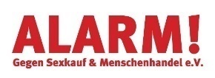
Amnesty for Women e.V. | 
Arbeiterwohlfahrt Bundesverband e.V. | 
Arbeitskreis Frauengesundheit in Medizin, Psychotherapie und Gesellschaft e.V. (AKF) | 
Ärztinnen Pro Choice Berlin

Bundesverband der Mütterzentren e. V. -  Federation of Mother Centers | 
Business and Professional Women (BPW)  Germany e.V. | 
Bündnis Frankfurt für Frauen*rechte | 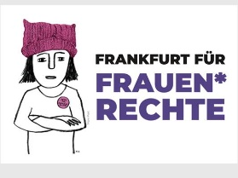
Bündnis für sexuelle Selbstbestimmung  Alliance for sexual self-determination | 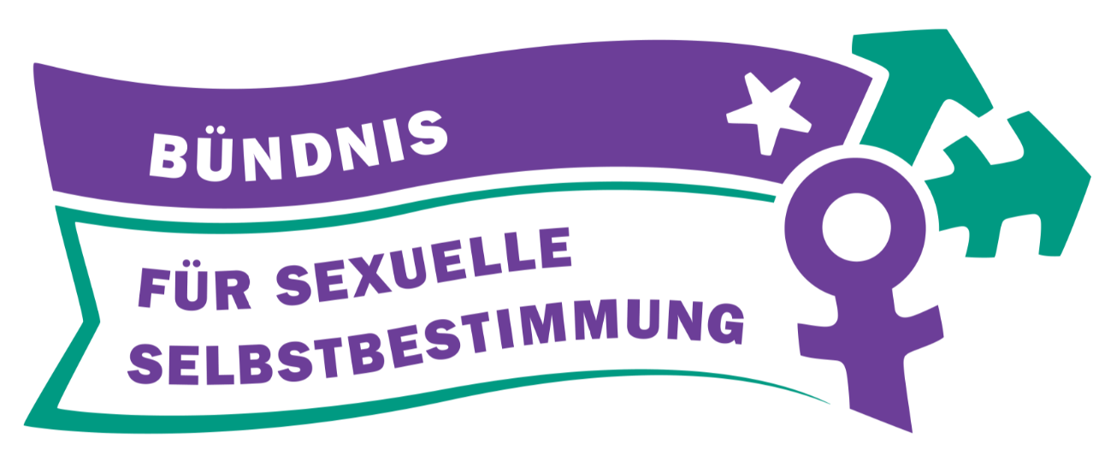
Bündnis für sexuelle Selbstbestimmung Mecklenburg-Vorpommern

Bündnis für sexuelle Selbstbestimmung Münster  Alliance for sexual self-determination Münster | 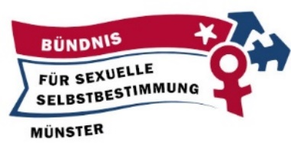
Centre for Feminist Foreign Policy - CFFP | 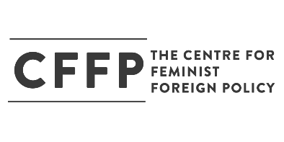
DaMigra e.V. - Dachverband der Migrantinnenorganisationen  Umbrella Association of Migrant Women Organizations | 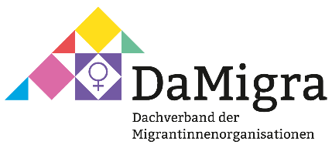
DENKtRÄUME, Hamburg

Deutsche Gesellschaft für psychosomatische Frauenheilkunde und Geburtshilfe – DGPFG | 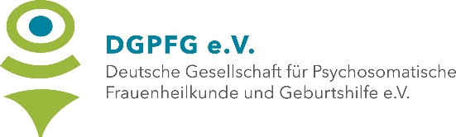
Deutsche Gesellschaft für Verhaltenstherapie (DGVT) e.V. | 
Deutscher Frauenring e.V. | 
Deutscher Frauenring Landesverband Berlin e.V. German Women's Council, Section Berlin | 
Deutscher Gewerkschaftsbund (DGB)
German Trade Union Confederation

DGB Hessen-Thüringen | 
DGB-Region Mittelhessen
Doctors for Choice Germany e.V. | 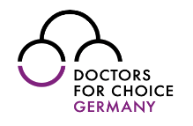
Elisabeth-Selbert-Verein e.V.  Frauenkulturzentrum Gießen | 
Fachberatungsstelle für Frauen* in der Sexarbeit  Counselling services for sex workers | 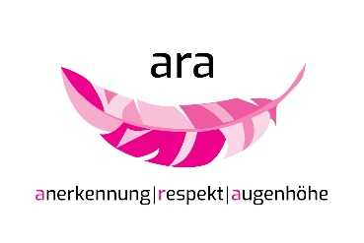
Frauenverband Courage e.V.  Women’s Association Courage | 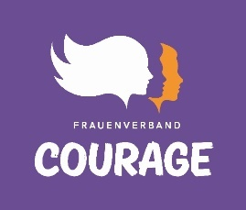
GeN - Gen-ethisches Netzwerk e.V. | 
Giordano-Bruno-Stiftung  Giordano Bruno Foundation | 
gbs Karlsruhe e.V.  Regionalgruppe der Giordano-Bruno-Stiftung | 
Hamburger Frauenring e.V. | 
Heinrich-Böll-Stiftung e.V. | 
Humanistischer Verband Deutschlands – Bundesverband | 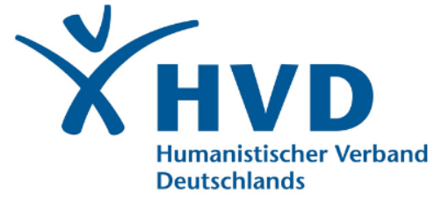
Karlsruher Bündnis für das Selbstbestimmungsrecht der Frau

Kritische Mediziner*innen Freiburg | 
Kritische Mediziner*innen Gießen | 
Kritische Medizin Leipzig | 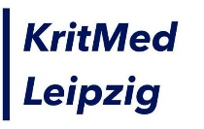
KritMed Marburg | 
LACHESIS e.V., Berufsverband für Heilpraktikerinnen Gemeinnütziger Verein von Frauen zur Förderung der Naturheilkunde | 
Landesfrauenrat Berlin e.V. | 
Landesfrauenrat Hamburg e.V. | 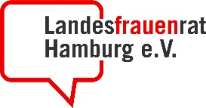
LandesFrauenRat Hessen | 
Landesfrauenrat Mecklenburg-Vorpommern | 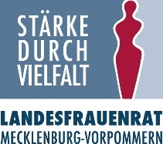
LandesFrauenRat Schleswig-Holstein e.V.

Landesfrauenrat Thüringen e.V. | 
mädchentreff schanzenviertel e.V. | 
Medeq - Equality in Medicine, Marburg  Gleichstellungs-AG des Fachbereichs Medizin (Fb20) der Philips-Universität Marburg | 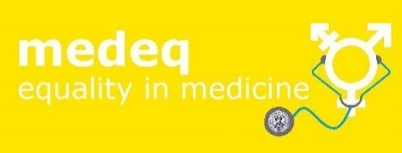
Medical Students for Choice Berlin | 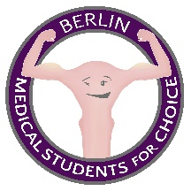
Medical Students for Choice Düsseldorf | 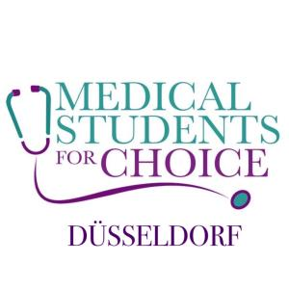
Medical Students for Choice Gießen

Medical Students for Choice Marburg | 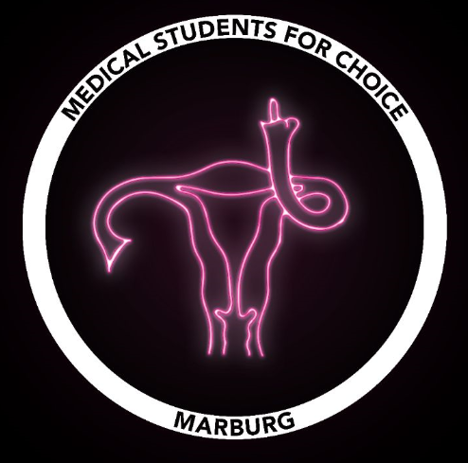
Medica mondiale e.V. | 
Netzwerk Frauengesundheit Berlin | 
Netzwerkstelle Lesben in Hamburg  Lesbenverein Intervention | 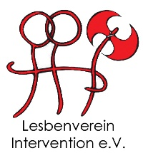
Omas-gegen-Rechts-Gießen  Grandmas against the Far Right | 
Politischer Runder Tisch der Frauen Magdeburg  Netzwerk der Frauenvereine/ Projekte und engagierter Bürger*innen der Landeshauptstadt Magdeburg | 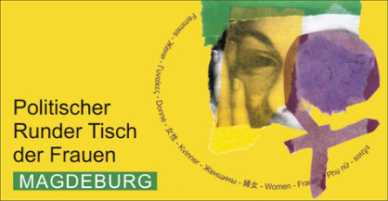
Pro Choice Deutschland e.V. | 
pro familia Deutsche Gesellschaft für Familienplanung, Sexualpädagogik und Sexualberatung e.V. | 
pro familia Bayern e.V. | 
pro familia Hamburg e.V. | 
pro familia NRW e.V. | 
pro familia Sachsen e.V. | 
pro:fem - Verbund der Hamburger Frauen- und Mädcheneinrichtungen e.V. | 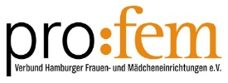
ragazza e.V. | 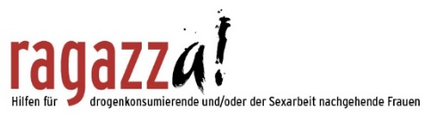
UN Women Deutschland  UN Women Germany | 
Verein demokratischer Ärztinnen und Ärzte | 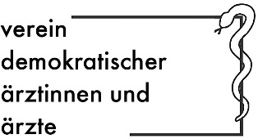
Vive Žene e.V. Dortmund | 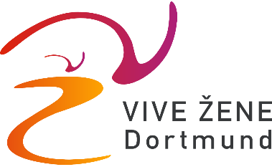

In this document, women* is used to include all persons who can get pregnant, including persons under the age of 18, transmen, non-binary and intersex persons.
CEDAW/C/GC/28
CEDAW/C/GC/35
CESCR: E/C.12/GC/22
CEDAW/C/DEU/CO/7-8, para 37b
GDR`s Journal of Law , GBL.1, Nr.5, S.89, 09.03.1972. This law was not part of GDR Criminal Code.
https://www.rv.hessenrecht.hessen.de/bshe/document/LARE190006030, File no.3 Ns 406 Js 15031/15, para. IV.4)
207 charges filed, with addresses of abortion providers and date of case filed, are listed on the website of one of the anti-abortion activists: http://www.abtreiber.com/anz/219-me.htm
authors’ translation; German version available at https://dejure.org/gesetze/StGB/219a.html
Expert Opinion by the Center for Reproductive Rights to the Parliament of the Federal Republic of Germany on the Draft Law of the Federal Government on Improving Information on Abortion (Print No. 19/7693) , 15 February 2019
CEDAW/C/DEU/CO/7-8, para 10 (2017) or before see CEDAW/C/DEU/CO/6, para 11, 21/22 and CEDAW/C/2004/I/CRP.3/Add.6/Rev.1, Para 26/27
Already in 2017, CEDAW/C/DEU/CO/7-8, Para 11/12, recommended to “ensure the uniformity of results in the implementation of the Convention throughout the State party”.
Outpatient and inpatient treatment within the framework of statutory health insurance is defined in SGB V (§§ 24, 92). The legal basis for ensuring the provision of outpatient contract physician care is regulated in the Social Code Book (SGB V § 75) and is the responsibility of the Associations of Statutory Health Insurance Physicians and the National Association of Statutory Health Insurance Physicians towards the health insurance funds.
Rocca, Corinne, h. et al. 2019. p. 8
ToRs:https://www.forschung-bundesgesundheitsministerium.de/dateien/foerderung/bekanntmachungen/bkm-ungewollt-schwanger.pdf
Deutscher Bundestag, Drucksache 19/5957;
taz, 2018; pro familia, 2019; pro familia magazine 2. 2019
Deutscher Bundestag 2019 Drucksache 19/6519
CEDAW
CEDAW/C/GC/35, p.13
https://www.bundestag.de/resource/blob/485866/978f0a3aeab437dc5209f5a4be9d458d/wd-8-071-16-pdf-data.pdf
https://www.forschung.sexualaufklaerung.de/fileadmin/fileadmin-forschung/pdf/Jugendendbericht%2001022016%20.pdf, p. 36
https://hpd.de/artikel/lebensschuetzer-sexualkunde-grundschule-16101
https://newhorizonsfoundation.com/operating-projects/1767
https://www.infoticker-passau.org/node/419
Nitz T, Busch U., 2014
Thonke, I., 2011
WHO, 2014
see as well the report published by German Women Lawyers‘ Association (djb) in Nov. 2019
https://hpd.de/artikel/stadtbusse-werben-fuer-umstrittene-schwangerenberatung-17225
https://www.buzzfeed.com/de/julianeloeffler/schwanger-profemina-beratung-abtreibung-218
https://www.hessenschau.de/gesellschaft/mahnwache-von-abtreibungsgegnern-in-frankfurt-verlegt,abtreibung-mahnwache-100.html
for more details, see report of the German Women Lawyers‘ Association (DJB), Nov. 2019
Harlfinger, W., Gaase, R. 2019
Liste der Bundesärztekammer: https://www.bundesaerztekammer.de/aerzte/versorgung/schwangerschaftsabbruch/
Liste der BZgA: https://www.familienplanung.de/beratung/schwangerschaftsabbruch/praxen-kliniken-und-einrichtungen/
Haist, M., 2019
Großkreutz, V., 2019
Ärzteblatt Rheinland-Pfalz, 06/2019
https://www.gesetze-im-internet.de/englisch_stgb/englisch_stgb.html#p1821
see Committee on Economic, Social and Cultural Rights general comment No. 14, para. 12 (a); and A/HRC/21/22 and Corr.1 and 2, para. 20
https://doctorsforchoice.de/ueber/forderungen/
Positionspapier der Bundesvertretung der Medizinstudierenden vom 02.05,19 , Zeilen 155-188 und 385-443
Approximately 100,000 abortions in Germany per year. Federal Statistical Office, Germany. p. 27. Data published on 27/02/2019
https://www.impp.de/pruefungen/allgemein/gegenstandskataloge.html
The government has acknowledged the need for the development of further education, http://dipbt.bundestag.de/dip21/btp/19/19120.pdf#P.14861
Czygan/Thonke, 2014
Bundesärztekammer, 2018
Medical Students For Choice
Federal Statistical Office, Germany, p. 11. Data published on 27/02/2019
WHO, 2012, p. 2
ibid, footnote 45
Bundestag 2018. Drucksache 19/6519. http://dipbt.bundestag.de/doc/btd/19/065/1906519.pdf
Großkreutz, Verena, 2019
SEYDACK, N. , 2019
Pro familia, 2019a

