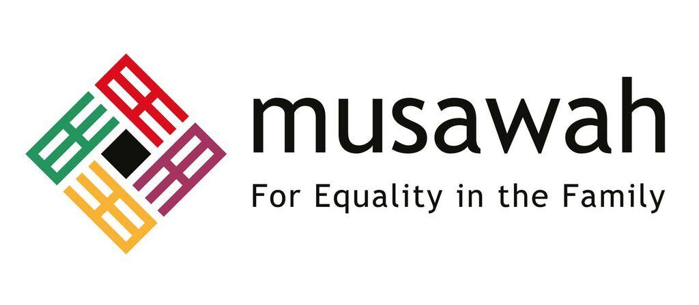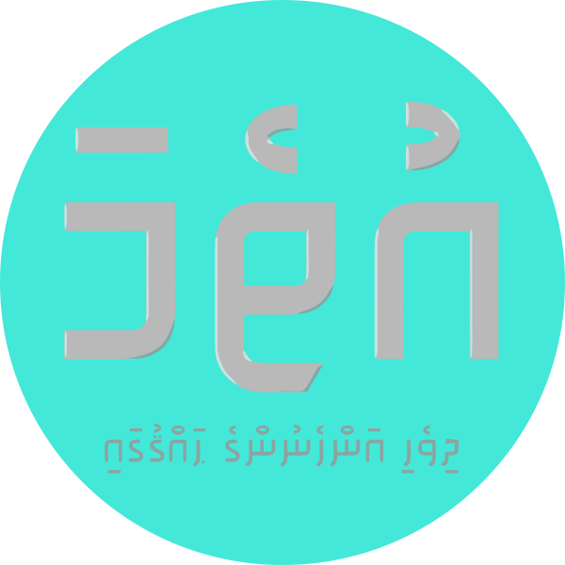

JOINT REPORT ON ARTICLE 16, MUSLIM FAMILY LAW AND MUSLIM WOMEN’S RIGHTS IN
MALDIVES

June 2020

Musawah
15 Jalan Limau Purut, 59000 Kuala Lumpur, Malaysia
Tel: +603 2083 0202
Email: musawah@musawah.org
Website: www.musawah.org
Uthema
H. Mundooge, Violet Magu,
Male’, Maldives
Email: uthema.mv@gmail.com
Website:www.uthema.org

INTRODUCTION

Uthema, a Maldivian NGO advocating for gender equality and women's empowerment in Maldives, together with Musawah, the global movement for equality and justice in the Muslim family, jointly submit this shadow report for consideration by the CEDAW Committee in its review of the 6th Periodic State Report by the government of the Republic of Maldives. This report makes the case for the removal of all reservations to Article 16 and examines Maldivian laws and practices that enforce de jure and de facto discrimination against women in the areas of access to justice, polygamy, matrimonial assets and divorce rights under the Law No. 4/2000 (Family Act) and Law No. 9/2016 and the Second Amendment to the Family Act.

We hope that the CEDAW Committee will utilize this report as a key resource during its Constructive engagement with the State party, and in follow-up issues in the Concluding Observations.

B. LEGAL BACKGROUND

According to the Constitution, Maldives is considered a 100% Muslim country. Article 9(d) of the Constitution of Maldives provides that a non-Muslim may not become a citizen of the Maldives. Article 17 and Article 20 of the Constitution guarantees non-discrimination based on gender and equality before the law. Article 16 of the Constitution however provides a limitation of a right or freedom in order to protect and maintain the tenets of Islam.

The Family Act is applicable to all marriages solemnised and/or registered in the Maldives, while Maldivians married out of the country are required to register their marriages under the Family Act. Only Muslim marriages are registered and recognised under this Act. Regulations enacted pursuant to the Family Act are applicable to all courts, including the Family Court and Magistrate Courts across the country.

C. RESEVATIONS TO ARTICLE 16

In 1993, Maldives signed CEDAW with reservations to Article 7 and 16. The original reservations to Article 16 reads as: “The Government of the Republic of Maldives reserves its right to apply article 16 of the Convention concerning the equality of men and women in all matters relating to marriage and family relations without prejudice to the provisions of the Islamic Sharia, which govern all marital and family relations of the 100 percent Muslim population of Maldives.

Following the enactment of the 2008 Constitution which removed the existing barrier for women to occupy the position of head of State, the government withdrew the reservation on Article 7 in 2010, as the Constitution nullified that reservation. On February 24 2020, Maldives officially lifted reservations to Part 1 (b)(e)(g)(h) and Part 2 of Article 16. Maldives continues to hold reservations to sections a, c, d and f of paragraph one of Article 16.

Women’s rights advocates have called on the government to remove all reservations to Article 16, citing precedents in other majority-Muslim nations including Tunisia, Morocco and Indonesia where reservations to Article 16 have been completely lifted. In March 2020, Uthema urged the government to remove all reservations to Article 16 in order to guarantee women's rights, and to uphold the State's obligation to prioritise and act in the best interests of children. Under a different government administration in 2011, the proposal to lift reservations included Part 1 (a), while in 2020, the clause has been omitted. Hence, obstacles are not ‘culture’ or ‘religion’ per se, but perspectives that privilege particular religious interpretations, often patriarchal in nature and based on political interests and power relations.

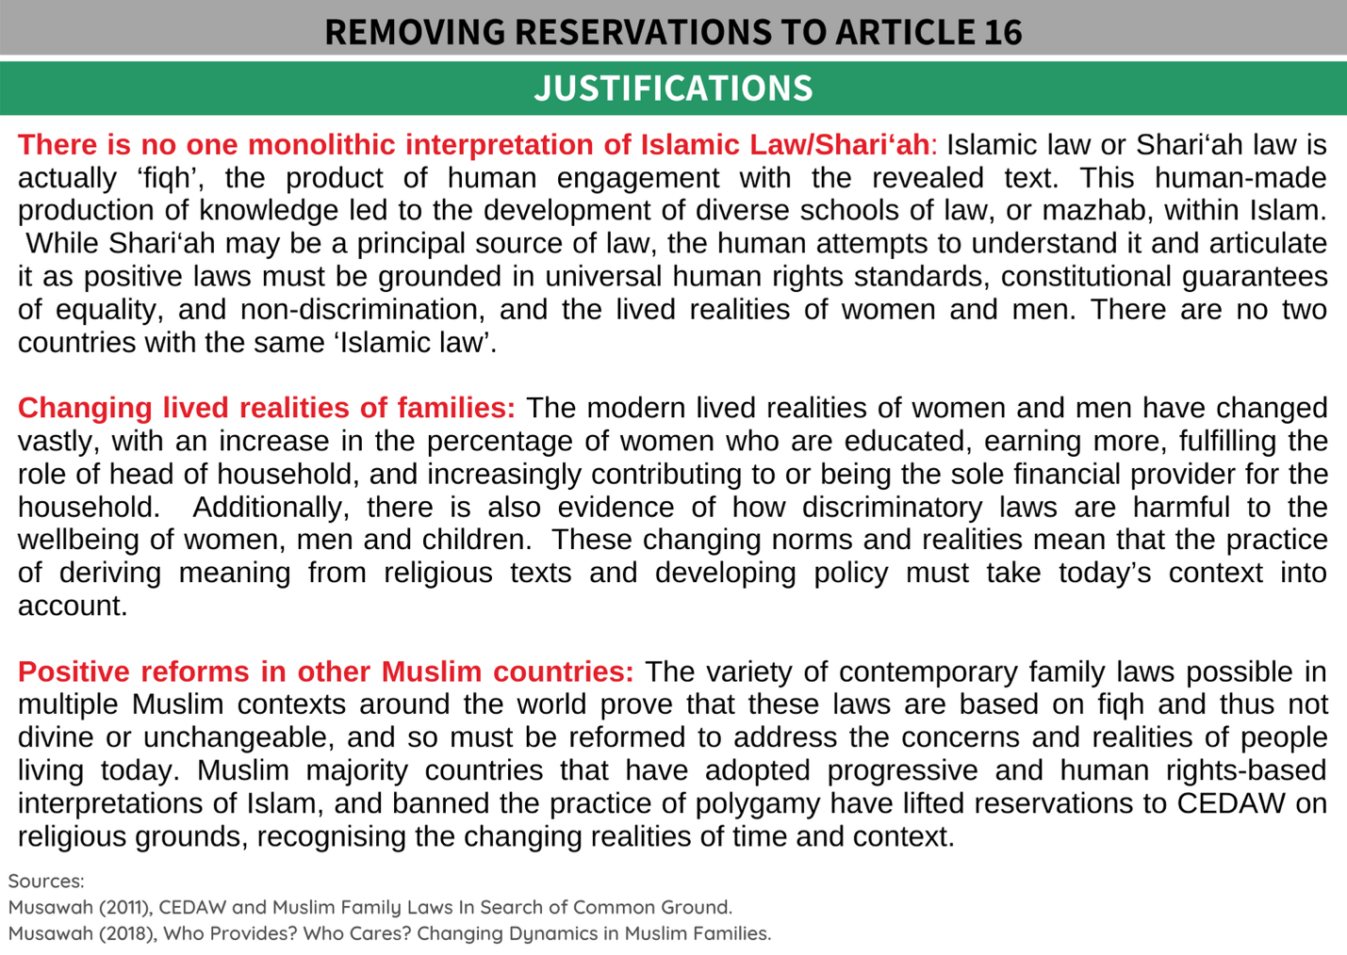

D. KEY ISSUES AND LIVED REALITIES

POLYGAMY

The Family Act allows men to marry up to four wives. Section 12 of the Family Act specifically states that marriage with more than one woman must be approved by the Registrar of Marriage, based on a man’s financial competence to provide for existing wives and/or children. As of 2012, any man wanting to enter into a polygamous marriage must earn at least 15,000 MRF (roughly 971 USD).

The assumption that this amount can sustain two marriages is highly unrealistic in today’s economy and lived realities in Maldives. In the largest urban centre Male' City, 63% of households live in rented homes, with the cost of renting a 2-bedroom apartment close to or upwards of this amount. In many cases it remains difficult to support multiple families, often causing emotional, financial, and physical stress to all parties involved.

A man does not require consent of the first wife to enter into another marriage, with some women reporting that husbands use the possibility of taking a second wife as a threat in order to control and humiliate. In accordance with the law, registration of all marriages are mandatory and an application requesting approval for polygamous marriage must be made to the Registrar of Marriage. That said, there is no centralised marriage register and the Magistrate Courts in the islands solemnise marriage without the mandatory approval of the Registrar of Marriage and the per-requisites under Section 12 of the Family Act, rendering inequality of law enforcement towards women in communities outside the urban centre and capital, Male’ City.

Many of these marriages continue to remain unregistered and are later likely the cause of disputes pertaining to legitimacy of children and inheritance. This issue has been raised by the court in 2010, where religious extremists in the country have both endorsed and performed out-of-court marriages. Women’s rights activists predict that there are many unregistered polygamous marriages of men marrying women in different islands throughout the State. The implementation of child maintenance provisions via the courts also remains weak.

Case Study: One woman’s experience of polygamy and divorce

A single mother if two, who had divorced the father of her children due to his obsessive and controlling behavior, and forcing her to give up her job, decided to become the second wife of her old school boyfriend. While initially hesitant to enter into a polygamous marriage and her parents with whom she currently lived disapproved due to the man’s history of substance abuse, she was convinced by him. Her new husband rented an apartment before they got married but one month into their marriage said he could no longer afford to rent a separate place for her, and hence she was forced to move back into her parent’s home. However, due to the parent’s disapproval of her husband, he was not permitted to enter their home, significantly impacting the marital relationship.

The woman stated that the Magistrate Court did not verify his income status, and that the court blindly accepted that the man earns 15,000 MRF in the form, concluding that he can support two families. She has now filed for a divorce, and despite providing evidence that her husband cannot provide housing and care for her children, the couple received court ordered reconciliation and was told that she would need to apply for divorce again after three months if reconciliation failed. As a result, she is forced to remain in the polygamous marriage.

RECOMMENDATIONS
We recommend the CEDAW committee to urge the State party to:

Short term:
- Impose stringent application of section 12 of the Family Act throughout the country, and not just the capital, Male’, ensuring all polygamous marriages are administered through the courts, specifically subsection (b) where a man must demonstrate adequate financial capacity and commitment to support multiple wives and families.
- Develop a centralised marriage register to better regulate and halt secret polygamous marriages in different islands.
- Undertake research and collection of data, cases and evidence of the impacts of polygamy on Maldivian families, especially women and children.

Long term:
- Ensure that existing Family Law and any amendments thereto, must contain provisions to prohibit polygamy by, following examples of other Muslim countries which have abolished the practice in the best interest of family well-being, taking into account progressive and egalitarian interpretations of Shari’ah that considers sociocultural realities of Maldivian women.

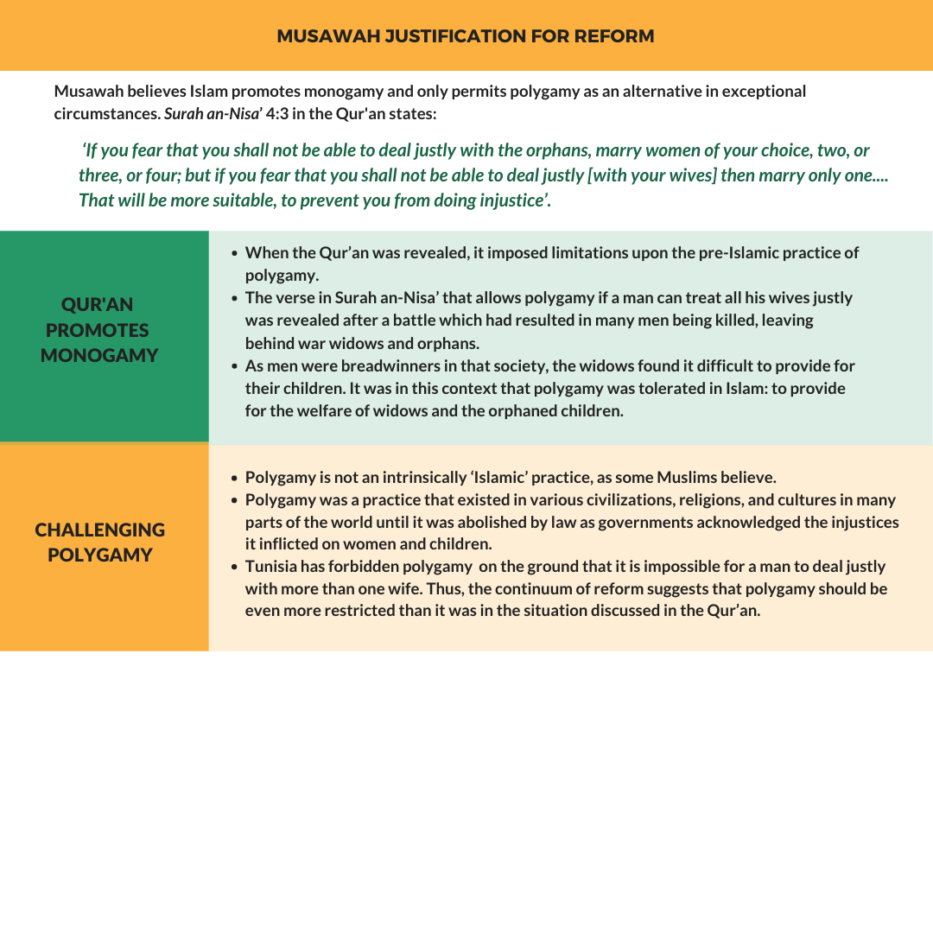

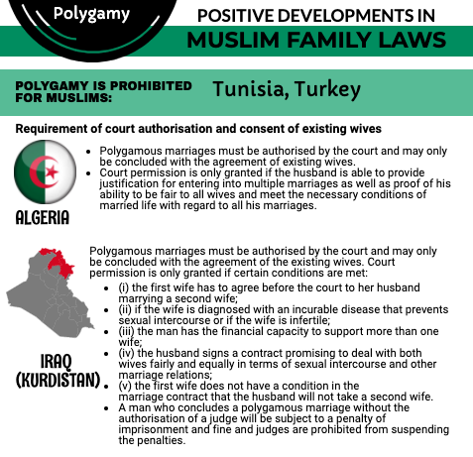

UNEQUAL PROVISIONS FOR DIVORCE

While Maldivian law allows for both men and women to commence divorce proceedings, divorce rights between the two genders are unequal. The Family Act recognizes three types of divorce; Ruju’, Khul’ and Faskh divorce. The law requires men to obtain court permission to exercise divorce, however if the man pronounces divorce verbally without court permission, the divorce still comes into effect, with the Family Act requiring that the divorce be registered within three days, with a financial penalty for non-compliance. There need not be any justifiable grounds or reason for such pronouncement. On the other hand, a wife would need to file for divorce in a court and seek a pronouncement by either the husband or court.

Women have a much harder time accessing and obtaining divorce than men. A wife can file for divorce on specific grounds, but these are said to become quite ambiguous in court and she has the responsibility to bring the burden of proof. In the case of rural women seeking recourse in the Family Court in Male’, the women also have to bear the financial burden involved in accessing the courts.
Lawyers inform that if the husband is unwilling to divorce the wife, it is very difficult and time consuming for a woman who has initiated the process. In cases of domestic violence, delays and other challenges in divorce processes can further traumatise victim-survivors.

Lack of access to justice for women in communities outside the Greater Male' urban centre
There also exists an inequity in practice in Male’ and the islands. In the event the husband is unwilling to grant divorce, it is difficult for a woman to procure a faskh (judicial dissolution of marriage) at Family Court in Male', and in an island it is next to impossible for a woman to be granted a faskh divorce. Most divorces initiated by women drag on for approximately six to 10 month and in some cases, years. Applications for divorce in Male' are often delayed due to the mandatory reconciliation process through court.

The Magistrate courts do not have an automatic reconciliatory mechanism in place, unlike the Family Court, and hence the Magistrate in islands act as the mediator. Women's application for a faskh in islands often result in dismissals of claims with advice to reconcile irrespective of women's desire to procure a divorce, resulting in the woman being forced to remain in the marriage.

RECOMMENDATIONS
We recommend the CEDAW committee to urge the State party to:

- Embark on a consultative process with full involvement of women’s groups to assess the areas of discrimination faced by women and men pertaining to divorce and family matters and access to justice in the Family Court, and Magistrate Courts located in islands.
- Undertake family law reform including equalizing conditions and procedures of divorce for women and men. Equal rights and access for both women and men to matters related to the dissolution of marriage, including the grounds for divorce and standards of proof.
- Ensure divorce procedures are just and fair for women, despite residential locality.
- Ensure women have access to justice through the existing Domestic Violence Prevention Act of 2012, with timely access to judicial divorce to prevent survivors of domestic violence and their families being exposed to further violence and trauma.
- Ensure that the practice of solemnisation of marriages via video conferencing in light of the COVID-19 pandemic be made available to enable both marriages and divorces across the country, without discrimination to the residential locality of persons.

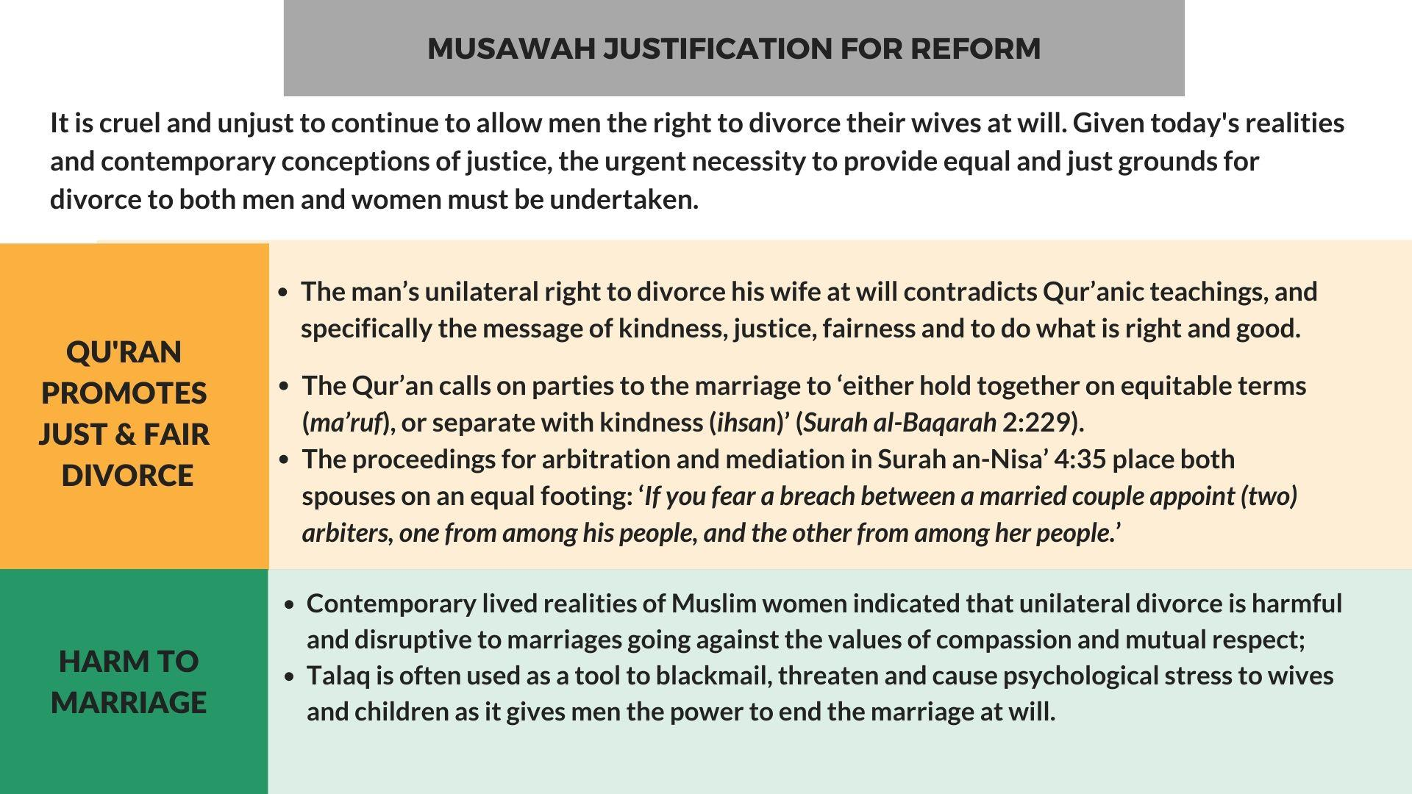

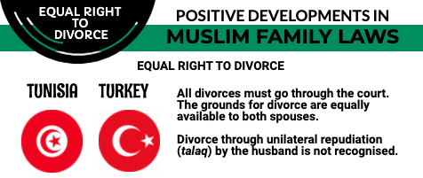

MATRIMONIAL PROPERTY – LACK OF COMPREHENSIVE LEGISLATION

There is currently no legislation guaranteeing equitable division of matrimonial assets between spouses after divorce. The 2016 amendment to Section 32 of Family Act makes provision for distribution of matrimonial assets only in the event a prenuptial agreement recognising matrimonial assets is executed between the couple before marriage. Prenuptial agreements are not widely known about, practiced or encouraged in the country and hence inapplicable to a majority, if not all currently registered marriages. In addition, the amendment also adds a new clause to the original statute, with section 11(b) which states that a prenuptial agreement must comply with the principles of Islamic Shari’ah. Hence, creating further confusion regarding interpretation and a possibility of exclusion to those who have existing prenuptial agreements which may be viewed as being noncompliant based on interpretations of Islamic Shari’ah.

In cases where no such agreement has been reached, the court will decide on division of assets, where inequity in the division of matrimonial assets are influenced by the assumption that men are primary breadwinners. Hence not much importance is given to compounding the nonpecuniary but yet essential contributions of a wife to the matrimonial home in distributing matrimonial properties after divorce, causing insecurity in asset ownership, that directly impacts their access to credit facilities and economic independence. Similarly, research done by Uthema has shown that women's contribution to build family homes and joint business investments are not acknowledged in practice and are not taken into account during the division of assets. This further contributes to a significantly lower HDI (Human Development Indicator) for women than men, despite women progressing better with regard to life expectancy and expected years of schooling.

Lack of access to justice for women in communities outside the Greater Male' urban centre
In cases of eligibility for social housing and land allocation both in the capital Male' and in the islands, points are awarded based on marital status, and often this is beneficial. Allocation of social housing in Male' may result in registration of property under both husband and wife's name. In the event of divorce, women have been able to claim their rightful share in the property, on the basis of registration, rather than eligibility and awarding of points based on marital status.

In the case of land allocation in the islands, eligibility is also often based on marital status. However, women are often denied the right to be listed on the land registry by local councils without any legal justification for such denial, especially when a man's eligibility for allocation of land is usually based on his marital status. In the event the woman wishes to leave the husband or get a divorce, she has neither the financial means of support nor a roof over her head, as she would not have a share of the land that was procured by the husband through his marriage to her. Women also find it difficult to move back to the parent's house for sociocultural reasons.

RECOMMENDATIONS
We recommend the CEDAW committee to urge the State party to:

- Introduce measures for the division of matrimonial property drawing from progressive legislation in other Muslim contexts (like Malaysia and Brunei) which will be applicable to all marriages in Maldives. Law on matrimonial property must consider the financial and non-financial contributions of women during marriage.
- To redress the gaps by adopting progressive and meaningful change to achieve equity in matrimonial asset distribution within the current review of the family law.
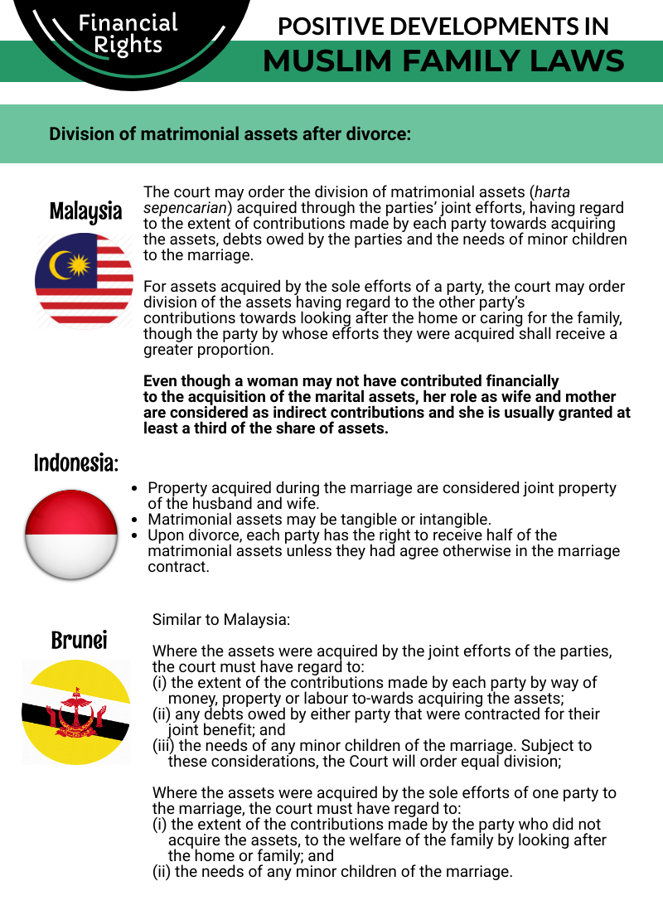

ANNEXE 1: MUSAWAH VISION FOR THE FAMILY
Musawah asserts that in the twenty-first century, there cannot be justice without equality. Many provisions in Muslim family laws, as defined by classical jurists and as reproduced in modern legal codes, are neither tenable in contemporary circumstances nor defensible on Islamic grounds. Not only do these family laws fail to fulfill the Shari’ah requirements of justice, but they are being used to deny women rights and dignified choices in life. These elements lie at the root of marital disharmony and the breakdown of the family.
Musawah believes that Qur’anic principles and the richness of the Islamic juristic tradition enable us to formulate Muslim family laws today that are egalitarian and reflect the needs of contemporary societies. Islamic teachings and universal human rights standards, including the CEDAW Convention, are fully compatible and are dynamic and constantly evolving, based on changing times and circumstances. Inspired by the Qur’anic vision of justice and gender relations, Musawah contends that gender equality and non-discrimination can only be achieved with laws that transform power relations in the family and in society in the direction of just outcomes.
It is our hope that the CEDAW Committee will encourage Governments everywhere, and particularly those purporting to speak for and in the name of Islam and Muslim communities, to:
- Recognize the diversity of opinions, laws and practices in the Muslim world and the growing scholarship in Islam that recognizes equality and justice and the possibility and necessity for reform of Muslim family laws today.
- Promote human rights standards as intrinsic to the teachings of Islam, national guarantees of equality and non-discrimination, and the lived realities of men and women today.
- Encourage open and inclusive public debate regarding diversity of opinion and interpretations in Muslim laws and principles relating to family laws and practices.
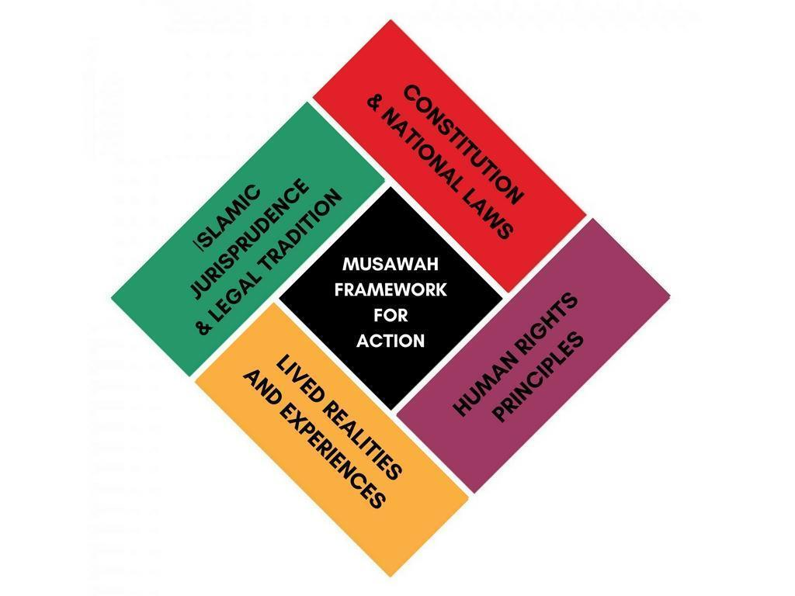

Article 9, The Constitution of Constitution of the Republic of Maldives (2008).
The Constitution of the Republic of Maldives (2008), https://storage.googleapis.com/presidency.gov.mv/Documents/ConstitutionOfMaldives.pdf
Article 16, The Constitution of Constitution of the Republic of Maldives (2008).
Section 1 and 2 of Family Act.
Section 19 of Family Act.
Status of Treaties, 8. Convention on the Elimination of All Forms of Discrimination against Women (2020), https://treaties.un.org/Pages/ViewDetails.aspx?src=IND&mtdsg_no=IV-8&chapter=4#39
United Nations, (2020), Reference: C.N.73.2020.TREATIES-IV.8, https://treaties.un.org/doc/Publication/CN/2020/CN.73.2020-Eng.pdf
Malsa, Mariyam. (2020), “Uthema demands govt to remove all CEDAW reservations”, The Edition, https://edition.mv/news/15366
Hope for Women, (2012), Maldives NGO Shadow Report to the Committee on the Elimination of Discrimination Against Women https://tbinternet.ohchr.org/Treaties/CEDAW/Shared%20Documents/MDV/INT_CEDAW_NGO_MDV_19479_E.pdf
Article 12 of Family Act (4/2000), http://www.agoffice.gov.mv/pdf/sublawe/Family.pdf
National Bureau of Statistics (2016), Household Income and Expenditure Survey, http://statisticsmaldives.gov.mv/nbs/wp-content/uploads/2016/03/HIES-Report-2016-Expenditure.pdf
Fulu, E. (2014), Domestic Violence in Asia: Globalization, Gender and Islam in the Maldives, Routledge.
Article 19 of Family Act (4/2000)
Minivan News Archives, (2010), “Unregistered marriages leave children unable to inherit, warns Family Court”, https://minivannewsarchive.com/society/unregistered-marriages-leave-children-unable-to-inherit-warns-family-court-5744
Minivan News Archives, (2014), “Fatwas against registering marriages a huge challenge: Family Court chief judge”, https://minivannewsarchive.com/politics/fatwas-against-registering-marriages-a-huge-challenge-family-court-chief-judge-83630
See case studies collected by Uthema. “Women’s lived realities - Maldives”, YouTube, 20 March (2020), https://www.youtube.com/playlist?list=PLZQL_QMqfnbB_IHLt9wyq81nGg1W_PSod
Forms of Divorce: 1. Raju’ee divorce (consensual divorce):This occurs when divorce is pronounced by the husband; and is uncontested. (Section 23 (b) of Family Act). 2. Thafreeq divorce (dissolution of marriage by the Court) This occurs when the husband contests the divorce and the Court finds that the marriage has irretrievably broken down. (Section 24 ( c ) of Family Act). 3. Faskh divorce - Annulment of marriage on application by wife based on the following grounds (Section 28 of the Family Act):lapse of a period of one year without knowing the whereabouts of her husband; failure of husband to provide maintenance for a period exceeding three consecutive months (acted in default of two Court Orders to pay; maintenance by the husband); husband’s impotence; insanity for a period exceeding 2 years; husband’s continued suffering from a communicable and an incurable disease occurrence of other events/incidents that justifies a faskh under Shari’ah. 4. Khul’u divorce - initiated on application by wife whereby the parties agree on divorce upon wife making a payment or giving something of monetary value in return of granting divorce (Section 27 of Family Act).
Article 23 of Family Act (4/2000)
Family Court of Maldives, (2020) Family Court announces the solemnisation and registration of marriages via video conferencing (Dhivehi), http://familycourt.gov.mv/wp-content/uploads/2020/05/Video-Conference-koh-Kaiveni-koh-dhinun.pdf
Second Amendment to the Family Act (9/2016)
Article 11 (b), Second Amendment to the Family Act (9/2016)
Uthema, (2020), Comprehensive NGO Shadow Report Responding to the 6th Periodic State Report of the Maldives, April 2019 to the UN CEDAW Committee, https://uthema.org/wp-content/uploads/Uthema-Comp-CEDAW-Shadow-Report-20Apr2020.pdf
See case studies collected by Uthema. “Women’s lived realities - Maldives”, Youtube, 20 March, 2020, https://www.youtube.com/playlist?list=PLZQL_QMqfnbB_IHLt9wyq81nGg1W_PSod
Uthema, (2020), Comprehensive NGO Shadow Report Responding to the 6th Periodic State Report of the Maldives, April 2019 to the UN CEDAW Committee, p.45 https://uthema.org/wp-content/uploads/Uthema-Comp-CEDAW-Shadow-Report-20Apr2020.pdf

