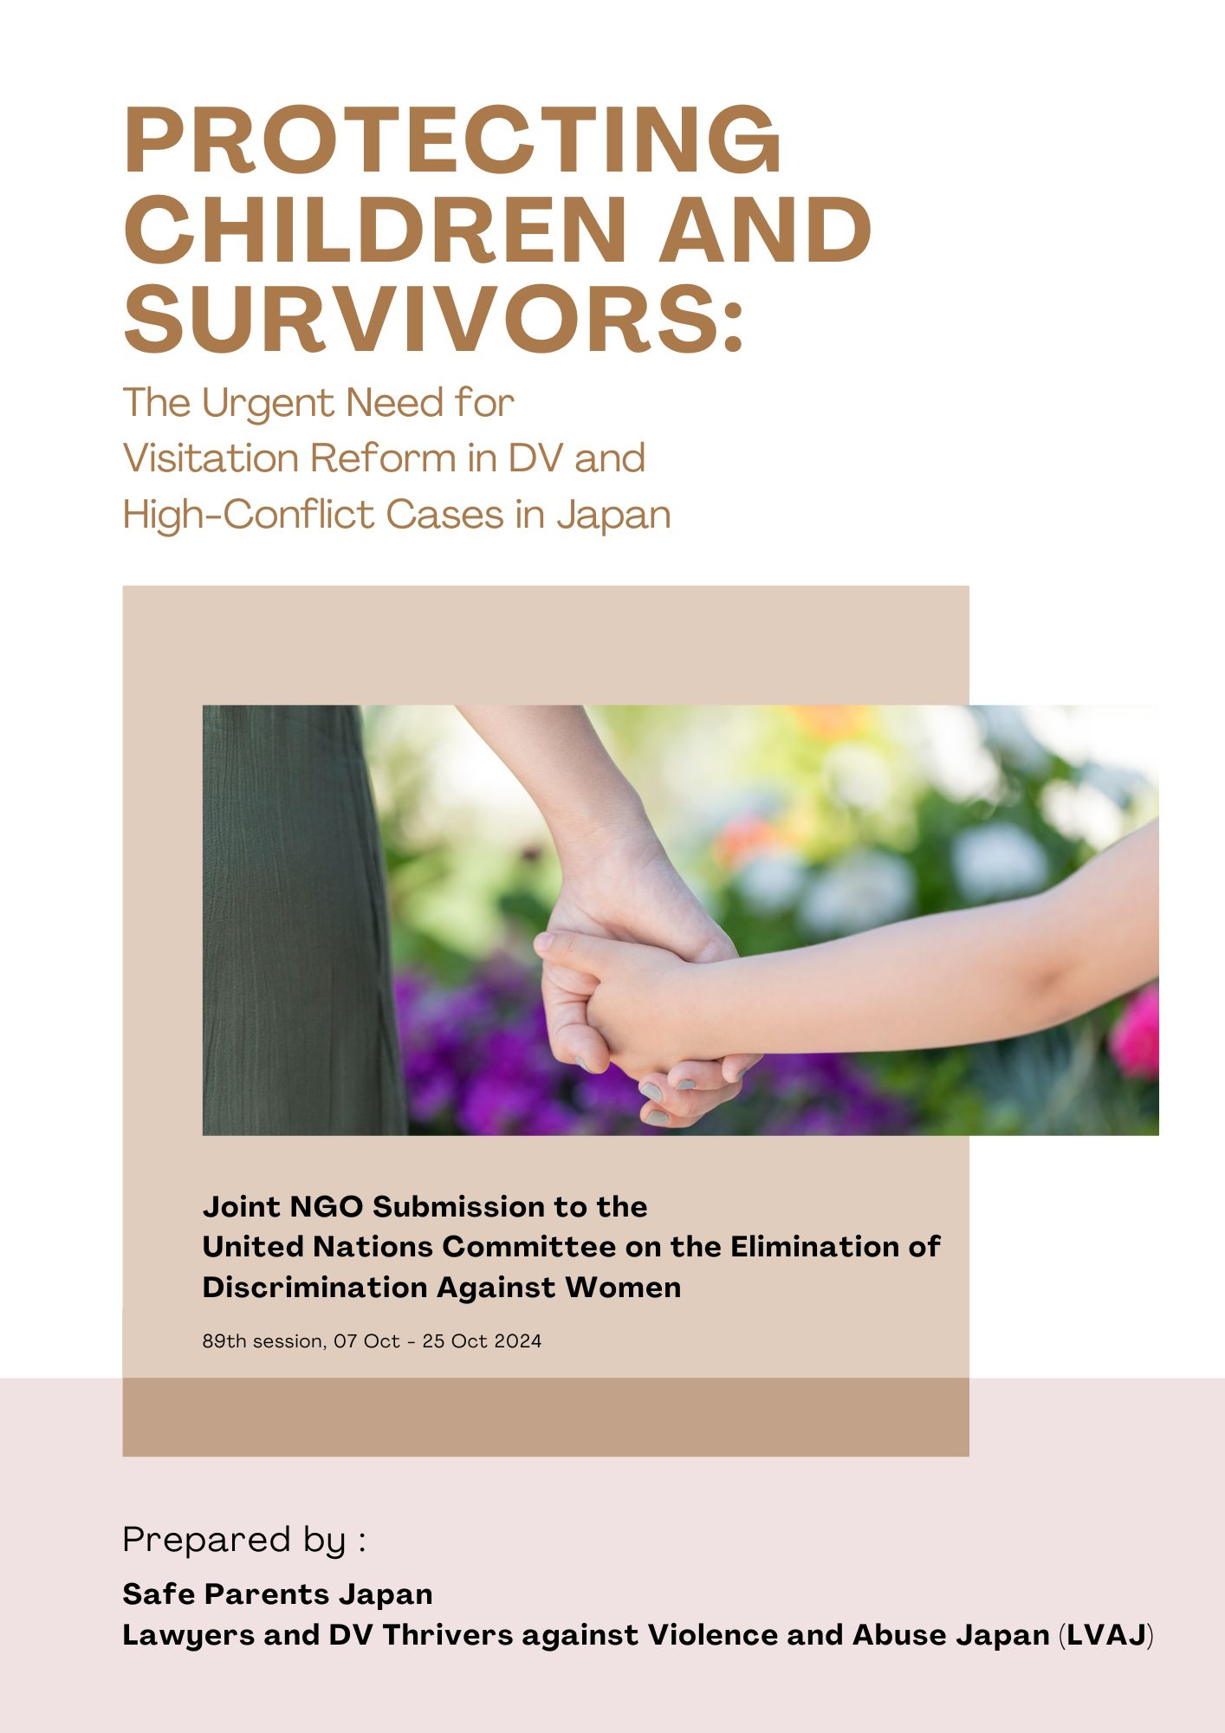
Table of Contents
1. Introduction 2
2. Recommendations Sought 2
2-1. Investigation into the Realities of Enforcing the Pro-Visitation Enforcement Policy 3
2-2. Examination of the Harmful Realities of Visitation Detrimental to the Child’s Welfare 4
2-3. The Necessity of Examining Murders Occurring During Visitation 5
2-4. The Need to Establish a Support System for Individuals Facing Difficulties with Visitation 7

1. Introduction
We assert to the CEDAW at its 89th session that, despite numerous issues arising in Japan regarding visitation between non-resident parents, mostly fathers, and children after separation or divorce, the government has taken no action to address these concerns. This inaction continues to harm vulnerable individuals, particularly victims of domestic violence (DV) and children. Furthermore, we express grave concerns that the upcoming implementation of a kyōdō shinken (“joint parental authority”) system by 2026 will increase the risk of enforcing visitation in cases where it poses a clear danger, thereby exacerbating the harm caused. We call upon CEDAW to issue appropriate recommendations to Japan on this matter. Terminology defined:
- Shinken (“parental authority”): Shinken encompasses a broad spectrum of parental rights and duties regarding childcare, education, legal representation, and the right to determine the child's place of residence and permit work.
- Kango (“custody”): This refers to the responsibility to raise the child.

2. Recommendations Sought

2-1. Investigation into the Realities of Enforcing the Pro-Visitation Enforcement Policy
Japan should conduct an investigation into the reality faced by resident parents and the children following the revision of Civil Code Article 766 and the implementation of the so-called the family court’s policy of prioritising the visitation (“pro-visitation enforcement policy”).
Reason:
After the amendment of Article 766 of the Civil Code in 2011, family court practices have adopted a principle of enforcing visitation, whereby visitation is granted unless there are special circumstances that would harm the child’s welfare. This has resulted in intense pressure on resident parents to allow visitation, even in cases where children strongly refuse or where DV against the (ex-)partner and child abuse are present. Family courts have also issued rulings ordering direct visitation in such cases.
In 2016, a group of volunteers from the Japan Federation of Bar Associations’ Committee on Gender Equality conducted a survey on visitation cases in family courts, receiving responses from 65 lawyers.The survey revealed that visitation was often imposed in family court mediations and rulings, even when children refused or DV survivors expressed concerns.
According to the results, 49 lawyers reported experiences where family court personnel, including mediators, court investigators, and judges, pressured parents to allow children to meet with non-resident parents despite evidence of DV or child abuse. Of these, 43 lawyers indicated that direct visitation was ultimately enforced.
Additionally, 35 lawyers reported experiencing mediation agreements or court rulings on visitation that were impractical to implement. For example, in cases where a restraining order had been issued due to DV by the non-resident parent, direct visitation was still permitted. Other cases involved excessive visitation frequency that exhausted the resident parent, or distant, frequent visitations ordered for young children. There were also reports of resident parents suffering a mental health decline due to the psychological burden, exacerbated by repeated visitation following unresolved trauma from DV during the marriage.
As noted in Section 3, multiple murders occurred during visitation between 2016 and 2017. In response, family courts announced in 2020 a policy of maintaining a "neutral and balanced position" (favoring neither the resident nor non-resident parent, and solely prioritizing the child's best interests). However, little has changed in practice.
A 2022 survey conducted by the National Council of Single Mother Support Groups (consisting of 31 groups nationwide) revealed that family court mediation and investigations were not neutral. The survey found asymmetry, with resident parents (mainly mothers) being pressured to compromise on visitation. Additionally, visitation was encouraged even when children refused or DV was involved. DV has been downplayed, with reports of cases where visitation was still ordered despite protection orders being in place. There have also been instances where it was stated during mediation that shinken (“parental rights”) could not be granted if visitation could not be arranged.

2-2. Examination of the Harmful Realities of Visitation Detrimental to the Child’s Welfare
Japan should conduct an investigation into the harm caused by the continuation of abusive visitation that negatively affect resident parents and children following separation.
Reasons:
According to the lawyers’ survey mentioned on the previous page, 22 lawyers reported cases where visitation, based on mediation agreements or court rulings, negatively impacted the child. Specific examples include children becoming rebellious due to their wishes being ignored and being forced into visitation, children crying or bed-wetting after visits (in one case, a 4-year-old), deterioration in the parent-child relationship between the resident parent and child, and children experiencing insomnia, frequent urination, and requiring treatment from mental health specialists (diagnoses included anxiety neurosis and depressive states). Other symptoms reported were hives, fevers, regression (e.g., acting like a baby), emotional disturbances such as violent behavior towards friends, emotional instability, and frequent episodes of agitation.
Furthermore, 28 lawyers reported cases where resident parents experienced physical or mental health deterioration due to the enforcement of visitation agreements or rulings. Examples include developing depression, insomnia, anxiety disorders, frequent headaches, vomiting, stress-induced insomnia or nightmares, becoming severely depressed as visitation days approached, and displaying symptoms typical of PTSD or related conditions such as emotional instability, heart palpitations, or dizziness. In some cases, resident parents had to be hospitalized due to panic attacks or stress-related conditions, leading to a temporary inability to work.
There were also reports of non-resident parents verbally abusing or harassing resident parents during visitation.
Despite issuing visitation enforcement rulings, family courts do not conduct follow-up investigations to ensure that their decisions align with the child’s welfare. As mentioned in the following section, there have been multiple cases of murders occurring during visitation. Despite the gravity of these situations, the government has yet to conduct any official investigation into the actual conditions. To implement appropriate measures, a public investigation into these realities is necessary.

2-3. The Necessity of Examining Murders Occurring During Visitation
Japan should investigate past cases in which children were killed during visitation and promptly take concrete measures to prevent such tragedies.
Reasons:
In cases of high-conflict separations involving DV, it is not uncommon for a parent dissatisfied with the separation or divorce to kill their child during visitation as a means of revenge against their former partner. This is a serious issue in many countries, and addressing it is of paramount importance.
Similar incidents have occurred in Japan in recent years, such as the following:
(1) June 2016, Sakai City, Osaka Prefecture
During visitation, a father and his first-grade son were found dead in a submerged car. It is suspected to have been a murder-suicide.
(2) January 2017, Nagasaki City, Nagasaki Prefecture
A mother was stabbed to death after visiting the father’s residence to allow him to see their 2-year-old child, as stipulated by a visitation agreement following their divorce. The father then committed suicide. Despite the mother suffering from stalking and threats from her ex-husband, she was forced to meet him for visitation, leading to the tragedy.
(3) April 2017, Itami City, Hyogo Prefecture
A father killed his 4-year-old daughter during visitation and then committed suicide. The father had been violent while living together, such as by giving all-night lectures and breaking furniture. After the divorce, the family court ruled that visitation should take place, and the tragedy occurred during their first visit.
In particular, case (3) highlights the failure of the family court to recognize the risks involved, despite its involvement in deciding the visitation arrangements. This incident underscores the need for family courts to seriously reconsider how they assess risks when determining whether visitation should proceed and under what conditions.
Recently in Japan, amendments to the Family Law system have been made, and a new kyōdō shinken (“joint parental authority”) system is set to be introduced by 2026. However, DV survivors and their advocates have expressed deep concerns that the introduction of joint parental authority will make it more difficult for victims of DV and abuse to escape their abusers. A petition against the hasty implementation of this system garnered 240,000 signatures.
While the option for sole parental authority will remain, there is a heightened risk that joint parental authority will be used as leverage, with demands such as, “If you want a divorce, it must be under joint parental authority; if you want sole parental authority, you must allow unrestricted visitation.” This increases the danger that visitation will be enforced even in cases where it should not take place.
However, the government has admitted to having no comprehensive investigation into these issues. On April 5, 2024, in the House of Representatives' Committee on Judicial Affairs, Justice Minister Koizumi stated, “We are aware through media reports that tragic incidents, such as murders, have occurred during parent-child visitations. However, the Ministry of Justice has not conducted a thorough investigation or review of these incidents."
To prevent even one more child from losing their life in a visitation that should never have taken place, it is imperative that the government conduct a detailed investigation into past cases and swiftly implement concrete measures.

2-4. The Need to Establish a Support System for Individuals Facing Difficulties with Visitation
Japan should expand concrete measures to address the challenges faced by individuals who are forced to carry out visitation despite difficulties, such as cases involving DV or post-separation abuse (PSA).
Reasons:
When married parents are separated, or when parents are divorced, the non-resident parent can petition the family court for mediation or a ruling to obtain visitation with their minor child. In practice, even if the resident parent or the minor child is reluctant about visitation, the family court often orders the resident parent to cooperate in arranging visitation unless clear evidence of DV or child abuse is presented. It is not uncommon for resident parents to be persuaded to allow visitation during mediation. As a result, if a victim is unable to provide clear evidence of DV or child abuse, they may be forced into a situation where visitation must take place, even in cases where such abuse has occurred.
In these cases, individuals face the following difficulties:
(1) Lack of a robust support system for visitation
Japan lacks public institutions to support parent-child visitation after divorce, which are present in other countries. For example, in Australia, high-conflict families can use facilities known as contact centers, where family court counselors are available for support.
However, in Japan, there is no public institution to assist in the safe implementation of visitation. While there are NGOs or other private institutions that offer support, the level of expertise and understanding of DV varies significantly between them. The availability of such services also varies by region, with some areas having no access at all. Moreover, the use of these services comes at a cost, making it difficult for low-income single parents to afford their services.
Due to these factors, even after a family court orders visitation, individuals—regardless of the presence of DV or PSA—are often left without support. They must manage all the logistics, such as scheduling and attending the visits, on their own.
Perpetrators of DV or abuse may use visitation as an opportunity to pressure their former partner into reconciliation or to commit further abusive acts. This makes visitation a painful and distressing experience for victims, sometimes even leading to new instances of violence.
(2) Economic Hardship Due to Indirect Compulsory Fines in Cases of Difficult Visitation
When visitation ordered through family court mediation or a ruling is not carried out, the non-resident parent can file a petition for compulsory execution. The court may then order the resident parent to pay the non-resident parent an "indirect compulsory fine", a fine imposed to enforce compliance with a court order, if the visitation is not implemented as decided. "Indirect compulsory" refers to a system where a fine is imposed if the obligated party fails to fulfill their duty within a specified period. The purpose is to apply psychological pressure to encourage voluntary compliance.
If the resident parent does not comply with the visitation order, they may be ordered to pay an indirect compulsory fine. There have been reports of cases where visitation was ordered even when the child strongly opposed it, forcing resident parents into a harsh dilemma: either pay a substantial indirect fine or compel the child to participate in a visitation they do not want.
Although resident parents can apply for changes to visitation orders, the family court system is severely understaffed relative to the number of cases, and in some regions, mediation or hearings may only take place three or four times a year. This makes it extremely difficult to adjust visitation arrangements to fit the actual situation, and in the meantime, resident parents continue to be burdened with paying large fines.
In recent years, these indirect fines have become increasingly high, posing a significant threat to the child’s welfare. A typical case is the ruling by the Nagoya High Court on March 17, 2017, which prohibited direct visitation after recognizing the negative effects that previous visitations had on the child’s physical and mental well-being. In this case, despite the child’s strong rejection and physical symptoms, the family court ignored these concerns and ordered visitation after the father, who had been separated from the child, filed four visitation petitions over seven years. The resident mother was forced to pay a total of ¥1.72 million (€10,851) in indirect fines to protect her child, but she could not afford the payments and had to borrow from relatives, putting her in severe financial distress. This situation further worsened the child’s mental state.
There are numerous cases where visitation is ordered despite it being inappropriate. In 2022, Safe Parents Japan, an advocacy group, collected over 44,000 signatures for an online petition titled “Do Not Force Visitation Between DV/Abuse Perpetrators and Children,” which was submitted to the Minister of Justice. However, neither the government nor the courts have conducted any investigations, and many children continue to suffer irreparable harm from unwanted visitations.
The increasing amounts of indirect fines only add to this burden. Even if resident parents wish to renegotiate visitation arrangements, the process takes months, during which fines continue to accumulate. There are no surveys or statistics on the amount of these fines, and even lawyers find it difficult to estimate the going rates. By ignoring these realities and allowing fines to increase, resident parents—many of whom are economically struggling mothers—are pushed further into hardship, suffering severe secondary harm. Moreover, children who do not wish to attend visitation are forced into it, exposing them to mental and physical risks.
The increasing fines are a harsh punishment for resident parents. It goes without saying that high levels of conflict exist between parents, not only due to distrust but also because of feelings of being penalized. In such cases, it is impossible for the child to attend visitation without feeling burdened, and the forced nature of visitation can even lead to future rejection. We must not turn a blind eye to the limitations of using money and legal measures to resolve human relationships. There is an urgent need to review both the increasing fines and the fundamental issue of forced visitation.

Kani, Y. (2016). A Critical Examination of Family Court Practice on Contact. Hanrei Jihou, No. 2229.
National Council of Single Mothers Support Groups . (2022). “Results of a survey of persons who have experienced family court proceedings related to child custody and requests to the family court.” www.moj.go.jp/content/001383775.pdf
Sankei WEST. "Kaichū no kuruma ni shou-ichi danji to chichi no itai ka Sakai, kongetsu itsuka kara yukue fumei" [Bodies of Missing Father and Son Found in Submerged Car in Sakai]. Sankei WEST, 24 June 2016.
"Post-Divorce Fathers as Avengers? The Unending Tragedies of Murder During 'Parental Visitation'." Sankei News, 23 May 2017, www.sankei.com/article/20170523-OGODUTQJRZLAFHVEJ2RXRBWXUE
Kyodo News Service. "DV de wakareta moto-otto ha 4-sai no musume wo naze michi-zure ni shita noka" [Why Did an Abusive Ex-Husband Take His 4-Year-Old Daughter's Life? The Risks of Overlooking Tragedies in the 'Parental Rights' Debate]. Kyodo News, 30 Dec. 2024
Chottomatte Kyōdō Shinken Project. #ChoiceNotCourt: Oppose Mandatory Joint Parental Authority Legislation in Japan, Change.org. Available at: https://www.change.org/kyodoshinken (Accessed: 14 August 2024).
Safe Parents Japan. “DV kagaisha to kodomo no menkai kōryū wo kyosei shinaide kudasai” [Don't Force Visitation Between Abusive Parents and Children]. Change.org. Available at: https://www.change.org/kyodoshinken (Accessed: 14 August 2024).

