

UNITED NATIONS CONVENTION ON THE RIGHTS OF THE CHILD

ALTERNATIVE REPORT ON SINGAPORE

PREPARED BY YAYASAN MENDAKI

FOR THE 81st SESSION OF THE COMMITTEE ON THE RIGHTS OF THE CHILD

MAY 2019

Table of Contents
Introduction 4
Methodology and General Approach 5
Key Concerns
Plight of stateless children from socio-economically disadvantaged backgrounds (article 6) 6

Strengthening support for children of incarcerated parents (article 9) 8
Access to child care subsidies by low income families (article 18) 10
Access to consistent pre and post-natal care by low income mothers (article 24) 13
Reducing achievement gaps of minority students by levelling the playing field (article 28) 15
Strengthening support in promoting the mental health and well-being of children (article 29) 18
Conclusion 19
Annex A: List of Recommendations 20
Annex B: Participants of Focus Group Discussions (FGDs) 23

List of acronyms and abbreviations
CDA Child Development Account
CLF Community Leaders Forum
COS Committee of Supply
DOS Department of Statistics
HPB Health Promotion Board
ICA Immigration and Checkpoints Authority
KKH KK Women’s and Children’s Hospital
MMC Malay/Muslim Community
MMO Malay/Muslim Organisation
MMVS Malay/Muslim Voluntary Sector
MOE Ministry of Education
MSF Ministry of Social and Family Development
MTS MENDAKI Tuition Scheme
OECD Organisation for Economic Co-operation and Development
PISA Programme for International Student Assessment
PSLE Primary School Leaving Examination
SHG Self-Help Group
SPS Singapore Prison Service
UPLIFT Uplifting Pupils in Life and Inspiring Families Task Force
VWO Voluntary Welfare Organisation
Introduction
- Yayasan MENDAKI (Council for the Development of Singapore Malay/Muslim Community) is a pioneer self-help organisation incepted in 1982. With its community of excellence vision, MENDAKI is dedicated to empowering the Malay/Muslim Community (MMC) through excellence in education, in the context of a multi-racial and multi-religious Singapore.
- MENDAKI’s programmes are preventive and developmental in nature, designed to supplement or complement national initiatives. We provide early assistance to enable our beneficiaries to be School Ready, Perform in School, and ultimately be Future Ready citizens. Our highly subsidised programmes benefit mainly families and children in the bottom 30th percentile of the MMC.
- In a 2019 Public Engagement Index study involving 1,340 Muslim respondents, 75% of respondents rated a high 8-10 scale on MENDAKI’s role in advocating for low income family issues and education through policy and research. MENDAKI is also the MMC’s top-of-mind recall in matters concerning educational support, second only to the Ministry of Education (MOE). This shows public trust in MENDAKI to lead and advocate on issues faced by low income families, especially in areas related to education.
- Since 2003, MENDAKI also carries the secretariat role for the Community Leaders’ Forum (CLF) which is an initiative to have a concerted pursuit with the Malay/Muslim Organisations (MMOs) in addressing community issues and building professional capacities through research, trainings and sharing of best practices.
- Malays make up 13.4% of the total resident population in Singapore. Like other ethnic groups, the MMC has made significant progress in areas of education, employment and quality of life. Currently, 99% of Malay children complete 10 years of primary and secondary education and 94% have post-secondary education. The percentage of professionals, managers, executives and technicians (PMETs) from the community has also increased from more than 7% in 1980 to more than 32% in 2015.
- However, the median monthly income of Malay households at S$3,844 (US$2,841) is below that of national median at S$5,000 (US$3,696); and the lowest when compared against other ethnic groups (Census of Population, 2010). MENDAKI is of the view that there can be improvements to support lower income families as a whole, consequently benefiting Malay children in these families too, in having equitable assistance to reduce social inequalities and help them achieve real social mobility.
Methodology and General Approach
- In preparing this report, MENDAKI draws from its 37 years of experience in working with low income families to support the educational and developmental needs of children ages 0 to 18. MENDAKI also sought inputs from other key MMOs on issues related to Malay/Muslim children’s educational needs and the protection of their welfare and well-being. The conversations also explored strategies to strengthen collaboration between the State, MMOs and other community agencies in protecting the rights of children.
- MENDAKI notes that at the time this report was written, the State had introduced various policies and initiatives for children and their families, such as the strengthening of support and services for families and parents’ partnership with schools. The State was also making laudable changes to the school system, such as the PSLE scoring system, removal of examinations at non-critical levels and subject-based banding. The impact of these changes and new initiatives such as UPLIFT (Uplifting Pupils in Life and Inspiring Families Task Force) in reducing excessive stress and supporting under-performing children from disadvantaged families have yet to be seen, but they appear to be initial steps in the right direction.
- This report aims to bring forth MENDAKI’s perspective as well as some of the “voices” and lived experiences of the Singapore families and children from low income backgrounds. For the purpose of this report, “low income families” refer to families with Gross Household Income (GHI) not exceeding S$2,750 (US$2,033) per month or Per Capita Income (PCI) not exceeding S$690 (US$510) per month. This report will highlight six key issues that we like to bring to the Committee’s attention.

Key Concerns
- General principles
Article 6: Right to life, survival and development
Plight of stateless children from socio-economically disadvantaged backgrounds
- As of 31 December 2018, there were 1,303 stateless persons living in Singapore. These stateless persons also include children who were born in Singapore but were ineligible for Singapore Citizenship (SC) at birth due to varying circumstances such as that their parents were not Singapore Citizens or their Singapore Citizen parents had failed to register the children for citizenship at point of birth.
- Being non-citizens, stateless children are not eligible for subsidised education and health care. A stateless child, though born and lived his entire life in Singapore, is considered as foreigners. He will be charged the same school fees as foreigners, up to S$453 (US$334) per month for primary school and S$740 (US$547) per month for secondary school. The fees are slated to increase in 2020 to S$478 (US$353) and S$800 (US$591) respectively. In terms of access to health care, a stateless child will have to pay up to S$51 (US$37) for a consultation with a physician at government-run polyclinics, as compared to a Singaporean child who is required to pay only S$7 (US$5). These children are also not entitled to subsidised childhood immunisations and dental services.
- We note that stateless children have access to the same quality education and learning as Singaporean children for as long as they attend either non-national schools or national schools with the payment of school fees. For stateless children in low income households however, without subsidy, parents are unable to afford the school fees and access to quality education becomes unattainable. Despite being born and/or growing up in Singapore, stateless children from low income families are at a huge disadvantage. Being stateless is no mere administrative quirk as they face a multitude of problems that would have long-term implications – lack of education means having low skills and little prospects for employment when they grow up. Lack of basic healthcare makes them more vulnerable to illnesses, a factor that heavily impairs an already low income family and incurring potentially significant medical costs to the State. The cycle continues as their children could also end up being stateless.
Case Studies: Stateless and in-limbo
First case: A 6-year old child engaged by MENDAKI was found to be stateless. Despite being granted a Special pass by Immigration and Checkpoints Authority (ICA) that allowed him to attend school in Singapore, he did not attend preschool as his guardian was unable to afford the foreigner rates. The child was also not eligible for child care subsidies due to his stateless status. Hence, the child is unable to optimise his early learning years and less prepared for primary education.
Second case: Three stateless siblings receiving MENDAKI’s help, aged between 15 and 17 years old. Due to unfortunate circumstances, these siblings were rendered stateless despite their parents being Singapore Citizens. Even though they were issued with the Special Pass, the siblings did not attend mainstream schools as they could not afford the fees. As a result, they do not even have the basic proficiencies in literacy and numeracy and likely to face difficulties in securing stable employment in future.
- Applying for citizenship is a long process that could be daunting. Applicants are assessed on several factors, such as whether they can contribute to society or prove their intention to reside in Singapore permanently. They also have to prove that they can financially support themselves and their dependents while demonstrating good conduct.

- Recommendations:
  - To review the application process and eligibility criteria for citizenship, and provide concession to stateless children from low income backgrounds as their parents are not able to satisfy the financial dependency criterion.
  - To extend access to subsidised primary and secondary education in national schools and subsidised primary health care to stateless children from low income families. These children should not be denied their basic rights to education and to live, survive and develop healthily.
- Family environment and alternative care
Article 9: Separation from parents
Strengthen support for children of incarcerated parents
- Until recently, children of incarcerated parents have almost been invisible from the attention of policymakers, academic researchers and social service professionals. Having a parent in prison can have an impact on a child’s mental health, social behaviour, and educational prospects. The emotional trauma that may occur and the practical difficulties of a disrupted family life can be compounded by the social stigma that children may face as a result of having a parent in prison.
- The Singapore Prison Service (SPS) ensures that inmates are in safe and secure custody, and supported in their efforts to change and become responsible citizens. The provision of rehabilitation and reintegration programmes is guided by the Rehabilitation Framework that is divided into three main components, namely, in-care, half-way care and aftercare.
- In supporting the family members of inmates, in particular their children, SPS works closely with voluntary welfare organisations (VWOs) like Singapore Children’s Society, Fei Yue Family Service Centre and New Life Stories to provide developmental programmes such as tutoring, mentoring and befriending. Family-based programmes are provided to offenders who are parents and financial and social assistance is also rendered to the families when needed.
- While these programmes and initiatives address the needs of both inmates and their family members, they are often conducted in silo and rarely involve interactions between children and their incarcerated parents. While a child under the age of three may also be admitted with his/her mother, such privilege is subjected to approval of the Minister of Home Affairs for older children. Open visits are also limited as inmates are provided with one open visit per year.
- A joint project between CapitaLand and Yellow Ribbon Fund was implemented in 2017 and it brought together different partners who conduct children programmes. The collaboration piloted a programme that supported the cognitive and socio-emotional needs of children whose mother and/or father are incarcerated or were formerly incarcerated. It is a good start but more needs to be done for the children immediately and urgently.
Dreaming for a family
Case study: H, the youngest of four children, was born in prison during her mothers’ incarceration and was entirely raised by her grandmother for the first 5 years of her life. H was aware that she was born in prison and her mother is servicing her sentence. However she has not seen her mother all her life until her mother’s release. She did not experience seeing, touching or hugging her mother. She was not close to the woman who suddenly appeared in her life.

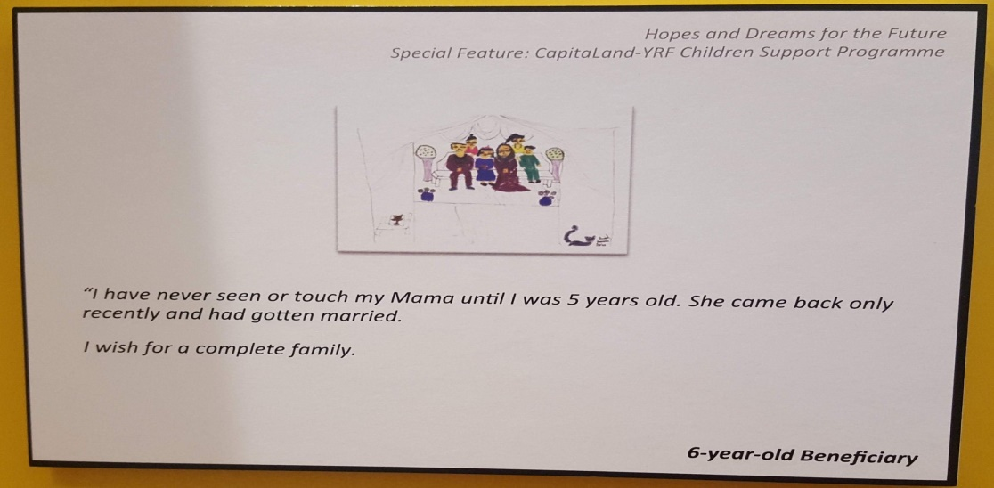

Case study and image courtesy of New Life Stories

- Recommendations:
  - To develop a holistic child-centric rehabilitation framework that safeguards and promotes the mental, emotional and developmental needs of inmates’ children through consistent opportunities for physical and emotional bonding with their incarcerated parents.
  - To allow bi-monthly open visits for children under 12 years old, especially in the women’s prison. This is to ensure that the child is not deprived of consistent communication with his/her mother.
Article 18: Parents’ common responsibilities, assistance to parents and the provision of child care services
Access to child care subsidies by low income families
- Access to quality and affordable child care services should be a right of all children as they provide important opportunities for the early developmental needs and ensure that all children have a strong start in life.
- In its recent Committee of Supply (COS) debates, the Ministry of Social and Family Development (MSF) presented policies that are targeted to provide better support for parents of pre-schoolers and the early childhood sector, especially for non-working mothers.
- MENDAKI notes that non-working mothers now can tap on six months of Basic Subsidy (S$300 per month) (US$221) for preschool fees while looking for a job. This is an increase from the previous where the Basic Subsidy was only extended up to three months. Non-working mothers seeking employment are also eligible for six months of means-tested Additional Subsidy of S$100 (US$73) to S$440 (US$325) per month. These subsidies are also eligible for non-working mothers who require child care services for their older children while caring full-time for their young child aged 24 months and below, until the young child turns 24 months.
- While these policies provide enhanced support to non-working mothers, especially those from economically disadvantageous backgrounds, preschool subsidies are still tied to the employment status of mothers. The employment-linked policy was meant to encourage more women to remain or return to the workforce after they have children but they tend to favour families where mothers have such an option.
- Caregiving responsibilities and challenges in redistributing the responsibilities due to lack of consistent and dependable family support are real barriers faced by low income mothers in being able to consider full-time paid work. Many are main caregivers to young children of varying ages or to elderly or sickly dependents. As a result they either forgo full-time employment or engage in casual labour or part-time work which renders them ineligible for preschool subsidies for their children.
- Mothers who engage in casual labour earn low wages and also likely not to be protected by employment legislations and lack benefits such as paid leave and protection from termination. According to the Department of Statistics (DOS), the percentage of Malay women in formal employment is lower than the national average. Through our focus group discussions and interactions with Malay/Muslim families, it is also noted that many of the women are involved in ad-hoc small home business to supplement the family income. Such work methods are not acknowledged as ‘formal employment’ and does not qualify them for subsidised caregiving help for their children.
- The employment-linked policy also puts low income mothers in uncertainty as they risk the possibility that the temporary subsidies are stopped after 6 months if they are unable to secure full-time employment and/or if they lose their jobs. Facing the risk that they might have to remove the children from preschool subsequently when the subsidies stop, mothers make the simpler choice to not enrol their children in the first place. Such decisions results in their children lagging behind other children who have the advantage of an optimised early learning before they enter primary school.

Challenges faced by low income families in accessing child care services
“Wary about the cost… if only deposit does not exist.”
S, 36 years old, research study interviewee
“Child care is expensive and most of us are housewives so we do not receive additional subsidy.”
K, 32 years old, research study interviewee

- Additionally, applying for financial assistance could be administratively distressing for low income families. They are often required to complete a fair amount of paperwork before their application is processed. There is also the barrier of start-up costs and upfront deposits which even after subsidies still require cash top-ups. The Child Development Account (CDA) for every citizen child helps in boosting parents’ savings with co-matching from the State and can be used to pay for child care. However, the CDA tends to benefit more for parents who have the ability to save. Low income families have difficulties in saving up and therefore unable to unlock the full potential of the State support that can go up to S$18,000 (US$13,307) for 5th child or higher birth orders.
Administrative cost in accessing child care subsidies
“Because financial require a lot of paperwork…the paperwork for parents’ to apply for financial help in child care is a lot.”
M, 33 years old, research study interviewee

- Recommendations:
  - To remove employment condition of mothers for eligibility for child care subsidies. All children should have access to quality preschool education and not be limited to whether their mothers are working or otherwise. Subsidies for child care should be to support children’s early learning in the foundation years instead of economic-driven. Numerous research has shown the importance of maximising the learning in the 0-6 years, especially for children from low income backgrounds.
  - To remove 1:1 matching criteria or provide 1: multiple (e.g. 1:5) matching to parents’ savings in Child Development Account (CDA) for children in low income families. This will allow low income families to unlock the State support fully and faster to defray costs of preschool education and health care for their children.
  - Disability, basic health and welfare
Article 24: Right to health and health services, in particular primary health care
Participation and access to consistent pre- and post-natal care, and regular health and children’s developmental screenings for low income mothers
- Singapore continues to have low child mortality rate and this is a reflection of the State’s commitment to provide quality health care for its citizens.
- The health of children is greatly emphasised as the State systematically encourages preventive health measures such as immunisations, annual health screenings, basic dental services and health promotion activities for school children. Since 1982, every child born in Singapore has the Health Booklet, containing records of the child’s health info, from immunisation records to developmental milestones. Parents can also easily store and access their children’s records through the Health Promotion Board (HPB) HealthHub mobile application under the Children’s Health section.
- Apart from good postnatal care, studies have also shown that prenatal care and prevailing health conditions of mothers are equally important and affect the growth and development of infants and young children. Findings from the “Growing Up in Singapore Towards Healthy Outcomes (GUSTO) longitudinal research study highlight that, amongst other factors, gestational diabetes has acute and long-term consequences for mother and child and prenatal anxiety is linked to risks of mood disorders in babies.
- It is thus important to ensure that expectant mothers undergo routine health check-ups and screenings to monitor their health and well-being, and ultimately the health and development of their infants. Similarly mothers of newborn babies and young children should also be encouraged to bring their infants and children for regular health and developmental check-ups.
- However the reality is, not all pregnant women and mothers of young children are aware of these important medical screenings. This is especially so for mothers from low income households where due to limited resources for transport, inability to get leave from work and lack of awareness, they do not have the privilege of easy access to relevant medical and health care.
- A qualitative study of 25 Malay/Muslim low income households conducted by MENDAKI highlighted that one of the top priorities of families from low income households is to ensure that the daily bread-and-butter needs of their family members are met. The study also revealed that many households in the research sample could not afford proper nutrition and the cost of daily living puts them under financial strain.
Living on a tight budget
“I must ensure that they (family members) have enough to eat.
P, father of four children, research study participant
“From the past until now, my practice has always been (…) to buy a sack of rice immediately upon receiving my pay.”
H, sole breadwinner, research study participant
“I think the amount of money spent on food is the highest (expenditure). If we do not have enough money, we will just eat rice and egg. We live on a budget.”
J, mother of three children, research study participant

- With daily challenges taxing their bandwidth, low income families are less likely to prioritise the preventive health care and well-being of expectant mothers and their young children. Even if they are aware of the importance, low income mothers may be unsure on how to navigate the help available.

- Recommendations:
  - To strengthen last mile service delivery and bridge mothers from low income backgrounds to regular pre and post-natal care services, and regular health screenings for their young children. Successful pilot programmes such as the Kids Integrated Development Service 0-3 (Kids 0-3) by the KK Women’s and Children’s Hospital (KKH) and funded by Temasek Foundation Cares should be made a state supported national programme and scaled up to provide community health and social care support system for more children from disadvantaged families. Health campaigns encouraging citizens to go for regular health screenings and follow ups, such as “Screen for Life”, can also be replicated to target mothers and their young children.
  - To enhance the MediSave Maternity Package and introduce more financial assistance schemes to expectant mothers and mothers from low income backgrounds to allay financial worries and facilitate access to pre and post-natal medical costs.
- Education, leisure and cultural activities
Article 28: Right to education
Reducing achievement gaps of minority students by levelling the playing field in early years
- Singapore invests heavily in education for the holistic development of children. Meritocracy is the country’s main principle of governance where all students are allowed the opportunity to succeed based on the same tests, and the most talented are selected based on non-discriminatory criteria.
- While Malay students have made significant progress in the last three decades (reference to Paragraph 5), data show persistent performance gaps by Malay students in national examinations. This performance gap is related to the structural and psychological barriers that Malay students faced by virtue of their families being in the lower income range, and thus limiting their access to additional learning resources.
- As mentioned in earlier paragraphs, without quality preschool education children from low income families already have a disadvantage as they lag behind others at the start of their primary school years. Primary schools currently offer Learning Support Programmes (LSP) for English and Mathematics for all children, regardless of family income, who are assessed to lack a strong foundation academically. However, LSP is offered for up to Primary 2 only and should students continue to be underperforming after Primary 2, teachers exercise discretion to engage these students and use a different pedagogy to help them learn. Given the discretionary nature, there is likely to be unevenness in assistance given to underperforming students across schools.
- Academic competition is intense in Singapore and children from financially advantageous backgrounds are able to access “external” educational-related materials and learning experiences such as tuition and enrichment classes. There are stark differences in the monthly household expenditure on tuition and other educational courses by households - households in the 1st to 10th percentiles spent a total of S$25.10 (US$18.55) while those in the 90th to 100th percentiles spent seven times as much. The enrichment industry with programmes like speech and drama, public speaking and coding widens the knowledge gap between children of high and low income families.
- Exposure to enrichment programmes gives children the confidence to build social and cultural capital that will have long term benefits for them. MENDAKI’s conversations with children aged 13 to 18 years old revealed that they view themselves as “global citizens” and aspire to have overseas opportunities, be it for work or study. This desire for global exposure requires children to have access to the right networks from young as these networks open up more opportunities as they get older. The reality is that due to lack of resources and exposure, children from low income families have very small social capital.
Desire for global exposure
“I would like to work at an overseas design and architecture company.”
A, 17 year old, Institute of Technical Education (ITE) student
“Working overseas… is a good career exposure.”
D, 15 year old, Secondary School student

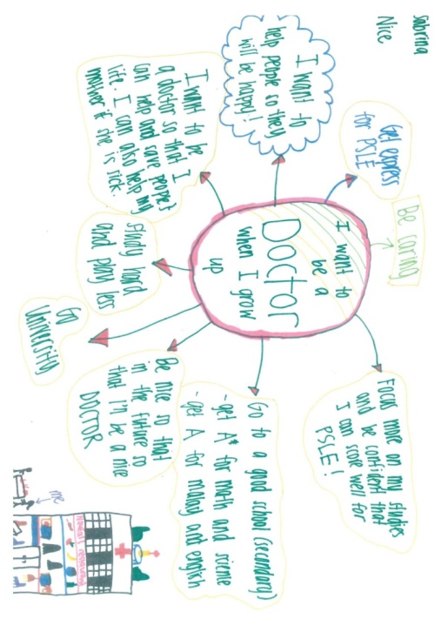

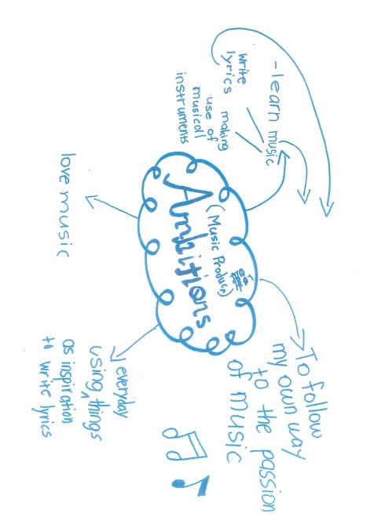
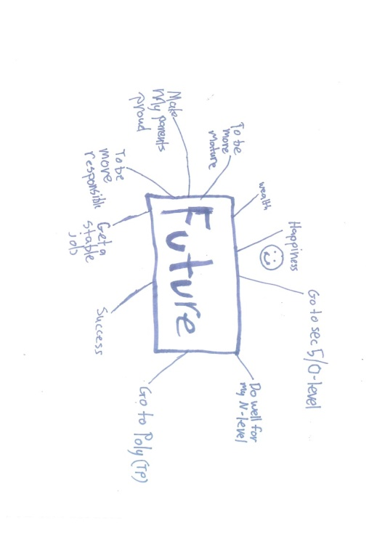

- Recommendations:
  - To ensure access to preschool education for low income children in order to level the playing field before entry into primary education (reference to paragraph 23). The early formative years are imperative for children’s development as the brain is most receptive to learning.
  - To have affirmative action in schools to bridge existing gaps by underperforming children in primary school. Affirmative action is important so that assistance given is equitable to the students that need the most help to level up, instead of an equal dosage of help given to all students. Structured programmes like Learning Support Programme (LSP) and Learning Support for Mathematics (LSM) should be intensified and extended beyond 2 years for children who need it. Providing the extra assistance to underperforming students beyond Primary 2 should be systematic and not left to the discretion of individual teachers to identify and provide.
  - To extend the use of low income children’s CDA savings to enrichment programmes. CDA savings, which can be used until the child is 12 years old, should be allowed to pay for enrichment programmes that would facilitate in widening the children’s exposure to varying knowledge and learning experiences.
  - To review the structure and flexibility of the Edusave and Post-Secondary Education Account schemes to allow funds to be used for internships both locally and overseas for children in post-secondary institutions.
Article 29: Aims of education
Strengthening support in promoting the mental health and well-being of children in schools
- The promotion of children’s mental health and well-being is important as it ensures that children are able to develop and flourish well and in a safe environment. Findings from the Organisation for Economic Cooperation and Development (OECD) study revealed that the connection between well-being and achievement in the Programme for International Student Assessment (Pisa) tests suggested that 76% of Singaporean students polled reported feeling very anxious for a test even if they were well-prepared compared with the OECD average of 55%. Study also showed that four in 10 Singaporean children are sleep deprived.
- MENDAKI conducted a survey with students enrolled in its flagship programme, the MENDAKI Tuition Scheme (MTS) to gather insights into their learning environment and experiences. While students surveyed generally reported that they received adequate parental support at home, experienced positive student-tutor relations and that they enjoyed hanging out with their peers in MTS, it is noteworthy to highlight that students also reported low levels of intrinsic motivation and self-efficacy.
- Upon further analysis, data suggested that the level of intrinsic motivation was the lowest amongst Primary 5 and 6 students (children ages 11 and 12 years old) while level of self-efficacy was the lowest amongst similar group of children as well as Secondary 1 students (children ages 13 years old). The findings also suggested that there were gender differences in students’ level of self-efficacy as female students, in particular those aged 13 to 16 years old, reported lower levels of self-efficacy.
- Children should be empowered to talk about their thoughts and feelings and also be accorded the safe space for them to seek help and advice regarding their mental health and well-being without prejudice and stigma.
Recommendations:
  - To strengthen focus on mental health and well-being in the health education curriculum in schools.
  - To enhance parents-school partnership in identifying, reaching out and helping children who display mental health concerns.
Conclusion
- MENDAKI is of the view that in general the state of children in Singapore is good and the fundamental structures to safeguard children’s best interests are sound. However, as modern and affluent Singapore matures in her 54th year since independence, it is important to look beyond the general and into specific groups of children that would require more support and attention to ensure their well-being. The more Singapore society progresses, the higher likelihood that social inequality gaps will be wider and the more obvious that specific groups of children, in particular those from lower income families, would find it harder to achieve real social mobility.
- MENDAKI’s recommendations advocate for the State to review the relevance on which certain policies were formulated, to build in flexibility in administering policies for certain groups and to strengthen the last mile delivery. MENDAKI remains committed to work collaboratively with the State, MMOs and other community agencies in advocating and protecting the rights of children in Singapore.
Annex A
List of Recommendations
- General principles
Article 6: Right to life, survival and development
  - To review the application process and eligibility criteria for citizenship, and provide concession to stateless children from low income backgrounds as their parents are not be able to satisfy the financial dependency criterion.
  - To extend access to subsided primary and secondary education in national schools and subsidised primary health care to stateless children from low income families. These children should not be denied their basic rights and they have the right to live, survive and develop healthily.
- Family environment and alternative care
Article 9: Separation from parents
- To develop a holistic child-centric rehabilitation framework that safeguards and promotes the mental, emotional and developmental needs of inmates’ children through consistent opportunities for physical and emotional bonding with their incarcerated parents.
- To allow bi-monthly open visits for children under 12 years old, especially in the women’s prison. This is to ensure that the child is not deprived of consistent communication with his/her mother.
Article 18: Parents’ common responsibilities, assistance to parents and the provision of child care services
- To remove employment condition of mothers for eligibility for child care subsidies. All children should have access to quality preschool education and not be subject to whether their mothers are working or otherwise. Subsidies for child care should be to support children’s early learning in the foundation years instead of economic-driven. Numerous research has shown the importance of maximising the learning in the 0-6 years, especially for children from low income backgrounds.
- To remove 1:1 matching criteria or provide 1: multiple (e.g. 1:15) matching to parents’ savings in Child Development Account (CDA) for children in low income families. This will allow low income families to unlock the State support fully and faster to defray costs of preschool education and health care for their children.
- Disability, basic health and welfare
Article 24: Right to health and health services, in particular primary health care
- To strengthen last mile service delivery and bridge mothers from low income backgrounds to regular pre and post-natal care services, and regular health screenings for their young children. Successful pilot programmes such as the Kids Integrated Development Service 0-3 (Kids 0-3) by the KK Women’s and Children’s Hospital (KKH) and funded by Temasek Foundation Cares should be made a state supported national programme and scaled up to provide community health and social care support system for more children from economically disadvantaged families. Health campaigns encouraging citizens to go for regular health screenings and follow ups, such as “Screen for Life”, can also be replicated to target mothers and their young children.
- To enhance the MediSave Maternity Package and introduce more financial assistance schemes to expectant mothers and mothers from low income backgrounds to allay financial worries and facilitate access to pre- and post-natal medical expenses.
- Education, leisure and cultural activities
Article 28: Right to education
- To ensure access to preschool education for low income children in order to level the playing field before entry into primary education (reference to paragraph 23). The early formative years are imperative for children’s development as the brain is most receptive to learning.
- To have affirmative action in schools to bridge existing gaps by underperforming children in primary school. Affirmative action is important so that assistance given is equitable to the students that need the most help to level up, instead of an equal dosage of help given to all students. Structured programmes like Learning Support Programme (LSP) and Learning Support for Mathematics (LSM) should be intensified and extended beyond 2 years for children who need it. Providing the extra assistance to underperforming students beyond Primary 2 should be systematic and not left to the discretion of individual teachers to identify and provide.
- To extend the use of low income children’s CDA savings to enrichment programmes. CDA savings, which can be used until the child is 12 years old, should be allowed to be used to pay for enrichment programmes that would facilitate in widening the children’s exposure to varying knowledge and learning experiences.
- To review the structure and flexibility of the Edusave and Post-Secondary Education Account schemes to allow funds to be used for enrichment programmes and relevant courses, and internships both locally and overseas for children in post-secondary institutions.
Article 29: Aims of education
- To strengthen focus on mental health and well-being in the health education curriculum in schools.
- To enhance parents-school partnership in identifying, reaching out and helping children who display mental health concerns.
Annex B
Participants of Focus Group Discussions
- Jamiyah Singapore
Jamiyah Singapore, also known as Muslim Missionary Society Singapore, was founded in 1932. Its vision and mission is to serve the community and to provide welfare services to the less privileged and disadvantaged of all races and faiths. Jamiyah provides various community services such as the running of welfare homes and education centres, and the rendering of welfare services.
- PERTAPIS
PERTAPIS was registered under the Societies Act in 1970. The principal activity of PERTAPIS is the running of welfare projects which are designed to address some of the social problems faced by the community. These projects include the running of welfare homes, providing social support for the needy families and educational services.
- Persatuan Pemudi Islam Singapura (PPIS)
Founded in 1952, Persatuan Pemudi Islam Singapura (PPIS) or the Singapore Muslim Women’s Association is a non-profit organisation focused on community services. PPIS is dedicated to working with women of all ages in carrying out their multiple roles in society. PPIS runs three core community services namely Family Services, Student Care and Early Childhood Education (ECE).
- New Life Stories
New Life Stories is a non-profit that supports children of incarcerated mothers through the provision of essential educational skills namely reading and pro-social skills. Its holistic approach extends to the children’s incarcerated mothers too. This ensures each child receives vital educational assistance while their mother is supported during her frequently stressful reintegration into society.

Conversion rates were calculated on 15 April 2019 using www.xe.com
Representatives from Jamiyah Singapore, Persatuan Pemudi Islam Singapura (PPIS), PERTAPIS and New Life Stories provided their perspectives. Please refer to Annex B for more information on the respective organisation.
This benchmark is similar to the eligibility criteria for the Financial Assistance Scheme (FAS) by the Ministry of Education.
Ministry of Home Affairs, (2019). Written Reply to Parliamentary Question on Stateless Residents Living in Singapore as of January 2019, by Mr K Shanmugam, Minister for Home Affairs and Minister for Law. Accessed via https://www.mha.gov.sg/newsroom/in-parliament/written-replies-to-parliamentary-questions/news/written-reply-to-parliamentary-question-on-stateless-residents-living-in-singapore-as-of-january-2019-by-mr-k-shanmugam-minister-for-home-affairs-and-minister-for-law.
Ministry of Education (2019). General Information on Studying in Singapore: monthly school and miscellaneous fees. Accessed via https://www.moe.gov.sg/admissions/international-students/general-info
SingHealth (2019). Charges and Payment. Accessed via https://polyclinic.singhealth.com.sg/patient-care/charges-payment
Poor state of stateless children, The Straits Times, 25 May 2014, https://www.straitstimes.com/singapore/poor-state-of-stateless-children
Confused and dejected, stateless persons plead to be called Singaporeans, TODAY Online, 26 September 2016, https://www.todayonline.com/singapore/confused-and-dejected-stateless-persons-plead-be-called-singaporeans
Singapore Prison Service. (2018). Rehabilitation Process. Accessed via https://www.sps.gov.sg/connect-us/rehabilitation-process
CRC/C/SGP/2-3/para.205.
CRC/C/51/Add.8/para.229
Care Network Workplan Seminar 2018 – Speech by Mr Amrin Amin, Senior Parliamentary Secretary, Ministry of Home Affairs and Ministry of Health, accessed via https://www.mha.gov.sg/newsroom/speeches/news/care-network-workplan-seminar-2018-speech-by-mr-amrin-amin-senior-parliamentary-secretary-ministry-of-home-affairs-and-ministry-of-health
New Life Stories is a non-profit organisation that supports children of incarcerated mothers.
Ministry of Social and Family Development. (2019). Better support for parents of pre-schoolers and the early childhood sector. Accessed via https://www.msf.gov.sg/media-room/Pages/Better-Support-for-Parents-of-Preschoolers-and-the-Early-Childhood-Sector.aspx
The means-tested Additional Subsidy is only for households with monthly household income of S$7,500 (US$5,544) and below, or per capita income of S$1,875 (US$1,386) and below.
AWARE. (2018). “Why are you not working?”: Low income mothers explain challenges with work and care.
Non-working mothers are eligible to only S$150 (US$110) of Basic Subsidy.
Child Development Account (CDA) is part of the baby bonus scheme designed to help parents with the cost of raising children. All Singaporean children born from 24 March 2016 onwards will receive an initial S$3,000 in their CDA. The government will do a dollar-to-dollar matching whenever parents top up their child’s CDA.
In 2016, the neonatal mortality rate was 1.4 per 1,000 resident live-births, and 3.0 per 1,000 live-births and still-births for perinatal mortality rate. Infant mortality rate was 2.4 per 1,000 resident live-births (as reported in CRC/C/SGP/4-5).
Health Promotion Board (HPB). (2019). Going Digital: Keeping Track of Your Children’s Health is as Easy as ABC. Accessed via https://www.healthhub.sg/live-healthy/1962/Digital-healthcare-technology-parents-children
GUSTO is a Singapore’s largest and most comprehensive birth cohort study. Through collaborations between the Agency for Science, Technology and Research (A*STAR), the National University Health System (NUHS) and Kandang Kerbau Hospital (KKH) Singapore, the study aims to investiagate if mothers' diet and lifestyle during pregnancy affect their babies' growth after birth. More information can be accessed via http://www.gusto.sg/
One in 5 mums-to-be may develop diabetes, The Straits Times, accessed via http://www.gusto.sg/one-in-5-mums-to-be-may-develop-diabetes/
Stressed mums may have ‘moody’ babies, The Straits Times, accessed via http://www.gusto.sg/stressed-mums/
Yayasan MENDAKI. (2015). Living on a tight budget: a qualitative study of 25 Malay/Muslim low income households. Singapore: Yayasan MENDAKI.
Nearly 300 vulnerable kids get early leg-up, The Straits Times, 5 June 2018, accessed via https://www.straitstimes.com/singapore/nearly-300-vulnerable-kids-get-early-leg-up
Under the MediSave Maternity Package, expectant mothers may withdraw up to S$900 for pre-delivery medical expenses, an additional surgical withdrawal limit between S$750 and S$2,150 depending on the type of delivery procedure and up to S$450 for each day in the hospital. More information is available on https://www.moh.gov.sg/cost-financing/healthcare-schemes-subsidies/marriage-and-parenthood-schemes
Lee Kuan Yew School of Public Policy (LKYSPP). (2018). Meritocracy in Singapore: Solution or Problem? Accessed via https://lkyspp.nus.edu.sg/gia/article/meritocracy-in-singapore-solution-or-problem
Ministry of Education. (2016). 10-Year Trend of Educational Performance 2006 – 2015. Accessed via https://www.moe.gov.sg/news/press-releases/10-year-trend-of-educational-performance-2006--2015#footnote-1
Zhang Jiayi. (2014). “Debunking the Myth of the Lazy Malays” in MENDAKI Occasional Paper Series: Education, Issue 1, Singapore: Yayasan MENDAKI
Singapore Department of Statistics (2013) as quoted in Teo (2018). This is what inequality looks like: Essays by Teo You Yenn. Singapore: Ethos Books
Report of the Yayasan MENDAKI Future-Ready Conversation Series (2017).
Singapore students suffer from high levels of anxiety: Study. The Straits Times (2017), accessed via https://www.straitstimes.com/singapore/education/spore-students-suffer-from-high-levels-of-anxiety-study
Four in 10 Singaporean children aged 6 to 9 are sleep deprived. TODAYOnline (2015), accessed via https://www.todayonline.com/singapore/lower-primary-school-children-not-getting-enough-sleep
The MENDAKI Tuition Scheme (MTS) is a highly subsidised programme that provides academic and non-academic support to Malay/Muslim students in Singapore. The programme is open to Primary 1 to Secondary 5 students (children ages 7 to 17). 70% of students enrolled in MTS are from low income backgrounds.
Pang, S., Liu, J., Mahesh, M., Chua, B. Y., Shahwan, S., Lee, S. P., Subramaniam, M. (2017). Stigma among Singaporean youth: a cross-sectional study on adolescent attitudes towards serious mental illness and social tolerance in a multiethnic population. BMJ open, 7(10), e016432. doi:10.1136/bmjopen-2017-016432

