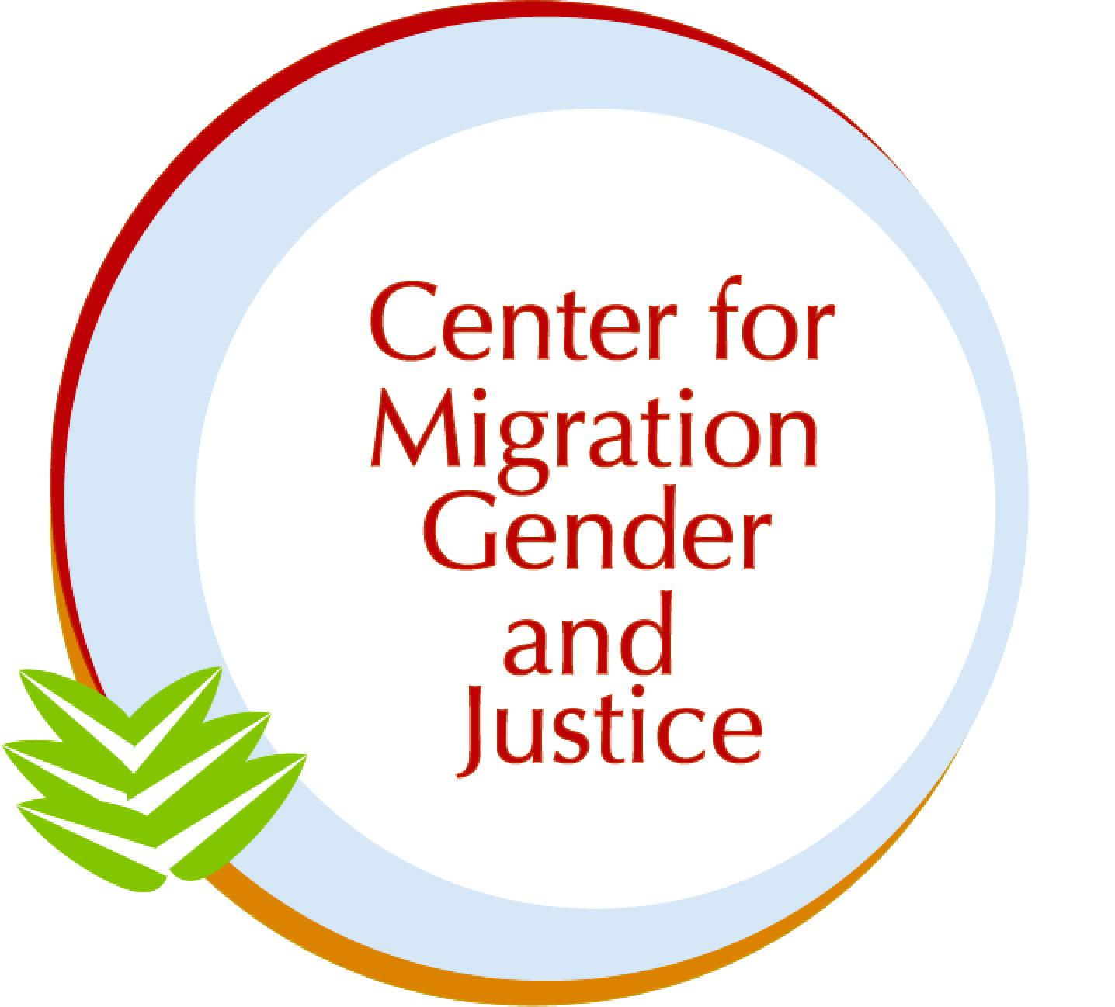

Submission to the Committee on the Elimination of Discrimination against Women (CEDAW)

SHADOW REPORT: Democratic Republic of the Congo

January 6, 2024

Authors: Chaimae Haddoumi, Stacy Ogembo, Dr. Lara-Zuzan Golesorkhi

The Center for Migration, Gender and Justice (CMGJ) is a migrant- and women-led non-profit NGO that addresses human rights at the intersection of migration and gender through research, advocacy, and education. Within our areas of expertise, this shadow report speaks to the Democratic Republic of the Congo’s (DRC) implementation of CEDAW in light of the Committee’s 90th session (February 3 - February 21, 2025). Throughout the report, the names of any alleged victims, witnesses, and perpetrators have been anonymized, and no photographs of alleged victims, witnesses, or perpetrators have been included.

In this CEDAW Report, we employ a working definition of migrant as a person who moves away from their place of usual residence, whether within a country or across an international border, temporarily or permanently, and for a variety of reasons (voluntary and/or forced). The term includes a number of legal statuses of persons, such as refugees, stateless, and undocumented. We identify the specific legal statuses when necessary and/or to amplify particular experiences.
Migration and Gender in the Democratic Republic of the Congo Report under the exceptional reporting procedure:

The Democratic Republic of the Congo (DRC) is party to various international and regional legal-institutional frameworks that are relevant to considerations of the rights of women, girl, LGBTQIA+, and gender diverse migrants. The DRC has ratified the 1951 Convention Relating to the Status of Refugees (Refugee Convention) and its 1967 Protocol, the 1969 Organization of African Unity Convention Governing the Specific Aspects of Refugee Problems in Africa, and the African Union Convention for the Protection and Assistance of Internally Displaced Persons in Africa (Kampala Convention).

Furthermore, the DRC has affirmed its commitments to the Global Compact on Refugees (GCR) and is part of regional initiatives such as the 2024-2025 DRC Regional Refugee Response Plan (RRP) (UNHCR, 2024). The DRC has also expressed support for the Global Compact for Safe, Orderly, and Regular Migration (GCM) through participation in the Southern Africa Development Community GCM regional review. During this review, the Congolese government emphasized the importance of establishing a national migration policy and creating an inter-ministerial committee on migration (IOM, 2023).

While we acknowledge the DRC’s promising progress in certain aspects of migration as outlined above, there remain prevailing concerns regarding the needs and challenges of women, girl, LGBTQIA+, and gender diverse migrants in the country. These concerns involve policy areas of gender-based violence (GBV), health, and livelihood provisions. Based on an analysis using our Gender-Migration Index (GMI), a guidance tool for gender-responsiveness and migration-inclusion in policy, we find that while CEDAW/C/COD/QPR/EP/1 outlines notable efforts in addressing GBV in displacement camps, other connected and distinct areas of migrants’ lived experiences are overlooked.

The 9-page-long report refers to aspects of migration a total of twelve times, namely internally displaced persons (IDPs) ten times as well as refugees and civilians fleeing conflict once, respectively. These mentions are mainly in relation to sexual violence in the context of displacement camps and measures taken to combat insecurity in the DRC. For instance, the report highlights the establishment of mobile clinics and the creation of community policing to provide protection against GBV in displacement camps.

Yet, the report does not fully consider risks of GBV outside of camps as well as during varied displacement phases. This is of particular urgency as the majority (72%) of those displaced in the country live outside of camps or settlements (UNHCR, n.d.a). Furthermore, risks of GBV are connected to health impacts and limited livelihood provisions. In terms of health, unwanted pregnancies, the spread of sexually transmitted diseases such as HIV, impotence, social isolation and suicidal thoughts, as well as complications from unsafe abortions have been identified (ReliefWeb, 2024). Relatedly, limited livelihood provisions have forced women and girls to resort to other coping mechanisms, including survival sex (transactional sex), early and forced marriages, and sexual exploitation, often earning as little as $1 a day through these means (Ibid).

These concerns around GBV outside of camps, health, and livelihood provisions are not explicitly addressed in CEDAW/C/COD/QPR/EP/1 and deserve further attention.

Based on the information provided, we recommend that the Committee ask the government of the DRC the following questions and that these enquires are included in the Concluding Observations:

- Considering that the DRC currently lacks a national migration strategy, what steps are being taken to ensure gender-responsiveness in the planning, implementation, monitoring, and evaluation of the anticipated strategy?
- What measures are being taken to consult women, girl, LGBTQIA+, and gender diverse migrants in the creation of the inter-ministerial committee on migration in efforts to close the gap between migrant communities and governing bodies?
- As part of the DRC’s commitment to the GCR, the ongoing project “Forced displacement in the Democratic Republic of Congo,” implemented by UNDP and UNHCR, aims to build capacities of authorities and strengthen local governance. What progress has been made in terms of the project and in what ways, if at all, has it addressed areas of gender-specific concerns such as GBV, health, and livelihood provisions (UNHCR, n.d.b)?

Gender-Based Violence:
In relation to GBV, our analysis of CEDAW/C/COD/QPR/EP/1 reveals that varied forms of GBV (i.e. sexual violence, violence against women) are frequently mentioned throughout the state party report, highlighting the urgency of addressing GBV. However, the references primarily focus on camp settings, which limits the scope of GBV prevention, mitigation, and response across the displacement continuum.
The state party report details several initiatives within camps such as the deployment of GBV coordinators and special police units. Outside of camp structures, the report outlines a roadmap for combating violence against women in the 2028 election cycle, supported by UN Women. This roadmap includes areas like legal reform, capacity-building for the judiciary, and victim support. While these efforts are important, it remains unclear what the government plans to do to prevent, mitigate, and respond to GBV faced by the 72% of displaced individuals living outside of camps.
CARE DRC found an average of 20 GBV cases daily in and around camps, with over 90% of survivors being women and girls (ReliefWeb, 2024). Nationally, the scale of sexual violence is staggering, with the UN documenting over 113,000 cases in 2023. Conflict-related sexual violence more than doubled in the first half of 2024 compared to the same period in 2023 (Physicians for Human Rights, 2024). These numbers must be contextualized against the widespread underreporting of GBV cases in displacement contexts. In Goma, North Kivu, for example, GBV accounts for approximately 30% of the risks faced by women, yet only 8% of these incidents are officially reported (Mercy Corps, 2024). This further emphasizes the disconnect between government efforts and the lived experiences of those on the ground.

Based on the information provided, we recommend that the Committee ask the government of the DRC the following questions and that these enquires are included in the Concluding Observations:

- What measures has the government taken or plans to take to extend protection mechanisms to the majority (72%) of displaced individuals living outside camps, particularly women, girl, and LGBTQIA+ migrants at risk of GBV?

- The state party report indicates that data on sexual violence is “currently being compiled” (p.8). What progress has been made in this regard and does the compiled data capture disaggregated experiences of women, girl, and LGBTQIA+ migrants, specifically distinguishing between cases occurring inside and outside displacement camps?
- In what ways does the roadmap for combating violence against women in the 2028 election cycle configure into strategies of preventing, mitigating, and responding to GBV in displacement settings? More specifically, will the mentioned legal reform, capacity-building for the judiciary, and victim support, be accessible to those of varied migration status?

Health
When it comes to health, our GMI analysis indicates that CEDAW/C/COD/QPR/EP/1 highlights several important measures such as the deployment of humanitarian midwives, the establishment of multisectoral service centers for survivors of GBV, and the training of healthcare providers to offer holistic care. These actions are of utmost importance as the DRC is facing a severe health crisis, with women disproportionately affected (CARE, 2023). The country has one of the highest maternal mortality rates globally, ranking third in maternal deaths (Phiri, George, & Iseghehi, 2024). This crisis is worsened by inadequate access to antenatal and postnatal care, a lack of skilled birth attendants, and limited availability of routine child health check-ups. According to Doctors Without Borders (2023), an average of 10 women give birth daily under unsafe conditions, putting both mothers and newborns at significant risk.
The situation in displacement settings is even more dire. Poor access to clean water, sanitation, and healthcare increases the risk of infectious disease outbreaks. Overcrowded and unsanitary conditions have led to the rapid spread of diseases like cholera, measles, mpox, and COVID-19. In the first half of 2024 alone, the WHO reported over 20,000 cholera cases and 1,523 deaths from measles, with women and children most affected (VOA News, 2024). As primary caregivers, women are particularly vulnerable to disease transmission, which only worsens their already precarious health situation.
The DRC’s efforts to address these complex health challenges are still in the early stages. Measures like Decree No. 23/09, which details the aforementioned initiatives, are positive but do not fully cover critical issues such as maternal mortality, child health, and infectious disease control. Additionally, the healthcare system remains overwhelmed and displaced populations bear the brunt of this. More so, the state party report overlooks related concerns such as food insecurity, nutrition, and more detailed health needs; issues that are particularly urgent for those displaced. Indeed, malnutrition compounds existing health challenges, with over 2.8 million children and 605,000 pregnant or breastfeeding women facing risks in this context (CARE, 2023).
Based on the information provided, we recommend that the Committee ask the government of the DRC the following questions and that these enquires are included in the Concluding Observations:

- While the DRC has deployed humanitarian midwives, how is the government ensuring that akin health services, including for maternal and child health, are accessible to displaced populations living outside of camps?
- What measures have been taken to fill the shortage of healthcare providers in the DRC, especially in conflict-affected areas and displacement settings?
- How does the government plan to address related concerns such as food insecurity, nutrition, and more detailed gendered health needs as per CEDAW Article 12?
Livelihood Provisions:
Our analysis of CEDAW/C/COD/QPR/EP/1 shows significant gaps in livelihood provisions for women, girl, LGBTQIA+, and gender diverse migrants in the DRC. Although the government has initiated efforts, namely through subsistence support in camps like Bulengo by assisting 9,500 women and the Ministry of Social Affairs and Humanitarian Action has developed an action plan to strengthen the humanitarian response, these measures alone do not fully address the systematic livelihood challenges faced by displaced populations.

In both camp and non-camp settings, a quarter of the displaced population, including women and girls, face severe economic obstacles, often leading to alternative coping mechanisms. According to the World Food Program (2024), nearly 49% of displaced women are resorting to survival sex due to a lack of income-generating opportunities.

Relatedly, sexual exploitation is prevalent not only in brothels but also in private accommodations, hotels, agricultural plantations, and when women leave camps to collect firewood or water (ReliefWeb, 2024; UNHCR, 2023). In cases involving minors, intermediaries take over 70% of the money paid by perpetrators for the sexual acts, further exacerbating exploitation (ReliefWeb, 2024). This economic vulnerability reinforces the exposure to GBV, such as sexual assault, physical violence, and psychological abuse, as household and personal needs are unmet.

Based on the information provided, we recommend that the Committee ask the government of the DRC the following questions and that these enquires are included in the Concluding Observations:

- In line with CEDAW Article 6, what programs are in place to support displaced women and girls who are most vulnerable, such as those facing sexual exploitation, to meet their basic needs?
- How does the government plan to expand livelihood provisions outside of the camps?
- What mechanisms are employed to monitor and evaluate the impact of existing socioeconomic integration assistance initiatives (i.e. Bulengo camp) in terms of self-reliance?

References:
CARE. (2023). Health sector in DRC crumbles amidst conflict, negatively impacting survivors of sexual assault. Retrieved from https://www.care.org/media-and-press/health-sector-in-drc-crumbles-amidst-conflict-negatively-impacting-survivors-of-sexual-assault/
Doctors Without Borders. (2023). Why is sexual violence on the rise in Goma’s displacement camps? Retrieved from https://www.doctorswithoutborders.org/latest/why-sexual-violence-rise-gomas-displacement-camps
International Organization for Migration (IOM). (2023). Migration Governance Indicators Profile 2023 – Democratic Republic of the Congo. Geneva: IOM. https://publications.iom.int
Mercy Corps. (2024). Rapid Gender Analysis: Kanyaruchina Displacement Site, Goma, North Kivu - “A woman has to do anything to provide for her family”. Mercy Corps. Retrieved from https://reliefweb.int/report/democratic-republic-congo/rapid-gender-analysis-kanyaruchina-displacement-site-goma-north-kivu-woman-has-do-anything-provide-her-family-march-2024
Phiri, S. S., George, N. S., & Iseghehi, L. (2024). Protecting the health of the most vulnerable in the overlooked Democratic Republic of Congo crisis. Health Science Reports, 7(8), e70011. https://doi.org/10.1002/hsr2.70011
Physicians for Human Rights. (2024, October 22). Massive influx of cases of sexual violence in DRC. Retrieved from https://phr.org/our-work/resources/massive-influx-of-cases-sexual-violence-drc/
ReliefWeb. (2024). UN review of DR Congo exposes lack of progress on rights. Retrieved from https://reliefweb.int/report/democratic-republic-congo/un-review-dr-congo-exposes-lack-progress-rights
ReliefWeb. (2024). Key Findings of a Study on Sexual Exploitation of Women and Girls in Brothels in Nord Kivu. Retrieved from https://reliefweb.int/report/democratic-republic-congo/keys-findings-study-sexual-exploitation-women-girls-brothels-nord-kivu
UNHCR. (2024). 2024-2025 Democratic Republic of the Congo Regional Refugee Response Plan.https://reliefweb.int/attachments/4a90efb9-7955-449a-a93d-ab824dbcfbc8/2024-2025%20DRC%20Regional%20RRP%20Final.pdf
UNHCR. (2023). UNHCR warns of mounting violence against women and girls in eastern DRC. Retrieved from https://www.unhcr.org/news/briefing-notes/unhcr-warns-mounting-violence-against-women-and-girls-eastern-drc
UNHCR. (n.d.a). Democratic Republic of Congo. Retrieved from https://reporting.unhcr.org/operational/operations/democratic-republic-congo#:~:text=The%20Democratic%20Republic%20of%20the,3%25%20live%20in%20urban%20areas
UNHCR. (n.d.b). Forced displacement in the Democratic Republic of Congo. Retrieved from https://globalcompactrefugees.org/good-practices/forced-displacement-democratic-republic-congo#:~:text=The%20joint%20programming%20contributes%20to,(national%2C%20provincial%20and%20local)
VOA News. (2024). DR Congo faces catastrophic health, humanitarian crisis. Retrieved from https://www.voanews.com/a/dr-congo-faces-catastrophic-health-humanitarian-crisis/7696676.html
World Food Programme (WFP). (2024). Women, girls, and the protection crisis in eastern DRC. Retrieved from https://reliefweb.int/report/democratic-republic-congo/women-girls-and-protection-crisis-eastern-drc

