CONTRIBUTION TO THE COMMITTEE ON THE ELIMINATION OF RACIAL DISCRIMINATION (CERD)

ADOPTION OF THE LIST OF ISSUES PRIOR TO REPORTING

INDIA

MINORITY RIGHTS GROUP INTERNATIONAL

104th Session of the Committee on the Elimination of Racial Discrimination (CERD) 11-29 August 2021

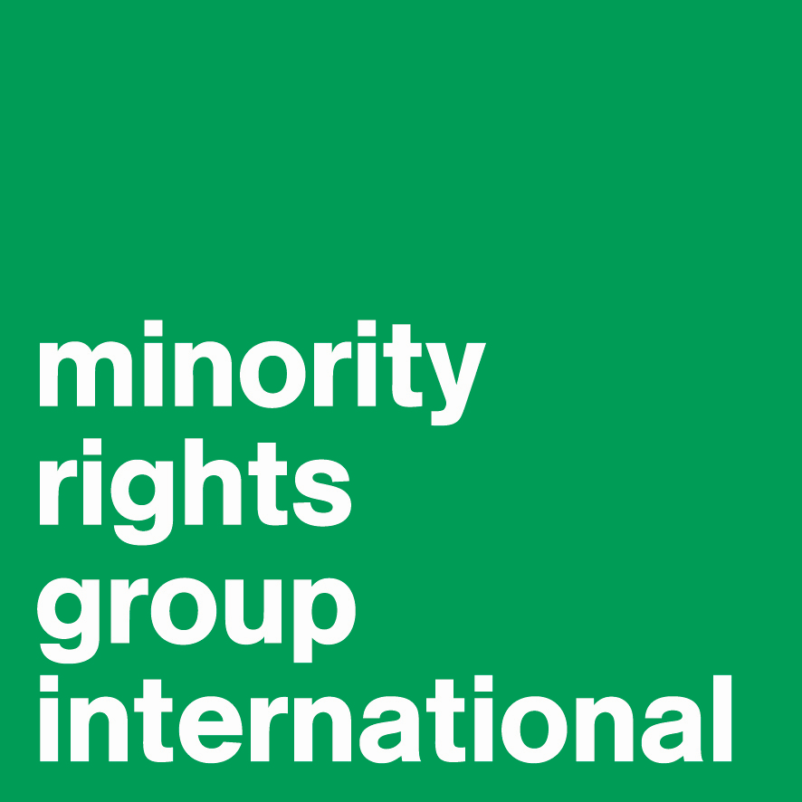

54 Commercial Street,
London E1 6LT
United Kingdom
Tel: +44 (0)20 7422 4200
Web: www.minorityrights.org

Contact: Glenn Payot, Representative to the UN, glenn.payot@minorityrights.org
- Context
Since the previous CERD review of India in 2007, the human rights situation has deteriorated sharply for the many individuals and communities who are perceived as falling outside of the majority identity. With identity becoming a central plank in political strategies, the assertion of a strong majoritarian identity based on a single religion and belief system has effectively racialized and marginalized all who fall outside its remit. One of the areas of most concern as far as ICERD it concerned, has been in the dismantling of human rights protections made at a time of independence to a variety of ethnic, linguistic, racial and religious groups to protect their rights equally in the newly independent State.

- Scope of racial discrimination (article 1)
Discrimination based on descent is affecting a wide variety of groups and communities in the Indian context. Affected groups include Dalits (referred to as “Scheduled Castes” in India), Adivasis (collective name used to designate the indigenous peoples of India, referred to as “Schedule tribes”), persons of African descent (including Afro-descendent tribes known as Siddis and African migrants), as well as large groups that are increasingly perceived as alien to a monolithic vision of the Indian identity as being essentially Hindu. This last category includes people of actual or perceived Muslim descent, forming large portions of the Indian population, who are effectively racialised and subjected to racial discrimination in the meaning of Article 1 of the Convention.
The increasing assertion of a new majoritarianism within the country has effectively racialized any group that does not fit within the ambit of a narrow gauge of identity. Persons of actual or perceived Muslim descent therefore came to be perceived as a separate ethno-religious group that has become the sharp target of mob violence and police brutality, that state institutions are largely failing to prevent and punish while clamping down heavily on journalists who report such atrocities.
We request CERD to question the Government of India about the impact of its assertion of supremacist ideas, notably on racializing other communities.

- Non-citizens (Article 1(2)& 1(3))
The Constitutional changes being made since September 2020 that include the revocation of article 370 of the Constitution that effectively removes the special status of Jammu-and-Kashmir and associated privileges enjoyed by its inhabitants in terms of access to property and to employment, is part of a wider trend of the elimination of special measures as envisaged in art. 1(4) and 2(2).
The Committee should also be concerned that the Citizenship Amendment Act passed by the Parliament of India in 2019 may retrospectively and disproportionally impact ethno-linguistic minorities (including non-Assamese speakers in the state of Assam) and Adivasis, with the National Register of Citizens creating a mechanism that could result in the arbitrary deprivation of nationality and its accompanying rights on the basis of processes that have yet to be determined and that may violate the Convention. Much of the action that is extending the reach of the National Register of Citizens to various parts of the country will specifically target communities presented and perceived by the State to be from specific nationalities in contravention of the explicit text of Article 1(3). The attempted retrospective application of law defeats basic provisions of global rule of law standards and contravenes the text and spirit of the rights the drafters and signatories of the Convention sought to celebrate.
In addition the colour bars that exist often prevent the large number of African students who come to India to study from finding suitable accommodation, often forcing them into segregated areas where they are then victims of racial stereotyping.
We urge CERD to address the situation of non-citizens facing discriminatory practices including Rohingya seeking state protection, Tibetans who have long sheltered under Indian protection, African students who face stigmatization and harassment and communities who face an imminent risk being made non-citizens in significant number.

- Racial discrimination against North Eastern communities during the pandemic
Following the outbreak of the pandemic, communities from the North Eastern Region of India, whose facial features resemble those of the Chinese, were commonly deemed infected and seen as a threat; slurs previously used against them were increasingly used after the outbreak of Covid. The media coverage largely denied that this stigma was indeed racist stigmatization, and used a terminology that echoed and further legitimized the hate speech used against these communities. As in instances elsewhere around the world, women from such communities bore the brunt of the violence.
We urge questions towards the Government of India, with a view to active condemnation and the seeking of remedies against those who perpetrated these forms of racial superiority that result in violence against subaltern communities.

- Racial discrimination and racist violence against African migrants
Recent years have seen an increase in racist violence and discrimination against Africans living in India – constituted by a growing population constituted primarily of students, asylum seekers/refugees, and labour migrants. There remains an absence of data around the scale of Africans in India, but some estimates suggest there are up to 30,000 African students in public and private universities. High profile events have occurred in Bengaluru, Noida (a satellite city of New Delhi) but Africans in India report daily harassment shaped by racial stereotyping and violence, including specifically targeted at women.

The Government of India should be asked to systematically collect data about incidents that impact African migrants and to show the extent to which the police are effectively addressing the security of these communities.

- Situation of the Siddis
The Siddis are an Afro-descendant population that are primarily based in the states of Karnataka, Gujarat, Maharashtra, and Andhra Pradesh. There remains an absence of reliable information concerning the size and the socio-economic conditions of Siddis in India. Despite their long presence in India – having arrived from Africa as slaves or migrants between the 13th and 16th centuries – they face entrenched marginalization, perceived as ‘migrants’ by state officials and the population. This marginalization manifests in their isolated living conditions, with reportedly high levels of illiteracy, with many forced into casual labour, creating a forms of socio-economic precarity. Their treatment by the wider population reflects notions of ‘untouchability’, manifest in being served food separately when participating in social functions with others.

- Data and Positive Obligations (article 2)
The lack of disaggregated data on the basis of the grounds identified in the Convention hinders the extent to which the Government can design effective policies to ensure the reach of all the human rights contained in its Constitution. This obscures the extent to which the Committee can satisfy itself of the extent to which racial discrimination continues to be a structural ground for access to rights within the remit of Art. 2(1). Besides Dalits and Adivasis as a pan-national protected community, we also draw attention to the situation of the Siddi, the Bodo and other North Indian tribal communities, the Nagas, Jewish ethnic minorities, and tribal communities that are coming under serious threat from development based projects in the Andaman and Nicobar Islands. While this list of communities is not exhaustive, the lack of data collection in the context of the size of the country is revealing. As referenced above newer groups, including migrant workers from one ethno-linguistic community who seek work in the region where another ethno-linguistic community dominates risk becoming marginalized in a febrile identity-oriented environment that germinates hate.
We urge CERD to emphasize the positive obligation of the Government of India to discourage anything which tends to strengthen racial division as mandated by art. 2(1)(e) of the Convention

- Racial Segregation and apartheid (article 3)
In light of the context described above and the specific impact of rendering specific ethno-linguistic, religiously distinct communities stateless with potential long-term incarceration as a consequence, the Committee should also be concerned about how such measures could effectively defeat the provisions of article 3. Thus, the prospective provisions in Assam could render Bengali speakers in that state subject to a form of segregation. The medium-term prospect of such a move could also result in other states in India, who were formed on the basis of linguistic identity, to take similar actions to distinguish populations who form part of the ethno-linguistic majority from other ethno-linguistic communities, effectively resulting in segregation and creation of differential rights access.
As a strong institution against segregation and cognisant in particular of how this could fragment societies, we urge the Committee to seek guarantees that any policy or measures taken will not create structures that lead to a form of institutionalised segregation.

- Hate Speech (article 4)
India’s slide down the ranking of press freedoms has been widely noted and commented upon. With the significance attached to hate speech in the Convention it should be a matter of grave concern for the Committee to address this issue. The Government of India should be specifically probed about its failures to take action in ensuring that hate speech promoted by the media can be effectively combatted. There is also a specific case to answer about the extent to which the spreading of false news and rumours attributed to outlets linked to the Ministry of External Affairs (at international level) and to groups such as the Akhil Bharatiya Vidyarthi Parishad and the Rashtriya Swayamsevak Sangh, directly linked to the governing party at domestic level, have created an ambience for the spread of hate speech against any members of the community who are not deemed to fit its interpretation of the majority population of the State.
In light of the shrinking of civil space and the prevalence of fear among minorities through incitement to violence, we urge CERD to call on the Government of India to identify specific measures it has taken with respect to fair and transparent investigation, and enforcement actions against those guilty of hate speech against racialized minorities.

- Rewriting Indian history (article 7)
The Committee should be gravely concerned by attempts to rewrite India’s history by erasing certain communities from its educational materials. It must impress upon the Government that cultural revisionism of the kind envisages effectively contributed to the racializing of communities, creating structural schisms that could undermine peace and security and the ability of the State to uphold its own Constitution.
The Government of India must be called upon to explain why such measures should not be deemed to defeat the object and purpose of the Convention, namely the obligation to implement education, cultural, informational and teaching measures to combat racial discrimination.

