THEMATIC REPORT ON THE
ITALIAN JUVENILE JUSTICE
SYSTEM

JOINT SUBMISSION
Alternative report for the adoption of the list of issues prior to reporting (LOIPR)

JULY 2025

Table of contents

Authors 3
Introduction 4
The regression of the Juvenile Justice System in Italy 4
For the first time in history, juvenile prisons in Italy are overcrowded 5
The system is no longer capable of protecting the best interests of the child 7
Recommendations 7
Annex: Signatories 9

Authors
Antigone onlus
Founded in 1991, Antigone is an Italian organisation which deals with human rights protection in penal and penitentiary systems. It carries on a cultural work on public opinion through campaigns, education, media, publications, researches and its self-titled academic journal. An Observatory on Italian prisons, involving around 80 people, has been active since 1998, when Antigone received from the Ministry of Justice special authorizations to visit prisons with the same power that the law gives to parliamentarians. Every year Antigone’s Observatory publishes a Report on the Italian penitentiary system. Since 2008, Antigone is allowed to enter also in all Italian juvenile prison facilities, also with camera in order to bear witness to internal life within juvenile prisons through images. Through a prison Ombudsperson to which it gave birth, Antigone also collects complaints from prisons and mediates with the Administration in order to solve specific problems. Furthermore, Antigone’s lawyers and physicians operate in some Italian prisons giving suggestions and monitoring life conditions. Antigone carries on investigations about ill-treatments and is formally involved in criminal trials for torture in prison. Antigone is also the leading organisation of the European Prison Observatory, engaging 13 European countries.

Defence for Children International Italia
Defence for Children International Italia is an independent organisation, part of the Defence for Children International movement based in Geneva, Switzerland. DCI Italia was founded in 2005 by Renzo Maffei and Pippo Costella when they decided to take on a new global challenge to research and promote socio-educational perspectives and opportunities to reaffirm the protagonism of young people in youth culture through acknowledgment of their rights. Defence for Children Italia operates both autonomously and in cooperation with other associations, movements and institutions to establish a new cultural model for young people to be recognized as citizens entitled to rights and active participation in family, social, cultural and civil life. During the global meeting of the International Social Service (ISS) held in Malta in May 2018, DCI Italia also became an official member of this network, which includes over 120 countries. The movement leverages the UN CRC as a systemic, comprehensive platform that helps redefine the socio-educational approach towards children and the relationship between adults and young people.

Libera
Libera is a network of associations, social cooperatives, movements and groups, schools, unions, dioceses, parishes, and scout groups, involved in a commitment not only against mafias, corruption, crime and those who feed them, but also strongly for social justice, the search for truth, the protection of rights, transparent politics, a democratic legality based on equality, a living and shared memory, and for a citizenship that lives up to the spirit and hopes of the Constitution.
Established in 1995, over the years it has maintained its ethical and practical orientations, such as continuity, proposal and co-responsibility. Libera is present throughout Italy in 20 regional coordination groups, 83 provincial coordination groups, and 296 local groups.
Internationally, Libera acts through three regional networks: ALAS in Latin America, PLACE in Africa, and CHANCE in Europe, involving over 120 organizations in more than 35 countries.
Each year, over 4,000 young people join Libera’s summer camps on confiscated assets, and more than 5,000 schools and university faculties are engaged in educational paths on accountability and democratic legality.

Introduction
On June 23, 2025, Antigone, Defence for Children, and Libera launched a joint appeal expressing grave concern about the direction the Italian juvenile justice system is taking despite this system was once considered by countries worldwide an advanced model to be admired and from which to draw inspiration for their own practices.

This alternative report is submitted in the framework of the pre-sessional working group for the adoption of the List of Issues Prior to Reporting (LOIPR) concerning Italy. It is aimed at providing the Committee on the Rights of the Child with updated and evidence-based information on the deterioration of the juvenile justice system in Italy, in light of Articles 37 and 40 of the Convention.

After its launch, the appeal quickly gained widespread support, with numerous civil society organisations working on these issues signing up to it. It was therefore deemed appropriate and necessary to ensure that the appeal also reaches the Committee on the Rights of the Child , by means of a thematic report on the current state of the Italian juvenile justice system. The focus of the joint reflections concerns children and young adults deprived of their liberty, with particular attention to unaccompanied foreign children, who are over-represented among the prison population of minors and young adults. Thus, the report refers to the “Special protection measures” cluster of the Convention, also providing several recommendations on the matter.

With regard to the methodology used, the contribution essentially reproduces the contents of the aforementioned statement, expanding on certain points where deemed appropriate. The data presented are those published by the Ministry of Justice and the analysis proposed is based on the long-standing experience of the three proposing organisations in the field and, in particular, on the monitoring visits to the juvenile prisons carried out by the Observatory on Juvenile Justice of Antigone.

The regression of the Juvenile Justice System in Italy
The 1988 Criminal Procedural Code for Minors, which anticipated the international standards of the UN Convention on the Rights of the Child (1989) ratified by Italy in 1991, has proven itself capable to offer an educational approach to juvenile perpetrators of crime, which makes imprisonment a measure of last resort and is much rather supporting the child’s social rehabilitation and (re-)integration in the society, recognising that an individual in the midst of a process of evolution cannot and should not be determined at the moment of committing a criminal offence.

Unfortunately, amid a rapid legal and cultural transformation, today we are witnessing a growing divergence from the principles of Presidential Decree 448/88 and from international and European standards – standards that are binding for our institutions in Italy – in favour of a purely punitive approach. This approach, far removed from rehabilitative dialogue and genuine engagement, relies solely on disciplinary measures, lacking the necessary medium and long-term perspectives needed to assess the impact and effectiveness of the actions taken in regard to education and the prevention of recidivism.

For the first time in history, juvenile prisons in Italy are overcrowded
In October 2022, when the current government took office, Italian juvenile prisons housed 392 minors and young adults, representing less than 3% of the total youth under the care of the juvenile justice system. As can be seen in the graph, by the end of 2024, that number has risen to 587 in Juvenile Penal Institutions (IPMs), representing a 54% increase over two years.
There were 586 inmates in IPM as of 30 June, confirming the overcrowding situation. This sharp rise is particularly notable following the enactment of the Caivano Decree in September 2023, which expanded the scope for applying pre-trial detention to minors and reduced the use of alternatives to incarceration.

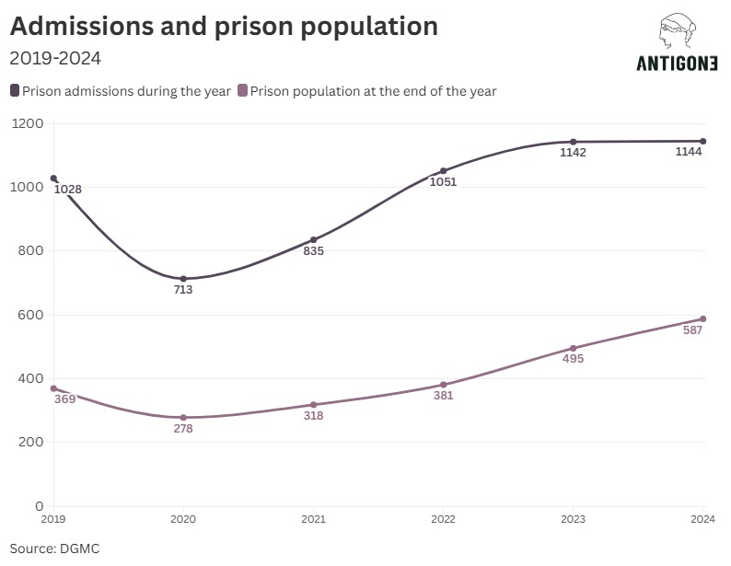

These figures would be significantly higher were it not for the fact that many young people, who were under 18 years old when they committed a criminal offence and who would have been eligible to remain in juvenile facilities until age 25, have instead been transferred to adult prisons upon turning 18. This practice, which the Caivano Decree has greatly facilitated in punitive terms, shows a complete disregard for the young person’s rehabilitative path. It is worth noting that the adoption of the decree followed sensationalist reporting, yet it did not correspond to a factual emergency in juvenile crime as, in reality, involving children had actually decreased by 4.15% in 2023.

Today, 9 out of the 17 IPMs across the country are experiencing overcrowding, an issue never previously recorded. In Treviso, the number of inmates is almost double the facility’s official capacity. The IPM in Milan and the IPM in Quartucciu (Cagliari), have an overcrowding rate of 150%, while the IPM in Florence exceeds 147%.

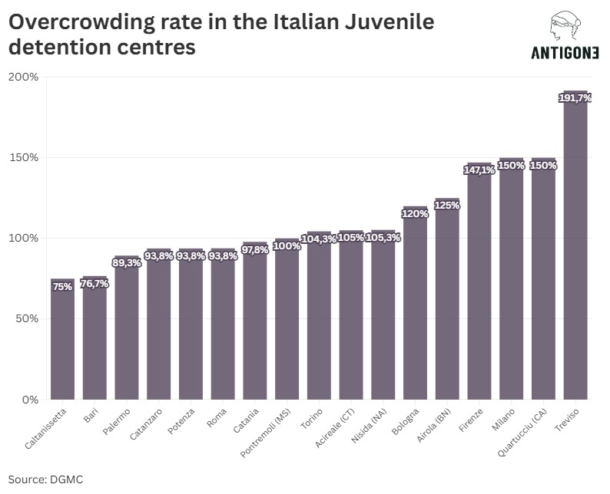

To cope, foam mattresses are left on the floor at night for the extra juveniles to sleep on. The lack of physical space is matched by the system's inability to properly support youth in detention, many of whom have to spend almost the entire day locked in their cells (often without doing the 4 hours of yard time as prescribed by prison law), deprived of meaningful activities including education. Roughly half of the young detainees are unaccompanied foreign children, many of whom have endured traumatic experiences and never received adequate reception or support upon arriving in Italy. Some of their understandable behavioural difficulties are met solely with the excessive use of psychotropic drugs, administered in a neutralising manner.
The solution to overcrowding cannot be the one recently implemented in Bologna of simply converting a section of the Dozza adult prison into an IPM. Through an administrative act, the Ministry of Justice decided to abruptly place this section under the management of its Department of Juvenile and Community Justice — yet its structural characteristics of an adult prison remain unchanged. It is, in effect, a juvenile prison trapped within an adult prison, with 50 beds intended to house young adults who had previously been in the juvenile system and were transferred there. The repurposing of the section blatantly violates the internationally recognised principle of a clear and strict separation between the criminal justice response for adults and the one for children. More and more, on the contrary, our juvenile justice system is beginning to resemble that of adults, betraying the principles and international commitments undertaken by our institutions regarding children and their relationship with the justice system.

The system is no longer capable of protecting the best interests of the child
The grave state of neglect and extremely inadequate standards of living affecting these children in penal institutions have been at the root of many protests that have taken place in juvenile detention centres over the past year. These protests, however, did not lead the competent authorities and institutions to listen or engage in dialogue, but rather to punitive responses —both disciplinary and criminal— and to further lockdowns of the prisons. The new criminal offence of ‘prison riot’ - introduced by the so-called Decreto Sicurezza, converted into Law No. 80 of June 9, 2025 - under Article 415 bis of the Criminal Code provides for penalties of up to 5 years in prison also for those who passively react to the orders of a prison police officer and up to 8 years for those considered instigators of the riot. Protests carried out by young people in juvenile prisons may also constitute an offence, thereby with the risk of burying young detainees under piles of additional years in prison.

In the past years, hence, the strength of the Italian juvenile justice system has lain in its ability to adapt to the needs of each individual young person in its care. Today, despite the outstanding professionalism displayed by many dedicated professionals, the system has become rigid, expecting the youth to adapt to it, leaving those who cannot behind.

For all of these reasons a revision of penal policies targeting young people is extremely urgent, as well as a return to that educational approach which once embraced each individual life story and was the defining feature of juvenile justice in Italy.
The current practice constitutes a violation of standards set by international and EU law, such as the UNCRC and EU Directive 2016/800. Furthermore, current policies against children do not contribute to the prevention of recidivism, moving away from the promotion of security, stability, and equitable development within society

Recommendations
In line with the principles and provisions of the UN Convention on the Rights of the Child, in particular Articles 37 and 40, further elaborated by the UN Committee in its General Comment No. 10 of 2007 and No. 24 of 2019on child justice, taking into account the Council of Europe Guidelines on Child-Friendly Justice, and in light of EU Directive 2016/800 on procedural safeguards for children who are suspects or accused persons in criminal proceedings, we call for:
- The abolition of the Caivano Decree
- The hiring of adequately trained educators and social workers, including training in children's and adolescents’ rights and their specific vulnerabilities
- Adequate, ongoing, and verifiable training for prison police, based on the principles and standards relating to the rights of children and adolescents
- The implementation of an individual assessment for every child entering a juvenile detention centre, and the development of an integrated educational plan to ensure the effectiveness of the rehabilitative process
- The constant presence in IPMs of professionals and resources dedicated to cultural mediation
- The immediate closure of the IPM section within the adult prison in Bologna
- The establishment of low-security custody sections, as provided for by Legislative Decree No. 121/2018
- The effective possibility for young people in IPMs to benefit from extended visits, as provided for by Legislative Decree No. 121/2018
- The enforcement of Constitutional Court ruling No. 10/2024 on emotional and intimate relationships in prison
- The abolition of disciplinary solitary confinement, in accordance with Rule 45 of the United Nations Mandela Rules
- Coordination between IPMs and local schools and services, including allowing children to attend external schools
- Greater commitment from regional authorities to provide vocational training opportunities for young people in the penal system
- Enhanced support for community facilities that host youth from the justice system
- Regular monitoring of physical and mental health, and appropriate care to always guarantee the best interests of the child
- Support for and strengthening of mechanisms for the independent monitoring of all places of detention where children are held

Annex: Signatories
- A Buon Diritto
- A Roma, Insieme - Leda Colombini ODV
- ACLI APS
- ACMOS
- ACSI – ASSOCIAZIONE DI CULTURA SPORT E TEMPO LIBERO
- ALPIM - Associazione Ligure per i minori
- ÀP - Antimafia Pop Academy
- ARCI
- Arciragazzi Nazionale
- ARPJTETTO
- Associazione AMALTEA
- Associazione "Matteo 25,36
- Associazione Radicali Rimini "Piergiorgio Welby"
- Associazione Yairaiha
- ASSOCIAZIONE BIR ODV
- Cooperativa Comunità la Collina ODV
- Camera Penale di Milano
- Caritas Italiana
- CCO - Crisi Come Opportunità
- Chi rom e...chi no
- Cittadinanzattiva
- CNGEI
- Comunità Nuova onlus
- Conferenza nazionale dei Garanti territoriali delle persone private della libertà personale
- Conferenza Regionale Volontariato Giustizia del Friuli Venezia Giulia
- Cooperativa Articolo Uno
- Cooperativa Lotta Contro l’Emarginazione
- Cooperativa PID - Pronto Intervento Disagio
- Cooperativa Sociale Diversamente
- CNCA
- CNVG – Conferenza Nazionale Volontariato Giustizia
- Dipartimento Carceri del Movimento Forense - Avv. Gargiulo Alessandro n.q. di Coordinatore Nazionale
- ECOS - MED Cooperativa Sociale
- Fondazione Casa della Carità Angelo Abriani
- Fondazione Lila Milano ETS
- Fondazione Lorenzo Paolo Medas
- Forum Droghe
- FuoriRiga ODV
- Giuristi Democratici
- Granello di Senape Padova
- Gruppo Abele
- Il Granello di Senape ODV Venezia
- ISMES - Istituto per la mediazione sistemica (Centro Giustizia Riparativa)
- Kairos Cooperativa sociale
- L' Altro Diritto
- La Società della Ragione
- Libera Università dell’Educare (LUdE)
- Link - Coordinamento Universitario
- Loscarcere ODV
- Naga
- Nanà Cooperativa Sociale
- Nonna Roma ODV
- Opera Don Calabria
- PuntoZero
- Rete degli Studenti Medi
- Rete della Conoscenza
- Ri-Belle
- Ristretti Orizzonti
- Sailing for Blue Lab
- Salesiani per il Sociale
- SEAC-Coordinamento Enti e Associazioni di Volontariato Penitenziario
- Sparwasser
- Terre des Hommes
- UdS (Unione degli Studenti)
- UdU (Unione degli Universitari)
- UISP APS
- Giuseppe Apprendi - Garante per i diritti delle persone detenute del Comune di Palermo
- Angela Barbaglio - Garante dei Diritti delle persone private della libertà personale del Comune di Vicenza
- Francesca Bertolini - Garante per le persone private della libertà del Comune di Reggio Emilia
- Antonio Bincoletto - Garante dei diritti delle persone private o limitate nella libertà del Comune di Padova
- Graziella Bonomi - Garante dei diritti delle persone detenute e private della libertà personale della città di Mantova
- Elisabetta Burla - Garante comunale dei diritti dei detenuti del Comune di Trieste
- Valentina Calderone - Garante dei diritti delle persone private della libertà personale di Roma Capitale
- Samuele Ciambriello - Garante dei Diritti delle Persone sottoposte a misure restrittive della libertà personale della Regione Campania e Portavoce della Conferenza dei Garanti
- Sofia Ciuffoletti - Garante dei Diritti delle Persone Private della Libertà Personale del Comune di San Gimignano
- Monica Cristina Gallo - Garante dei diritti delle persone private della libertà personale della città di Torino
- Raimonda Lobina - Garante dei Diritti delle Persone private della libertà personale del Comune di Porto Azzurro
- Francesco Maisto - Garante dei diritti delle persone private della libertà personale del Comune di Milano
- Maria Mancarella - Garante dei diritti delle persone private della libertà personale della Città di Lecce
- Mariarosa Ponginebbi - Garante dei diritti delle persone private della libertà personale del Comune di Piacenza
- Carla Puligheddu - Garante per l’infanzia e l’adolescenza della Regione Sardegna
- Lucia Risicato - Garante dei diritti per le persone private della libertà del Comune di Messina
- Tommaso Sannini - Garante dei diritti delle persone private della libertà del Comune di Pistoia
- Doriano Saracino - Garante dei Diritti delle Persone sottoposte a misure restrittive della libertà personale della Regione Liguria
- Vincenzo Scalia - Professore Associato di Sociologia della Devianza, Università degli studi di Firenze
- Gianluca Schiavon - Responsabile nazionale Giustizia del PRC
- Marco Solimano - Garante dei Detenuti del Comune di Livorno
- Guia Tanda, Garante per i diritti dell’infanzia e dell’adolescenza della Regione Liguria
- Tina Zaccato - Garante dei diritti delle persone detenute o private della libertà del Comune di Castrovillari
- Ettore Cannavera - Cappellano REMS Sardegna
- Aurora Compagnone - Educatrice
- Ludovico Di Martino - Regista
- Leonardo Fiorentini - Direttore di Fuoriluogo
- Giuseppe Mosconi - Docente ordinario di Sociologia del Diritto presso l’Università di Padova
- Francesca Rapanà - Il Granello di Senape ODV Padova
- Grazia Stella - Educatrice
- Maria Voltolina - Presidente di Il Granello di Senape OdV Venezia

Ministry of Justice
National Guarantor for the Rights of Persons Deprived of Liberty
On that the OSCE pointed out how "most of the provisions have the potential to undermine the fundamental principles of criminal justice and the rule of law." Harsh criticism was also later voiced by the Commissioner for Human Rights of Council of Europe and 7 UN Special Rapporteurs.

