Table of Content of the Annexes

Contents
Annex 2 Practices of Child Service at Sub National Level 5
Annex 3: Obstacle of PWD to Access to Justice 7
Annex 4: Data on violence against PwD, including women with disabilities: DPO’s Monitoring Report 8
Work Participation of Persons with Disabilities 11
Annex 5: Vocational Training and Employment of Persons with Disabilities 14

Annex 1: Gaps of Regulation on the PWDs
- The government has issued policies and regulations; but some gaps should be improved to fulfill the rights to health for persons with disabilities. The following gaps confirm such issues:
        - Presidential Regulation No. 12 of 2013 jo 26 year 2016 jo 82 year 2018 jo 75 year 2019 jo 64 year 2020 concerning National Health Insurance. Article 52 paragraph 1 letter (r) regulates that women of victims of abuse, sexual violence, trafficking, and terrorism are not guaranteed by the National Health Insurance Program (JKN). Even though in the previous regulation, namely Presidential Regulation No. 19 of 2016, the victims were guaranteed by JKN. This regulation regulates the guarantee of contributions by the State only for those categorized as having severe disabilities as mentioned in Article 8 of Presidential Regulation.
        - Some policies concerning health have not accommodated the needs of persons with disabilities yet; thus, they can not access the scheme of contribution assistance as recipients called (PBI) as persons with disabilities are not included in the social insurance scheme. Persons with disabilities stigmatized because they are deemed a burden for family, friends, and the environment. Besides, the standard used is poverty-based, not the vulnerability of a disability basis. That causes persons with disabilities are not indicated in the program target by the government, albeit persons with disabilities need higher expenses, especially assistive devices, in the households compared to non-disabilities persons.
        - The social health coverage system is not compatible with the needs of persons with disabilities and it does not address accessibility issues in accessing health services. TheDecree of Ministry of Health No. 28 Year 2014 concerning the Standard of Implementation of Health Insurance Program ensures to distribute the mobility assistive devices for persons with disabilities, except wheelchairs with time limitation about the assistive device distribution, once every five years. The program also includes coverage for 150 illnesses. The Decree of the Ministry of Health regulates the home visit program in a local health care center called Puskesmas, which is not borne by BPJS. That program hampers persons with disabilities from accessing the information, treatment, and medication; since the psychosocial disabilities must go to the hospital to get such healthcare facilities with BPJS. The health care providers do not perform services in the rehabilitation institutions. Furthermore, persons with disabilities can not go to the hospital quickly.
        - Persons with disabilities do not have adequate healthcare services and information in the social security (BPJS Kesehatan) scheme, which belongs to all Indonesians for accessing any healthcare facilities, treatments, and medications if they possess any disease and illness. Consequently, they do not register the BPJS Kesehatan scheme or do not recognize the available healthcare services provided with BPJS Kesehatan in the Puskesmas and hospital. One running doctor per day in Puskesmas and hospital limits persons with disabilities to access the services since the location of those healthcare facilities are distant from community, city, and regent levels besides they are far from appropriate.
        - The government’s definition of disabilities is limited to physical disabilities; consequently, the existing regulations do not accommodate the needs for assistive devices for other forms of disabilities. The government has allocated some funds into the National Mid-Term Development Plan (RPJMN) to provide assistive devices in all regencies/municipalities. However, the implementation is not well monitored, and there is confusion at the municipality level, hampering the effective implementation of the program. In the manner of necessity, decent healthcare facilities and hospitals are needed in the community or regency level as close as possible to the community environment. Besides, a dedicated center or desk for persons with disabilities installed in those places is important and impelling. However, for the long-range and sustainability of the shifting paradigm, all sections and facilities in the healthcare services and hospitals should increase awareness and preparedness for serving healthcare towards persons with disabilities. Being that said, stigma and discrimination should be eliminated in any healthcare services so that all persons with disabilities can access and receive services in those facilities equally with other people.
- In the context regulation, the existing regulations are still discriminatory and not in accordance with the CRPD. This is reflected in the following regulations, such as Law No. 13 Year 2003 on Employment that still uses the phrase “disorder” and allows termination of employment due to disability (Article 153 and 172). Similar example in Law No. 21 Year 2000, Article 12 section “Membership” has not accommodated workers with disabilities, Article 8 of Law No. 14 Year 2005 concerning Teachers and Lecturers states that, “teachers must have academic qualifications, competence, certification as educators, physical and mental health, as well as having the ability to realize the goal of national education”. Law No. 36 Year 2009 on Health perpetuates the stigma on persons with disabilities through the term “physic and mental health.”
- One of the serious challenges in the implementation of Law No. 8 Year 2016 is related to the interpretation of 2% and 1% in the law. There is a different interpretation of Article 53 of the Law No. 8 Year 2016 that sets 2% and 1% quota for disability employment. It is because there are no guidelines for both government and private entities in applying the provision. In practice, government institutions apply this provision by allocating 2% in every term of civil servant recruitment. Whereas, the Law No. 8 Year 2016 requires each government institution to hire at least 2% of the total numbers of employees. The lack of segregated data, including the number of working women with disabilities, both in public and private sectors, is one challenge in applying the 2% and 1% quota provision.
- The implementation of provisions that ensure persons with disabilities’ right to employment remains challenging due to the lack of propagation to the local level. Even policies at local level are not widely disseminated to all private entities. As a result, discrimination and violations in accessing employment for women with disabilities, starting from the job requirements, recruitment, selection, to finally acceptance at workplace and within the workplace. The protection assurance is still limited to operational matters such as facility, social security, or accessibility, which often cause women with disabilities unable to work professionally due to unhealthy work relationships (such as workplace bullying). In Central Java, one victim had suffered from constant verbal bullying in her workplace. She was so stressed out that she decided to quit from the job.
- The third challenge is the lack of public facilities for persons with disabilities. The lack of accessibility and reasonable accommodations for different types of disability also still became a challenge on this matter. It raises the stigma and discrimination for those who are accepted as civil servants or private employees. The lack of accessibility also makes persons with disabilities question themselves and to be transferred to jobs that are not suitable to their capacity and capability. For instance, a blind civil servant that is not equipped with an accessible computer, a staff with physical disability who works in an inaccessible office, and so on. This happened to a woman with physical disability who was discriminated against in her workplace at a state-owned company in Central Java. Unfortunately, there were no significant efforts taken by her supervisor to eliminate the discrimination, thus, she decided to quit her job.
- Persons with disabilities currently publicly reported their cases to the local governments, state recruitment agency, and the ministry of social affairs regarding the rejection result during the state official’s recruitment process because of their disabilities. One of the cases involved a woman with disability; Dr. Romi S. Ismael, who applied as a dentist in Puskesmas (community healthcare service) in West Sumatra, was rejected because of her physical limitation. However, it does not guarantee the practice will not reoccur in other regions both in the center and local government recruitment.
- The forth challenge is related to lack of employment due to low education status. Statistically, 45.74% of persons with disabilities never attend or finish primary school. The experiences of Lampung Provincial Vocational Training Center (BLK), for instance, since 2017 opens opportunities for people with disabilities to get skills training. The enthusiasm of persons with disabilities who are high enough to get skills training and interest in work has led to an increase in the number of participants with disabilities in the BLK. In 2017 participants with disabilities were 18 people, and in 2018 increased to 68 people. This significant increase was not matched by the distribution of workers with disabilities in various sectors of the company related to their education background and skills. This is due to a number of things, including a low education status and some that do not have educational status, as well as the absence of competency tests for participants with disabilities, as a condition for the distribution of labor.
- The vocational training center is intended for people who already have educational status, at least having completed senior secondary education. The fact is that persons with disabilities who are accepted by BLK do not have senior secondary education status, some even have never attended school. This is a problem when the BLK will channel persons with disabilities to the world of work. Problems faced by BLK, persons with disabilities cannot be included in competency tests on the skills they have acquired. In addition, the BLK cannot distribute persons with disabilities to recipients of work because of the educational status and stigma of the BLK who have not fully considered that persons with disabilities can work.
- The fifth challenge is related to the administrative requirement, especially Mental Health Certificate requirements for all of work/job recruitment. Adversities are also found by the group of psychosocial disabilities who apply for employment in state-own and private agencies as they are required to include a letter of health confirmation that informs mental and physical condition. If they are ineligible because of mental conditions, they will not acquire their wished employment. Furthermore, psychosocial disabilities also address the need for day leaves for regular checks into the doctor without decreasing their annual paid leaves. The working method and time flexibility will significantly help people with psychosocial disabilities in the working environment.
- This discrimination takes place in the form of Mental Health Certificate requirements that must be fulfilled by every job seekers in Indonesia who wish to apply to be a civil servant, state-owned enterprises (SOEs) and private companies. The requirement for a mental health certificate is based on Government Regulation No. 11 Year 2017 on the Management of Civil Servants. Article 23 of the regulation states that all persons who wish to apply to become a civil servant must be physically and mentally sound in accordance with the requirements of the position being applied for.
- Another factor related to the administrative issue is in the recruitment process, the government has set up a special formation for persons with disabilities, but it does not give a chance for persons with disabilities to compete in a regular formation. As the result, even though persons with disabilities can compete, they may be prone to discrimination or their numbers become too small, as shown in a case occurred in Solok, West Sumatera. A woman who uses a wheelchair passed the test of civil servant recruitment as a doctor, but the decision was dismissed by Solok City Administration because the recruitment was not according to the formation. After receiving strong protest from many OPDs, the Minister of State Apparatus Empowerment restored the decision.
- The sixth challenge is related to the data of people with disabilities in Indonesia. As mentioned in the ILO report (2017), the lack of accurate data on the number of persons with disabilities acts as a brake on a range of actions and measures that could be taken otherwise. In fact, there is no accurate and comprehensive data regarding persons with disabilities in Indonesia.

Annex 2 Practices of Child Service at Sub National Level
In Bandung Regency, West Java, there had been an early detection program for PwDs through the Mobile Social Service Unit of the Social Service, but it has not been evenly distributed due to budget constraints. In East Kalimantan, this program is implemented by the Health Office and provided by health service centers. In Riau, regional hospitals provided early detection services, in high cost, while programs for the community are not carried out routinely. In Yogyakarta City, the Early Detection program is provided through the Early Growth and Development Stimulation, Detection, and Intervention Program (BKB PAUD SDIDTK) at the integrated health care center (Posyandu).
In practice in East Kalimantan, there are at least 2 institutions that play a role in serving children with disabilities, namely: The Care Forum for Children with Special Needs (FPAB) and the PLA (Autism Service Center), both under the auspices of the East Kalimantan Provincial Government. FPAB is an institution that provides educational services for parents and teachers on how to assist children with special needs. During the Covid-19 pandemic, this activity was stopped due to budget cuts. Meanwhile, the PLA, an institution under the auspices of the East Kalimantan Provincial Education Office, has quite good equipment from the Central Government assistance. It is still operating now, especially for those who are economically disadvantaged.
In practice in South Sulawesi, children also experience limited access to physiotherapy services. In the city of Makassar, there is only physiotherapy in two special schools, namely SLB Negeri Parangtambung and SLB YPAC Makassar. Physiotherapy services in some hospitals are paid and quite expensive for parents of children with PD. Many children with CP need physiotherapy services but do not get them because their parents cannot afford it economically, either for transportation or to pay for physiotherapy costs.
In Riau Province, a number of programs are carried out by the local government, including providing daily living activity training for mothers who have children with disabilities. Riau also has a Special Service Center (PLA) which is provided free of charge using the local budget. Although, according to DPO, the complicated bureaucracy makes it difficult for parents or children with disabilities to access these services.
In Yogyakarta, with a note that its implementation needs to be streamlined and improved again, there are child-friendly villages in which there are specific protection indicators. PATBM (Community-Based Integrated Child Protection), Child Friendly Health Center, Child Friendly Islamic Boarding School, Inclusion City and District, Yogyakarta City Children's Forum. Meanwhile, the Disability Service Unit is located in the Province which is still limited to services related to education, including consultation and assessment.

Annex 3: Obstacle of PWD to Access to Justice
In practice, persons with disabilities still have difficulty accessing the judiciary. Among the problems that currently arise include:
- Sign language for various disabilities has not been provided since the investigation process, so that PwDs often find it difficult to communicate or provide information.
- There are not many lawyers who understand sign language and are therefore unable to assist PwDs in contact with the law.
- Guidelines in the justice system are not yet fully accessible to PwDs, including their families, making it difficult to bring their cases to legal proceedings. Through a number of organizations such as SIGAB, SAPDA, PUSHAM UII, Disabilities LBH, and other organizations, law enforcement agencies have begun to obtain information related to access to justice.
- Buildings, facilities, and infrastructure that are not accessible to PwDs, both physically and to information, technology, and communication, including the understanding and awareness of law enforcers about the variety of disabilities and their needs (reasonable accommodation).
- In general, access to legal aid is difficult for the community, especially the poor, including cases of PwDs who are in conflict with the law. The Law on Legal Aid has not specifically stated that PwDs are entitled to legal assistance.
- People with psychosocial disabilities who were in social rehabilitation centers had difficulty accessing justice. When they experienced violence, they could not immediately report it to the authorities. This is because there was no complaint mechanism within the institution that is integrated with law enforcement, officers and residents of social rehabilitation institutions cannot communicate with their families or parties outside the institution. And the mindset of the authorities is still strong, which considers people with psychosocial disabilities to have no legal skills and are still being accused of making things up.

Annex 4: Data on violence against PwD, including women with disabilities: DPO’s Monitoring Report

- Currently, the Central and Regional Governments do not have disaggregated data on violence against PwD, including women with disabilities.
- The CIQAL Annual Note states that violence against persons with disabilities occurred during 2019 and spread across a number of areas in Indonesia.

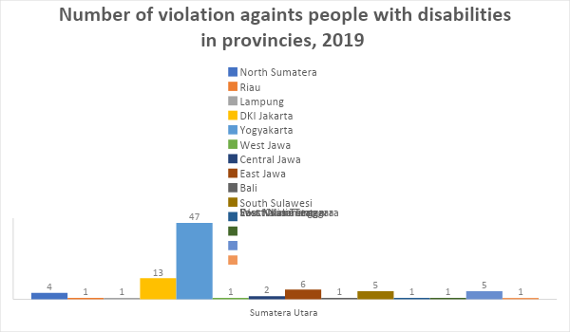
Source: CIQAL, 2020

Data: Number of Cases of Violence against Women with Disabilities in Yogyakarta (2017–2020)
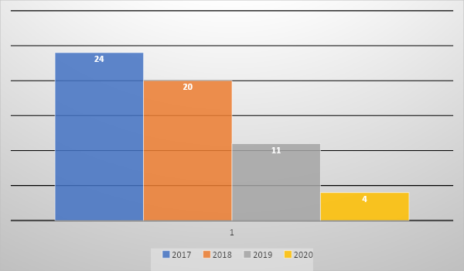
Source: CIQAL, 2020

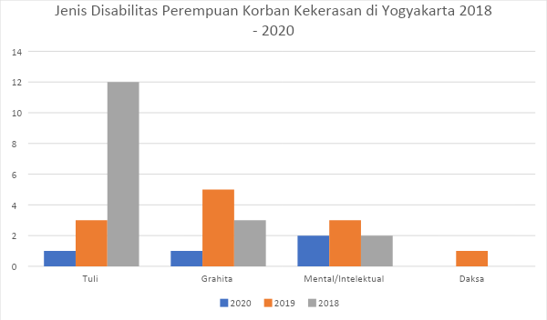
Source: CIQAL, 2020

- For cases in nursing homes, due to the ineffectiveness of supervision carried out by the Central and Regional Governments, cases of sterilization or forced contraception are completely unknown. Only from the confession of a number of administrators or families of PwD who stated that contraception was the only way to prevent pregnancy in women with psychosocial disabilities. In many cases, sexual violence such as rape is also strongly associated with the practice of forced contraception.
- While the case of the impact of Covid-19 on gender-based violence against women with disabilities in May 2020, as many as 50 respondents, consisting of 48 women with disabilities and 2 men with disabilities from 14 provinces in Indonesia, out of 54% of people with physical disabilities, 20% with disabilities sensory, 6% intellectual disability, and 2% mental and multiple disabilities, respectively. As many as 80% experienced violence once in a while and 4% every day, violence in the form of insults (48%) and physical violence in the form of beatings (10%). Meanwhile, of the respondents who experienced sexual violence, 70% experienced violence in the form of sexual harassment, 15% rape, 10% sexual exploitation. Around 36% of violence was experienced in person, 36% through online media, and 2 percent in the form of hacking.

Work Participation of Persons with Disabilities

According to data by the National Workforce Survey (SAKERNAS) 2017, the population of persons with disabilities is 21,930,529 people. The number of disability workforce is 11,224 673 people or 51.18%. Meanwhile, the number of employed Disability Workforce is 10,810,451 people or 96.31%, while open unemployment amounted to 414,222 people or 3.69%. There are still 48.82% (10,705,845 people) unemployed workforce that require decent work.

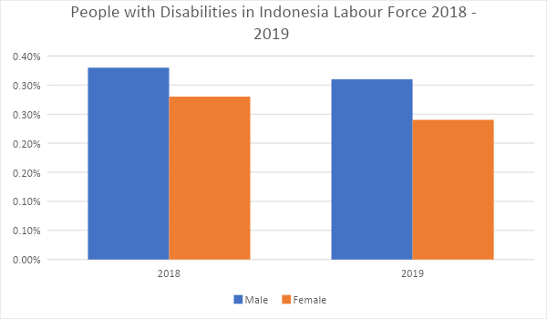
Source: National Labor Force Survey, 2019.
- National Labor Force Survey 2019 showcases, there are 0.28% of participation of people with disabilities in Indonesia above 15 years in the workforce and 0.31% in 2018. In terms of sex, the proportion of male workers is higher than women. In 2018, male workers were 0.33% and women were 0.28. While in 2019, men would be 0.31% and women would be 0.24%. Economically active population in Indonesia by age and sex group in 2019 is 126,515,119 in total male and female.
- The government's efforts to create job opportunities have not been made inclusively, including during the implementation of labor markets in the regions. In 2019, for example, in South Sulawesi, the Makassar City Manpower Office held a Labor Exchange Week 3 times but only once was informed to OPDs and people with disabilities participated. To date, the implementation of the Labor Exchange does not provide adequate accommodation, for example a sign language interpreter on the grounds that there is no budget so that it is the disability organization that needs to provide it. There is a strong suspicion that this practice also occurs in other areas, not only in South Sulawesi.

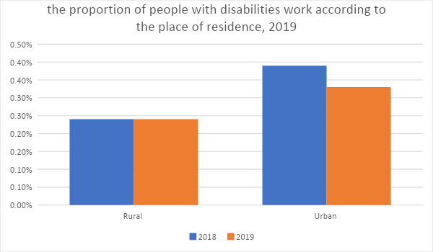
Source: BPS, 2019.

- The table below shows the distribution of the proportion of the worker population with disabilities according to employment status in Indonesia. In 2019, the occupation distribution worked with the greatest disability among self-employed workers, namely 29.19%. Then in the status of self-employed with non-permanent workers as much as 20.9%. Disability persons as employees as much as 19.77% of labor status. The smallest proportion is in self-employed with permanent or paid workers, namely 3.99%.
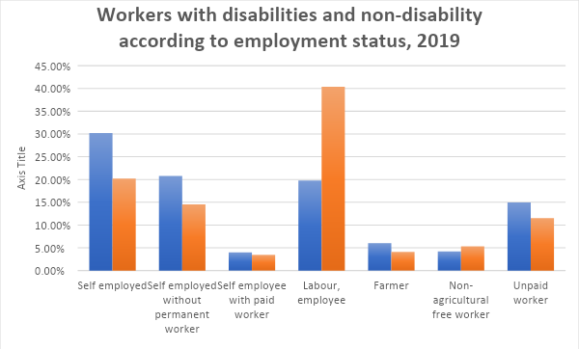
Source: BPS, 2019
- According to the ILO in 2017, people with disabilities are mostly working in informal sectors with relatively lower take-home pay to persons without disabilities. The percentage of people with mild and severe disabilities who work in informal jobs is 64.93 percent and 75.80 percent, respectively. This number is much higher compared to persons with disabilities at only 49.27 percent.
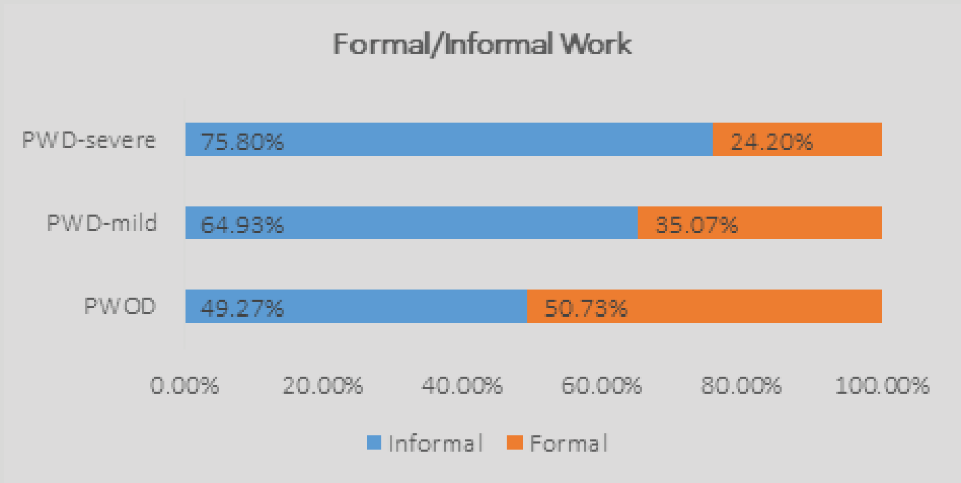
Source: ILO, 2017

Annex 5: Vocational Training and Employment of Persons with Disabilities

- “The Minister of Manpower Decree No. 205 of 1999 on Vocational Training and Employment of Persons with Disabilities” has limited the jobs for persons with disabilities according to the type of disability, reinforcing the stereotypes of disabilities. For example, visual disabilities are identical with masseurs, physical disabilities are identified with tailors, people with hearing loss are synonymous with jobs done in a noisy place, while intellectual disabilities are deemed as weaving.
- Despite the existence of the policy, the concern about employment services for persons with disabilities is growing. The situation is inevitable since many persons with disabilities in Indonesia are “underemployed, engaged in insecure jobs, and have less opportunity to advance their careers”. The statistics of Population Census 2020 also showcases that persons with disabilities in Indonesia face employment problems. Among citizens aged 15 and above, there are 12.15% of people who live with disabilities, 1.87% of them with severe disability and 10.29% with mild disability. Their participation in the labor force is as low as 20.27% (severe disability) and 56.72% (mild disability), much lower than the participation of those without disabilities at 70.40%.
- The high number of informal workers with disabilities is related to the difficulty of persons with disabilities reaching the requirements and criteria for formal employment. People with intellectual disabilities, for instance, mostly work in contemporary jobs such as trading, selling, self-employment, and other types because they cannot pursue a permanent job in private and state-own agencies. Therefore, people with intellectual disabilities find it more convenient to work as designers with a small team to produce their products, clothes, and crafts.

Ministry of Health Regulation No. 28, the Year 2014 on the Guideline Implementation of Health Insurance
Indonesian DPOs’ alternative report to the UN CRPD, coordinated by OHANA, 2020. The report accessed at https://tbinternet.ohchr.org/_layouts/15/treatybodyexternal/Download.aspx?symbolno=INT%2fCRPD%2fICO%2fIDN%2f41184&Lang=en
Article 12 Law No. 21, the year 2000 concerning Labour Union: “Labor unions, federations and confederations of labor unions must be open to accept members regardless of their political orientation, religion, race religion, and gender.”
As a result of this arrangement, a woman in Bantul, Yogyakarta, retired early from her job as a teacher because of paralysis caused by a spinal cord injury.
Almost all agencies and institutions within the government, private sectors, law enforcement officers, even human rights organization, include physical and mental health requirements for prospective employees. The same is also true in the education sector. DisCo Initial Report to the CRPD Committee
Case documented on November 2019 by HWDI Central Java; quoted from HWDI’s alternative report to the CRPD Committee
Indonesian DPOs Coalition, Our Agenda for Inclusive Development, p. 18
Indonesian DPOs Coalition, Our Agenda for Inclusive Development, p. 21
A Mental Health Certificate is a letter issued by a health services agency to prove that the holder has no mental disorder.
PJS’s alternative report to the UN CRPD
“Disabled dentist finally appointed civil servant in West Sumatra”, 7 August 2019, https://www.thejakartapost.com/news/2019/08/07/disabled-dentist-finally-appointed-civil-servant-in-west-sumatra.html; see also, “Dentist in Sumatra finds dream crushed because of disability”, 10 July 2019, accessed from https://www.thejakartapost.com/news/2019/07/10/dentist-in-sumatra-finds-dream-crushed-because-of-disability.html
Namely: North Sumatra (4 cases), Riau (1 case), Lampung (1 case), DKI Jakarta (13 cases), Yogyakarta (47 cases). cases), West Java (1 case), Central Java (2 cases), East Java (6 cases), Bali (1 case), South Sulawesi (5 cases), East Kalimantan (1 case), South Kalimantan (1 case), West Nusa Tenggara (5 cases), and East Nusa Tenggara (1 case).
HWDI “Quick Assessment Report on the Impact of Covid-19 for Persons with Disabilities/Persons with Disabilities throughout Indonesia” (May 2020).
ASEAN Disability Forum, the 2020 Baseline Report the Rights of Persons with Disabilities: The Implementation of SDGs and CRPD in ASEAN Countries, (2020).
ILO, Inclusion of People with Disabilities in Indonesia, p. 16
Endah Tri Anomsari and Siti WIidhretno Mursalim, “Mainstreaming Disability: Challenges and Strategies Toward Equality and Decent Work in Indonesia”, Journal of Social Sciences and Humanities, volume 10, Number 1, 2020.
ADF Report from Focus Group Discussion with Vulnerable Groups of Persons with Disabilities, March 2020

