Shadow report submitted for the 71st Session of the Committee on Economic, Social and Cultural Rights (CESCR) regarding The Czech Republic's Protection of the Rights of LGBTI+ Persons

NGO information to the UN Committee on Economic, Social and Cultural Rights
71st Session (14 Feb 2022 - 04 Mar 2022)

Submitted by:

Prague Pride z.s.
ARA ART, z.s.
Amnesty International
PROUD - Platforma pro rovnoprávnost, uznání a diverzitu, z.s. (in English PROUD - Platform for Equality, Recognition and Diversity)
Queer Geography, z.s.
Trans*parent z.s.
Česká společnost AIDS pomoc, z.s. (in English Czech AIDS Help Association)

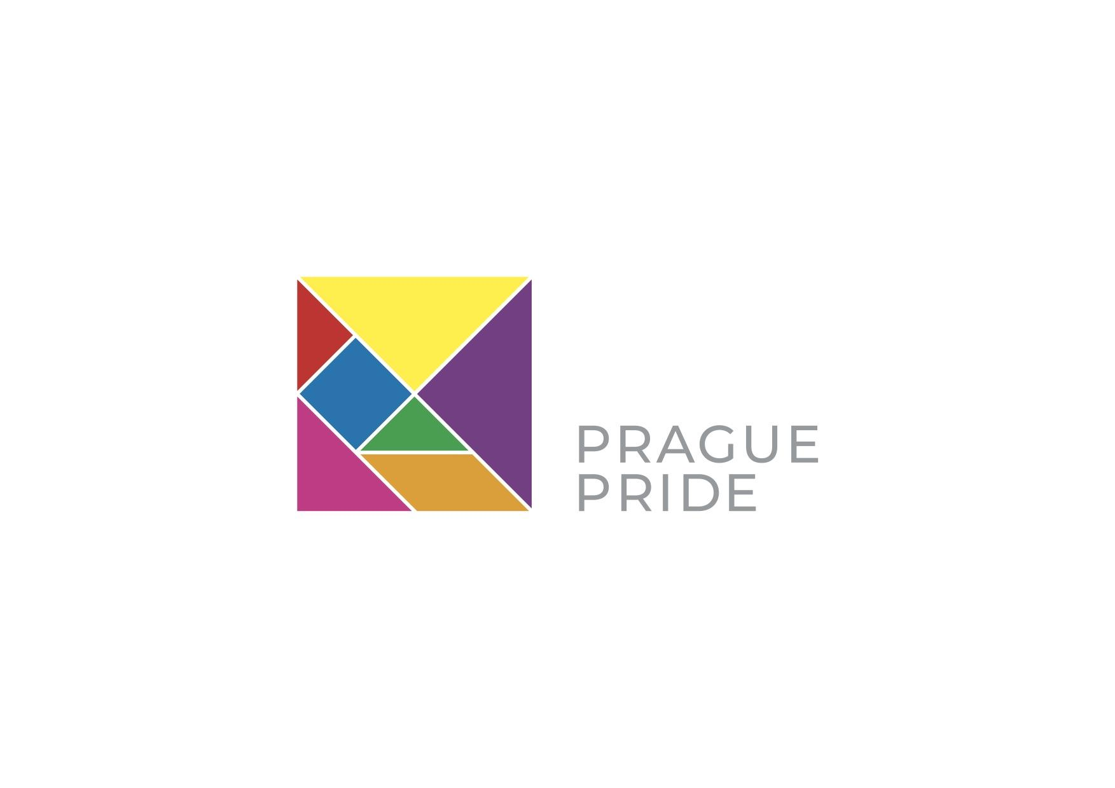
ILGA World

January 2021







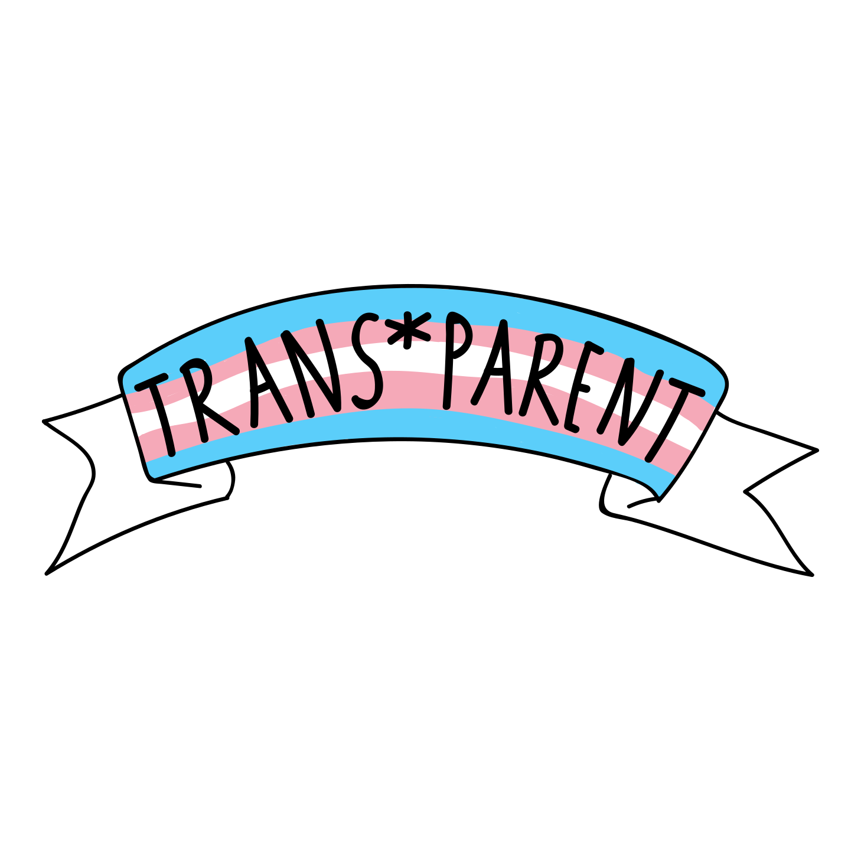

TABLE OF CONTENT

Introduction 3
The measures taken to combat prejudice and discrimination based on sexual orientation and gender identity (Article 2 of the ICESCR) 3
Prejudice, discrimination and violence against LGBTI+ people 3
Need for amendment to the Criminal Code 4
Awareness raising of public prosecutors, the Police and others 4
Non-approval of the government strategy for LGBTI+ people 4
Lack of statistical data collection 5
Roma LGBTI+ people in the Czech Republic 5
The status of the same-sex marriage bill; discrimination of children brought up by same-sex couples (Articles 9, 10 of the ICESCR) 7
The status of the same-sex marriage bill 7
Discrimination of children brought up by same-sex couples 8
Access to reproductive health care by same-sex couples (Articles 10, 12 of the ICESCR) 9
Assisted reproduction for same-sex couples 9
Non-adoption of the law on assisted reproduction for single women 10
Procedure and conditions of gender affirming procedures (Article 12 of the ICESCR) 10
Compulsory surgery of trans people 10
Non-adoption of new law concerning sterilization of trans people 11
Other problems for trans people in the Czech Republic 11
Minority stress and the mental health of LGBTI+ people (Article 12 of the ICESCR) 12
Stigma as a fundamental cause of health disparities 12
Minority stress of non-heterosexual people 12
People living with HIV (Article 12 of the ICESCR) 13
Criminalization of people with HIV diagnoses 13
The HIV prevention system 14
Marginalization and stigma of people lining with HIV 14
Blood donation of men having sex with men 14
ANNEX I: ORGANISATIONS OVERVIEW 16
ANNEX II: CONTEXTUAL BACKGROUND 19

Introduction

- We address the issues related to the lives of LGBTI+ people and their families, including children in the Czech Republic. In particular, but not limited to, we will address the specific issues mentioned in the List of issues in relation to the third periodic report of Czechia dated 17 April 2020, i.e.:

- the measures taken to combat prejudice and discrimination based on sexual orientation and gender identity, including hate crime legislation, education of law enforcement authorities, preparation of LGBTI+ Government Strategy, collection of statistical data and position of Roma LGBTI+ people;
- the status of the same-sex marriage bill; and
- the procedure and conditions of gender affirming procedures.

In addition we will also address the following issues:

- discrimination of children brought up by same-sex couples (jointly with the section on equal marriage);
- access to reproductive health care by same-sex couples;
- minority stress and the mental health of LGBTI+ people; and
- people living with HIV.

The measures taken to combat prejudice and discrimination based on sexual orientation and gender identity (Article 2 of the ICESCR)

Prejudice, discrimination and violence against LGBTI+ people

- LGBTI+ people continue to experience prejudice, discrimination, including discriminatory violence, in the Czech Republic. According to the 2019 Public Defender of Rights research only one third of the Czech population thinks that LGBTI+ people are discriminated against in the Czech Republic. On the other hand, among the LGBTI+ respondents, three quarters think that LGBTI+ people are discriminated against in the Czech Republic. According to the same research, in the last five years more than one third of LGBTI+ people felt discriminated against which is three times higher than the rate expressed by the general public in the Czech Republic. ​​Physical or sexual violence, attacks and threats were experienced by 15% of respondents. We are aware of several stories of people facing prejudice and discrimination in their daily lives. One of the biggest problems is that the cases of discrimination or hate speech and hate crime are not reported to the Police. Up to 91% of LGBTI+ respondents in the above-mentioned research did not report those cases to the authorities. 47% of respondents framed them as trivial incidents that are not worth reporting and 44% expressed their belief that nothing would change by reporting the case anyway. However, recently a specific case that took place in May 2021 was reported to the Police and it was also covered by the media. Two men were attacked in Prague while holding their hands walking in the street. They were also the target of verbal abuse. Police are currently still investigating the case and, according to our information, it is headed to criminal court.

Need for amendment to the Criminal Code
- Prejudice against LGBTI+ people may be significantly reduced if legal norms clearly and unequivocally point out that violence against LGBTI+ people is unacceptable and punishable. This is often done via criminal law norms which provide measures of protection to LGBTI+ people who are targeted by crimes motivated by hate. However, Czech criminal law does not recognize sexual orientation and gender identity as hate motives, unlike, for example, race or religion. These motives are not considered at the level of special offences, qualified essential of certain general offences nor general aggravating circumstances. In practice, this means that racist or religious attacks should be recognized as serious crimes during investigation, prosecution and sentencing. As a result, the criminal justice system treats homophobic and transphobic attacks in the same way as in case of misdemeanors. Recognizing these shortcomings, the Public Defender of Rights recommended to amend its Criminal Code so that LGBTI+ hate crime victims receive the same protection as victims of other hate motivated crimes. No such amendment has been adopted yet.

Awareness raising of public prosecutors, the Police and others
- The courts, the public prosecutors office, the Police and other bodies (such as those dealing with minor offenses) are crucial in protection against discrimination, hate crimes and other forms of attacks. It is therefore essential that these authorities are aware of and have adequate training on the rights of LGBTI+ people and are capable of protecting their rights. However, issues related to LGBTI+ people's rights are not part of the methodologies and training of these bodies. It is important to prepare such methodologies and training to educate and train these relevant actors.

Non-approval of the government strategy for LGBTI+ people
- The Czech Government has its advisory body called the Government Council for Human Rights. This Council can submit recommendations to the Government and establish committees for specific human rights issues. One of the committees is the Committee for Sexual Minorities. Members of the Committee are among others representatives of the civil society. Recently, this Committee prepared in cooperation with the Government Plenipotentiary for Human Rights a proposal of the “Government Strategy on Equality and Elimination of Barriers of Dignified Life of LGBTI+ People in the Czech Republic 2021–2026” (hereafter: Strategy). It contains six strategic areas and includes all relevant issues or issues of concern for LGBTI+ people in the Czech Republic. Even though the Committee for Sexual Minorities finished the work on the document with the view to be submitted to the Czech Government in May 2021, it has not yet been submitted to the Government. Following the Parliamentary elections in October 2021, and the new Government at the time of writing (January 2021), the support and timeline for the adoption of the Strategy remained unclear.

Lack of statistical data collection
- One of the major problems in the Czech Republic regarding the position of LGBTI+ people is the lack of statistical data on their situation. Statistical data is the cornerstone of an ability to take relevant action and improve the situation of LGBTI+ people. The Czech Republic does not currently collect the data on:
  - the number of hate crimes against LGBTI+ people,
  - the number of cases of discrimination against LGBTI+ people in the areas of work and employment, housing, health and social care, education and access to goods and services,
  - the number of same-sex couples entering into registered partnerships,
  - the number of children raised by same-sex couples, number of children born from or adopted by same-sex couples,
  - the number of social benefits (survivors' pensions, family allowances, etc.) paid to same-sex couples and their families,
  - the number of people undergoing official gender affirming procedures,
  - the number of international protection proceedings motivated by persecution of LGBTI+ people,
  - the number of cases of bullying motivated by LGBTI+ status,
  - the number of suicide cases motivated by LGBTI+ status,
  - the number of cases of mental illness related to LGBTI+ status,
  - the number of people with intersex/DSD diagnoses.
It is therefore crucial to collect this statistical data as a starting point to enable a better understanding of and response to the specific situation of LGBTI+ people in the Czech Republic.

Roma LGBTI+ people in the Czech Republic
- In 2021, an analytical report on the situation of Roma LGBTI+ people in the Czech Republic was prepared by the organisation ARA ART. Thanks to this analytical report, there is some information on the living conditions of Czech Roma LGBTI+ people and the main problems they face. The analytical report stated that there is a low level of awareness of the specific status of Roma LGBTI+ people and their needs. There is no institutional support targeted towards addressing the specific needs of Roma LGBTI+ people. There is also a lack of systematic and targeted support for the non-profit sector on addressing hate crimes, breaking down stereotypes, and addressing anti-Roma speech and hatred. There is limited or almost no funding for issues faced by Roma LGBTI+ people. LGBTI+ Roma are a particularly vulnerable group, especially during the COVID-19 pandemic, due to multiple disadvantages and discrimination bordering on anti-Roma racism, homophobia and transphobia. National health systems and most civil society organizations, however, do not take into account the specific needs of LGBTI+ Roma.

- The analytical report proposed recommendations that can improve the situation of Roma LGBTI+ people. There is a complete lack of provisions relating to multiple discrimination in national legislation. Multiple discrimination is not explicitly prohibited by law and there is no case law dealing with multiple discrimination. There is a very weak monitoring mechanism. Social policies and legal provisions need to be extended to include an intersectional approach, as well as to incorporate intersectionality at the heart of national law.

- Moreover, according to Ara Art´s report, the Czech Republic did not take all the steps to combat prejudice and discrimination based on sexual orientation and gender identity. The steps have not been taken on any level, neither soft steps (e.g. adoption of a complex strategy, education of law enforcement authorities or proper statistical data collection), nor legislative steps (e.g. change of criminal law in the area of hate crime).

- Recommendations for the Government:

We recommend to the Czech government to:

- Combat all forms of prejudice, discrimination and violence against LGBTI+ people in the Czech Republic by any possible means to prevent it in all public or private life.

- Ammend criminal and anti-discrimination law to reduce crimnal offences as well as prejudice and discrimination based on sexual orientation and gender identity. Specifically, amend the Czech Criminal Code to the effect that victims of crimes motivated by hate towards LGBTI+ people receive the same protection as victims of other hate motivated crimes, e.g. race or religion.

- Educate and raise awareness of relevant actors, such as the courts, the public prosecutors office, the Police or social workers in criminal and anti-discrimination law and policy.

- Adopt as soon as possible the government strategy for LGBTI+ people in the Czech Republic which is prepared by experts and ready to be adopted.

- Start to collect statistical data that relates to LGBTI+ people, especially those statistical data proposed by the non-adopted LGBTI+ strategy prepared by the Committee for Sexual Minorities.

- Improve the position of Roma LGBTI+ people in the Czech Republic, especially in the area of multiple discrimination, including possible changes of legislation.

The status of the same-sex marriage bill; discrimination of children brought up by same-sex couples (Articles 9, 10 of the ICESCR)

The status of the same-sex marriage bill
- Marriage is still allowed only for an opposite-sex couple consisting of a man and a woman (Sec. 655 of Civil Code). Only a married couple may be granted joint or second-parent adoption rights for the children they bring up together (Sec. 800 and Sec. 832 of Civil Code). Same-sex couples are allowed to enter into a “registered partnership” under the Act on Registered Partnership. However, registered partnership provides significantly less rights and protections than marriage both to the registered partners as well as to the children they jointly care for. For example, registered partners are not allowed to jointly adopt a child or adopt a child of the other partner (second parent adoption). Therefore, children brought up by same-sex couples have only one of the de facto parents recognised as a parent by law. As a result, these children have significantly reduced legal protections compared to children brought up by married couples. For example, there is no right of visitation or alimony in case of breakdown of the partnership. Their health and life are in danger when medical assistance is required and the de facto parent not recognised by law does not enjoy the same array of rights to care for and represent the child vis-à-vis medical institutions (for example in case of urgent hospitalisation). They are not entitled to an orphan's pension and neither are statutory heirs if the de facto parent, not recognised by law, dies. Registered partners have reduced access to social security compared to married couples. For example, (i) they are not entitled to widow/widower pension, (ii) accrued but not yet disbursed social welfare benefits do not transfer to the surviving partner after death of one of the partners and (iii) after birth of a child the legally non-recognised de facto parent may not draw same parental benefits.

- In June 2018 a bill which would extend the right of marriage to same-sex couples (including the joint and second-parent adoption rights) was submitted in the Parliament by a group of MPs. The then acting Government consented to the bill. While support of the general public for equal marriage is around 60-65%, the bill faced fierce opposition from several political parties as well as non-state actors including churches. After 10 attempts to reach at least a 1st reading vote the bill was finally voted in the 1st reading in April 2021 and passed to 2nd reading. However, at the same time deadlines for deliberating the bill were further extended. The general election was approaching in October 2021 and extending deadlines meant effectively that there would not be enough time for the bill to be debated in the 2nd, let alone 3rd reading before the election. As a result the bill (as any other bill in the same situation) would have ceased to exist and would have to be re-submitted after the October 2021 election. Therefore, the equal marriage bill passed to the 2nd reading but was neither approved nor dismissed by the lower house of the Parliament and ceased to exist at the end of the election period.

- After the October 2021 general election, political representation in the lower house changed and a new Government was formed by previously opposition forces in December 2021. This Government in formation issued a coalition agreement which contains no mention of extending marriage to same-sex couples, only a vague statement of “amendment of legal conditions for registered partners” without any specification of what does that entail. Other than that the coalition agreement does not include any measures to be taken to improve the lives of LGBTI+ people and their children in the Czech Republic.

- It should be noted that 3 days after the equal marriage bill was submitted to the lower house of the Parliament in June 2018, another bill was filed by a different group of MPs which aims to introduce a ban on same-sex marriage in the Charter of Fundamental Rights and Liberties. If this bill is adopted, any efforts to introduce equal marriage in the future would require a constitutional majority in the Parliament in order to pass. The constitutional ban bill was also voted in April 2021 and also passed to the 2nd reading and - similar to the bill which would allow equal marriage - was neither approved nor dismissed by the end of the election period in October 2021.

Discrimination of children brought up by same-sex couples
- The Charter of Fundamental Rights and Liberties (a national instrument, which is part of the constitutional order) stipulates that “people are free and equal in dignity and in rights” (Art. 1 para. 1), “parenthood and family are protected by law” (Art. 32 para. 1) and that “children born within marriage or outside thereof have the same protection” (Art. 32 para. 3).

- Recognising parental rights acquired via adoption in a foreign country is, in the Czech Republic, subject to an unusual condition that the same type of adoption must be allowed under Czech law (in addition to the usual condition of public order) (Section 63 of Act on International Private Law). Since under Czech law, joint adoption is only allowed for married couples and same-sex couples are not allowed to get married, even the parental rights of same-sex couples acquired under foreign law are not recognised in the Czech Republic. As a result, when a gay couple adopts a child in neighboring Germany, they will not be recognised as parents in the Czech Republic. In January 2021 Czech Constitutional Court ruled that such a condition of reciprocity on recognition of foreign adoption is not unconstitutional and therefore it remains in effect.

- As a result of the status quo described, the rights of Czech LGBTI+ citizens under several articles of the International Covenant on Economic, Social and Cultural Rights are being violated. Namely, under Article 10 whereas the Czech Republic fails to assure the widest possible protection and assistance to familes formed by same-sex couples and their children. Also under Article 9, whereas registered partners have decreased access to social welfare compared to married couples. Importantly, children brought up by same-sex couples are discriminated against compared to children brought up by married couples solely on the sex of their parents, which is a clear violation of Article 10 para. 3 of the Covenant which among others states that special measures of protection and assistance should be taken on behalf of all children and young persons without any discrimination for reasons of parentage or other conditions.

- Recommendations for the Government:

We recommend to the Czech government to:

- Extend the right of marriage to same-sex couples, thereby removing the discrimination children brought up by same-sex couples face compared to the children brought up by heterosexual married couples.

- Allow recognition of parental rights acquired by adoption under foreign law, removing the condition of reciprocity.

Access to reproductive health care by same-sex couples (Articles 10, 12 of the ICESCR)

Assisted reproduction for same-sex couples
- Assisted reproduction may in the Czech Republic be provided only to an opposite-sex couple (who do not need to be married) (Sec. 6 of Act on Specific Health Services). The cost of assisted reproduction performed by in vitro method is reimbursed from public health insurance to all women of a certain age. It is construed as a public health service to couples who may not (or have a “low probability”), for various reasons, conceive a child by sexual intercourse.

- Such conditions are fulfilled also by female same-sex couples. Yet they are denied access to this public health service, solely on the grounds of their sexual orientation. Even though they are, as all Czech citizens, participants to the mandatory system of public health care and as such a part of their earnings are levied by the state in order to finance the public health care system. They are essentially contributing to the system in the same way as everyone else but are allowed to access fewer services. And as a result they are forced, when they want to start a family, to seek other, less secure and safe ways to conceive a child, including artificial insemination performed at home.

Non-adoption of the law on assisted reproduction for single women
- When the current law was drafted in 2008 the then-minister of health care proposed assisted reproduction to be accessible to any woman without the consent of a man. This proposal was not approved by the Government. Later, in 2017, one MP tabled the same proposition, yet it was not adopted by the lower house of the Parliament.

- Article 12 of the Covenant provides that “The States Parties to the present Covenant recognize the right of everyone to the enjoyment of the highest attainable standard of physical and mental health”. Article 10 of the Covenant provides “The widest possible protection and assistance should be accorded to the family, [...] particularly for its establishment [...]”. Not allowing female same-sex couples access to health care service of assisted reproduction, even though they are contributing to the public health care system as everyone else, thus forcing them to seek other less safe and secure methods of conceiving a child, is in our view a violation of the said Articles.

- Recommendations for the Government:

We recommend to the Czech government to extend the right of access to assisted reproduction also to female same-sex couples and single women.

Procedure and conditions of gender affirming procedures (Article 12 of the ICESCR)

Compulsory surgery of trans people
- For trans people, having their gender legally recognised is critical to being able to live freely, authentically and openly. Under the Czech law (law on specific health services) there are a number of requirements to undergo legal gender recognition. To achieve gender affirmation in personal documents and in state administrative systems, it is necessary to undergo a medical operation that will prevent reproductive function, i.e. sterilization. However, compulsory surgery to prevent reproductive functions is considered to be an unwarranted interference with the rights of trans people as was stated in the judgement of the European Court of Human Rights in the case of A.P., Garcon and Nicot v. France as well as in the decision of the European Committee of Social Rights in the case No. 117/2015 of Transgender Europe and ILGA-Europe v. the Czech Republic from 2018.

Non-adoption of new law concerning sterilization of trans people
- Under international human rights law, no one should be forced to choose between their identity and bodily integrity. After the European Court of Human Rights decision, the Ministry for Justice started to prepare changes of the Czech legislation which would result in the abolition of sterilization of trans people which is contained in the Czech Civil Code as well as in the Act on Specific Health Services. The amendment was prepared and consulted with the most relevant ministries, however, it was never submitted to the Government for its approval. Trans people are still sterilized in the Czech Republic which violates multiple human rights, such as the right to bodily integrity, the right to privacy and family life, and the right to the highest attainable standard of health.

Other problems for trans people in the Czech Republic
- There are many other problems in Czech legislation that force trans people in the Czech Republic to repeatedly face the need to reveal their identity. In Czech ID cards, a person's gender is listed as mandatory information. In the gender affirmation process, it is not possible for trans people to change their name arbitrarily, and they must follow strict rules for changing it. They are only entitled to change the name to a so-called neutral one. What is considered a ‘neutral’ name often depends on how benevolent the registry office in question is and what it is willing to allow. After completing the transition process, trans people change their name for a second time if they don't want to stay with a neutral one. Birth numbers in the Czech Republic are gender specific which means that it is possible to know the gender of the person based on the birth number. These and many other issues face trans people in the Czech Republic. So far, legislative initiatives in this area have either not taken place or have not found sufficient support in the Government or Parliament, even though this affects the lives of trans people in a profound way.

- Given that the Czech Government has not yet moved to amend the legislation on administrative gender affirming procedures (and other necessary changes mentioned above), despite calls to do so from international human rights authorities, we believe that there is a fundamental violation of Article 12 of the International Covenant on Economic, Social and Cultural Rights. The inaction of the Czech Government results in serious interference with personal and bodily integrity of trans people and forces them to undergo interventions that are already unacceptable in terms of the international human rights obligations.

- Recommendations for the Government:

We recommend to the Czech government to:

- Amend the legislation in accordance with international human rights standards in the field of gender affirming procedures, especially ending the practice of sterilisation of trans people as the compulsory part of gender affirming procedure. Legal gender recognition must not be contingent on psychiatric assessment, surgical, hormonal or other medical treatment.

- Amend the legislation and bring it into line with international human rights considerations in the field of non-relevance of identity of trans people such as gender identity as a mandatory field of information in ID cards. Legal gender recognition should be made accessible to all, and the State must ensure that transgender people can obtain legal recognition of their gender – including by issuing all documents with their chosen names, correct gender markers and changing the gender-related information kept in state-run registries – through a quick, accessible and transparent procedure in accordance with the individual’s own sense of their gender identity, while preserving their right to privacy.

Minority stress and the mental health of LGBTI+ people (Article 12 of the ICESCR)

Stigma as a fundamental cause of health disparities
- Stigma has been recognized as a fundamental cause of health disparities at the population level. LGBTI+ people have faced stigma in relation to cultural, legal and societal heteronormativity and in some countries homonegativity and discimination sanctioned by law. Aside from general health risk-factors that undermine people’s health at the population level, a specific type of minority stressors have been identified as having a unique negative and chronic influence on LGBTI+ people’s lives. Minority stressors have been recognized to have a systemic foundation at the level of cultural norms and the legal system. Minority stressors are further enabled or legitimized by institutional and interpersonal forms of discrimination (e.g. school bullying, victimization, everyday microaggressions etc.). Eventually at the level of individuals these forms of minority stress give substance to anxious expectations of rejection from others, sexual identity concealment or internalization of stigma (also known as internalized homonegativity).

Minority stress of non-heterosexual people
- The minority stress model combined with other psychological findings have been used as the primary explanation of health disparities between heterosexuals and non-heterosexuals. These health disparities include internalizing disorders (e.g. depression, anxiety disorders), higher prevalence of health-risk behaviors including suicidality, substance (ab)use, or risky sexual behaviors.

- Minority stress research and specific interventions have only been given attention very recently, whereas most research as well as activities rely on private funding and voluntary resources. Several NGOs including Prague Pride, Linka Bezpečí, Queer Geography, Trans*parent and other organizations promote affirmative change and invest resources in addressing these health disparities. However, no public health policy (perhaps with the exception of the recently adopted state action plan for suicide prevention) addresses specific needs.

- Recommendations for the Government:

We recommend to the Czech government to pay attention to the topics of minority stress and the mental health of LGBTI+ people, especially in institutions where the state addresses mental health such as the Ministry of Health or National Institute of Mental Health. Allocate sufficient funding to the topics and support NGOs which deal with the minority stress and the mental health of LGBTI+ people.

People living with HIV (Article 12 of the ICESCR)

Criminalization of people with HIV diagnoses
- Men having sex with men (MSM) are one of the key populations with the highest risk of HIV acquisition, accounting for nearly 70% of new HIV diagnoses in the Czech Republic. Although HIV remains incurable, modern treatment methods make it possible to significantly reduce the viral load, which not only improves patients' health but also reduces the risk of transmitting the virus. International expertise show that in the vast majority of human activities, including sexual intercourse, treated people with undetectable viral loads have virtually no risk of transmitting HIV infection. In the Czech Republic, however, being HIV positive amounts to carrying a contagious disease, the transmission of which and even exposure of which are criminal offenses. According to Czech case law, unprotected sexual intercourse of a person living with HIV is usually considered a grievous bodily harm, or an attempt to do so with indirect intent. Restrictive approaches have no significant effect on overall reduction of the number of new infections. On the contrary, we know from concrete cases that criminalization intimidates key populations and undermines their trust in State authorities, which can lead to late detection and late treatment, further fueling the spread of the infection. In the Czech Republic, the growth rate of HIV infections has increased by more than 50% in recent years, while in Western Europe it has been declining.

The HIV prevention system
- The HIV prevention system in the Czech Republic does not include practices that are recommended by international bodies such as WHO, UNAIDS or ECDC. In particular, new prevention tools such as pre-exposure prophylaxis (PrEP) and post-exposure prophylaxis (PEP), which have proven efficacy and combine the best available science with the clinical experience of physicians and the preferences and needs of patients, are not accessible in the Czech Republic. By accessibility we mean physical, information and financial accessibility as defined by WHO.

Marginalization and stigma of people lining with HIV
- People living with HIV often face the same or similar problems as marginalization and stigmatization. It can lead for example to refusal to provide health care which is however against the law. According to the research of the Public Defender of Rights more than one third of people living with HIV often or always experience institutional stigmatization and a similar number social stigmatization, one fifth physical stigmatization, and 16% verbal stigmatization. The legal obligation for people living with HIV to disclose their HIV status in healthcare settings often leads to refusal to provide healthcare. This may further fuel stigma and discrimination, although the relevant medical guidelines do not provide for any special procedures and measures to ensure the protection of healthcare professionals in contact with patients living with HIV. There is a need to find ways to properly educate health professionals about current HIV treatment options, the risks involved and how to avoid them, as well as their responsibilities, including a ban on refusing to provide health services to people living with HIV. A discussion should also be launched on the regulation of the obligation to disclose the HIV status under the Public Health Protection Act in order to ensure the protection of the health and rights of patients and healthcare professionals is in line with the constitutionally guaranteed right to privacy. Finally, it would be appropriate to update the Methodological Guidelines on Addressing HIV in the Czech Republic, which regulate practical procedures for prevention and treatment in accordance with the state of scientific knowledge, including the use of new prophylaxis methods, the use of which into the HIV prevention system is lege artis in the Czech Republic.

Blood donation of men having sex with men
- The sexual behaviour of men having sex with men is considered risky in terms of the possibility of HIV transmission. Therefore, in accordance with Czech professional standards, men having sex with men are excluded from blood donation for a period of 6 months following their last sexual intercourse. In practice, however, transfusion stations sometimes exclude all gays from blood donation regardless of the time limits from donation which can cause discrimination on the basis of sexual orientation.

- Recommendations for the Government:

We recommend to the Czech government to:

- Introduce internationally recommended HIV prevention tools - in particular PEP and PrEP - into national HIV strategic programming documents and provide full access to these tools to all key populations, namely MSM.

- Revise Public Health Protection Act provisions on mandatory HIV status disclosure of people living with HIV in the healthcare setting so that they are not in breach of the patients’ constitutionally guaranteed right to privacy.

- Bring legislation related to criminalization of HIV as a contagious human disease in accordance with the latest findings of medical science respecting the medical fact that "undetectable equals untransmittable" to increase legal protection and human rights of people living with HIV.

- Prepare and fund concrete programs or initiatives that proactively tackle HIV stigma in the Czech Republic and lead to reduction of marginalization and stigmatization of people living with HIV.

ANNEX I: ORGANISATIONS OVERVIEW

- This shadow report was prepared in collaboration with several national and international organizations that deal with rights of LGBTI+ people. These organizations are Prague Pride z.s. as the main submitter of the report, Amnesty International, ARA ART, z.s., Queer Geography, z.s., Trans*parent z.s., Česká společnost AIDS pomoc, z.s. and international LGBTI+ organization ILGA world (please find below some more detailed information about activities of all the mentioned organizations). This shadow report aims to present some, but not all, of the issues affecting LGBTI+ people in the Czech Republic that the Czech Government is not addressing adequately or that are in direct violation of the Government's international obligations.

- Prague Pride z.s. is a non-governmental non-profit organization which places people and their human dignity first. Respect and diversity are its core values. Prague Pride z.s. believes in democracy and rule of law based on respect for human rights. Prague Pride z.s. aims to create a respectful and safe environment where LGBTI+ people can be themselves. Prague Pride z.s. believes in the power of personal stories that unite us. Prague Pride z.s. helps LGBTI+ people on their journey towards self-acceptance and coming out. Only a society that knows such people and their narratives can fully accept their diversity. Because Prague Pride z.s. strives for a level playing field in Czechia, it jointly created the We are fair initiative which aims to enforce marriage for same-sex couples and co-founded the Pride Business Forum platform gathering business supportive for LGBTI+ peopel. Prague Pride z.s. creates space that promotes safety and belonging through the Prague Pride festival, which gives LGBTI+ people the opportunity to be seen and heard by wider society. Prague Pride z.s. provides support in various life situations through the Sbarvouven.cz counselling centre, and also focuses on prejudice-motivated violence and its victims through the #ozvise project. Prague Pride z.s. also educates about our themes at schools, companies, and professional forums. Prague Pride z.s. is establishing the first LGBTI+ community centre in Czechia to continue mutually connecting LGBTI+ people.

- Amnesty International is an international non-governmental, non-profit organization representing the largest grassroots human rights movement in the world with more than ten million members and supporters. Amnesty International’s mission is to advocate for global compliance with international human rights law, the development of human rights norms, and the effective enjoyment of human rights by all persons. It monitors state compliance with international human rights law and engages in advocacy, litigation, and education to prevent and end human rights violations and to demand justice for those whose rights have been violated. Amnesty International has researched, documented and campaigned on the human rights of LGBTI+ people in different countries.

- ARA ART, z.s. deals with artistic creation and organising cultural events with a social dimension and overlap. Apart from general cultural and social activities, a unique topic of ARA ART is the Roma LGBTI+ minority and the issue of multiple discrimination.

- PROUD - Platforma pro rovnoprávnost, uznání a diverzitu, z.s. (in English PROUD - Platform for equality, recognition and diversity) is an organization supporting an open atmosphere in educational institutions, where homophobic and transphobic bullying or animosity (both symbolic and physical) will be unacceptable. It supports the presence of lesbian, gay, bisexual and transsexual topics on all levels and in all areas of education. PROUD is for unproblematic coming-out (in the family and in a broader environment) and against any kind of violence (both physical and psychological) that has its roots in homophobia and transphobia. PROUD is for emancipation of the civil partnership and reaching the legislative status when same-sex couples will be able to enter into civil marriage equal to the marriage of heterosexual couples and for acknowledging the same-sex partnership as a full family relationship. PROUD is for legalising second parent adoption and FOR legalising both individual and joint adoption by same-sex couples in civil partnership and for supporting the voice of the LGBT (lesbian, gay,bisexual and transgender) community and creating its non-stereotyped image. PROUD wants to stop ignoring the fact that a lot of LGBT senior citizens living in our society face difficulties in everyday life caused by their rejection by their neighbourhood. This group is almost invisible. PROUD is also for securing protection against discrimination in the workplace: i.e. inclusion of the ban on discrimination based on gender identity into the anti-discrimination legislature, better enforceability of the rights for LGBT people, support and enforcement of so-called soft measures in companies and at offices – education, affirmation action etc.

- Queer Geography z. s. (QG) is a professional think - tank, i.e. a group of experts, scientific, pedagogical and professional staff, as well as other people interested in interdisciplinary understanding and study of human sexuality (sexualities), gender identity (identities) and issues related to them. The QG focuses on promoting holistic, syndemic and therefore biopsychosocial understanding of related social and health problems, questions or challenges; in the sense of contributing to more effective acceptance of sexual and gender diversity within the wider society, reducing stigmatization, discrimination, and the removal of other normative, institutional, legal or other barriers to the quality of life of some people. QG will stimulate interdisciplinary collaboration, streamline knowledge transfer between disciplines, and promote new interdisciplinary fields such as geographies of sexualities, LGBTQ psychology, and social epidemiology.

- Trans*parent z.s. strives for the empowerment, social justice, promotion of rights and positive social changes for the benefit of trans men, women and other non-cis persons. The organisation was founded in Prague in the spring of 2015 by a group of trans activists in response to the urgent need to create a support space and change policies to promote the advancement of transgender equality. Trans*parent thus works towards understanding and acceptance of trans and non-cis persons on both the social and the legislative level.

- ​​Česká společnost AIDS pomoc, z.s. (in English Czech AIDS Help Association) is a patient organization providing services to people living with HIV and defending their interests. It is also the largest national NGO providing HIV prevention services to LGBT+ community through a network of HIV testing checkpoints, web-based and peer-to-peer counselling, and outreach work. A member of the European AIDS Treatment Group (EATG) and of the National HIV Committee, the organization plays an important role in policy advocacy for social and patient rights of LGBT+ people.

- ILGA World – the International Lesbian, Gay, Bisexual, Trans and Intersex Association is a worldwide federation of more than 1,700 organizations from over 160 countries and territories campaigning for lesbian, gay, bisexual, trans and intersex human rights.Established in 1978, ILGA World has ECOSOC consultative status at the United Nations and its members are based in six regions: Pan Africa ILGA, ILGA Asia, ILGA-Europe, ILGALAC (Latin America and the Caribbean), ILGA North America and ILGA Oceania.

ANNEX II: CONTEXTUAL BACKGROUND

- The Czech Republic is bound to respect, protect and fulfil the rights of LGBTI+ people under its commitments under international human rights treaties, as well as its commitments as a member of the European Union. The Czech Republic is one of the States parties that have ratified the International Convention on Economic Social and Cultural Rights (ICESCR). However, there are still some important human rights issues that need to be considered in regard of LGBTI+ people living here.

- Consensual same-sex sexual relations between adults were decriminalised in Czechoslovakia in 1961. Some of the first gender affirmations took place in the 1960s. During that period, Czechoslovakia was one of the first countries that legally allowed gender affirmation. However, in the past three decades, there has been little progress in ensuring LGBTI+ people are not discriminated against. The only legislation after the regime change in 1989 concerning LGBTI+ people was an Act on Registered Partnership for same-sex couples in 2006. From that time until today there has not been neither legislative nor any other State initiative positively affecting the lives of LGBTI+ people. While in other European countries rights of LGBTI+ people are the subject of public debate, legislative changes and other soft measures, in the Czech Republic LGBTI+ people are invisible for both: state institutions as well as for lawmakers.

- In 2019 the Public Defender of Rights carried out a research called “Being LGBT+ in the Czech Republic”. This research showed the experience of many LGBTI+ people being treated with prejudice, discrimination, harassment and violence due to their sexual orientation or gender identity. 55% of LGBTI+ people who participated in the research experienced verbal attacks and 15% physical or sexual attacks. Only 13% of them reported an attack to the police and about a fifth refrained from contacting the police because they did not trust them, feared ridicule or thought that their case would not be taken seriously.

- LGBTI+ people in the Czech Republic are significantly restricted in family rights, as they can only enter into a registered partnership with limited rights. Particularly, rights concerning their children are very limited, which interferes with the rights to private and family life of homoparental families with children. 11% of LGBTI+ employees have experienced discrimination and more than half of them hide their sexual orientation or gender identity at work. These are just some examples of the situation of LGBTI+ people in the Czech Republic.

See the List of issues in relation to the periodic report of Czechia, 17 April 2020. p. 2. Available here: https://tbinternet.ohchr.org/_layouts/15/treatybodyexternal/Download.aspx?symbolno=E%2fC.12%2fCZE%2fQ%2f3&Lang=en
See the research of Public Defender of Rights, 2019. “Být LGBT+ v Česku.” p. 14 - 15. Available here: https://www.ochrance.cz/uploads-import/DISKRIMINACE/Vyzkum/Vyzkum-LGBT.pdf
See the research of Public Defender of Rights, 2019. “Být LGBT+ v Česku.” p. 41 - 43. Available here: https://www.ochrance.cz/uploads-import/DISKRIMINACE/Vyzkum/Vyzkum-LGBT.pdf
For more information about the case see for example here.
Article 42, para. 2 of the Czech Criminal Code, Act No. 40/2009 Coll.
See the research of Public Defender of Rights, 2019. “Být LGBT+ v Česku.” p. 17 Available here: https://www.ochrance.cz/uploads-import/DISKRIMINACE/Vyzkum/Vyzkum-LGBT.pdf
See the analytical report of Ara Art, 2021. “The Roma LGBTIQ Minority and its Status in Selected EU Countries (CZ, SK AND HU).” p. 20 et al. Available here: https://www.araart.cz/getmedia/ef0f673d-2134-49c8-b56c-46db9a7416eb/ARA-ART-analyticka-zprava-A4-V2-korektura-CR.pdf
See the analytical report of Ara Art, 2021. “The Roma LGBTIQ Minority and its Status in Selected EU Countries (CZ, SK AND HU).” p. 18 - 22 Available here: https://www.araart.cz/getmedia/ef0f673d-2134-49c8-b56c-46db9a7416eb/ARA-ART-analyticka-zprava-A4-V2-korektura-CR.pdf
See the analytical report of Ara Art, 2021. “The Roma LGBTIQ Minority and its Status in Selected EU Countries (CZ, SK AND HU).” Available here: https://www.araart.cz/getmedia/ef0f673d-2134-49c8-b56c-46db9a7416eb/ARA-ART-analyticka-zprava-A4-V2-korektura-CR.pdf
Summary of several public opinion surveys is available here: https://www.jsmefer.cz/novy_pruzkum_2021_65_procent
The full text coalition agreement is available here: https://www.pirati.cz/assets/pdf/KOALICNI_SMLOUVA.pdf
Constitutional Court Decision, No. Pl. ÚS 6/20 dated 15 December 2020. Available here: https://www.usoud.cz/fileadmin/user_upload/Tiskova_mluvci/Publikovane_nalezy/2021/Pl._US_6_20_vc._disentu.pdf
The Law on Specific Medical Services, Act No. 373/2011 Coll., Article 21 et al.
Applications nos. 79885/12, 52471/13 and 52596/13, dated 6 April 2017
The case available here: https://www.coe.int/en/web/european-social-charter/processed-complaints/-/asset_publisher/5GEFkJmH2bYG/content/no-117-2015-transgender-europe-and-ilga-europe-v-czech-republic?inheritRedirect=false
Case of A.P., Garcon and Nicot v. France, Applications nos. 79885/12, 52471/13 and 52596/13, dated 6 April 2017. Available here: https://hudoc.echr.coe.int/spa#{%22itemid%22:[%22001-172913%22]}
Hatzenbuehler, M. L., Phelan, J. C., & Link, B. G. (2013). Stigma as a fundamental cause of population health inequalities. In American Journal of Public Health (Vol. 103, pp. 813-821).
Minority stressors are for example discriminatory laws, public official’s statements or media representations.
Frost, D. M., Lehavot, K., & Meyer, I. H. (2015). Minority stress and physical health among sexual minority individuals. In Journal of Behavioral Medicine (Vol. 38, pp. 1-8).
Plöderl, M., & Tremblay, P. (2015). Mental health of sexual minorities: A systematic review. In International Review of Psychiatry (Vol. 27, pp. 367-385).
However, even this document does not directly address the LGBTI+ health disparities as only its situation analysis makes references to LGBTI+ health https://www.mzcr.cz/narodni-akcni-plan-prevence-sebevrazd-2020-2030/
2020 HIV Annual Surveillance Report, Czech Public Health Institute
See, for instance, Expert consensus statement on the science of HIV in the context of criminal law at https://onlinelibrary.wiley.com/doi/full/10.1002/jia2.25161 and U=U / Public Health and HIV Viral Load Suppression (UNAIDS, 2018)
See publication WHO and European Centre for Disease Control (ECDC) HIV/AIDS surveillance in Europe 2020 here.
Methodological Guidelines on Addressing HIV in the Czech Republic. Available in Czech from: https://www.infekce.cz/Standardy/Vestnik10-2016hiv.pdf.
See Recommendation of the Society for Blood Transfusion, Czech Medical Association of J. E. Purkyně no. STL_03 version 8 from 14th June 2019. Available in Czech from: https://www.transfuznispolecnost.cz/doporucene-postupy/posuzovani-zpusobilosti-k-darcovstvi-krve-a-krevnich-slozek-239.
See, for instance, Report of the Public Defender of Rights from 21st December 2017. Available in English from: https://eso.ochrance.cz/Nalezene/Edit/5760.
For more information see www.araart.cz.
For more information see www.proud.cz.
For more information see www.queergeography.cz.
For more information see www.jsmetransparent.cz.
For more information see www.aids-pomoc.cz.
For more information see www.ilga.org.
The Act on Registered Partnership, No. 115/2006 Coll.
See the research of Public Defender of Rights, 2019. “Být LGBT+ v Česku.” p. 14 - 15. Available here: https://www.ochrance.cz/uploads-import/DISKRIMINACE/Vyzkum/Vyzkum-LGBT.pdf
For example it is not possible that child has two same-sex legal parents (meaing the parent with legal connection to the child opposite to social parent which is the one who only take care of child but has no legal connection to the child) which can cause many problematic situations such as in case of death of the legal parent there is no obligation of social parent to keep a custody of the child. In case the social parent died the child is not entitled to an inheritance or orphan's pension.
See the research of Public Defender of Rights, 2019. “Být LGBT+ v Česku.” p. 15 and 44 et al. Available here: https://www.ochrance.cz/uploads-import/DISKRIMINACE/Vyzkum/Vyzkum-LGBT.pdf

