Submission from Hong Kong Watch (HKW), Freiheit für Hongkong e.V. (FfHK), and Hongkonger in Deutschland e.V. (HKDE) to the Committee on the Elimination of Discrimination against Women on the Implementation of the Convention on the Elimination of All Forms of Discrimination against Women (CEDAW) in the Hong Kong Special Administrative Region (HKSAR)

85th session
March2023

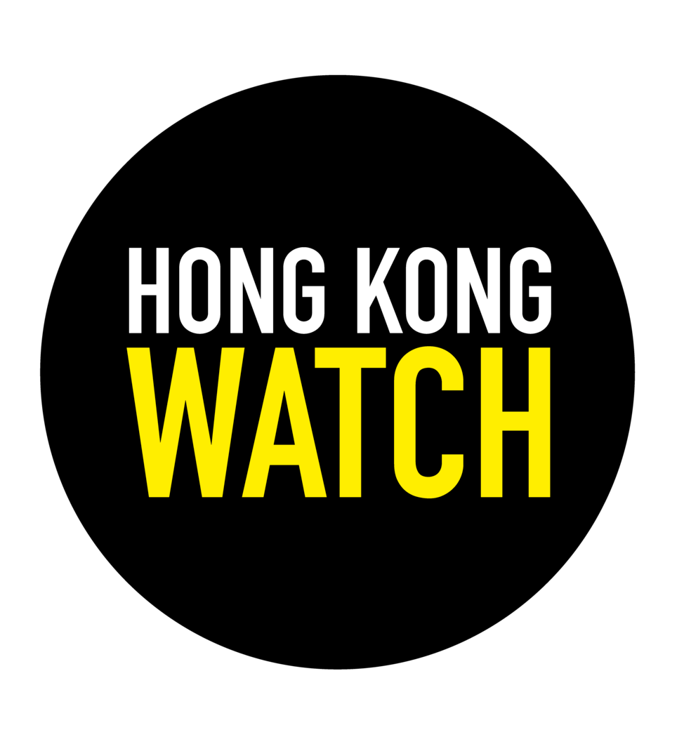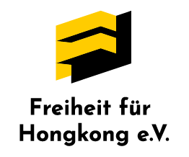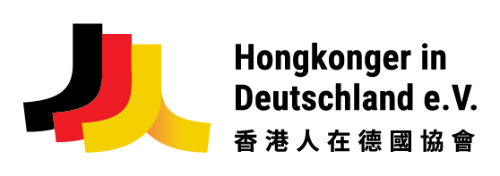

For enquiries, please contact Anouk Wear (anouk@hongkongwatch.org) from Hong Kong Watch.
- Introduction

Hong Kong Watch (HKW), Freiheit für Hongkong e.V. (FfHK), and Hongkonger in Deutschland e.V. (HKDE) make this submission to the United Nations (UN) Committee on the Elimination of Discrimination against Women (the Committee) as input into its consideration and adoption of the List of Issues (LOI) in advance of review of the Hong Kong SAR (HKSAR) government during the 85th Session. This submission can be published on the OHCHR website for CEDAW for public information purposes.

Hong Kong Watch is a UK-based registered charity which researches and monitors threats to Hong Kong’s basic freedoms, the rule of law and autonomy as promised under the ‘one country, two systems’ principle which is enshrined in the Basic Law and the Sino-British Joint Declaration.

Freedom for Hong Kong Association (Freiheit für Hongkong e.V.) is a non-profit organization based in Berlin. The association was founded in 2022 by activists from Germany and Hong Kong – in response to the steady deterioration of the human rights situation in Hong Kong. Our founding members unite a common mission: We strive for a free and democratic Hong Kong.
Hongkongers in Germany Association (Hongkonger in Deutschland e.V.) is a non-profit organization which was founded in 2019, acting as a bridge connecting Hong Kong and Germany, aiming to provide a platform for people in Hong Kong and Germany to network and offer mutual support. We also seek to gather and share information on Hong Kong’s state of affairs by closely monitoring the economic and political situation in Hong Kong. Our mission is to promote Hong Kong culture to Germans, facilitate access to the latest local information, and engage people in Germany to learn more about the history and current situation in Hong Kong.
Although China (including the HKSAR) was last reviewed by the Committee in 2014, this submission focuses on events and developments since 2019, which was when the Anti-Extradition Protests occurred, leading to the passage of the National Security Law (NSL), and followed by the NSL-related charges, arrests, and trials that are ongoing.

Since 2019, and particularly since the introduction of the NSL, there has been a rapid and severe decline in the rights and freedoms that can be enjoyed in the HKSAR. This submission highlights the women’s rights violations that are increasing under this climate.

We welcome this opportunity to submit information, highlight concerns, and give recommendations related to recent developments that impact adversely on rights under the CEDAW. We also support the People’s Republic of China’s (PRC) signature (1980) and ratification/ accession (1980) of the CEDAW and urges the PRC to fulfill their legal obligations in the HKSAR under this treaty.

- Gender-based violence against women
During the mass protests against the anti-extradition law from June until December 2019, women faced sexual harassment and assault from the Hong Kong Police Force (HKPF) and state-backed media, which greatly threatened their right not to be subject to torture or to cruel, inhuman or degrading treatment or punishment, as specified in Article 1 of the CEDAW.
Women were subjected to sexual assaults from police officers during stop and search routines. Ms CCK recounted an incident where she was stopped and searched by male police officer who refused her request for a female officer. According to the testimony from Ms CCK, this situation is far from an isolated event. In 2019, women who were stopped or arrested by the police were frequently searched by male officers, despite their specific request for a female officer. The women recalled being touched by male police officers on their inner thighs, close to their private areas, and described these touches to be invasive, degrading, and unnecessary. This is a violation of the Police General Orders Chapter 44-05, which stipulates that an officer shall not conduct nor observe a search of someone of the opposite sex. In the absence of a female officer, the female suspect should be escorted to a police station to be searched by a female officer.
The HKPF refuted these claims by accusing them of being malicious and without grounds. They insisted that no one lodged any complaints. However, all interviewees expressed distrust of the complaint-reporting mechanism of the HKPF, and cited that as the reason why they chose not to file a complaint. Ms CCK expressed doubts that the police would conduct investigations even upon receiving her complaint, quote “it is useless to report [this incident] to the police, because justice will not be served”. Ms CCK described the Independent Police Complaints Council (IPCC) as a “façade” that would disregard any complaints from female protesters as having “no evidence”.
This feeling of disempowerment is widespread among women in the HKSAR, and it was well-demonstrated by the chilling effect following Ms X’s cases. The then-18-year-old Ms X lodged a criminal complaint of rape by multiple police officers on 22 October 2019 following her arrest and detention at the Tsuen Wan Police Station. In her public statement through her legal counsel Vidler & Co. Solicitors, she subsequently became pregnant and had an abortion. The DNA sequence of the foetus was also filed along with the report in the hope of finding at least one of the assailants. She filed the report with no intention of seeking public attention. She was only forced to make the public statement after the police obtained a search warrant, which was immediately suspended by court after being challenged by Ms X’s counsel, to seize her private medical records and CCTV footage of the private clinic she visited on 4 November 2019. On 16 November 2019, the Police Commissioner alluded to the public that her criminal complaint contained “fake information” and that the investigators would begin investigating her case in the direction of “misleading police officers”. Ms X was informed by the Department of Justice that no further action on her complaint would be taken, claiming that her complaint is “contrary to the evidence [the police] obtained”. On 12 May 2020, the Police Commissioner publicly announced that Ms X was facing arrest for “making a false statement”. During the entire time, Ms X requested many updates via her legal representative but received no response.
The HKPF’s actions on Ms X’s case violated its own Victim’s Charter, which guarantees (1)privacy; and (2)victims’ right to information, as “victims of crime shall be kept fully informed of the progress of the case. The police’s non-compliance with their own regulations indicated a breach of the rule of law. Despite not being a protester, the grave nature of the sexual violence experienced by Ms X served as a deterrence for female protesters, both in participating in the protest and in lodging complaints to the police. A female protester was considering lodging a complaint about the sexual assault she experienced at a police station, but she dropped the idea citing Ms X’s experience. Furthermore, an anonymous HKPF officer admitted, on South Korean State TV, that the HKPF was following at least two cases of protestors who were allegedly raped by the HKPF.
The Committee acknowledged the adverse impact of women’s ability to gain access to justice on an equal basis with men through gender-based violence. Through the recounting of the experiences of Ms X and other women during the 2019 protest, we hope to demonstrate that (1)there were gross human rights violations committed by the HKSAR government and its related institutions during the above mentioned time frame against women who were perceived as protesters; and (2)the HKPF’s failure to provide the public with any satisfactory investigation that complies with the rule of law guaranteed by the law enforcement and the judiciary led to the general sentiment of fear among women in the HKSAR. This posed an obstruction to women’s access to justice, which eventually led to a sentiment that sexual violence was used as a repressive instrument, further limiting the right of women in the HKSAR to participate in political life.
The HKSAR government has an obligation of an immediate nature to pursue all appropriate means and policy to address this issue, including the provision of an effective and accessible legal and legal services framework to rectify gender-based violence against women committed by State agents, as well as the prevention of such acts. The HKSAR government also has an obligation to fulfill its guarantee to provide access to justice which is protected under the scope of Articles 2 and 15 of CEDAW.
As per paragraph 8 of the LOI, the Committee has requested information on the “the status of the complaints filed by women against HKPF officers for sexual violence, including rape, excessive use of force and abuses while in detention” and “measures in place to guarantee the independence and effectiveness of the Complaints against Police Office and the Independent Police Complaint Council.”
We regret that neither the PRC nor the HKSAR provided information in response to this specific request, despite the extensive open source and government information on these topics.
Our CEDAW submission provides first-hand accounts on the gender-based violence that women human rights defenders in the HKSAR face, and the lack of support to achieve accountability from the perpetrators.
In fact, the HKSAR itself was often the perpetrator of gender-based violence against women, therefore failing in their legal obligation, and causing women to fear seeking justice because they would not ask the perpetrator itself for help.

- Participation in political and public life
Article 7 of the CEDAW protects women’s equal rights to political and public life, and stipulates that the State Parties have the responsibility to ensure women’s participation.
Despite having a female Chief Executive during 2017-2022, the HKSAR’s women's rights progress has stalled in the 2019 movement, as women’s space to participate in public life was deterred by gender-based violence. The gross violation of human rights of the women who were protesters or were perceived as protesters and the subsequent failure to proper investigations by the HKPF led to a chilling effect.
The verbal and physical sexual abuse faced by female protesters in 2019 stirred fear, deterring them from fully exercising their freedom of assembly. These experiences range from unpleasant remarks to rape threats, from inappropriate touches to sexual assaults by the police. One female protester recalled an unwelcomed suggestive remark, “you are very pretty”, from a male police officer during a body search; others cited male police officers threatening them with “we will rape you later” while they were being detained in a police station. Multiple accounts of sexual assaults of protesters by police officers were reported to the media, particularly in the San Uk Ling Holding Centre. Among female protesters, “San Uk Ling” later became synonymous with police sexual abuse. One of the interviewees, Ms AK, commented that “there was an extra layer of worry for women in the HKSAR that they might get sexually assaulted if they were arrested”, threatening women’s participation in the public sphere.
Female activists and politicians in the HKSAR also faced verbal abuse, which deterred them from fully participating in political and public life. Interviewees who were active as female political figures in 2019 and 2020 all recounted the verbal abuse they experienced while being politically active in the HKSAR. Ms CL commented that “verbal abuse is one of the things female politicians have to face, and we have become accustomed to these behaviours.” On online fora, they were frequently referred to with derogatory terms with sexual connotations online and offline, implying that they were sex workers, promiscuous, and “loose women”.

3.1 Retrogression of Women’s Rights after the National Security Law
On top of the already hostile public sphere, politically active women faced an additional threat to their political and civil rights after the implementation of the NSL on 30 June 2020. After the NSL was implemented, there was a wave of suspension and arrests across the pro-democratic bloc. Political organisations dissolved or suspended their activities in the HKSAR on 30 June 2020. Many pro-democratic political figures were arrested for violating the NSL, including many women who had been vocal about gender issues:
- Chow, Hang-tung – Barrister and human rights defenders. Arrested on 4 June 2021 on the ground of promoting an unauthorised assembly (32nd anniversary of the Tiananmen massacre).
- Ho, Denise – Singer, pro-democracy and LGBTI+ activist. arrested on 29 December 2021 by the National Security Department of the HKPF on the ground of the production and distribution of seditious materials.
- Ho, Gwyneth – journalist-turned-politician. Arrested on 6 January 2021 on the ground of committing conspiracy to commit subversion under NSL.
- Wong, Pik-wan Helena – former Legislative Councillor and gender studies scholar, Arrested on 6 January 2021 on the ground of committing conspiracy to commit subversion under NSL.
- Yuen, Ka-wai Tiffany – politician and feminist. Arrested on 6 January 2021 on the ground of committing conspiracy to commit subversion under NSL.
Another prominent political figure Agnes Chow cited the fear induced by the NSL as her reason to quit politics. With these women’s rights leaders arrested and thus having their political voice silenced, the space for advocating women’s rights greatly diminished.
One of the interviewees, Ms AK, commented that post-NSL, it became very difficult for anyone to know “what they can or cannot say”. As a result, people in the HKSAR became cautious and refrain from openly discussing any political issues, including women’s rights. She commented that in the era when “human rights” became a sensitive topic for the PRC government, “women’s rights” have become a term that could potentially bring political consequences.
On 5 March 2023, the first Women’s Day March after the pandemic was cancelled. Organisers of the March released statements announcing that the Letter of No Objection issued by HKPF was subsequently suspended, rendering anyone who would march on that day as participating in an “unlawful assembly”.
As fear tactics evolved into the criminalisation of pro-democratic female political figures and suspension of women’s rights activities, there has been a clear retrogression of women’s right to political participation in the HKSAR following the implementation of the NSL in 2020.
As per paragraphs 11 and 12 of the LOI, the Committee has requested information on “the measures taken to accelerate women’s full and equal participation in elected and appointed bodies, including in decision-making positions at all levels” and “the investigations conducted into cases of violence and abuse against women who stand for election as independent candidates, and about the prosecution and punishment of perpetrators.”
In the HKSAR specifically, the Committee requested “information on the measures taken to protect women and girls from violence and harassment when participating in peaceful demonstrations, particularly during the protests in 2019.”
We regret that neither the PRC nor the HKSAR provided information in response to these specific requests, despite the extensive open source and government information on these topics. The reply to paragraph 11 only addressed information in the PRC (excluding the HKSAR) and there was no reply to paragraph 12.
Our CEDAW submission outlines the many factors which prevent women in the HKSAR from participation in political and public life, in particular the threats of and real incidents of gender-based violence, particularly sexual assaults and harassment.
This is a violation of Article 7(c) of CEDAW, which is an obligation to ensure women’s equal right “To participate in non-governmental organisations and associations concerned with the public and political life”.

This is also a violation of Article 15 of CEDAW, which legally binds the HKSAR to “accord to women equality with men before the law.” When women face incidents of gender based and sexual violence, they do not have the legal means to seek redress and are often harrassed and discriminated by the HKSAR itself.

- Representation of Women
As per paragraph 6 of the LOI, the Committee has requested information on the “measures taken to accelerate the representation of women in decision-making positions at all levels” in the HKSAR.
We regret that neither the PRC nor the HKSAR provided information in response to this specific question, despite the extensive open source and government information on these topics. The report only included measures taken in the PRC.
Our CEDAW submission outlines the many factors which prevent equal representation of women in the HKSAR, especially the obstacles to participation in political and public life and in particular the threats of and real incidents of gender-based violence, particularly sexual assaults and harassment.
Specifically, the violations that women face for seeking to participate in political and public life, as well as the violations that women human rights defenders face, create more obstacles for the representation of women in decision-making positions in the HKSAR.

- Women Human Rights Defenders and Women’s Non-Governmental Organisations
As per paragraph 13 of the LOI, the Committee has requested information on measures taken “to ensure that women human rights defenders may provide information to the Committee without fear of reprisals.”
We regret that neither the PRC nor the HKSAR provided information in response to this specific question, despite the extensive open source and government information on these topics. The report only included measures taken in the PRC.
Our CEDAW submission outlines the challenges and attacks on women human rights defenders from the HKSAR and demonstrates that they cannot advocate for human rights without fear of reprisals. This report draws from the interviews of three prominent political figures from the HKSAR.
They consented to publish their name in this report because all three of them had already left the HKSAR. They have either obtained refugee status or are in the process of seeking asylum outside of the HKSAR. They confirmed that many protesters and activists who were sexually assaulted by the police are unwilling to come forward and reveal their identities due to fear of persecution. Those remaining in the HKSAR are particularly at risk, leading to many people suspending their communication channel in the fear of data leak.
Our CEDAW submission outlines the challenges and attacks on women human rights defenders that are from the HKSAR, working on topics related to the HKSAR, whether they are physically in the HKSAR or abroad.
This includes the many factors which prevent equal representation of women in the HKSAR, particularly the obstacles to participation in political and public life, in particular the threats of and real incidents of gender-based violence, especially sexual assaults and harassment.

Recommendations

Women Human Rights Defenders
- We urge the Committee to ask the HKSAR what actions are taken to protect women human rights defenders from reprisals;
- We urge the Committee to ask the HKSAR what channels are available for support and accountability when the rights of women human rights defenders are violated;
- We urge the Committee to ask for a clarification on what rights women rights defenders can advocate for without violating the National Security Law;
- We urge the Committee to ask how the rights of women human rights defenders are protected and not violated under the National Security Law.

Gender-Based Violence
- We urge the Committee to ask the HKSAR to provide additional information in response to the LOI that is separate from the PRC information;
- We urge the Committee to ask the HKSAR what institutional support is available to victims of gender-based violence and what accountability tools there are;
- We urge the Committee to ask the HKSAR what has been done to investigate the allegations of rape and other sexual violence in relation to the 2010 protests.

Participation in political and public life
- We urge the Committee to ask the HKSAR to provide additional information in response to the LOI that is separate from the PRC information;
- We urge the Committee to ask the HKSAR what institutional efforts are made to improve the participation of women in political and public life.

Representation of Women
- We urge the Committee to ask the HKSAR to provide additional information in response to the LOI that is separate from the PRC information;
- We urge the Committee to ask the HKSAR what institutional efforts are made to improve the representation of women.

Appendix. Testimonies from women human rights defenders
The following section contains three testimonies and interview excerpts from three women human rights defenders, who are exiled political figures from the HKSAR. They are Ms CL, Ms CCK, and Ms AK.
Ms CL was an elected District Councillor in the HKSAR and served the office from 1 January 2020, a legislative assistant to a lawmaker who is now detained under the National Security Law, and the former deputy secretary-general of the Civic Party, a now dissolved pro-democratic party. She left the HKSAR in 2021 after the implementation of the National Security Law in 2020.
Ms AK is the Executive Director at Hong Kong Democracy Council (HKDC), and previously worked as an anonymous global campaigner during the 2019 movement. She is currently exiled in the United States.
Ms CCK is a political activist, PhD candidate in law on data protection and data transfer at the Hamburg University, and the campaign coordinator at the Inter-Parliamentary Alliance on China. She was threatened with arrest upon returning to the HKSAR after the implementation of the National Security Law.

Testimony from Ms CL

“As a female district councillor in Hong Kong, it is common to experience harassment or humiliation based on one's appearance, clothing style, or even just gender. Online harassment, harassment during face-to-face community work, and verbal abuse are all the things that female politicians have to face, and we have become accustomed to these behaviors. Many people in the society actually believe that "there's no rose without a thorn" and that women in politics must be prepared to face these things.

During my time as a district councilor in Hong Kong, the most serious accusation against me was being falsely labeled as a “prostitute". Right after I was elected, some pro-Beijing Facebook groups circulated several videos of naked women, claiming that I was a sex worker before being elected as a district councilor. However, the women in the videos looked nothing like me, and each video actually featured a different woman. Nevertheless, this false information and the videos spread widely in local community chat groups and even in real life. As a result, some people in the district believed it to be true and even came to my office to harass and verbally abuse me, calling me a "dirty whore”.

At the time, I did not dare to report to the police or seek assistance from any government department because I was afraid that it would be used as an excuse for further online censorship or the promotion of “internet real-name registration”. I could only rely on independent fact-checking media to clarify the situation, but most of these media outlets have now been shut down due to the National Security Law.”

Summary of the interview of Ms AK
Ms AK recalled what the female protestors experienced during the 2019 anti-extradition law protests. During that time, she was working within an anonymous network to support the front-line protesters. She stressed that she had since lost contact with most of the protesters as they had deactivated their Telegram or Signal accounts to prevent the government from tracking them and obtaining any evidence against them, due to their fear of repercussions from the government after the implementation of the NSL, or they have been arrested.
Regarding gender-based violence against women, Ms AK remembered observing verbal abuse on female protesters on online fora . As soon as they were revealed as women, they were called derogatory names, such as “黃天使” (wong4 tin1 si3), which can be translated literally as ‘yellow angel’. Yellow is a shorthand for people with a political affinity to the pro-democratic bloc, and angel means any women who would offer sexual favors or “services'' to male protesters. Ms AK herself was specifically compared to “李香蘭” (lei5 hoeng1 laan4), Li Hsiang-lan or Yamaguchi Yoshiko, a famous singer who performed for the occupied force of Japan in China in the 1930s, alluding to a sexualised and politicized figure. She also added that state-backed media outlets such as Takungpao 大公報 and Wenweipo文匯報 would also use these derogatory terms to call female protesters. She commented that the atmosphere at the time was as if the Hong Kong government “wanted to frame women as submissive, sexualized objects who were misguided by male leader”.
Ms AK recounted many incidents of sexual assaults she learnt of during the time of the 2019 protests, when she was working in an anonymous support network. Many female protesters complained to her that when they were stopped and searched by the police, they were often searched by male police without female officers present. One person recounted that the male police officer who conducted a body search on her commented, “You’re so pretty.” When the female protesters were brought to the police stations, they were ordered by female police officers to strip naked in front of male officers for a search. During the search, they would also be touched on their inner thighs, which made them feel violated.
Rape threats by police officers were also a frequent complaints from female protesters. Some of them received rape threats such as, “We will rape you later”, from police while being detained. Ms AK remarked that male protesters also received rape threats by the police, but overall, female protesters were more frequently threatened. She cannot assert that female protesters were more frequently threatened. She can only say I have heard more stories from women. This can also be because women tend to tell women these stories.
Ms AK remarked that “there was an extra layer of worry for women in Hong Kong, that they might get sexually assaulted if they were arrested”, pointing to a sense of fear that they might be targeted. There was also a general sense of disempowerment and distrust from female protesters at the state organs. She commented that protesters were reluctant to lodge formal complaints due to fears and dismissed complaints, since they have no confidence in the police investigation process. The vast majority of protesters agreed that the police would simply cover up the crimes the police officers committed. She called the Independent Police Complaints Council (IPCC) a “façade”. None of the cases would be deemed admissible because the IPCC would claim that there was “no evidence”, or that they have already “investigated internally”. Protesters would instead contact NGOs specializing in sexual harassment cases and/or the media. They seek help from the former for psychological counseling, and the latter as a way to warn other female protesters.
Regarding the NSL’s effect on female human rights defenders’ political participation, Ms AK commented that after the implementation of NSL, it has been very difficult for anyone to know where the red line is, “no one knows what they can or cannot say”. Previously, supporters of gender equality could openly discuss the issue of women’s rights; after the NSL, people became “cautious and subtle”. She commented that the Hong Kong Government’s claim to be a city embracing international values such as gender equality has in fact merely been “rhetoric”. Instead of implementing concrete gender equity policies, the Government resorted to only having superficial female representation. She cited the cancellation of the International Women’s Day March on 5 March 2023 as emblematic of the retrogression of women’s rights in Hong Kong.

Summary of the interview of Ms CCK

Regarding gender-based violence against women, Ms CCK reported frequent verbal harassment with sexual implications on her social media platforms. For example, she was called “雞” (gai1), a degrading Cantonese slang, implying the female targets are prostitutes, ”人盡可夫” (jan4 zeon6 ho2 fu1), degrading Chinese idiom, implying ‘loose woman’ that is sexually available to all men, and ”天使” (tin1 si3), which literally means angels, but is a new Cantonese slang that was developed and popularised during the 2019 protest that implies female protesters provide sexual favors to male protestors. Ms CCK described this as “slut shaming”, with the goal of denigrating women who participated in the political sphere in Hong Kong. Ms CCK also received rape threats on her social media platforms. Worried about her own safety, she began carrying an alarm device as soon as she left her home.

On top of verbal abuse, Ms CCK also experienced physical sexual violence from the police. She recounted an incident where she was stopped and searched on the street. Despite her request for a female officer, a male police officer proceeded to search her body. Apart from violence against her own person, she also stressed on the sexual assaults and rapes suffered by female protesters during detention by the police, particularly in San Uk Ling Holding Centre.

However, she did not consider lodging a complaint against the police and was not surprised that the majority of female protesters did not do so either, as they have no faith for a fair investigation. She recounted a separate incident where she lodged a police report after being sexually assaulted on the street. When making a statement at the police station, she was questioned by the female officer, “why were you wearing headphones? It is your fault.” She said that she did not report the abuse to HKPF due to a feeling of disempowerment. She concluded that such victim-blaming culture and behavior is deeply embedded in the police training. In addition, she expressed doubts that the police would take her report seriously, nor would they conduct proper investigations and provide protection to her, citing the pattern of victim blaming and the misogynistic culture of the police. Furthermore, the police’s failure to open any investigation on the rape allegations at San Uk Ling Holding Centre further deterred and discouraged female activists and protesters from reporting. She told us that “it is useless to report [these incidents] to the police ''because she knew “justice will not be served”. She also accused the IPCC of a lack of independence and impartiality, “Their own people investigate their own people (自己人查自己人) (zi6 gei2 jan4 caa4 zi6 gei2 jan4)”.

Ms CCK described that her mental health had taken a toll from the frequent abuse and threats. She also commented that sexual assault survivors suffered even more.

Regarding NSL’s effect on female activists and human rights defenders’ political participation, Ms CCK commented that the already small and hostile political space in Hong Kong for women has further deteriorated after the implementation of the NSL. Due to mass arrests and the rapid shrinking of civil society, the space for women to participate in politics, as well as the space to promote gender equality, has virtually disappeared. She cited journalist-turned-politician Gwyneth Ho (何桂藍), lawyer and human rights defender Chow Hang-tung鄒幸彤, activist and politician Wong Ji-yuet (黃子悅) who were arrested for violating the NSL. As they are some of the most prominent advocates for gender equality in Hong Kong, their arrests led to even less discussions of gender issues because they are no longer able to participate in public discourse, and other people are less inclined to get involved in advocating for gender equality. She also referred to Agnes Chow (周庭) who left politics due to the hostile environment after NSL. Ms CCK cited the Women’s Day March on 5 March 2023 being canceled, commenting that it was “unprecedented” and symptomatic that the space for advocating women’s rights is rapidly diminishing.

Moreover, the case of Lucy Chung also illustrates the institutional violence against women who advocate for women’s rights. While imprisoned, former member of Hong Kong Indigenous, Lucy Chung, filed a judicial review on the requirement for female prisoners to wear long trousers in the summer, citing gender discrimination as male prisoners are allowed to wear shorts. Subsequently, she was subjected to solitary confinement “水飯房” (seoi2 faan6 fong4) until she dropped the case.

United Nations Human Rights, Status of Ratification, accessed 12 January 2023, https://indicators.ohchr.org/
https://www.police.gov.hk/info/doc/pgo/tc/Cpgo044.pdf
https://www.news.gov.hk/eng/2019/08/20190816/20190816_172129_497.html?type=category&name=law_order&tl=t
The details and timeline of events of Ms X’s case can be found on the archived facebook page of her legal representative, Vidler & Co. Solicitors. https://www.facebook.com/profile.php?id=100063962133862. Mr Michael Vidler of the Vidler & Co. Solicitors (ceased practice on 3 June 2022) has consented to be contacted by the Committee should more information regarding Ms X’s case is required at mvidler@vidler-co.com.
Hong Kong Police Force. (Last update: April 2023) Victims Charter. https://www.police.gov.hk/ppp_en/04_crime_matters/vic_charter.html.
Ms X was not a protester and she has never participated in any protests in 2019. However, the time of the incident overlapped with the movement. Consequently, female protesters took her experience as a warning.
韓官方電視台訪現職港警 指強姦示威者確有其事 [South Korea's official TV station interviewed the current Hong Kong police, saying that the rape of the demonstrators was true], Radio Free Asia, 12 November 2019, https://www.rfa.org/cantonese/news/htm/kr-kbs-11122019074737.html
Committee on the Elimination of Discrimination against Women. (2015) General recommendation No. 33 on women’s access to justice. Para. 8.
Committee on the Elimination of Discrimination against Women. (2017) General recommendation No. 35 on gender-based violence against women, updating general recommendation No. 19. Para. 21.
List of issues and questions in relation to the ninth periodic report of China, 10 March 2021, https://tbinternet.ohchr.org/_layouts/15/treatybodyexternal/Download.aspx?symbolno=CEDAW%2FC%2FCHN%2FRQ%2F9&Lang=en
Male protesters also received rape threats during detention. Though interviewees agreed that they knew of more women who had experienced such violence.
https://www.bbc.com/zhongwen/simp/chinese-news-54915637
Hong Kong Women Workers' Association. (8 March 2023). https://www.facebook.com/hkwwa/photos/a.278028837139/10160600648682140/ Network for Women in Politics (8 March 2023). https://www.facebook.com/HKWomenInPolitics/posts/pfbid0uRye5KovoPVDTstPwuqarQGKadujU1exUrBh6wzXTtUotTntQ4H17xdkvG3HJQe6l
List of issues and questions in relation to the ninth periodic report of China
The Convention on the Elimination of All Forms of Discrimination Against Women
The Convention on the Elimination of All Forms of Discrimination Against Women
List of issues and questions in relation to the ninth periodic report of China

