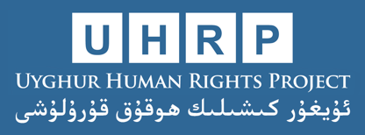

Submission to the UN Committee on Economic, Social and Cultural Rights (73rd Session)
Uyghur Human Rights Project, January 2023
The Uyghur Human Rights Project (UHRP) writes in advance of the 73rd session of the Committee on Economic, Social and Cultural Rights (“the Committee”) relating to China’s 3rd cycle review and compliance with the International Covenant on Economic, Social and Cultural Rights (ICESCR).
The following submission makes recommendations to the List of Issues (LOI) to be raised with China during the session, and addresses issues related to articles 2, 6, 7, 10, 12, 13 and 15 of the Covenant.
Executive Summary:
The government of China is perpetrating crimes against humanity and genocide in the Xinjiang Uyghur Autonomous Region (“Uyghur region”), targeting Uyghur and other Turkic and Muslim-majority peoples on the basis of religion and ethnicity.
The Chinese government is engaging in a systematic campaign to eradicate Uyghur culture, religion, and language through policy and practice, including the destruction of sacred cultural and religious sites such as mosques, cemeteries, and shrines, as well as marginalizing UNESCO-sanctioned intangible cultural heritage. The government has banned the use of Uyghur language in schools and detained and sentenced scholars wishing to establish Uyghur-language schools within the region.
Other systematic abuses include mass arbitrary detention of Uyghurs and Turkic peoples in order to “cleanse” detainees of “extremist” thoughts through “re-education” and forced labor. Clear Chinese government policy involves exploiting the labor of Uyghurs detained in internment camps and through forced labor programs at workplaces throughout the Uyghur region and across China.
China’s use of forced sterilizations and coerced IUD implants on Uyghur women represents a clear violation of the Covenant’s protections on the right to family and bodily autonomy, and observers argue that this meets the definition of genocide under the UN Convention.
The Chinese government has not adequately included Uyghurs in development planning, despite touting the benefits of the Belt and Road Initiative (BRI). Uyghurs continue to lag substantially behind as a result of inadequate attention to employment opportunities, lack of access to employment in the Uyghur language, and discriminatory hiring practices.
Below, we focus on six issues related to the Covenant, and present for each: List of Issues questions; the State Party’s response to the List of Issues questions; and suggested questions for Committee members during the examination of the State Party under review.
- Non-discrimination (Article 2)
List of Issues summary (2021): “Please also provide information on the measures taken, and their effectiveness, to combat the widespread social stigma and discrimination against disadvantaged and marginalized individuals and groups, including ethnic and religious minority groups, rural migrants …” (para. 12)
State Party response: “Citizens enjoy equal rights in accordance with the law. The Constitution as well as the Law on Regional Ethnic Autonomy, the Labour Law, the Law on the Protection of the Rights and Interests of Women, the Law on the Protection of the Rights and Interests of the Elderly, the Law on the Protection of Minors […] all stipulate that discrimination is prohibited.”
Suggested questions: How will the government of China ensure that benefits from development and the Belt and Road Initiative (BRI) accrue equitably to all ethnic groups? Can the government provide disaggregated data on income disparities between ethnic groups?
- The Chinese government, while touting the success of development policies in the Uyghur region for many years, has failed to provide detailed, disaggregated data showing disparities between ethnic groups. In doing so, it remains difficult to adequately understand how development policies have been impacting Uyghur and Chinese populations as such.
- Uyghurs suffer from significantly higher unemployment rates than Chinese due to exclusion by state and private employers in sectors like energy, construction, resource extraction, and government positions, as well as exclusion based on language skills. The Belt and Road Initiative has boasted the potential development advantages for the entire region, but many past development campaigns have actually exacerbated economic problems for Uyghurs and led to greater inequities.
- Uyghurs rely largely on agriculture for employment and have reported increased rates of poverty and unemployment, citing land degradation, lack of water, and land grabs from Chinese settlers. Uyghur migration to the north has resulted in labor-intensive jobs paying significantly less than Chinese workers. Rural Uyghur workers also face significant barriers accessing credit as well as an adequate share of resources like water.
- Forced Labor (Articles 6, 7, and 12)
CESCR List of Issues (LOI): “…please provide information on the steps taken to address reports about forced labour and physical and mental abuse allegedly involved in vocational training programmes provided by the State party, including through vocational training centres, for surplus rural workforce, particularly Uighurs, Tibetans and other ethnic minority groups…”
Government response: “Workers of all ethnic groups in Xinjiang choose occupations completely according to their own wishes, and their personal freedom has never been restricted in any way.” (para. 16)
- There is a substantive body of evidence that the Government of China is subjecting the Uyghur population and other Turkic and Muslim-majority peoples to state imposed forced labour as part of a programme including so-called ‘poverty alleviation’, ‘vocational training’, ‘re-education through labour’ and ‘de-extremification’ focused on eliminating Uyghur culture and religious practices.
- Forced labour transfers: At least 80,000 Uyghurs and other ethnic minorities have been forcibly transferred from the Uyghur region to factories in eastern and central China between 2017 and 2019. This is part of a state-sponsored transfer-of-labour scheme that goes beyond just the cotton and garment manufacturing sector, marketed as ‘Xinjiang Aid.’ The vast majority of workers forced into these “labour transfer” schemes, however, have been transferred within the Uyghur region itself—either to another prefecture or county.
- Coerced labour of the rural poor in the ‘poverty alleviation programme’: The Chinese government plans to have at least one million workers in the textile and garment sectors, with at least 650,000 coming from the Uyghur region by 2023. Regional and local government directives indicate that refusal to participate in poverty alleviation in the Uyghur region is considered a sign of the “three evils”—terrorism, separatism, and religious extremism—which are punishable by internment or imprisonment.
- Forced labour of current and ex-detainees, including in internment camps: In a separate but parallel policy to China’s public poverty alleviation plan, the government has enacted a public “re-education” policy that involves internment with some vocational training, indoctrination, and finally release to factories in nearby industrial parks or camp factories. Estimates based on interviews and government statements are at least 100,000 former detainees who have been forced to work in garment and textile factories.
- Cultural rights (Article 15)
CESCR List of Issues (LOI): “Please also comment on reports that the State party has: (a) attempted to eradicate the culture, religion and language of Uighurs and Tibetans through massive destruction of sacred cultural and religious sites and bans on the practice of religious rituals and on the use of the Uighur and Tibetan languages in schools; and (b) suppressed individuals and institutions promoting education in minority languages in school.”
State Party response: “The Xinjiang Uighur Autonomous Region has 24,800 mosques, churches, monasteries, Taoist temples and other places for religious activities, including more than 24,400 mosques and 29,300 clerical teaching staff.”
Suggested questions: How does the Chinese government intend to protect cultural rights embedded in the Covenant while researchers have documented the destruction of thousands of Uyghur mosques, shrines, and graveyards? What steps will the Chinese government take to ensure Uyghurs are able to rebuild these sites?
- Evidence clearly indicates that the Chinese government has destroyed Uyghur cultural landmarks, including mosques, shrines, and cemeteries (See figures 1 and 2). The current number of mosques cited in the Chinese government response (24,400) is not supported by evidence.
- China’s actions in the Uyghur region constitute what UNESCO calls “strategic cultural cleansing”: the deliberate targeting of individuals and groups on the basis of their cultural, ethnic or religious affiliation, combined with the intentional and systematic destruction of their cultural heritage. As acknowledged in the 2021 International Criminal Court framework on cultural heritage, acts of dispossession and destruction of cultural heritage are often inseparable from—or the precursor to—acts of genocide.
- According to forthcoming research by the Uyghur Human Rights Project, the Chinese government’s management of the cultural heritage of the Uyghur region places control firmly in the hands of the government and its chosen commercial partners. Heritage is exploited for economic profit and used to promote the government’s chosen versions of history and culture, regardless of established historical fact and regardless of the rights of communities and culture bearers acknowledged in UNESCO’s conventions. This mismanagement of heritage includes bans on grassroots cultural practices; the detention and imprisonment of culture bearers; forced expulsion of residents from their ancestral lands; and environmental damage to heritage sites.
- In 2019, UHRP conducted an investigation through geospatial analysis, calculating that 10–15,000 Uyghur religious sites have been destroyed or damaged by the Chinese government since 2016. A separate study focused on damage to Uyghur mosques calculated that over 8,500 mosques across the Uyghur region have been demolished by the Chinese government since 2017—a figure representing the destruction of over one third of the region’s total mosques.
- Mosques have been forced to remove Islamic architecture, symbols, or Arabic writing, including the crescent moon or domes which adorn the top of the structures. Some mosques have also been converted entirely into shops, housing, and even bars. In one instance, the local government razed a mosque in Atush in order to install a public toilet.
- Nearly 85 percent of the Old City of Kashgar, a 2000-year-old city, was demolished between 2009 and 2017, displacing hundreds of thousands of residents without consultation. A UNESCO cultural specialist in Beijing called the redevelopment of Kashgar “one of the black spots of heritage conservation.”
- Since April 2017, the Chinese government has interned, imprisoned, or disappeared at least 312 Uyghur and other Turkic Muslim intellectual and cultural elites. These actions amount to a campaign to suppress Uyghur cultural expression. Among those detained include Uyghur teachers, scholars, students, poets, musicians, as well as the academic staff of Xinjiang University. Those targeted include writers, poets, academics, researchers, artists, and performers. As a component of genocide, the assault on intellectual and cultural elites may constitute a new form of eliticide meant to exterminate Uyghur (and other) cultural identity.
- The teaching of religion is also prohibited from curriculum at all education levels in the Uyghur region. Outside of schools, Uyghurs under the age of 18 are unable to enter mosques or participate in religious activities of any kind. In 2018, Uyghur students were forced to sign pledges in schools stating that they would not fast during Ramadan.
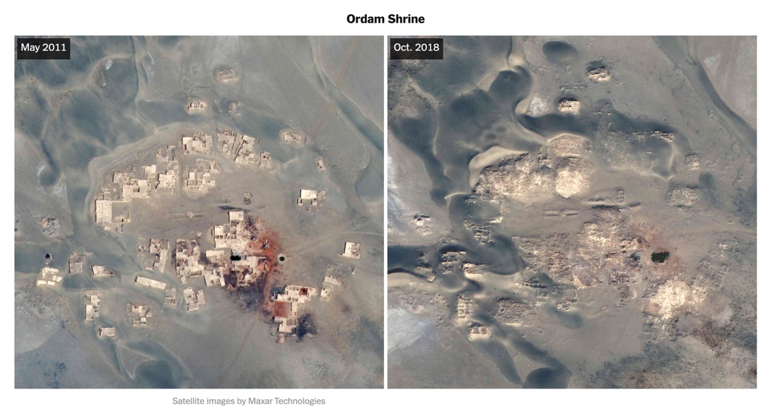

Figure 1: Geospatial analysis of the now destroyed Ordam Shrine (2011–2018)

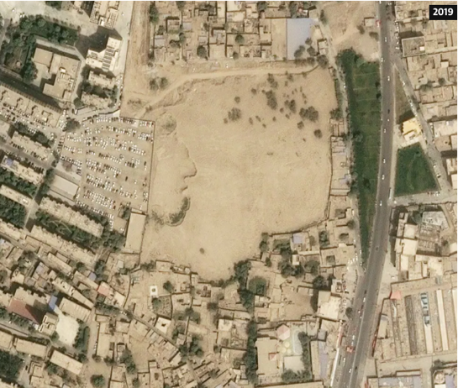
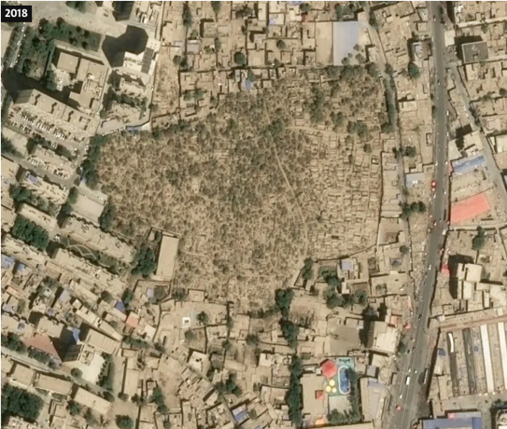

Figure 2: Geospatial analysis of the destroyed Sultanim Cemetery (2018–2019)

- Forced sterilization (Article 10)
CESCR List of Issues (LOI): “Please indicate any action taken to prevent and criminalize the use of coercive measures, particularly targeted at ethnic minority groups, in the implementation of the birth control policy…and provide statistical data, disaggregated by ethnicity and region, on the number of abortions and sterilizations carried out. Please also clarify the reasons for the reportedly marked decline in birth rates among religious minority groups and provide information on the trend in the demographic composition in the Xinjiang Uighur and Tibet Autonomous Regions over the past five years.”
State Party response: “The implementation of family planning policy in China is relatively relaxed for ethnic minorities, and no coercive measures are directed against them … The population of ethnic minorities increased by 1.865 million or 14.27 per cent compared with 2010, a growth rate that was 4.01 percentage points higher than that of the overall ethnic minority population nationwide.”
Suggested questions: According to government statistics, Uyghur birth rates fell dramatically between 2015 and 2018—what accounts for this declining birth rate? Will the government release disaggregated statistics on birth rates among Uyghurs and other ethnic minorities?
- The Chinese government response to the List of Issues report does not engage at all with the question of declining birth rates among the Uyghur population. Rather, the response cites population increases among all ethnic minorities across the country, which purposefully obscures the declining birth rate among Uyghurs in particular. Likewise, the response does not respond to the allegations made by the Committee. Rather, the response simply denies the existence of coercive birth policies without refuting the specific claims based on statistical data.
- Birth rates among Uyghurs plummeted from 2015–2018, with population growth in the Uyghur region falling by over 84 percent in that period in the two largest Uyghur prefectures, Kashgar and Hotan. See chart below for birth rate declines from 2015–2018.
- Since 2015, the government of China has made efforts to reduce the birthrate of Uyghur women through coercive family planning—including forced sterilization. In 2018, 80 percent of all net added IUD placements in China were performed in the Uyghur region, despite the fact that the region only makes up 1.8 percent of the nation’s population. Between 2015 and 2018, the regional government placed 7.8 times more net-added IUDs per capita than the national average.
- Government documents show that local authorities are instructed to punish Uyghur women who “violate” birth control targets with extrajudicial internment and “vocational skill” training camps. A leaked document known as the Qaraqash List showed that in one county in the Uyghur region, the most frequently cited reason for internment of Uyghur women was a violation of birth control regulations. A Qaraqash county’s official, in a 2018 government work report stated that “[by] severely curbing behaviors that violate birth control [policies], birth and natural population growth rates have declined dramatically.”
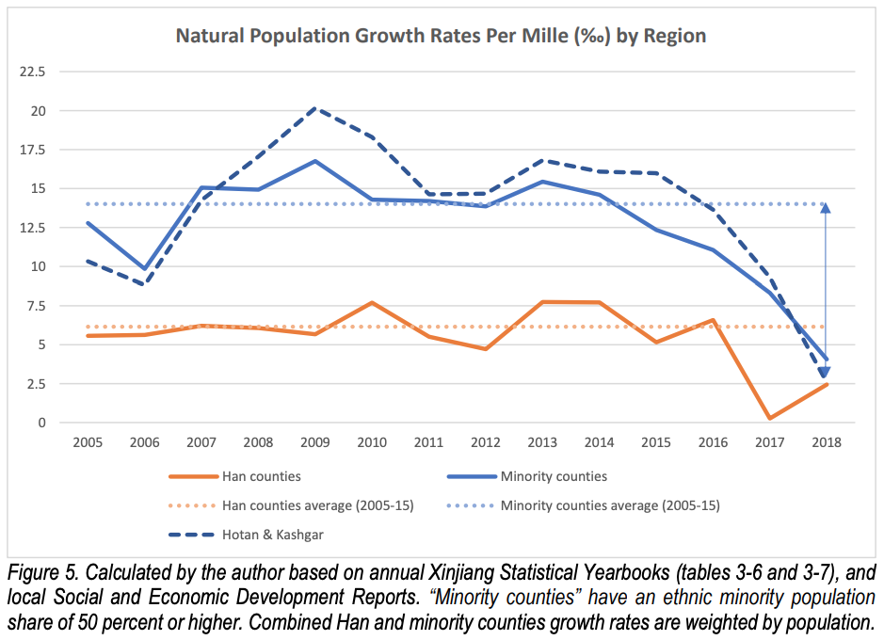
- Authorities have planned a campaign of mass female sterilization in rural Uyghur regions, noting in official documents they wish to target 14 and 34 percent of all married women of childbearing age in two Uyghur counties that year. The campaign aims to permanently sterilize rural minority women with three or more children, as well as some with two children, criteria which would cover at least 20 percent of all childbearing-age women. In 2018, one Uyghur prefecture publicly set a goal of leading its rural populations to accept widespread sterilization surgery.
- Forced and incentivized marriage (Article 10)
- According to recent research, it is highly likely that the Chinese government is systematically imposing forced interethnic marriages on Uyghur women. Chinese state media videos, government sanctioned stories, and accounts from women in the diaspora offer evidence that government incentivized and forced interethnic marriages have been occurring in the Uyghur region since 2014.
- The Chinese state maintains that interethnic marriage promotes ethnic unity and social stability. However, evidence indicates that the government’s program to incentivize and promote interethnic marriage is in fact a tactic intended to assimilate Uyghurs into Han society. Forced and incentivized marriages in the Uyghur region are forms of gender-based crimes that violate international human rights standards and further the ongoing genocide and crimes against humanity being committed in the Uyghur region.
- Right to education/language rights (Articles 13 and 15)
CESCR List of Issues (LOI): “Please clarify how the replacement of ethnic minority languages, including Uighur, Tibetan and Mongolian, by Chinese (Putonghua) as the medium of instruction in compulsory education is justified under the policy.”
State Party response: “To ensure that students from all ethnic groups receive a quality education in their own spoken and written languages, ethnic-group language curricula are being set up, the compilation of teaching materials in ethnic-group languages is being improved, and teaching resources in spoken and written ethnic-group languages are being developed.”
Suggested questions: Are Uyghur students provided equal access to Uyghur-language instruction in schools at all education levels? How does the government ensure Uyghur children are able to study in their mother tongue?
- In 2017, the Hotan Prefecture Education Department banned the use of the Uyghur language “at all education levels up to, and including secondary school, in favor of Mandarin.” It also instructed authorities in Hotan Prefecture to “prohibit the use of Uyghur language, writing, signs and pictures in the educational system and on campuses.” The directive also called upon local schools to “resolutely correct the flawed method of providing Uyghur language training to Chinese language teachers.”
- In January 2018, four UN Special Rapporteurs issued a Joint Other Letter to the government of China regarding its ban of the Uyghur language in schools, writing: “We would like to express our serious concern over the directive issued by the Education Department in Hotan Prefecture on 28 June 2017…We are concerned at the disproportionate and hence discriminatory provisions of the directive, which impose a ban on, or seriously reduce, the use of the Uyghur language in educational settings in the Xinjiang Uyghur Autonomous Region.”
- The government of China’s implementation of ‘bilingual education’ programs in the Uyghur region beginning in the mid-1980s has intentionally weakened teaching and the use of the Uyghur language. In practice, “bilingual education” in the Uyghur region constitutes a policy of transitioning Uyghur students at all levels of education to speak and learn only in Mandarin Chinese, rather than having them learn simultaneously in their native tongue.
- The numbers and funding of “bilingual educational institutions” indicate a growing monopoly of Chinese-language schools. The regional government has set a target of 2,600,000 students for 2020—a goal which constituted enrolling nearly all non-ethnically Han students in the Uyghur region into these schools in order to firmly establish Mandarin as their primary language in education.

* * *
About the Uyghur Human Rights Project:
UHRP promotes the rights of the Uyghurs and other Turkic Muslim peoples in East Turkistan, referred to by the Chinese government as the Xinjiang Uyghur Autonomous Region, through research-based advocacy. UHRP publishes reports and analysis in English and Chinese to defend Uyghurs’ civil, political, social, cultural, and economic rights according to international human rights standards.
UHRP documents violations; highlights human rights defenders, survivors, and victims; and researches avenues for defense and positive promotion of Uyghurs’ human rights, especially in the arenas of policymaking, grassroots action, and cultural rights promotion. We emphasize bringing forward Uyghur voices and Uyghur experiences to international fora and decision-makers.

Uyghur Tribunal Judgement, December 9, 2021. Available online: https://uyghurtribunal.com/wp-content/uploads/2022/01/Uyghur-Tribunal-Judgment-9th-Dec-21.pdf.
Ilham Tohti (2015, April 15). Present-Day Ethnic Problems in Xinjiang Uighur Autonomous Region: Overview and Recommendations – Unemployment, China Change. Retrieved from: https://chinachange.org/2015/04/22/present-day-ethnic-problems-in-xinjianguighur-autonomous-region-overview-and-recommendations-1.
Uyghur Human Rights Project (April 2017). “Discrimination, Mistreatment and Coercion: Severe Labor Rights Abuses Faced by Uyghurs in China and East Turkestan.” Retrieved from: https://uhrp.org/docs/Discrimination_Mistreatment_Coercion.pdf.
Uyghur Human Rights Project (2016). “End of the Road: One Belt, One Road and the Cumulative Economic Marginalization of the Uyghurs.” Retrieved from: http://uhrp.org/docs/End-of-the-Road.pdf.
Howell, A. & Fan, C., Migration and Inequality in Xinjiang: A Survey of Han and Uyghur Migrants in Urumqi, (Eurasian Geography and Economics, 2011).
9 Jiang Leiwen, Tong Yufen, Zhao Zhijie, Li Tianhong and Liao Jianhua. (2005). Water Resources, Land Exploration and Population Dynamics in Arid Area – The Case of Tarim River Basin in Xinjiang of China. Asian Metacentre Research Paper Series, 18. Retrieved from: http://www.populationasia.org/Publications/RP/AMCRP18.pdf.
Research organisations, including the Center for Strategic and International Studies, the Worker Rights Consortium, the Helena Kennedy Centre for International Justice at Sheffield Hallam University, and the Australian Strategic Policy Institute, and investigative journalists from The Wall Street Journal, the BBC Associated Press, The New York Times, The Globe and Mail, ABC Australia, Radio Free Asia, Reuters and other outlets have documented specific cases of forced labour in the apparel and textile industry, including in gloves and shoe manufacturing, in PPE production, in the solar industries, in the automotive industry, in electronics, in hair products and in tomato processing in the Uyghur Region and wider China.
Uyghur Human Rights Project (October 2019). “Demolishing Faith: The Destruction and Desecration of Uyghur Mosques and Shrines.” Retrieved from: https://uhrp.org/press-release/demolishing-faith-destruction-and-desecration-uyghur-mosques-and-shrines.html; see also Australia Strategic Policy Institute (September 24, 2020). “Cultural erasure: Tracing the destruction of Uyghur and Islamic spaces in Xinjiang,” pp5. https://www.aspi.org.au/report/cultural-erasure.
UNESCO, “Reinforcement of UNESCO’s Action for the Protection of Culture and the Promotion of Pluralism in the event of Armed Conflict,” Document 39 C/57, October 24, 2017.
ICC Policy on Cultural Heritage, 2021, p.30, https://www.icc-cpi.int/sites/default/files/itemsDocuments/20210614-otp-policy-cultural-heritage-eng.pdf.
See the forthcoming 2023 UHRP report, “The Complicity of Heritage: Cultural Heritage and Genocide in the Uyghur Region.” Available online: https://uhrp.org/the-complicity-of-heritage-cultural-heritage-and-genocide-in-the-Uyghur-region.
Uyghur Human Rights Project (October 2019). “Demolishing Faith: The Destruction and Desecration of Uyghur Mosques and Shrines.” Available at: https://docs.uhrp.org/pdf/UHRP_report_Demolishing_Faith.pdf.
Deng, Chao (September 2020). “China Razed Thousands of Xinjiang Mosques in Assimilation Push, Report Says,” The Wall Street Journal. Available at: https://www.wsj.com/articles/china-razed-thousands-of-xinjiang-mosques-in-assimilation-push-report-says-11601049531.
Buckley, Chris (September 2020). “China Is Erasing Mosques and Precious Shrines in Xinjiang,” The New York Times. Available at: https://www.nytimes.com/interactive/2020/09/25/world/asia/xinjiang-china-religious-site.html.
Nathan Ruser, James Leibold, Kelsey Munro & Tilla Hoja (September 2020). “Cultural erasure: Tracing the destruction of Uyghur and Islamic spaces in Xinjiang,” Australian Strategic Policy Institute. Available at: https://www.aspi.org.au/report/cultural-erasure.
Radio Free Asia (August 2020). “Public Toilet Erected on Former Site of Razed Xinjiang Village Mosque.” Available at: https://www.rfa.org/english/news/uyghur/toilet-08132020142800.html.
Uyghur Human Rights Project (March 2012). “Living on the margins: The Chinese state’s demolition of Uyghur communities.” Retrieved from: http://docs.uyghuramerican.org/3-30-Living-on-the-Margins.pdf.
Levin, Dan (March 5, 2014). “China Remodels an Ancient Silk Road City, and an Ethnic Rift Widens,” The New York Times. Retrieved from: https://www.nytimes.com/2014/03/06/world/asia/china-remodels-an-ancient-silk-road-city-and-an-ethnic-rift-widens.html.
Uyghur Human Rights Project (December 2021). “The Disappearance of Uyghur Intellectual and Cultural Elites: A New Form of Eliticide,” Retrieved from: https://uhrp.org/report/the-disappearance-of-uyghur-intellectual-and-cultural-elites-a-new-form-of-eliticide/.
Uyghur Human Rights Project (March 25, 2019). “Detained and Disappeared: Intellectuals Under Assault in the Uyghur Homeland.” Available at: https://uhrp.org/press-release/detained-and-disappeared-intellectuals-under-assault-uyghur-homeland.html.
Uyghur Human Rights Project, "Report: The Persecution of the Intellectuals in the Uyghur Region Continues," January 2019. Available at: https://docs.uhrp.org/pdf/UHRP_UPDATE-ThePersecution_ofTheIntellectuals-in-the-Uyghur-Region.pdf.
A full list can be found here: https://uhrp.org/intellectuals/.
Hoja, G. (February 6, 2006), “China Bans Officials, State Employees, Children from Mosques,” February 2006. Radio Free Asia Uyghur Service. Available at: https://www.rfa.org/english/uyghur/uyghur_religion-20060206.html.
Hoja, G. (May 21, 2018), Uyghur schoolchildren, Parents Forced to Abstain From Fasting During Ramadan, Radio Free Asia Uyghur Service. Available at: https://www.rfa.org/english/news/uyghur/schoolchildren-05212018151019.html.
Zenz, Adrian (July 2020). “Report: Sterilizations, IUDs, and Coercive Birth Prevention: The CCP’s Campaign to Suppress Uyghur Birth Rates in Xinjiang,” The Jamestown Foundation - China Brief Volume: 20 Issue: 12, p. 8–9. Available at: https://jamestown.org/program/sterilizations-iuds-and-mandatory-birth-control-the-ccps-campaign-to-suppress-uyghur-birth-rates-in-xinjiang/.
Zenz, Adrian (July 2020). “Report: Sterilizations, IUDs, and Coercive Birth Prevention: The CCP’s Campaign to Suppress Uyghur Birth Rates in Xinjiang,” The Jamestown Foundation - China Brief Volume: 20 Issue: 12, p. 3. Available at: https://jamestown.org/wp-content/uploads/2020/06/Zenz-Internment-Sterilizations-and-IUDs-UPDATED-July-21-Rev2.pdf?x99616.
Uyghur Tribunal Judgement, p. 33. Available online: https://uyghurtribunal.com/wp-content/uploads/2022/01/Uyghur-Tribunal-Judgment-9th-Dec-21.pdf.
Ibid.
Shepherd, Christian, “The Karakax list: how China targets Uighurs in Xinjiang,” The Financial Times, February 2020. https://www.ft.com/content/e0224416-4e77-11ea-95a0-43d18ec715f5.
Zenz, Adrian (July 2020). “China’s Own Documents Show Potentially Genocidal Sterilization Plans in Xinjiang,” Foreign Policy. Available at: https://foreignpolicy.com/2020/07/01/china-documents-uighur-genocidal-sterilization-xinjiang/.
Ibid.
Zenz, Adrian (July 2020). “Report: Sterilizations, IUDs, and Coercive Birth Prevention: The CCP’s Campaign to Suppress Uyghur Birth Rates in Xinjiang,” The Jamestown Foundation - China Brief Volume: 20 Issue: 12. Available at: https://jamestown.org/program/sterilizations-iuds-and-mandatory-birth-control-the-ccps-campaign-to-suppress-uyghur-birth-rates-in-xinjiang/.
Ibid.
Uyghur Human Rights Project (November 2022). “Forced Marriage of Uyghur Women: State Policies for Interethnic Marriages in East Turkistan,” Retrieved from: https://uhrp.org/report/forced-marriage-of-uyghur-women/.
Ibid., 34.
Mandates of the Special Rapporteur on minority issues; the Special Rapporteur in the field of cultural rights; the Special Rapporteur on the right to education and the Special Rapporteur on the promotion and protection of the right to freedom of opinion and expression, "Concerning the directive on bilingual education issued on 28 June 2017 by Hotan’s Education Department", OHCHR, January 2018. Available at: https://spcommreports.ohchr.org/TMResultsBase/DownLoadPublicCommunicationFile?gId=23557.
Uyghur Human Rights Project (May 2019). “Resisting Chinese Linguistic Imperialism: Abduweli Ayup and the Movement for Uyghur Mother Tongue-Based Education.” Available at: https://docs.uhrp.org/pdf/UHRP_Resisting_Chinese_Linguistic_Imperialism_May_2019.pdf.
Mandates of the Special Rapporteur on minority issues; the Special Rapporteur in the field of cultural rights; the Special Rapporteur on the right to education and the Special Rapporteur on the promotion and protection of the right to freedom of opinion and expression, “Concerning the directive on bilingual education issued on 28 June 2017 by Hotan’s Education Department,” OHCHR, January 2018. Available at: https://spcommreports.ohchr.org/TMResultsBase/DownLoadPublicCommunicationFile?gId=23557.
Uyghur Human Rights Project (May 2015). “Uyghur Voices on Education: Chinese Assimilative ‘Bilingual Education’ Policy in East Turkistan.” Available at: https://uhrp.org/press-release/uhrp-releases-report-bilingual-education-east-turkestan—uyghur-voices-education.html.
Ibid.

