
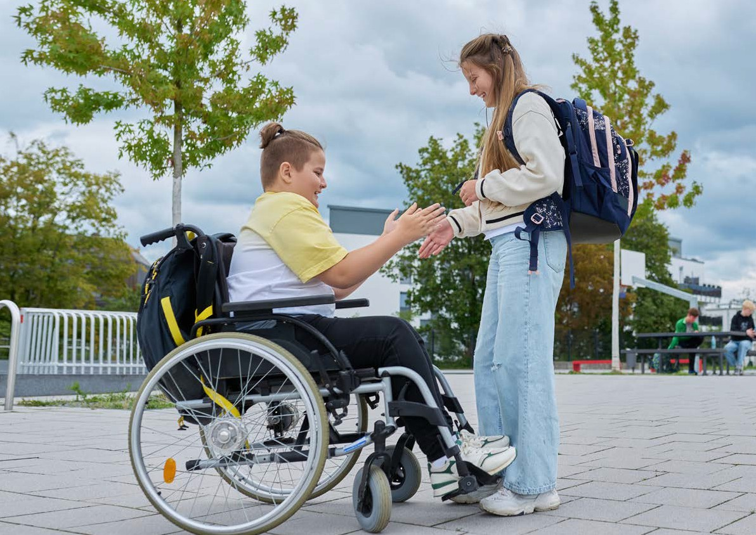
National strategy to implement the UN Convention on the Rights of Persons
with Disabilities

Contents
Preface
Introduction
UN Convention on the Rights of Persons with Disabilities
Moving towards an inclusive and accessible society
People with disabilities and those close to them
The National Strategy and the Netherlands in the Caribbean
Readers’ guide
Major principles
- Equal rights
- Self-determination and legal position
- Socioeconomic security
- A society in which everyone feels welcome
Life domains
- Work and income
- Living independently and housing
- Education and development
- Health and support
- Transport and mobility
- Culture, media, leisure, sport and exercise
- Safety and legal protection
Governance, roles and responsibility
Nothing about us without us
Consultative structure
Monitoring

Ministry of Health, Welfare and Sport National Strategy to implement the UN Convention on the Rights of Persons with Disabilities

Preface
Almost one in eight people in the Netherlands has some kind of disability, something that prevents them from fully developing their talents, to the extent that it can stand in the way of their happiness in life. Together we can organise society in such a way that everyone, whether they have a disability or not, can fully participate. So that as a country and as individuals we can be satisfied that everyone feels welcome to make their own contribution to a better society. This is important to us. It is the reason why the Netherlands has signed up to the UN Convention on the Rights of Persons with Disabilities. In this National Strategy, we show how our country has committed itself to achieving the goals of the Convention, in order to build an inclusive and accessible society for all.

Far too often, people with disabilities still experience barriers in society that stand in the way of equal participation in all areas of life. The aim of this National Strategy is to introduce a range of improvements and to ensure that they are interconnected. For example, the workplace is only genuinely accessible if you can reach it using accessible transport. In addition, we want to combat stigma and bias, so that people with disabilities not only have the same opportunities, but also feel completely accepted.

People with disabilities are more knowledgeable than anyone about the barriers that prevent them from fully participating in society. They encounter them every day. That is why I have drawn up this strategy with them and their representative organisations. They are also involved in implementing the measures contained in the strategy, which will be brought together in a work agenda.

We cannot implement the strategy and work agenda alone. To build an accessible and inclusive society we need everyone’s input. We are working with all national and local authorities, companies, civil society organisations and the general public towards a society in which children, young people and adults with disabilities have the same opportunities as everyone else. A society we can be proud of.
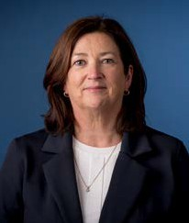

Conny Helder
Minister of Health, Welfare and Sport, Coordinating Minister for the UN Convention on the Rights of Persons with Disabilities

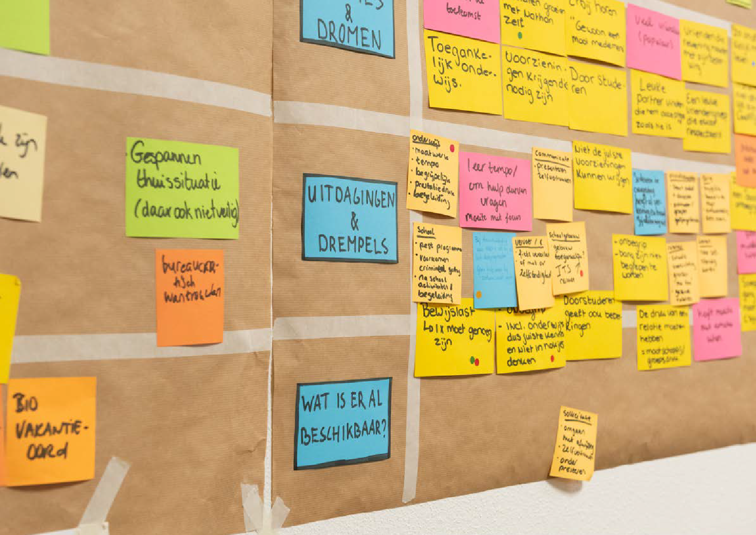

Introduction

A society in which everyone can participate, in which children, young people and adults with disabilities have the same opportunities as everyone else to join in and develop their talents. A society in which human dignity and equality of opportunity are central themes. That is the society we in the Netherlands seek to create. Our aim is to be pioneers in the field of equal opportunities and equal rights for people with disabilities. For this we need to change the way we look at how our society is organised.

UN Convention on the Rights of Persons with Disabilities
In 2016 the Netherlands ratified the UN Convention on the Rights of Persons with Disabilities. This commits the government to realising the rights arising from the Convention, which focuses on an inclusive and accessible society. The key principles are full participation in society, the freedom to make your own choices, independence, human dignity and equality of opportunity. In addition, the Convention, and therefore also the National Strategy, are based on the social model of disability: the problem is not the disability but the way society is organised. The essence of the model is that people are disabled not by their impairment but by the way things are organised or constructed. Inaccessibility, whether created by physical barriers or by people’s attitudes, is usually the cause of disability. And if it is created by how we think about people with disabilities, then the solution to the problem lies not with the individual but with all of us. In line with the Convention, we are therefore focusing on removing the barriers preventing people with disabilities from fully participating in society.

Moving towards an inclusive and accessible society
The Netherlands believes it is important to commit to the goals of the UN Convention on the Rights of Persons with Disabilities. For this reason, after ratifying the Convention, it initiated a movement towards improving the position of people with disabilities and towards changing perceptions in this area. Many civil society organisations and companies are willing and able to contribute to such improvements. Together with residents, local authorities are taking steps to achieve an inclusive community. Through the Participation without Limitations programme, the Ministry of Health, Welfare and Sport, together with other ministries, has contributed in recent years to improving the position of people with disabilities.
Without detracting from the efforts that have been made, we have to conclude that there is still a long way to go. There are too many signals, research reports and evaluations of legislation showing that people with disabilities cannot participate in society on an equal basis.

That is why we wish to make a concerted effort, through this strategy, to bring the position of people with disabilities in line with the Convention by 2040.

The strategy embodies a commitment to enabling equal participation for this group. We drew up the strategy together with people with disabilities and their representative organisations. This intensive and highly productive process led to a document setting out the main objectives for enabling participation. To achieve these objectives, we will draw up a work agenda incorporating concrete measures. It is our explicit intention to continue our cooperation with people with disabilities in this endeavour. Only in this way can we bring about a lasting improvement in their daily lives.

The strategy and the achievement of its objectives is a government-wide responsibility. The work agenda makes it clear which ministry plays a leading role in which area, since we will only achieve an inclusive and accessible society if we also look at improving implementation and modernising legislation. However, the successful implementation of the strategy is the shared responsibility of public authorities, companies, social partners, civil society organisations and every single individual in the Netherlands.

People with disabilities and those close to them
Almost one in eight people in the Netherlands has a long-term disability or chronic condition. They are the people we share our lives with: brothers, sisters, parents, children, colleagues, neighbours, partners and friends. They may have a sight or hearing impairment, be neurodivergent, have a physical or intellectual disability or a psychosocial condition.
Some disabilities are more visible, are more well-known or receive more attention in the media and elsewhere. In developing policy and legislation, it is important not to exclude anyone, since the Convention concerns the rights of all persons with a lifelong impairment or chronic condition who encounter obstacles to participating in society. And it therefore includes the rights of people without visible disabilities, such as those with a mild intellectual disability, developmental language disorder, chronic disease or energy impairment.

Participating in society on an equal basis can take different forms for all these people in their daily lives. For example, work, independent living or establishing a family may not be possible for everyone, but all people with disabilities have the right to an accessible and inclusive society.

The National Strategy therefore focuses on protecting and strengthening the position of everyone with disabilities. This includes addressing the position of those close them (partners, parents, children or friends), whether they are caring for the person in question or not. They too are confronted with barriers in society. Think, for example, of loss of income because informal care tasks are no longer compatible with full-time work. Or of the investment required for home adaptation and mobility.

The National Strategy and the Netherlands

in the Caribbean
The UN Convention on the Rights of Persons with Disabilities has not yet been ratified for the Netherlands in the Caribbean: the islands of Bonaire, St Eustatius and Saba. Before it can be ratified for the islands, they must first have realised the civil and political rights referred to in the Convention. This requires implementing legislation, which is currently being drafted. In the meantime, steps are being taken on Bonaire, St Eustatius and Saba to improve accessibility and participation for people with disabilities.

For the best possible alignment with the local context, a separate programme is due to start in 2024 that will focus on accessibility and participation for those who live on Bonaire, St Eustatius and Saba. It will include activities in line with the National Strategy that are conceived and developed together with people with disabilities, local authorities, care providers and other organisations on the islands.

Readers’ guide
The National Strategy to implement the UN Convention consists of two parts: Key Principles and Life Domains. Both contain quotes from people who have worked on the strategy. Their experiences form the basis for the changes that are needed.
The key principles represent the common thread in translating the strategy to the work agenda. They are partly based on the General Principles of the Convention and must be present in all aspects of the work agenda.
In order to make the achievement of an accessible and inclusive society a practical reality, under each life domain we describe the desired situation and the current situation. This clarifies the changes that are needed and the objectives we must achieve. These objectives form the basis of the government’s work agenda.

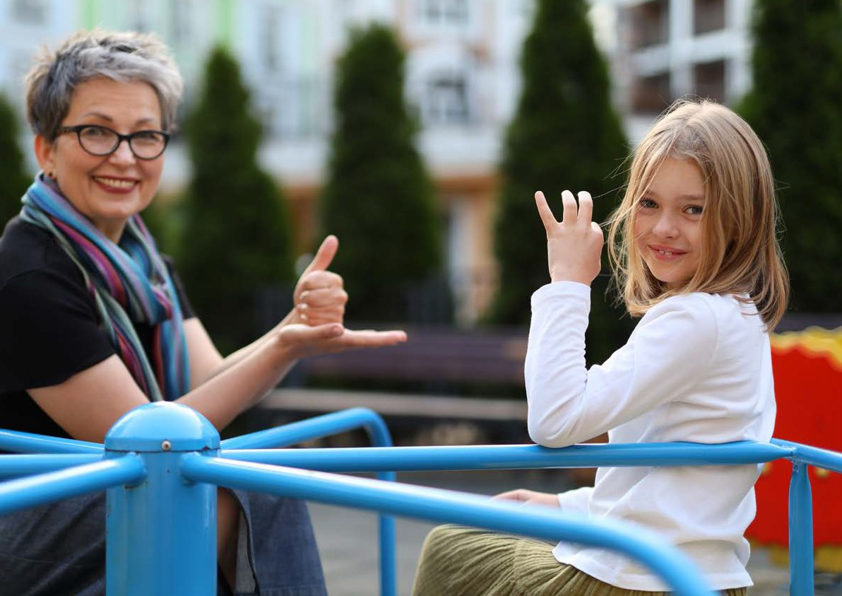

Key principles

Article 3 of the UN Convention on the Rights of Persons with Disabilities sets out a number of General Principles. They are the foundation of everything we do and are essential to understanding what is required to ensure that the rights deriving from the Convention are realised. Our strategy must safeguard this foundation. That is why we are working with a number of key principles, which include the general principles from the Convention. These key principles are divided into a number of priorities. These priorities serve as a compass, directing the development of the objectives in each life domain and the activities in the work agenda. They are also our anchor points. They apply at all times, whatever the circumstances. In this way, they provide guidance and stability in our efforts to achieve the goals of the Convention.

Equal rights

‘After graduation I wanted to spend a year serving on the board of a student association. But the board I wanted to join had five full-time posts. A board position can sometimes take from 40 to 60 hours a week. I have a chronic condition and am unable to work that many hours in a week. I was told that part-time working or job sharing was out of the question as they could only apply for funding for full-time positions. This means, unfortunately, that I won’t be able to get this experience.’

Every individual has equal rights, but in our society people with disabilities are often unable to live their lives as they would wish. Removing barriers is often seen as a courtesy. But it is not a courtesy, it is a question of human rights. Specific reference is made in the UN Convention on the Rights of Persons with Disabilities to women and children, since they more frequently find themselves in a disadvantaged position, or have their lives dictated to them by others.

Policy and legislation must not exclude or seriously disadvantage people with disabilities. The Convention therefore states that when drawing up policy and legislation relating to persons with disabilities, the States Parties must actively involve them and their representative organisations. The public authorities must act as a role model in this process and this practice must be implemented at every level of government by 2040 at the latest.

In the implementation of policy and legislation, everyone must be treated equally in equal circumstances. Yet in order to ensure equal opportunities for all, it may sometimes be necessary not to treat everyone equally. For example, at a job interview or in the workplace.

If people with disabilities enjoy fewer opportunities for reasons other than their impairment ─ for example, because of their gender, gender identity or skin colour ─ this can compound inequality. Our efforts to achieve an inclusive and equal society oblige us to take account of this complexity.
Equal rights – priorities
- Public authorities, implementing organisations and civil society organisations must be familiar with the rights of persons with disabilities as formulated in the Convention. These rights must also be observed.
- As far as necessary and possible, policy and legislation must be aligned with the Convention.
- At all levels of government, people with disabilities and their representative organisations must be enabled to participate in discussions on the development, implementation and evaluation of policy and legislation relating to them.

Self-determination and legal position

‘I find it difficult to make financial decisions on my own, so I asked my mother for help. She never decides for me. She explains what the various choices mean. Then I decide for myself or I ask her to make the decision. In this situation, she makes the decision and that is my choice. What I want to eat or who I want to live with: these are decisions I want to make on my own, and so I do. And where relationships and sex are concerned, I decide. My caseworker sometimes supports me in such matters, for example with regard to contraception. In the beginning, my mother had difficulty with that, but my caseworker and I explained to her that I have the right to make decisions regarding my own body. Even if it means that I sometimes make choices that she would not make for me.’

Self-determination is about freedom of choice. Every individual has a fundamental need to make their own choices and organise their lives in the way that suits them. People with disabilities say that they experience insufficient freedom of choice in all areas of life. This also applies to their families and informal carers. It is often the capabilities and opinions of other people and organisations that carry the most weight. Sometimes the various help services operate independently of each other and people are sent from pillar to post. This reduces their degree of control over their own lives.

It is a fundamental right to be able to make decisions about your own life as far as possible by yourself, or where necessary with support. It strengthens the individual’s self-esteem and sense of independence. That is why it is important that self-determination for people with disabilities lies at the heart of policymaking and implementation in this field.

The right to self-determination also applies to people with a moderate or serious intellectual disability. They too have the right to make their own choices and to receive support in making those choices. In order to ensure they can actually exercise this right, people with disabilities and their legal representatives must receive clear information on their choices and the consequences of those choices. In all the life domains. For example, with regard to the support they are entitled to with regard to their finances. If people with disabilities need support in making decisions, it is essential that this support is independent. If they – and their representatives – are not properly informed, their legal position becomes unequal.

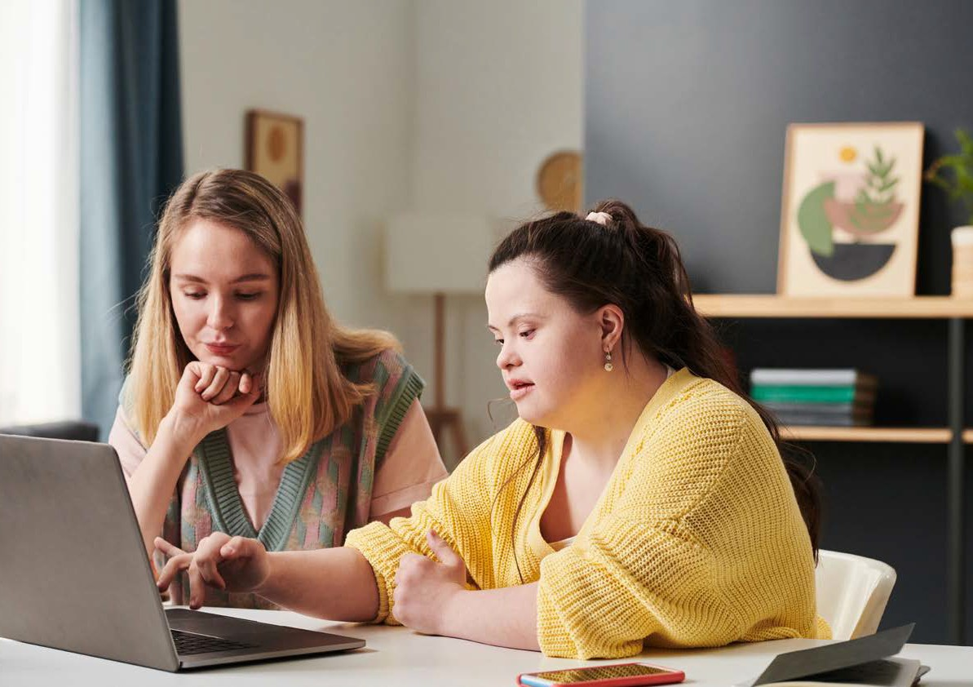

Self-determination and legal position – priorities
- Self-determination for people with disabilities must be the guiding principle in drafting and implementing policy and legislation that applies to them.
- People with disabilities have a right to support in making decisions, where necessary or desirable, and this must be provided.
- Information on disability rights must be available, easy to understand and usable.
- Making Easy-read information available to people with disabilities regarding the choices they make in all life domains enhances their self-determination and, as a result, strengthens their legal position.
People with disabilities must be offered independent support if they need it in making those choices.

Accessibility

‘I‘ve been active in politics for over 13 years. Despite the good intentions of everyone I encountered, I was constantly confronted with problems. Transport to meetings was often an issue. And once I arrived at the town hall, I had to use the back entrance because the building was not easily accessible. Inside there were no disabled access doors, so I was always dependent on others to keep the door open for me. Meetings were sometimes held at locations that were not accessible, so I would literally be confronted with a closed door. I got no help in carrying piles of heavy documents, not to mention assistance in accessing the toilet facilities. Being dependent on good intentions is a definite disadvantage for someone who works in politics.’

Being unable to access a building, use a device, website or application, understand a text or exercise your rights, as well as being confronted with unpleasant comments and being unable to participate are all examples of inaccessibility. Lack of accessibility means exclusion and constitutes discrimination.

Our aim is to achieve a fully inclusive society by 2040. A society in which people with disabilities can lead their lives as they wish. In which, like everyone else, they have access to every area of life. Everyone understands that accessibility is necessary to ensure that no-one is excluded. This means that no-one needs to worry about barriers, whether physical, social, digital, legal, bureaucratic or financial. It means that standardised information is available regarding access to public buildings and spaces. And everyone is able to access the information they need to make choices for themselves. This information must be easy to understand and provided in a form appropriate to the person receiving it. Every aspect of accessibility is equally important. If your workplace is accessible but you can’t get there because there is no suitable form of transport, you can’t do your job.
Accessibility – priorities

- Accessibility must be the norm in legislation and implementation.
- All new concepts and manufactures should be based on the principles of universal design so that they can be used by most people. This also applies to products and services.
- Existing buildings or manufactures should as far as possible be adapted so they can be used by everyone according to the principles of universal design. This also applies to products and services.
- The public information and communication necessary to making life choices should be available to everyone in the desired form and easy for the recipient to understand.

Socioeconomic security

‘I worked very hard to get a proper job and I’ve succeeded. Nevertheless, I earn very little more money than I would if I didn’t work at all. Because of my salary my benefits are reduced. It’s actually very strange that participating in society through work is not rewarded but punished. What I want is for the government to look at people’s capabilities. Everyone can be a valuable member of society.’

Everyone has a right to an adequate standard of living, enough to provide them with sufficient food, clothing, education, leisure, healthcare and a place to live.
The socioeconomic status of people with disabilities and their families can come under pressure more quickly than that of people without a disability. This is because workplaces or schools may be insufficiently accessible or participating in education or paid work is too difficult. The accumulation of additional costs can also be problematic.
Paid employment is further complicated for people with disabilities and their families by the multiplicity of organisational tasks and the administrative burden that arranging for appropriate care and support entails.

The Convention states that people with disabilities have the right to an adequate standard of living for themselves and their families. They further have the right to continuous improvement of their living conditions. We must take steps to ensure that the accumulation of additional costs does not pose a threat to this right. With the necessary income and support, people with disabilities can make their own choices for the future and have control over their lives. This enables them to participate in society. It also reduces the risk of losing everything you have if your life suddenly changes.
Socioeconomic security – priorities
- New policy measures must maintain and improve wherever possible the socioeconomic security of people with disabilities, including their ability to improve their living conditions.
- The costs incurred by people with disabilities as a result of their impairment must not undermine their right to an adequate standard of living.
- Participation in employment by people with disabilities should as far as possible be equal to that of people without a disability. This means they must have equal opportunities on the labour market and receive equal pay.
- The administrative burden and organisational tasks that fall to people with disabilities and their families must no longer stand in the way of participating in society.

A society in which everyone feels welcome

‘Last year I attended an arts festival in my neighbourhood and it was wonderful. Walking around there, I felt whole. Everyone was welcome to come and join in. Access was well organised and there was even a stall with relevant information. The people there were very diverse, and the atmosphere was so relaxed. It felt like coming home!’

Society is all of us. At present, people with disabilities experience various forms of exclusion and discrimination in society. Accepting people as they are and making the effort to understand one another is not yet the norm.

One of the reasons for this may be that people with disabilities and people without disabilities often live in separate worlds. As a result, we do not know each other and this can lead to lack of understanding, awkwardness and unequal treatment. But even in the spaces where people with and without disabilities do live or work together, there is a lack of empathy, exclusion and discrimination.

By 2040, we must have a society in which every individual can be who they want to be. In which everyone respects everyone else as they are. An important element here is the role of the media. A portrayal of people with disabilities in the media that realistically depicts inclusiveness and equality can dispel prejudice. That is something we all have to work on. Another element is the broad representation of people with disabilities in politics. There are still a number of barriers to the exercise of political rights. For example, in areas such as voting, participating in the discussions on policy or legislation and being active on behalf of a political party.
A society in which everyone feels welcome – priorities
- Children and young people with and without disabilities must be enabled to grow up, develop, play and exercise together.
- Society must be socially accessible to people with disabilities. They should experience no discrimination and be able to participate in society in the way they themselves wish.
- Representation in the media must provide a realistic portrayal of people with disabilities and to equality for this group.
- People with disabilities should not encounter barriers to holding public office or exercising political rights.

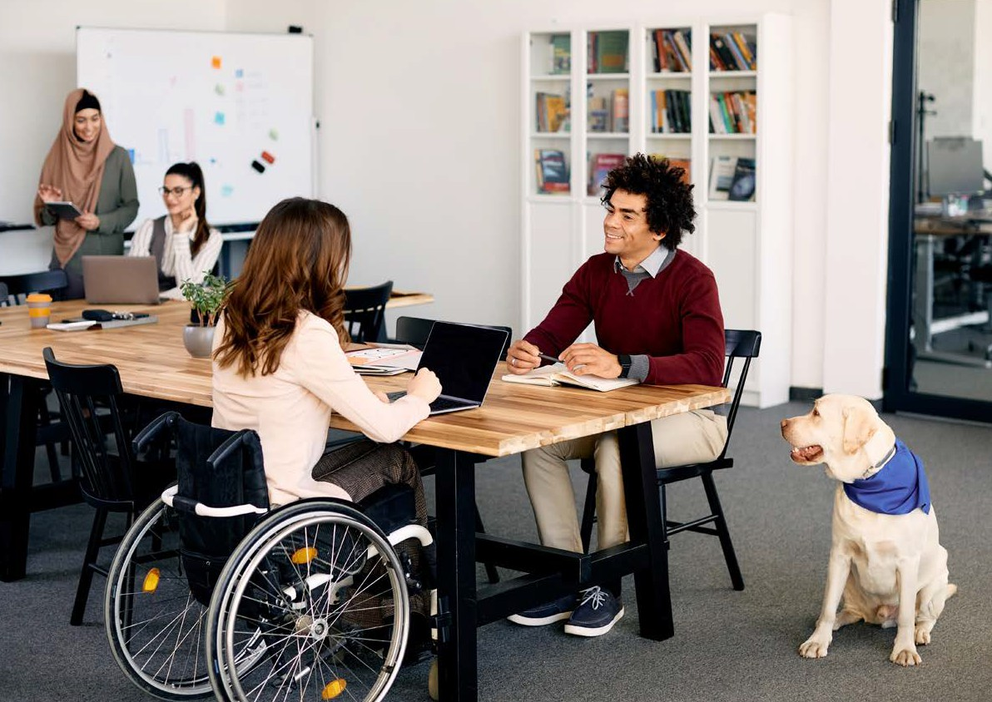

Life domains

The principles set out above impact on every area of life. Below we outline the intended changes in various life domains. The emphasis is on the way society is organised. This concerns us all. Policymakers, politicians, companies and the general public are still largely unfamiliar with the UN Convention on the Rights of Persons with Disabilities and with disability rights in general. Nor are they aware of how inaccessibility in society is incompatible with those rights. It’s not about helping people with disabilities to surmount the barriers. It’s about removing those barriers so that they no longer obstruct anyone.

If we are to be an accessible and inclusive society by 2040, change is needed in all areas of life, for all ages and in every phase of life.
A child of five with a disability and their parents have totally different ambitions, wishes and needs from a person of 29 who wants to move in with a partner or start a family. Or someone aged 18 who wants to get a job or go on to higher education and needs an accessible place to live and to lead an active social life. Or someone who becomes disabled at the age of 50 and needs all kinds of adaptations in order to be able to continue living, travelling and working independently.

Life domains are interconnected and influence each other. Better education, for example, leads to better job opportunities. A better legal position can lead to a higher level of well-being.
We therefore take a broad, integrated view in implementing the objectives in each life domain and the concrete activities and measures. Only in that way will there be coherence in policy and legislation. Only then will society and its structures be aligned with the daily lives of people with disabilities.

Work and income

‘I’m living on benefits and have a motor disability. I don’t qualify for the target group register of people with a work disability but I have found a job. Only now my municipality is refusing to pay for the necessary workplace adjustments.’

The desired situation
Paid employment enables people to have greater control over their lives, be financially independent and experience an adequate standard of living. It is also beneficial in terms of leading a meaningful life, developing talents and building social contacts.
If barriers to work are removed, people with disabilities can contribute to the economy. Public authorities and employers should help in finding appropriate and attractive work, whether as an employee or self-employed person. Employers should be committed to flexible working and an accessible working environment.

Social security should provide a sustainable safety net for people who are unable to work full or part-time, either temporarily or long term, or for those who cannot find a job. It should provide income support, offer peace of mind and builds confidence.
If paid employment is not feasible, various day programmes should be available. These can offer space for people to develop their talents and the chance to progress towards paid employment according to their wishes and capabilities. The family and friends of people with disabilities and their informal carers play a major role in their lives, especially if they are closely involved in care, support or other forms of assistance. They need financial support or respite care if the intensive support they provide means they have to work fewer hours.

The current situation
The employment rate of people with disabilities is currently much lower than that of people without disabilities. A major barrier is the inaccessibility of the working environment. This goes beyond physical accessibility or access to systems: social accessibility is also a problem.
Although there is a range of assistive aids, schemes and other forms of support available, employers regard these as an administrative burden involving a great deal of research.
The way social security is currently organised is not flexible enough to deal with the situation experienced by people with disabilities, who often alternate between benefits and employment, or combine the two. The pressure on family and informal carers providing intensive care and support to persons with disabilities is huge. They themselves receive insufficient support if this means that they have to reduce their working hours either temporarily or long term. This can have consequences for them and their families, such as stress, lower income and having to cope with red tape and bureaucracy.
An agreement between the government and the social partners on creating extra jobs for persons with disabilities was signed in 2013. The aim is to create 125,000 extra jobs by 2026 for people with a work disability. By the end of 2022 over 81,000 such jobs had been created. The people covered by this agreement are listed in the target group register.
Objectives for 2040
- Where the type of work allows, workplaces must be digitally, physically and socially accessible. Employers should not encounter any barriers to hiring people with disabilities.
- Where disability leads to a change in work, economic security must be safeguarded. For example if people work more or fewer hours.
- Work must pay, including for people who work while receiving (partial) incapacity benefit.
- People with disabilities must receive equal pay for equal work.
- Family, friends and informal carers must be able to combine work and care responsibilities.
- Parents of children with intensive care needs who as a result have to work fewer hours should be financially recompensed for extra costs that are not covered by the guaranteed minimum income.

Living independently and housing

‘All my life I have been unable to move house because of the adaptations necessary. It would mean going from an adequate housing situation to an inadequate one. When I was looking for another house, I was constantly confronted with an inability to think in human terms.’

The desired situation
In every phase of life it must be possible for people with disabilities to live as they wish. How that works out in practice depends on a range of factors. For example, the degree of care and support needed and the extent to which the property is accessible or can be made so. The accessibility of public spaces and services in the neighbourhood is also important.
Like everyone else, people with disabilities have a ‘housing career’ covering every phase of life. From living with parents to living independently (alone or with a partner, children or other housemates) or for example living with a new partner after a break-up.
Accessible and, where necessary, adapted housing helps people achieve independence. To this end, we need a sufficiently diverse and widespread housing supply. New housing developments should be built according to inclusive design principles, so that they are accessible to the majority of people. Existing housing should be adapted to make it more accessible for the majority of people. This will increase the social participation of people with disabilities, since it removes obstacles to visiting neighbours, friends and family.
Alongside the physical accessibility of housing, arrangements for care and support, including assistive aids, must be aligned with people’s needs and enable them to lead a full life in and around their homes, as independently as possible of the people with whom they live. In this way, parents, brothers, sisters and partners can focus on their role of relative or loved one.

The current situation
At present the supply of accessible new and existing housing is insufficient and insufficiently diverse. As a result, people with disabilities do not always have the opportunity to live independently or visit friends and family. They often live in an institution or continue to live with their parents.
Living alone in inaccessible housing is detrimental to people with disabilities because it saps their energy and undermines their self-reliance. And once they have found an accessible home, it can be difficult to move somewhere else. This means that the path their housing career takes will be different from everyone else’s. If you want to move house, in many municipalities you cannot take the adaptations made to your existing home with you. And if you move to another municipality, continuity of care is the exception rather than the rule.
If someone with a disability is living alone and alterations to the property are necessary to enable them to continue to live independently, there is no comprehensive and long-term consideration of the necessary changes. Yet, it may be desirable, for example in the case of a person suffering from a progressive condition such as muscular dystrophy, to make all the modifications needed now and in the future in one go.
The assistive aids required to help people with disabilities live in and around their homes as independently as possible are available. But applying for such aids is complex. If repairs are necessary, adequate solutions are hard to find and involve long waiting lists.
Finally, organising the care and support needed to enable independent living entails a considerable administrative burden on the person in question or their family or friends.
Objectives for 2040
- There should be a sufficient supply of affordable and accessible housing:
  - new build should be accessible and inclusive
  - existing properties should gradually be made accessible where possible.
- People with disabilities should be able to move independently in and around their homes.
- People with disabilities should be able to move house without losing care, support and assistive aids.
- The public space should be accessible to all and inclusively designed and maintained.
- Care and support provision should be consistent with independent living and participation.

Education and development

‘I attended two primary schools and four secondary schools, including special and mainstream schools. I was “too good” for special education and “not good enough” for mainstream education. I ended up at a top-level school for professional athletes where I finally received the help and support I needed. Flexible arrangements were not a problem and I could stagger my exams so I didn’t have two on one day.’

The desired situation
Every individual wants to learn, develop their talents and gain new experiences. Like everyone else, people with disabilities have the right to lifelong development. This is why all forms of education must be accessible: from primary and secondary education, practical training, special education, secondary vocational and higher professional education, and university education to courses and training that fall outside of formal education. This includes language courses for people with a migration background.
Inclusive education and development opportunities must be affordable and physically, socially and digitally accessible. It must be possible to adapt to the needs of pupils/students. That requires expertise on the part of the people who provide education. It means that the support needed to enable participation is available and that there is alignment between education and care.
Providing inclusive education and development opportunities also means that people with and without disabilities can learn and develop their talents together according to their capabilities. That no-one is discriminated against on the grounds of their disability. That the elements are present to enable people to develop according to their capabilities and to find and keep a job after graduation.

The current situation
In the Netherlands most children go to school and many adults take a variety of courses. But too little of the education and training available, including lesson material and exams, are accessible to people with disabilities.
Alongside mainstream education, the Netherlands has various forms of special education and children and young adults with and without disabilities learn and develop in separate worlds. They do not go to school together, which means they do not play, learn and work together, or get to know each other. However, there are a few schools that offer inclusive education, both at primary and secondary level. Through the introduction of tailored education, children increasingly receive the support they need to continue to learn and develop within the framework of mainstream education. In higher education (secondary vocational education, higher professional education and university education) students with disabilities encounter barriers because of the way these types of education are organised. This includes inaccessible buildings and teaching materials. They are also confronted with stigmatisation and bias, and are not always satisfied with the facilities offered by educational institutions.
Tailored education is not available everywhere. Too often, there is little flexibility in combining study and work placement, so some students have to drop out. As a result, they are unable to develop their talents to the full and have a disadvantage on the job market.
Objectives for 2040
- People with disabilities should be able to access lifelong learning and development. A variety of forms of education and training should be available for this purpose.
- Every child should be welcome in childcare facilities and at school. Children and young adults, and their parents, should have freedom of choice with regard to the school that suits them best and is close to home.
- Appropriate care and support should be available, so there are no barriers to learning and developing one’s talents.
- Education, training, work and services for young people with disabilities should complement each other.
- Locations and opportunities to learn and develop should be physically and digitally accessible and, where necessary, be tailored to the individual.

Health and support

‘I have three health workers funded from my personal budget (PGB) and my own care team. This means I can live independently. But it also entails an enormous amount of bureaucracy. Under the Social Support Act I have a personal budget, which means I have to deal with the municipality as well as the Social Insurance Bank, with its rules and regulations. I also have a personal budget under the Healthcare Insurance Act, which entails a care needs reassessment every two years. I spend at least one day every week on the administration and organisation of the care I receive – and I’m not an accountant!’

The desired situation
To ensure that people with disabilities can live independently in the way they wish, care and support for them and their families must be appropriate and available close to home. Alignment between the various forms of care and support is essential. People who need support should have control over the care and support they receive. It is important for care and support to evolve with changing situations, and to be tailored to the individual needs and wishes of people with disabilities or a chronic condition, and their families. The costs involved must not prevent individuals from maintaining an adequate standard of living.
It should be a simple process for people with disabilities and their families to apply for, organise and account for care and support. The assessment of applications should be transparent. Professionals working in the field must have the appropriate expertise. Needs assessments and the funding of care and support require awareness of the context of people with lifelong and lifewide impairments. Accounting for funding should also be straightforward.

The current situation
The care and support needed by people with lifelong and lifewide disabilities is regulated by a number of Acts of Parliament. These include care legislation (the Youth Act, the Chronic Care Act, the Social Support Act and the Healthcare Insurance Act), the Participation Act and the Appropriate Education Act. They and their families therefore encounter a great deal of bureaucracy, fragmentation, administrative burden and the accumulation of care costs and additional expenses.
An unfortunate aspect of the need to apply for support under different laws is that every provision has a different system of organisation and accounting. This makes arranging for care and support highly labour intensive. Each provision has its own needs assessment and reassessment system, compelling people with disabilities to repeatedly demonstrate that they need care and support.

Objectives for 2040
- People with disabilities must be able to exercise control over the care and support they receive.
- People with disabilities should receive the care and support appropriate to the context of their lives and their needs. This should not depend on where a person lives or wants to live.
- People with disabilities should receive the support they need, without the costs of such care presenting a threat to an adequate standard of living.
- Access to care should be straightforward and transparent.
- All professionals working in the field of access to care should have the appropriate expertise to be able to support people with disabilities and their families.
- Family, friends and informal carers should where possible be recognised and supported as equal members of the team supporting someone with disabilities.
Informal care for people with a lifelong and lifewide impairment demands adequate support.
- It should be straightforward for people with disabilities or their families to organise the assistive aids they need themselves.

Transport and mobility

‘Our daughter’s custom-made bicycle was damaged. The supplier had to come and collect the bike and the manufacturer is carrying out the repairs. They are unaware of the impact not being able to cycle has on our daughter, on her routine, her freedom of movement, her physical health and consequently on her behaviour. We have now been waiting for four weeks.’

The desired situation
To be able to participate in society, it is important that people with disabilities can move around independently and freely, in the way they wish: on foot, by car, bus, boat, train or aeroplane. Like everyone else they must be able to travel to school or work, visit family, participate in social activities or go on holiday without great difficulty. Parents with disabilities should be able to take their children to school, swimming lessons and other activities.

All forms of public transport must be accessible and information on accessibility should be available. This also applies to travel information and ticket purchase. If a person is prevented by their disability from using public transport there must be a good alternative, such as publicly funded transport for vulnerable groups or an individual or private alternative such as a customised car or bicycle. All alternatives must be affordable. Cyclists and hikers with disabilities must be able to travel independently from A to B without encountering barriers in the public space.

The current situation
At present people with disabilities regularly encounter obstacles that prevent them from travelling freely and independently. For example, in some locations it is still sometimes difficult for many people with a sensory disability (whether visible or not) or a chronic condition to travel by public transport: lifts at stations may be out of order or passenger assistance may be limited.
Even publicly funded travel for vulnerable groups has its problems. Community service buses are not always accessible. Some people have problems with the kilometre allowance for publicly funded taxis, as it does not take account of individual wishes. In addition public transport and publicly funded transport for vulnerable groups are not well coordinated. People with disabilities spend a long time waiting for their bus or taxi to arrive.
Another problem is that the public space is often full of obstacles, such as excessively high pavements, tactile paving indicators that are obstructed or absent, no benches for people to sit and rest or poor lighting.
Objectives for 2040
- People with disabilities should be able to travel freely and independently from A to B even if they have young children. Easy-read travel information must be available. Public transport should be accessible or there should be a suitable alternative.
- The public space must be accessible to pedestrians, wheelchair users and cyclists with a disability.
- Assistive aids and the support necessary to move freely and independently from A to B must be available.

Culture, media, leisure, sport and exercise

‘There is a wall of concrete between the professional film and theatre world, and people with disabilities. It begins early in life. Just try and get some experience with a theatre group if it rehearses on the third floor of a building without a lift.’

The desired situation
People with disabilities, including children, should be able to take part in cultural, recreational, leisure and sporting activities. Both as participants and consumers. In practice, this means that all sporting locations and activities, television programmes, cinemas, theatres, museums, holiday accommodation, amusement parks, bars and restaurants should be accessible to people with disabilities, whether as employees or visitors. This means, for example, making audio description and interpreter services available and providing information on various accessibility options. Furthermore, people with disabilities must be able to develop their creative, artistic and intellectual talents.
To be able to take part in sport, play or exercise people with disabilities must have access to appropriate assistive aids, instruction and training, so that they encounter no barriers to participating like everyone else.

The current situation
In the fields of culture, media, recreation and sport, people with disabilities are rarely seen in ‘ordinary’ jobs. In addition they often encounter social, financial or practical barriers if they wish to go on holiday, take up a sport, visit museums or amusement parks, or participate in other leisure activities.
One of these barriers is the lack of accessible public toilets, including facilities adapted for people who need to be changed lying down. Another is getting hold of the right assistive aids to be able to engage in sport. Another common problem is the lack of information about access and support that is available to people who want to play a sport or visit a museum, bar or restaurant.
Nevertheless, a number of museums, festivals, amusement parks, zoos and other recreational venues are taking steps towards improving access and are setting a good example for the rest of the sector.
Objectives for 2040
- Cultural activities, media, sport, exercise and recreation should be accessible to all, whether participant or consumer.
- People with disabilities should be visibly represented in culture, media and sport.

Safety and legal protection

‘Asserting your legal rights, especially if you become disabled at a young age, is far from straightforward. For example, taking out legal expenses insurance. In most cases, that is only possible if cases arising from your disability are excluded. Which is precisely what causes most of my problems.’

The desired situation
Everyone should have equal access to justice. This means there must be sufficient provision for people with disabilities so they have access to information, advice and support, as well as a decision from a neutral body, including the courts. Support may include legal advice or legal aid. People with disabilities must also be able to lodge objections and complaints with authorities and other bodies.
It is a human right to be free from violence, abuse and exploitation. In all areas of life, whether outside the home, at home, or in personal or care relationships, there must be protection and safety for people with disabilities. If the safety of the person in question or of others is at risk, access to (medical) assistance and the police must be guaranteed.
Victims with disabilities must receive appropriate assistance and support. At the same time, an accessible criminal justice system contributes to equality before the law for offenders with disabilities.
If the safety of a large group is at risk, for example as a result of a disaster or crisis, there must be specific attention for the situation of people with disabilities. Information, communication and public safety policy must be inclusive in these situations.

Current situation
Many people find access to justice complicated. They don’t know how to find their way to a mediator, notary, lawyer, disputes committee or the courts, and there are often obstacles in the way. They often have difficulty lodging objections and complaints with public authorities and other bodies. In addition, the same obstacles are encountered by people who come into contact with the criminal justice system, whether as victims, suspects, defendants or convicted offenders.
There is often insufficient support and guidance available for people with disabilities, such as the use of sign language interpreters and speech-to-text reporters or the provision of easy-read information. There must be a greater focus on protection from violence, abuse and exploitation: at present, people with disabilities face a greater risk of becoming a victim. Unsafe situations are not recognised in time, and appropriate help and support is not always available, although the accessibility of emergency communication systems – such as the 112 telephone number – is constantly being improved.
There is still too little attention for the needs of people with disabilities in the management of crises and disasters. It is important for there to be a continuing focus on these issues, in the interests of all people with disabilities, whether they live in a care institution or independently. There is increasing awareness of the need to make crisis communication as accessible as possible.
Objectives for 2040
- Access to justice and legal protection must be strengthened. People with disabilities and those close to them must know how to access frontline legal services, a lawyer and the courts and there must be no obstacles in their way. If they wish, they should have guidance in this process.
- Like everyone else, people with disabilities must be protected from violence, abuse, exploitation and neglect, wherever they live. There must be specific attention for groups at greater risk of violence or abuse, such as women, children and LGBTQ+ people.
- In a crisis or disaster people with disabilities must be as safe as everyone else. Public safety policy must be inclusive and focus on people with disabilities and their families. Part of this is that information and communication must be easy to find, accessible and transparent.

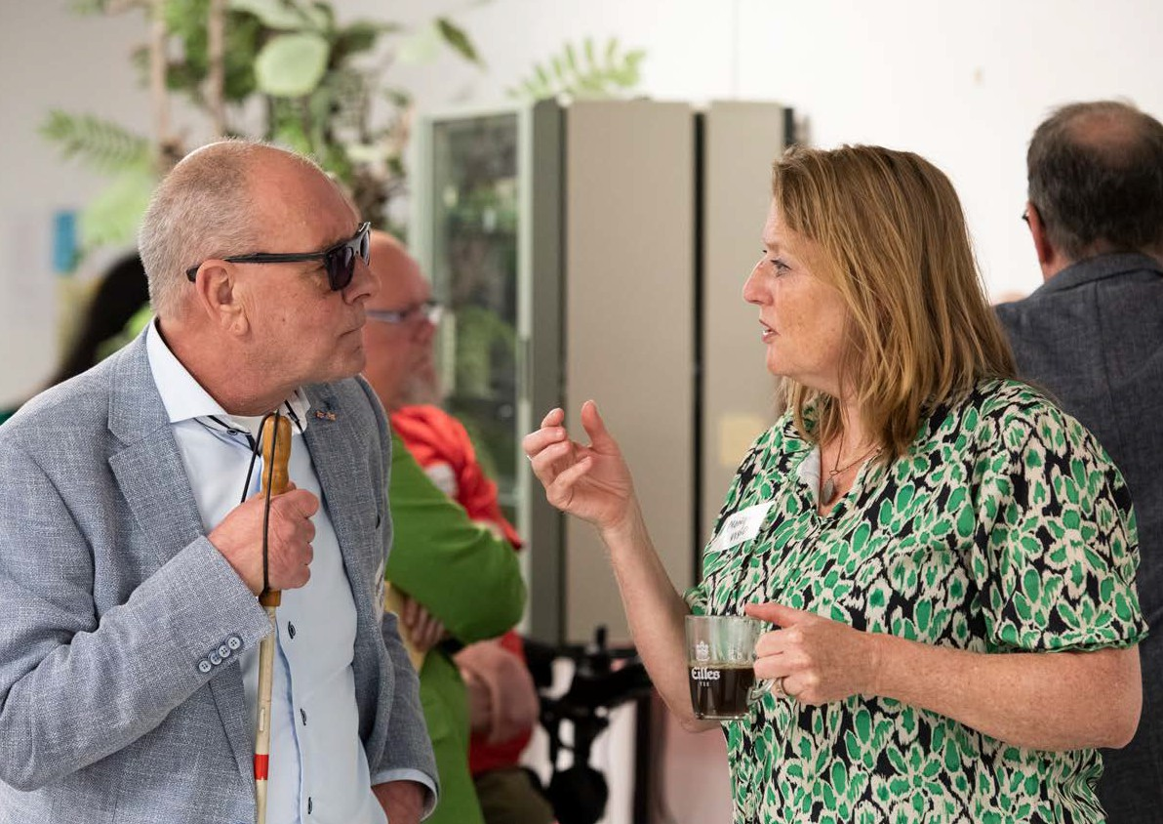

Governance, roles and responsibility

The National Strategy can be implemented only on the basis of a clear allocation of responsibility in the areas of advice and decision-making.

Important decision-making on implementing the strategy is the responsibility of the government. Structural consultations will take place between the directorates-general of the ministries concerned: the Ministry of Health, Welfare and Sport; Social Affairs and Employment; the Interior and Kingdom Relations; Infrastructure and Water Management; Education, Culture and Science; Justice and Security; Finance; and Economic Affairs and Climate Policy.
Together with people with disabilities and their representative organisations, the ministries will draw up a work agenda, giving the strategy government-wide effect. The work agenda describes concrete actions aimed at achieving the objectives for 2040 and it will be reviewed every five years. Existing government programmes and improvement agendas will be included in the work agenda.

The Ministry of Health, Welfare and Sport plays a coordinating role in implementing the UN Convention on the Rights of Persons with Disabilities and consequently in achieving the objectives of the National Strategy. The strategy can be successful only if local and provincial authorities take responsibility for fulfilling their obligations under the Convention and the law. To this end, the Ministry will work with parties including the Association of Netherlands Municipalities and the Association of Provincial Authorities. The strategy cannot be implemented by the authorities without the input of business, civil society organisations, people with disabilities and their representative organisations. Both the Confederation of Netherlands Industry and Employers/Royal Association MKB-Nederland (representing small and medium-sized businesses), and the Alliance for the Implementation of the UN Convention on the Rights of Persons with Disabilities are partners in implementing the strategy.

Nothing About Us Without Us
Under the UN Convention on the Rights of Persons with Disabilities, policy regarding people with disabilities must be made with them and their representative organisations. ‘Nothing About Us Without Us’ is a slogan that communicates this idea. The National Strategy was drawn up in accordance with this inclusive approach. It is essential to take the same approach when implementing the strategy. For this reason, a permanent coordination system in the form of an advisory council will be set up. In addition, people with disabilities and their representative organisations will be involved on a structural basis by the various ministries in drafting and implementing the work agenda.

Consultative structure
Since this is a long-term strategy, continuing input and advice will be organised in the following way:
- the advisory council and the Board of Directors-General will discuss the implementation of the strategy twice a year;
- inter-authority consultations will take place once a year involving, at a minimum, the Association of Netherlands Municipalities, the Alliance for the Implementation of the UN Convention on the Rights of Persons with Disabilities and the Confederation of Netherlands Industry and Employers, chaired by the coordinating minister or state secretary at the Ministry of Health, Welfare and Sport;
- the Netherlands Institute for Human Rights will discuss progress in the implementation of the Convention in its annual report.

Monitoring
The Statistics Overview drawn up by the Participation without Limitations programme was used until the end of 2022 to monitor the implementation of the Convention. In 2022 a start was made on revising the Overview on the basis of the follow-up strategy for the Participation without Limitations programme.

The content of the National Strategy forms the basis for the way monitoring is organised. The aim is to shed light on the extent to which its objectives are being achieved, in order to establish a clear picture of improvements in the situation of the broad and diverse group of people with disabilities. People with disabilities, their representative organisations and other stakeholders are closely involved in developing the new monitoring system and decision-making in its regard. The new system will enable us to present a clear picture every two years of the progress made in achieving the objectives of the National Strategy.

This is a publication of the Ministry of Health, Welfare and Sport

Address for visitors
Parnassusplein 5 | 2511 VX Den Haag

Postal address
Postbus 20350 | 2500 EJ Den Haag
Telephone +31 (0)70 340 7911 www.rijksoverheid.nl
January 2024

Not everyone is happy to be described as a ‘person with disabilities’, though others see it as an acceptable, neutral term. We are aware that there is no single description that everyone would recognise as relevant to them. For the sake of readability, we use the term ‘persons/people with disabilities’ in line with the UN Convention on the Rights of Persons with Disabilities.

