Submission to
the UN Committee on Economic, Social and Cultural Rights
5th Review of France at the 74th session
The right to higher education in France

July 2023

SUBMITTED BY
Right to Education Initiative
La FAGE, Fédération des Associations Générales Etudiantes
Global Students Forum

This report focuses on the right to higher education, questioning France’s compliance with its obligations regarding article 2.2 and article 13.2 (c) of the International Covenant on Economic Social and Cultural Rights (ICESCR).
It is based on a five year research project developed by the Right to Education Initiative (RTE) in collaboration with students from Sciences Po Law School Clinic (Paris) and researchers from the University of Geneva, University of Orléans and ENS Paris Saclay.
Background
In 2016, the Committee on Economic, Social and Cultural Rights (CESCR) in its concluding observations urged France to take steps to rectify the impact of social and economic inequalities on school performance (para. 52) and: (b) provide the necessary resources in terms of both budgetary allocations and qualified instructors; (d) ensure that indirect costs associated with school attendance at the secondary and tertiary levels do not reduce the accessibility of education for persons from disadvantaged households.
In the list of issues prior to the 2021 reporting, CESCR asked France to ‘describe the impact of the measures taken to reduce the influence of a person’s social origins on his or her educational achievement’ and ‘describe the difficulties encountered in combating discrimination in access to education (…)’ (question 26).
With regards to this issue, France, in its report submitted in July 2021, mentions some policies put in place to address this issue including a programme called: ‘Cordées de la Réussite’, which aims to promote academic aspirations and the pursuit of higher education (para. 184), and the reform of the university application process and strengthening of social support for students (para. 185-186), mentioning that they are grounded in the principles of non-discrimination and equality (para. 186).
Our submission highlights that the public policies aiming to reduce inequalities in access to higher education implemented by the French government since the last periodical reporting session are insufficient, and need to be reinforced and expanded. It argues that structural, territorial, and socio-economic inequalities as well as the State’s higher education financing policy hinder equality and non-discrimination in access to higher education and increase the privatisation trend.
The ICESCR’s provisions applying to this issue
The International Covenant on Economic, Social and Cultural Rights (ICESCR), ratified by France in 1980, provides that higher education shall be made equally accessible to all, on the basis of capacity, by every appropriate means, and in particular by the progressive introduction of free education.
According to the interpretation made by CESCR in its General comment 13, this means that states have an immediate obligation to ensure that higher education institutions are available and accessible to all students who are capable of pursuing higher education, without any discrimination. States are required to provide students with adequate facilities and a sufficient number of trained teachers in order to support the delivery of higher education, which must be affordable as well as physically accessible. Physical accessibility means that higher education must be within physical reach for all students, either by attending classes in a reasonably close area or using new technologies. Affordability means that education must be financially accessible to all, and that states are required to use the maximum of their available resources to ‘advance as quickly and efficiently as possible’ towards the full implementation of free higher education. This implies that any ‘deliberately regressive measures’ in higher education, such as budget cuts, would require the most careful consideration: the State must demonstrate that such regressive measures are fully justified, by reference to the totality of the rights provided for in the Covenant and in the context of the full use of the maximum available resources.
Non-discrimination is also guaranteed in article 2.2 of the ICESCR, which ensures that the right to education (including higher education) must be exercised ‘without discrimination of any kind as to race, colour, sex, language, religion, political or other opinion, national or social origin, property, birth or other status’.
The national legislation applying to higher education
France’s constitution goes beyond international law, establishing that ‘the provision of free, public and secular education at all levels is a duty of the State,’ and that ‘the Nation guarantees equal access for children and adults to instruction, vocational training’ (para. 13 of the Preamble of the Constitution of 1946). A decision of the Constitutional Council from 2019 stated that the tuition fees set by public higher education institutions must take into account the financial resources of students. In addition, the Education Code establishes that higher education should contribute to the fight against discrimination, to the reduction of social and economic inequalities, and to a more inclusive society. To this end, it determines that higher education seeks to promote the inclusion of all individuals without distinction of origin, social background, and health condition. Higher education is also legislated in a myriad of French laws that regulate all post-secondary education and establish France’s public policies with regards to higher education.
Overview of the French higher education system
The French higher education system offers a variety of institutions, courses and tracks, characterised by high institutional differentiation and academic hierarchy among tracks. Access to Higher Education is based on a two-track system. On the one hand, there is an open system, without prior selection, which includes public universities delivering three types of diplomas—bachelor’s degrees, master’s degrees and doctorate degrees, after a minimum of three, five, or eight years of study, respectively. On the other hand, there is a selective system, with both public and private establishments providing highly specialised programs which can last from two years in vocational tracks to five years to obtain a Master’s or equivalent level diploma. Admission into selective institutions relies on a selection process that is usually based on student profiles and motivations, except for the distinct Grandes Écoles path which uses entrance exams.
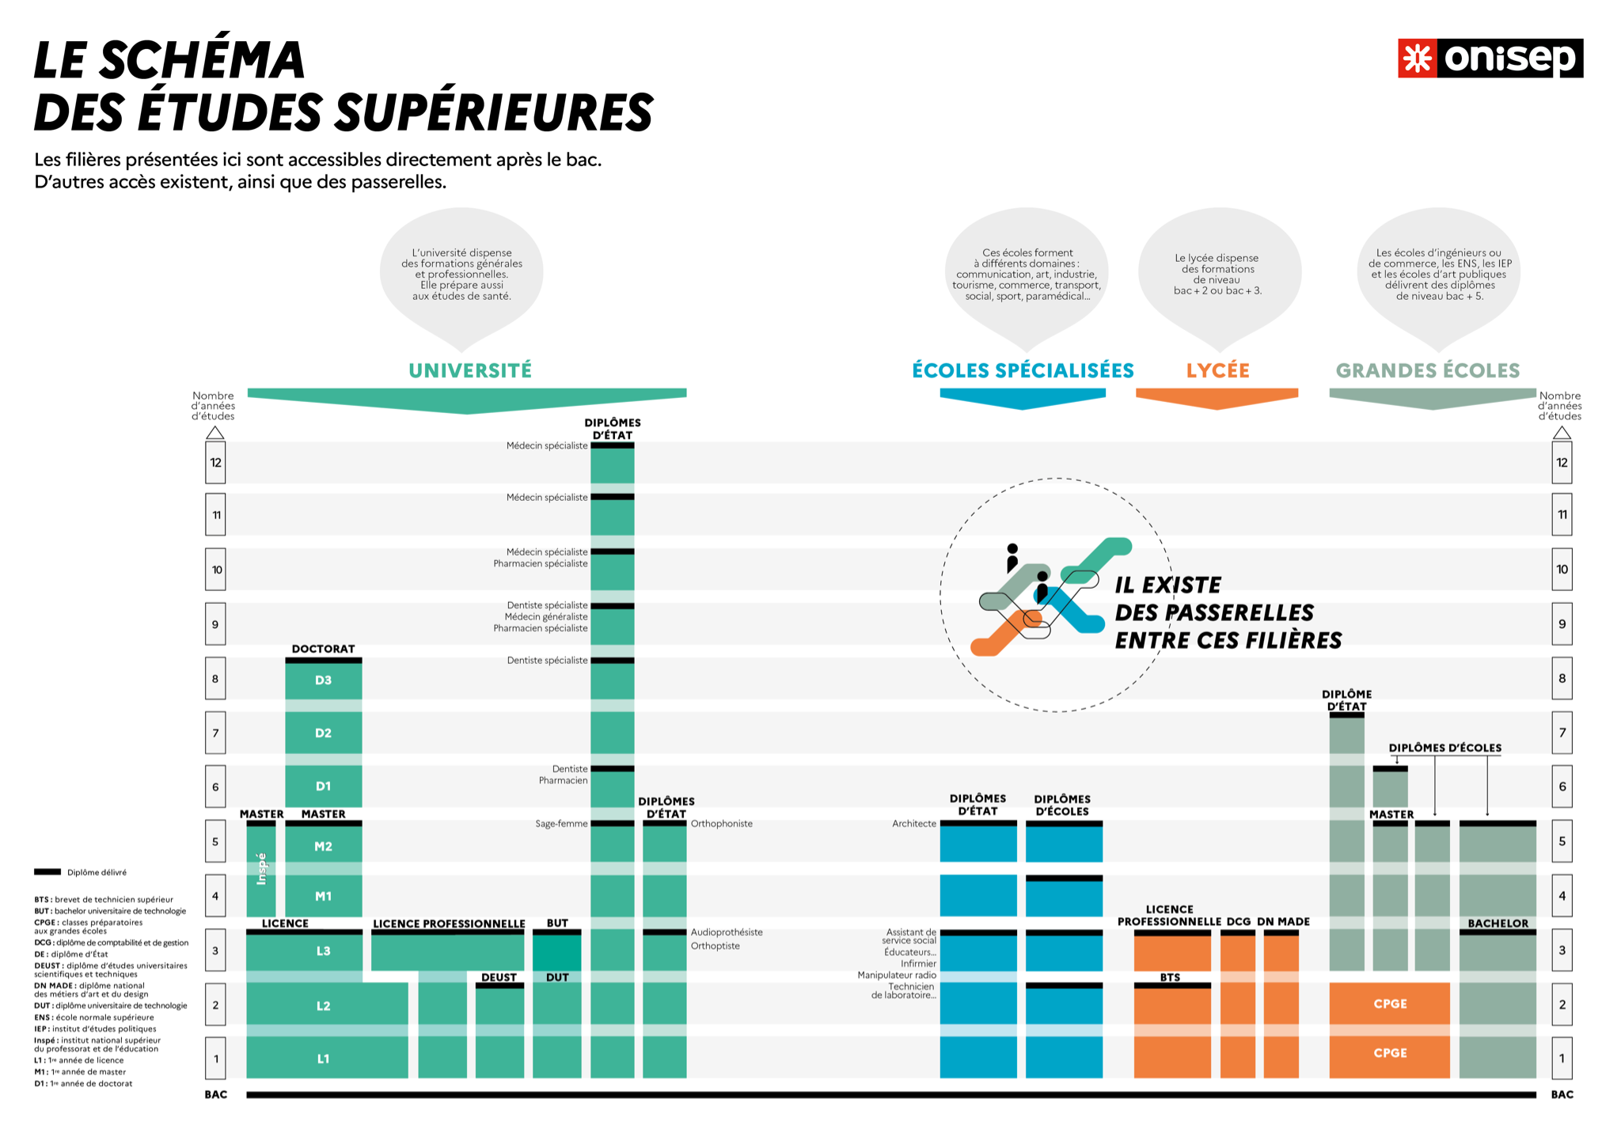
Figure 1. Overview of the French Higher Education system

The polarisation and vertical stratification of the French higher education system create inequalities in access to higher education
Geographical polarisation
While higher education institutions are generally available across the country, some regions offer a variety of paths, programmes, fields of study and institutions, whilst others have a limited offering. There is a significant concentration of public institutions in the Parisian region (Ile-de-France) (Fig. 2). High quality and specialised institutions are located around large city hubs (e.g. Paris, Lyon, Lille). This uneven distribution of higher education institutions in France is reflected in the numbers of students: in 2019, more than a quarter of higher education students (26.5%) were enroled in institutions in the Parisian region of Île-de-France (Fig. 3).
Data on the mobility of students show that students tend to move to cities with the widest choice of higher education programmes. Indeed, fewer than 20% of all students enrolled in Paris in 2017 were from Île-de-France.
This disparity in higher education offerings across regions makes it more difficult for students who live far away from main urban centres to access their institutions, due to the distance from their original place of residence and to additional transportation and housing costs.

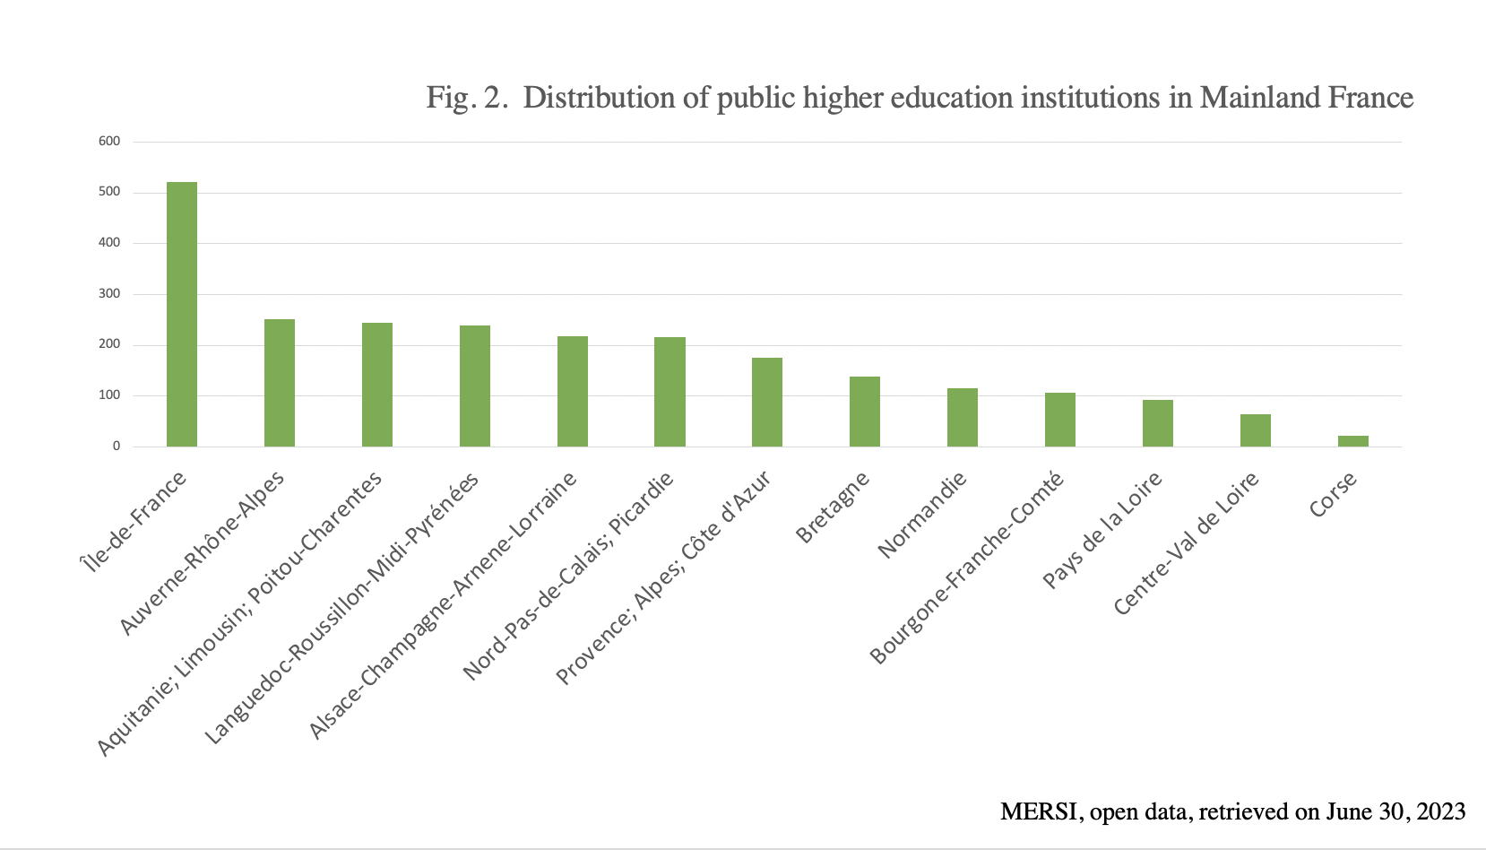

Figure 3: Distribution of Higher Education students
in France (2019/2020)

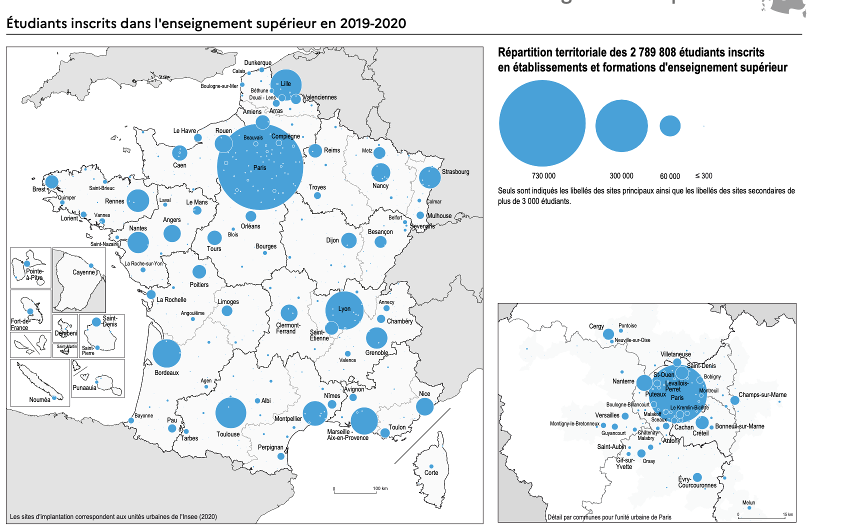
Source: MESRI (2021): Atlas régional. Effectifs d’étudiants en 2019-2020.

Vertical stratification
The geographical polarisation of the higher education system intersects with its vertical stratification, ‘whereby disadvantaged students enrol in institutions of lower quality and/or prestige’, thus reflecting and reproducing disadvantage and differential social positioning.
In France, there is an institutional differentiation between universities and Grandes Écoles that leads to long-lasting inequalities. Grandes Écoles are prestigious institutions, which are highly specialised (business, management, engineering, arts, politics, etc.), public or private, with very selective admission procedures, and often high tuition fees. They benefit from historical roots educating France’s elite, which ensures their social legitimacy and leads to higher and faster employability rates and salaries. 57.4% are hired before they graduate, and 80% of students get a job within the six months following graduation.
These elite institutions are mainly concentrated in the regions of Île de France (Paris) and Auvergne-Rhône-Alpes, which have the highest median standard of living in France. Yet studies show that the share of children of cadres (those in senior managing positions), mainly represented in these regions, is higher in more selective and prestigious tracks (about half of the students). In contrast, the children of working class parents are under-represented in most tracks, except in STS (Section de Technicien Supérieur) programs (22.9%), and in paramedical and social work schools (18.7%).
The vertical stratification of the higher education system worsens socio-economic inequalities both in access to higher education and labour market outcomes.
In her latest report, the UN Special Rapporteur on the right to education stresses that ‘the vertical stratification of higher education systems and the impact of concepts of “merit” or “capacity” that sustain, justify and legitimise inequalities are of particular concern.’
Tuition and indirect costs of studies increase existing inequalities in access to higher education
Tuition
Although French public universities have generally affordable annual tuition (for European Union students, costs are €170 for a bachelor's degree, €243 for a master’s degree, and €380 for a PhD), however some public establishments offering highly specialised training apply much higher fees, ranging from €601 to €2,500. Tuition in Grand Écoles, whether they are public - such as Institut Polytechnique (a school specialised in engineering) - or private - such as HEC (business school) and Sciences Po (politics school), can reach up to €10,000 for a school year. A bachelor’s degree from Institut Polytechnique, for example, will cost between €3,500 and €7,750 a year for European students. Some Grandes Écoles have institutionalised a graduation in tuition aiming to promote the inclusion of students from socially disadvantaged backgrounds. In Sciences Po for example, the 2023-2024 tuition for a first year enrolment is calculated according to the household tax income, varying from €0 to €14,210 for a bachelor’s degree and from €0 to €19.670 for a master’s degree.
These fees remain much too high for students from low- or middle-income households who do not receive any State financial aid. Yet, these institutions with high tuition fees are the ones that offer the best professional opportunities, thereby further increasing inequality.
The disparity in registration fees, depending on courses and on the type of establishment, only exacerbates the inequality of access described above. For example, since most Grandes Écoles are located in areas where living costs are higher, students have to pay for indirect mobility costs in addition to tuition fees.
Indirect costs
Due to the polarisation of the higher education system described above, a high number of students have to move to main urban areas where there is greater quality and diversity of the higher education offering, but where the cost of living is also usually higher. In 2022, students’ cost of living increased by 6.47%, representing €428.22, in comparison to 2021. Paris is the most expensive city for students, with average monthly expenses of €1,332. The difference between the most expensive city and the cheapest one is €482.08.
Students’ living costs mainly include transportation and housing expenses. Housing expenses represent the biggest share of students’ monthly budget, notable as 68.7% of students don’t live in their parents’ home. The average student rent in Paris is €862 per month, over two times higher than the average monthly student rent in the cheapest city of Le Mans (€361). Student mobility puts even more pressure on the student housing market, creating a vicious cycle. On average, housing costs increased by 1.37% in 2022. Transportation also heavily affects student budgets, with an annual cost of over €300 in Île-de-France as well as in three French cities that are higher education hubs: Lille, Lyon, and Rennes. Other indirect costs such as books and pedagogical material significantly impact students’ budgets at the start of the year and may represent a heavy load in certain fields of study (e.g. health/medical degrees). According to the Fédération Générale des Associations Étudiantes (FAGE), the average cost of studies for French higher education students at the start of 2023 is €3,024 (for a student without scholarship or financial aid), comprising €1,824 of one-off fees, and €1,199 corresponding to monthly expenses. This is an general increase of €135 in comparison with 2022. The monthly expenses have soared by almost 9%.
More and more students take part-time jobs while studying, which extends the duration of their studies and affects their chances for success. A 2019 report from the Inspection générale de l’Administration de l’Éducation nationale et de la Recherche (General Education and Research Administration Inspectorate—IGAENR) points out that three out of four undergraduate students have worked for an entire semester and 36% have worked regularly for at least two years in a row.

A combination of factors leading to unequal access to higher education in contradiction with the ICESCR
The cost of studies exacerbates the existing inequalities due to the polarisation and vertical stratification of the higher education system. A student’s social and economic situation can lead to unequal access to higher education, in contradiction to the ICESCR.
Students from socially disadvantaged backgrounds coming from an area which is a university hub (e.g. Île-de-France or Lyon) are more likely to overcome socio-economic barriers than those living in remote areas where the higher education offer is less present and/or less diversified. Furthermore, students coming from socioeconomic disadvantaged backgrounds and from regions with limited possibilities in terms of higher education instruction are more likely to face difficulties accessing higher education. They are therefore less likely to improve their social status, further increasing regional vulnerabilities and perpetuating the social reproduction of inequalities. Finally, students living in remote areas but with economic means will be more likely to overcome barriers in access, as they will be able to afford the costs imposed by geographical mobility, by a longer programme, and/or by a selective institution, especially when considering the privatisation of the higher education sector and France’s public policies regarding the financing of higher education (see hereafter).
Thus, a student's place of residence becomes a factor of exclusion in access to higher education, in contradiction to the ICESCR.
Research demonstrates that France’s higher education system leads to social polarisation: on the one hand, top-ranked universities located in large cities, concentrating competitive funding and attracting the most privileged students; and, on the other hand, universities of secondary importance established across the rest of the territory, ensuring accessibility to higher education for those from less privileged backgrounds.
Other research shows that access to higher education in France is strongly correlated to parental income: at the bottom of the income distribution, 35% of individuals have access to higher education compared to 90% at the top of the distribution (Fig. 4). Inequalities are even more pronounced in access to selective programs and master’s degrees: in the bottom half of the income distribution, less than 5% of individuals access selective programs compared to 40% in the top 2% of the distribution (Fig. 5).
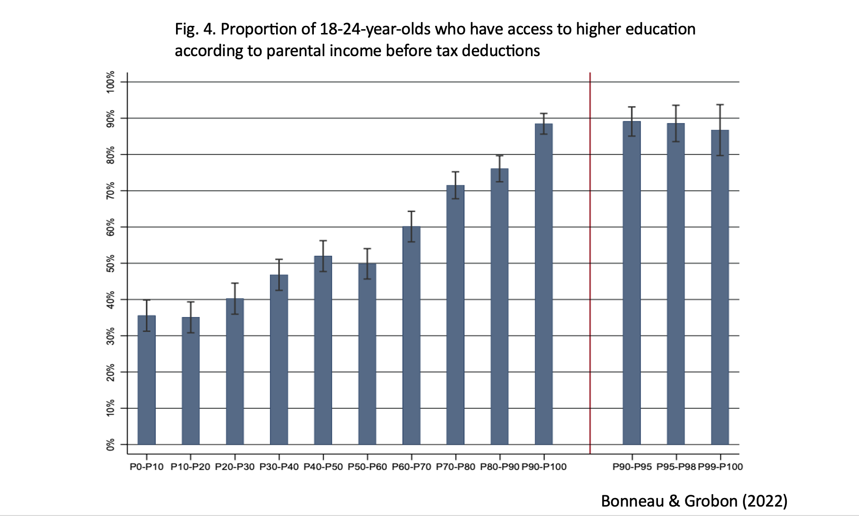

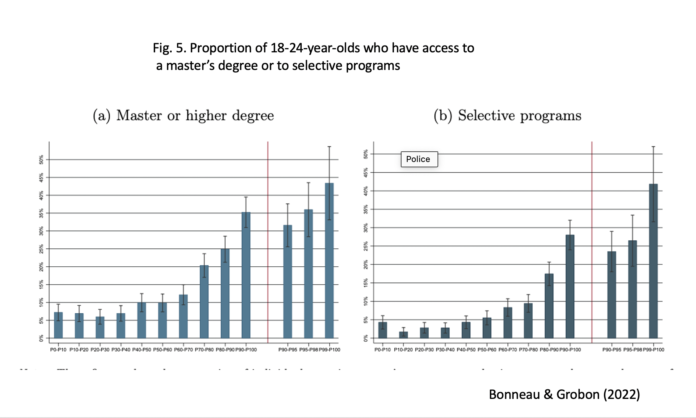
Moreover, research shows that parental income is complementary to parental occupation and level of education. ‘For a given occupation and educational degree, the higher the percentile rank of parental income, the greater the proportion of young people accessing higher education and different programs. For example, those whose mother’s highest degree is a high school diploma (12 years of education or less) have a 35 percent rate of access to higher education between the ages of 18 and 24 when their parents are in the bottom income quintile and 72 percent when they are in the top quintile. Conversely, for a given level of parental income, the more privileged the parents’ occupation or the higher their educational degree, the higher the proportion of children accessing higher education’.
The specificities of the French higher education system thus create barriers to equal access to higher education for many students, especially students from regions with few higher education establishments or those offering fewer academic programmes. Place of residence thus becomes a factor of exclusion, especially since students have to move for their studies and need to pay for additional costs to access higher education. Since the most prestigious establishments, such as Grandes Ecoles or engineering schools, charge higher registration fees and are located in the most expensive cities, some students can be excluded because they cannot afford the direct and indirect costs related to the higher education program of their choice, even though they are willing and capable of studying in such renowned institutions.
Privatisation and commodification of higher education exacerbate existing inequalities in access to higher education
The number of students enroled in private institutions has grown significantly over the past two decades in France, with a 60% increase since 2011 against a 16% rise in the public sector. Almost one in four higher education students in France (24,8%) is enroled in a private higher education institution.
Not only has the number of private higher education institutions increased, the sector has also expanded and become more diverse in the fields and programmes offered. These institutions, often of for-profit private character, are filling the gap left by public universities who struggle to innovate and integrate new technologies and respond to market changes and new needs (particularly in the areas of design, commerce, digitalization, visual arts, mode, video games, etc.). They offer the promise of employment in exchange for very expensive but well-supervised education. France’s legislative provisions have also facilitated the privatisation process, making it even more difficult to monitor and control the quality of private higher education instruction.
The privatisation of institutions has also been coupled with the commodification of higher education in France in recent years, having a direct impact on tuition fees. The increasing internationalisation of educational policies has pushed higher education institutions to be in competition at a global level. The ranking of universities —especially the Shanghai Ranking— pushes even public higher education institutions into the market, seeking economic value and profits. This phenomenon has also impacted some public universities.
The intensified privatisation and commercialisation of higher education, associated with a growth of tuition and indirect costs (e.g. private tutoring), exacerbates existing socio-economic inequalities. Private institutions are accessible to the most privileged students, leaving behind students who have the capacity to follow high prestige tracks in private institutions, but do not have the financial means to do so. Even if some disadvantaged students receive scholarships, they do not cover all costs related to higher education. Studies show that student debt becomes a major concern (for 11% of students in business school and 6% of students in engineering school) and a heavy burden at the beginning of their career.
State funding of higher education is insufficient and unequal to address persistent inequality in access to higher education
State financial disengagement in higher education
In France, national expenditure on tertiary education has been rising almost continuously since 1980, with an increase of more than 273.9% over 40 years. However, at the same time expenditure per student has been in constant decline for six years (-1.4% in 2019 and -7.9% since 2009). Since 2010, the increase in the number of students (18.7% in 10 years) has not been compensated by a proportional increase in spending, leading to unjustified underfunding of higher education in France (fig. 6). In addition, while in 2010 the share of State investment in higher education was 71.4%, it has declined progressively to 66.3% in 2019. Conversely, the share of private companies and family participation in higher education has risen: private business share has gone from 7.8% in 2010 to 10.1% in 2019 whereas household participation in higher education has risen from 8.5% to 10.1% in the same period.
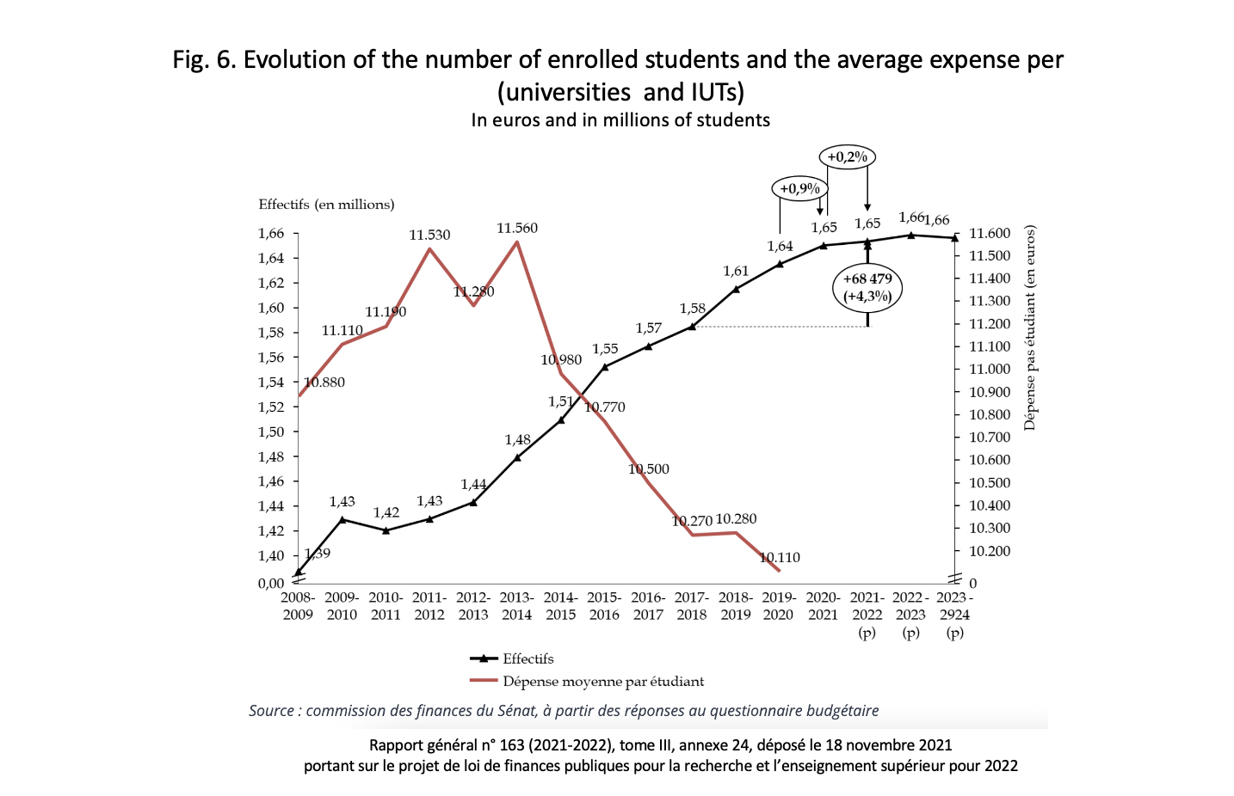
General Report No. 163 of the Senate Finance Committee, concerning the Finance Bill for Research and Higher Education for 2022, emphasises that ‘the ad hoc mobilisation of extrabudgetary credits in favour of higher education casts doubts on the sustainability of funding mobilised for universities’.

State financial aid is not enough to cope with the raise in tuition and the above mentioned indirect costs. Even if the share of financial aid granted to students for the academic year 2019/2020 (41.9%) was slightly higher than for 2018/2019 (39.5%), the raise is mostly due to special transitory measures implemented during the COVID-19 pandemic. Meanwhile, we have seen above that the cost of living has increased over recent years.
The most significant student aid granted in France is based on social criteria . This means that the annual amount of the student aid is calculated according to the student’s household resources and expenses, following a national scale. The attribution of social aid is differentiated according to types of tracks and programmes. Scholarship students, who represent 37% of total students, are largely under-represented in business schools, where they constitute only 12% of students. Another distinction is observed between the private and the public sector: 21.8% of students in the private sector receive a scholarship based on social criteria, against 39.4% in the public sector.
The most recent report from the French Court of Auditors stressed that the precarious economic situation of students was particularly worrying, even before the pandemic. Research has shown that young adults from the upper classes appear to be more likely to pursue higher education and to claim the most prestigious, but also the most expensive diplomas (in terms of public expenditure). Over 70% of inequalities in public spending on higher education are due to unequal access to higher education. Research shows that the fiscal advantages granted by the State to families who have a child in higher education end up benefiting households with a higher income, to the point where tax reductions for the most privileged roughly equal the amount of grants paid to the poorest students.
Unequal budget distribution amongst institutions, programmes, and fields of study
Moreover, the higher education budget is disproportionately distributed among fields of studies and types of higher education institutions. Prestigious higher education institutions or those leading to socially recognised diplomas and which most often welcome students from privileged socio-economic backgrounds tend to receive more state funding. For example, supporting one student in the CGPE (preparatory class to enter the Grand Ecole track) costs 50% more to the state than a public university student. Such differences in budgetary allocation are to the detriment of socioeconomically disadvantaged students: while the children of typically blue-collar profession parents constitute 28.5% of the gross enrolment rate in higher education, they represent only 18.2% of CPGE students. Conversely, students from families of executives and higher intellectual professions constitute 34.2% of the student population and 52.1% of CPGE students. They are thus over-represented in institutions favoured by public funding. State funding thus intersects with previously mentioned inequalities: rather than reducing barriers in access and accomplishment for the most disadvantaged students, it contributes to fund those who have a better cultural, economic, and social capital. Moreover, the unequal distribution of budget allocation affects quality of education and student’s achievement: disparities in budget allocation are correlated to hours invested in teaching, research and student’s supervision as well as on student/professor ratios.
The commodification of higher education and increased competition between establishments also affect state funding. Certain higher education institutions benefit from additional funding according to their performance, which is evaluated based on a variety of criteria – including, for example, the institution’s capacity to find external economic partners. Those types of ‘excellence funds’ increase social segregation since the enrolment rates among socially disadvantaged students in those institutions is relatively low if compared to the enrolment rates of students from middle and upper income classes in the same institution. The attribution of ‘excellence funds’ does not take into consideration (for example, in the performance criteria) the institution's efforts to be more inclusive and to reduce barriers in access to socioeconomically disadvantaged students .
Those conclusions call into question the effectiveness of budget allocation in terms of social justice: public investment has benefited those who are enroled in the longest and most expensive programmes. Moreover, the State spends, on average, around €20,000 for the entire tertiary cycle of a young person from a wealthy background, compared to less than €10,000 for students belonging to lower social classes.
Conclusion
France has ratified the ICESCR and thus is required to implement the right to higher education. It must also fulfil its constitutional duty to implement free higher education accessible to all. The analysis presented in this report shows that:
- Inequalities in access to higher education according to socio-economic background and according to the place of origin/residence of students constitute discrimination as defined by the ICESCR.
  - The privatisation and commodification of the French higher education system have pervasive consequences in access to and quality of education, leading to increased inequalities, which is contrary to article 13 of the ICESCR (para 30 of General Comment 13 of the Committee on Economic, Social and Cultural Rights, Abidjan Principles, Principle director 48).
  - The rise in tuition fees as well as indirect costs (housing, transportation, books, etc.) weigh heavily on students’ budgets and represent an additional barrier in access to higher education, especially for the most socioeconomically disadvantaged students.
  - Global state funding to higher education has increased over the years but it has not followed the rise in enrolment rates: the share of public funding of higher education per student has been in constant decline for six consecutive years, which constitutes a regressive measure contrary to the ICESCR because it is unjustified.
  - The unequal distribution of state funding across establishments, tracks and fields of study increases socioeconomic and territorial inequalities. Public investment has benefited those who are enroled in the longest and most expensive programmes, who are often the most socio-economically and culturally advantaged students.
  - Financial aid does not compensate for socioeconomic disparities amongst aspiring and enroled higher education students, thus contributing to the reproduction of social inequalities.
France has adopted a series of measures aimed at reducing inequalities and ensuring equal conditions of access and achievement in higher education, without discrimination. In some respects, the public policies put in place by France have provided support to the most marginalised and disadvantaged and to address certain discriminatory gaps in access to higher education. Despite those efforts, the above mentioned conclusions show it is not enough.
Recommendations
The organisations submitting this report call on this committee to:
- Ask France to justify the decline in the share of public funding of higher education per student and recommend that public funding follows the growth of enrolment rates.
- Recommend that France take steps to reduce inequalities in access to higher education, including those linked to place of origin/residence, and ensure that indirect costs do not hinder access to higher education.
- Recommend that France revises the overall distribution of public funding to higher education (including direct and indirect funding to higher education institutions and all types of financial aid) so that it contributes to reduce inequalities in access and completion.
- Recommend that France clarifies and reinforces national legislation regarding privatisation of the sector (functioning and quality of private higher education institutions, state relations with private EdTech companies working in higher education, private financing of higher education, partnerships between public universities and the private sector, etc.) and ensure the implementation of the International Conventions it has ratified and of the Abidjan Principles.
- Recommend that France enhances its monitoring of private higher education institutions.

www.right-to-education.org
https://www.fage.org
www.globalstudentforum.org
Thibaut Lauwerier (University of Geneva), Hugo Harari-Kermadec (University of Orleans), Claire Calvel and Victor Chareyron (ENS paris Saclay).
The published documents include: a report titled ‘Limited Potential’ - The right to higher education in France: impact of place of origin and of cost on inequality (2020); a position paper titled The impact of place of origin on Inequalities in higher education in France (2020); a report to the UNESCO World Conference on Higher Education titled Higher Education in France: A right threatened by increasing inequalities? (2022); a report on the financing of higher education in France (in French) titled: Le Financement de l’Enseignement Supérieur en France: Une synthèse bibliographique des effets des politiques de financement de l’Enseignement Supérieur depuis le début des années 2000 (2023). This research was fuelled by discussions with student unions, MPs and government representatives at round tables organised by RTE in collaboration with students from the Sciences Po Law Clinic. See Threatened by inequalities: the right to higher education in France (2022) and Right to Higher Education - the impact of place of origin and cost of studies in the realisation of the right to higher education in France (2021). The students have also published blog posts on the impact of Covid-19 on higher education, particularly in France.
CESCR, E/C.12/FRA/CO/4. Para. 52 (b), Concluding observations on the 4th periodic report of France : Committee on Economic, Social and Cultural Rights,
CESCR. E/C.12/FRA/QPR/5, List of issues prior to submission of the fifth periodic report of France
France, E/C.12/FRA/5 Cinquième rapport périodique soumis par la France en application des articles 16 et 17 du PIDESC
ICESCR. art. 13, 2 (c),
Committee on Economic, Social and Cultural Rights (CESCR), General Comment 13, para. 6 (b) (ii).
Committee on Economic, Social and Cultural Rights (CESCR), General Comment 13, para. 6 (b) (iii).
Committee on Economic, Social and Cultural Rights (CESCR), General Comment 13, para. 44.
Committee on Economic, Social and Cultural Rights (CESCR), General Comment 13, para. 45.
International Covenant on Economic, Social and Cultural Rights, art. 2.2.
As part of the French constitutional block, the Preamble to the Constitution of 1946 has the same normative status as the (current) Constitution of 1958, which refers to it in paragraph 1 of its own Preamble. See French Constitutional Council, 16 July 1971, Décision n° 71-44 DC.
See Right to Education Initiative, Decision on higher education tuition fees in public universities (Constitutional Court, France, 2019)
French Education Code, Article 123-2, para 3.
French Education Code, Article 123-2, para 3bis.
Right to Education Initiative (2020), Limited Potential” The Right to Higher Education in France Impact of Place of Origin and of Cost on Inequality; Cécile Bonneau, Sébastian Grobon (2022). Unequal access to higher education based on parental income: evidence from France.
Grandes Écoles are elite establishments which serve to recruit and prepare the future leadership of France.
Onisep, Le schéma des études après le bac 2021-2022
Ministère de l’Enseignement Supérieur, de la Recherche et de l’Innovation - MESRI, (2022). Note Flash du SIES, N° 20.
Etudes statistiques de la Depp, Géographie de l'École, douzième édition, (2017) in Right to Education Initiative, Sciences Po Law Clinic (2020), Limited Potential’ - The right to higher education in France: impact of place of origin and of cost on inequality.
​​UNESCO and Right to Education Initiative (2022). Right to Higher Education: Unpacking the international normative framework in light of current trends and challenges
See for instance Brendan Cantwell, Simon Marginson. Vertical stratification, in Higher participation systems of higher education (2018).
The public Grandes Ecoles generally have affordable tuition fees, but these have been rising over the last ten years or so; some pay their students.
Confédération des Grandes Écoles. (2022), Livre Blanc Ouverture Sociale Et Territoriale Des Grandes Écoles
See map on Conference des Grandes Ecoles website.
INSEE, Revenus et patrimoine des ménages (2021)
INSEE, Emploi, chômage, revenus du travail (2021)
MENJS (2021) : Repères et références statistiques, chap 6, p. 178.
MENJS (2021) : Repères et références statistiques, chap 6, p. 178.
Report of the Special Rapporteur on the right to education: Securing the Right to education: advances and critical challenges, A/HRC/53/27, Para. 33 (2023).
https://www.service-public.fr/particuliers/actualites/A14725.
French students, under certain conditions do not pay tuitions and are remunerated during their studies. See https://programmes.polytechnique.edu/cycle-ingenieur-polytechnicien/cout-de-la-formation
https://www.sciencespo.fr/students/en/fees-funding/tuition-fees
UNEF (2022). Classement des villes universitaires selon le coût de la vie étudiante.
UNEF (2022). Classement des villes universitaires selon le coût de la vie étudiante.
UNEF (2022). Classement des villes universitaires selon le coût de la vie étudiante.
UNEF (2022). Classement des villes universitaires selon le coût de la vie étudiante.
UNEF (2022). Classement des villes universitaires selon le coût de la vie étudiante.
UNEF (2022). Classement des villes universitaires selon le coût de la vie étudiante.
UNEF (2022). Classement des villes universitaires selon le coût de la vie étudiante.
Fédération des Associations Générales Étudiants - FAGE (2023), Indicateur du coût de la rentrée étudiante 2023.
Fédération des Associations Générales Étudiants - FAGE (2022), Indicateur du coût de la rentrée étudiante 2022.
MENJS/IGERS (2019) : L’emploi étudiant. Rapport 2019-75
CESCR, General Comment No. 20, para. 35 stating that socioeconomic status should not be a barrier to equal access to education
Right to Education Initiative (2020), Limited Potential” The Right to Higher Education in France Impact of Place of Origin and of Cost on Inequality ; Right to Education Initiative (2020), Policy brief: The impact of place of origin on inequalities in higher education in France ; Right to Education Initiative (2022), Higher Education in France: A right threatened by increasing inequalities?
CESCR, General Comment No. 20, para. 34 stating that the rights afforded by the Covenant ‘should not be conditional on, or determined by, a person’s current or former place of residence’ and that ‘disparities between localities and regions should be eliminated’
Avouac, Harari-Kermadec (2021). L’université française, lieu de brassage ou de ségrégation sociale ? Mesure de la polarisation du système universitaire français (2007‑2015), cited in Victor Charayron, Hugo Harrari-Kermadec et Gilles Martinez (2023). Des centres aux périphéries du système universitaire : visualiser la différenciation sociale et géographique à l’entrée en licence.
Cécile Bonneau, Sébastien Grobon (2022). Unequal access to higher education based on parental income: evidence from France.
Ibid.
MENJ – Ministère de l’Éducation Nationale et de la Jeunesse (2022). RERS Repères et Références Statistiques. See also: Claire Calvel and Victor Chareyron (2023). Le Financement de l’Enseignement Supérieur en France : Une synthèse bibliographique des effets des politiques de financement de l’Enseignement Supérieur depuis le début des années 2000.
MENJ – Ministère de l’Éducation Nationale et de la Jeunesse (2022). RERS Repères et Références Statistiques. See also: Claire Calvel et Victor Chareyron (2023). Le Financement de l’Enseignement Supérieur en France : Une synthèse bibliographique des effets des politiques de financement de l’Enseignement Supérieur depuis le début des années 2000.
Right to Education Initiative (2022). Higher Education in France: A right threatened by increasing inequalities?
Béjean, S. & Monthubert, B. (2015). Pour une société apprenante - propositions pour une stratégie nationale de l'enseignement supérieur.
Harari-Kermadec, H. (2019). Le classement de Shanghai. L’université marchandisée.
See Right to Education Initiative (2022). Higher Education in France: A right threatened by increasing inequalities?
For details see: Right to Education Initiative (2022). Higher Education in France: A right threatened by increasing inequalities?
Gourdon, J. & Davidenkoff E. (2019) : L’irrésistible ascension de l’enseignement supérieur privé
Observatoire de la vie étudiante (2016) : Enquête nationale Conditions de vie des étudiant.e.s 2016
Gourdon, J. (2022) : L’insolente santé de l’enseignement supérieur privé. For details, see also Right to Education Initiative (2022), Higher Education in France: A right threatened by increasing inequalities?
Rosenwald, F., Demay, V., Duquet-Métayer, C., & Jouvenceau, M. (2021). Repères et références statistiques sur les enseignements, la formation et la recherche 2021
See: https://publication.enseignementsup-recherche.gouv.fr/eesr/FR/EESR14_Annexe_1/les_etudiants_inscrits_dans_l_enseignement_superieur/.
Claire Calvel et Victor Chareyron (2023). Le Financement de l’Enseignement Supérieur en France : Une synthèse bibliographique des effets des politiques de financement de l’Enseignement Supérieur depuis le début des années 2000.
Rapport général n° 163 (2021-2022), tome III, annexe 24, déposé le 18 novembre 2021, portant sur le projet de loi de finances publiques pour la recherche et l’enseignement supérieur pour 2022.
MESRI (2021). L’état de l’Enseignement supérieur, de la Recherche et de l’Innovation en France, n° 14.
Right to Education Initiative (2022), Higher Education in France: A right threatened by increasing inequalities? ; Claire Calvel et Victor Chareyron (2023). Le Financement de l’Enseignement Supérieur en France : Une synthèse bibliographique des effets des politiques de financement de l’Enseignement Supérieur depuis le début des années 2000.
Cour des Comptes (2022). Les acteurs publics face à la crise : une réactivité certaine, des fragilités structurelles accentuées, Rapport public annuel de la Cour des comptes.
Cécile Bonneau, Sébastien Grobon (2022). Unequal access to higher education based on parental income: evidence from France.
Ibid.
Charayron V, & Harrari-Kermadec H, & Martinnette,G (2023). Des centres aux périphéries du système universitaire : visualiser la différenciation sociale et géographique à l’entrée en licence.
Ibid.
Calvel, C & Chareyron, V (2023). Le Financement de l’Enseignement Supérieur en France : Une synthèse bibliographique des effets des politiques de financement de l’Enseignement Supérieur depuis le début des années 2000.
Avouac, R., & Harari-Kermadec, H. (2021). L’université française, lieu de brassage ou de ségrégation sociale? Mesure de la polarisation du système universitaire français (2007‑2015), Économie et Statistique, 528(1), 63-84 in Right to Education Initiative (2022), Higher Education in France: A right threatened by increasing inequalities?

