BRIEFING ON THE RUSSIAN FEDERATION FOR THE COMMITTEE ON THE RIGHTS F THE CHILD, SESSION 94 PRE-SESSIONAL WORKING GROUP- February 2023
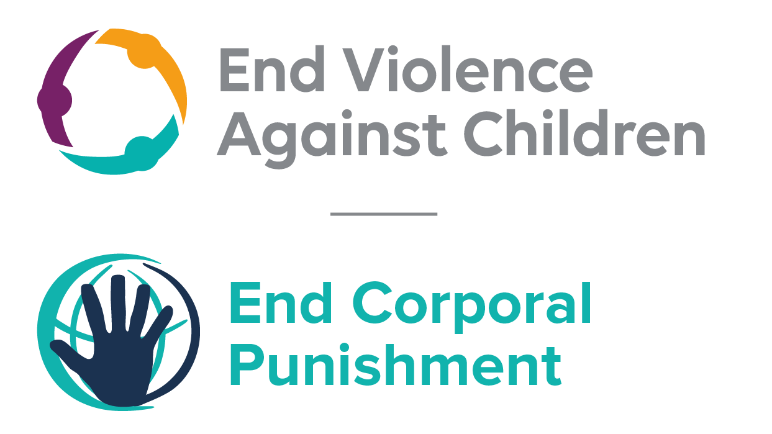
The Global Partnership to End Violence Against Children, October 2022

This briefing describes the legality of corporal punishment of children in the Russian Federation. In light of the Committee’s General Comment No. 8 on “The rights of the child to protection from corporal punishment of children and other cruel or degrading forms of punishment”, its repeated recommendations on the issue and the importance of eradicating this form of violence given by the UN Secretary General’s Study on Violence against Children. Considering the recommendations to prohibit all corporal punishment made during the Universal Periodic Review in 2018, as well as the global commitment to ending all violence against children in the context of the 2030 Agenda for Sustainable Development, we hope the Committee will:
• in its List of Issues Prior to Reporting for the Russian Federation, raise the issue of corporal punishment of children, in particular asking what steps are being taken to enact a legislation to explicitly prohibit corporal punishment of children in all settings; and,
• in its concluding observations on the sixth-seventh report of the Russian Federation, recommend that a legislation is enacted as a matter of priority to explicitly prohibit corporal punishment of children, in all settings including the home and repeal all provisions allowing the use corporal punishment by adults.

Summary of necessary legal reform to achieve full prohibition
Prohibition is still to be achieved in the home, alternative care settings and day care.
There appears to be no defence of “reasonable chastisement” or similar in existing legislation but the near universal acceptance of corporal punishment in childrearing necessitates clarity in law that no level of corporal punishment is acceptable. Prohibition should be enacted of all corporal punishment and other cruel or degrading forms of punishment, in the home and all other settings where adults have authority over children.
Alternative care settings – Prohibition should be enacted in legislation applicable to all alternative care settings (foster care, institutions, places of safety, emergency care, etc).
Day care – Corporal punishment should be prohibited in all early childhood care (nurseries, crèches, kindergartens, preschools, family centres, etc) and all day care for older children (day centres, after-school childcare, childminding, etc).

- Current legality of corporal punishment in the Russian Federation
  - Home: Corporal punishment is lawful in the home. The Family Code 1995 provides for the protection of children’s human dignity by their parents (art. 54) and protection from abuse by parents (arts. 56 and 69). It states that parents have a right and duty to educate their children and must care for their children’s “health, physical, mental, spiritual and moral development” (art. 63) and that “methods of parenting should not include neglectful, cruel or degrading treatment, abuse or exploitation of children” (art. 65). The Criminal Code 1996 punishes intentional serious, less serious and minor harm to health (arts. 111 to 115) and “beating or other violent acts which cause physical pain but not the consequences in article 115” (art. 116 and 116-1). In 2010, the Ministry of Justice stated that provisions in the Family and Criminal Codes amount to prohibition of corporal punishment of children. However, in the absence of explicit prohibition it is not clear that they effectively prohibit all forms of physical punishment in childrearing.
  - There is no explicit prohibition of corporal punishment of children in the Law on Guarantees of the Rights of the Child 1998, the Law on Guardianship and Custody 2008, the Criminal Code 1996, the Code on Administrative Offences 2001 or the Constitution 1993. President’s decree No. 761 dated 1 June 2012 “On the national strategy of activities in the interests of children for 2012-2017” states that one of the measures focused on the formation of a safe and comfortable family environment is the creation and adoption of a programme promoting intolerance to any forms of violence and corporal punishment of children. However, no such programme appears to exist.

  - The Council of Europe’s petition against all corporal punishment, part of its campaign to achieve prohibition in all member states, was supported by Russian officials but to our knowledge there have been no moves towards law reform on the issue. A Law on Domestic Violence is being drafted - in 2017, it was “pending adoption”. Draft amendments to the Code of Administrative Offences have been submitted to the State Duma: the aim of the bill is to prohibit insulting harassment, vulgar language and other intentional behaviour disturbing the public order or peace of citizens conducted at home.

  - In December 2014, the member of the Federation Council proposed amendments to the Criminal Code introducing higher liability for intentional minor harm to health (art. 115), beating (art. 116) and torture (art. 117) committed against relatives or former relatives. Amendments to the Criminal Code were voted in July 2016 to criminalise family violence by modifying article 116 to include having a family relationship with the victim as an aggravating factor of battery. A new article 116-1 made the first occurrence of battery without an aggravating factor an administrative offence. Both articles 116 and 116-1 referred to battery that does not cause “substantial bodily harm”, but neither explicitly prohibited corporal punishment of children. The criminalisation of family violence was overturned in January 2017 when the Criminal Code was again amended to remove from article 116 the mention of the family relationship as an aggravating factor, making the first occurrence of domestic violence an administrative offence under article 116-1. Repeat offenses within a year can still result in criminal prosecution.
In December 2018, Russian Commissioner for human rights ​Tatyana Moskalkova​ declared that decriminalising family violence had been a mistake and called for a new law to be enacted.

  - Alternative care settings: Corporal punishment is lawful in alternative care settings as in the home. There is no explicit prohibition of corporal punishment in all alternative care settings (foster care, institutions, places of safety, emergency care, etc). Children are legally protected from some but not all physical punishment under the Family Code 1995 and the Criminal Code 1996 (see under “Home”).

  - Day care: Corporal punishment is considered unlawful in pre-school day care settings under the Law on Education 2012 (see under “Schools”, below). There is no prohibition of all forms of corporal punishment in other early childhood care and in day care for older children. Act No. 3185-1 on Psychiatric Care and Guarantees for the Rights of Citizens Receiving Such Care 1992 states that the provision of care must be humane and must respect human and civil rights but it does not explicitly prohibit corporal punishment. Children are legally protected from some but not all physical punishment under the Family Code 1995 and the Criminal Code 1996 (see under “Home”).

  - Schools: Corporal punishment is considered unlawful in schools, though it is not explicitly prohibited. Article 34 of the Law on Education 2012 states that students have the right to “(9) respect for human dignity, protection from all forms of physical or mental violence, injury personality, the protection of life and health”; article 43(3) states that “discipline in educational activities is provided on the basis of respect for human dignity of students and teachers” and “application of physical and mental violence to students is not allowed” (unofficial translation). The Code on Administrative Offences 2001 punishes violations of the right to education (art. 5(57)).

  - Penal institutions: Corporal punishment is considered unlawful as a disciplinary measure in penal institutions, though there appears to be no explicit prohibition. Article 12(2) of the Criminal and Executive Code 1997 states (unofficial translation): “Prisoners are entitled to courteous treatment by staff of penal institutions. They should not be subjected to cruel, inhuman or degrading treatment or recovery. Coercive measures to convicts can be applied not only as to the law.” There is no provision for corporal punishment in correctional institutions (arts. 115 and 136). Article 8(1)(4) of the Law on the Fundamentals of the System of Prevention of Neglect and Offences of Minors 1999 states that in the case of minors “the use of physical and psychological violence” and “the application of measures with an anti-pedagogical nature, degrading human dignity” are prohibited. The provisions against beating and intentional causing of harm in the Criminal Code 1996 (arts. 111 to 116) are also applicable.

  - Sentence for crime: Corporal punishment is unlawful as a sentence for crime. There is no provision for judicial corporal punishment in criminal law. Article 7 of the Criminal Code 1996 states that punishment and other measures applied to a convicted person “cannot have the purpose of causing physical suffering or humiliation of human dignity”. The Code sets out the sentences which may be given to minors and these do not include corporal punishment (art. 88).

Recommendations by human rights treaty bodies and during the UPR

  - CRC: On two occasions, the Committee on the Rights of the Child has recommended to the Russian Federation that legislation be enacted to explicitly prohibit corporal punishment in all settings: in its concluding observations on the state party’s third report in 2005 and on the fourth-fifth report in 2014.

  - ECSR: In 2016 and 2020, the European Committee of Social Rights concluded that the situation in the Russian Federation is not in conformity with the Charter on the ground that not all forms of corporal punishment are prohibited in the home and in institutions.

  - UPR: At the third cycle of the Universal Periodic Review of the Russian Federation in 2018, recommendations to enact a legislation to prohibit corporal punishment in all settings were made and supported by the Government.

10 November 2010, Letter to Council of Europe Commissioner for Human Rights Mr Thomas Hammarberg
Latham & Watkins (UK) in correspondence with the Global Initiative, 18 May 2015
22 August 2014, CEDAW/C/RUS/8, Eighth state party report, para. 105
28 September 2017, E/C.12/2017/SR.60, Summary records of 60th meeting, para. 31; see also 12 June 2018, A/HRC/39/13, Report of the Working Group, para. 12
The draft law No. 545442-6 “On introducing the amendments to the article 20.1 of the Code of Administrative Offences of the Russian Federation (regarding amendments of the disposition of article 20.1 of the Code and harsher punishment for the violations established by this article)”
The draft law No. 665512-6 “On introducing the amendments to the Criminal Code of the Russian Federation (regarding establishing the higher criminal responsibility for the crimes, envisaged by articles 115-117 of the CC RF, committed against relatives or former relatives)”
See https://meduza.io/en/news/2016/06/28/russian-senator-says-special-criminal-punishment-for-domestic-violence-is-anti-family, accessed 13 January 2017; Federal law 323-FZ of 7 March 2016, http://kremlin.ru/acts/bank/41057/page/1
See https://www.ft.com/content/e523d036-e482-11e6-9645-c9357a75844a, accessed 31 January 2017
See https://www.independent.co.uk/news/world/europe/russia-domestic-violence-decriminalised-law-victims-human-rights-putin-a8666901.html, accessed 17 December 2018
23 November 2005, CRC/C/RUS/CO/3, Concluding observations on third report, paras. 7, 36, 37, 46 and 47
31 January 2014, CRC/C/RUS/CO/4-5 Advance Unedited Version, Concluding observations on fourth/fifth state party report, paras. 32 and 33
January 2016, Conclusions 2015
March 2020, Conclusions 2019
12 June 2018, A/HRC/39/13, Report of the Working Group, paras. 147(58), 147(279) and 147(280)
3 September 2018, A/HRC/39/13/Add.1 Advance unedited version, Report of the Working Group: Addendum, paras. 15 and 16

