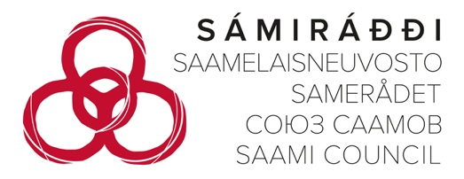
25 May 2026

Submission by the Saami Council to The Committee on the Elimination of Racial Discrimination – Information for the List of themes for the review of Finland at the 118th session

Introduction

- This submission covers Saami Council’s suggestions for the list of themes, including question that the committee should ask Finland under it’s review.

About the Saami Council

- The Saami Council is a voluntary Sámi organization (a non-governmental organization), with Sámi member organizations in Finland, Russia, Norway and Sweden. Since it was founded in 1956 the Saami Council has actively dealt with human rights issues. The primary aim of the Saami Council is the promotion of Sámi People’s rights and interests in the four countries where the Sámi live.

- The Saami Council's work is based on the decisions, statements, declarations and political programmes of the Saami Conference. The Saami Council renders opinions and makes proposals on questions concerning Sámi People’s livelihoods, rights, language and culture and especially on issues concerning the Sámi in different countries.

- The Saami Council has nine member organizations: three in Norway, three in Sweden, two in the Russian Federation and one in Finland. Central Saami Association (Finland) (Suoma sámiid guovddášsearvi) is the Saami Council’s member organization in Finland. The Central Saami Association has seven member associations: Sámi Siida rs., Johtti Sápmelaččat rs., Roavvenjárgga Sámiid Searvi Mii rs., Suoma Sámi Nuorat SSN rs, Sámi Soster rs., Suoma Boazosámit rs. and Saa’mi Nue’tt rs.

List of themes

A: Sámi People’s right to land

- The Saami Council remains concerned that Finland has still not legally recognized Sámi land rights or secured adequate protection for the material basis of the Sámi culture, particularly in relation to property rights and land encroachment cases.

- Furthermore, Finland’s consultation framework raises concerns regarding compliance with international standards relating to the rights of Indigenous Peoples, including the lack of implementing the right to Free, Prior and Informed Consent.

CERD may ask Finland:

- How does Finland intend to ensure legal recognition and effective protection of Sámi Peoples’ property rights, including the right to manage land and natural resources?

- How does Finland intend to address land encroachment and ensure that Sámi Peoples’ rights are effectively protected in decisions concerning land use and development?

- How does Finland guarantee the right to Free, Prior and Informed Consent of affected right-holders in decision-making processes concerning land use, natural resources, and industrial development in Sámi territories?

- What measures are in place to address the cumulative impacts of land-use decisions, including mining, forestry, and renewable energy projects, on Sámi cultural practices and livelihoods?

B: Fishing rights and the Deatnu/Tana River

- The Saami Council remains concerned about the impacts of the Deatnu/Teno River regulatory framework on Sámi fishing culture and traditional livelihoods.

- Restrictions affecting traditional salmon fishing practices continue to have significant cultural and social impacts on Sámi communities that depend on the Deatnu/Teno river system as part of their cultural identity and way of life.

- The river is a transboundary river, and its use is therefore affected by both Finnish and Norwegian regulations. The Saami Council is particularly concerned that Sámi on the Finnish side are excluded from these processes on the Norwegian side.

- The Saami Council emphasizes that traditional fishing practices are an essential part of Sámi culture and intergenerational knowledge transmission. Measures affecting these practices must therefore be assessed not only as environmental or fisheries management issues, but also as questions concerning the rights of Indigenous Peoples.

CERD may ask Finland:

- How does Finland ensure that restrictions concerning traditional salmon fishing respect the rights of the Sámi People?

- What measures has Finland taken to ensure effective participation and the right to Free, Prior and Informed Consent in decision-making concerning traditional Sámi fisheries?

- How does Finland assess the cultural impacts of fisheries regulation on Sámi communities?

- What steps is Finland taking to ensure that state authorities coordinate effectively with Sámi institutions and right holders in cross-border issues affecting Sámi territories?

C: Follow-up to the Truth and Reconciliation Commission

- The Finnish Truth and Reconciliation Commission concerning the Sámi People submitted its report in 2025. The report documents historical and ongoing discrimination, assimilation policies, loss of language, land and culture, and structural injustices affecting the Sámi People.

- The Saami Council considers the current CERD review an important opportunity to follow-up on the implementation of the Commission’s findings and recommendations.

- Particular attention should be given to structural racism, institutional discrimination, unresolved land rights issues, and the weakening of traditional livelihoods identified through the truth and reconciliation process.

- The Commission’s findings further illustrate how state regulation of lands, waters, fisheries, and natural resources has contributed to cumulative harms affecting the transmission of Sámi culture across generations and threatening the survival of the Sámi culture and livelihoods.

CERD should ask Finland:

- What concrete measures has Finland taken to implement the recommendations of the Truth and Reconciliation Commission?

- How will Finland address structural discrimination against the Sámi People identified in the Commission’s findings?

- What mechanisms exist to ensure meaningful participation from Sámi institutions and representatives in implementation and follow-up processes?

- How will Finland ensure that the reconciliation processes lead to substantive legal and institutional reforms, especially concerning land rights?

D: Sámi children and intergenerational transmission

- Industrial development, land fragmentation, environmental degradation, and restrictions on traditional livelihoods disproportionately affect Sámi children and youth by undermining the intergenerational transmission of language, cultural knowledge, and traditional practices.

- Recent UN treaty body decisions recognized that failures to protect Sámi lands and ensure participation in decision-making can amount to discrimination against Sámi children.

CERD should ask Finland:

- How does Finland ensure protection of the cultural rights of Sámi children in land-encroachment decisions?

- What measures are being taken to safeguard intergenerational transmission of Sámi language, livelihoods, and culture?

Yours Sincerely,

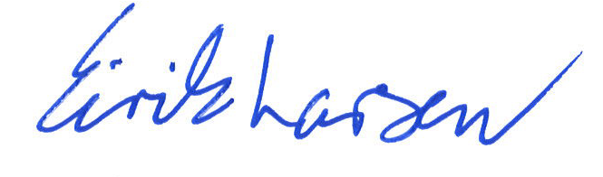
Eirik Larsen
Head of the Human Rights Unit
Saami Council

UN Committee on the Rights of the Child (2024): CRC/C/97/D/172/2022; and Committee on Economic, Social and Cultural Rights (2024): E/C.12/76/D/289/2022.

