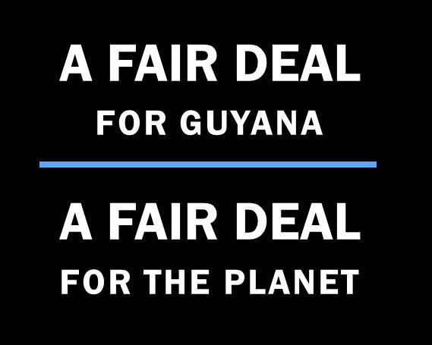
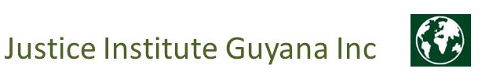

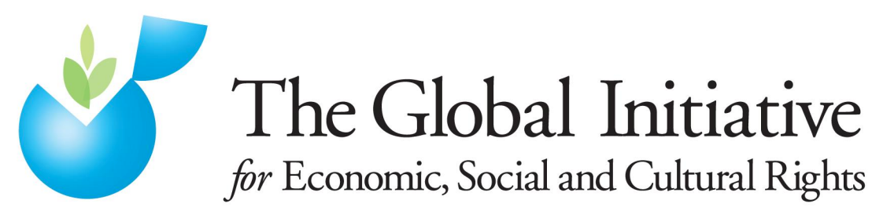
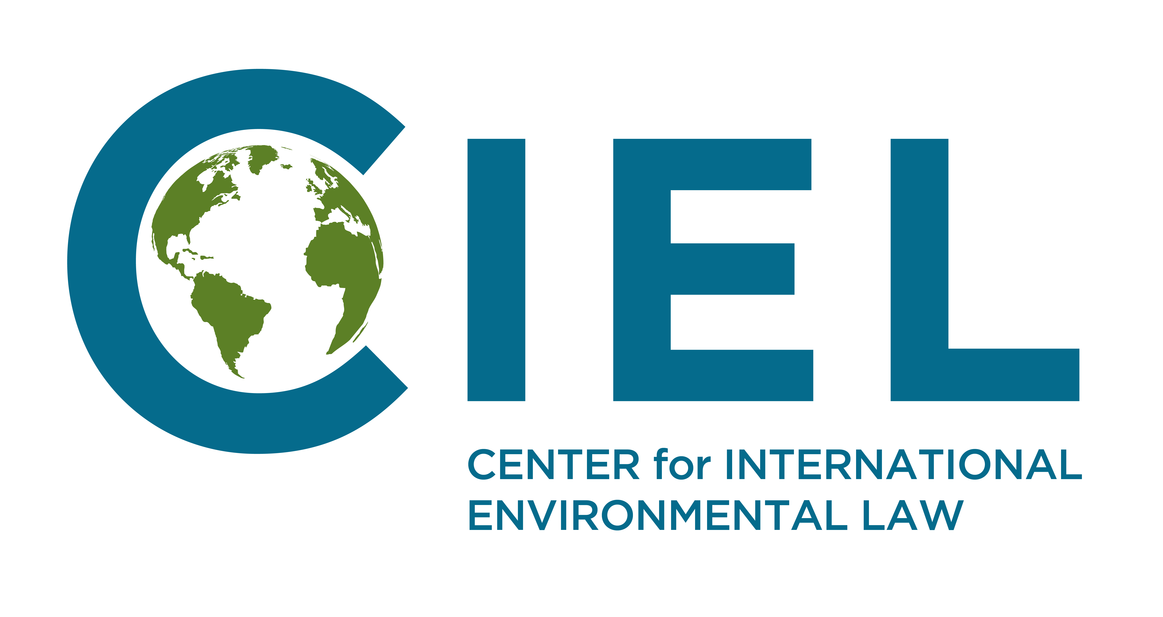

Joint Parallel Report submitted by
the Center for International Environmental Law, and
the Global Initiative on Economic, Social and Cultural Rights,
in consultation with:
Fair Deal for Guyana – Fair Deal for the Planet,
The Justice Institute Guyana Inc.,

to the
Committee on the Elimination of Discrimination Against Women
For the Dialogue with Guyana during the Committee’s Working Group for the 73rd Session , 12th July 2019

EXECUTIVE SUMMARY
Guyana’s proposed extraction of fossil fuels conflicts with the fulfilment of its obligations under the Convention on the Elimination of all forms of Discrimination Against Women as fossil fuels contribute significantly to dangerous climate change and investment in fossil fuels exacerbate existing inequalities between men and women as women disproportionately bear the burden of climate-related impacts while any expected benefits of the fossil fuel industry itself flow disproportionately to men.
We therefore encourage the Committee on the Elimination of all forms of Discrimination Against Women to adopt the following recommendation with respect to Guyana:
- Recommends that the government of Guyana halts its proposed plans to begin offshore oil production and puts all oil production related activities on hold, until such time as Guyana is able to provide evidence that the proposed oil production does not and will not conflict with Guyana's obligations under ICEDAW, and encourages Guyana to promote alternative and renewable energy sources in a gender-responsive manner taking into account in particular the vulnerability and needs of households that are headed by single women;

- Recommends further that Guyana ensures the effective participation of women in all climate and energy-related decision-making – including that of women living in areas that are below sea-level and who are therefore most at risk from the impact of rising sea-levels as a result of global warming.

Submitting Organizations
This parallel report is submitted to the Committee on the Elimination of Discrimination Against Women by the following organizations:
The Center for International Environmental Law uses the power of law to protect the environment, promote human rights, and ensure a just and sustainable society.
The Global Initiative on Economic, Social and Cultural Rights is an international non-governmental human rights organization which seeks to advance the realization of economic, social and cultural rights throughout the world.
In consultation with:
Fair Deal for Guyana - Fair Deal for the Planet is a network of concerned citizens in Guyana and elsewhere.
Justice Institute Guyana Inc. is an independent and impartial legal institute in Guyana which promotes respect for the rule of law and environmental justice.

Adverse impacts of climate change on women
Climate change affects women disproportionately and more severely than men. The IPCC’s Fifth Assessment report reads ‘People who are socially, economically, culturally, politically, institutionally or otherwise marginalized are especially vulnerable to climate change’. Since women make up the vast majority of the world’s poor, are more dependent for their livelihood on natural resources, have unequal access to decision-making processes, and often have limited mobility and networks, they are more vulnerable to the effects of climate change.

This is also underlined by the CEDAW Committee in their General Recommendation 37 (GR37) on the gender-related dimensions of disaster risk reduction in the context of climate change, which states ‘Women, girls, men and boys are affected differently by climate change and disasters, with many women and girls experiencing greater risks, burdens and impacts. Situations of crisis exacerbate pre-existing gender inequalities and also compound intersecting forms of discrimination against, inter alia, women living in poverty, indigenous women, women belonging to ethnic, racial, religious and sexual minorities, women with disabilities, women refugees and asylum seekers, internally displaced, stateless and migrant women, rural women, single women, adolescents and older women, who are often affected disproportionately compared to men or other women.’

- Climate Change and women’s rights in Guyana
Guyana is home to one out of four remaining intact tropical rainforests in the world. Guyana is particularly vulnerable to effects of climate change because of its dependency on its natural environment. Moreover, 76% the country’s population is living below sea level and depends on deficient infrastructure, making the country particularly sensitive to sea level rise and flooding. These factors result in the particular vulnerability of urban women, riverine communities and Amerindians to the effects of flooding and other climate change impacts.

Guyana has acknowledged the threat climate change poses to human security, especially that of low lying countries and developing countries and recognized that ‘[t]his global threat requires a united and strong global position to reduce carbon emissions and reverse the worst impact on future generations.’

- Guyana’s policy concerning the extraction of fossil fuels
However, the government of Guyana has also adopted policies that would significantly increase the risk and impacts of climate change through extraction of fossil fuels and through the increase in emissions of greenhouse gases that ineluctably would result from it.

The government and oil companies have stated that production should begin in 2020, with the production of 120.000 barrels per day. Guyana’s oil fields are estimated by ExxonMobil to be more than 5 billion oil equivalent barrels. This amount will increase, as discoveries are still being made, with the last one during writing 18th of April 2019. This proposed fossil fuel production and exploitation will exacerbate climate change and therefore adversely impact women, both in Guyana and in other countries. At 120.000 barrels a day, Guyana will contribute, upon burning of the oil, about 18,8 million metric tons of CO2 per year to global emissions, which is equivalent to roughly 9 times the annual CO2 emissions of Guyana’s entire population. In addition to this contribution to global emissions, the extraction of oil has other environmental impacts.

Oil extraction can lead to water pollution, water loss and scarcity, and fossil fuel extraction is inextricably linked to air pollution. Simply by taking up space in the ocean and seabed and by carrying out drilling, transportation and related activities, oil production will adversely affect the marine environment and have adverse impacts on Guyana’s fisheries. This is turn affects the communities who depend on marine resources for their livelihoods, with women bearing a disproportionate part of the burden.

Offshore oil exploitation in particular can lead to additional environmental harms. Each year, about 880,000 gallons of oil are released into the ocean from North American offshore oil drilling platforms alone. These include accidental discharges of oil into the ocean. Offshore oil drilling also produces operational discharges of oil, resulting from the extractive activities. Oil spills adversely impact birds, fish, marine mammals and marine and onshore ecosystems. Oil spills are difficult to clean up, and the clean-up process usually connected to the release of toxic chemical dispersants, which cause further harm to the environment. Natural disasters also increase the likelihood of oil spills, and with Guyana’s geographical characteristics, it is particularly prone to natural disasters, such as the 2005 swell event in that caused widespread flooding after overcoming Guyana’s sea defences. Potential oil spills, but also the drilling itself and the water produced along with oil cause the release of various toxics into the water, which threaten the marine ecosystem.

Guyana’s coastal land is also highly sensitive. Protection of this coastal land is imperative, not only because it contains the capital city Georgetown, most of the productive agricultural land, and the bulk of Guyana’s population, but also because it contains mangrove forests. These mangrove forests protect Guyana’s coast and help mitigate climate change, since it is estimated they are capable of fixing up to 17 tonnes of carbon/hectare/year. Mangrove forests are found at the interface between the terrestrial and marine ecosystems. Offshore oil drilling can negatively impact both ecosystems and destroy these mangrove forests, which in turn will worsen climate change. This will ultimately affect all of Guyana’s forests, including its rainforests, which currently help to mitigate climate change by photosynthesis. Given the scale of Guyana’s proposed oil exploitation, these risks are especially pertinent.

- States’ obligations related to climate change

States’ obligations under ICEDAW
States have the obligation under Article 2 of ICEDAW to respect women’s right to non-discrimination and to the enjoyment of equality, which means that States must ‘[r]efrain from making laws, policies, regulations, programmes, administrative procedures and institutional structures that directly or indirectly result in the denial of the equal enjoyment by women of their civil, political, economic, social and cultural rights’

Furthermore, under Article 2, States’ obligation to fulfil women’s right to non-discrimination and to the enjoyment of equality, requires that States ‘[t]ake a wide variety of steps to ensure that women and men enjoy equal rights de jure and de facto, including, where appropriate, the adoption of temporary special measures’. States’ obligations under Article 2 include refraining from taking steps that will lead to the further and disproportionate impoverishment of women and the undermining of women’s substantive equality, caused by climate change. This obligation requires States to refrain from taking steps that will worsen the impacts of climate change, particularly given these impacts affect the rights of women disproportionately.

The CEDAW Committee has also stressed the importance of mitigation in combatting the adverse effects of climate change on women in its General Recommendation on Gender-related dimensions of disaster risk reduction in the context of climate change. In GR37, the Committee reiterates that ‘[l]imiting fossil fuel use and greenhouse gas emissions and the harmful environmental effects of extractive industries (…) are regarded as crucial steps in mitigating the negative human rights impact of climate change and disasters.’ Therefore, to reduce the gender-skewed impact of climate change, governments must take adequate action aimed at mitigating climate change. Guyana’s plans to begin oil extraction in 2020 is incompatible with its international obligations, because it will contribute significantly to dangerous anthropogenic climate change.

In addition, GR37 views promoting the transition to renewable sources of energy as crucial steps to mitigate the effects of climate change globally and underlines that States are under the obligation to ensure that women benefit from this transition. The proposed scale of oil exploitation in Guyana will require decade-long investments in fossil fuels, which will stymie efforts to make the urgent and critical shift to renewables necessary to protect life on earth. Moreover, investments in renewable energy not only mitigate climate change but offer investment and employment opportunities for women to lift themselves out of poverty and to achieve greater equality.

States’ obligations under the UNFCCC

Mitigating the emissions of greenhouse gases
Guyana is a Party to the UNFCCC and has ratified the Paris Agreement. Under the Paris Agreement, States committed to limit the increase of global average temperature to well below 2ºC above pre-industrial levels and to pursue efforts to limit the temperature increase to 1.5ºC. States recognised that keeping global temperature increase to below this threshold would ‘[s]ignificantly reduce the risks and impacts of climate change’ and that ‘[d]eep reductions in global emissions will be required in order to achieve the ultimate objective of the Convention’. The necessity of committing to a world below 1.5ºC warming is reiterated by the release of the IPCC’s Special Report on 1.5ºC. In this report the IPCC underlines, with high confidence, that the human rights related risks are higher for global warming of 1.5°C than present, but lower than at 2°C. It further recognizes that ‘[a]mbitious mitigation actions are indispensable to limit warming to 1.5°C while achieving sustainable development and poverty eradication (high confidence).’
The use of oil products is estimated to account for around 35% of global GHG emissions, and the oil industry itself consumes an additional 3-4% of global energy. To keep dangerous anthropogenic warming under 1.5°C and protect the human rights of all, governments need to reduce greenhouse gas emissions. The pathway to 1.5°C can only be achieved if governments halt as a matter or urgency the development of new infrastructures to extract fossil fuels and if the majority of existing and all future oil, gas and coal reserves and resources remain unexploited. The proposed exploitation of new fossil fuel reserves undermines the objectives of the Paris Agreement. To limit global warming to 1.5°C requires an urgent phase-out of current fossil fuel production. Consequently, to start the extraction of fossil fuels, including through licensing and infrastructure development, particularly in highly sensitive areas such as low-lying Guyana with its fragile ecosystem, is incompatible with the objectives of the Paris Agreement.

It is also incompatible with sustainable development obligations since fossil fuel extraction and production will inevitably compromise the ability of future generations to meet their needs in a world that is undergoing anthropogenic and catastrophic climate change. Absent such urgent action, UN Special Rapporteur on Extreme Poverty has warned of the risk of ‘climate apartheid’ in which the rich are able to pay to escape the effects of climate change, leaving the poor to suffer. As noted above, the majority of those living in poverty are women.

Making financial flows compatible with the low-carbon development
Moreover, the Paris Agreement includes, as one of its three long-term goals, a commitment to "making finance flows consistent with a pathway towards low greenhouse gas emissions and climate-resilient development." This provision is not only applicable to international climate finance, but looks at all financial flows. It therefore covers both public and private, domestic and international financial flows. This is a testament to the fact that the objectives of the Paris Agreement will only be met if financial resources are directed towards carbon neutral technologies such as renewable energy and if any financial incentives and support for industries related to the fossil fuels are rapidly terminated.

The planned extraction of oil in Guyana is of such a large scale, with a continuous discovery of new oil wells, that it will require and attract massive investments in the fossil fuel industry. A project like this would lock in decades of investments in fossil fuels. This renewed investment in the fossil fuel industry will redirect the financial flows towards fossil fuels, and simultaneously move away from the phase-out of fossil fuels and the necessary investment in renewable energy and other low carbon development initiatives vital to the achievement of this objective.
Furthermore, investments in oil production can exacerbate gender inequality and impact women adversely. The World Bank 2013 study “Extracting the Lessons on Gender in the oil and gas sector” pointed out that, “In social contexts where existing gender inequalities are pronounced, the pressure of changes wrought by oil can deepen the disadvantaged status of women as community members and within their families.” The study also shows that benefits which might flow from oil production are more likely to go to men, while women bear the burden of the brunt of the risks associated with oil extraction. Guyana therefore needs to put in place adequate measures to ensure equality and protect women by making its financial flows consistent with a pathway of low-carbon development.

Suggested Recommendations
In light of the above, we encourage the Committee on the Elimination of all forms of Discrimination Against Women to adopt the following recommendation with respect to Guyana:
- Recommends that the government of Guyana halts its proposed plans to begin offshore oil production and puts all oil production related activities on hold, until such time as Guyana is able to provide evidence that the proposed oil production does not and will not conflict with Guyana's obligations under ICEDAW, and encourages Guyana to promote alternative and renewable energy sources in a gender-responsive manner taking into account in particular the vulnerability and needs of households that are headed by single women;

- Recommends further that Guyana ensures the effective participation of women in all climate and energy-related decision-making – including that of women living in areas that are below sea-level and who are therefore most at risk from the impact of rising sea-levels as a result of global warming.

See IPCC, ‘Climate Change 2014: Synthesis Report. Contribution of Working Groups I, II and III to the Fifth Assessment Report of the Intergovernmental Panel on Climate Change’ (2014).
As recognized in Draft General Recommendation No. 37 on Gender-related dimensions of disaster risk reduction in the context of climate change CEDAW/C/GC/37, paras 2-3.
Ibid, para 2.
CRC National Report 2012, para 41.
See Hickey, C. and T. Weis, 2012: The challenge of climate change adaptation in Guyana. Climate and Development, 4(1).
IPCC AR5, WGII, Part B: Regional Aspects, at 27.3.3.2. The report speaks of low-income urban populations, and since women make up the vast majority of the world’s poor, this results in urban women being particularly vulnerable.
CEDAW National Report 2018, para 108. See for example of the adverse effects of oil extraction on vulnerable communities Osofsky, H.M. 'Is Climate Change "International"?: Litigation's Diagonal Regulatory Role' (2009) 49 Va J Int'l L 585; Osofsky, 'The Geography of Climate Change Litigation' (n 8) at 1838.
CESCR National Report 2014, para 378.
https://corporate.exxonmobil.com/en/locations/guyana.
https://corporate.exxonmobil.com/en/Locations/Guyana/Guyana-project-overview#drillingActivityInTheStabroekBlock.
https://corporate.exxonmobil.com/en/Locations/Guyana/Guyana-project-overview#drillingActivityInTheStabroekBlock; it is expected it might even constitute 13 to 15 billion oil reserves, see https://www.stabroeknews.com/2019/sunday/guyana-and-the-wider-world/02/17/road-map-why-guyanas-13-to-15-billion-barrels-of-oil-reserves-are-on-the-cards/.
Based on IPCC and EPA formula 5.80 mmbtu/barrel × 20.31 kg C/mmbtu × 44 kg CO₂/12 kg C × 1 metric ton/1,000 kg = 0.43 metric tons CO₂/barrel, see https://www.epa.gov/energy/greenhouse-gases-equivalencies-calculator-calculations-and-references.
This refers to Guyana’s emissions in 2014, see https://www.macrotrends.net/countries/GUY/guyana/carbon-co2-emissions for metric tons of emissions per capita and https://www.worldometers.info/world-population/guyana-population/ on Guyana’s population.
Ellis, J., ‘The Effects of Fossil-Fuel Subsidy Reform: A review of modelling and empirical studies’ GSI, IISD (2010) p. 38.
See Johnston, J.E., Lim, E., Roh, H., ‘Impact of upstream oil extraction and environmental public health: A review of the evidence’ 657 Science of the Total Environment 189 (2019); Protecting Our Ocean and Coastal Economies: Avoid Unnecessary Risks from Offshore Drilling.” Edited by Melissa Waage and Alison Chase, Ocean Facts, Natural Resources Defense Council, Sept. 2009, page 3.
See, Finer, M., et al., ‘Oil and Gas Projects in the Western Amazon: Threats to Wilderness, Biodiversity, and Indigenous Peoples’, 3(8) PLoS ONE (2008). Onshore infrastructure is needed for the transportation, storage, processing, and delivery of oil, see also Waage, Chase supra note 14.
Supra note 10. For example, in 2008, over 60,000 tons of nitrogen oxides (NOx) and 50,000 tons of volatile organic compounds (VOCs) were released from U.S. offshore oil platforms. These substances can impact human health, water quality, contribute to climate change and more (National Service Center for Environmental Publications. 1998, NOX: How Nitrogen Oxides Affect the Way We Live and Breathe. US EPA, Office of Air Quality Planning and Standards).
Outer Continental Shelf Drilling. Edited by Sandra Purohit, Defenders of Wildlife, defenders.org/publications/impacts_of_outer_continental_shelf_drilling.pdf.
See http://oils.gpa.unep.org/facts/operational.htm.
For example, during the Deepwater Horizon oil spill, it was estimated 115.000 birds, sea turtles and marine mammals were killed www.biologicaldiversity.org/programs/public_lands/energy/dirty_energy_development/oil_and_gas/gulf_oil_spill/a_deadly_toll.html.
‘The Use of Dispersants in Marine Oil Spills Responses’, The National Academy of Sciences (2019), available at: https://www.nap.edu/read/25161/chapter/1.
van Ledden, M., G.Vaughn, J. Lansen, F.Wiersma, and M.Amsterdam, 2009: Extreme wave event along the Guyana coastline in October 2005. Continental Shelf Research, 29(1), 352-361.
See Environmental impacts of produced water and drilling waste discharges from the Norwegian offshore petroleum industry https://www.sciencedirect.com/science/article/pii/S0141113613001621.
See Guyana Forestry Commission and Integrated Coastal Zone Management (ICZM)–EPA (2001). National Mangrove Management Action Plan.
For example, terrestrial effects of offshore drilling were in part attributed to offshore oil drilling because of its significant onshore infrastructure such as new roads, pipelines, and processing facilities in Louisiana, Boesch, Donald, ‘The awful price of coastal ruin’ Baltimore Sun (2005).
See Guyana’s Second National Communication to the UNFCCC, for example page 227, document available at https://unfccc.int/resource/docs/natc/guync2.pdf.
CEDAW, ‘General Recommendation No. 28 on the core obligations of States parties under article 2 of the Convention on the Elimination of All Forms of Discrimination against Women’, (2010), UN Doc. CEDAW/C/GC/28, paragraph 9.
Ibid.
Supra note 2, para 13.
Ibid, paras 43, 54.
CEDAW COB Nigeria 2017, paras 39, 40.
UNFCCC, Paris Agreement adopted at the 21st Session of the Conference of the Parties (12 December 2015) (Paris Agreement), article 2.1.a.
Paris Agreement, preamble.
Ibid.
IPCC Special Report, ‘Global warming of 1.5°C. An IPCC special report on the impacts of global warming of 1.5 °C above pre-industrial levels and related global greenhouse gas emission pathways, in the context of strengthening the global response to the threat of climate change, sustainable development, and efforts to eradicate poverty’ (2018) (SR 1,5), Chapter 1 Executive Summary.
Key World Energy Statistics (Intl. Energy Agency, 2015).
See McGlade, C., & Ekins, P. (2015). The geographical distribution of fossil fuels unused when limiting global warming to 2 [deg] C. Nature, 517(7533), 187-190.
This is also of particular importance given the outcomes of the Global Assessment of the IPBES on biodiversity, which paints a bleak picture about the status of biodiversity worldwide and calls for transformative change to recover ecosystems and biodiversity, including through rights-based action (accessible at https://www.ipbes.net/deliverables/2c-global-assessment).
https://www.ohchr.org/EN/NewsEvents/Pages/DisplayNews.aspx?NewsID=24735&LangID=E
Paris Agreement, article 2.1c.

