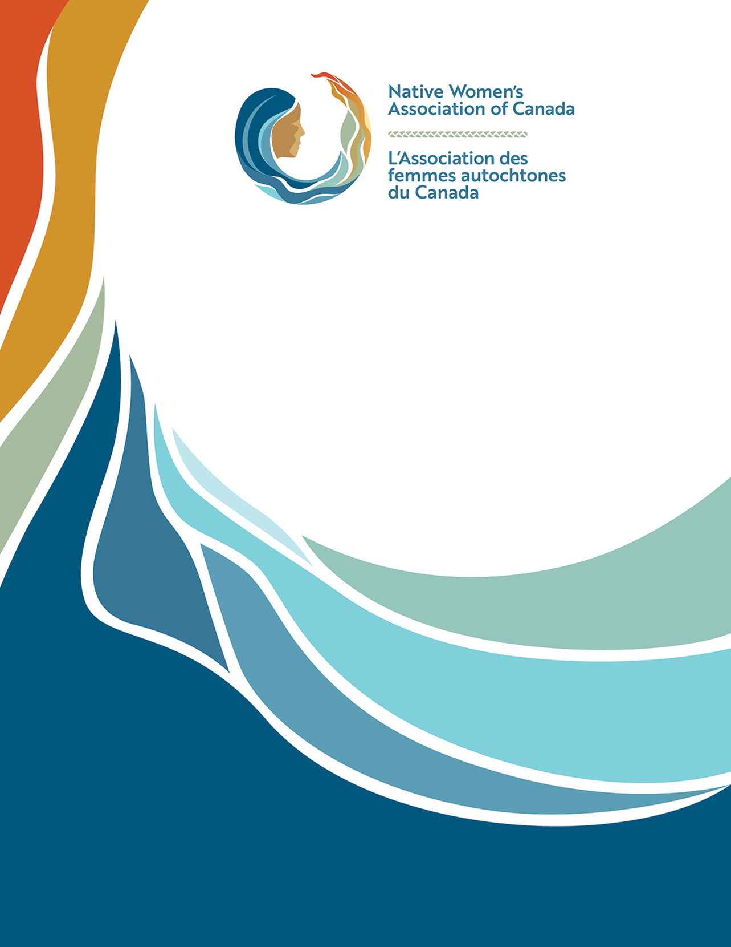
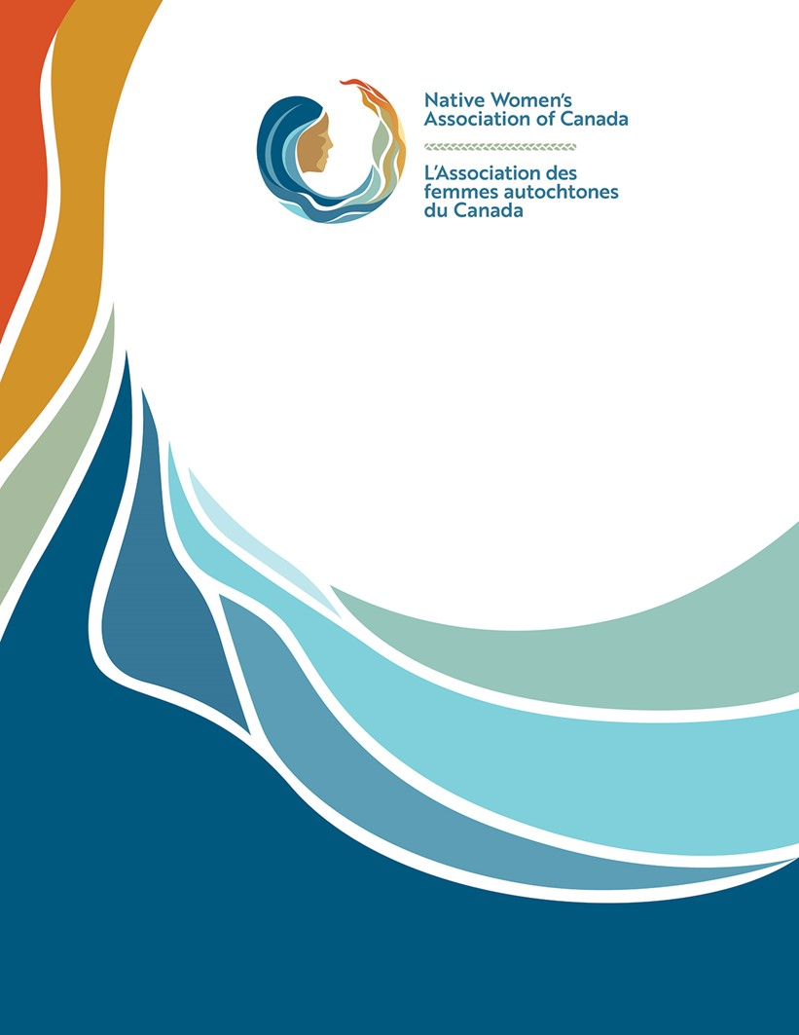
They Are Worthy: Indigenous Children’s Rights in Canada

UN Committee on the Rights of the Child – Canada’s Joint 5th/6th Periodic Review
Alternative Report
Suitable for public posting
14 April, 2022

Headquarters
120 Promenade du Portage
Gatineau, QC, J8X 2K1
Tel: (613) 722-3033
Toll Free: 1-8800-461-4043
Email: reception@nwac.ca
Table of Contents
Introduction 3
Background 3
Situation Analysis 3
Overview 3
Issue settlements 4
Access to clean drinking water 4
Health and mental health 4
Standard of living 5
Education 5
Preservation and identity 5
Corporal punishment 6
Children of incarcerated mothers 6
Dissemination and awareness-raising 6
Children’s rights and the business sector 7
Best interests of the child 7
Birth registration, name and nationality 7
Conclusions and Recommendations 7
Recommendations 8

Introduction
While Canada has taken important steps to realize children’s rights domestically as a party to the Convention on the Rights of the Child (CRC) and its protocols, much work remains when it comes to meaningful action for Indigenous children. The Native Women’s Association of Canada (NWAC) offers this report to the Committee on the Rights of the Child (“the Committee”) to provide a more fulsome analysis of Canada’s steps to ensure Indigenous children have equal opportunity to realize their rights under the CRC.
This report will provide the Committee background information about NWAC’s domestic advocacy, analyses of Canada’s practical measures to improve rights protections for Indigenous children, and recommendations the Committee may consider in its 5th-6th review of Canada in May 2022.

Background
NWAC is a grassroots national Indigenous organization representing Indigenous women, girls and gender-diverse people across Canada. The Committee welcomed NWAC’s submissions in past reviews of Canada’s CRC rights implementation progress. NWAC appreciates the Committee’s role in holding Canada to account for its responsibilities to all children.
NWAC’s mandate specifically includes advancing equality rights for Indigenous girls, however NWAC honours its responsibility to amplify the view of all Indigenous women’s relations, including children, families and communities.

Situation Analysis

Overview
Indigenous children face significantly worse outcomes than non-Indigenous children in Canada. They experience disproportionate poverty rates, domestic violence rates, food insecurity, lower education attainment, health conditions and systemic discrimination. Indigenous children inherit intergenerational harms from Canada’s colonial legacy, including Indian Residential Schools, 60s scoop and membership exclusion laws.
A tragic by-product of Canada’s discriminatory practices against Indigenous Peoples is the point at which Indigenous children internalize discriminatory messages that they are less worthy because they are Indigenous. This manifests as severe mental health conditions among Indigenous young people, who experience much higher rates of suicide and mental health crises than other kids.
Indigenous children continue to reclaim their rights and roles as valuable community members in Canada. To help realize Indigenous children’s rights, NWAC recommends Canada allocate stable, long-term funding resources to support Indigenous children’s equal access to clean water, child and family services, health care, civil rights and environmental rights.

Issue settlements
In January 2022, Canada negotiated a plan to provide financial redress to Indigenous children and families affected by its discriminatory funding patterns in child and family service provision. This agreement-in-principle follows decisions from the Canadian Human Rights Tribunal (CHRT) and Federal Court of Appeal holding Canada accountable for its “wilful and reckless” discrimination in the way it funded Indigenous children’s child and family services and health services. By Fall 2022, Canada is scheduled to reach a binding Final Settlement Agreement outlining steps to both align federal laws and programs with judicial rulings and to compensate Indigenous children and families.
Had Canada corrected its funding practices when Indigenous child advocates first raised discrimination issues in the early 2000s, Indigenous children would have been spared continuous suffering. Instead, Canada litigated the complaints for over a decade, leaving Indigenous children to receive sub-par funding for health and social services. This discriminatory funding meant alarming and disproportionate numbers of Indigenous children were removed from their homes. Canada’s Truth and Reconciliation Commission of Canada calls this “growing crisis” of Indigenous children in foster care a continuation of the harms Indian Residential Schools created.
NWAC recommends Canada immediately begin issuing compensation payments to the children and families harmed by discriminatory funding patterns. Until Canada issues settlements to the children and families affected, Canada’s promise remains unfulfilled.
NWAC recommends Canada review and improve funding frameworks that support Indigenous children realize their rights under the CRC and the United Nations Declaration on the Rights of Indigenous People (UNDRIP).

Access to clean drinking water
The CRC and other UN human rights committees are aware many Indigenous Peoples in Canada, including children, do not have access to clean drinking water in their communities. Canada’s current government engaged a plan to lift all boil-water advisories in Indigenous communities, although the timeline for achieving this goal keeps being pushed further into the future. In the interim, many Indigenous children are growing up far below the highest attainable standard of health Article 24 promises and non-Indigenous children in Canada enjoy.
NWAC recommends Canada work with Indigenous communities to provide sustainable, long-term water infrastructure in every Indigenous community by 2024.

Health and mental health
Indigenous children in Canada grow up with significantly poorer health outcomes than non-Indigenous kids. Indigenous kids living in reserve communities face challenges accessing clean water. Canada recently agreed to apply Jordan’s Principle, a legal principle mandating Canada to provide Indigenous kids the health supports they need upfront and figure out costs and jurisdictional disputes with provinces later. This principle responds to vast inequities Indigenous children faced when seeking medical and health supports from the government.
The health and mental health gaps between Indigenous and non-Indigenous children persist in Canada. Health is influenced by a confluence of factors, including poverty, food insecurity, intergenerational trauma and access to health supports and services.
NWAC recommends Canada prioritize improving Indigenous children’s health by addressing the underlying casus of poor health outcomes.
NWAC recommends Canada provide legislative protection for Indigenous Peoples’ inherent right to determine their healthcare.

Standard of living
Another social determinate of health separating Indigenous children from the rest of Canada is the Indigenous housing crisis. Too many Indigenous children are growing up in overcrowded homes and homes in need of major repair. In Nunavut, the Canadian territory experiencing the worst housing crisis, Inuit families sometimes sleep in shifts in overcrowded housing to meet their basic shelter needs. UNCRC Article 27 provides that governments such as Canada have a responsibility to help fund children’s housing needs.
More than half of First Nations children in Regina, Winnipeg and Saskatoon, three of Canada’s biggest prairie cities, live below the poverty line. For children living on Indigenous reserve communities and the northern Territories, this figure is expected to be higher- but Canada does not have a poverty line applicable to reserve communities or the Territories.
NWAC recommends Canada fund immediate housing solutions for Indigenous families.

Education
Indigenous children who live in isolated geographic communities often have to travel away from their home community to complete secondary school. This means children are sent to urban settings without their families to attain the same education non-Indigenous kids receive in their own communities. This perpetuates the family separation harms associated with the Indian Residential School program. Indigenous children have lower educational attainment rates than their non-Indigenous counterparts and suffer needlessly when they are separated from their families just so they can access education.
NWAC recommends Canada develop Indigenous education legislation that specifically acknowledges Indigenous Peoples’ inherent right to determine their education and provides funding equal to non-Indigenous education.

Preservation and identity
A relic from Canada’s colonial legacy is the state’s legal authority to determine which Indigenous people are eligible for Indian status membership under the Indian Act. Indian status membership provides economic and membership benefits, depending on separate classes of status. Canada assigns status class eligibility based on an applicant’s ability to demonstrate family lineage. When Canada denies full status membership, the applicant and their children (and grandchildren) are ineligible to participate in legally protected activities, such as hunting and fishing, in accordance with their Indigenous customs.
Indian Act membership laws have a long history of denying equality to Indigenous women and their children. Canada amended these laws numerous times to redress inequality, but the Indian status membership laws still create separate classes and still give the government the final word on whether to bestow membership status. Canada indicated it plans to table legislation in 2022 to address remaining inequities in the Indian Act ’s registration provisions. The UN Committee on the Elimination of Discrimination Against Women (CEDAW) recently issued the same plea, urging Canada to address the Indian Act’s remaining inequities.
NWAC recommends Canada amend the Indian Act to comply with UNDRIP, which clarifies Indigenous Peoples’ inherent right to determine their own membership, and CRC Article 8, which provides a child’s right to preserve their family and cultural identities.

Corporal punishment
NWAC does not support Canada’s continued reservation under CRC Article 37(c). Indigenous children today inherit the intergenerational traumas associated with Indian Residential Schools, including corporal punishment. Today in Canada, Criminal Code s. 43 permits parents and authority figures to use corrective force as a defence to criminal assault charges against a child. The Truth and Reconciliation Commission of Canada’s Call to Action 6 calls on Canada to abolish this criminal law.
NWAC recommends Canada withdraw its reservation and repeal Criminal Code s. 43.

Children of incarcerated mothers
Indigenous women’s overincarceration rates approach 50 per cent of the federal institution population, leaving too many Indigenous children without their primary care providers. Canada has not taken meaningful action to redress Indigenous overincarceration.
NWAC recommends family separation be a codified sentencing principle judges must consider when sentencing Indigenous women.

Dissemination and awareness-raising
NWAC recommends Canada consider developing and disseminating children’s rights awareness programs specifically for Indigenous children. In keeping with UNDRIP principles and Canada’s Indigenous Languages Act, NWAC suggests developing materials in widely-spoken Indigenous languages. These materials should be developed in consultation with Indigenous language knowledge keepers to ensure children’s rights are clearly communicated and reinforce Indigenous legal principles, especially since the UN General Assembly proclaimed the period between 2022 and 2032 as the International Decade of Indigenous Languages.

Children’s rights and the business sector
Canada is home to numerous industrial and resource extraction operations that create immediate and long-term impacts on Indigenous children. Canada’s National Inquiry into Missing and Murdered Indigenous Women and Girls raised the risks “man camps” pose to Indigenous children. The term ‘man camps’ refers to adult male transient workers who set up camp near Indigenous communities while working in extractive operations. Indigenous children become less safe when such workers are present in their communities because of associated risks of human trafficking, violence and land use disputes.
NWAC recommends Canada apply the National Inquiry’s Calls for Justice 13.1-13.5, which call on Canada to consider, study and prevent violence against Indigenous children in Canada related to resource extraction operations.

Best interests of the child
NWAC is pleased Canada has enacted legislation honouring the best interests of the Indigenous child, which pay particular attention to cultural concerns. Canada’s federal justice department recently engaged NWAC to review this law’s effectiveness and impacts.

Birth registration, name and nationality
As Indigenous Peoples in Canada reclaim their traditional languages and combat language extinction, some parents give their children Indigenous names. The CRC provides every child the right to identification, including birth certificates, but in Canada, some Indigenous parents are unable to register children’s births using Indigenous language names that use different symbols than the Latin-script alphabet.
NWAC recommends Canada ensure all its provinces comply with UNDRIP’s Indigenous language rights and the CRC to allow Indigenous parents to register their children’s names in their Indigenous languages on birth certificates and other government identification documents.

Conclusions and Recommendations
Children growing up in Canada face different outcomes depending on whether they are Indigenous. The CRC makes no such distinction; indeed, Article 2 provides states must not discriminate based on ethnic origin or race. Canada continues to take steps to improve outcomes for Indigenous children, but disparities persist.
Indigenous children are more likely than other Canadian children to grow up with limits claiming their CRC rights. Many Indigenous children face significant barriers accessing clean water, safe housing and education. Many Indigenous children live with the intergenerational traumas associated with Canada’s discriminatory programs and policies; these traumas manifest as poor health and social outcomes.
Canada needs to improve its commitment to ensure today’s generation of Indigenous children’s CRC rights are realized.

Recommendations
- NWAC recommends Canada immediately begin issuing compensation payments to the children and families harmed by discriminatory funding patterns.
- NWAC recommends Canada review and improve funding frameworks that support Indigenous children realize their rights under the CRC and the United Nations Declaration on the Rights of Indigenous People (UNDRIP).
- NWAC recommends Canada work with Indigenous communities to provide sustainable, long-term water infrastructure in every community by 2024.
- NWAC recommends Canada prioritize improving Indigenous children’s health by addressing the underlying casus of poor health outcomes.
- NWAC recommends Canada provide legislative protection for Indigenous Peoples’ inherent right to determine their healthcare.
- NWAC recommends Canada fund immediate housing solutions for Indigenous families.
- NWAC recommends Canada develop Indigenous education legislation that specifically acknowledges Indigenous Peoples’ inherent right to determine their education and provides funding equal to non-Indigenous education.
- NWAC recommends Canada amend the Indian Act to comply with UNDRIP, which clarifies Indigenous Peoples’ inherent right to determine their own membership, and CRC Article 8, which provides a child’s right to preserve their family and cultural identities.
- NWAC recommends Canada withdraw its reservation and repeal Criminal Code s. 43.
- NWAC recommends family separation be a codified sentencing principle judges must consider when sentencing Indigenous women.
- NWAC recommends Canada consider developing and disseminating children’s rights awareness programs specifically for Indigenous children.
- NWAC recommends Canada apply the National Inquiry’s Calls for Justice 13.1-13.5, which call on Canada to consider, study and prevent violence against Indigenous children in Canada related to resource extraction operations.
- NWAC recommends Canada ensure all its provinces comply with UNDRIP’s Indigenous language rights and the CRC to allow Indigenous parents to register their children’s names in their Indigenous languages on birth certificates and other government identification documents.

Endnotes Natasha Beedie et al, “Towards Justice: Tackling Indigenous Child Poverty in Canada” (July 2019) Upstream, pdf online: <https://www.afn.ca/wp-content/uploads/2019/07/Upstream_report_final_English_June-24-2019.pdf>.
Valerie Nicholls, “Aboriginal Children Exposed to Family Violence” (Ottawa: Native Women’s Association of Canada, 2008), pdf online: <https://www.nwac.ca/wp-content/uploads/2015/05/2008-Children-Exposed-to-Family-Violence-A-Discussion-Paper.pdf>.
Statistics Canada, “Food Security by Aboriginal Identity” (Ottawa: Statistics Canada, 2015), online: <https://www150.statcan.gc.ca/t1/tbl1/en/tv.action?pid=4110000901>.
Statistics Canada, “The educational attainment of Aboriginal peoples in Canada” National Household Survey, (Ottawa: Statistics Canada, 2011), pdf online: < https://www12.statcan.gc.ca/census-recensement/alternative_alternatif.cfm?t=99-012-XWE2011003&k=248&l=eng&loc=http://www12.statcan.gc.ca/nhs-enm/2011/as-sa/99-012-x/99-012-x2011003_3-eng.pdf>.
Leanne Findlay & Teresa Janz, “Health of First Nations children living off reserve and Métis children younger than age 6” (Ottawa: Statistics Canada, 2015), online: < https://www150.statcan.gc.ca/n1/pub/82-003-x/2012001/article/11624-eng.htm>.
D. Atkinson, “Mental Health Status” Considerations for Indigenous child and youth population mental health promotion in Canada (Canada: National Collaborating Centres for Aboriginal Health, 2017), pdf online: < https://nccph.ca/images/uploads/general/07_Indigenous_MentalHealth_NCCPH_2017_EN.pdf> at p 3.
First Nations Child and Family Caring Society of Canada, “AIP on Long-Term Reform of the First Nations Child and Family Services Program and Jordan’s Principle” online: <https://fncaringsociety.com/sites/default/files/aip_on_long-term_reform_info_sheet_english.pdf>.
First Nations Child & Family Caring Society of Canada et al v Attorney General of Canada (representing the Minister of Indigenous and Northern Affairs Canada), 2019 CHRT 39 at para 15.
Truth and Reconciliation Commission of Canada, What We Have Learned: Principles of Truth and Reconciliation (Winnipeg: Truth and Reconciliation Commission of Canada, 2015) at p 69.
See e.g. Canada’s response to the Committee’s 2012 Concluding Observations on the Convention on the Rights of the Child at para 141.
Canada, “Ending long-term drinking water advisories” (March 2022), online: <https://www.sac-isc.gc.ca/eng/1506514143353/1533317130660>.
Amanda Klasing, Make it Safe: Canada’s Obligation to End the First Nations Water Crisis (New York: Human Rights Watch, 2016), pdf online: <https://www.hrw.org/sites/default/files/report_pdf/canada0616web.pdf>.
Statistics Canada, “The Housing Conditions of Aboriginal People in Canada” Census of Population, 2016 (Ottawa: Statistics Canada, 2017), pdf online: < https://www12.statcan.gc.ca/census-recensement/2016/as-sa/98-200-x/2016021/98-200-x2016021-eng.pdf>.
Beedie, supra note 1.
Ibid at p 16.
UN Committee on the Elimination of Discrimination Against Women, “UN women’s rights committee urges Canada to amend transgenerational discriminatory Indian Act” (3 March 2022), press release online: <https://www.ohchr.org/en/press-releases/2022/03/un-womens-rights-committee-urges-canada-amend-transgenerational>.
Criminal Code, RSC, 1985, c. C-46, s 43.
Truth and Reconciliation Commission of Canada, Honouring the Truth, Reconciling for the Future Summary of the Final Report of the Truth and Reconciliation Commission of Canada (Winnipeg: Truth and Reconciliation Commission of Canada, 2015).
Office of the Correctional Investigator, “Annual Report, 2020-2021” (Ottawa: OIC, 10 February 2022).
Indigenous Languages Act, SC 2019, c 23.
UN Educational, Scientific and Cultural Organization (UNESCO), UN GA Res A/Res/74/135, UNGAOR, 74th Sess, Agenda Item 67(a), (18 December 2019).
Reclaiming Power and Place: The Final Report of the National Inquiry into Missing and Murdered Indigenous Women and Girls, Vol 1a (Ottawa: 2015) AT P 584.
Ibid, Calls for Justice 13.1-13.5.
An Act respecting First Nations, Inuit and Métis children, youth and families, SC 2019, c 24, s 9.
Charlotte Morritt-Jacobs, “Denesuline family challenges N.W.T. legislation to use traditional names” (8 January 2022), online: APTN News < https://www.aptnnews.ca/national-news/denesuline-family-challenges-n-w-t-legislation-to-use-traditional-names/>.

