A Report from a Perspective of National Minimum
for the 136th Session of CCPR-
International Covenant on Civil and Political Rights

September 2022

Resource of Poverty, Women, Children, and People with Disability in Japan

Contents

Introduction 3
Executive Summery 4
Reduction in Welfare Payment Amount 5
Restrictions for the Public Assistance as a Measure of Budget Suppression 6
Difficulties among children and youths who escaped from abusive families (sometimes in psychiatric hospitals) 6
Psychical restraints 8
Involuntary hospitalization 9
Long time psychiatric hospitalization and “community life support” 9
(1) difficulty to start life in community 9
(2) New institutionalizations as “deinstitutionalization” 10
(3) social welfare budgets as financial resources for private psychiatric hospitals 10
Social welfare as a reason to human rights deprivation 11
Proposal for recommendations 12
Article 2: Applicability of the Covenant rights by national courts 12
Article 2: National human rights institution 12
Article 2, 3, 6, 7, 19, 20, 26, and 27: Cross-sectional discriminations 12
Article 7 and 9: Forced medication and involuntary hospitalization 13
Appendix I: A press release about a local court decision for lawsuit after involuntary hospitalization by a family member 15
Appendix II: An article about the lawsuit in Appendix I 16
Appendix III: An experience of domestic violence victims, a single mother and her daughter 18
Appendix IV: A message by a single mother in Appendix III for the CEDAW Committee 20
Appendix V: A message for the presession from Ms. Mari Yamamoto on July 8, 2017 23

Introduction

The Resource of Poverty, Women, Children and People with Disability in Japan (RPWCDJ) is an organization which founded by a journalist with disabilities and a psychiatrist without disabilities in 2019. Each of the members has been working as various professionals with close relations to people with vulnerability, including people with disability, especially for people with poverty. In addition to that, the members already have made effective reporting for the Special Rapporteurs, reporting for CEDAW in 2016, speech in the UPR review process for Japan in 2017 as individuals or a former member of an NGO, and participated for the 22nd and the 27th session of CRPD in August 2022.
Japan has structured domestic laws, official records, and data, though not all of them have official translation into other languages. The first mission of RPWCDJ is to lower the language barrier and make them more accessible for persons those who are hard to read written Japanese.
The director of RPWCDJ is a journalist with physical and psycho-social disability, who is specialized in Japanese social welfare policy making. The members with or without disabilities have been working together in equal relationship.

Resource of Poverty, Women, Children, and People with Disability in Japan (RPWCDJ)
Yoshiko Miwa, miwachan@protonmail.com
For postal mail: POSTE RESTANTE, Ogikobo Post Office, 2-3-2 Momoi, Suginami, Tokyo, Japan
(Notification by e-mail is needed)

Executive Summery

In this report, we describe institutionalization (includes hospitalization in psychiatric hospitals) from a perspective of national minimum of Japan and its crisis, because it is tightly related to human rights in the International Covenant on Civil and Political Rights.

Background of National Minimum and Current Situations

Japanese national minimum is defined as the public assistance standard by the Public Assistance Act (1950 [1], rev. 2013 and 2018). In the law, the national responsibility has been clarified to guarantee “the right to maintain the minimum standards of wholesome and cultured living” in Article 25 in the Japanese Constitution in 1947. The minister of Health, Labour and Welfare (MHLW) decides the standard at the beginning of every fiscal year. Though, since 1950, the standard has never guaranteed the right to maintain wholesome and cultured living. After 2013, the amount reduction has been progressing. In 2013 (for livelihood assistance), 2015 (for addition for extra expense in winter season and housing assistance), and 2018 (for livelihood assistance and addition for households with children). Also, plans for additional reduction in is progressing now.
Not only the reduction for payment amount, self-responsibility and unreasonable restrictions have been increasing. In the law revisions in 2013, 2018 and 2023(planned), transformation from national responsibility to self-responsibility have been progressing. For example, it was planned to transform application procedure to the public assistance to require particular legal action. The plan was de facto refusal to application for persons with insufficient cognition ability, or persons without enough education. The capture rate of the public assistance is estimated by MHLW as about 32% in 2018. According to MHLW, Japan has about 2,000,000 recipients in 2022 and they are 32 % of eligible 6,250,000 persons. The difference 4,250,000 is the smallest estimation for the number of persons who are in need and eligible for the public assistance but are not recipients. In 2013, Japan received recommendations in the Concluding Observation after the 50th session of CESCR Committee(E/C.12/JPN/CO/3). In the section 22, those problems were indicated as below.

The Committee reiterates its previous recommendation calling on the State party to introduce a minimum guaranteed pension into the national pension system. The Committee also calls on the State party to take measures to simplify the procedures for applying for public welfare benefits and to ensure that applicants are treated with dignity. The Committee also recommends that the State party educate the population with a view to eliminating the stigma attached to public welfare benefits. The Committee requests the State party to provide in its next periodic report information on the situation of older persons, including hibakusha, disaggregated by sex, source and level of income. The Committee refers the State party to its general comments No. 6 (1995) on the economic, social and cultural rights of older persons and No. 19 (2007) on the right to social security.

In December 2020, amid Covid-19 infections, MHLW showed an attitude to inform the Public Assistance as a human right. But there is no evidence that application and life on this welfare became easier and decently.

Reduction in Welfare Payment Amount

The payment amount of the Public Assistance has been reduced in 2013, 2015, 2018, and 2023(planned), while consumer price has been rising. According to the calculation by Dr. Keita Sakurai, a scholar who have been studying social security and a former social worker in a local government, especially large amount of benefit reduction is shown in urban area. For example, for households on the public assistance in Tokyo city area, from 2012 to 2020, the livelihood assistance was reduced by 6.7 % (single person (50 years old) households) and 10.9 % (households with two adults and two children). The amounts of the monthly livelihood assistance benefits in 2020 for each household was 76,160 yens and 196,010 yens. The maximum amounts of the housing assistance benefits for each household were 53,700 yens and 69,800 yens. The housings under these maximums are old or inconvenient, and not effective for air conditioning. In the Northern area of Japan with heavy snow and cold in winter, the addition for winter season was reduced in 2015, and remained in the amount in spite of rising energy cost since 2017, especially since late 2021 according to the situations in Ukraine. Every summer and winter, we hear cases of heat strokes and cold-introduced health damage, but the whole effects and real situations are unknown, because there is no official survey.

Restrictions for the Public Assistance as a Measure of Budget Suppression

Since the beginning of the Public Assistance in 1950, the Ministry of Finance has been pressured to MHLW to suppress welfare payment. Since 1954, under the name of “correction”, MHLW has been promoting suppression for the budget and the number of recipients in various reasons, though the method is almost in common. At first, label small numbers of the recipients as inadequate ones by media campaign. After the public opinions grow up, application for the public assistance become harder than before. Labelling has been promoted for foreign residents, members of organized crime groups, single mothers or persons working age and in need, car owners, house owners, persons in needs who have relatives not in needs, and students in higher education institutes. It is the reason of the low capture rate and the cause for another human rights violation for people in need. In 2010, a male person in Sizuoka city at age 64 was stopped welfare payment, because he did not make enough effort to work, though the doctor ordered him not to work. The lawsuit against this decision was called as “The April fool lawsuit”, and he won in 2015. But in the same year 2015, a male person at 40s in Tachikawa city committed suicide because he was stopped the welfare payment. According to the city, the reason was he did not find a job despite he could work, but the expectation was impossible for him, a person with a mild disability.

Difficulties among children and youths who escaped from abusive families (sometimes in psychiatric hospitals)

Exclusion from the public assistance because of higher education afflicts children and youths with adverse childhood experiences.
When they grow up enough to escape from abusive families, they often in professional schools, collages, and universities. They can live and receive medications for damaged minds and bodies on the public assistance, though they must quit from higher education. For high schoolers, it means that they can escape from their families, but they cannot attend higher educational institutes.
High school education for households on the public assistance was allowed in 1970. In the year, the advancement rate for high school exceeded 80 %, and the government recognized high school education as commodity. The advancement rate for higher education reached 80% in 2016, though higher education for public assistance recipients is still not allowed in 2022.
Some of the children who escaped from the family, live for years in psychiatric wards. Children under age 18 are eligible for childcare institutions, but there are not enough vacancy and staffs. Children who need intensive attention and mental care are hard to be admitted in those institutions, so they are often sent to psychiatric hospitals. The real number, situations, and outcomes of those children are unknown, though some survivors are alive and talking their experiences. According to the official survey, in 2015, there are 103,286 abuse cases. Children in 17, 801 cases were temporarily protected, those in 4,570 cases sent to social care, childcare institutes, infant homes, foster parents, and the "other institutes". The "other institutes" may include psychiatric hospitals, though the detail is not disclosed.
Mr. Maito Nakamura, a child abuse survivor and a founder of a support organization, has an experience in a psychiatric hospital because of those reasons. He says that he met children and youths with similar backgrounds in the ward and some of them committed suicide. During these years, Mr. Nakamura has been working to enable higher education on the public assistance for young people who experienced child abuse, with a lawyer Ms. Kei Hida, a lawyer Mr. Shinji Ota, youths experienced abuse, and many supporters. Currently, Yokosuka city in Kanagawa prefecture provides own financial support equivalent to the public assistance for those students in higher education. The city is asking for the government to establish similar assistance nationally.
A study group on the public assistance in MHLW has been discussing about this issue now. They discuss for the scheduled law revision every 5 years. But this time, it is assumed that they will summarize not to allow higher education on welfare even for abuse victims.

Psychical restraints

There are no signs of improvement, as the Committee on the Rights of Persons with Disabilities pointed out the need for improvement in the Concluding Observation in September (CRPD/C/JPN/CO/1). The number of cases of physical restraints continues to exceed 10,000 per year. According to the most recent survey in 2015 on physical restraint time, the average was 96 days.
In December 2021, in a lawsuit filed against the hospital, the Supreme Court ruled in favor of the family of a man in his 40s who died of a pulmonary thromboembolism related to physical restraints. At that time and currently, the requirements for physical restraints are determined in a notice by MHLW, as (1) when a suicide attempt or self-injurious behavior is extremely imminent, (2) when the patient is hyperactive or restless, and (3) when the patient's life may be in danger due to mental illness if left untreated. The male person who died was not man in either of these categories. The hospital argued that physical restraints were necessary for examination and treatment, but the judiciary found no legal basis.
In response to this ruling, MHLW established a study group established and reviewed the requirements for physical restraints as one of the issues. However, members on the side of psychiatric hospitals attempted to add a new requirement "when it is necessary for examination or treatment".
As a result, this proposal was not realized due to opposition from human rights groups and others. The study group stated in the report in June 2022 to clearly the requirements as "urgency, non-substitutable, and temporariness" of physical restraint. Also, they said that the current requirement of "cases of marked hyperactivity or restlessness" would be limited to "cases where treatment of the patient is difficult and there is an imminent threat of danger to the patient's life if left untreated" and "cases where there is an imminent threat of danger to the patient's life even with constant clinical observation”. In addition, they described that to eliminate "unnecessary" physical restraints is important, without description on elimination or reduction for physical restraints themselves.

Involuntary hospitalization

Japanese mental health system has two types of involuntary hospitalization, by Administrative Order（措置入院）and by consent of other persons (usually one of family members, 医療保護入院). Especially the latter often leads severe human right violation by family member in consequence of abuses, domestic violence, and disputes about the succession. The We show one of examples of a lawsuit in Appendix I and II. The plaintiff, who experienced involuntary hospitalization by a family member and was taken most of her asset by the family, lost in the local court decision. Those human rights violation have been reported at least since 1970s, and the situation remains in 2022.
The study group in above reviewed this type of involuntary hospitalization, though no effective change for the interest of the patients was stated in their report.

Long time psychiatric hospitalization and “community life support”

In 2020, Japan has about 263,000 psychiatric inpatients and 164,200 of them were hospitalized over 1 year. The number of patients who leave the hospital and living in the community has not increased. Since 2020, because of Covid-19, discharge from hospitals has been suppressed.
In relation to national minimum, there are three obstacles, (1) difficulty to start life in community, (2) new institutionalizations as “deinstitutionalization, and (3) social welfare budgets as financial resources for private psychiatric hospitals.

difficulty to start life in community

Long time inpatients often send to psychiatric hospitals in rural area. It means that are registered as citizen of the district. To start a community life, their only financial resources are disability pension and the public assistance. To apply for the public assistance, they should have an address in the district which they like to live, but it is too hard for them to move and find a housing, because of discrimination for people with psycho-social disability. To promote living in community, financial support to initial cost to start is necessary.

New institutionalizations as “deinstitutionalization”

The government considers that to live in group home is a style of community life, though it is one of institution internationally. In the Social Welfare Law revised in 2018. another kind of institution for the public assistance recipients is legalized as a facility with daily life support, and it was legalization for “poverty business”. The "poverty business" was a type of facility which provides poor living environment and poor food to those who lost housings. The providers receive most of the welfare payments for residents as fees and there is no effective monitoring. Since 2020, some of “poverty business” facilities have transitioned to the legalized housing facilities with daily life support. The intended residents are the public assistance recipients with some disability who need support for daily life. Local governments entrust recipients for the facilities on their will in nominal,
and the right to leave is not guaranteed. Those facilities may adopt some part of long-time inpatients of psychiatric hospitals in some years, as a new “living in community”.

(3) social welfare budgets as financial resources for private psychiatric hospitals

In these years, the total budget of the public assistance is about 5 trillion yen. About the half is for medication, and the half of medication is for psychiatric hospitalization. It means that about 0.6 trillion yen is paid from the government to psychiatric hospitals every year. The number of psychiatric inpatients on the public assistance is estimated as 50,000. Since 1954, MHLW issued notices which facilitate hospitalization of the public assistance recipients. For the recipients, only governmental order was needed to hospitalize. Many recipients without psycho-social disability might be involuntary hospitalized, but the real situations are unknown. In 1961, To reduce social unrest, MHLW provided financial incentives for local governments to promote psychiatric hospitalization. The concepts in these notices may remain because they are not explicitly abandoned.

Social welfare as a reason to human rights deprivation

With strong “welfare stigma”, the public assistance has often become the reason to deprive human rights. We show again after the 63rd session of CEDAW in 2016, an experience of a single mother while she was on the public assistance just after escaped with her daughter from domestic violence by ex-husband in Appendix III and her message to the CEDAW committee in Appendix IV. She was protected in a facility with her daughter as a public assistance recipient household, though their human rights have been severely violated. In 2009, she has been separated from her daughter at age 3 with unclear reason and could have met with the daughter in a childcare facility only 3 times in these 13 years.

Proposal for recommendations

We describe proposals for recommendations, with our own view and in respect for Ms. Mari Yamamoto, a disability activist who has been specialized in human rights for persons with psycho-social disability (Appendix V).

Article 2: Applicability of the Covenant rights by national courts
The State party should ensure that the application and interpretation of the Covenant form part of the professional training of lawyers, judges and prosecutors at all levels, including the lower instances.
The State party should ensure that effective remedies for violations of the rights under the Covenant.
The State party should ratify to the Optional Protocol to the Covenant.

Article 2: National human rights institution
The State party should establish an independent national human rights institution as in the Paris principles.

Article 2, 3, 6, 7, 19, 20, 26, and 27: Cross-sectional discriminations

Against cross-sectional discrimination, especially minority in poverty or who are welfare recipients,

The State party should assess and support the inclusion and participation of people with cross-sectional difficulties, minority, for example, a female person with disability in poverty on the public assistance or .an aged foreign person with limited skill for Japanese language.
The State party should guarantee enough national minimums for all in the land by combination of welfare payment, pensions, and job income.
The State party should recognize its responsibility to struggle against poverty. The State party should not require self- responsibility for people in need by any reason.
The State party should help recovery of abused children/youths, domestic violence victims, and rape victims, by financial aid, housing supports, medication, and educational support. After their recovery, the State party should help their job career in respect of their own needs with recognition for times and opportunities they had lost.

Article 7 and 9: Forced medication and involuntary hospitalization

The State party should set plan for “real” community-based services for persons with mental disabilities, with numerical target and deadline.
The State should include psychiatric hospitals and special needs school for the subjects of the Act on the Prevention of Disabled Abuse.
The State should create a domestic preventive institution under the Optional Protocol to the Convention against Torture, etc., and monitor psychiatric hospitals.
The State party should eliminate involuntary hospitalization, medication without consent, and actually forced support after hospital discharge.
The State party should set numerical target in discharging from psychiatric hospital, not by deinstitutionalization from hospitals equal to other kind of institutionalization.
The State party should ensure an effective and independent monitoring and reporting system for mental institutions, to investigate and sanction abuses, and to provide compensation to victims and their families.
The State party should take measure to eliminate physical restraint and confinement in psychiatric hospitals.
The State party should States Parties should remove the Act on Mental Health and Welfare for the Mentally Disabled, destruct the existing mental health care system, and establish by legislation a new community-based mental health care system in respect for the Concluding Observation on September 2022 by the CRPD Committee(CRPD/C/JPN/CO/1).

Article 18 and 19: Restriction of fundamental freedoms on grounds of “public welfare”

The State party should not use public opinions against welfare recipients to cut the social welfare budget. Also, the State party should educate the public that to live on welfare is not an action against “public welfare”.
The State party should eliminate any form of human rights violation against people in need and people on the public assistance.
The State party should recognize poverty is not a reason to deprive any part of human rights. Also, the State party should recognize that right to live (on the public assistance or other welfare payment) should not be deprived by any reason.

Appendix I: A press release about a local court decision for lawsuit after involuntary hospitalization by a family member

Resource of Poverty, Women, Children and People with Disability in Japan

A LOCAL COURT DECISION ON A LAWSUIT BY AN WOMAN AGAINST A BANK
for over 30 million Yen Withdrawal without Identification

Chiba, Chiba - May 20, 2022, A local court decision on a lawsuit against Chiba Bank will be announced Friday, May 20, 2022, at 1:10 p.m. at the Chiba District Court (Chiba City, Chiba Prefecture).

In February and March 2012, relatives of the plaintiff, Kayoko Matsuura, 54, withdrew over 30 million yen from accounts in her name. The relatives did not have any documents of proxy, and the branch offices did not require any proof of identities. The only reason that those branch offices accepted those withdrawals was Matsuura's mental health condition told by one of the relatives.

At that time, Matsuura was involuntarily hospitalized in a psychiatric hospital in Tokyo. She was committed to "Iryou-hogo-nyuin (hospitalization for medication and protection)", one of two types of involuntary hospitalizations in Japan, with her sister's consent. While she was being hospitalized, the sister took her deposit passbooks, name seal, and driver's license away. It enabled the withdrawals.

Matsuura demanded Chiba Bank to refund the withdrawn deposits, but the bank denied. In July 2019, she filed a lawsuit seeking compensation for damages.

Resource of Poverty, Women, Children and People with Disability in Japan was established in 2019 to collect and provide information around those social issues. It has been sending reports for international human rights organizations, includes UN Committee on the Rights of Persons with Disabilities. This is the first press release.

Appendix II: An article about the lawsuit in Appendix I
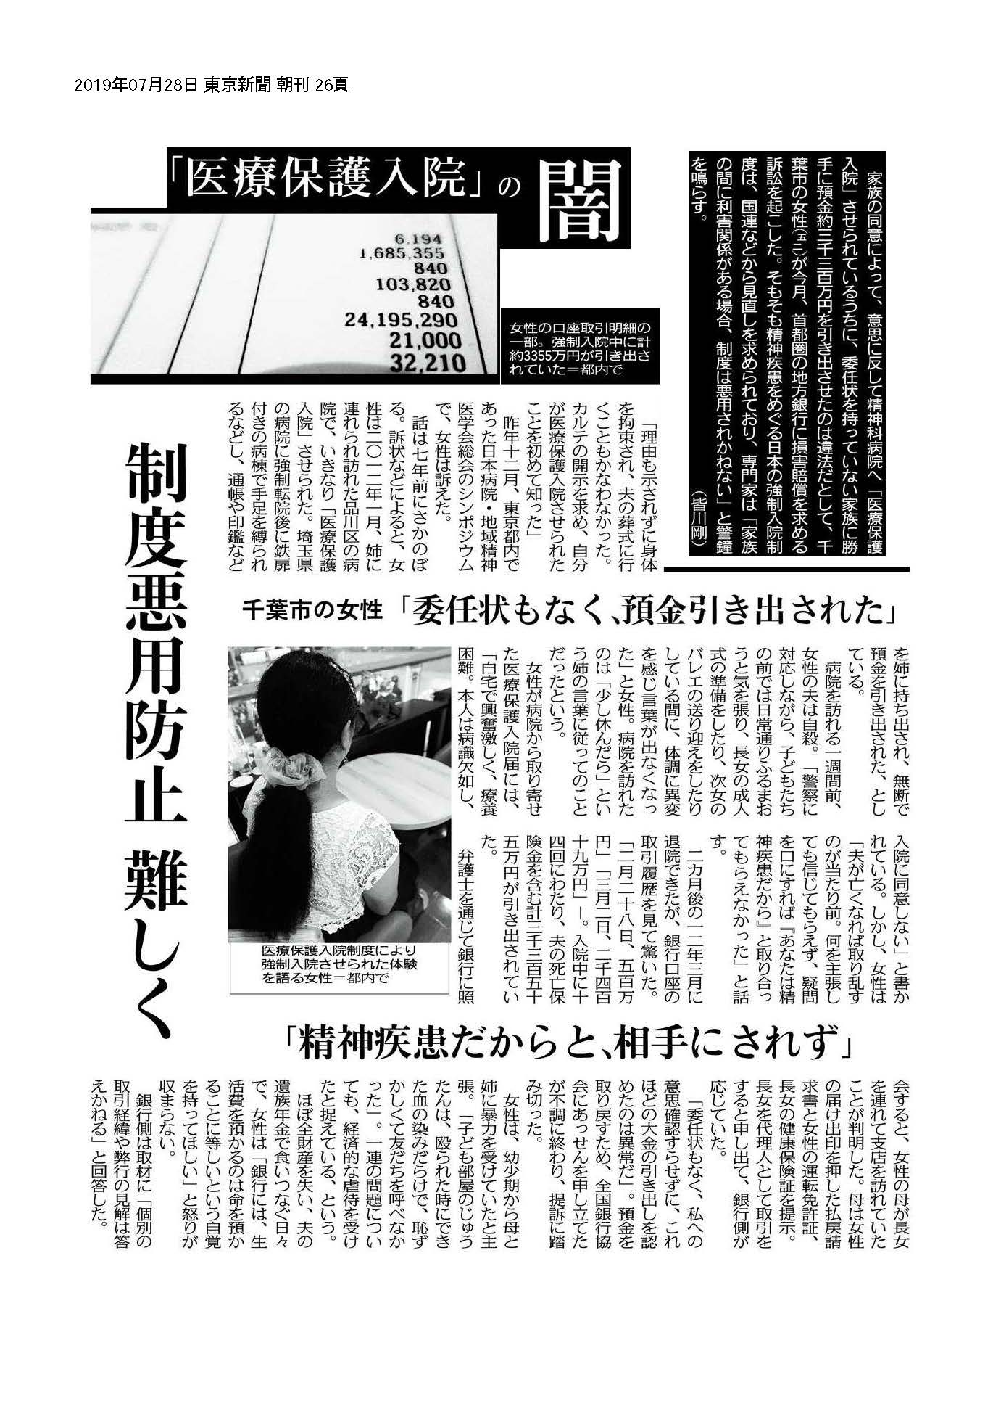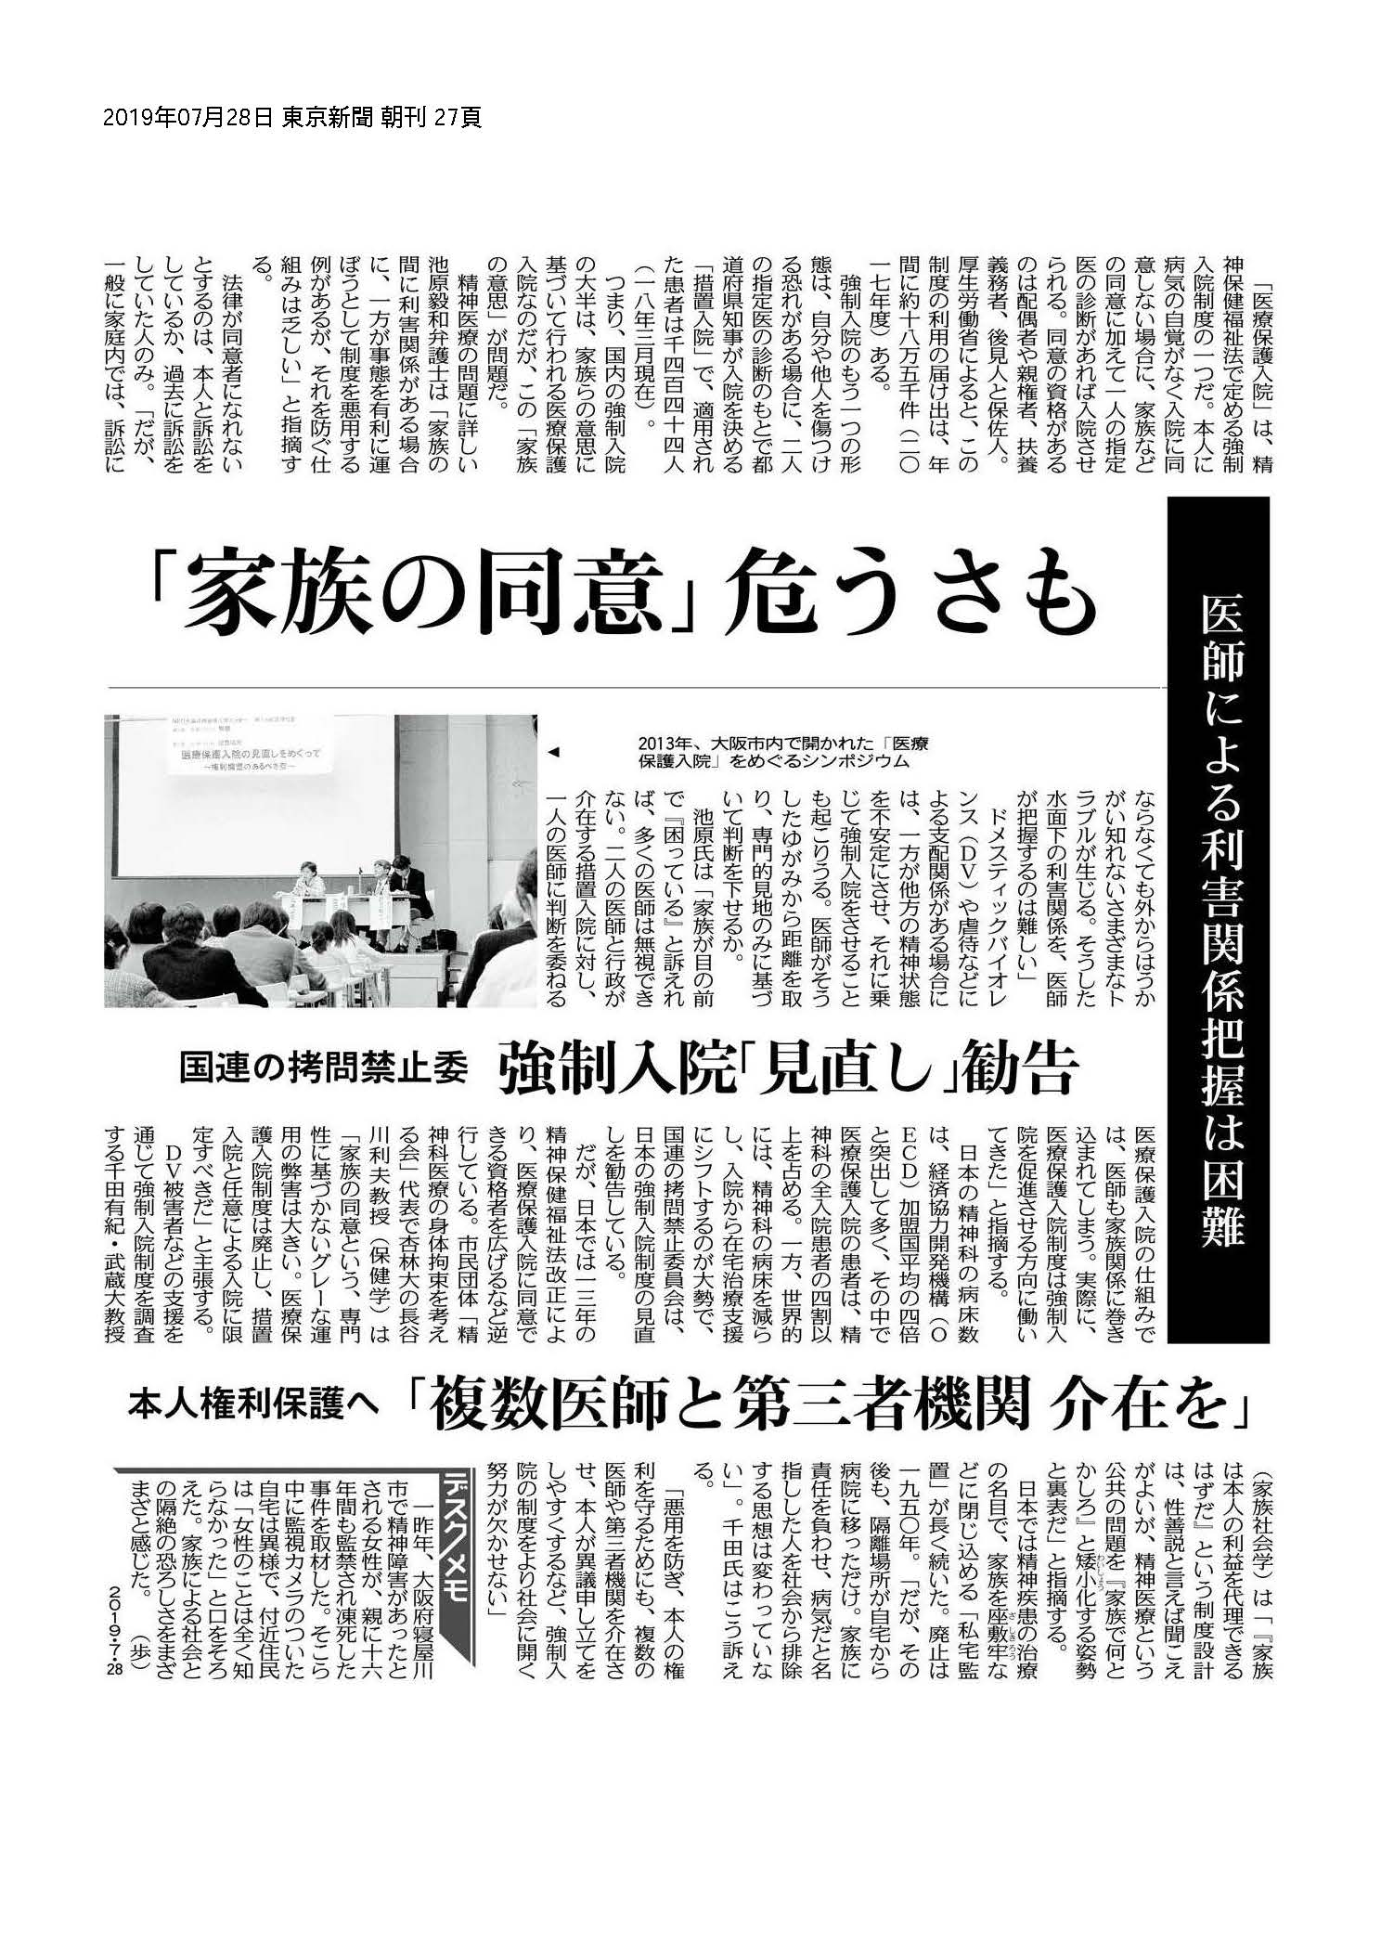

Appendix III: An experience of domestic violence victims, a single mother and her daughter

Setsu Inui (assumed name), 30, lost her father soon after her birth. After her mother married again when she was at the age of 4, she had been physically and sexually abused by this non-biological father. Setsu’s mother divorced from this guy because of his gambling addiction, but she passed away when she was the last of teenage. Working to earn and taking care of the half siblings, Setsu barely graduated from high school.
Setsu married with Hideki (assumed name) when she was 20. At first, Hideki expressed compassion to her developmental history and will to support her brother and sister. After a short time, Setsu became pregnant with her daughter Fumi (assumed name), and Hideki started to violate Setsu physically, sexually, mentally and economically. Hideki told the reason to Setsu in pregnancy that she didn’t keep up with the housework.
Domestic violence by Hideki escalated after Setsu gave a birth to Fumi in 2005 when she was 21. Hideki often violated and raped Setsu in front of Fumi. Hideki abused small Fumi by beating with belt, body hanging upside down and slapping that left imprint to Fumi’s body.
Moreover, Hideki expressed strong sexual interest to small Fumi. Hideki manipulated Fumi’s sexual organ, forced to caress his male sexual organ and to watch porn videos. As Setsu, Hideki often told her his desire to fuck around Setsu and Fumi. In 2009 when Fumi was only 3, Setsu heard from Fumi that Hideki forced her to give fellatio. With a sense to crisis, Setsu visited an official consultation service with Fumi. They are protected in a shelter for single mother and children, and the local government dictated Setsu to receive psychiatric treatment. Setsu and Fumi repeated for several times to be protected in shelters and to return to living with Hideki.
In 2009, Setsu fell into severe depression and became aware of she couldn’t give enough care to Fumi. Setsu decided to leave Fumi for temporary care service provided by a child consultation center. But just after that, the psychiatrist altered her disease name from depression to schizophrenia. The child consultation center decided to isolate Fumi in a foster home in a forceful manner. According to the child consultation center, Setsu neglected Fumi because of schizophrenia. The isolation has been continued for 7 years to the present time. The child consultation center doesn’t consider abuse and violence by Hideki as major problems in a consistent way. The center asked Hideki for several times to live with Fumi, Setsu said. The child consultation center allowed Setsu to see Fumi only 2 times in 2011 and 2015 while they were isolated from 2009 to 2016. The center had been explaining the reason “It is inequitable that only Setsu see Fumi while Hideki don’t see her”, but in spite of the center’s recommendation, Hideki had been expressed that he didn’t want Fumi anymore. As the child consultation center, the biggest and the only problem have been the neglecting by Setsu with psychiatric disability, and they have never taken into the consideration that Setsu and Fumi have the ability to live within one family.
In 2015, when Setsu saw Fumi at the age of 10, Fumi seemed in harsh condition, mentally and physically. Some specialists about child abuse concern a possibility that Fumi have been being abused in the foster home.
Setsu was diagnosed as schizophrenia in 2010, but no evidence was found in medical records by the psychiatrist at the time. In 2015, a psychiatrist who was specialized in child abuse, examined Setsu and reviewed previous medical records, and diagnosed that Setsu was suffering from PTSD in 2010, not from schizophrenia.

Appendix IV: A message by a single mother in Appendix III for the CEDAW Committee

Thanks to the committee’s kind attention and this precious opportunity to my harsh experiences and current status.
I had to part from my birth father at the age of 2 because of my mother decided to divorce. After her next marriage when I was at the age of 4, I lived with my mother, non-biological father and half siblings. The new father was in gambling addiction and abused me repeatedly. Finally, my mother divorced from the father and we soon felt in hard living in a single mother household. In addition to that, my mother suffered from blood cancer just after the divorce. I was weighted in my late teenage years by my mother’s illness and care of young half siblings. I was longing for an ordinary family.
When I was in deep sadness after my mother had passed away, I married at a young age with ex-husband because he sympathized my unfortunate development history. Just after marriage, I became pregnant with my only daughter. After she was born, I raised her alone with many distresses without supports from relatives or public welfare. In the end, I felt unbearable to domestic physical/sexual/mental/economical violence from the ex-husband since I was pregnant. The ex-husband domestically violated my daughter too. He violated and raped me in front of her. He hanged her upside down, beat her with a belt, and beat her with his hand as hard as to left damage with her body. He also manipulated her sexual organ, forced to stroke his male sexual organ and to watch porn videos.
When my daughter was at the age of 3, she said to me “Dad forced me to fellate him”. I experienced flashbacks of abuses by my non-biological father in my childhood. I felt a sense of crisis, and consulted official organizations repeatedly. Each time we were protected in shelters, but my money and mobile phone were confiscated, and we were placed under lock and key. I was medicated with psychotropic drugs forcibly, bullied from staffs and other residents, and received poor foods every day. My daughter became unstable. She desired to back to home and play in preschool. I told that to the staff, but they had never considered. In the meantime, she became to have difficulties with excretion under the horrible environment of the shelters. I hoped to live in an apartment with her, and make her to attend preschool again. But no one considered to realize my hope, including psychiatrist to whom I was visiting because I was prescribed to visit her by the local government.
I repeated to be protected in shelters with my daughter and to return to the ex-husband with the expectation that he would retrieve himself. There was not suitable care in the shelters, but we suffered from punitive treatment under the Anti-Prostitution Act and became disordered physically and mentally. In 2009, I lost hope and felt into depression. I decided to put her into a childcare institution temporally when she was at the age of 3. As a consequence, I was labeled an abusing mother who can’t protect the child by the local government and the child consultation center. I also was condemned as a neglecting mother with psychiatric disease. They also considered that I could not break the chain of abuse and my childcare was unstable, because I was abused in my childhood.
Since the time, my daughter and I have been isolated each other for 7 years. The child consultation center is still arguing discriminatory that “For women with disability and single mother in economically/socially unstable status, there is no right to bring up their own children”. When my daughter and me will celebrate reunion in one family? I was a domestic violence victim, and I have never received human consideration. Finally, I divorced from the ex-husband, but the court deprived me of the parental authority to my daughter. Only custody remained for me. Now, the ex-husband is still keeping parental authority.
I was allowed to see my daughter in 2011 for the first time a year and 6 months later the isolation was started. My daughter was a really vibrant and active girl when I was living with her, but at the time, I found that she became mute. After 2011, the local government has been continuing not to allow me to see my daughter for many reasons like “the equal opportunity to visit the daughter for both parents”. In 2015, a lawyer on my expense negotiated with the local government, and succeed to make me see my daughter again after 4 years. She, at the age of 11, didn’t have the concept of “parent”. Her body height was only 120 centimeters in spite of her age, and was wearing a set of broken shoes. I can’t consider that she has been under adequate and enough care, while she has been cared in an official foster home under the child consultation center with tax revenues.
In addition, I have been demanded child support for her from the child consultation center. They insist many reasons to suppress my visiting right to my daughter, for example, “Now she is in bad condition”, “In the past, you, the mother of her, had abused her. It is the fact”, “You don’t have the parental authority for her”.
When I visited my daughter at the age of 11 in 2015, her head was hidden by a cloth. I couldn’t know the condition of her head and hair. She told me “I am eating food waste like the homeless”, ”I have no favorite food” and ”I have no dream”. I remember her childhood when she was at the age of 3. She went to preschool, had been in physically normal development. She also in intellectually advanced development as same as children at the age of 4 or above. Some specialists about child abuse are worrying if she was abused and the foster home is obscuring the fact.
I have a hope to make my daughter to learn about “loving family” and “reliable parent”. I hope her future without discrimination because of psychiatric disability, and of course, I hope that someday she will return to me, to her own family. I have a psychiatric disability, and I have parental love because I am a human being same to all other.
At last, I hope that the committee will express recommendations to the Japanese government to realize all of my hope.

Sincerely,
Setsu Inui

Appendix V: A message for the presession from Ms. Mari Yamamoto on July 8, 2017

Ms. Mari Yamamoto, a disability activist and a former member of the Japan National Group of Mentally Disabled People (JNGMDP, 1974-2019) until its dissolution, proposed below for members to prepare for the submission of the LOI session of this review on ICCPR.

自由権規約の委員会 人権委員会への予めの質問リストに対して
全国「精神病」者集団

ポイントのみ
１ 長期入院の方の退院促進に向けて具体的数値目標はあるのか
病床削減の数値目標と期間についての具体的計画は
２ 強制入院と入院そのものを減らしていく地域支援の取り組みについては
数値目標と期間についての具体的計画は
３ 病院と学校が障害者虐待防止法の通報義務の対象外となっているが、虐待防止法の改正はするのか、とりわけ精神病院、特別支援学校での虐待は頻発しており、暴露されても
直接の加害者が刑罰に課されるだけであり、組織の問題として取り組まれない
それどころか刑法の対象にすらないらない、障害者が被害者にすらならない例がある
４ 「重度かつ慢性」故に退院できない人が１０万人以上いるあるいは２０２５年に至っても慢性患者要病床の需要が１０万床であり、それに合わせて障害福祉計画を立てるということはこれを固定化するのでは
５ 精神保健福祉法案は地域に強制医療体制を拡大し、プライバシーの権利を侵害し、専門職に守秘義務を破らせるがその目的は
これに背景説明を加えて、UPRへのレポートの説明を加えます
強制入院も身体拘束隔離も増え続けていること
病床削減の兆しが全く見えないこと
認知症患者の件など
締切は７月２２日です ７月１５日までにご意見を
2014年の人権委員会の勧告は以下
非自発的入院
１７ 非常に多くの精神障害者が極めて広汎な要件で、そして自らの権利侵害に異議申し立てする有効な法的な救済手段なしに非自発的入院を強いられていること、また代替サービスの欠如により入院が不要に長期化していると報告されていることに、委員会は懸念を
表明する。（7条および9条）
国家は以下を行わねばならない
(a) 精神障害者に対して地域に基盤のある代替のサービスを増やすこと
(b) 強制入院は、最後の手段としてのみ必要最小限の期間、本人の受ける害から本人を守りあるいは他害を避けることを目的として必要で均衡が取れる時にのみ行われることを確保すること
(c) 精神科の施設に対して、虐待を有効に捜査し罰し、被害者またはその家族に賠償を提供することを目的として、有効で独立した監視と報告体制を確保すること
(b)については、障害者権利条約の水準 強制入院強制医療の廃止という視点から言うと非常に問題、ではありますが、
指摘は正しいし、(a)(c)については今までになかった勧告です
最後については障害者虐待防止法の対象から病院が外れていること、さらに拷問等禁止条約の選択議定書による国内防止機関がないことが大問題であること
とりわけ障害者虐待防止法の見直しは来年 全く議論されていない状態ですが、何らかの動き作る必要があると考えますが

Data was personally gifted from Dr. Sakurai. He collected the original data from annual documents by MHLW.
A news report in a legal news site at the day of success of the lawsuit (in Japanese) https://www.bengo4.com/c_18/n_3475/
The report by the investigation team (in Japanese) http://665257b062be733.lolipop.jp/190415tachikawa.pdf
https://gyakutainet.org/ (In Japaenese)
Kei Hida is a director of a child support center with legal aid "Tsunagg" https://tsunagg.com/tsunagg (In Japanese)
A signature campaign to the objective by Shinji Ota (In Japanese) https://bit.ly/3dnzQqQ
A written request by Yokosuka city https://www.city.yokosuka.kanagawa.jp/3920/nagekomi/20220128.html (In Japanese)
https://www.mhlw.go.jp/stf/shingi/shingi-hosho_443308.html (In Japanese)
A position paper by Kanagawa Bar Association (In Japanese)
“精神保健及び精神障害者福祉に関する法律第三十七条第一項の規定に基づき厚生労働大臣が定める基準” (In Japanese)
https://www.mhlw.go.jp/content/12200000/000949216.pdf (In Japanese)
Official survey called “630 survey” https://www.ncnp.go.jp/nimh/seisaku/data/ (In Japanese)
“生活保護法による医療扶助と公衆衛生法規との関係について”
One of founders of RPWCDJ is a former member of the Japan National Group of Mentally Disabled People (JNGMDP, 1974-2019).
There are many unreasonable restrictions. For example, when a person on the public assistance goes abroad, the person should return the amount same to travel expense to the local government. It means that the travel costs twice.

