

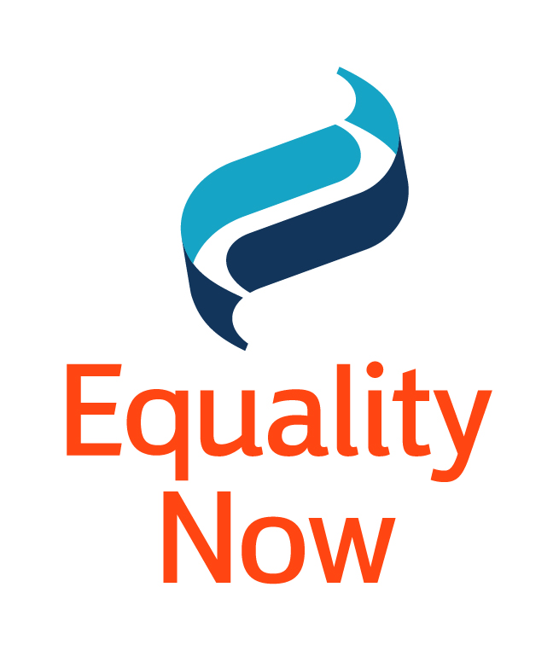
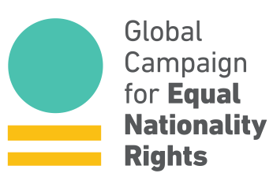

Kate Fox
Secretary of the Human Rights Committee (A. I.)
Human Rights Committee and Treaty Bodies Division Office of the High Commissioner for Human Rights
UNOG-OHCHR
CH-1211 Geneva 10
Switzerland
By E-mail: kfox@ohchr.org; ccpr@ohchr.org

Re: Jordan – 119th Session (06-29 March 2017)

6 January 2017

Distinguished Committee Members,

We respectfully submit this letter in advance of the Human Rights Committee’s (“the Committee”) discussion on Jordan during its 119th Session from 06-29 March 2017. Equality Now, Arab Women Organization (AWO), “My mother is Jordanian, and her nationality is right for me” Campaign and The Global Campaign for Equal Nationality Rights are greatly concerned about the exemption from punishment under the Jordanian Penal Code of offenders, including rapists, who marry their victims. We are also concerned about the sex-based discrimination against Jordanian women married to foreigners who are not able to pass on their nationality to their children under Law No. 6 of 1954 on Nationality, with severe consequences for those children and their families. These laws violate the equality and non-discrimination principles (Articles 3 and 26), as well as the right to a nationality (Article 24) of the International Covenant on Civil and Political Rights, which Jordan does not have reservations on, and they deprive women from enjoying their rights as equal citizens with men.
Equality Now is an international human rights organization with ECOSOC status working to protect and promote the rights of women and girls worldwide since 1992, including through our membership network comprised of individuals and organizations in over 190 countries. Arab Women Organization (AWO) is a grassroots, non-governmental organization working since 1970 to strengthen the status of Jordanian women to become equal and effective partners in development. “My mother is Jordanian, and her nationality is right for me” Campaign is a collective initiative of Jordanian mothers married to non-nationals working to ensure amendments to the nationality law to let women pass their nationality to their husbands and children. The Global Campaign for Equal Nationality Rights mobilizes international action for the removal of gender discriminatory provisions from all nationality laws, through its coalition of national, regional and international organizations and activists, including Steering Committee Members Equality Now, Equal Rights Trust, the Institute on Statelessness and Inclusion, and Women’s Refugee Commission.
Exemption of rapists from punishment upon marriage

Article 308 of the Jordanian Penal Code exempts rapists from punishment if they marry their victims, promoting violence against women and girls. The Jordanian Civil Coalition to Repeal Article 308 is a coalition coordinated by Sisterhood is Global (SIGI) of 92 organizations and community based organizations working to ensure its repeal as soon as possible. We understand that while a bill to completely revoke the article has not yet been re-submitted to the parliament, in May 2016 the Jordanian Cabinet approved certain amendments to this article. The proposed amended article, however, would maintain discrimination against women and girls by exempting from punishment rapists who rape girls between the ages of 15 - 18 and then marry them. The full revocation of this article, on the other hand, would conform with Jordan’s obligations under international law.

In its concluding observations of March 2012, the Committee on the Elimination of of Discrimination against Women expressed concern about remaining discriminatory provisions in the Jordanian Penal Code, which would include article 308. The Committee on the Rights of the Child, in July 2014, also stated in its concluding observations to the Jordanian Government that it “is deeply concerned that article 308 of the Criminal Code allows for the impunity of perpetrators of rape if they marry the girl they abused,” and urged Jordan “to expeditiously repeal articles 308 and 310 of the Criminal Code and all legal provisions that can be used to excuse perpetrators of child sexual abuse.” (CRC/C/JOR/CO/4-5). A new draft resolution on Child, early and forced marriage adopted by the General Assembly’s Third Committee, “Also calls upon States to enact, enforce and uphold laws and policies aimed at preventing and ending child, early and forced marriage and protecting those at risk, to ensure that marriage is entered into only with the informed, free and full consent of the intending spouses and to amend relevant laws and policies to remove any provision that enables perpetrators of rape, sexual abuse or abduction to escape prosecution and punishment by marrying their victims.” (A/C.3/71/L.13/Rev.1¶2)

The Committee’s General Comment 28 to article 3 of the Covenant states, “Another factor that may affect women’s right to marry only when they have given free and full consent is the existence of social attitudes which tend to marginalize women victims of rape and put pressure on them to agree to marriage. A woman’s free and full consent to marriage may also be undermined by laws which allow the rapist to have his criminal responsibility extinguished or mitigated if he marries the victim. States parties should indicate whether marrying the victim extinguishes or mitigates criminal responsibility and, in the case in which the victim is a minor, whether the rape reduces the marriageable age of the victim, particularly in societies where rape victims have to endure marginalization from society.” The Government’s obligations under the ICCPR require it to ensure repeal of article 308 of the Jordanian Penal Code to remove all discrimination in line with your recommendations and the above-mentioned treaty-monitoring bodies. We hope your Committee will urge Jordan to do so without delay.
Nationality
Hardships caused by the inability of a Jordanian woman to pass on her nationality to her children under Law No. 6 of 1954 on Nationality include the fear that children will be taken out of the country by her non-Jordanian husband leaving her with huge legal and practical difficulties in getting access to them, exploitation by employers of foreign-born men and their grown children because of their precarious residency status, and the urge to marry off girls at a very young age to gain security. Currently, additional restrictions, such as where or whether children from these marital unions can work or study, in their access to government hospitals, and the need to obtain Ministry of the Interior approval to marry, are all contributing to the increased strain on and vulnerability of these children, some of whom are rendered stateless by the discriminatory law, and their families. In partnership with the Arab Women Organization and the Campaign, Equality Now issued an Action in 2012 calling on Jordanian government officials to amend the Nationality Law to give Jordanian women the equal right to pass their nationality on to their children and husbands without delay.

Jordan’s fifth periodic report of States parties, submitted to the Committee in July 2016, states in response to Recommendation 3 with regards to Transmittal of nationality to children, “On 9 November 2014, the Jordanian Government decided to grant the children of Jordanian women married to foreign nationals privileges (“Mazaya”) regarding health, education, employment, residence and driving licenses. The number of Jordanian women married to foreign nationals is estimated at approximately 88,983 and some 355,932 children will benefit from these privileges. These figures are high and will add to the burden on the public budget. The resulting financial cost is estimated to be around 63 million Jordanian dinars (JD).” (CCPR/C/JOR/5¶7vi) Unfortunately, these “Mazaya” have not yet been fully implemented as revealed by Azza, a Jordanian woman with four children who is married to a non-Jordanian man, who states, “The government failed to treat our children as Jordanians [though] this is what the Cabinet declared. Still my children cannot access public services.” While we welcome all measures to alleviate the hardships of the children and husbands unable to obtain Jordanian nationality through the Jordanian woman, we nonetheless regret these measures are necessary at all and hope that a full revocation of discrimination in the law is made without delay.

In its Concluding Observations following its review of Jordan in November 2010 the Committee expressed its serious concern that under the Nationality Act, Jordanian women are not entitled to pass on their nationality to their foreign spouses and their mutual children and recommended that, "The State party should bring its legislation, including the Personal Status Act, into conformity with the Covenant and ensure that women are not subjected to de jure or de facto discrimination, inter alia in matters of marriage, divorce, custody of children, inheritance or the transmittal of nationality to children. The State party should also continue and strengthen its efforts to address discriminatory traditions and customs, including polygamy, through education and awareness-raising campaigns. In this connection, the Committee draws the attention of the State party to its general comment No. 28 (2000) concerning equality of rights between men and women.” (CCPR/C/JOR/CO/4, ¶7). Several other UN treaty monitoring bodies, including the Committee on the Elimination of Discrimination Against Women (CEDAW) and the Committee on the Elimination of Racial Discrimination (CERD), have also addressed this issue in their most recent review of Jordan’s implementation of their respective human rights treaties. All of these committees, as well as yours, have urged Jordan to amend its nationality law.

In addition, in June 2016, the Human Rights Council passed a resolution, “The right to a nationality: women’s equal nationality rights in law and in practice,” which, “Urges all States to refrain from enacting or maintaining discriminatory nationality legislation, with a view to avoiding statelessness and loss of nationality, preventing vulnerability to human rights violations and abuses, decreasing the risk of exploitation and abuse, and promoting gender equality in the acquisition, change, retention or conferral of nationality;” It also “Urges States to take immediate steps to reform nationality laws that discriminate against women by granting equal rights to men and women to confer nationality on their children and spouses and regarding the acquisition, change or retention of their nationality;” (A/HRC/32/L.12, ¶¶ 4-5).

We welcomed the Jordanian government’s approval to grant certain rights, or “privileged services” (Mazaya), to children of Jordanian mothers and foreign fathers, giving great hope to many families. However, these privileges are not yet implemented. The Government’s obligations still require it to ensure amendment of the Nationality Law to remove all discrimination in line with the recommendations of the above-mentioned treaty-monitoring bodies. We hope your Committee will again urge it to do so without delay.

Although Jordanian law allows for the possibility of naturalization of a non-national husband married to a Jordanian woman and their children together, we understand it is at the discretion of the Committee of Ministers and applications must be obtained and filed in person with the Ministry of Interior. No woman in the campaign has even managed to have her petition considered and sometimes women are unable even to obtain an application form, so their children have no chance of becoming naturalized. We urge the Committee to ask that the Government ensure this is investigated and that fair procedures are put in place, in the interim, to allow such families to take proper advantage of existing law.

Suggested Questions for the State Party’s List of Issues

We would respectfully urge the Committee to raise with the Jordanian government in its State Party’s List of Issues the following questions with regard to violations of the International Covenant on Civil and Political Rights addressed in this letter:
- What are the Government’s plans to revoke article 308 as soon as possible and publicize its repeal?

- What plans does the government have to remove the discrimination in the Nationality Law of No. 6 of 1954 so that Jordanian women can enjoy equal rights with Jordanian men to pass their nationality to their children and their husband?

- What is the Government doing to ensure that the “privileged services” (Mazaya) approved by the government are implemented immediately without delay?

- What is the Government doing to ensure that families can access their rights under naturalization laws until the Nationality Law is revised? What further proposals are being considered by the Government to alleviate the effects of the discrimination in the Nationality Law until it can be fully amended?

Thank you very much for your kind attention, and please do not hesitate to contact us if we can provide further information.
Sincerely,
Layla Issa Khalefeh Naffa
Director
Arab Women Organization of Jordan (AWO)


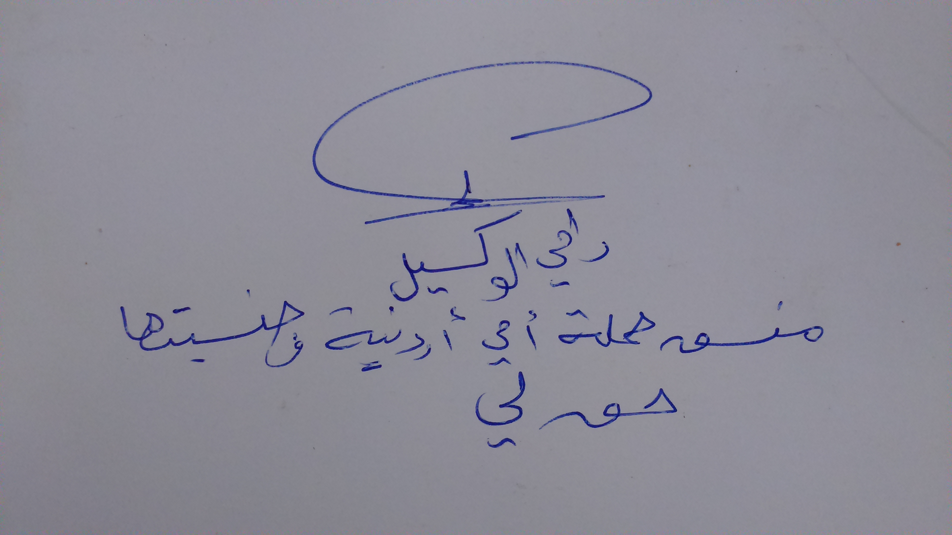

Yasmeen Hassan
Global Director
Equality Now

Rami Al Wakeel
Coordinator
“My Mother is Jordanian, and her nationality is a right for me” Campaign



Catherine Harrington
Global Campaign Manager
Global Campaign for Equal Nationality Rights

Available at http://www.equalitynow.org/action-alerts/give-women-equal-citizenship-rights-men in English, Arabic, French and Spanish, last updated 26 July 2016.
Id.
Available at http://www.un.org/ga/search/view_doc.asp?symbol=A/HRC/32/L.12

