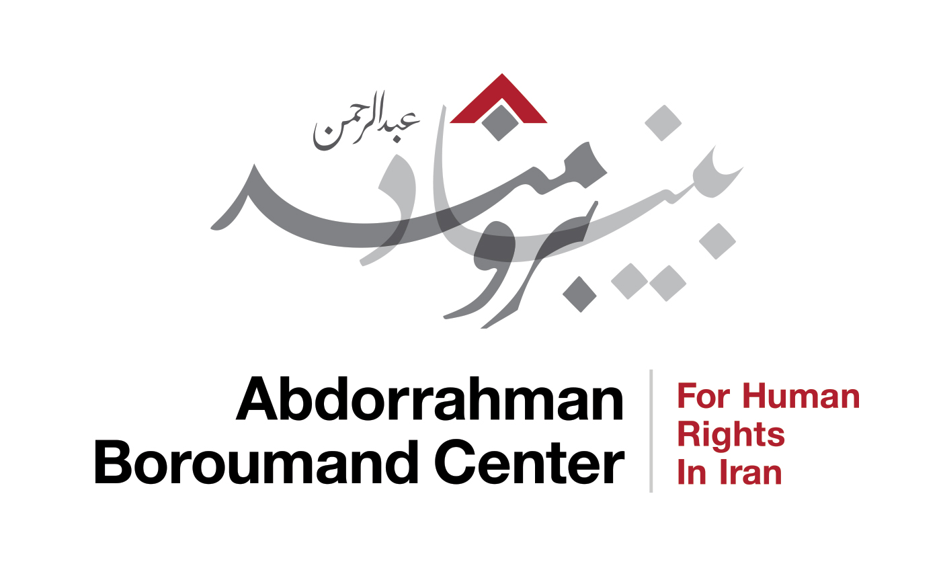
Extrajudicial Killings and the Islamic Republic of Iran

Abdorrahman Boroumand Center for Human Rights in Iran
Prepared for the 139th session of the Human Rights Committee
September 27, 2023

The Islamic Republic of Iran has a long history of politically motivated violence in Iran and around the world. Since the 1979 Revolution, Iranian state agents have kidnapped, forcibly disappeared, and killed a significant number of individuals whose activities they deemed undesirable outside of the country. The actual number of the victims of extra-territorial extrajudicial executions by the government of Iran is not known. Nonetheless, Abdorrahman Boroumand Center for Human Rights in Iran (ABC) has so far identified over 500 such killings attributed to the Islamic Republic of Iran outside the country alone, suggesting a much higher figure for instances in Iran. Credible reports of extrajudicial executions in the context of the crackdowns on recent protests, as well as death threats to journalists and activists outside Iran, which continue to be investigated by ABC, underscore the urgency of the international community bringing attention to these widespread but too-often unacknowledged violations of the rights of freedom of expression, association, and assembly, as well as the rights to life and due process, which Iran has an obligation to respect under the International Covenant on Civil and Political Rights.
Documenting cases of extrajudicial executions without field access and in circumstances where sources are also at risk of persecution is a challenge. In most cases information regarding these killings is scarce though in one occasion, official investigations of a series of murders of intellectuals and opposition figures have exposed a decades long state-sanctioned policy of physical elimination of dissidents. For cases outside Iran, local authorities have been, for various reasons, often secretive and reluctant in pursuing prosecutions or making attributions. In some cases however, investigations have resulted in the expulsion or arrest of Iranian diplomats, as well as the indictment of diplomats and high level Iranian officials. In other cases, documentation of patterns, the activities of targeted individuals (which establish motive), and available evidence and clues obtained through investigations conducted by local police and judicial authorities (where they have been conducted) confirm the hypothesis of state involvement. Further, official statements, threats against victims who filed complaints, and impunity for perpetrators in Iran are also indications of state sanction.
Despite methodological difficulties, UN human rights authorities have reported on such cases in the past. Judicial proceedings in countries outside Iran confirm such activities have continued: in February 2021, a court in Belgium convicted Assadollah Assadi, an Iranian diplomat based in Vienna, of attempted terrorism and sentenced him to 20 years in prison for his role in a bomb plot targeting a rally by opponents of the Iranian regime in France in 2018.

Similarities across cases in different countries point to the Iranian government as the principal entity ordering and implementing them. Iranian authorities have rarely accepted responsibility for these extrajudicial executions, which they attributed to internal strife in opposition groups, crimes for which there are rarely precedents. Nevertheless, since the very inception of the Islamic Republic, its officials have acknowledged and justified these killings from an ideological and legal standpoint.

Extrajudicial killings conducted by agents of the state or proxies constitute a clear violation of Article 6, as well as due process and fair trial guarantees foreseen in Article 14. Where such killings are motivated by religious or political beliefs and activities of the individuals targeted, they violate Article 18 guarantees of freedom of thought, conscience and religion, Article 19 guarantees of freedom of opinion and expression, and Article 21 guarantees of freedom of assembly.

Even where direct state intent and involvement is uncertain, the state nonetheless bears certain obligations vis-a-vis prevention and investigation, as developed in the Committee’s General Comment Number 36 on Article 6. The state has a duty to ensure Article 6 rights of “all persons who are within its territory and all persons subject to its jurisdiction,” including arrestees and detainees. This duty extends to not “[aiding] or [assisting] activities undertaken by other States and non-State actors” (paragraph 63). The State is also expected to take “necessary measures to prevent arbitrary deprivation of life by their law enforcement officials,” to include “mandatory reporting, review and investigation of lethal incidents and other life-threatening incidents” (paragraph 13). In general, the state must “enact a protective legal framework that includes effective criminal prohibitions on all manifestations of violence or incitement to violence that are likely to result in deprivation of life” (paragraph 20). When an extrajudicial killing is alleged, the State must, as with all Article 6 violations, conduct investigations which are “independent, impartial, prompt, thorough, effective, credible and transparent.” Where a violation is found, the State must provide “adequate measures of compensation, rehabilitation and satisfaction” (paragraph 28).

Cases investigated by Abdorrahman Boroumand Center for Human Rights in Iran (ABC) spanning the last 11 years, pertaining to incidents both inside and outside Iran, illustrate that the Islamic Republic of Iran has failed to respect its international obligations under the Covenant¨.
Ata’ollah Rezvani, was a well-known and respected member of the Baha’i community in Hormozgan Province, who worked in water engineering in Bandar Abbas. Authorities had persecuted him, obstructed his business contracts, and detained and beat him in the 1980s. Despite multiple threats, summons, and interrogations from security officials, Mr. Rezvani, one of the three members of Baha’i Community Servers, continued to advocate for Baha’is’ rights. These efforts included writing a letter to Ayatollah Gholamali Na'im Abadi, Assembly of Experts’ member, Representative of the Supreme Leader in Hormozgan, and the local Friday Imam, expressing concern about the danger of his inflammatory anti-Baha’i statements. The latter made multiple anti-Baha’i statements and described Baha’is as “germs” and “hard core infidels who are thoroughly and completely in fundamental conflict with Islam,”and prohibited Muslims from doing business with them.

On the evening of August 24, 2013, Mr. Rezvani was at a friend’s home when a household worker saw him take a long phone call, leave, and never return. Mr. Rezvani was found in a vehicle on the outskirts of town with a bullet wound behind his right ear and no other injury or signs of struggle. Several weeks later, the worker in his friend’s household – a young Afghan immigrant who was the last to see him alive – disappeared. Authorities were evasive with Mr. Rezvani’s family about his phone’s whereabouts and never provided them with a list of the last phone calls he made or received, and never investigated his case further, instead voicing the theory that he died by suicide. Family members appealed to high-ranking government officials for follow-up into the case, to no avail.
Amin Korki was a 31-year-old day laborer from the town of Andimeshk, residing in the city of Dezful. Korki’s body was discovered at an unfinished sports complex in Dezful, Khuzestan on March 30, 2018, a day after Korki disappeared from his family home. Korki had previously been arrested on January 4 of that year on charges of leading protest activity in Dezful and tearing up pictures of Ayatollahs Khomeini and Khamenei. Conditionally released on March 17, 2018 pending his trial, Korki had not left the house.

Approximately three months after Korki’s death, several of the eyewitnesses informed Mr. Korki’s family that on the afternoon of March 29, a number of Dezful’s Hamzeh 18th Police Precinct officers and some known individuals in the local Basij, had attacked Mr. Korki’s home, had proceeded to beat Mr. Korki, and had taken him away. Mr. Korki’s family’s efforts to summon the individuals who had witnessed the events of the day of his disappearance, as well as their attempts to clarify the statements made by people with knowledge of the case (including the Hamzeh 18th Police Precinct’s deputy chief and one of the people in charge of the local Basij who was allegedly present at the scene on the day of the event) bore no fruit. The police precinct’s then-deputy chief, the person in charge of the local Basij, and the guard at the sport complex under construction, all of whom were named in all of the reports as persons with knowledge of the existence of the deceased’s body, provided contradictory and diverging information at various interrogations regarding the manner they became aware of the existence of the body, and also provided contradictory information regarding the location they had gone to in order to discover the body. In December 2018, the Ministry of Justice office in Dezful declared the case closed.
Mas’ud Molavi (born 1986 in Najafabad, Esfahan Province) was a civil engineering and computer science expert who resided in Turkey starting in the spring of 2018 with the hope of finding a safer country to move to. Before moving to Turkey, he had been the director of planning and development, as well as network security adviser to the Iranian State Radio and Television for three years. He was subsequently deputy director of research and development for five years at the Support and Renovation of Iran’s Helicopters Company affiliated with the State Aerospace Industries Organization, and at the same time, for about seven years, was reportedly among the high-ranking directors of the Cyber Defense Command under the supervision of the Armed Forces General Headquarters. Molavi had been arrested in 2009-2010, on the charge of “acting against national security.”

In Turkey, Mr. Molavi ran a Telegram page and several other accounts in other social networks called Ja’beh-ye Siah (“the Black Box”) which published articles, news, and documented pieces that exposed government institutions and individuals, including the Supreme Leader’s Beit (the Leader’s Offices and administration, among others), the Judiciary Branch, the Information Ministry, the Communications Ministry and its then-Minister, and the Revolutionary Guards Corps. A few months after it started its activities, the channel started directly criticizing the Leader of the Islamic Republic and making certain claims about possessing documents and evidence regarding the Islamic Republic of Iran’s nuclear activities and regarding corruption in various organs including the Judiciary Branch and the Office of the Supreme Leader.

Mr. Molavi had been threatened numerous times during his stay in Turkey. On the night of November 14, 2019, as he was walking with an individual named Ali Esfanjani on the sidewalk of Ajza Alley in Istanbul’s Shishli neighborhood, Mr. Molavi was shot 11 times, at least one bullet hitting him in the heart.

The police report identified Esfanjani as the mastermind behind the plot to kill Molavi. He was transported to the other side of the Turkish-Iranian border by an Iranian smuggler three days after the assassination. According to security sources Esfanjani visited the Iranian consulate the day before the assassination and met the defendants to discuss the details of the operation. Turkey’s authorities announced that “the order to kill Mas’ud Molavi” was issued by “Iran’s Consulate in Turkey.” 16 members of a group linked to the Iranian security services were arrested in Turkey in 2021 in connection with Mr. Molavi’s murder. According to media reports, Turkish sources said that the Turkish and Iranian suspects admitted they acted on the orders of two intelligence officers at the Iranian consulate in Istanbul. The suspects' statements revealed they had received assassination orders from Iranians with diplomatic passports.
In November of 2021, proceedings were set to commence in the case, with 14 defendants which included Naji Sharifi Zeyndashti, a drug trafficker suspected of having ties to Iranian security organs, and Iranian diplomat Mohammad Reza Nasserzadeh. Prosecutors sought life prison terms for both. The trial was postponed until March 2022, as one defendant was granted release on bail, and Nasserzadeh’s lawyer sought to secure him diplomatic immunity. In July of 2022, the Turkish court sentenced one of the co-defendants in the case to life in prison for Molavi’s murder, and four others to jail terms.

Aside from a news conference in which they promised they would follow up on the case, Iranian officials have not commented on the case. As of May 2020, Molavi’s mother reported authorities have prohibited the family from leaving Iran since before the murder, preventing them from following up on the case abroad. The family had filed a complaint with Iranian authorities.

Mohammad Ebrahim Safizadeh was born in 1955 in the village of Fandokht, Southern Khorasan Province, and was the married father of eight children. A Sunni muslim and adherent of the Hanafi religion, he studied in Pakistan and Saudi Arabia. Mr. Safizadeh campaigned to advance Sunni rights, most recently in 2017 as director and spokesperson for Iran’s Sunni Adherents’ Front, and in 1989 as a co-founder of the Sunni Religious Leaders Coordination Council of Khorasan. Between 1989 and 1990 he spent a total of three years and 10 months in jail, once on the pretext of having burnt religious papers, and the second time on charges of “acting on behalf of the Wahabi Sect and insulting and demeaning [Islamic] sanctities.” His religious activities were severely restricted upon his release, and he was eventually defrocked. Mr. Safizadeh left Iran for Harat, Afghanistan, where he and his family obtained refugee status in 2018, but were not granted a host country to move to.

He and his family were threatened by Iranian authorities pressuring him to return to Iran, and Afghanistan authorities forced him to move multiple times, stating that his life was in danger. On May 17, 2019, Mr. Safizadeh was shot in the face, shoulder, and liver by four unknown men while walking near a mosque in Herat. He died in hospital on May 22, 2019. Officials in Afghanistan were vague and uncooperative with the family about Mr. Safizadeh’s case. Iranian authorities attributed the murder to ISIS. Mohammad Ebrahim Safizadeh’s son believes that his father’s history of threats and persecution point to a targeted assassination by Iran’s security apparatus. He said that his family has been threatened several times since the murder, and that he himself was threatened at his father’s burial not to talk about Iran in connection to the killing.

Suggested Questions:
- What steps has the government taken to prohibit inflammatory and inciteful rhetoric on the part of religious leaders against religious minorities like the Bahai’s, such as that which preceded the killing of Ata’ollah Rezvani?
- What mechanisms are in place to investigate and follow up on allegations of extrajudicial killings by state agents, including those that have allegedly been committed outside of the country?

Suggested Recommendations:

- Iran must conduct transparent, impartial investigations into allegations of extrajudicial executions, whether they have allegedly been committed inside or outside the country, and make the information available to victims.

See the case of Leila Mada'en https://www.iranrights.org/memorial/story/-8521/leila-madaen
See the case of Kambiz Sadeqzadeh Milani https://www.iranrights.org/memorial/story/-8568/kambiz-sadeqzadeh-milani
See the case of Shahriar Shafiq https://www.iranrights.org/memorial/story/-7088/shahriar-shafiq
See for example the case of writer Ahmad Miralai, a victim of these “Chain Murders” https://www.iranrights.org/memorial/story/-7011/ahmad-miralai
On March 4, 1996, the German Federal Supreme Court in Karlsruhe issued an arrest warrant for then-Minister of Information Ali Fallahian for his role in the killings of Kurdish dissidents at the Mykonos restaurant in Berlin in 1992 (https://www.iranrights.org/library/document/4057). The German government expelled four Iranian diplomats in connection with the case (Washington Post, April 11, 1997, https://www.washingtonpost.com/archive/politics/1997/04/11/german-court-tehran-ordered-exile-killings/0a33d5cc-6f2c-40ed-aa3b-7b30ce21d767/). In 2006, Swiss authorities also issued an arrest warrant against Fallahian in connection with the killing of Kazem Rajavi in Geneva (https://www.iranrights.org/library/document/3901).
In his thematic report on accountability in Iran, the UN Special Rapporteur on the situation of human rights in the Islamic Republic of Iran has mentioned the “killings of activists outside of the country’s borders” as one of the five “emblematic examples of failure to ensure accountability” (A/HRC/49/75, January 2022, para. 59, accessible at https://undocs.org/A/HRC/49/75). Special Representative of the Commission on Human Rights on the situation of human rights in the Islamic Republic of Iran Reynaldo Galindo Pohl also raised extrajudicial executions, including outside Iran, in correspondence with Iranian officials and in reports in 1993 and 1994. (https://www.iranrights.org/library/document/2404/situation-of-human-rights-in-the-islamic-republic-of-iran-8-november-1993; https://www.iranrights.org/library/document/378/1994-un-commission-on-human-rights-report-on-the-situation-of-human-rights-in-iran).
See ABC’s July 27, 2021 newsletter: “Without a Definitive, Coordinated Response from the International Community, Iran's Violence Abroad will not Cease” https://www.iranrights.org/newsletter/issue/120. Three accomplices — a Belgian-Iranian couple caught with explosives in their car on the day of the rally and another Belgian-Iranian man meant to guide the couple once in France — were also given jail sentences (Politico, November 27, 2020, https://www.politico.eu/article/terror-trial-in-antwerp-will-test-eu-iran-relations/; Radio Free Europe, February 4, 2021, https://www.rferl.org/a/iranian-diplomat-assadi-sentenced-20-years-foiled-bomb-attack/31085913.html; France24, May 5, 2021, https://www.france24.com/en/live-news/20210505-iran-diplomat-s-20-year-sentence-for-france-bomb-plot-confirmed). In June of 2023, Assadi was returned to Iran in the framework of a prisoner exchange (Reuters, June 3, 2023, https://www.reuters.com/world/three-other-europeans-exchanged-irans-assadi-iran-belgium-prisoner-swap-2023-06-02/).
In the spring of 1979, Sadeq Khalkhali, the first Chief Shari’a Judge of the Islamic Revolutionary Courts, officially announced the regime’s decision to implement extrajudicial executions, and justified the decision: “ … These people have been sentenced to death; from the Iranian people’s perspective, if someone wants to assassinate these individuals abroad, in any country, no government has any right to bring the perpetrator to trial as a terrorist, because such a person is the implementing agent of the sentence issued by the Islamic Revolutionary Court….” In a August 31, 1992 speech broadcasted by Iran media, Ali Fallahian, Minister of Information, referred to the elimination of members of the opposition: “ … We have had success in inflicting damage to many of these little groups outside the country and on our borders” (quoted from Asr-e Iran, May 19, 2010); see the case of Shapur Bakhtiar, https://www.iranrights.org/memorial/story/-8733/shapur-bakhtiar.
https://www.iranrights.org/memorial/story/-7460/ataollah-rezvani
https://www.iranrights.org/library/document/2770
https://www.iranrights.org/memorial/story/-8386/amin-korki
https://iranrights.org/memorial/story/-8448/masud-molavi-vardanjani
Radio Farda, November 11, 2021, https://www.radiofarda.com/a/turkey-court-massoud-molavi-murder-iranian-diplomat/31604443.html
IranWire, December 13, 2021, https://iranwire.com/en/features/10951
The remainder of the 14 co-defendants were acquitted. Asharq al-Aswat, July 8, 2022 https://english.aawsat.com/home/article/3747461/turkey-convicts-14-accused-killing-iranian-dissident
Negaam News, May 11, 2020, https://www.youtube.com/watch?v=0fzunTtmRYA&t=13s
https://iranrights.org/memorial/story/-8425/mohammad-ebrahim-safizadeh

