Voice of Disabled People International -VDPI - Mauritius Shadow Report on the UN Convention on the Rights of Persons with Disability (the Convention)
I. A. Introduction 3
What is Voice of DPI of Mauritius? 3
Field of Activities 3
Methodology of the Report 3
General Principles and obligations (arts. 1- 4) 4
Assessment Procedure 4
B. Specific rights (arts. 5-30) 5
Equality and non-discrimination (art. 5) 5
Women with disabilities (art. 6) 6
Children with disabilities (art. 7) 6
Awareness-raising (art. 8) 7
Accessibility (art. 9) 7
Situations of risk and humanitarian emergencies (art. 11) 7
Equal recognition before the law (art. 12) 8
Access to justice (art. 13) 8
Liberty and security of the person (art. 14) 9
Freedom from Torture or cruel, inhuman or degrading treatment or punishment (art. 15) 9
Freedom from exploitation, violence and abuse (art. 16) 9
Protecting the integrity of the person (art. 17) 10
Living independently and being included in the community (art. 19) 10
Respect for Privacy (art. 22) 11
Education (art. 24) 12
Health, habilitation and rehabilitation (arts. 25 and 26) 12
Work and employment (art. 27) 13
Participation in political and public life (art. 29) 14
Participation in cultural life, recreation, leisure and sport (art. 30) 14
C. Specific Obligations (arts. 31-33) 15
Statistics and data collection (art. 31) 15
International cooperation programming and i (art. 32) 15
National implementation and monitoring (art. 33) and (art 34) 15
Annex 1 (a) & (b) 16
Annex 2 18
Annex 3 (a) & (b) 20

A. Introduction

What is Voice of DPI of Mauritius?
- Voice of DPI (Mauritius) is a federation of Disabled Person Organizations (DPO). It is an alliance of 10 DPOs which also comprises another federation namely Inclusion Maurice which represents 12 NGOs with cross disability representation. The DPO’s affiliation with Voice of DPI Mauritius is conditional upon strong disability representation and their engagement with advocacy work. We accordingly represent Persons of all types of impairment as enshrined in the convention. VDPI Mauritius is also affiliated with Disabled People International.

Field of Activities
- Our fields of activities include but not limited to the following:
- Vigorous and regular campaign for the rights of persons with disabilities to be respected, protected and promoted.
- To combat the charitable model of disability in all its form.
- Work with other Civil Society Organization with the common goal of building up a full inclusive society.
- Fight for equality and non-discrimination.
- Alert Public opinion by way of awareness campaign to oppose policies and practices which are violative of the rights of persons with disabilities.
- Above all, promote the human rights model of disability in line with the Convention.

Methodology of the Report
- A first draft was prepared by the executive committee members of VDPI Mauritius. Same was circulated to all our affiliated DPO’s and other Civil Society Organizations. They were given one month to submit their views and comments. The services of an Independent consultant were then hired to prepare the final draft. This report reflects the daily experience of persons with disabilities living in Mauritius, Rodrigues and Agalega. It also takes into consideration the daily experience faced by individual persons with disabilities with whom we are in direct contact. It should also be underlined that the government has completely disengaged itself with the present exercise and has not allocated any resources be it financial or otherwise to support this initiative.

4) In 2015, the UNCRPD Committee issued its first country report. The report was never disseminated in consultation with DPO’S and Civil Society Organizations as was recommended by the committee at paragraph 48, 49 (CRPD/C/MUS/CO/1). The government has not taken any initiative to implement the concluding observation and recommendation. Consequently, no policies or legislative measures have been put in place. By contrast VDPI, with its affiliated member’s organization have been very active in lobbying government ministries. Our main areas of activities on the ground include, inter alia;
1) Campaign for the right to inclusive education.
2) Training opportunities.
3) Employment Services.

There are valid and good justifications for VDPI Mauritius to believe that persons with disabilities are worse off today than in 2015.This shadow Report analyses the different provision of the Convention and explains in detail in an objective manner the reality faced by persons with disabilities.

General Principles and obligations (arts. 1- 4)

Assessment Procedure
5)The assessment of disabilities for the purpose of allocating disability benefits is still purely and simply medicalized. All person must be certified of being 60 percent disabled in order to qualify for what is still called ‘basic invalidity pension’. The medical examinations are carried by general medical practitioners who are not necessarily versed with specific types of impairment. The criteria for eligibility are ill-defined, vague and arbitrarily applied. Over and above, Basic Invalidity pensions, persons who are ‘severely disabled’ are entitled to carer’s allowance. However, it is still unclear as to who is eligible to benefit from this carer’s allowance. There are no defined criteria for disability assessment in Mauritian law.

6) Despite recommendations to amend the Equal Opportunity Act (EOA) and the Training and Employment of Disable Person’s Act (TEDP act) by the UNCRPD Committee due to their incompatibility with the Convention, the government has simply ignored these recommendations. Although the TEDP Act stipulates that suitable accommodation should be provided upon employment of PWDs, the EOA stipulates that employers may not employ PWDs if suitable accommodation is a burden on their finance. By contrast the Training and Employment of disabled board has been dysfunctional and has not been able to provide training services which are in line with the demand of the labour market.
7) The National Strategy Paper and Action Plan 2007 – 2015 has not been updated and there is no forum for persons with disabilities to be consulted through their representative organization on policies and legislative measures which affect their daily living condition.
8) At paragraph 4 of its initial country report (CRPD/C/MUS/CO/1), the UNCRPD Committee commended Mauritius in:
- Country Report: The Employment Rights Act of 2008, which specifically prohibits harassment on the basis of disability at work (CRPD/C/MUS/CO/1, para. 4a)

Comment: VDPI Mauritius reiterates that there has been no awareness raising as to where and how complaints should be registered. At any rate, up to date there is no data on the number of complaints so far registered.

- Country Report: The launch of a database on disability in 2012 (CRPD/C/MUS/CO/1, para. 4b)

Comment: Up to date the database is still not operational (project funded by the UNITED Nation Development Program)

- Country Report: The substantial increase of the social budget in support of persons with disabilities (CRPD/C/MUS/CO/1, para. 4c)

Comment: The social budget was further increased to extend basic invalidity pension to children with disabilities from 0 to 15 in 2016 budget. However, as mentioned above the criteria of eligibility are still ill defined and vague.

- Country Report: The establishment of a national monitoring and implementation committee on persons with disabilities under the Ministry of Social Security (CRPD/C/MUS/CO/1, para. 4d)

Comment: The monitoring and implementation committee provided for by the National Action Plan 2007- 2015 has not met at all since 2015. It will be recall that it was intended to be chaired by the Honorable Minister of Social Security.

9) The state of Mauritius has violated its commitments:
- Has not ratified the optional protocol to the UNCRPD.
- Has not ratified the Marrakesh Treaty.
- Has not withdrawn its reservations on articles 9, 11 and 24 of the Convention.

10) The state of Mauritius does not recognize denial of ‘’reasonable accommodation’’ as a form of discrimination and nor does the law provide for any sanction for non-compliance.
Proposed Question:
- Please provide information on the reasons that prevented the meaningful consultation and active involvement of persons with disabilities, including children with disabilities, through their representative organizations, in decision-making processes on all matters related to them since the last Concluding Observations of 2015?

B. Specific rights (arts. 5-30)

Equality and non-discrimination (art. 5)
11) The State of Mauritius:
- has not amended Section 16 of the Constitution to provide for the explicit principle of non-discrimination against persons with disabilities. As such disability discrimination is still non-justiciable.

- has not reviewed all its legislations and brought them in line with the Convention.

- Despite strong lobby from DPO’s and Civil Society, the government has not introduced the Disability Bill in the National Assembly. Annex 1(a and b)
Proposed Questions
- Please inform on the process undertaken, if any, to amend the definition of discrimination provided in Article 16 of the Constitution, so that it will cover discrimination based on disability.
- Please provide information on the process, including a timeframe, to amend Article 3 of the Constitution so that it will prohibit discrimination against persons with disabilities.

Women with disabilities (art. 6)
12) In its 2018 Report, the UN Committee on the Elimination of all Forms of Discrimination against Women (CEDAW/C/MUS/CO/8, para. 11) clearly demonstrated that women with disabilities are a disadvantaged class and as such are exposed to intersectional and multiple forms of discrimination. Since the issue of the last UNCRPD report concluding observations, the government has failed to:
- Address the issue of gender in balance in relation to women and girls with disabilities.
- Has not introduced any legislative measures to protect women and girls with disabilities from domestic violence both within and outside the home. Annex 2

13) Subsequent to the issue of General Comment number 3 on article 6 (CRPD/C/GC/3) of the Convention, the Federation of women with disabilities called for a dissemination of the same in order to formulate policies and legislative measures to combat discrimination experienced by women and girls with disabilities. However, the Ministry of Gender Equality and Child Development refused to embark on such an important path.
Proposed Questions:
- Please provide information on the steps taken, including timeframe, modalities and budget allocation, to promote the inclusion of representative of women with disabilities in boards and committees set up by the Ministry of Gender and Equality for the drafting of bills, acts and reports, i.e. in the Committee against domestic violence set up in 2015 which, so far, does not represent women with disabilities.
- Please provide information on the reasons why activities organized for women are not opened to women with disabilities as well, and on the measures taken to overcome this situation

Children with disabilities (art. 7)
14) In its last report, the UNCRPD endorsed the Committee on the Rights of Child (CRC) findings (CRC/C/MUS/CO/3-5, para. 49). The CRC concluded that there is an undue and disproportionate reliance upon NGO’s to dispense segregating education services to children with disabilities. The system does not provide for an effective monitoring of quality education services as a result of which most of these NGO’s are running day care centers as opposed to decent inclusive educational set up. To add insult to injury in 2018 the government has set up Special Education Needs (SEN) with a view to further support NGO’s.
Proposed Questions:
- Please provide information on the measures taken to foster the rights of children with disabilities to leisure, health, sport, and inclusive education.
- Please inform the Committee on the steps taken to reduce the risk of children with disabilities being abused in shelters and whether fostering programs are available for them.
- Please provide information on the modalities, programs and policies for the taking in charge of children with intellectual and psychosocial disabilities, in accordance to the human rights-based model enshrined in the Convention

Awareness-raising (art. 8)
15) As per Action Plan 2007 to 2015 the then government embarked on a vigorous awareness raising campaign entitled Valuing Persons with Disabilities. However, since 2015 there is no itemized budget for awareness-raising.
Proposed Questions:
- Please provide information on the reasons that prevented the government to implement any effective awareness raising campaign since 2015, as recommended by the Committee.
- Please provide information on when and how the government will reverse this situation by initiating and maintaining effective public awareness campaigns to nurture receptiveness of rights of persons with disabilities and to promote positive perceptions and greater social awareness towards persons with disabilities

Accessibility (art. 9)
16) Despite the recommendation on accessibility, no legislative and policy measures have been introduced. The government is massively investing in what is term Metro Express as a new mode of transport. However, there have been no consultations with persons with disabilities through representative organization. It is clear from the designed plans that persons with disabilities shall not be able to access this new mode of transport due to become operation as from September 2019. Annex 3 a & b
Proposed Questions:
- Following the commitment made during the budget speech 2018-2019 to enhance accessibility of public infrastructure, please provide information on the practical measures taken so far, including budget allocation, to implement this obligation under the CRDP
- Please provide data on the number of buildings and infrastructure, either public and private that offer public services, that are fully accessible to persons with disabilities and on the number that still needs to be made accessible.
- Please inform the Committee on the complaint mechanisms available to persons with disabilities to obtain redress with regard to issues related to accessibility, according to article 9. If not available, please provide information on the steps taken, including timeframes and modalities to establish one.

Situations of risk and humanitarian emergencies (art. 11)
17) The National Risk Reduction and Disaster Management ACT is not in line with article 11 of the Convention in as much as persons with disabilities through their representative are not actively engaged in its implementation. There is no accessible policy to evacuate persons with disabilities in situation of risks or of personnel of the Fire Service Force or Police Force are not trained to do so. Moreover, there is no data on the number of persons of disabilities who might need assistance during or after natural calamities.
Proposed Questions:
- Please provide information on the reasons that prevented the government to include and meaningfully consult representatives of organizations of persons with disabilities with physical, sensory and intellectual disabilities in the framework of the board of the risk and humanitarian emergency Committee
- Please provide data, on the number of persons with disabilities living in areas at risk of natural hazards. If these data are not available, please inform on any measures to initiate the collection of related data disaggregate by age, sex and disability.
- Please also provide information on whether the Government has an emergency evacuation plan that takes into consideration the needs of persons with disabilities, and whether this plan was formulated in consultation with their representative organizations.

Equal recognition before the law (art. 12)
18) No legislation has been introduced in line with article 12 of the convention and its general comment number 1 (CRPD/C/GC/1/Corr.1) to replace substituted decision making by supported decision making regime. As such the legal capacity of persons with disability to enter into insurance contracts, to hold bank account, to marry, to vote are still within the purview of archaic guardianship laws under the civil code.
Proposed Questions:
- Please inform the Committee on the appropriate measures taken to provide adequate support to persons with disabilities in exercising their legal capacity in areas as ownership, inheritance of property, bank loans, mortgages, deprivation of property, especially for persons with hearing, visual and intellectual/psychosocial disabilities.

Access to justice (art. 13)
19) Since ratification of the UNCRPD, no single effort has been made for the implementation of Article 13 in as much as:
- The concepts of ‘’procedural accommodation’’ and ‘’age appropriate accommodation’’ as enshrined in Article 13 have not been domesticated in our legislation and policies.

- None of our courts are physically accessible and/or provisions made to cater for sign language, braille or other alternative accessible mode of communication.

- Legal and paralegal professionals including judges, magistrates, prison officers, court ushers have never received any training on the implementation of Article 13.

- Persons with Disabilities are not themselves educated on how they can be direct or indirect participants in our justice system.

- The government is massively investing in a new Supreme Court. However, despite request from DPO’s to assist actively in the implementation of the project our voices have remained unheard.

Proposed Questions:
- Please inform on the training provided by the Government to the staff and personnel working in the field of administration of justice, including police and prison staff, to facilitate access to justice of persons with disabilities
- Please provide information on the measures that prevented the Government to provide procedural and age appropriate accommodations to grant the right to justice of persons with disabilities, in particular with regard to participating in legal proceedings as witnesses for persons and children with visual, hearing and intellectual disabilities

Liberty and security of the person (art. 14)
20) Under the Mental Health Act persons with disabilities, in particular persons with psychosocial and intellectual disabilities, are involuntarily detained. The Act even empowers the medical board to incarcerate persons with disabilities without the right to legal representation or a right to appeal against such decision.
Under the Community Service order Act, in case parents declares to the police that a child is ‘’beyond control’’ the Magistrate have the power to immediately commit the child to RYC or CYC. Again the child has no right to Legal Representation. Children’s with disabilities liberty and security are accordingly compromised.
21) Recalling the recommendations of the HRC on article 2 (CRPD/C/MUS/CO/1, para. 6) we invite the committee’s attention to the following:
- Mauritius has not yet introduced the Police and Criminal Evidence Act to the assembly.
- No training has so far been dispensed to police officers as to how to properly address persons with disabilities, in particular persons with psychosocial and intellectual disabilities in the course of the enquiries.
- It is reported that during pretrial procedures persons with disabilities do make confessions due to unfair means exerted by police officers.
Proposed Questions:
- Please inform on the will, if any, to repeal the guardianship system in place for persons with intellectual and psychosocial disabilities so to put in place a system of supported decision making.

Freedom from Torture or cruel, inhuman or degrading treatment or punishment (art. 15)
22) No research has been carried out so far on the extent to which persons with disabilities are subject to torture by police or prisons officer and/or their condition of detention. This conclusion has been reached after asking the question to representative of the national human rights commission and cross checked with DPO’S and civil society organizations and is able to confirm that no research has been carried out.

Proposed Questions:
- Please provide information on the measures taken by the State Party to protect accused persons with intellectual disabilities from releasing statements under coercion or without his/her free and inform consent; and to make sure such statements are not used as proof against them in legal proceedings

Freedom from exploitation, violence and abuse (art. 16)
Proposed Questions:
- Please provide data on the number of cases of violence, exploitation and abuse against persons with disabilities that were reported to the police, and on the number of such cases that actually led to an investigation and appropriate prosecution of the perpetrators. Please also provide information on the kind of redress obtained by the victims and the protection measures put in place for them.
- In case a person with disability is victim of violence, exploitation or abuse, which are the complaint mechanisms available to them? Please provide information on whether the procedures to fill complaints are fully accessible to persons with intellectual disabilities and with hearing impairment? Please also provide information on whether adequate reasonable accommodation is provided.
- Please provide information on whether shelters for victims of violence are accessible to persons with disabilities. If not, what measures is the State undertaking to reverse this situation?
Please also provide information on whether training is provided to shelter’s staff on how to deal with persons with disabilities victims of violence. Is the staff trained on the human rights of persons with disabilities.

Protecting the integrity of the person (art. 17)
23) The recommendation of the initial UNCRPD report (see CRPD/C/MUS/CO/1, para. 28) has so far not been implemented. There is no disseminated data on the number of persons with disabilities who are subject to exploitation, violence and abuse who are living in homes and shelters. These persons are not even able to access the Criminal Justice System or claim damages. Boys and girls with disabilities in institutions are particularly exposed to sexual violence and abuse.
In Relation to articles 16 and 17, women and girls with disabilities both inside and outside institutional sets up are still subject to forced sterilization and abortion without any mechanism for redress before our Justice System.
Proposed Questions:
- Please provide data on the number of children with disabilities not registered at birth. Please inform about any measure in place to make sure that all newborn babies with disabilities are given a name and nationality

Living independently and being included in the community (art. 19)
24) Subsequent to General Comment number 5 on article 19 (CRPD/C/GC/5), Civil society and VDPO’S strongly lobbied for the state to organize a dissemination session for all stakeholders in the sector. Our appeal has so far remained unheard. The concept of independent living and inclusion in the community is neither understood nor implemented. By contrast, there is both private and public sector investment in day care centres and homes.
Proposed Questions:
- Please provide information on the measures and services, including support services, community-based services, provision of personal assistance, foreseen to create opportunities for independent living for persons with disabilities. If such measures do not exist, please provide information on the reasons that prevented their implementation.
- Please provide information on the steps undertaken by the government to develop and formulate policies and practices recognizing the right of persons with disabilities to be fully included and to participate in the community on an equal basis with others, so as to prevent segregation and isolation.
Personal Mobility (art 20)
Proposed Questions:
- Please provide an explanation on the reasons why low-floor buses are not allowed to circulate in Mauritius? Is the State Party planning to reverse this situation.
- Will the busses connecting “metro leger” to the metro station be accessible for passengers using a wheelchair or with reduced mobility?
- Please provide information, including a timeframe, on the process to make all pavements and sidewalls accessible to persons with physical impairments and with reduced mobility.
Freedom of expression and opinion, and access to information (art. 21)
25) While Freedom of Expression is recognized by Article 11 of the Constitution of Mauritius, no steps have so far been taken for sign language to be recognized as an official language.
Other formats such as Braille easy to read are available only in specialized NGOs. Subtitles in films are at source and no local programs are subtitled on National TV channels.
Questions:
- Please provide information on whether assistive devices and technological tools are available free of charge to persons with disabilities, in particular to those using alternative methods of communication.
- Please provide information on the measures taken, including budget allocation, to promote research in the use of modern technologies for persons with disabilities in the field of information and communication, so that accessible information will be systematically
- Please provide information on whether subtitles and sign language interpretation are available for all disseminated news bulletin on the national television company. If not, please inform on the measures planned, including budgetary ones, to make these accommodations available

Respect for Privacy (art. 22)
26) No specific legislation or policies are in place to protect the specific needs of persons with disabilities privacy.
Questions:
- Please explain about the procedures and legislative measures put in place to ensure the confidentiality of data of persons with disabilities when undergoing rehabilitation and psychological therapies, so as to prevent that private information are not used to discriminate them in employment practices or to attack their honor and reputation
- Please provide information on the measures in place to keep the diagnose of disability confidential for children with disabilities so that it does not affect their enrolment in mainstream schools and future prospects as adults
Respect for home and the family (art.23)
Proposed Questions:
- Please inform the Committee on the national policies and programs of the Ministry of Gender and Equality to educate women with disabilities on their sexual and reproductive rights and rights to willfully constitute a family. Do these policies entail awareness raising to promote the image of women with disabilities as being equal to others in all aspects of life, including motherhood and sexual life
- Please provide information on the measures taken to form the staff and psychologist of the Family planning association on the issue of parenting a child with disabilities and on individualized support to women with disabilities who are single parents.

Education (art. 24)
27) The National Action plan 2006 on inclusive education is not only completely outdated but has never been implemented. Despite requests by civil society to carry out research on the Socio Economic and cultural Benefit of inclusive Education the State has still not done so. There is no curricular adaption and adjustment by any institution to kick off any program of inclusive education.
28) There is still a confusion between the concept of Integrated and inclusive education and nor has the government moved away from integrated to inclusive education. It is unclear as to what percentage of children are completely excluded from school due to inaccessible transportation and buildings being inaccessible.
Proposed Questions:
- Please provide information on the assistive technology provided by the Ministry of Education to both governmental mainstream schools and to Special Needs Schools run by NGO. Do children with disabilities enrolled in these schools equally receive assistive devices, for example free digital tablets, in the framework of promoting ICT and foster digital competencies nationwide
- With regard to Special Needs Schools run by NGO, please explain the process and criteria of nomination of such NGOs, in terms of transparency and democracy
- Please provide information on the steps taken, including a timeframe, to make the Mauritian Education System fully inclusive at all level of education, through the adoption of universal learning design. Also provide information about the transition policy that will be put into place so that the students with “mild to moderate disabilities” currently in Special Needs School run by NGO will attend to mainstream primary schools

Health, habilitation and rehabilitation (arts. 25 and 26)
29) The National Health Service in Mauritius is free but remains largely inaccessible to people with disabilities due to lack of training to medical and paramedical personnel. There is no data on the number of patients with disabilities who cannot simply access services on an equal basis with others.
30) There is no community-based rehabilitation although there is a Community Based Rehabilitation Unit which falls under the Ministry of Health and Quality Of Life. There is evidence to suggest that women with disabilities are exposed to aggravated form of discrimination in accessing gynecological public services.
Proposed Questions:
- Please inform us on cancer prevention and screening for persons with disabilities, in particular for women with reduced mobility and on wheelchair. Are examination couches and mammography machines in public health centers and hospitals accessible.
- Please provide information on the measures foreseen by the Government to make sure public health services provide regular therapies for children with disabilities, such as speech therapy so that children with disabilities do not have to rely solely on NGO for those services and the latter are minimally funded to operate same
- Please inform us on the plans to make services, including toilets, accessible to persons with disability at the regional health centers
- Please provide information on the early intervention strategies for children with disabilities in place, from infancy to early childhood
- Please provide information on the number of rehabilitation centers available to persons with physical impairment and which services and programs they do offer
- Please provide information on the actions undertaken by the Ministry of Health to promote the knowledge and use of assistive devices and technologies designed for persons with disabilities

Work and employment (art. 27)
31) The Recommendations of the UNCRPD on Article 27 (see CRPD/C/MUS/CO/1, para. 37) have been completely ignored and the Training and Employment of Disabled Person Act is completely dysfunctional in as much as: Please provide information on the
- It has not even recruited trained personnel including a general manager to coordinate its services.
- It has only been accessing the ability and/or suitability of persons to be placed in employment and the assessment procedures are highly medicalized.
- There is either no training or the training provided are not in line with the demand of the labor market. As a consequence, the number of persons with disabilities employed in the labor market has substantially decreased.
- At any rate there is no data collection.
32) In Mauritius, there is a Universal Basic Elderly Pension that anyone reaching the age of 60 is legally entitled to. However, persons with disabilities who benefit from basic invalidity pension becomes ineligible to the disability benefit same upon reaching the age of 60. The state takes the view that they are only an elderly person without a disability
Questions:
- Please provide information on the measures taken to ensure the practical implementation of the Training and Employment of Persons with Disabilities Act amended in 2012 and how the different elements provided by the ACT are functioning nowadays
- Please provide information, including a time frame, on the creation of inclusive vocational and technical centers for the training of youth with disabilities to access open market employment, so as to move away from the traditional basket weaving and beads making and sheltered workshops
- Please inform us on the facilities and services available to persons with disabilities to create their own enterprises
Adequate standard of living and social protection-(art. 28)
Proposed Questions:
- Please provide information in the number and percentage of persons with disabilities currently employed in the public and private sectors, specifying in which field they are mostly employed. Please also specify if the salary earned by persons with disability is aligned to the minimum salary.
- Why allocation for persons with disabilities are not carried with old age pension when the person with disabilities reaches sixty years old? Mainly the cutting off of the carer’s allowance once PWDs reach 60 years of age.

Participation in political and public life (art. 29)
33) The discriminatory provision enshrined in constitution has so far not been repealed and replaced by provisions which are in line with article 29 of the convention.
34) It is unclear as to what percentages of persons are simply unable to cast a vote for numerous reasons:
- Election information being inaccessible.
- Physical inaccessibility of polling station.
- Bulletin papers not being in an accessible format.
- There is no data on the number of persons who actively participate in public administration including the Civil Service or are able to participate in decisions which affect their daily living condition.
Proposed Question:
- Please provide information on the guarantees provided by the government to persons with disabilities, in particular to those with intellectual disabilities, to avoid that they are not influenced to vote for the political party that offers transportation to the polling centers

Participation in cultural life, recreation, leisure and sport (art. 30)
35) While Mauritius is a touristic destination none of the leisure site is accessible.
Proposed Questions:
- Please provide information on the accessibility to persons with physical impairments and reduced mobility of some newly renovated recreational centers that include theaters and salle de fetes, such as Plaza Salle des Fetes in Rose Hill
- Please provide information on the measures taken to make public beaches and other touristic facilities accessible to persons with disabilities.
- Please inform us on the measures taken by the Ministry of Sport to take into account persons with disabilities in all policies and programs related to sports, and to accommodate existing facilities to their needs

C. Specific Obligations (arts. 31-33)

Statistics and data collection (art. 31)
36) As mentioned above, (para. 29) the database initially intended to collect data on areas covered by the convention in line with the Washington Group Methodology is still not yet implemented.
Proposed Questions:
- Please provide information on the collection of data related to persons with disabilities and their specificities in Mauritius, disaggregated by age groups, gender, employment, socio-economic status, health and education. In particular, provide information on how the funding provided by the UNDP for this purpose has been used.

International cooperation programming and i (art. 32)
37) International Development programs are not inclusive of and accessible to persons with disabilities or their representative organization. PWDs or their representative organisations are not consulted in the programming and implementation of these programs. There is absolutely no policy to include participation of PWDs.

Proposed Questions:
- Please inform the Committee on the effort undertaken by the State Party to to seek international cooperation to develop an inclusive society and education for persons with disabilities and the results achieved so far

National implementation and monitoring (art. 33) and (art 34)
38) As of today, no focal point has been designated with the required disabilities representation and with adequate financial support. As mentioned above, the monitoring committee intended to be chaired by the honorable minister of social security has not met at all. The composition of the Committee is supposed to be multi-sectoral and comprised of representatives of different Ministries, Departments, Attorney General’s Office, the Private Sector, NGOS, DPOS, local branches of International Disability Organizations and Disability Activists to promote collaboration as well as monitoring and representation of the voice of a range of stakeholders. Government is regularly apprised, through the Cabinet, of the work of the Committee and progress regarding the implementation of CRPD. The work of the Committee is to be carried out through several sub-committees such as- Education, Accessibility, Human Rights, Awareness, Training and Employment and Sports, Culture and Leisure. These committees must be represented by different government and non-governmental stakeholders with expertise in the concerned area, promoting networking, collaboration and monitoring. The Government of Mauritius was supposed to set up since 2012 a Human Rights Monitoring Committee which would be located at the Prime Minister’s Office, composed of representatives of Government and other stakeholders, for the monitoring and evaluation of measures taken.
39) There is no independent mechanism in line with the Paris Principles to monitor the implementation of the convention
Proposed Questions:
- Please provide an explanation for the delay in establishing an independent Committee monitoring the implementation of the Convention, that includes representatives of organizations of persons with disabilities
- Please inform the Committee on the plans, including a timeframe, to withdraw all reserves to the ratification of the Optional Protocol

Annex 1
(a)
‘Nothing about us without us’
01.03.2017
Honorable Etienne Sinatambou
Minister of Social Security National Solidarity & Environment & Sustainable Development
Renganaden Seeneevassen Building
Port Louis
Subject: Disability Bill and the Constitution of Mauritius
Dear Honorable Minister
We have been been positively surprised upon hearing your statement on the amendment of the Constitution on Sunday during the MBC TV news. We commend your understanding of this important step so as to bring Persons with Disabilities at par with their citizens without disabilities..
It is to be noted that there has been no consultation with the disability sector regarding the Disability Bill Draft already circulated among the different ministries till now as stipulated in Article 4 – Section 3 of the United Nations Convention for the Rights of Persons with Disabilities referred to as the UNCRPD which has been signed and ratified by the Republic of Mauritius since 2007 and 2010 respectively.
We view with major concern this gross neglect from all those concerned.
The promulgation of a long awaited Disability Bill is commendable but it is not exclusive of the amendment of Section 16 of the Constitution whereby discrimination on the basis of Disability is still not recognized in this 21st century. Hence, our appreciation for seeing that the needful is done regarding the latter. Please refer to Article 4 –Section 1(b) of the UNCRPD as the bill will
have the required impact if it is not aligned with the Constitution, the sole law of the Republic of Mauritius or vice versa.
We reiterate through this mail our request to meet with you at your earliest to discuss about our vision and aspirations.
We sincerely believe in the commitment of this Government to end discrimination so as to create an equal opportunity society where all citizens’ rights are given due consideration by the governing body. Let us work together to make this a reality.
Thanking you for your kind consideration.
Yours faithfully
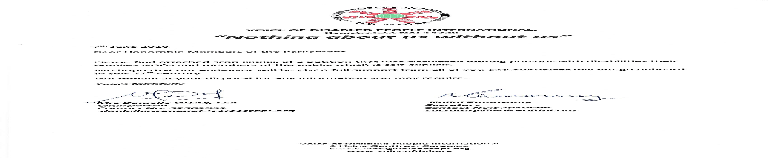

(b) TO THE HONORABLE MEMBERS OF THE PARLIAMENT OF THE REPUBLIC OF MAURITIUS
DEAR HONORABLE MEMBERS OF THE PARLIAMENT,
WE THE UNDERSIGNED WOULD LIKE TO DRAW YOUR ATTENTION TO THE FACT THAT ALTHOUGH MAURITIUS HAS SIGNED AND RATIFIED THE UNITED NATIONS CONVENTION ON THE RIGHTS OF PERSONS WITH DISABILITIES(UNCRPD) SINCE 2007 AND 2010 RESPECTIVELY , AS AT DATE NO SIGNIFICANT STEPS HAVE BEEN TAKEN TO IMPLEMENT SAME.
NON DISCRIMINATION –Article 3-AND DIGNITY OF PERSONS WITH DISABILITIES ARE THE BASIS OF THIS CONVENTION. IN ORDER TO APPLY THE ABOVE, AMENDMENTS TO THE CONSTITUTION OF MAURITIUS ARE PRIMORDIAL FOR US TO BE INCLUDED AS FULL FLEDGED CITIZENS OF THIS COUNTRY- Article 4-(1b)..
WE WOULD BEGRATEFUL IF YOU COULD PLEASE ADDRESS THIS ISSUE AT THE EARLIEST SO THAT THE DISABILITY BILL BE A REALITY SOON AFTER CONSULTATION -Article 4 –(3)WITH THE STAKEHOLDERS I.E THE PERSONS WITH DISABILITIES.
THNKING YOU

NAME SIGNATURE
Annex 2
27.06.2015
Honorable Mrs Aurore Perraud
Minister of Gender Equality, Child Development & Family Welfare
7th Floor, Newton Tower
Port Louis
Dear Madam,
We have learnt through the media of all the measures being taken by your Ministry together with all stakeholders so as to prevent and manage cases of child abuse which are unfortunately increasing in the country.
However we also note with concern that cases of abuses against girls and women with disabilities are not being given utmost attention from the concerned parties. We feel that these cases are not treated as important by the different departments looking into cases of rapes/sexual harassment against this portion of the population and are often considered as not requiring attention hence creating a situation of impunity vis a vis those perpetrating such immoral actions. Violence against Women with Disabilities occurs primarily as a result of attitudes towards women in patriarchal society coupled with vulnerability from the conditions that result from the disability itself such as:
- Being physically less capable of defending themselves
- Difficulty in reporting due to lack of accessible forms of communication
- Inaccessibility of information and counselling services due to barriers in the physical environment and due to lack of accessible forms of communication
- A greater amount of dependence on other persons for care
- Lower self esteem and fear of reporting the abuse as it might result in the loss of the care
- Failure of others to believe some survivors that results in questioning the credibility when reporting violence in institutions
- Less risk of discovery as perceived by the perpetrator
- Low level of education about appropriate and inappropriate sexuality
- Denial of human rights that result in experience of powerlessness.
Women with Disabilities have also reported experiencing abuse of longer duration and having fewer alternatives for escaping or ending the abuse. Indeed while women with disabilities share the barriers that any other woman has to face to escape or end violence, there are far more barriers that specifically affect women with disabilities.
Parents of those girls do not know whose door they should knock on for justice as often they are looked upon with condescension by the police officers when they seek help from them. Most of these cases are not reported by the parents as they fear the reactions of those in the vicinity who will not hesitate to blame them for such situations or for alerting sexual predators of the existence of their daughters/sisters, etc. Moreover all officers who come in contact with the victims are not truly trained to deal with such persons. Even the shelters do not provide accommodation or psychological assistance to the victims who have a disability after a case of rape. It is even more traumatising for the victims when they go to hospital after such a vile act and the victims are treated as ‘crazy’ as most of them are either intellectually or hearing impaired and cannot express themselves properly and are often interned at the Brown Sequard Hospital. Most often reports of abuses made by teachers of disabled girls are not given the needed follow up and ends up in a drawer somewhere.
We at the Women with Disabilities association feel very concerned by this case of discrimination against girls with disabilities and we urge you to please address this issue as we feel that a strong and official action should be taken by your office at the earliest as disability is not the responsibility of the ministry of social security only. A need to bring harsher penal punishment to sexual abuse perpetrators should be on the agenda as well as the creation of a centre with qualified officers who will be able to help the victims after such a degrading act that directly soil the dignity of the vulnerable person.
I would be grateful if the executive members of the association could meet with you so as to elaborate an action for addressing violence against girls and women with disabilities and who feel left out of all projects/programs involving non-disabled girls and women.
Thanking you for your understanding.
Nalini Ramasamy

President-Women with Disabilities
Executive Committee Secretary-Fraternité Mauricienne des Malades et Handicapés
Secretary-Voice of Disabled People International-Mauritius
Email : nalini.r@intnet.mu
Mob: 5-7910698

Annex 3
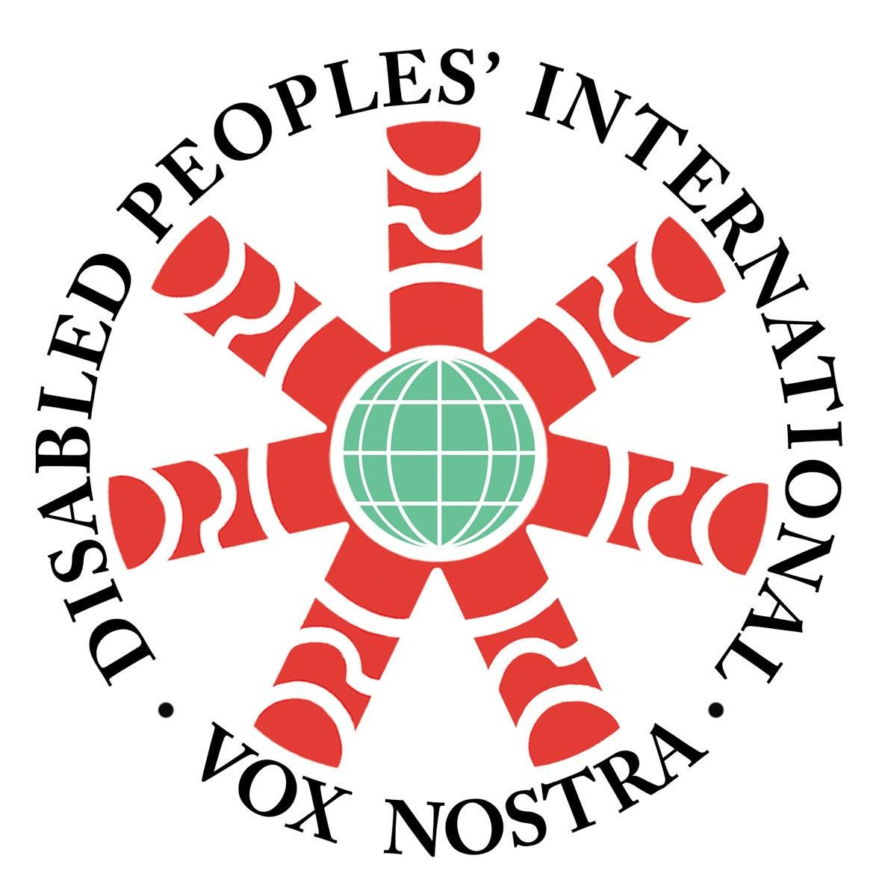
a)

VOICE OF DISABLED PEOPLE INTERNATIONAL.
Registration No: 14730
“Nothing about us without us”

01.09.2018
The Permanent Secretary
Ministry of Local Government& Outer Islands
Level 6, Renganaden Seeneevassen Building
Port Louis

Subject: Accessibility to Public Buildings
Dear Sir

The Voice of Disabled People International , a federation representing NGOs working in the Disability Sector in Mauritius would be grateful if you could please inform us about the measures taken by your ministry following the measure announced by our Prime Minister and Minister of Finance in the 2018-2019 budget so as to make all public buildings accessible for persons with disabilities.

Thanking you for your consideration and reply at your earliest convenience.

Yours faithfully

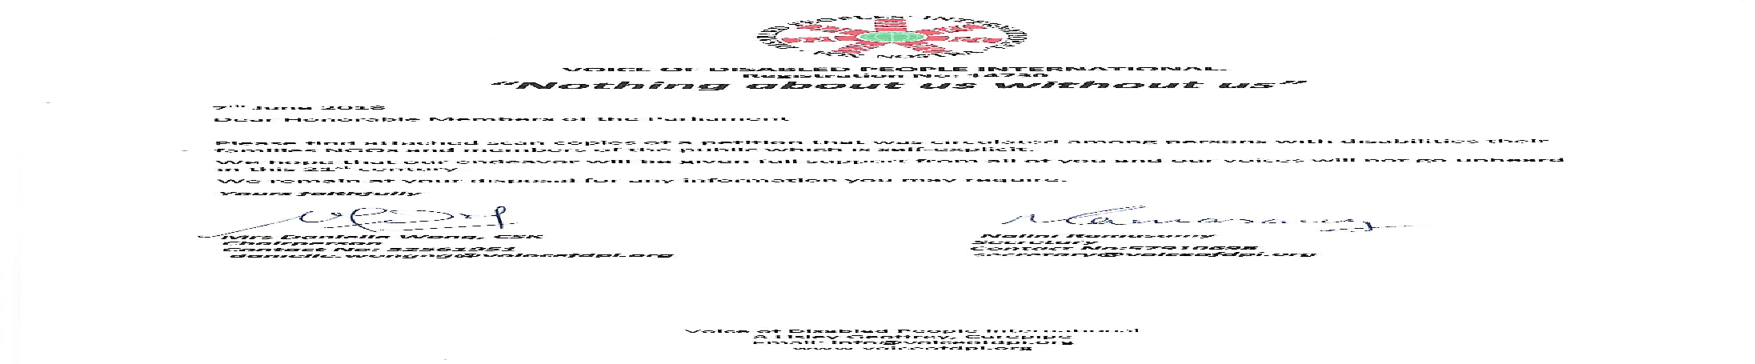

cc Prime Minister’s Office/Ministry of Public Infrastructure

b) Petition for Infrastructure
Honourable N. BODHA,
Attention: Mr. D. Raymond (Adviser to the Minister),
Minister of Public Infrastructure, NDU, Land Transport & Shipping,
Port Louis. February 11, 2016

Dear Sir,
Ref: Request to better the fate of Persons with Disabilities
We, the undersigned, the official representatives of associations of Persons with Disabilities throughout Mauritius, come forward with a few proposals to ease the fate of our daily life.

As Mauritius has signed and ratified the United Nations Convention for the Rights of Persons with Disabilities since 2010, it …we quote…”has unequivocally espoused the social and human rights model of disability, concomitantly, mainstreaming disability has become a key objective…”.

According to “Statistics Mauritius” the prevalence of disability in 2011 was 28,987 male, 30,881 female, thus a total of 59,868 which represented 4.8 % of the population. From that number 55,665 were following educational studies from pre-primary to University degree, whereas an additional 8,435 were in employment. If we take into consideration those who are pensioners, we believe that it is not exaggerated to sum up to some 100,000 consumers who have to use a means of transport regularly.

It is a recognized fact that innumerable initiatives have been taken to ensure the integration of persons with disabilities in the mainstream society since 1981, but it is not yet a fully and inclusive one because we feel that there is some hesitation and reluctance to pull down all the barriers that are impeding a more meaningful rehabilitation.

It has been brought to our knowledge that there are actually around 100 drivers with disabilities but only around 50(Blue) coupons for parking are allocated.
About 150 Special (Yellow) coupons are also allocated to persons with disabilities who do not drive but are allowed to use the dedicated parking spaces for the disabled whilst accessing those areas fitted with same . However we have noted that these are being used by the parents of those disabled persons thus enabling them to have free parking spaces in the absence of the beneficiaries.

We humbly submit to your Ministry of Public Infrastructure, NDU, Land Transport & Shipping the following requests and appeal to your kind and precious collaboration to materialize same:-
- To enhance the accessibility of persons with disabilities to all places where the public is deemed to have access in line with the concept of universal design (worship, educational, recreational … )
- To set up a monitoring mechanism to ensure that all new infrastructures are disabled-friendly and existing ones be retrofitted within a reasonable delay.
- Review procedures for grant of parking coupons and its renewal
- Increase / double the quantum of reserved parking bays for drivers with disabilities
- Reserved parking should not be placed next to parking spaces for motorcycles for obvious reasons
- The logo” Si tu prends mon parking, prends aussi mon handicap” be affixed conspicuously at all reserved parking bays which should be painted in blue with the accessible design white instead of printing the word “DISABLED”
- Those who illegally use the reserved parking spaces for Persons with disabilities without the adequate coupon be charged a heavier fine to discourage such irresponsible practice
- To introduce LOW Floor Buses along the main roads in the first instance
- Reserved safe seats in buses
(10) Flashing lights for the hearing impaired in buses when they have to stop
(11) Adequate Crossing for visually impaired persons…. Buzzing system to be provided
- Public infrastructures are not disability-friendly (pavements, Kerbs, ramps…)
- To amend existing legislations:-
- Town and Country Planning Act
- Local Government Act
- Roads Act
- Road Development Authority Act
- Road traffic Act
- Building and land Use guidelines and
- Equal Opportunities Act

We look forward to hearing from you and would like to let you know that we are prepared to participate in any working session that may be conveyed at your convenience.

Yours faithfully

