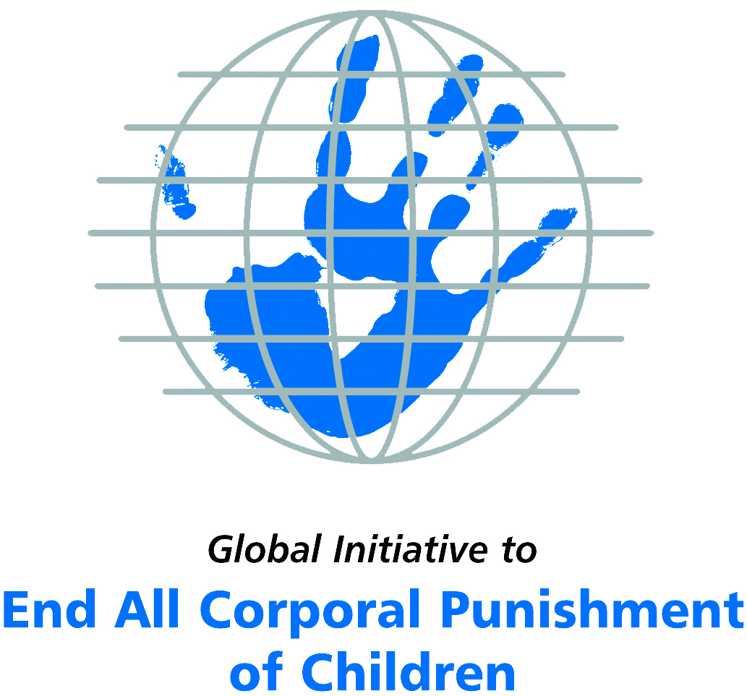
Briefing on the Russian Federation for the Committee on the Rights of Persons with Disabilities, 8th Pre-Sessional Working Group, September 2017
From the Global Initiative to End All Corporal Punishment
of Children, July 2017

(a) About the Global Initiative to End All Corporal Punishment of Children
1. The Global Initiative (www.endcorporalpunishment.org) promotes universal prohibition and elimination of corporal punishment in fulfilment of states’ obligations under the UN Convention on the Rights of the Child and other international treaties. Our aims are supported by UNICEF, UNESCO, human rights institutions and international and national NGOs. Since 2002, the Global Initiative has regularly briefed the Committee on the Rights of the Child on this issue, and since 2004 has similarly briefed the Committee Against Torture, the Committee on the Elimination of Discrimination Against Women, the Committee on Economic, Social and Cultural Rights, the Human Rights Committee and the Human Rights Council; we have briefed the Committee on the Rights of Persons with Disabilities since the beginning of its work.

(b) Summary
2. Corporal punishment of children in the Russian Federation is unlawful in schools and in the penal system, but it is not yet prohibited in the home, in alternative care and in all day care settings, in violation of the fundamental right of all children to protection from corporal punishment and other cruel or degrading forms of punishment.
3. With reference to articles 7, 15, 16 and 17 of the Convention on the Rights of Persons with Disabilities, and in light of the particular vulnerability of children with disabilities to corporal punishment by adults, the jurisprudence of the UN treaty bodies, the emphasis on eradicating this form of violence given by the UN Secretary General’s Study on Violence against Children and the importance of the issue to achieving target 16.2 on ending violence against children in the 2030 Sustainable Development Goals, we hope the Committee on the Rights of Persons with Disabilities will:
- include the issue of corporal punishment in its List of Issues for the Russian Federation, in particular asking: “what steps have been taken to ensure that domestic legislation in the Russian Federation fully protects all children from violent punishment and explicitly prohibit its use in all settings including the home?”;
- recommend to the Government of the Russian Federation, in the Committee’s concluding observations on the initial report, that “prohibition of corporal punishment of all children in all settings is drafted and enacted as a matter of priority and that measures are put in place to ensure the law is properly implemented”.

(c) Detailed briefing
The right of children with disabilities not to be subjected to corporal punishment
4. The Convention on the Rights of Persons with Disabilities confirms that children with disabilities should enjoy all human rights and fundamental freedoms on an equal basis with other children (art. 7). The Convention also states that all persons have the rights to freedom from torture or cruel, inhuman or degrading treatment or punishment (art. 15), to freedom from exploitation, violence and abuse within and outside the home (art. 16) and to respect for their physical and mental integrity (art. 17). The jurisprudence of treaty monitoring bodies, led by the Committee on the Rights of the Child monitoring the Convention on the Rights of the Child, is clear that these rights put an obligation on states parties to prohibit and eliminate all corporal punishment of children, including within the family. Although the Russian Federation’s state report refers to the right of children with disabilities to be protected from violence and abuse, the issue of the legality of corporal punishment is not addressed.
5. As confirmed in the UN Secretary General’s Study on Violence against Children, children with disabilities are particularly vulnerable to violence, including corporal punishment, and corporal punishment is a significant cause of impairment among children. Yet the obligation to prohibit corporal punishment is frequently ignored or evaded by governments. The near universal acceptance of violence in childrearing together with deeply held views that parents and other adults have a “right” to physically punish children can challenge efforts to achieve prohibition. It also means that corporal punishment – at least to some degree – is not readily perceived as violence in the same way as, for example, sexual and other socially unacceptable forms of violence.
6. The newly adopted Sustainable Development Goals under the 2030 Agenda include target 16.2 on ending all forms of violence against children. Violent punishment is the most common form of violence against children: ending it through the adoption and implementation of legislation prohibiting it in all settings including the home is critical.

The legality of corporal punishment of children with disabilities in the Russian Federation
7. In the Russian Federation, corporal punishment of children is unlawful in schools and in the penal system, but children with disabilities may lawfully be subjected to physical punishment in the home, in alternative care settings, and in most day care settings.
8. Corporal punishment is lawful in the home. In 2010, the Ministry of Justice stated that provisions in the Family and Criminal Codes protecting children’s rights to human dignity and to protection from abuse amount to prohibition of corporal punishment of children. However, in the absence of explicit prohibition it is not clear that they effectively prohibit all forms of physical punishment in childrearing. There is no explicit prohibition of corporal punishment of children in the Law on Guarantees of the Rights of the Child 1998, the Law on Guardianship and Custody 2008, the Criminal Code 1996, the Code on Administrative Offences 2001 or the Constitution 1993.
9. The Council of Europe’s petition against all corporal punishment, part of its campaign to achieve prohibition in all member states, was supported by Russian officials but to our knowledge there have been no moves towards law reform on the issue. President’s decree No. 761 dated 1 June 2012 “On the national strategy of activities in the interests of children for 2012-2017” states that one of the measures focused on the formation of a safe and comfortable family environment is the creation and adoption of a programme promoting intolerance to any forms of violence and corporal punishment of children. However, no such programme appears to exist. 2016 amendments to the domestic legislation criminalising family violence were overturned in February 2017.
10. Corporal punishment is lawful in alternative care settings. There is no explicit prohibition of corporal punishment in all alternative care settings (foster care, institutions, places of safety, emergency care, etc). Children are legally protected from some but not all physical punishment under the Family Code 1995 and the Criminal Code 1996.
11. Corporal punishment is partially lawful in early childhood care and in day care for older children, including for children with disabilities. Corporal punishment is considered unlawful in pre-school day care settings under the Law on Education 2012 (see below). There is no prohibition of all forms of corporal punishment in other early childhood care and in day care for older children. Act No. 3185-1 on Psychiatric Care and Guarantees for the Rights of Citizens Receiving Such Care 1992 states that the provision of care must be humane and must respect human and civil rights but it does not explicitly prohibit corporal punishment. Children are legally protected from some but not all physical punishment under the Family Code 1995 and the Criminal Code 1996.
12. Corporal punishment is considered unlawful in schools, though it is not explicitly prohibited. Article 34 of the Law on Education 2012 states that students have the right to “(9) respect for human dignity, protection from all forms of physical or mental violence, injury personality, the protection of life and health”; article 43(3) states that “discipline in educational activities is provided on the basis of respect for human dignity of students and teachers” and “application of physical and mental violence to students is not allowed” (unofficial translation). The Code on Administrative Offences 2001 punishes violations of the right to education (art. 5(57)).
13. Corporal punishment is considered unlawful as a disciplinary measure in penal institutions, though there appears to be no explicit prohibition. Article 12(2) of the Criminal and Executive Code 1997 states (unofficial translation): “Prisoners are entitled to courteous treatment by staff of penal institutions. They should not be subjected to cruel, inhuman or degrading treatment or recovery. Coercive measures to convicts can be applied not only as to the law.” There is no provision for corporal punishment in correctional institutions (arts. 115 and 136). Article 8(1)(4) of the Law on the Fundamentals of the System of Prevention of Neglect and Offences of Minors 1999 states that in the case of minors “the use of physical and psychological violence” and “the application of measures with an anti-pedagogical nature, degrading human dignity” are prohibited. The provisions against beating and intentional causing of harm in the Criminal Code 1996 (arts. 111 to 116) are also applicable.
14. Corporal punishment is unlawful as a sentence for crime. There is no provision for judicial corporal punishment in criminal law. Article 7 of the Criminal Code 1996 states that punishment and other measures applied to a convicted person “cannot have the purpose of causing physical suffering or humiliation of human dignity”. The Code sets out the sentences which may be given to minors and these do not include corporal punishment (art. 88).

Recommendations by human rights treaty monitoring bodies and during the UPR
15. The Committee on the Rights of the Child has recommended to Russia that corporal punishment of children be prohibited on three occasions – in concluding observations on the second report in 1999, the third report in 2005 and the fourth/fifth in 2014.
16. Specific recommendations to prohibit corporal punishment were not made during the Universal Periodic Reviews of Russia in 2009 and 2013, but the Government accepted more general recommendations to ensure national legislation complies with international standards of human and children’s rights and other relevant recommendations.

Briefing prepared by the Global Initiative to End All Corporal Punishment of Children
www.endcorporalpunishment.org; info@endcorporalpunishment.org

13 March 2015, CRPD/C/RUS/1, Initial report, para. 163
Pinheiro, P. S. (2006), World Report on Violence against Children, Geneva: United Nations. See also Krug E. G. et al (eds) (2002), World Report on Violence and Health, Geneva: World Health Organisation
10 November 2010, Letter to Council of Europe Commissioner for Human Rights Mr Thomas Hammarberg
Latham & Watkins (UK) in correspondence with the Global Initiative, 18 May 2015
See https://meduza.io/en/news/2016/06/28/russian-senator-says-special-criminal-punishment-for-domestic-violence-is-anti-family, accessed 13 January 2017; Federal law 323-FZ of 7 March 2016, http://kremlin.ru/acts/bank/41057/page/1
See https://www.ft.com/content/e523d036-e482-11e6-9645-c9357a75844a, accessed 31 January 2017
10 November 1999, CRC/C/15/Add.110, Concluding observations on second report, paras. 28, 29 and 30
23 November 2005, CRC/C/RUS/CO/3, Concluding observations on third report, paras. 7, 36, 37, 46 and 47
31 January 2014, CRC/C/RUS/CO/4-5 Advance Unedited Version, Concluding observations on fourth/fifth state party report, paras. 32 and 33
3 March 2009, A/HRC/11/19, Report of the working group, paras. 85(15), 85(17), 85(19), 85(33) and 85(39); and 8 July 2013, A/HRC/24/14, Report of the working group, paras. 140(31), 140(43), 140(44) and 140(46)

