Assessment of Economic and Social Rights Fulfilment in Croatia
Submission from the Human Rights Measurement Initiative to the United Nations Committee on Economic, Social and Cultural Rights for the 77th Pre-Sessional Working Group Geneva, February 2025.
I. Reporting Organisation
- The Human Rights Measurement Initiative (HRMI) measures the human rights performance of countries, including Croatia. HRMI is an independent, not-for-profit NGO with a primary base of operations in New Zealand, and a second base in the United States at the University of Georgia’s Center for the Study of Global Issues (GLOBIS).
II. Assessment Methodology
2. HRMI uses the award-winning and peer-reviewed SERF Index methodology to measure the fulfilment of economic and social rights (ESR).
3. This methodology uses bellwether indicator data from international organisations—such as the World Health Organization and UNICEF—and compares each country’s achievement to what other countries at the same level of income have achieved. In this way, HRMI measures progressive realisation of economic and social rights (ESRs) as defined in the International Covenant on Economic, Social, and Cultural Rights (ICESCR). A country’s income-adjusted HRMI score is a measure of how well its government is converting its resources into good human rights outcomes for its people.
4. HRMI supplements these scores with qualitative information sourced by a confidential survey of on-the-ground human rights experts, such as NGO researchers, journalists, and human rights lawyers and advocates. For more details on HRMI’s methodology, please refer to the resources on our website.
5. All HRMI’s data are published annually on the Rights Tracker and are freely available for non-commercial use under a Creative Commons License. HRMI’s Rights Tracker is a certified Digital Public Good with the Digital Public Good Alliance.
III. Overview of Economic and Social Rights Fulfilment in Croatia
6. HRMI’s most recent ESR scores for Croatia measures its achievement as of 2021 and show significant room for improvement. They are shown in the table below.
7. Croatia’s scores for 2021 are as follows:
▪ Overall Quality of Life score = 78.0%
▪ Right to education = 74.2%
▪ Right to food = 90.6%
▪ Right to health = 86.1%
▪ Right to housing = 81.8%
▪ Right to work = 57.3%
8. These scores fall between the ‘very bad’ and ‘fair’ ranges, with none reaching the ‘good’ range. This means that Croatia has a long way to go to meet its ICESCR obligations, and currently has the resources to lift achievement significantly.
9. Croatia scores 78.0% on Quality of Life rights when scored against the 'income adjusted' benchmark. This score takes into account Croatia's resources and how well it is using them to make sure its people's Quality of Life rights are fulfilled.
10. This score tells us that Croatia is only doing 78.0% of what should be possible right now with the resources it has. Since anything less than 100% indicates that a country is not meeting its current duty under international human rights law, our assessment is that Croatia has a long way to go to meet its immediate economic and social rights duty.
IV. Right to Education
12. HRMI defines the right to education in accordance with ICESCR Article 13 and CESCR General Comments 11 and 13. In the case of high-income countries, such as Croatia, HRMI further breaks down the right to education into four areas of measurement: secondary school enrolment, quality of education for maths, quality of education for reading and quality of education for science. Quality of education is measured using PISA score data from UNESCO and OECD and combining that data with HRMI methodology to adjust for income. Our scores show significant challenges across all areas, as the scores mostly lie within the ‘very bad’ range, with only secondary education enrolment lying within the ‘fair’ range.
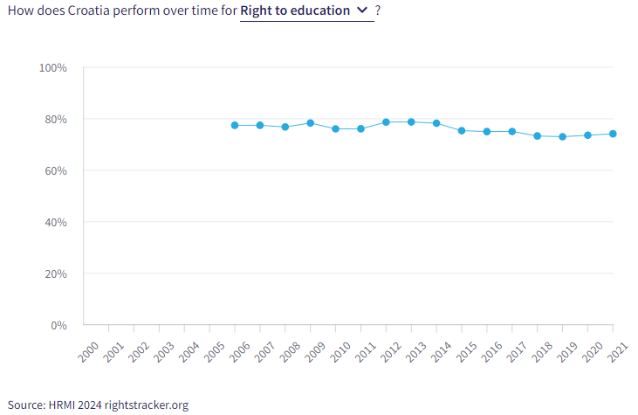
13. Croatia’s score for secondary school education (adjusted for income) is concerningly low. Our most recent score from 2021 indicates only slight increase over the last decade, as the score increased to 86.9%.
14. Quality education is also faring very poorly, as Croatia’s score of 57% for maths education lies within the ‘very bad’ range. The score draws on indicator data from OECD showing that only 41.5% of students were able to achieve level 3 or higher on the PISA math test in 2021. The HRMI score has been dropping since 2014, dropping from a peak score of 61.6% to 57.0% in 2021. Croatia is ranked 13th from the bottom compared to 49 other high-income countries.
15. The quality of education score for reading is also in the ‘very bad’ range and has been declining in recent years. The HRMI score peaked in 2012-2014 with a score of 72.3% but has now dropped to 64.8% in 2021.
16. The last quality of education score for science, similarly to maths and reading, has been declining over recent years. The score peaked in 2012, reaching 77.7%, but has been declining ever since. In 2021, Croatia achieved a HRMI score of only 62.5%. Compared to 49 other high-income countries, this score places Croatia in the bottom half at 18th from the bottom.
V. Right to Food
17. HRMI defines the right to food in accordance with ICESCR Article 11 and CESCR General Comment 12. For high-income countries, such as Croatia, HRMI measures the percentage of individuals in the population who have not experienced food insecurity at moderate or severe levels during the reference period using the global Food Insecurity Experience Scale from FAOSTAT. Croatia’s score for the right to food is 90.6% and falls in the ‘bad’ range. This means that Croatia is doing 90.6% of what ought to be possible to ensure the right to food for its people.
18. Over the last decade, the HRMI score for the right to food has been declining. Compared to 29 other high-income countries within the Europe and Central Asia region, Croatia is 8th from the bottom.
VI. Right to Health

19. HRMI defines the right to health in accordance with ICESCR Article 12.1 and CESCR General Comment 14. In the case of high-income countries, such as Croatia, HRMI uses three indicators to measure the country’s achievements regarding the right to health; percentage of children surviving to age 5, senior (60-80 years old) survival rate, and percentage of babies who do not have a low birth weight. HRMI sources its data from UN IGME, UNPD, Max Planck Institute Mortality Database, OECD and World Bank World Development Indicators. Croatia’s overall HRMI score for the right to health is 86.1%, meaning that Croatia is achieving only 86.1% of what is possible, taking its economic resources into consideration.

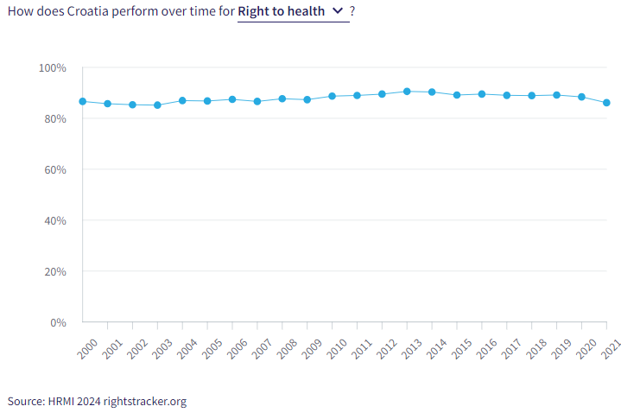
20. Croatia’s child health score has remained high, in the ‘good’ range, for the last two decades, like every country in Europe.
21. Croatia has faced significant struggles with adult health over the past decade. There was improvement over the 2003-2014 period as the score went from a low of 66.2% in 2003 to a peak score of 79.5% in 2014. However, the score has been declining since 2014, steadily worsening over the period of the Covid-19 pandemic, likely reflecting significant loss of life. In 2021, the HRMI score was 71.4% as the senior survival rate was only 53.6%. Within the Europe and Central Asia region, compared to 31 other high-income countries, Croatia is 7th from the bottom.
22. Scores for reproductive rights have been volatile over two decades, and declining fairly steadily within Croatia since 2013, worsening from a peak score of 94.0%. In 2021, 94.5% of babies were born without a low birth weight. This led to a 2021 HRMI score of 88.4%, in the ‘fair’ range. Improvement is urgently needed to reverse this trend.
VII. Right to Housing

23. HRMI defines the right to housing in accordance with ICESCR Article 11.1 and CESCR General Comment 4. In the case of high-income countries, such as Croatia, HRMI uses two assessment standards: affordable housing and safely managed sanitation. Affordable housing data is taken from Eurostats and safely managed sanitation data is gathered from the WHO UNICEF Joint Monitoring Project. For affordable housing and safely managed sanitation, both scores are in the ‘bad’ range.

24. Affordable housing within Croatia has had significant improvement 2010-2020 period. The score increased by 33.7 percentage points over this decade, achieving a peak HRMI score of 88.3% in 2020. However, the score dropped back slightly to 84.3% in 2021. Compared to 37 other countries, Croatia is 14th.
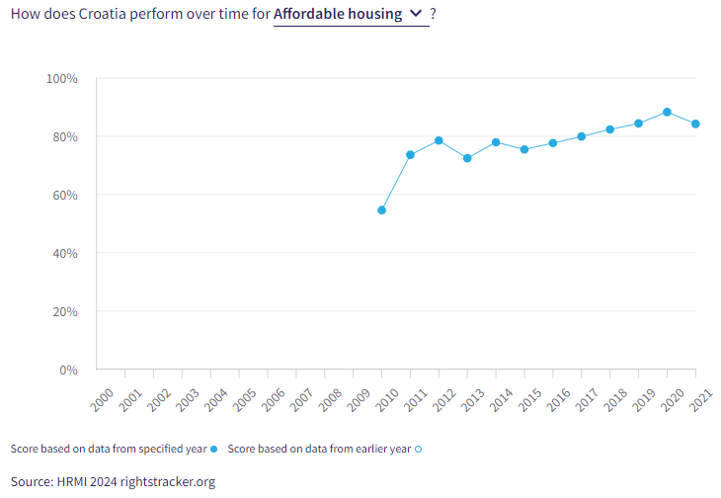

25. The right to safely managed sanitation has been decreasing steadily over the past two decades. Starting with a peak HRMI score of 85.4% in 2000, the score has dropped to a low of 79.4% in 2021. Among other high-income countries in the Europe and Central Asia region, Croatia is fifth from the bottom.

VIII. Right to Work
26. HRMI measures the right to work in accordance with ICESCR Articles 6 and 7. For high-income countries, such as Croatia, HRMI measures the right to work by drawing on data from the Luxembourg Income Study, the OECD and World Bank PovcalNet. Specifically, HRMI uses data regarding how many people are not relatively poor as well as the percentage of people who have not been unemployed long-term. Croatia has achieved an overall HRMI score for the right to work of 57.3%, with a relative income score of 62.9% and an employment score of 51.7%.
27. The percentage of people who were not relatively poor in 2021 was 87.6%, leading to a HRMI score of only 62.9%, falling within the ‘very bad’ range. However, Croatia’s score has improved from a low of 58.3% in 2009 to a score of 62.9% in 2021.
28. The HRMI score for long-term employment is residing within the ‘very bad’ range. Over the course of the last two decades, Croatia has had several rises and falls regarding this right but has ultimately not recovered since reaching a peak HRMI score of 64.9% in 2020. Compared to 38 other countries, Croatia is 16th from the bottom among high-income countries for this right.

IX. Concluding Remarks

29. Croatia’s best score is for child health (based on survival to age five), which has been consistently high over two decades, along with the rest of Europe.

30. Croatia’s most concerning scores are for the rights to work, quality education, fair income, and employment.

31. Croatia’s biggest improvements have been for the right to a job, and the right to affordable housing.

32. HRMI respectfully submits its data and findings on the fulfilment of economic and social rights in Croatia. We hope that this Submission will serve as a useful resource to the Committee on Economic, Social and Cultural Rights for drafting specific and meaningful questions to Croatia during the CESCR’s 77th Pre-Sessional Working Group.

Visit HRMI’s website to learn more about our mission and work, https://humanrightsmeasurement.org/.
This content represents the opinions of the Human Rights Measurements Initiative. It carries no endorsement of the University of Georgia.
See HRMI’s methodology for measuring economic and social rights: https://humanrightsmeasurement.org/methodology and https://rightstracker.org/page/methodology.
Ibid
Ibid
HRMI 2023 Rights Tracker, https://rightstracker.org/
See Human Rights Measurement Initiative (HRMI) Digital Public Good Certificate, https://app.digitalpublicgoods.net/a/10388? The Digital Public Goods Alliance is endorsed by the UN Secretary General’s “Roadmap for Digital Cooperation,” https://www.un.org/en/content/digital-cooperationroadmap/assets/pdf/Roadmap_for_Digital_Cooperation_EN.pdf. It defines digital public goods as: “open source software, open data, open AI models, open standards and open content that adhere to privacy and other applicable laws and best practices, do no harm, and help attain the SDGs,” https://digitalpublicgoods.net/standard/.
HRMI 2024 Rights Tracker, https://rightstracker.org/country/HRV?qolFdScore=hrmi&tab=report-esr
The labels on the country charts of good, fair, bad, and very bad are used to give a general indication of how to understand the scores. HRMI’s income adjusted Quality of Life scores can be broadly interpreted as showing the percentage of the country’s obligation it has met, compared to what the best performing countries have achieved at each income level. A country scoring below 75% with a label of “Very bad” is failing to put in place the kinds of structures and policies that help people claim the right concerned, but the structures and policies in place most likely prevent many people from claiming their rights. See HRMI’s methodology for measuring human rights, https://rightstracker.org/page/methodology.
HRMI 2024 Rights Tracker, https://rightstracker.org/country/HRV?qolFdScore=hrmi&tab=report-esr
HRMI 2024 Rights Tracker, https://rightstracker.org/country/HRV?qolFdScore=indicator&tab=report-esr
HRMI 2024 Rights Tracker, https://rightstracker.org/country/HRV?qolFdScore=hrmi&tab=report-esr
HRMI 2024 Rights Tracker, https://rightstracker.org/metric/pisa-math?tab=report-esr&qolFdScore=hrmi&atRisk=11&income=hi
HRMI 2024 Rights Tracker, https://rightstracker.org/metric/pisa-science?tab=report-esr&qolFdScore=hrmi&atRisk=11&income=hi
HRMI 2024 Rights Tracker, https://rightstracker.org/country/HRV?qolFdScore=indicator&tab=report-esr
HRMI 2024 Rights Tracker, https://rightstracker.org/country/HRV?qolFdScore=hrmi&tab=report-esr
HRMI 2024 Rights Tracker, https://rightstracker.org/metric/pisa-science?tab=report-esr&qolFdScore=hrmi&atRisk=11&income=hi&subregion=europe
HRMI 2024 Rights Tracker, https://rightstracker.org/metric/senior-survival?tab=report-esr&qolFdScore=hrmi&atRisk=11&income=hi&region=europe-central-asia
HRMI 2024 Rights Tracker, https://rightstracker.org/country/HRV?qolFdScore=indicator&tab=report-esr
HRMI 2024 Rights Tracker, https://rightstracker.org/country/HRV?qolFdScore=hrmi&tab=report-esr
HRMI 2024 Rights Tracker, https://rightstracker.org/metric/affordable-housing?tab=report-esr&qolFdScore=hrmi&atRisk=11
HRMI 2024 Rights Tracker, https://rightstracker.org/metric/safe-sanitation?tab=report-esr&qolFdScore=hrmi&atRisk=11&income=hi&region=europe-central-asia
HRMI 2024 Rights Tracker, https://rightstracker.org/country/HRV?qolFdScore=indicator&tab=report-esr
HRMI 2024 Rights Tracker, https://rightstracker.org/country/HRV?qolFdScore=hrmi&tab=report-esr
HRMI 2024 rights Tracker, https://rightstracker.org/metric/longterm-unemployment?tab=report-esr&qolFdScore=hrmi&atRisk=11&income=hi

