The UN Committee on the Rights of Persons with Disabilities
Review of Canada’s Implementation of the
Convention on the Rights of Persons with Disabilities – 2025
Submission by Ehlers-Danlos Syndromes Canada Foundation

Summary: Canada's approach to disability is based on sympathy for well-recognized visible medical conditions. This approach is not effective for Ehlers-Danlos Syndromes which are conditions that are not well recognized by the health care system and are not generally regarded with sympathy.

We would like to thank the UN Committee for the opportunity to put forward issues facing Canadians living with Ehlers-Danlos Syndromes (EDS). We would also like to thank the National ME/FM Action Network, which works on behalf of Canadians with Myalgic Encephalomyelitis, Fibromyalgia or both, for making us aware of this opportunity. There is frequently overlap between ME, FM and EDS.



EDS Canada Foundation has been working on behalf of Canadians living with EDS since 2011.
The UN declaration of disability rights states that people with disabilities have the right to the same quality of life as everyone else. This includes the right to healthcare, education, and employment. Unfortunately, many people with EDS in Canada do not have access to these rights.
About Ehlers-Danlos Syndromes
The Ehlers–Danlos Syndromes (EDS) are a clinically and genetically heterogeneous group of heritable connective tissue disorders (HCTDs) characterized by joint hypermobility, skin hyperextensibility, and tissue fragility. Thirteen subtypes have been recognized. People with EDS are often discriminated against and have difficulty accessing healthcare. This is because 12 types of EDS are considered rare diseases (1:2,500-10,000). In the Hypermobile EDS type with the Hypermobility Spectrum Disorder type is now considered to affect 1:300, and many doctors are not familiar with it. There is no cure for EDS and treatments that may help a person’s quality of life are expensive. One patient reported that in one year they spent “$32,000 for medications and treatments not covered by provincial medical plans.”
Many people with EDS have trouble finding a doctor who is knowledgeable about their condition and is willing to take them on as a patient. This can lead to misdiagnosis and inadequate care. In addition, there is a lack of research on EDS, which means that there are few effective treatments available. As a result, many people with EDS are unable to work and/or go to school.
This lack of knowledge about EDS also leads to discrimination. People with EDS are often viewed as being lazy or hypochondriacs because multiple body functions can be affected due to weak connective tissue. This can make it difficult to find a job or make friends. As a result, many people with EDS experience social isolation and depression.
The onset of symptoms for some can be as early as infancy and there is often a missed opportunity to recognize EDS in children born with osteogenesis imperfecta. For others, onset is during adolescence and currently takes on average 9 months for males and up to 16-years for females to be diagnosed .

EDS often comes with additional symptoms as shown in the diagram below.
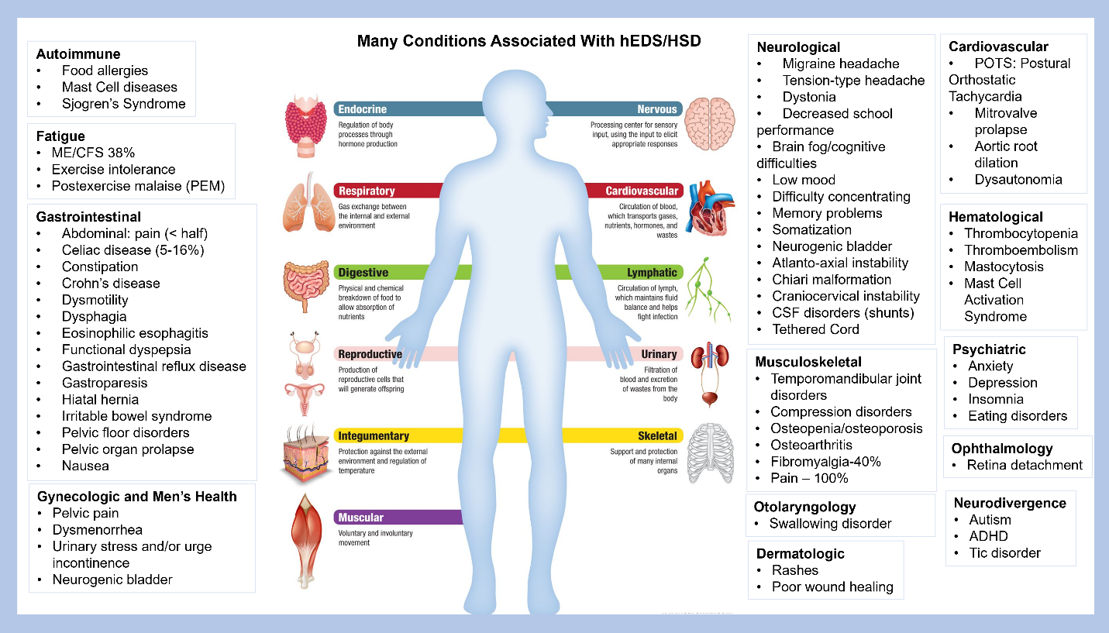
Canada's traditional approach to disability focuses on sympathy for well-recognized visible medical conditions. This approach is not effective for EDS which is a condition that can be challenging to diagnose with its 13 sub-types, most of which are considered rare. The most common sub-type is Hypermobile EDS (or Hypermobility Spectrum Disorder which is a diagnosis of exclusion), affecting 1:300, but it is rarely diagnosed and may not always evoke immediate healthcare care pathways, social support or public understanding. As recently noted in a media story on medical gaslighting of patients, an EDS patient voiced her experience which is all too common.
The UN Convention on the Rights of Persons with Disabilities (CRPD) offers a more comprehensive framework for disability. It defines disability as the interaction between impairments and environmental and attitudinal barriers. This shift in focus emphasizes the need to remove barriers that hinder full and effective participation in society for people with EDS, regardless of the level of public awareness or sympathy. The CRPD calls on governments to look for barriers within their purview and to try to reduce or remove them. This is for the benefit of the individual, but it also increases participation in society which benefits everyone.
Examples of government barriers in Canada include the low level of medical services for persons living with EDS due to lack of care pathways, including patient safety guidelines; the unfair eligibility requirements in the federal Disability Tax Credit, which is the gateway for many disability supports; and the lack of recognition of EDS in various provincial special education systems.

EDS Canada Foundation has identified five initiatives that would go a long way toward implementing the necessary paradigm shift. These align with initiatives put forward by the National ME/FM Action Network, but we have added some detail relevant to EDS. We then discuss three more topics, domestic violence, medical assistance in dying, and in particular issues around neurosurgery.
- Address gaps in the health care system for EDS:
  - Provide accredited continued medical education about EDS to healthcare professionals and introduce EDS into the medical school curriculum.
  - Increase equitable access to early diagnosis to speciality services such as neuroradiology, neurosurgery and to supportive interventions. This would reduce the level of disability by decreasing the harm that comes from doing too much of the wrong things and not enough of the right things.
  - Increase funding for EDS research.
  - Increase access to Allied Health Professionals to treat symptomatology (physiotherapy, massage therapy, occupational therapy, mental health supports etc.) as well as access to products (bracing, compression wear medications, etc.) to reduce the level of disability and increase quality of life.
- Increase disability literacy in government.
- Review the content, accessibility, use and messaging of disability statistics.
- Update the Disability Tax Credit criteria. Also, do not require that people reapply unnecessarily. Our population has a heritable connective tissue condition that they inherited from their parents, and it will not go away and demonstrated decline with short periods of improvement. To have individuals reapply for a genetic condition with no cure is comparable to asking an amputee if their limb grew back.
- Ensure the availability of education for young people living with EDS. With the frequent delay in diagnoses noted earlier, accommodations are required for suspected cases to ensure equal success in the school system.

Domestic Abuse and the Disability Community:
Research indicates that individuals with disabilities are at a significantly higher risk of experiencing domestic abuse than those without disabilities. This vulnerability is often linked to factors such as:
- Dependency: Individuals with disabilities may rely on caregivers or partners for daily living tasks, making them more susceptible to abuse and exploitation.
- Isolation: Social isolation can make it difficult for people with disabilities to recognize and report abuse, or to seek help from others. The concerns of accessible shelters that can accommodate individuals with disabilities.
- Disbelief: Unfortunately, reports of abuse from individuals with disabilities are sometimes dismissed or not taken seriously by authorities, healthcare providers, and the general public.
The Canadian government needs to address the complex needs of people with EDS by ensuring access to high-quality healthcare, including pain management and mental health support. Additionally, it is crucial to raise awareness about EDS and its associated challenges to reduce stigma and discrimination. By taking these steps, the Canadian government can help to improve the lives of people with EDS and ensure that they can live with dignity and respect.
Increasing funding for EDS community-based support service programs that are ancillary to healthcare – EDS Canada Foundation has worked to develop support service programs that help to reduce fear, anxiety, isolation by validating their condition and helping them to know they are not alone.

Canadian Studies & Advocacy Initiatives:
- Statistics Canada has reported that women with disabilities are nearly twice as likely to experience physical or sexual assault by an intimate partner compared to women without disabilities.
- Dawn Canada has highlighted the increased risk of various forms of abuse, including neglect, physical abuse, sexual abuse, and psychological abuse, among individuals with disabilities.
- 90% of hypermobile Ehlers-Danlos Syndromes with disabilities are women according to EDS Canada Foundation’s research. 20% of our attendees of our EDS Wellness Support Clients report domestic violence in their lives.

Medical Assistance in Dying (MAiD)
The Canadian Ehlers-Danlos Syndromes (EDS) patient experience with the UN declaration of disability rights is further complicated by the increasing use of Medical Assistance in Dying (MAiD). People with EDS often experience chronic pain and disability, which can significantly impact their quality of life. In some cases, the severity of their symptoms may lead them to consider MAiD as a way to end their suffering.
While MAiD is a legal option in Canada, it raises concerns about the accessibility of adequate pain management and support services for people with EDS. Some advocates argue that the increase in MAiD use among people with EDS may be due to a lack of comprehensive care and support, rather than a genuine desire to end their lives.
It is important to note that this is a complex issue with various perspectives. Some people with EDS may find that MAiD is a compassionate and appropriate option for them, while others may prefer to continue seeking treatment and support.
Neurosurgical Need
With the lack of research studies on neurosurgical interventions, that is inclusionary of the EDS population, neurosurgeons lack the training to recognize the differences in the presentation of symptomology. This causes increased level of disability, poor quality of life and mental health impacts. Several EDS patients reported that they choose MAiD due to neurosurgical needs not being met.
It is considered that 1% of 1:300 people with Hypermobile EDS in Canada may experience one or more of these conditions: Cranio-cervical Instability (CCI), Atlanto-Axial Instability (AAI), Chiari Malformation, Compression Disorders, Spontaneous Cerebral Spinal Fluid Leaks, Tethered Cord, and other neurological complications requiring specialized neurosurgery. However, Canada has a shortage of neuroradiologists trained in the diagnostic criteria in EDS patients impacted by weak connective tissue i.e.: supine MRI vs weight bearing Upright MRI imaging, or neurosurgeons with the expertise to treat and respond to complications that can occur in EDS patients. Several patients have had to fundraise and/or leave Canada to obtain care that is offered here in Canada because of discrimination. One patient reported: “EDS is the scarlet letters in the medical system. I was being prepped for emergency neurosurgery when they stopped due to my EDS. No care was provided.” This leads to:
- Long wait times for diagnosis and treatment: Snapshot of Neurosurgical Need of Ehlers Danlos Syndromes and Hypermobility Spectrum Disorders Patients in Ontario indicates that many EDS patients face significant delays in accessing necessary neurosurgical care. This can exacerbate their conditions and lead to further complications.
- Inadequate care: Due to the lack of specialized knowledge, some EDS patients receive inadequate or even inappropriate care, which can negatively impact their quality of life and overall health outcomes.
- Limited access to appropriate imaging: Specialized imaging techniques are crucial for diagnosing CCI and other neurological issues in EDS patients. However, access to these imaging modalities and radiologists trained to interpret them is often limited.
The "Letter to MOH EDS Neurosurgical Healthcare" highlights the lack of progress in addressing these issues despite previous commitments from the Ontario Ministry of Health. This situation directly contradicts the UN Declaration of Disability Rights, which guarantees people with disabilities the right to the highest attainable standard of health without discrimination.

Key Impacts on Disability and Rights Violations:
The UN Convention on the Rights of Persons with Disabilities (CRPD) provides a framework for understanding and addressing the rights of individuals with disabilities. Through the lens of the CRPD, we have examined the impact of Tethered Cord and Cranio-cervical Instability in the EDS population.
Tethered Cord:
Right to Health:
- Access to Diagnosis and Treatment: Many individuals with EDS and tethered cord face significant challenges in accessing timely and accurate diagnosis and treatment as EDS doesn’t present the same.
- Pain Management: Chronic pain associated with tethered cord can severely impact quality of life. Effective pain management strategies should be accessible to all.
- Neurological Rehabilitation: Individuals with neurological deficits resulting from tethered cord require specialized rehabilitation services to maximize their functional abilities. This is not offered to the individuals with EDS.
Right to Live Independently and Be Included in the Community:
- Accessibility: Physical and attitudinal barriers can hinder the ability of individuals with tethered cord to participate fully in society.
- Assistive Technology: Access to appropriate assistive technology can empower individuals with tethered cord to live independently.
- Education and Employment: Educational and employment opportunities should be inclusive and accessible to individuals with tethered cord.

Right to Non-Discrimination:
- Stigma and Prejudice: Individuals with EDS and tethered cord may face stigma and discrimination, particularly when their symptoms are not visible.
- Discrimination in Healthcare: Healthcare providers may not be adequately trained to recognize and treat tethered cord in the EDS population, leading to delayed diagnosis and inadequate care. One patient reported: “It took three years to see neurosurgery and by then my bladder nerves are dead and the surgeon decided not to operate as the damage is done.” As a result, this patient has been left disabled, suffering with chronic pain, physical disability, and irreversible nerve and tissue damage.

Cranio-cervical Instability:

Without timely and effective neurosurgical intervention, EDS patients with Cranio-cervical Instability (CCI) and other neurological complications can and may experience:
- Debilitating pain: Chronic pain is a hallmark of EDS, and neurological complications can significantly amplify this pain, impacting daily activities and overall well-being.
- Neurological decline: Untreated CCI can lead to a progressive worsening of neurological symptoms, including dizziness, headaches, and difficulties with coordination.
- Paralysis: In severe cases, delayed or inadequate treatment of CCI can result in paralysis or other life-altering complications.
Recommendations
To address these challenges and uphold the rights of EDS patients, the Canadian government should:
- Invest in specialized training: Increase funding for training healthcare professionals, including neurosurgeons, in the diagnosis and management of EDS-related neurological complications.
- Improve access to specialized imaging: Ensure that EDS patients have access to appropriate imaging techniques and radiologists trained in interpreting these images.
- Establish specialized clinics: Consider establishing multidisciplinary clinics specifically for EDS patients, ensuring they have access to coordinated care from various specialists, including neurosurgeons.
Advocacy Strategies
- Raising Awareness: Educating healthcare providers, policymakers, and the general public about the specific needs of individuals with EDS and neurological comorbid conditions.
- Advocating for Early Diagnosis: Promoting early screening and diagnosis to prevent further complications and improve outcomes.
- Improving Access to Specialized Care: Ensuring access to qualified neurosurgeons, pain specialists, and physical therapists who understand the complexities of EDS and neurosurgery.
- Promoting Inclusive Policies: Advocating for policies that support the inclusion of individuals with disabilities in all aspects of society.
- Empowering Self-Advocacy: Encouraging individuals with EDS and tethered cord to advocate for their own rights and needs.
By addressing these issues and advocating for the rights of individuals with EDS we can work towards a more inclusive and equitable society thereby reducing the severity of disability.
By taking these steps, the Canadian government can move towards fulfilling its obligations under the UN Declaration of Disability Rights and ensure that EDS patients have access to the healthcare services they need to live full and productive lives.

https://onlinelibrary.wiley.com/doi/full/10.1002/ajmg.c.31552
https://cms.theilcfoundation.org//media/pdf/Engaging-the-Canadian-system.pdf
Source: Impression Design 92100 Boulogne-Billancourt, France. (2009, February 28). The Voice of 12000 patients: Experiences and Expectations of Rare Disease Patients on Diagnosis and Care in Europe. https://www.eurordis.org/wp-content/uploads/2009/12/EURORDISCARE_FULLBOOKr.pdf.
https://globalnews.ca/news/10953513/unviersity-of-windsor-study-medical-gaslighting/
https://cms.theilcfoundation.org//media/pdf/the-disaporatnate-effects-of-eds-on-women-hubbard.pdf
https://cms.theilcfoundation.org//media/pdf/socialnetworkimpactonchronicpain-pdf.pdf
https://cms.theilcfoundation.org//media/pdf/theilc_maid_statement.pdf
https://cms.theilcfoundation.org//media/pdf/theilc-ministry-report.pdf
https://cms.theilcfoundation.org//media/pdf/analysis-of-patient-submissions.pdf
https://cms.theilcfoundation.org//media/pdf/letter-to-moh-eds-neurosurgical-healthcare-may-3-2022.pdf
https://cms.theilcfoundation.org//media/pdf/theilc-ministry-report.pdf
https://rarediseases.org/rare-diseases/tethered-cord-syndrome/
https://cms.theilcfoundation.org//media/pdf/letter-to-moh-eds-neurosurgical-healthcare-may-3-2022.pdf
https://cms.theilcfoundation.org//media/pdf/national-pain-strategy.pdf
https://cms.theilcfoundation.org//media/pdf/cci-timelinministry-health.pdf
https://cms.theilcfoundation.org//media/pdf/the-added-value-of-an-eds-and-hsd-navigators.pdf

