REPORT ON THE IMPLEMENTATION OF CEDAW IN GUINEA-BISSAU
- CONTEXT
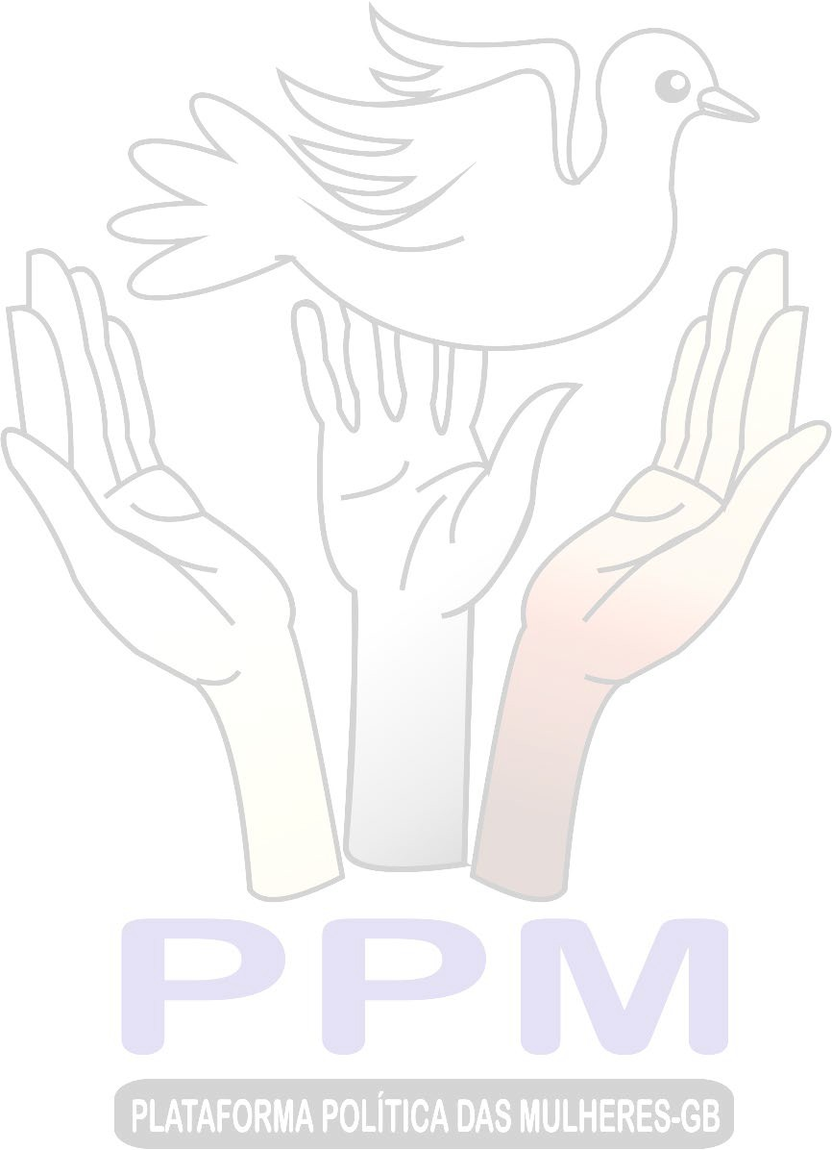
The State of Guinea-Bissau has signed and ratified several conventions, international and regional treaties and their respective optional protocols, for the promotion and protection of equal rights and opportunities between men and women. And among them we can highlight the Convention for the Elimination of All Forms of Discrimination Against Women (hereinafter referred to as CEDAW).
In accordance with CEDAW and in accordance with the lobbying and advocacy actions promoted and developed by civil society organizations, with technical and financial assistance from the United Nations System and international NGOs, several national laws, policies, strategies and action plans were adopted to promote women's human rights, promote gender equality and equity, combating violence and practices harmful to women's health, and women's participation in decision-making bodies.
However, although the context appears to be encouraging, the truth is that the reality of human rights for Guinean women is much more complex and multifaceted, especially for women in rural areas. The context is marked by challenges, advances and setbacks. The electoral promises and the design of the national governance plan sell to national and international public opinion an idea that the promotion of gender equality, the participation of women in decision-making and the fight against violence and discrimination are priorities on the country's agenda. But the practice is completely the opposite, because there is no will of the rulers to overcome cultural, economic, political and social challenges and barriers. A clear example of this lack of political will is the budget cake reserved in the General State Budget, for social areas, namely: education, health, justice, culture, environment, social assistance and protection, etc. These areas are directly linked to the protection and promotion of women's rights.
Thus, the daily lives of Guinean women continue to be marked by discrimination, violence and barriers to full political, social, economic and cultural participation, in flagrant violation of the principle of equal rights enshrined in Articles 24 and 25 of the Constitution of the Republic of Guinea-Bissau.

ADVANCES IN THE IMPLEMENTATION OF CEDAW
✪ Existence of several CEDAW-inspired/based projects, implemented by national and international civil society organizations and NGOs;

Existence of legislation to promote and protect women's human rights and combat violence and discrimination, namely: Law No. 6/2014, against domestic violence, Law No. 14/2011, against female genital mutilation, Law No. 12/2011, against human trafficking, Law No. 4/2018, parity of 36% of female representation in decision-making bodies, Code of Conduct against sexual exploitation in tourism and travel;
✪ Existence of the National Policy for Gender Equality and Equity and its Action Plan;
✪ Existence of a National Strategy for the eradication of female genital mutilation;
✪ Improvement of the technical capacity of CSOs that has made it possible to fill the existing institutional gaps with constant political instability;
✪ Further strengthening the institutional capacities and human resources of women's organisations (in order to reduce discrimination and women's participation in access to property and credit);
✪ Existence of the radio programme for the promotion of human rights,
gender equality, political participation and gender-based violence and discrimination, namely: program ''ora di mindjer ku mininus'' on Radio África FM, program "voz do defensor'' on Radio Capital CFM, among others;
✪ Existence of national and community-based women's organizations, namely: Women's Political Platform of Guinea-Bissau (PPM-GB), Women's Network for Peace and Security in the ECOWAS Area (REMPSECAO), Association of Women Media Professionals (AMPROCS), Association of

Women Lawyers, Association of Women Teachers and Educators, National Network of Young Girl Leaders (RENAJELF-GB), National Network for the Fight against Violence in Gender and Children (RENLUV-GC), Network of Women Mediators (REMUME), National Network of Working Women (RNMT), Committee of Women for Defense and Security, Mindjer I Ka Tambur Movement, among others;
Existence of the House of Rights, operational and available to human rights organizations;
✪ Existence of the Access to Justice Centre in the sectors of Bafatá, Gabú, Mansoa, Buba, Canchungo and in the Autonomous Sector of Bissau;
✪ Promotion and operationalization of the Guinean League for Human Rights;
✪ Existence of a Human Rights Observatory, to record and report situations of violence and discrimination against women and girls;
✪ Creation and promotion of the Women's Electoral Process Monitoring House (awareness of women to participate in the process, early warning, creation of the code of conduct with the commitment of the candidates, monitoring of the electoral process, sensitization of the candidates to accept the results, exchange of experience with women from the sub-region, participation in the announcement of the
election results).

CONSTRAINTS IN THE IMPLEMENTATION OF CEDAW
✪ Excessive politicization and partisanship of the structure responsible for implementing the policy on gender equality and equity favored disbelief in the institution and generated technical and operational incapacity;
✪ Clash of competences and protagonism between the Institute for Women and Children and the Ministry of tutelage - Ministry of Women, Family and Social Solidarity;

✪ Lack of regional offices of the Ministry of Women, Family and Social Solidarity or the Institute of Women and Children, to provide national coverage for actions to promote and defend the rights of women and children;

✪ The non-harmonization of the framework law on political parties, the electoral law with the requirements of Law No. 4/2018, on parity;
✪ Increase in illiteracy, especially among women and girls, caused by the ineffectiveness of the General Directorate of Literacy of the Ministry of National Education, due to lack of financial resources and logistical means;

The weak budget of the State Budget, intended for social areas, makes it difficult to monitor the implementation of laws, policies, programs and projects;
✪ Insufficiency of the dissemination and dissemination of CEDAW, Law No. 12/2011, Law No. 14/2011, Law No. 6/2014, Law No. 4/2018, National Policy for Gender Equality and Equity, with public authorities, private entities, religious and traditional leaders, community-based associations throughout the national territory;
✪ Lack of a Temporary Shelter for victims of violence, abuse and exploitation, with integrated and specialised services, in order to avoid exposing the identity of victims and allow their easy reintegration into their community;
✪ Lack of daycare centers for children up to 2 years of age, in order to allow parents to reconcile their family obligations with professional responsibilities and active participation in public life;
✪ Inefficiency of Law No. 4/2018 on the parity of 36% of women in the sphere of decision-making, due to the restriction of its scope to elective positions, the exclusion of gender alternation in the composition of plurinominal lists, and the weak application of sanctions in case of its violation;

✪ Restrictions continue regarding the right to bank loans, mortgage loans and other forms of financial credit, as they are less literate, without their own patrimony resources and lack the conditions to cope with the bureaucratic requirements of access to credit;
✪ Increase in early school leaving of girls, for reasons of forced marriage and early pregnancy, without any national strategy to eradicate this phenomenon;
✪ Cultures, traditions and social norms in some regions of the country still restrict women's full participation in politics, employment, health, community-based organizations, etc., especially in more conservative contexts;
✪ Insufficient adequate health services, including information, counselling and family planning services;
✪ Women still do not have the right to be able to decide freely and in full knowledge of the facts about the number of children and the spacing between births and to have access to information and education;
✪ Increase in cases of femicide, especially in rural areas, due to ignorance of the laws, lack of reporting and impunity

✪ Interference and politicization of the justice sector, thus conditioning the principle of independence of justice and favoring impunity for offenders;
✪ Insufficiency of the Courts and Centers for Access to Justice, as well as the insufficiency of the necessary human and logistical resources, to provide coverage throughout the national territory, and allow the speed of judicial proceedings;
✪ Lack of subsidies and exemptions for women's civil society organizations and NGOs creates constraints on their performance.

CONCLUSION
It is concluded that thanks to pressure from civil society organizations, the State of Guinea-Bissau has created structures for the promotion and defense of women's rights (Institute for Women and Children and Centers for Access to Justice) and has adopted important normative provisions, as well as policies on the promotion and protection of women's human rights, the promotion of gender equality, participation and combating violence and discrimination against women, but such structures are sometimes inoperative (due to lack of qualified human resources, financial and material resources), and sometimes insufficient to provide national coverage for assistance to victims of violence and discrimination. While the normative provisions are inefficient, due to the lack of national appropriation of public and private institutions, and due to the lack of follow-up mechanisms, for their implementation.
Likewise, it was found that illiteracy, limited access to resources, associated with socio-cultural challenges and barriers, continue to relegate women to a secondary role in community leadership and political participation, thus being exposed to the situation of harmful traditional practices, violence, discrimination, exploitation, devoid of power of choice over their lives and without access to reproductive health information and services.
It is also noted that the social sector is not a priority for the Guinean State, contrary to the speeches and fantasies in the national governance plan of successive governments, without any political will, to improve this sector, as can be seen in the successive State Budgets.
Finally, it is noted that women continue to have administrative restrictions regarding access to bank loans and access to credit funds, which is almost non-existent, taking into account the low level of education and lack of assets, a fact that limits the economic power of women

women to invest, actively participate in politics and face situations of violence and discrimination.

RECOMMENDATIONS
✪ Revise and regulate Law 4/2018 on parity with a view to achieving effective parity by extending its scope to elected and appointed positions, including gender alternation in public and private administration, and strengthening sanctions in case of violation of the law by 2029;
✪ Adopt the framework law on political parties, the electoral law and the requirements of the law on parity by 2027;
✪ Establish follow-up structures for the implementation of existing gender equality and equity conventions, laws and policies by 2030.
✪ Train and hold political leaders and government bodies accountable for the implementation, monitoring and evaluation of the National Policy for Gender Equality and Equity by 2030;
✪ Train and empower the community, parents and guardians, on the importance of basic education, women's schooling and their active participation in political life by 2028.
✪ Increase to 20% the budget of the General State Budget, intended for the social sector, including funds to support women candidates until 2026;
✪ Reduce socio-cultural barriers and raise awareness among men, especially traditional and religious leaders, of women's political rights by 2030;
✪ Clarify the IMC statutes in view of the need to reduce party-political interference in the appointment of its leadership and consequently in its institutional management, by 2030;

✪ Invest in the creation of an observatory for Gender Equality and Equity for the production, harmonization and permanent dissemination of data on the condition of women in the country, by 2030;
✪ Create a mechanism to combat early school leaving among girls, through a national programme of incentives for excellence, for young girls in vulnerable situations, by 2030;
✪ Create, in a first phase, 3 provincial Temporary Shelters, to assist victims of violence, abuse and exploitation, with integrated and specialized services, in order to avoid exposing the identity of victims and allow their easy reintegration into their community, by 2030;
✪ Encourage the creation of 9 regional crèches for children up to 2 years of age, in order to enable parents to reconcile their family obligations with professional responsibilities and active participation in public life, by 2030;
✪ Operationalise, boost and provide financial and logistical resources, the government structure responsible for combating illiteracy, in order to reduce illiteracy, especially among women and girls, by 2030;
✪ Strengthen and provide the necessary human and logistical resources, the Courts and Access to Justice Centres, throughout the national territory, in order to allow for faster judicial proceedings, by 2030;
✪ Create grants and exemptions for women's civil society organizations and NGOs, in order to encourage and encourage their actions, especially in rural areas, without coverage of government actions, by 2026.

