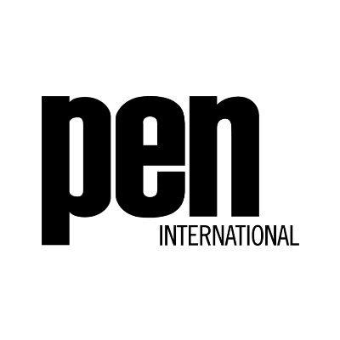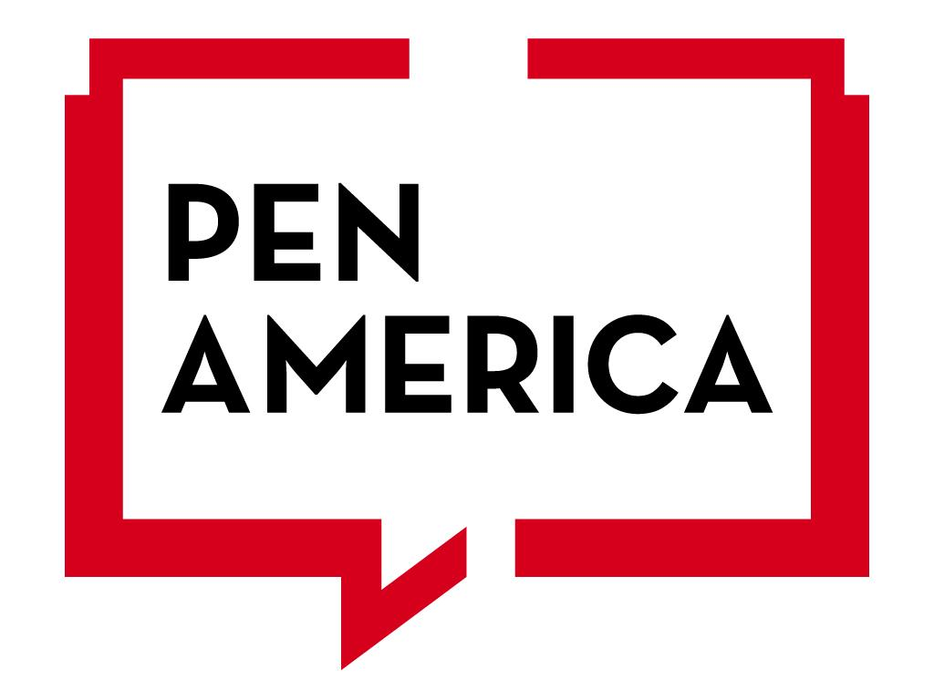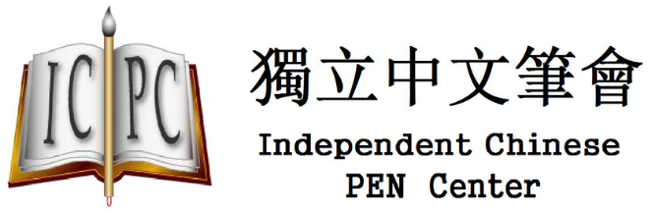

Joint Submission by PEN International, PEN America, and Independent Chinese PEN Center (3 PEN Centers) to the Committee on the Elimination of Discrimination against Women (CEDAW) ahead of its consideration of the People’s Republic of China’s ninth period report at the 85th Session in May 2023

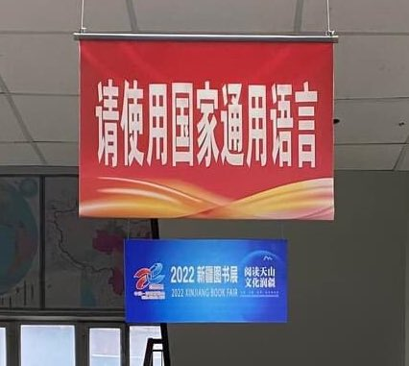
This photograph was taken in early 2023 at a branch of the state-run national Xinhua Bookstore in a city in the Xinjiang Uyghur Autonomous Region. The sign reads, “Please Use the National Language [Mandarin Chinese]”. This bookstore used to have an upper floor dedicated to Uyghur and Kazak language books but now mainly only stocks books translated from Mandarin Chinese in a smaller section. The photographer wishes to remain anonymous. (Credit: Anonymous)

Date of Submission: April 11, 2023

This submission was jointly prepared by:

PEN International

PEN International was founded in London, UK, in 1921, simply as PEN. Today, PEN International acts as the secretariat for a network of 147 PEN Centres across five continents in over 100 countries, which are dedicated to the unhampered transmission of thought within each nation and between all nations.

https://www.pen-international.org/
Ross Holder, Head of Asia/ Pacific Region, E: Ross.Holder@pen-international.org

PEN America

PEN America, the US center of the PEN network, stands at the intersection of literature and human rights to protect open expression in the United States and worldwide. We champion the freedom to write, recognizing the power of the word to transform the world. Our mission is to unite writers and their allies to celebrate creative expression and defend the liberties that make it possible.

PEN AMERICA
588 BROADWAY
SUITE 303
NEW YORK, NY 10012

Angeli Datt, China Research and Advocacy Lead, E: adatt@pen.org

Independent Chinese PEN Center

Independent Chinese PEN Center (ICPC) is a nongovernmental, nonprofit and nonpartisan organization beyond borders based on free association of those who write, edit, translate, research and publish literature work in Chinese and dedicated to freedom of expression for the workers in Chinese language and literature, including writers, journalists, translators, scholars and publishers over the world.

https://www.chinesepen.org/english/about-icpc
Teng Biao, Vice-President, E: office@chinesepen.org
LOI Para. 1 - Women’s rights and gender equality in relation to the pandemic and recovery efforts

- In the Committee’s List of issues and questions in relation to the ninth periodic report of China (LOI), it asked if the government of the People’s Republic of China (PRC)’s pandemic recovery efforts meet “the needs and uphold the rights of women and girls.” In response, we assert that the government’s pandemic response denied women and girls the right to freedom of expression and the right to seek, receive, and impact information about the COVID-19 pandemic. This is contrary to the government’s reply that “China prioritizes the protection of women’s health and rights and interests in public health and economic recovery”.

- Six UN special procedures reminded the PRC government in November 2021 that it is incompatible with article 19(3) of the ICCPR to “suppress or withhold from the public information of legitimate public interest, such as information relating to the COVID-19 pandemic.” In May 2020, eight Special Procedures raised concern to the government that “some steps taken by China to tackle the pandemic may be regarded as a clampdown on freedom of expression inconsistent with international human rights law, including with regard to the right of access to information.”

- In December 2020, a female citizen journalist received a four-year prison sentence on charges of “picking quarrels and provoking trouble” for reporting on the situation of the pandemic in Wuhan in early 2020. Authorities accused her of “spreading false information” and “maliciously stirring up the epidemic situation.” She went on a hunger strike, was reportedly force-fed, and her overall health has seriously deteriorated in custody. In April 2020, a female poet received a six-month sentence on the same charge after being found guilty of “knowingly spreading false information and causing serious disruption to public order” for posting online information which was largely verified about the Wuhan COVID-19 lockdown.

- In November-December 2022, vigils to commemorate victims of a fire in Urumqi morphed into protests about the government’s then-in-place “zero-COVID” measures and broader discontent with the government. Protests were reported to have taken place in at least 31 cities and were described as “White Paper” protests over the blank pieces of paper that protesters held up to protest censorship. In the weeks following the protests, during which the government abruptly dropped all pandemic measures leading to a wave of infections, police arrested several protesters, a disproportionate number of whom are women. Several of these women remain in custody and have been denied access to legal counsel.

We recommend the Committee call on the Government of China to:

The State Party must stop criminalising free expression about the COVID-19 pandemic, including the right to seek and receive information, by releasing immediately and unconditionally female journalists and commentators and “White Paper” protestors who have been detained for expressing themselves, reporting on, or sharing information about the pandemic.

LOI 14 - Education (Articles 10, 11, 13)
- As organisations committed to the promotion and protection of women and girls’ right to education, and linguistic diversity, we are deeply concerned about China’s implementation of education policy in the Xinjiang Uyghur Autonomous Region, Tibet and Inner Mongolia, and its discriminatory impact on ethnic minority women and girls.

- In its reply to the Committee’s LOI, the PRC has stated that it attached great importance “to safeguarding the right of ethnic minority students to learn the national common language and their own ethnic languages”.

- However, despite the existence of domestic legislation that ostensibly guarantees non-Chinese speaking ethnic minorities the freedom to develop their own spoken and written languages, the PRC’s provision of “bilingual education” that privileges education in Mandarin Chinese violates that right, resulting in widespread discrimination against ethnic minority children and a systematic failure in the provision of equal access to education through their mother tongue. The negative impact is particularly acute for ethnic minority women and girls who are vulnerable to multiple and intersecting forms of discrimination, including on the grounds of their gender identity, ethnicity and religion.

- In regions with concentrated ethnic minority populations, including in the Xinjiang Uyghur Autonomous Region, Tibet and Inner Mongolia, the PRC has continually implemented education policies that effectively marginalize the use of minority languages as part of the school curriculum, prioritising Mandarin Chinese as the primary language of instruction at the expense of minority languages. These policies have been imposed without public consultation and are often strongly opposed by local minority communities, who are subjected to arbitrary detention, including long-term imprisonment, and other forms of harassment when they try to express their concerns about these policies through peaceful demonstrations or online writing.

- In Tibet, the longstanding implementation of assimilatory language policies continues to undermine girls’ access to education in their mother tongue. This includes reports on the expansive use of Chinese-medium education in “residential” or boarding schools in both urban and rural areas, eroding the provision of education through the Tibetan language. Concerns over the forced assimilation of Tibetan children in education settings were expressed by several United Nations Special Rapporteurs in a communication sent on 11 November 2022. In the communication, the independent experts expressed their serious concerns over the reported “policy of acculturation and assimilation of the Tibetan culture into the dominant Han-Chinese majority”, noting that “the residential schools system for Tibetan children appears to act as a large-scale program to assimilate Tibetans into majority Han culture, contrary to the international human rights standards”.

- In the Xinjiang Uyghur Autonomous Region, the ongoing implementation of “bilingual education” policies has had a profoundly detrimental impact on the use of the Uyghur language, a key marker of Uyghur culture and ethnic identity. Examples of such policies include the “Xinjiang Class” boarding school programme, which relocates Uyghur children from Xinjiang to Central or Eastern China to receive an education that prioritises Mandarin Chinese as the language of instruction, and the implementation of directives that have prohibited the use of the Uyghur language in education settings at the prefectural level.

- The impact of the highly assimilatory education policy in the Xinjiang Uyghur Autonomous Region must be considered within the broader context of the mass arbitrary detention of Uyghurs and other ethnic minorities in re-education camps and through other forms of arbitrary detention and forced labour across the region from 2017 onwards. Included among those detained are numerous Uyghur women writers, poets, publishers, academics and other leading public intellectuals who play a crucial role in the development and dissemination of Uyghur culture. (See more on detained Uyghur women in paras. 20-21) In the UN OHCHR’s 2022 assessment of the human rights situation in Xinjiang Uyghur Autonomous Region, it highlighted that women were subjected to various forms of sexual violence, including rape, while arbitrarily detained, and concluded that the extent of the detentions may constitute crimes against humanity.

- In Inner Mongolia, education reforms announced in 2020 increased the number of class hours taught in schools through Chinese by changing subjects previously taught in Mongolian to Chinese as the language of instruction. The measures sparked protests and the government reportedly shut down a Mongolian-language social media platform that had 400,000 Inner Mongolian users at the time. For Mongolian-medium schools in the region, the recent changes have diminished their ability to provide children with an education in the Mongolian language. The policies were formally legalised when the revised Inner Mongolia Autonomous Region Education Regulations went into effect on January 1, 2022.

- When considered together, these discriminatory policies significantly undermine women and girls’ ability to use and develop their mother tongue, a key marker of their cultural and ethnic identity. Implementing education policies that promote the use of Mandarin Chinese at the expense of minority languages, places ethnic minority girls in a disadvantaged position and renders them acutely vulnerable to intersectional discrimination on the basis of their gender and identity.

We recommend that the Committee call on the People’s Republic of China to:

Adhere to their legal obligations under domestic and international human rights law to guarantee the right to education and to take part in cultural life. In particular, to immediately end policies that result in the discrimination against ethnic minority women, denying them equal rights in the field of education, employment, culture and other areas of economic and social life.

LOI Paras. 13 and 22 – WHRDs and Women in Detention (Articles 1, 2, 7, 8, 15)

- In the State report, the PRC claimed that its legal aid system protected “the procedural rights of female criminal suspects and defendants,” and in its reply to the Committee’s LOI para. 13, stated that China’s Constitution stipulates that “the state shall respect and protect human rights’. Chinese citizens enjoy extensive rights and freedom endowed by law.” In its reply to the LOI para. 22, the State also claimed, “There are no extra-legal detention facilities and so-called “re-education” camps in China”.

- In reality, women writers, publishers, and scholars have been subjected to various forms of imprisonment and denial of their human rights and due process rights guaranteed under China’s Criminal Procedure Law, China’s Constitution, and China’s international human rights obligations, including the Convention. Uyghur and other Turkic Muslim women and girls have been detained in extra-legal detention facilities in the Xinjiang Uyghur Autonomous Region and if eventually accused of a criminal charge, given extremely long prison sentences. Several women detainees have been subjected to torture and other cruel and inhumane treatment, including deprivation of medical treatment and forced feeding of detainees on hunger strike. Several have also been denied access to legal counsel and communication with their families.

- As the Committee noted in LOI para 11, women in China are “seriously underrepresented in legislative bodies, decision-making positions and public institutions at both the central and local levels.” The actions taken by the PRC are a violation of women’s equality and their freedom of expression. These violations disproportionately impact on women with opinions or expression critical of or dissenting from the PRC.

Several women writers have been detained in contravention of their right to freedom of expression.

- According to the Independent Chinese PEN Center, 14 women are currently detained in China at least in part for their writing. A further 25 have been detained at some point before being released. PEN America has also documented eight female writers currently in custody in China (excluding Hong Kong/Macao). The charges often brought against these women emanate from China’s Criminal Law and include “inciting subversion of state power,” a national security crime, or crimes such as “picking quarrels and provoking trouble” or “illegal business activity”, which have all been commonly used to punish free expression.

- For example, a female book publisher received a three-year prison sentence in February 2021 on charges of “illegal business activity” for publishing books without a license. In the months before her arrest, she had publicly spoken out in defence of a prominent critic of China’s leader Xi Jinping. Another female activist and online commentator received a four-year prison sentence in 2019 for social media posts criticising China’s leadership. In a particularly egregious case, a female writer received a 10-year prison sentence in 2018 on charges of “producing and selling pornographic materials” for writing erotic novels featuring gay characters. The heavy sentence was due to a 1998 judicial interpretation that classified if an author sells over 5,000 copies or makes over 10,000 yuan from the sales of a “pornographic” book the punishment is between 10 years and life imprisonment. Most authors and readers of books about romantic fiction involving gay storylines, also known as danmei in Chinese, are women.

Female journalists exposing sexual harassment have faced criminal prosecution

- Women journalists have been detained in part after gaining prominence for reporting on China’s #metoo movement. Female victims of sexual harassment have also been disappeared and silenced for publicising their stories. One female writer was detained in September 2021 on charges of “inciting subversion of state power” as she was preparing to study overseas. She had previously told PEN America about her writing on sexual harassment of Chinese women, “I reached out to women on social media to collect their stories, such as in WeChat groups and by contacting people through direct messages on Sina Weibo. I got nearly 1,800 responses this way.”

Uyghur women writers and scholars have faced heavy prison sentences and extra-legal detention.

- Uyghur women in large part due to their cultural, religious, and linguistic identity that is distinct from the majority Han Chinese have been denied due process and procedural rights, including being held in extra-legal detention in “re-education centers' ' or being sent to prison. Uyghur women writers or scholars, who study or use the Uyghur language, have been accused of charges of “separatism” for their cultural and linguistic expression, a national security charge which can carry up to a life sentence.

- For example, an internationally acclaimed Uyghur scholar and ethnographer whose work focused on folklore traditions of the Uyghur people disappeared in 2017 and her family didn’t receive information that she was in custody until the following year. To date, her family have not been informed of any criminal charge, trial hearing, sentencing, or place of detention, and she remains missing. According to media reports, a female Uyghur poet who disappeared in 2018 was reportedly held in an extra-legal “re-education” center before being sentenced to 17.5 years in prison on charges of “separatism.” A female Uyghur web administrator for a Uyghur-language website who wrote critically of the Chinese government’s policies received a life sentence in 2010, later reduced to 19 years in prison after a “confession” which was likely obtained under duress. One female Uyghur student who received a four-year prison sentence on charges of “separatism” should have been released in January 2018 but requests for information about her whereabouts, from independent journalists and civil society groups have been ignored. In April 2021, Chinese state-run media showed a video of her “confessing,” though such videos are routinely made under duress.

Female family members of detainees have faced reprisal for publicising information about their loved ones.

- Women are regularly harassed, threatened, or even subjected to criminal detention or prison sentences for advocating for their loved one’s release. The wife of an imprisoned poet received a 2.5-year prison sentence for “inciting subversion”, simply for speaking out about his case. The partner of another detained activist has been charged with “inciting subversion” for publicising information about the case. She has been denied adequate access to medical care and her physical and mental health has reportedly seriously declined.

Women writers are harassed online or subjected to extra-legal surveillance

- Women writers have faced online harassment and state surveillance in reprisal for their free expression. One female writer who published her diary of her experiences during the COVID-19 epidemic and lockdown in Wuhan in early 2020 received immense backlash online. A female Tibetan writer who has lived under strict police surveillance for years released a book in April 2020 and a few months later her digital platforms were deactivated for “vague reasons.”

We recommend the Committee call on the People’s Republic of China to:

Adhere to its legal obligations under domestic and international human rights law to guarantee the right to freedom of expression and opinion and end its practice of persecuting and prosecuting women writers and women exercising their right to free expression, and to remember that the right to freedom of expression and opinion includes the right to have critical and dissenting opinions about the State Party’s activities and policies.

United Nations Committee on the Elimination of Discrimination against Women, “List of issues and questions in relation to the ninth periodic report of China”, March 10, 2021, CEDAW/C/CHN/Q/9, para, 1.
PRC Government “Replies of China to the list of issues and questions in relation to its ninth periodic report,” February 23, 2023, CEDAW/C/CHN/RQ/9, para, 2.
While China has not ratified the ICCPR, as signatory to the treaty since 1998, it is obliged not to defeat the purpose of the treaty’s provisions in accordance to its obligations as State Party to the 1969 Vienna Convention of on the Law of Treaties.
UA CHN 12/ 2021 https://spcommreports.ohchr.org/TMResultsBase/DownLoadPublicCommunicationFile?gId=26821
AL CHN 8/2020 https://spcommreports.ohchr.org/TMResultsBase/DownLoadPublicCommunicationFile?gId=25211
UA CHN 12/ 2021; https://pen.org/press-release/china-must-release-ailing-journalist-who-covered-covid-outbreak/
https://pen.org/writers-at-risk-database/?ajax_s=zhang%20wenfang; https://www.scmp.com/news/china/politics/article/3123102/coronavirus-chinese-woman-spent-six-months-behind-bars-covid-19
https://pen.org/chinese-authorities-must-release-blank-paper-protesters-and-allow-free-expression-on-covid-19-pandemic/; https://www.wsj.com/articles/in-china-young-women-become-accidental-symbols-of-defiance-11674667983
https://www.nchrd.org/2023/03/cao-zhixin-%E6%9B%B9%E8%8A%B7%E9%A6%A8/
For background, please refer to PEN International’s Women’s Manifesto. https://www.pen-international.org‌‌‌‌/our-‌‌campaigns/akckmznbc0h5h2idhw5zmq8sz1r79t#‌:~:text=‌8%20March%‌202018%20%2D%20PEN‌%20International‌‌,censorship%2C%20harassment%2C%20or%20violence.
For further information, please refer to PEN International’s Girona Manifesto: https://static1.squarespace.com/static/628f9ae10b12c8255bd8814d/t/642ee8f0bbab1a4cb5173b85/1680795889880/Girona-Manifesto-ENGLISH+%281%29.pdf
PRC Government “Replies of China”, 2023, para. 42.
National People’s Congress, 2001. Regional Ethnic Autonomy Law of the People’s Republic of China (中华人民共和国民族区域自治法). http://www.gov.cn/test/2005-07/29/content_18338.htm.
United Nations Committee on the Elimination of Discrimination against Women, 2010. General recommendation No. 28 on the core obligations of States parties under article 2 of the Convention on the Elimination of All Forms of Discrimination against Women (CEDAW/C/GC/28). https://digitallibrary.un.org/record/711350?ln=en.
AL CHN 14/2022 February 6, 2023, https://spcommreports.ohchr.org/TMResultsBase/DownLoadPublicCommunicationFile?gId=27776
https://pen.org/advocacy-case/tashi-wangchuk/
Human Rights Watch, 2020. China's “Bilingual Education” Policy in Tibet. https://www.hrw.org/report/2020/03/05/chinas-bilingual-education-policy-tibet/tibetan-medium-schooling-under-threat.
Mandates of the Special Rapporteur on minority issues; the Special Rapporteur in the field of cultural rights; the Special Rapporteur on the right to education and the Special Rapporteur on freedom of religion or belief, 2022. (AL CHN 6/2022). https://spcommreports.ohchr.org‌/TMResultsBase/‌DownLoadPublicCommunicationFile‌?‌gId=27444.
Ministry of Education of the People’s Republic of China, 2000. Regulations of the Inland Xinjiang High School Class Management (trial) (内地新疆高中班管理办法（试行）), art. 6. http://www.moe.gov.cn‌/s78/A09/‌mzs_left/moe_752‌/tnull_1009.html.
PEN America, 2017. Decision to Ban Uyghur Language in Xinjiang Schools an Attack on the Minority Group’s Linguistic and Cultural rights https://pen.org/press-release/decision-ban-uyghur-language-xinjiang-schools-attack-minority-groups-linguistic-cultural-rights/.
https://www.pen-international.org/news/china-xinjiang-severe-prison-sentences-uyghur-writers-latest-example-government-efforts-erase-uyghur-culture.
Uyghur Hjelp, 2023. List of Uyghur intellectuals imprisoned in China from 2016 to the present (Last updated by Abduweli Ayup December 31, 2022). https://uyghurhjelp.org/2023/01/list-of-uyghur-intellectuals-imprisoned-in-china-from-2016-to-the-present-last-updated-by-abduweli-ayup-december-31-2022/.
United Nations Office of the High Commissioner for Human Rights, 2022. OHCHR Assessment of human rights concerns in the Xinjiang Uyghur Autonomous Region, People’s Republic of China. https://www.ohchr.org/en/documents/country-reports/ohchr-assessment-human-rights-concerns-xinjiang-uyghur-autonomous-region; https://www.bbc.co.uk/news/world-asia-china-55794071
PEN America, 2020. New Inner Mongolia Education Policy Threatens to Degrade Language Rights. https://pen.org/press-release/new-mongolia-education-policy-threatens-to-degrade-language-rights/; https://www.pen-international.org/news/china-inner-mongolia-changes-education-policy-endangers-linguistic-diversity-undermines-free-expression; https://madeinchinajournal.com/2020/08/30/bilingual-education-in-inner-mongolia-an-explainer/
Article 9 requires schools and educational institutions to use written and spoken Mandarin for education and teaching. Article 10 states that “Schools and other educational institutions with minority students as the majority” should “respect and ensure that minority students learn the language commonly used by their own or local ethnic groups” but does not have equal provisions for its requirement to be used in education and teaching. Inner Mongolia Autonomous Region Education Regulations (内蒙古自治区教育条例), http://inews.nmgnews.com.cn/system/2021/11/11/013220360.shtml
PRC Government, “Ninth periodic report submitted by China under article 18 of the Convention, due in 2018,” December 16, 2020, CEDAW/C/CHN/9, para. 26.
PRC Government “Replies of China”, 2023, para. 37
PRC Government “Replies of China”, 2023, para. 70
List of Writers in Prison (狱中作家名录), https://www.chinesepen.org/blog/archives/180, accessed April 6, 2023.
PEN America's Writers at Risk Database https://pen.org/writers-at-risk-database/, accessed April 6, 2023.
https://pen.org/press-release/chinese-publisher-faces-three-year-sentence-in-unjust-retaliatory-conviction/
https://www.pen-international.org/news/j3ohqrm4k7w8qn8zcho25sqo658hhc
Ji Yuqiao, “Writer faces 10 years in prison for selling homoerotic books,” Global Times, November 18, 2018 http://web.archive.org/web/20181118174627/https://www.globaltimes.cn/content/1127930.shtml; https://www.theguardian.com/books/2018/nov/20/chinese-writer-tianyi-sentenced-to-decade-in-prison-for-gay-erotic-novel
https://www.theguardian.com/world/2023/mar/13/chinas-rotten-girls-are-escaping-into-erotic-fiction-about-gay-men
https://www.nytimes.com/2022/01/26/sports/tennis/peng-shuai-china-australian-open.html, https://pen.org/press-release/pen-america-cheers-wwtas-support-for-peng-shuai/
https://pen.org/wp-content/uploads/2018/06/PEN-America_Forbidden-Feeds-report-6.6.18.pdf
https://pen.org/press-release/uyghur-professor-rahile-dawut-confirmed-to-be-imprisoned-by-chinese-authorities/
https://www.rfa.org/english/news/uyghur/gulnisa-emin-12152021171144.html; https://www.theatlantic.com/international/archive/2022/07/uyghur-poems-chinese-prison/670536/
https://www.rfa.org/english/news/uyghur/gulmira-imin-06222021101456.html; https://www.uyghurpen.org/pen-press-id177.html ; https://www.chinesepen.org/english/111-gulmira-imin
https://duihua.org/prisoner-updates-2021-5-part-i/ ; https://www.pen-international.org/news/s6h8qjm7jv8h3s9r0uxjpwi4q23v6i; https://safeguarddefenders.com/en/scripted-and-staged.
https://madeinchinajournal.com/2019/04/18/accidental-activists%EF%BB%BF-resistance-709-wives/; https://hongkongfp.com/2016/07/09/reluctant-human-rights-defenders-the-wives-of-those-detained-in-chinas-lawyer-crackdown/
https://pen.org/press-release/sentencing-of-poet-wang-zang-and-his-wife-to-prison-in-china-shows-repressive-environment-for-free-expression-as-pen-america-calls-for-their-release/
https://pen.org/press-release/china-formalizes-bogus-charges-against-rights-activist-li-qiaochu/
https://pen.org/writers-at-risk-database/?ajax_s=wang%20fang ; https://www.bbc.com/news/world-asia-54987675
https://pen.org/advocacy-case/tsering-woeser/

