Assessment of Economic and Social Rights Fulfilment in Kyrgyzstan
Submission from the Human Rights Measurement Initiative to the United Nations Committee on Economic, Social and Cultural Rights for the 74th Pre-Sessional Working Group Geneva, August 2024.
I. Reporting Organisation
- The Human Rights Measurement Initiative (HRMI) measures the human rights performance of countries, including Kyrgyzstan. HRMI is an independent, not-for-profit NGO with a primary base of operations in New Zealand, and a second base in the United States at the University of Georgia’s Center for the Study of Global Issues (GLOBIS).
II. Assessment Methodology
2. HRMI uses the award-winning and peer-reviewed SERF Index methodology to measure the fulfilment of economic and social rights (ESR).
3. This methodology uses bellwether indicator data from international organisations—such as the World Health Organization and UNICEF—and compares each country’s achievement to what other countries at the same level of income have achieved. In this way, HRMI measures progressive realisation of economic and social rights (ESRs) as defined in the International Covenant on Economic, Social, and Cultural Rights (ICESCR). A country’s income-adjusted HRMI score is a measure of how well its government is converting its resources into good human rights outcomes for its people.
3. HRMI supplements these scores with qualitative information sourced by a confidential survey of on-the-ground human rights experts, such as NGO researchers, journalists, and human rights lawyers and advocates. For more details on HRMI’s methodology, please refer to the resources on our website.
4. All HRMI’s data are published annually on the Rights Tracker and are freely available for non-commercial use under a Creative Commons License. HRMI’s Rights Tracker is a certified Digital Public Good with the Digital Public Good Alliance.

III. Overview of Economic and Social Rights Fulfilment in Kyrgyzstan
5. HRMI’s most recent ESR scores for Kyrgyzstan measure its achievement as of 2021 and show significant room for improvement. They are shown in the graph below.
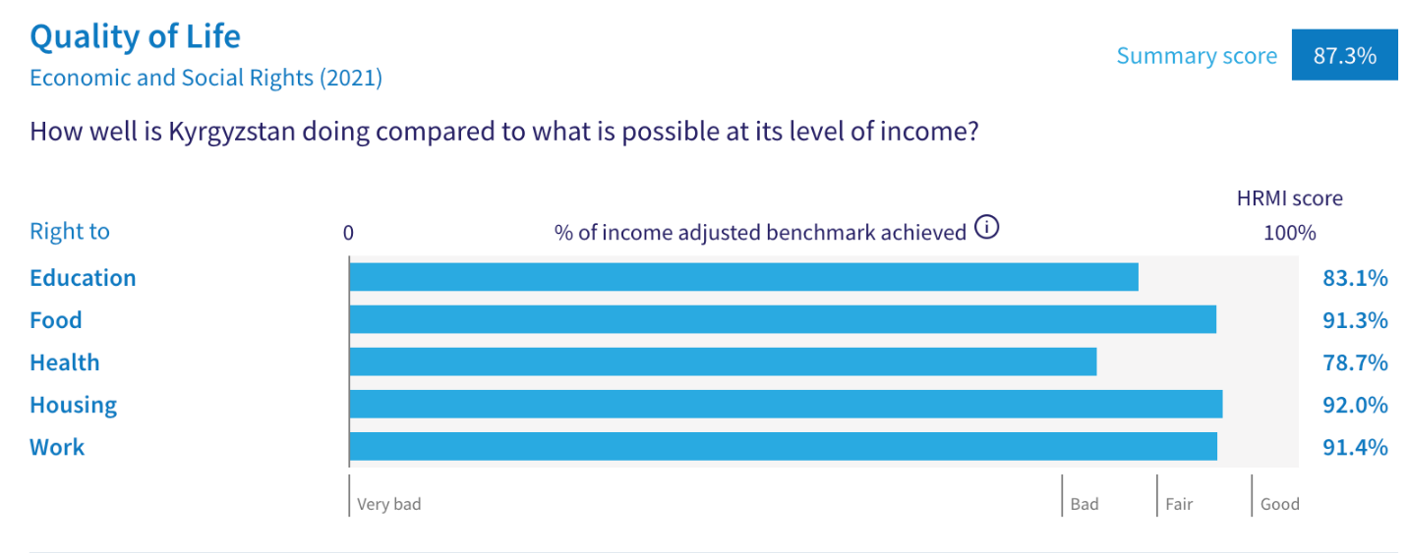

6. Kyrgyzstan’s scores for 2021 are as follows:
▪ Overall Quality of Life score = 87.3%
▪ Right to education = 83.1%
▪ Right to food = 91.3%
▪ Right to health = 78.7%
▪ Right to housing = 92.0%
▪ Right to work = 91.4%

7. These scores fall in the ‘bad’ and ‘fair’ ranges, with none reaching the ‘good’ range.
8. Kyrgyzstan scores 87.3% on Quality of Life when scored against the 'Income adjusted' benchmark. This score takes into account Kyrgyzstan's resources and how well it is using them to make sure its people's Quality of Life rights are fulfilled.
9. This score tells us that Kyrgyzstan is only doing 87.3% of what should be possible right now with the resources it has. This score may seem positive, however, since anything less than 100% indicates that a country is not meeting its current duty under international human rights law, our assessment is that Kyrgyzstan has a long way to go to meet its immediate economic and social rights duty.
10. Compared with other countries in Central Asia, Kyrgyzstan is performing lower than average on Quality of Life rights.

IV. Right to Education
11. HRMI defines the right to education in accordance with ICESCR Article 13 and CESCR General Comments 11 and 13. In the case of low- and middle-income countries, such as Kyrgyzstan, HRMI further breaks down the right to education into three areas of measurement: primary school enrolment, secondary school enrolment, and quality of education. Our scores show significant challenges in all three areas.
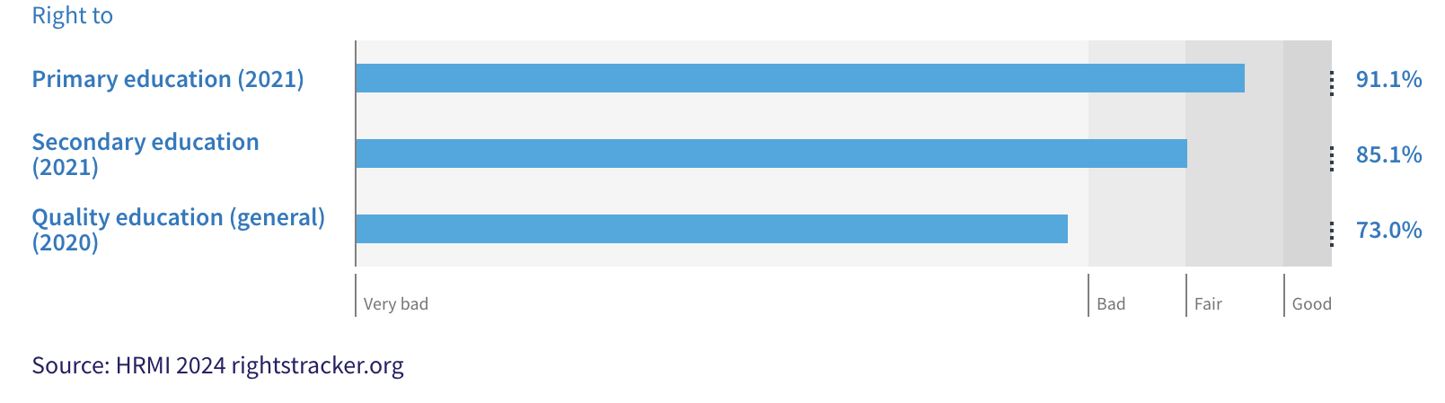

12. Kyrgyzstan’s score for primary school education (adjusted for income) has shown some periods of improvement over the last twenty years but has begun to fall markedly in recent years. Kyrgyzstan’s right to primary education score dropped from 97.7% to 91.1% across the period of 2018-2021. The score draws on indicator data from UNESCO showing that 94.7% of primary school-aged children were enrolled in school in 2021.
13. Secondary education is faring far worse as only 75.5% of children were enrolled in secondary education in 2021. Kyrgyzstan’s secondary education score dropped dramatically over the period 2005-2010 and has been steadily improving since then, but still falls at the very bottom of the ‘fair’ range.

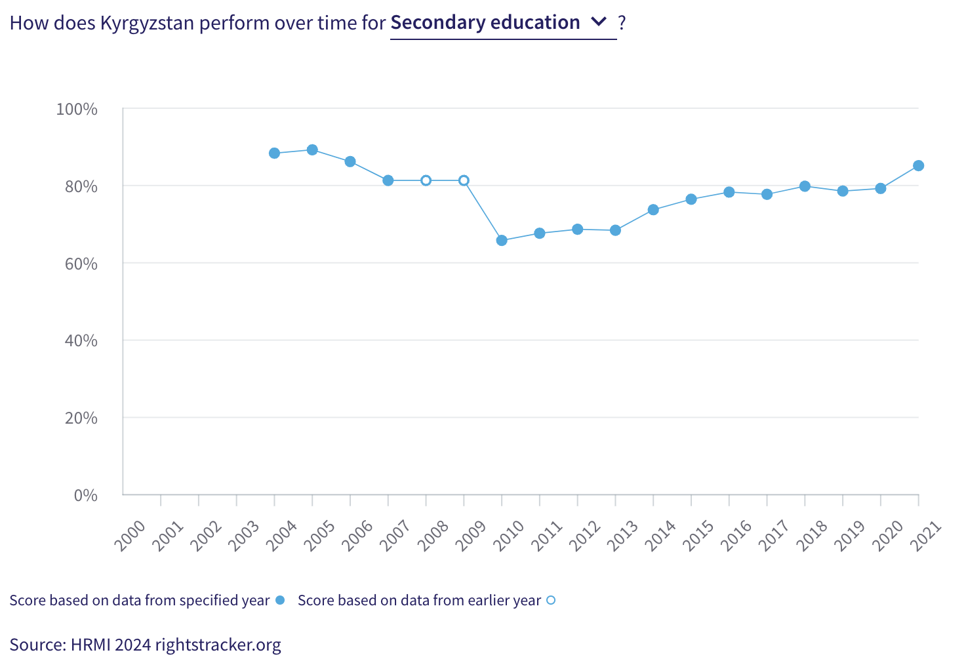
13. The quality of education score is also in the ‘very bad’ range. Kyrgyzstan is achieving only 73.0% of what we calculate ought to be possible in terms of quality of education. However, among all countries in Central Asia, Kyrgyzstan’s score is third highest.
14. The 2023 qualitative information supplied by human rights experts in Kyrgyzstan through HRMI’s annual survey reveals who is particularly at risk of not enjoying their right to education (see the data visualisation below). Poverty is a particularly significant issue for Kyrgyzstan in terms of the right to education. Other groups of people highlighted by many of HRMI’s respondents include refugees from ongoing conflicts, people with disabilities, orphans and women and girls who have been victimised by religious groups.

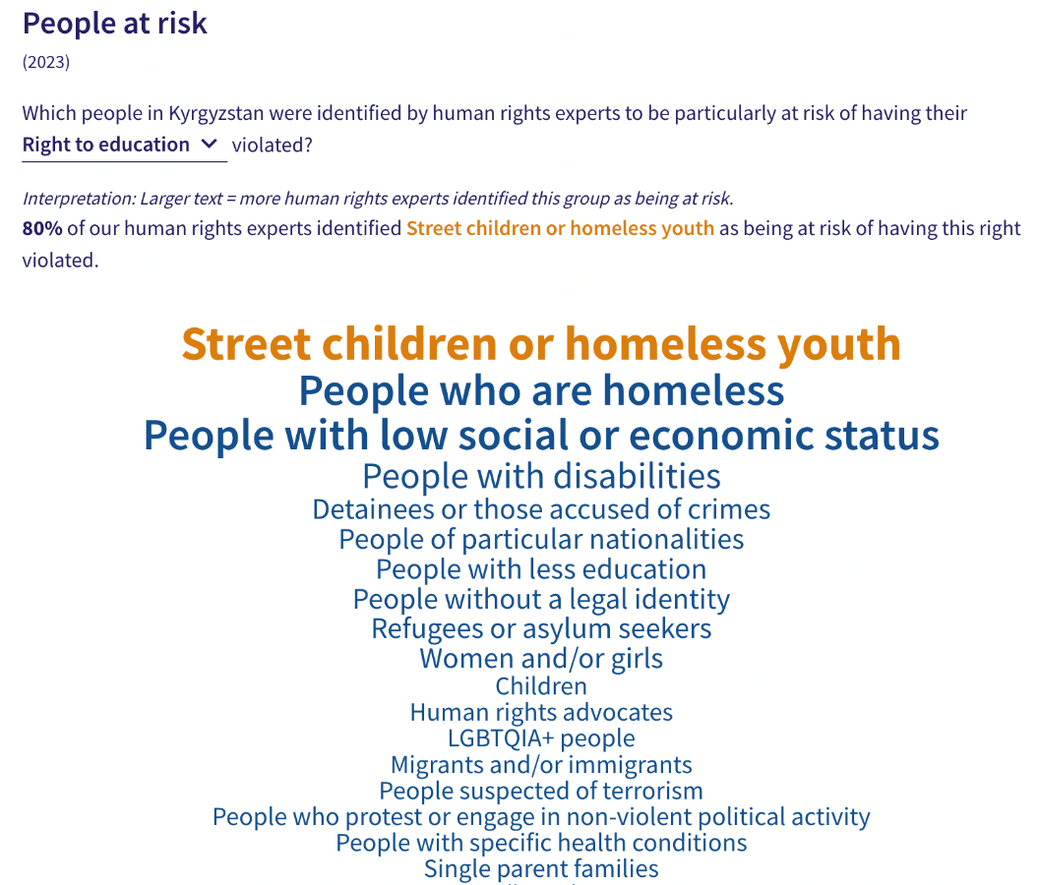
V. Right to Food
15. HRMI defines the right to food in accordance with ICESCR Article 11 and CESCR General Comment 12. For low- and middle-income countries, such as Kyrgyzstan, HRMI first uses a bellwether indicator of how many children are growing well (are not stunted). Kyrgyzstan’s score for the right to food is 91.3% and falls in the ‘fair’ range. This means that Kyrgyzstan is doing 91.3% of what ought to be possible to ensure the right to food for its people. This score draws on indicator data on child stunting rates published by the UNICEF-WHO-World Bank: Joint child malnutrition (JME) database.
16. We have a supplemental HRMI score of 100% on the right to food security, demonstrating that Kyrgyzstan is setting the benchmark and is one of only six nations that have been able to achieve a score of 100% in this regard.
17. Kyrgyzstan is achieving 91.3% of what is possible regarding the right to sufficient healthy food. The sufficient food score dropped in 2009, recovered steadily over the 2009-2014 period, but has begun to plateau over recent years. This demonstrates a stalling in human rights progression, leaving room for improvement.

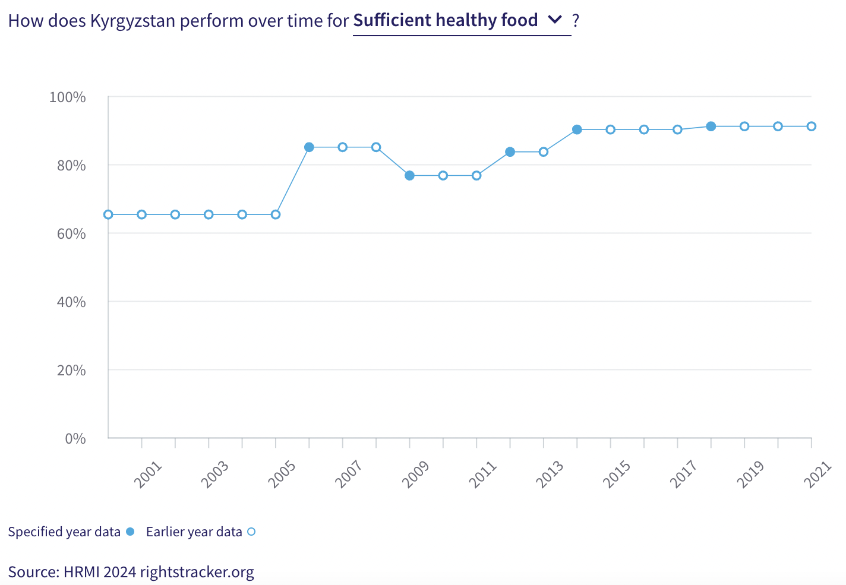18. Commenting on the 2022 human rights landscape, human rights experts in Kyrgyzstan identified a large range of people as being at an extra risk of not enjoying their right to food, including youth and adults experiencing homelessness, people with lower social and economic statuses, and those who have been detained or accused of crimes. Specifically, human rights experts identified that people with disabilities, regardless of age, especially struggle to access quality food due to a lack of food regulations. Refugees from ongoing conflicts who now reside in Kyrgyzstan are also greatly impacted.

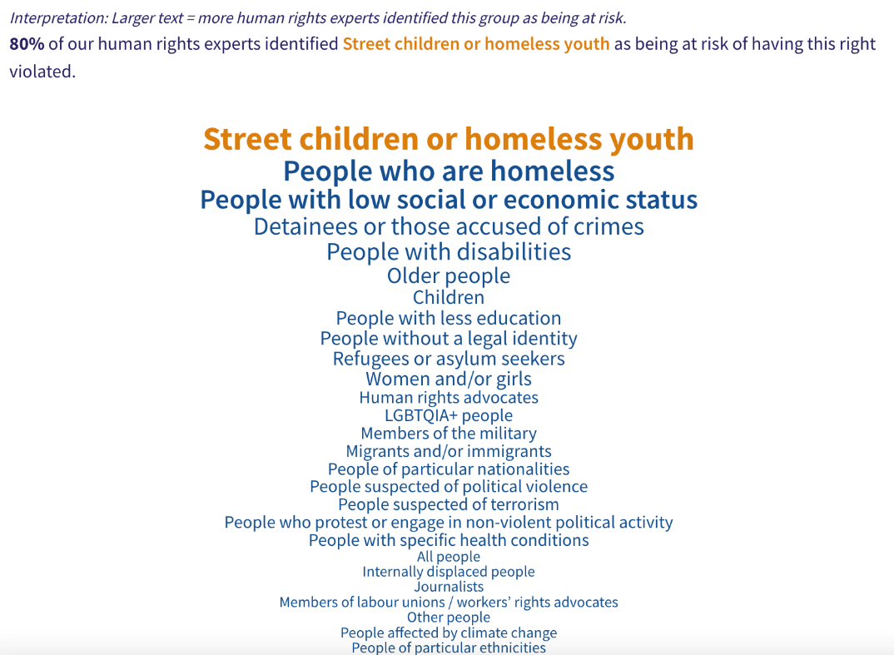
VI. Right to Health

19. HRMI defines the right to health in accordance with ICESCR Article 12.1 and CESCR General Comment 14. In the case of low- and middle-income countries, such as Kyrgyzstan, HRMI uses three indicators to measure the country’s achievement in child health, adult health, and reproductive health. While Kyrgyzstan’s reproductive health scores are concerningly low and the data supplied to the UNPD is patchy, there has been steady improvement in child health over the past 20 years (see the graph below, as measured by survival to age five).

20. The overall right to health has been falling since 2005. This data has contributed to a HRMI score of 78.7% on the right to health overall, falling into the ‘bad’ range. 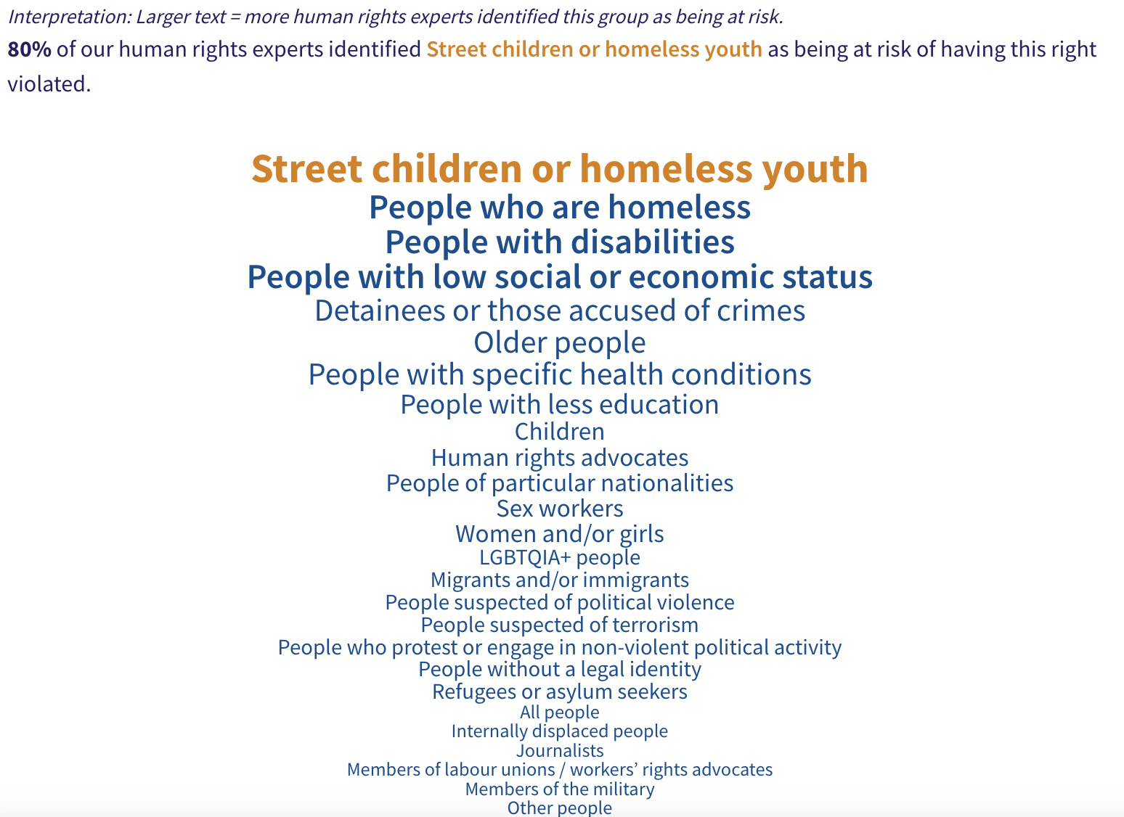

21. Kyrgyzstan is only doing 51.3% of what should be possible in terms of reproductive health, falling into the ‘very bad’ range. This is due to a very low rate of modern contraceptive use.

22. Child health has increased steadily over the course of our data, and in 2021, 98.3% of children survived to the age of 5.

23. Local experts identified that many recurring groups are at risk of not having adequate access to health, highlighting, people (especially youth) experiencing homelessness, people with disabilities, and people with low social or economic status, among many other groups.

VII. Right to Housing

24. HRMI defines the right to housing in accordance with ICESCR Article 11.1 and CESCR General Comment 4. In the case of low- and middle-income countries, such as Kyrgyzstan, HRMI uses an assessment standard that measures the right to water on premises and ‘basic’ sanitation (each household having its own improved toilet facilities). For basic sanitation, Kyrgyzstan has a ‘good’ score, and for water, its score has increased exponentially over the course of our data and is now in the ‘fair’ range.

26. Only 78.9% of households in Kyrgyzstan have water on premises, and 97.9% have access to basic sanitation. Given what other countries with the same level of income have shown to be possible, these statistics lead to HRMI scores of 86.1% for the right to water, and 97.8% for the right to sanitation. Many more people in Kyrgyzstan would have access to these basic necessities if Kyrgyzstan were using its maximum available resources towards progressive realisation of these rights.

27. There have been significant improvements regarding water access over the past two decades, as Kyrgyzstan was only doing 54.4% of what was possible in 2004, but that score has now risen to 86.4% in 2020. However, progress stalled entirely in the period 2020-2021, with the score falling slightly to 86.1%. While Kyrgyzstan is still not achieving 100% of what is possible, Kyrgyzstan’s substantial progress in the realm of right to water is a leap in the right direction.

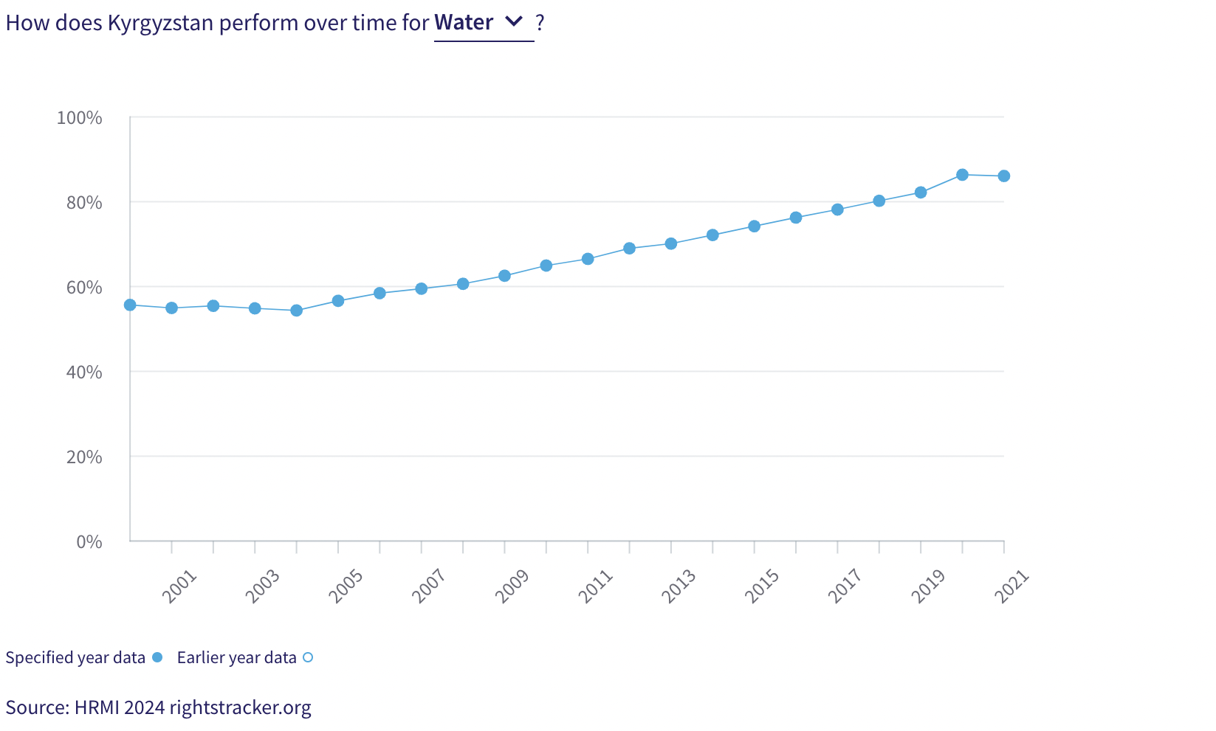
28. Local human rights experts identified a wide range of people not enjoying their right to housing in Kyrgyzstan, with many recurring groups stated across all rights. Detainees and those accused of crime, people with disabilities (including specific mentions of women), people with low social or economic status, and people with less education were all prominent in respondents’ answers.

VIII. Right to Work and Social Security

29. HRMI measures the right to work in accordance with ICESCR Articles 6 and 7. For low and middle-income countries, such as Kyrgyzstan, HRMI measures the right to work and social security using a subsistence income indicator. According to the World Bank PovcalNet in 2020, in Kyrgyzstan, the percentage of people who are not absolutely poor is 81.3%, leading to a HRMI score of 91.4%, which falls in the ‘fair’ range, indicating that Kyrgyzstan has some way to go to meet its immediate obligations.

30. Human rights experts in Kyrgyzstan identified a wide range of people at risk of missing out on their right to work and social security, headed by homeless youth, detainees, people with disabilities, and those with low social or economic status. Most of the groups identified are recurring across all rights.

IX. Vulnerable Groups

31. Homeless youth have been identified as the group most commonly identified as having their basic human rights violated across every one of our discussed rights. Other very prominent groups include people with disabilities, stateless people, the LGBTQIA+ community, women and girls, dissenters, human rights advocates and journalists.

32. People with disabilities, and especially women, were consistently recognised as a group who was at greater risk of not having access to basic rights, with 50% or more of human rights experts placing them as an at-risk group across all rights.

33. Stateless people, refugees, migrants and other displaced people are especially vulnerable. People who are fleeing from conflict and those without Kyrgyzstan citizenship are particularly at risk of rights violations.

34. The LGBTQIA+ community is at great risk of human rights violations. Human rights experts noted that government officials, politicians and government-owned media explicitly encourage violence against LGBTQIA+ people.

35. Dissenters, detainees, journalists and human advocates who speak out against the government are at risk according to our survey respondents.

X. Concluding Remarks

36. HRMI respectfully submits its data and findings on the fulfilment of economic and social rights in Kyrgyzstan. We hope that this Submission will serve as a useful resource to the Committee on Economic, Social and Cultural Rights for drafting specific and meaningful questions to Kyrgyzstan during the CESCR’s 76th Pre-Sessional Working Group.

Visit HRMI’s website to learn more about our mission and work, https://humanrightsmeasurement.org/.
This content represents the opinions of the Human Rights Measurements Initiative. It carries no endorsement of the University of Georgia.
See HRMI’s methodology for measuring economic and social rights: https://humanrightsmeasurement.org/methodology and https://rightstracker.org/page/methodology.
Ibid
Ibid
HRMI Rights Tracker, https://rightstracker.org/
See Human Rights Measurement Initiative (HRMI) Digital Public Good Certificate, https://app.digitalpublicgoods.net/a/11781. The Digital Public Goods Alliance is endorsed by the UN Secretary General’s “Roadmap for Digital Cooperation,” https://www.un.org/en/content/digital-cooperationroadmap/assets/pdf/Roadmap_for_Digital_Cooperation_EN.pdf. It defines digital public goods as: “open source software, open data, open AI models, open standards and open content that adhere to privacy and other applicable laws and best practices, do no harm, and help attain the SDGs,” https://digitalpublicgoods.net/standard/.
HRMI 2023 Rights Tracker, https://rightstracker.org/country/KGZ?tab=report-esr
The labels on the country charts of good, fair, bad, and very bad are used to give a general indication of how to understand the scores. HRMI’s income adjusted Quality of Life scores can be broadly interpreted as showing the percentage of the country’s obligation it has met, compared to what the best performing countries have achieved at each income level. A country scoring below 75% with a label of “Very bad” is failing to put in place the kinds of structures and policies that help people claim the right concerned, but the structures and policies in place most likely prevent many people from claiming their rights. See HRMI’s methodology for measuring human rights, https://rightstracker.org/page/methodology.
HRMI 2023 Rights Tracker, https://rightstracker.org/country/KGZ?tab=report-esr
Ibid
HRMI 2023 Rights Tracker, https://rightstracker.org/metric/education.
HRMI 2023 Rights Tracker, https://rightstracker.org/country/KGZ?tab=report-esr&qolFdScore=indicator
Ibid
HRMI 2023 Rights Tracker, https://rightstracker.org/metric/educqual?tab=report-esr&qolFdScore=indicator&subregion=central-asia
HRMI 2023 Rights Tracker, https://rightstracker.org/country/KGZ?tab=report-esr&qolFdScore=hrmi&atRisk=33
HRMI 2023 Rights Tracker, https://rightstracker.org/country/KGZ?qolFdScore=hrmi&atRisk=33
HRMI 2023 Rights Tracker, https://rightstracker.org/metric/not-stunted.
HRMI 2023 Rights Tracker, https://rightstracker.org/metric/food-security?qolFdScore=hrmi&atRisk=33
HRMI 2023 Rights Tracker, https://rightstracker.org/country/KGZ?tab=report-esr
HRMI 2023 Rights Tracker, https://rightstracker.org/country/KGZ?tab=report-esr
HRMI 2023 Rights Tracker, https://rightstracker.org/country/KGZ?tab=report-esr
HRMI 2023 Rights Tracker, https://rightstracker.org/country/KGZ?tab=report-esr
Ibid
HRMI 2023 Rights Tracker, https://rightstracker.org/country/KGZ?tab=report-esr
HRMI 2023 Rights Tracker, https://rightstracker.org/country/KGZ?tab=report-esr
HRMI 2023 Rights Tracker, https://rightstracker.org/country/KGZ?tab=report-esr
Ibid
HRMI 2023 Rights Tracker, https://rightstracker.org/country/KGZ?tab=report-physint
Ibid

