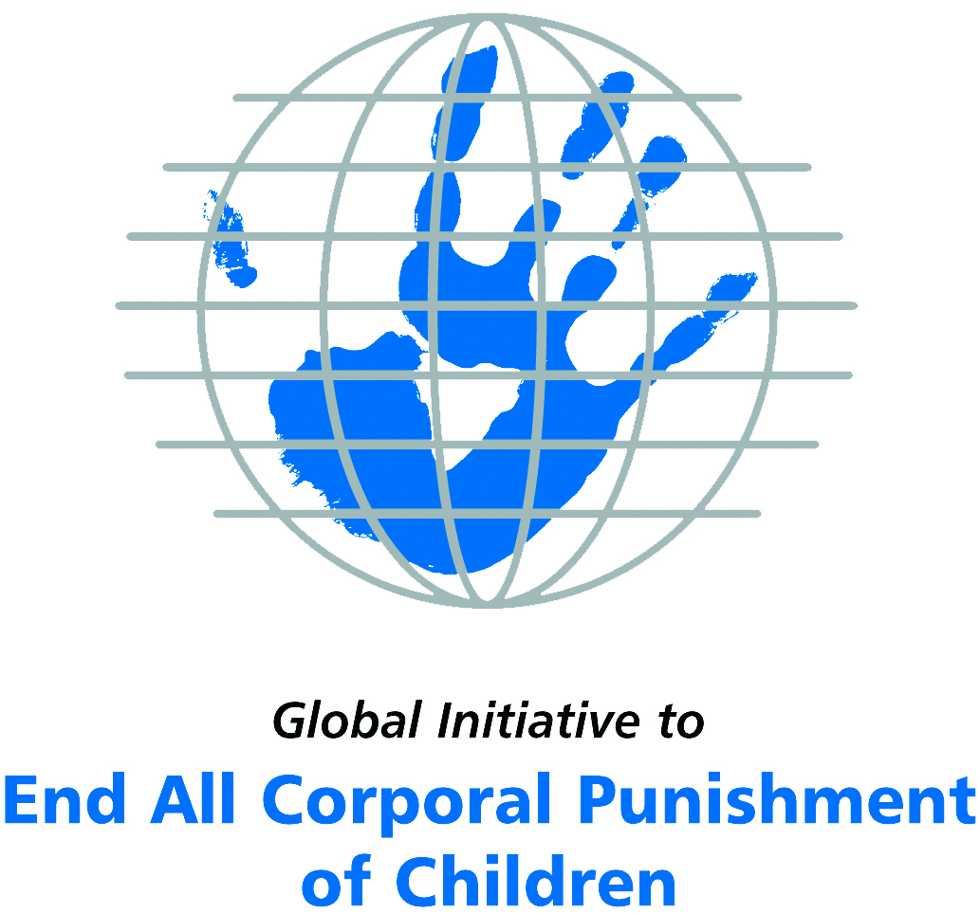
Briefing on Nepal for the Committee on the Rights of Persons with Disabilities, 8th Pre-Sessional Working Group, September 2017
From the Global Initiative to End All Corporal Punishment
of Children, July 2017

(a) About the Global Initiative to End All Corporal Punishment of Children
1. The Global Initiative (www.endcorporalpunishment.org) promotes universal prohibition and elimination of corporal punishment in fulfilment of states’ obligations under the UN Convention on the Rights of the Child and other international treaties. Our aims are supported by UNICEF, UNESCO, human rights institutions and international and national NGOs. Since 2002, the Global Initiative has regularly briefed the Committee on the Rights of the Child on this issue, and since 2004 has similarly briefed the Committee Against Torture, the Committee on the Elimination of Discrimination Against Women, the Committee on Economic, Social and Cultural Rights, the Human Rights Committee and the Human Rights Council; we have briefed the Committee on the Rights of Persons with Disabilities since the beginning of its work.

(b) Summary
2. Corporal punishment of children in Nepal is unlawful as a sanction for a crime, but it is not yet prohibited in the home, in alternative care and day care settings, in schools and in penal institutions, in violation of the fundamental right of all children to protection from corporal punishment and other cruel or degrading forms of punishment.
3. With reference to articles 7, 15, 16 and 17 of the Convention on the Rights of Persons with Disabilities, and in light of the particular vulnerability of children with disabilities to corporal punishment by adults, the jurisprudence of the UN treaty bodies, the emphasis on eradicating this form of violence given by the UN Secretary General’s Study on Violence against Children and the importance of the issue to achieving target 16.2 on ending violence against children in the 2030 Sustainable Development Goals, we hope the Committee on the Rights of Persons with Disabilities will:
- include the issue of corporal punishment in its List of Issues for Nepal, in particular asking: “what steps have been taken to ensure that national legislation in Nepal is harmonised with the 2004 Supreme Court ruling on the unconstitutionality of violent punishment of children?”;
- recommend to the Government of Nepal, in the Committee’s concluding observations on the initial report, that “prohibition of corporal punishment of all children in all settings is included in the draft Children’s Act and that measures are put in place to ensure the new Children’s Act is properly implemented”.

(c) Detailed briefing
The right of children with disabilities not to be subjected to corporal punishment
4. The Convention on the Rights of Persons with Disabilities confirms that children with disabilities should enjoy all human rights and fundamental freedoms on an equal basis with other children (art. 7). The Convention also states that all persons have the rights to freedom from torture or cruel, inhuman or degrading treatment or punishment (art. 15), to freedom from exploitation, violence and abuse within and outside the home (art. 16) and to respect for their physical and mental integrity (art. 17). The jurisprudence of treaty monitoring bodies, led by the Committee on the Rights of the Child monitoring the Convention on the Rights of the Child, is clear that these rights put an obligation on states parties to prohibit and eliminate all corporal punishment of children, including within the family. However, the issue is not addressed in Nepal’s initial state party report.
5. As confirmed in the UN Secretary General’s Study on Violence against Children, children with disabilities are particularly vulnerable to violence, including corporal punishment, and corporal punishment is a significant cause of impairment among children. Yet the obligation to prohibit corporal punishment is frequently ignored or evaded by governments. The near universal acceptance of violence in childrearing together with deeply held views that parents and other adults have a “right” to physically punish children can challenge efforts to achieve prohibition. It also means that corporal punishment – at least to some degree – is not readily perceived as violence in the same way as, for example, sexual and other socially unacceptable forms of violence.
6. The newly adopted Sustainable Development Goals under the 2030 Agenda include target 16.2 on ending all forms of violence against children. Violent punishment is the most common form of violence against children: ending it through the adoption and implementation of legislation prohibiting it in all settings including the home is critical.

The legality of corporal punishment of children with disabilities in Nepal
7. Corporal punishment of children in Nepal is unlawful as a sanction for a crime, but children with disabilities may lawfully be subjected to physical punishment in the home, in alternative care settings, in day care settings, in schools and in penal institutions.
8. Corporal punishment is lawful in the home. Article 7 of the Children Act 1992 states: “No child shall be subjected to torture or cruel treatment. Provided that, the act of scolding and minor beating to the child by his father, mother, member of the family, guardian or teacher for the interests of the child shall himself not be deemed to violate the provision of this section.” Following a writ petition filed by the Centre for Victims of Torture in Nepal on 16 June 2004, the Supreme Court ruled that the restrictive clause in article 7 was unconstitutional and, in accordance with article 88 of the then Constitution 1990, declared the portion “or give him/her minor beating” null and void with immediate effect. The judgment also issued a directive to the Government “to pursue appropriate and effective measures to prevent physical punishment as well as other cruel, inhuman or degrading treatment or punishment or abuse being imposed or inflicted on and likely to be imposed or inflicted on children”. However, there is also a legal defence for parental corporal punishment in Chapter 9 of the Muluki Ain 1963 (General Code). Provisions against violence and abuse in the Domestic Violence (Offence and Punishment) Act 2009, its Regulation 2010 and the Constitution 2015 are not interpreted as prohibiting all corporal punishment in childrearing.
9. Corporal punishment is lawful in alternative care settings. The legal defence was removed by the 2005 Supreme Court decision but this has not been confirmed in legislation and article 4 of Chapter 9 of the Muluki Ain allowing the use of “reasonable” force applies. Article 39 of the Children Act 1992 states that the powers of the chief of a children’s welfare home to punish a child do not include “to batter or detain the child in solitary confinement or to stop giving food and water to such child”, but does not prohibit all corporal punishment. Corporal punishment should not be used in residential institutions according to the Standards for Operation and Management of Residential Child Care Homes 2012 but there is no prohibition in law.
10. Corporal punishment is lawful in early childhood care and in day care for older children, including for children with disabilities. The legal defence was removed by the 2005 Supreme Court decision but this has not been confirmed in legislation and article 4 of Chapter 9 of the Muluki Ain allowing the use of “reasonable” force potentially applies.
11. Corporal punishment is lawful in schools. There is no explicit prohibition of corporal punishment in schools in the Education Act 1971 or the Education Regulation 2003, though severe punishment would be prohibited under article 7 of the Children Act 1992. The legal defence available to teachers was removed in 2005 by the Supreme Court ruling already noted but this has not been confirmed in legislation and the legal defence for the use of “reasonable” force in the Muluki Ain applies. The Education Act Eighth Amendment was passed in June 2016 – although we have not been able to study the text, there are no indications corporal punishment was addressed.
12. Corporal punishment is lawful as a disciplinary measure in penal institutions. There is no explicit prohibition of corporal punishment as a disciplinary measure in penal institutions, though article 7 of the Children Act 1992 and the 2005 Supreme Court decision presumably apply. Article 15 of the Children Act prohibits the use of handcuffs, fetters and solitary confinement of children but does not refer specifically to corporal punishment. There is no provision for corporal punishment in the Prisons Act 1963. The Constitution 2015 confirms the right of every person in detention not to be subjected to physical or mental torture, or be treated in a cruel, inhuman or degrading manner (art. 22).
13. Corporal punishment is unlawful as a sentence for crime. The Constitution states in article 39 (unofficial translation): “(7) No child shall be subjected to physical, mental, or any other forms of torture at home, in school, or in any other places or situations. (8) Every child shall have the right to child friendly justice.” The Children Act 1992, defining a child as under 16 (art. 2), prohibits cruel treatment (art. 7) and subjecting a child to handcuffs, fetters or solitary confinement (art. 15), and does not provide for sentencing to corporal punishment (art. 11). Under the Act, children aged 14-15 are liable to reduced sentences under criminal law (art. 11) and older children face full sentences under criminal law: criminal law (the Muluki Ain and other laws) does not provide for judicial corporal punishment. The Abrogation of Some Criminal Cases and Remission of Punishment Act 1963 explicitly prohibited a number of cruel and humiliating punishments, including shaving the head of the offender, impaling/piercing the body, branding the body and forcing the offender to eat forbidden/inedible foods (art. 5).
14. There have been reports that Maoist courts have been revived in a number of areas and sentences include physical punishment. However, this appears to be unlawful under article 126 of the 2015 Constitution, which states that the powers of courts must be in accord with the Constitution, other laws and the recognised principles of justice. In 2010, the Government was drafting sentencing legislation, including a criminal procedure code. As at April 2017, it appears a Criminal Code Bill has been tabled in Parliament but it does not seem prohibition of corporal punishment is being considered.
15. Opportunities for law reform. At a meeting of the South Asia Forum in July 2006, following on from the regional consultation in 2005 of the UN Secretary General’s Study on Violence against Children, the Government made a commitment to prohibition in all settings, including the home. Government representatives in SAIEVAC (South Asia Initiative to End Violence Against Children) developed a national action plan to achieve prohibition and in 2011 endorsed a report on progress towards prohibiting corporal punishment in South Asia states which included an analysis of the reforms required in Nepal. A second report was published in 2014. The National Child Policy adopted in 2012 states that legislation will be enacted to prohibit corporal punishment in all settings (s8.25). In September 2014, the Ministry of Women, Children and Social Welfare launched the National Campaign against Corporal Punishment of Children in Nepal.
16. A draft Children Bill is under discussion. In May 2016, the Government reported that it would prohibit corporal punishment in all settings and was expected to be submitted to parliament “after completing necessary process”.

Recommendations by human rights treaty monitoring bodies and during the UPR
17. The Committee on the Rights of the Child first raised the issue of corporal punishment in Nepal and recommended it be prohibited in the family and other settings in 1996. The Committee reiterated its concerns and recommended prohibition in all settings, both in 2005 and 2016.
18. In 2014, the Human Rights Committee recommended to Nepal that measures be taken – including legislative measures – to end corporal punishment in all settings.
19. At the second cycle Universal Periodic Review in 2015, the Government accepted a recommendation to intensify efforts to adopt revised child legislation which complies with international standards regarding violence against children.

Briefing prepared by the Global Initiative to End All Corporal Punishment of Children
www.endcorporalpunishment.org; info@endcorporalpunishment.org

Pinheiro, P. S. (2006), World Report on Violence against Children, Geneva: United Nations. See also Krug E. G. et al (eds) (2002), World Report on Violence and Health, Geneva: World Health Organisation
Mr Devendra Ale et al. v Office of the Prime Minister & Cabinet et al., Supreme Court decision 6 January 2005
For example, see https://southasiarev.wordpress.com/2010/02/20/nepal-maoists-reactivate-peoples-courts/ and http://news.bbc.co.uk/1/hi/world/south_asia/6048272.stm, accessed 29 May 2015
See for example https://thehimalayantimes.com/nepal/provisions-penal-code-bill-curb-delays/, accessed 15 May 2017
SAIEVAC (2011), Prohibition of corporal punishment of children in South Asia: a progress review
SAIEVAC (2014), Prohibition of corporal punishment of children in South Asia: progress and proposals for reform 2014
SAIEVAC (2014), Prohibition of corporal punishment of children in South Asia: progress and proposals for reform 2014
20 May 2016, CRC/C/NPL/Q/3-5/Add.1, Reply to list of issues, para. 1; see also paras. 22, 23 and 24
7 June 1996, CRC/C/15/Add.57, Concluding observations on initial report, paras. 10, 12, 19 and 34
21 September 2005, CRC/C/15/Add.261, Concluding observations on second and third combined report, paras. 47, 48 and 76
3 June 2016, CRC/C/NPL/CO/3-5, Concluding observations on fifth report, paras. 30 and 32
[April 2014], CCPR/C/NPL/CO/2 Advance Unedited Version, Concluding observations on second report, para. 15
23 December 2015, A/HRC/31/9, Report of the working group, para. 121(5)

