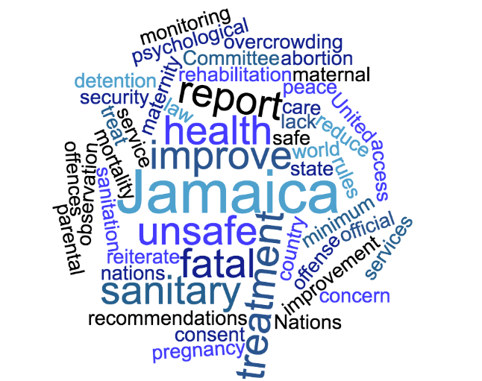

CSO follow-up report on the implementation of the Human Rights Committee’s recommendations
Jamaica
March 2019

With the support of 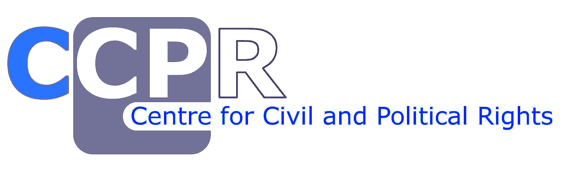

- INTRODUCTION

The fourth periodic report of Jamaica, on the State’s compliance with the International Covenant on Civil and Political Rights (ICCPR), was reviewed by the UN Human Rights Committee (the Committee) in November 2016. As the result of the review, the Committee issued its Concluding Observations (CCPR/C/JAM/CO/4) and made recommendations to the State party. The Concluding Observations also state in paragraph 50 that “In accordance with rule 71, paragraph 5, of the Committee’s rules of procedure, the State party is requested to provide, within one year of the adoption of the present concluding observations, information on the implementation of the recommendations made by the Committee in paragraphs 26 (voluntary termination of pregnancy), 32 (prohibition of torture and other cruel, inhuman or degrading treatment or punishment) and 44 (rights of the child) above”. The State provided the requested information to the Committee on 9 May 2018.

This CSO report aims at providing the assessment from a civil society perspective about the measures taken by the State to implement the recommendations selected by the Committee for the follow-up procedure.

It is submitted on behalf of:
Jamaicans for Justice
With the support of the Centre for Civil and Political Rights.

- VOLUNTARY TERMINATION OF PREGNANCY
“The Committee is concerned at the high levels of maternal mortality resulting from unsafe abortions and the lack of official data on the number of clandestine abortions and their linkage to high maternal mortality. It reiterates its concern at the general criminalization of abortion in the Offences against the Person Act (see CCPR/C/JAMCO/3, para. 14), including in cases of pregnancies resulting from rape, incest and fatal fetal abnormality. The Committee is also concerned about the lack of access by girls below the age of 16 years to sexual and reproductive health information and services without parental consent, especially in the light of the high incidence of adolescent pregnancy and incest in the State party (arts. 3, 6, 7 and 17)”.
Recommendation by Committee:  (Paragraph 26) | Actions taken by the State party (if any) and current situation:
The State party should, as a matter of priority, amend its abortion legislation to help women address unplanned pregnancies and not resort to illegal abortions that could put their lives at risk. | In June 2018, Parliamentarian Juliet Cuthbert-Flynn moved a motion for the Government to decriminalise abortion and provide women with safe and affordable methods to terminate pregnancy. She highlighted that the Government ratified the Convention on the Elimination of All Forms of Discrimination Against Women, which mandates that steps should be taken to reduce maternal mortality by tackling contributing factors, such as unsafe abortions.  The motion read:  “Be it resolved that this Honourable House consider the recommendations of the Abortion Policy Group, which was established to provide guidance to allow women the right to choose  “Be it further resolved that this Honourable House take steps to repeal sections 72 and 73 of the Offences Against the Persons Act, and substitute therewith a civil law titled “Termination of Pregnancy Act”, as recommended by the Abortion Policy Review Group in 2007”.  In December 2018 the Report of the Joint Select Committee appointed to review the Sexual Offences Act along with the Offences Against the Persons Act, the Domestic Violence Act and the Child Care and Protection Act was released. The report recommended that Parliament considers reconstituting the Joint Select Committee that deliberated on this matter or determine the method by which the draft report which had been prepared could be reviewed and submitted to Parliament.  It was thereafter announced that the Human Resources and Social Development Committee (HRSDC), chaired by Opposition Member of Parliament Ronald Thwaites, a Roman Catholic church deacon, would review the motion by Parliamentarian Juliet Cuthbert-Flynn.  The HRSDC has since heard submissions from numerous civil society groups, and conservative and religious based groups and individuals on the issue. The Committee is scheduled to hear oral submissions until June 2019. It is anticipated that the report stemming from the various submissions and with recommendations from the Committee will be released before the end of 2019 and will significantly impact the direction of the discourse.  It is 2016 there were 1,177 admissions to Victoria Jubilee Hospital for complications threatening the viability of a pregnancy including incomplete, inevitable and threatened pregnancies, and spontaneous abortions, as well as induced termination of pregnancy. 47 (4 per cent) of these patients were admitted with complications of either a failed attempt or completed induced termination of pregnancy.  While the current Minister of Health, Dr. Christopher Tufton, has indicated that the Ministry of Health is ‘…ready to participate in the discussions and to implement policies and procedures that will result in a healthy and stable population that is empowered to reach its fullest potential…’ there is genuine concern from civil society organisations that the report stemming from the Human Resources and Social Development Committee will be reflective of the campaign which has been mounted by fundamentalist conservative groups to prevent the provision of abortion services in any setting.  We reiterate that the high rates of maternal mortality and morbidity stemming from botched abortions and the absence of laws to decriminalise the procurement and performance of abortions has significant impacts on the reproductive health of women, especially those who are young, single, unemployed or in low paying employment and it is essential that the state take urgent steps to protect the health and wellbeing of women and girls.
It should take measures to protect women against the health risks associated with unsafe abortions by improving its monitoring and data collection on women’s access to health care and by enabling access to sexual and reproductive health information and services to all women, including girls under the age of 16. | The efforts made to address sexual and reproductive health of women and girls including the provision of information, services and commodities remains dependent on short term programmatic initiatives that are not enshrined in a sexual and reproductive law or policy through which accountability and consistency in implementation could be assured.  The government through the Minister of Health has again indicated that there are plans to develop a Sexual and Reproductive Health Policy. Despite these iterations since as far back as 2016, no such policy has been tabled and the progress of its development and the timeline for its completion have not been shared with the public.  We reiterate that to ensure that there is adequate protection for the sexual and reproductive health and rights of women, there must be a Sexual and Reproductive Health law which is legally enforceable, and which will work in conjunction with other laws and policies around HIV or AIDS and sexual harassment and violence to ensure accountability for all entities vested in health.  The small-scale efforts by the Ministry of Health and the National Family Planning Board to implement programs that only reach a miniscule portion of the population of women and girls is ineffective and inefficient to have a substantive impact on the sexual and reproductive health of Jamaican women and girls broadly.  The implementation of the Health and Family Life curriculum in schools remains highly subjective and schools can unilaterally determine the content which they opt to teach. This curriculum is the main avenue through which many of the issues around sexual and reproductive health can be addressed and many of the misconceptions can be tackled. However, its implementation remains weak with concerns constantly being raised about the capacity of teachers to correctly deliver the content and the requirement that it need only be taught up to the 9th grade level, and there are no clear mechanisms for monitoring and evaluation of its implementation.  The state must develop sustained public campaigns promoting the sexual and reproductive health of women including vulnerable women and marginalised women and girls including adolescents, lesbian, bisexual and transgender (LBT) women, women living with HIV, women with disabilities, and women and girls whose engaged in sex work.  The state must also provide women and girls with sexual and reproductive services and commodities at affordable rates, reduced costs or at no cost, including menstrual hygiene products, condoms, female condoms, and contraceptive pills, and other forms of contraception towards empowering women to take charge of their own sexual and reproductive health.  Additionally, there must be greater efforts to research social and cultural drivers which impact women’s sexual and reproductive health. A thorough examination of the role of gender roles, gender based violence including sexual violence and intimate partner violence and its impact on women’s sexual and reproductive health is essential.  The Joint Select Committee appointed to review the Sexual Offences Act along with the Offences Against the Persons Act, the Domestic Violence Act and the Child Care and Protection Act recommended in its December 2018 report that the age of consent to sexual intercourse should remain at 16 years and not be raised to 18 years and that the law should allow for a close-in-age exception for up to four years. It is anticipated that the government will follow these recommendations and will accordingly not introduce a new barrier to young women accessing information services and commodities.  Cultural norms still make it difficult for young people to readily access information and services. Accordingly it becomes essential that the government develops laws and policies to be the foundation for sustained advocacy and sensitization around the provision of information and services.

- PROHIBITION OF TORTURE AND OTHER CRUEL, INHUMAN OR DEGRADING TREATMENT OR PUNISHMENT
“The Committee remains concerned about the deplorable conditions in the State party’s prisons and detention facilities, including overcrowding, poor sanitary conditions and lack of medical care. It is also concerned about the lack of a clear statutory framework governing the treatment of persons in pretrial detention and failure to hold accused persons separately from convicted persons (arts. 7 and 10)”.
Recommendation by Committee:  (Paragraph 32) | Actions taken by the State party (if any) and current situation:
The State party should expedite its efforts to reduce overcrowding in places of detention, including by resorting to alternatives to imprisonment, and improve conditions of detention, particularly with regard to sanitary conditions and access to medical care, in accordance with article 10 of the Covenant and the United Nations Standard Minimum Rules for the Treatment of Prisoners (the Nelson Mandela rules) (General Assembly resolution 70/175, annex). | The State party systematically violates Articles 6, 7 and 10 of the Covenant. Jamaica’s places of detention are manifestly cruel, inhumane and degrading. The physical condition of lockups and prisons is indisputably deplorable, the treatment of detainees deeply discomforting, and the State party’s response indifferent.  The implementation of the state of emergency as a crime fighting measure has further led to the inhumane treatment of citizens. Persons who have been detained have complained of a number of violations including being unaware of:  - The persons within their own area who reviews detentions decisions  - The reasons for their detention  - When they would be released  - Whether there is a timeline for review of the specific reason for their detention  - The exact location and composition of their respective review tribunals  - How they can lodge challenges to their detention to the respective bodies/person(s)  - Whether there is any form for them to complete to lodge requests for review  - Whether citizens or detainees can approach the tribunals without an Attorney-at-Law  - Any proposed meeting dates for the respective tribunals or even an idea as to what would trigger the meeting of the review tribunal  The report of the Public Defender highlighted that at the Freeport Police Station Lock-Up which is the main lock-up for the St. James state of emergency, there was not enough space to accommodate the detainees which has led to massive overcrowding in the cages and cells. The cells are 8 feet by 6 feet and houses at least 6 men.  It was noted that in some instances there was only standing room available and detainees were not even provided with cardboard or newspaper on which to sit or sleep. The concrete floor was the only bed.  There was a notable lack of basic amenities such as lighting and ventilation and the cells are noted as being ‘hot, filthy, dirty, with wet floors, and walls’. There is no internal sanitation such as a toilet or wash basin and detainees are given buckets for their waste. Detainees complained of hunger, late or inadequate meals and there were concerns that the food served was not always maintained at safe temperatures.  A visit to the Freeport Lockup by the Ministry of Health in January 2018 revealed that one hundred and sixteen persons (116) were occupying thirty (30) cells. And the team diagnosed ten (10) people with fungal rashes, one (1) with scabies, four (4) with respiratory illnesses among other notable adverse health issues.  By April 2018 there was a massive outbreak of gastrointestinal illness which affected one hundred and five (105) persons who were detained.  The Public Defender has noted that the conditions were an assault on the dignity of each person.
The State party should adopt legislation governing pretrial detention and put in place a system to detain accused persons separately from convicted persons. | In Jamaica, there is currently no clear statutory framework governing the treatment of persons in pre-trial detention. The majority are held in police lockups – dungeon style areas inside police stations originally intended to be short-term holding areas. Police lockups have become long- term detention environments and incubators for the worst human rights violations, including killings and torture, already established by this Committee in its previous reviews.  Nearly all places of detention fall well below international minimum standards, and offend our collective humanity. Widespread unlawful detention exists, places of detention remain overcrowded public health hazards, and officials in charge of places of detention routinely abuse those in their care with impunity.  Places of detention are still filthy, unhealthy environments that precipitate health emergencies. At many places of detention and prisons, rats, roaches, lice, and crabs have overrun the facilities. t is standard practice for inmates to urinate and defecate in their cells, normally in lose bags and bottles they have acquired. Unsurprisingly, reports of infections and other sicknesses are high. To exacerbate that situation, prison officials routinely deny detainees and inmates access to medical care – in many cases as a punitive measure.  The November 2018 report of the Public Defender on the State of Emergency noted that the fact that detainees are not to be housed in the same space as persons who are charged with criminal offences is seemingly unknown to the JCF and other authorities. Detainees who were locked up at the Freeport Police Station Lock Up were placed with persons who are charged. The Public defender noted that detainees and persons charged are comingled, blended and mixed throughout the Lock up.  This was compounded by the fact that these persons are being kept in spaces which the Public Defender described as ‘abject, subhuman and unfit for human habitation’.

- RIGHTS OF THE CHILD
“The Committee welcomes the efforts of the State party to review the Child Care and Protection Act, including the removal of the possibility of incarcerating a child on the basis of him or her being “beyond parental control”, and provision of psychological and mental health services to children and their families by the Child Development Agency and Department of Correctional Services. Despite the fact that the number of correctional orders has significantly decreased, the Committee is concerned about reports that there are still children serving such orders. It is also concerned that minors are held in police lock-ups on a regular basis, often for more than 24 hours (arts. 9, 10 and 24)”.
Recommendation by Committee:  (Paragraph 44) | Actions taken by the State party (if any) and current situation:
The State party should amend its law in a timely manner in order to remove the possibility of incarcerating a child on the basis of him or her being “beyond parental control” and to address gaps in: service delivery to children in conflict with the law, the coordination and oversight of the child protection sector, support to families and rehabilitation of children who experienced exploitation, abuse and other trauma. | With regard to the status of reforms, the State Party has failed to deliver on the changes to the Child Care and Protection Act that it has promised reforms for over a decade. It’s commitments to this Committee are not new, and its assertion that a reform proposal is “under review,” has little value. The possibility of incarcerating a child on the basis of being beyond parental control exists in Jamaica, and is still being utilized.  The December 2018 report from the Joint Select Committee appointed to review the Sexual Offences Act along with the Offences Against the Persons Act, the Domestic Violence Act and the Child Care and Protection Act in considering Section 8 and Section 24 of the Child Care and Protection Act and the circumstances in which a child may be deemed to be in care and protection and the power of parents to bring an ‘uncontrollable’ child before the courts, did not recommend the removal of the section of the law speaking to children being beyond parental control.  The Committee reiterated its support for the retention of this aspect of the law, leaning towards submissions which were made to ensure that the Child Care and Protection Act had provisions for ‘caring parents who are not necessarily unfit but are unable to exercise proper care for their child because of that child’s aggressive and rebellious behaviour…thereby rendering the parent powerless…’ They added that the Child Diversion process, which has yet to be developed in alignment with the 2018 Child Diversion Act and should be an alternative to the formal court system, may not be the solution to treat with children with serious behavioural problems.  The Committee rejected the recommendation that Section 24 of the law should be repealed or amended to remove the provision allowing an ‘uncontrollable child’ to be placed in a correctional facility through a correctional order and instead allow for a more therapeutic approach to be devised for these children. The Committee noted that removing the option of the Court to make a correctional order would limit the capacity of the Court and that a correctional order could also include a therapeutic order. The Committee however conceded that prior to making Orders in respect of. A child that a mental health professional should be consulted by the court in determining the appropriate order, where practicable.  This remains deeply problematic given the fact that children can still be forced out of their homes and into places of detention on the basis that their parents find their behaviour to be aggressive or rebellious. The penal attitude towards children remains unchanged and a desire to place them before the criminal justice system persists despite clear indications that alternative therapeutic routes of dealing with children with behavioural issues is preferred and likely to have the positive long term impacts.  Though the inclusion of a mental health professional in the making of Court Orders will be beneficial, the proviso that these professionals should be included ‘where practicable’ can easily lead to the lack of resources and time limitations within Court processes being used to justify their exclusion.  If the drafting of the amendments to the law follows these recommendations, it is likely that the notion of uncontrollable children will persist and the trend children being wrongfully detained on the basis of behavioural issues will continue.
The State party should detain children only as a last resort and for the shortest possible period provided by law; continue establishing child-friendly holding cells; and provide alternative arrangements to detention, in line with the Covenant. It should continue to provide children in conflict with law with alternative support, including psychological and rehabilitation services and conflict resolution programmes. access to sexual and reproductive health information and services to all women, including girls under the age of 16. | The detention of children as a last resort for the shortest possible time remains a concern for human rights actors. With the State of Emergency operating throughout various parts of the island, there have been concerns raised about the arrest and detention of children within this framework. There are concerns that children are being held in inhuman situations.  The report of the Public Defender on the State of Emergency noted that persons under 18 were detained and kept in overcrowded and shameful conditions at the Freeport Police Station Lock Up.  In October 2018 the St. James Police Division’s statistics revealed that 7 children who were younger than fifteen year olds and 98 children between the ages of fifteen and seventeen years old had been detained during the State of Emergency.  In a January 2018 article in the Jamaican Gleaner a parent noted that the police had picked up his 17-year-old son and he was not able to get any information on him because families were not allowed any visits. He added “My son is not a criminal; he is a student at the Spot Valley High School, where he represents the school's football team…I understand that they are holding him at the lock-up at the Barrett Town Police Station and my information is that there is no water at the police station. It means he has not had a bath or change of clothes since Saturday…”  The implementation of the state of emergency as a crime fighting method has proven to be disastrous to the rights of citizens, including children who are being locked up and housed with adult detainees who have been picked up by the police for processing and adults who have been charged. The lack of care for children and the long term traumatic effects which being detained in inhumane conditions may have on them is not prioritised by the State. The length and conditions of their detention have been treated with wanton disregard.

Concluding Observations available at : https://tbinternet.ohchr.org/_layouts/treatybodyexternal/Download.aspx?symbolno=CCPR%2fC%2fJAM%2fCO%2f4&Lang=en
State report available at : https://tbinternet.ohchr.org/_layouts/treatybodyexternal/Download.aspx?symbolno=INT%2fCCPR%2fFCO%2fJAM%2f31882&Lang=en
Human Rights Committtee’s Concluding observations on the fourth periodic report of Jamaica, paragraph 25.
Human Rights Committtee’s Concluding observations on the fourth periodic report of Jamaica, paragraph 31.
Human Rights Committtee’s Concluding observations on the fourth periodic report of Jamaica, paragraph 43.

