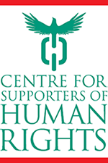
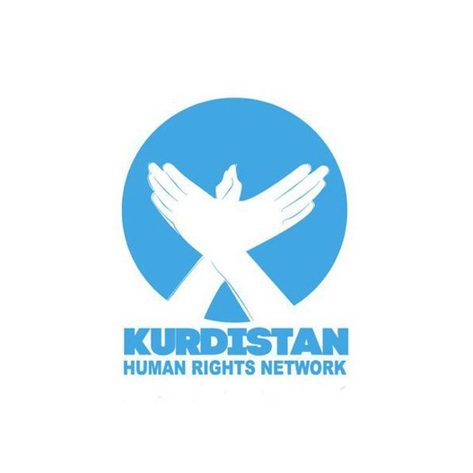
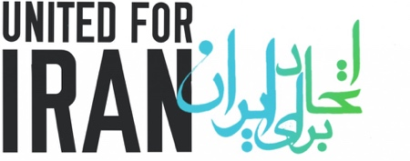
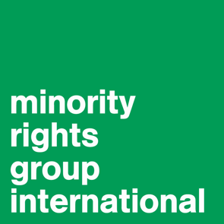

WRITTEN SUBMISSION TO THE HUMAN RIGHTS COMMITTEE

Adoption of the List of Issues for the
ISLAMIC REPUBLIC OF IRAN

Submitted jointly by
The Centre for Supporters of Human Rights
The Kurdistan Human Rights Network
United for Iran
and
Minority Rights Group International

136th Session of the Human Rights Committee
Geneva, 10 October – 04 November 2022

Contact: Glenn PAYOT, glenn.payot@minorityrights.org

CONTENTS:

1. SUBMITTING ORGANISATIONS 2
2. OVERVIEW AND GENERAL CONSIDERATIONS 3
3. THE GOVERNMENT OF IRAN’S CORE DOCUMENT 3
4. THE KULBARAN 4
5. LAWYERS AND THE ADMINISTRATION OF JUSTICE 10

SUBMITTING ORGANISATIONS

1.1 - The Centre for Supporters of Human Rights (“CSHR”) (cshr.org.uk) is a non-profit non-governmental organisation incorporated in the United Kingdom in 2012. The primary aim of CSHR is to improve the lives of Iranians in Iran through human rights awareness raising, education, and empowerment. CSHR is a leading expert in the situation of the Kulbaran (plural of Kulbar).

1.2 - The Kurdistan Human Rights Network (KHRN) is a France-based independent, non-profit and non-partisan organisation promoting human rights and documentation of violations in Iran’s Kurdish region. Its mission lies in contributing to the defence of human rights by informing the public and the media, to raise awareness locally and internationally about the ongoing developments. Its multi-lingual output is available in Persian (Farsi), English and Kurdish. KHRN is a member of the World Coalition Against the Death Penalty. It highly values collaborative work and regularly participates in joint tasks with other Iranian and international rights organisations.

1.3 - United for Iran (U4I) is an independent non-profit organisation based in the San Francisco Bay Area. It is the creator of the Iran Human Rights Barometer project. As a non-profit started and operated by Iranian activists, dissidents and former political prisoners, U4I’s mission is to champion civil liberties and human rights in Iran. It uses rigorous research, data and technology to improve human rights conditions, increase the capacity of civil society, and engage Iranian citizens.

1.4 - Minority Rights Group International (MRG) is an international non-governmental organisation working to secure the rights of ethnic, religious and linguistic minorities and indigenous peoples worldwide, and to promote cooperation and understanding between communities. MRG works with over 150 organisations in nearly 50 countries. MRG has consultative status with the United Nations Economic and Social Council, observer status with the African Commission on Human and Peoples’ Rights, and is a civil society organisation registered with the Organization of American States.

OVERVIEW AND GENERAL CONSIDERATIONS

2.1 - This submission addresses the Government of Iran’s (GoI) implementation of its obligations under the International Covenant on Civil and Political Rights (ICCPR, or the treaty or Covenant) with respect to three specific issues:

- The GoI’s Core Document
- The situation of the Kulbaran
- Lawyers and the administration of justice; and

2.2 - The authors adopt in this submission an intersectional and thematic approach. Suggested questions for the GoI are set out at the end of each section.

2.3 - Our organisations note that in November 2011, in paragraph (5) of section C .Principal matters of concern and recommendations, in its Concluding Observations, the Human Rights Committee noted “with concern that reference is made in the State party’s system to certain religious tenets as primary norms”, and called on the GoI to “ensure that all the obligations of the Covenant are fully respected and that the provisions of its internal norms are not invoked as justification for its failure to fulfil its obligations under the Covenant.” Iran failed to implement that fundamental recommendation of the Committee.

2.4 - In the same spirit, we therefore urge the Human Rights Committee (the Committee) to press the Government of Iran (GoI) to express both its understanding and formal acceptance of the primacy of international standards and the fundamental principles of indivisibility and interdependence of all human rights, which includes the fact that one set of rights cannot be enjoyed fully without the other.

2.5 - Our organisations call on the attention of the Committee to the existence of a number of indices and indicators from reputable sources relating to human rights, freedom of expression and rule of law, amongst others, that indicate Iran’s poor performance in terms of upholding key aspects of civil and political rights. For example:

- The World Justice Project (WJP) Rule of Law Index 2021 “presents a portrait of the rule of law in 139 countries and jurisdictions by providing scores and rankings based on eight factors: Constraints on Government Powers, Absence of Corruption, Open Government, Fundamental Rights, Order and Security, Regulatory Enforcement, Civil Justice, and Criminal Justice.” Iran ranked 119/139 (see page 10);
- The Reporters Without Borders (RSF)’s 2022 World Press Freedom Index, covering 180 states, is “based on a score ranging from 0 to 100 that is assigned to each country or territory, with 100 being the best possible score (the highest possible level of press freedom) and 0 the worst.” It is based on (i) “a quantitative tally of abuses against journalists in connection with their work, and against media outlets”; and (ii) “a qualitative analysis of the situation in each country or territory based on the responses of press freedom specialists[...]”. With respect to RSF’s index on the legal environment, Iran ranked 173/180 while its global ranking was 178/180.
- In the Economist Intelligence Unit’s global ranking in its Democracy Index 2021 of 167 countries, Iran - defined as an authoritarian state - is co-ranked with Yemen at 154/167

THE GOVERNMENT OF IRAN’S CORE DOCUMENT

3.1 - The co-submitting organisations regret that the state party did not update its Core Document forming part of the reports of state parties since it was first submitted in January 1999, 23 years ago, despite repeated calls from treaty bodies to do so. The text is out of date and relies on statistics and data that has been gathered at best in 1998. It also provides, in part, erroneous and misleading information to treaty bodies and other United Nations (UN) and other entities that may draw on it.

3.2 - For example, under B. Social and Demographic conditions, in paragraph 4, the state party states that “Iranians are of Aryan descent”, negating the ethnic diversity of Iranians, that include minorities that are not of Aryan descent, including Azeris, Turkmen, Qashqai, Assyrians, Armenians, and Arabs. Iran also omits completely from the Core Document the existence of the Turkmen people. Unofficial estimates of this community number up to one million, or around 1% of Iran’s population.

3.3 - Likewise, the state party addresses in paragraph (6) religious affiliation but pointedly fails to specify adherents to the Baha’i faith, or others whom UN bodies themselves have raised with the government in the context of human rights violations, including the Yarsans, Dervishes; the Mandaeans or converts to Christianity.

Suggested request: Please revise and update the state party’s Core Document as soon as possible, ​​in accordance with the harmonized guidelines on reporting under the international human rights treaties (2006), in order to ensure that the UN has relevant information and data that is accurate, up-to-date and disaggregated, including by ethnicity, religion or belief among other factors accurate

3.4 - The current Core Document asserts, in paragraph 38, under F. The judicial power, that the judiciary is an independent power, yet states, in contrast, that the “head of the judiciary is appointed by the Leader.” Paragraph 44 of the Core Document also points out the head of the judiciary is appointed by the Leader. Paragraph 38 also asserts that “members of the judiciary cannot be impeached” yet Article 171 of the Constitution contrasts this assertion, stating that:

“Whenever an individual suffers moral or material loss as the result of a default or error of the judge with respect to the subject matter of a case or the verdict delivered, or the application of a rule in a particular case, the defaulting judge must stand surety for the reparation of that loss [emphasis added] in accordance with the Islamic criteria, if it be a case of default. Otherwise, losses will be compensated for by the State. [...]”

Suggested request: Please clarify to the Committee, including in the revised Core Document, that the judiciary is, in fact, under the legal and effective control of the Leader and his Office (Bayt-e Rahbari, in Farsi), who appoints the position;.

THE KULBARAN

The Kulbaran - abide by laws or engage in activity that provides life?

“[...] advocates for kulbaris ask why a person who is deprived of the rights and the privileges of citizenship must observe laws that do not secure him any rights. According to them, the right to have a job and to fend off hunger takes precedence over legal restrictions on importing goods and the payment of customs fees. Since the basic rights of citizens take precedence over legislation, kulbars who have been stripped of their citizens’ rights have no duty to observe such laws, they argue.”

Kurdish journalist, Shahid Alavi, writing in Iran Wire in February 2020: Who are the Kulbars? Why are they Systematically Targeted and Killed?

4.1 - The Kulbar (plural: Kulbaran), literally, those who carry on their backs, are couriers - mainly men but also women - of Kurdish ethnicity, mainly from Iran but also Iraq. The “border couriers” use unmarked or informal crossing points on, mainly, Iran and Iraq’s 1,458 km border to smuggle a variety of, usually, consumer goods, to both sides of the border. The practice is peaceful, though illegal. The Kulbaran face considerable risk from border guards. They are estimated to number around 84,000 persons according to Kurdistan Human Rights-Geneva (KMMK-G).

4.2 - The Special Rapporteur (SR) on the situation of human rights in the Islamic Republic of Iran and other UN Special Procedures have repeatedly expressed concern over the human rights of Kulbaran. Paragraph 12 of the SR’s January 2022 report, for example, sets out the GoI’s excessive use of force with respect to peaceful cross-border smugglers in both the Kurdistan and Baluchistan regions, noting that “The use of live ammunition against border couriers continued, leading to the killing and injuring of over 200 individuals between 1 January and 1 December 2021.” The SR also notes that the GoI has not conducted any “investigation into these or any other killings of border couriers.”

4.3 - Primary sources of information for this submission are lawyers and activists inside and outside of Iran that advocate for the rights of the Kulbaran and their families. Persons, including their families and families of the deceased, informed the findings and data summarily set out in this submission. They were the ones impacted by police, border and Revolutionary Guard Corps’ excessive use of force, who fell from considerable heights while carrying the goods sought by the intended recipients, who became trapped in the cold and snow, who trod on long-forgotten landmines or who drowned in mountain rivers.

4.4 - Iran has a long history of prejudice towards its Kurdish population. The authorities have suppressed Kurdish economic aspirations as well as their social, political, and cultural rights. Our organisations assert that the GoI has socially and economically neglected areas of Kurdish settlement, resulting in widespread discrimination and failure to uphold the economic, social, cultural, civil and political rights of Kurds in the country. This neglect is related to patterns of ethnic and religious discrimination, in regions marked by periodic political unrest, partly related to the same disregard. Such neglect has and continues to exacerbate disproportionately high levels of absolute and relative poverty.

4.5 - The GoI denies Kurds equality in employment under the discriminatory 1995 gozinesh system, or selection process of employment that compels aspiring state officials and employees from the public sector to demonstrate allegiance to Islam and the Islamic Republic of Iran. In 2021, a legislation entitled Selection of managers and employees of the Islamic Republic, updating the 1995 provisions, was drafted, which continues to include gozinesh provisions that provide for an religious and ideological examination of individuals’ beliefs as a criterion for employment.

4.6 - The environment in which Kurds live remains precarious. Landmines and other live munitions, remnants of the 1980-1988 Iran-Iraq war remain, concealed, in Kurdistan. According to deminer Behnam Sadeghi - cited in a November 2020 press report in the Kurdish-focused media Rudaw - in 2019, landmines killed nine and injured 26 people. The Geneva-based Landmine and Cluster Munition Monitor identified a total of 2,823 deaths and over 7,000 injuries from landmines and explosive remnants of war in Iran between 1988 and 2017. As a result of what appears to be an allocation of national resources - which appears to favour, in the main, central, populous, Persian and Shi’a provinces over socially and economically marginalised regions, often with less significant levels of Persian, Shi’a population - the GoI appears to have reduced concentrated demining efforts, prolonging the threat to life in the impacted regions.

4.7 - Adequate housing, too, constitutes a socio-economic challenge. Poor historic levels of investment meant that events like a November 2017 earthquake - which reportedly killed 430 - also destroyed 12,000 homes.

4.8 - In this dire socio-economic context, due to the lack of economic infrastructure and apparent lack of political will to invest in such infrastructure, the people in Kurdistan and areas of Kurdish settlement have been forced, in effect, to engage in physically demanding, low-paid and some quasi-legal jobs that can endanger their lives. Inevitably, those who are able have turned to being Kulbaran rather than living their daily lives as farmers, nomads, shepherds or merchants.

4.9 - The Kulbaran transport tyres, washing machines and other consumer and capital goods weighing, according to one report, 15-25kg but sometimes up to more than 120kg and carry such payloads across the mountainous borders of Iran, Iraq, and Turkey. Despite the hardship of such activity, with payment at around US$10 for each successful border crossing, the Kulbaran are among the most poorly paid with respect to the nature of the activity. In Kurdish, they are sometimes referred to as koila, which literally means “slave”.

4.10 - Despite the fact that Article 1 of the “Law on the use of lethal weapons by armed and security forces in case of necessity” justifies the use of weapons by security forces only for the purpose of 1) establishing order and stability, 2) preventing the escape of an accused or an offender, and 3) executing judicial decisions or other assigned missions, officials routinely fire on Kulbaran.

4.11 - The formal legal position of the Kulbaran remains ambiguous. A February 2020 report notes that two provinces bordering Iraq issued permits for the activity. Yet, as far as we are aware, no specific national law or regulation concerning Kulbaran exists in Iranian law. The Supreme Leader reportedly proclaimed that the Kulbaran should not be considered smugglers due to the comparably small amount they bring into Iran, and yet border patrols and other GoI agents target them. State-affiliated media appear willing to insinuate that Kulbaran belong to organized gangs who force individuals to use arms to combat border patrols and to use drugs such as tramadol. At the same time, the geo-political context of the Kulbaran is, likewise, entangled with the GoI’s security concerns and objectives. The securitized border region, taken with pre-existing flaws in police and border guards’ practices, and a long-believed predisposition to fire first and ask questions later - on account of the socio-political status of the Sunni Kurds - is believed to shape officials’ inclination to shoot Kulbaran. The absence of clear policy or specific laws and regulations concerning the Kulbaran in Iranian law has created a dangerous situation in which no party emerges unharmed: lack of regulation and law does not justify the discriminatory excessive (sometimes lethal) use of force against the Kulbaran.

4.12 - Such excessive use of force and arbitrary killings are systematically ongoing, contradicting the pledges made by successive Islamic Republic governments to reform their security strategy toward Iranian Kurdistan. According to the 2021 annual report of the Kurdistan Human Rights Network (KHRN) one of the organisational co-authors of this submission, in 2021, at least 46 Kurdish Kulbaran lost their lives and a further 122 were injured in the border areas of the western provinces of West Azerbaijan, Kurdistan, and Kermanshah, including by way of shooting as well as a result of environmental factors. The KHRN reported that GoI security forces shot and killed 17 of the 46 and injured 74 of the total of 122 persons harmed. A member of parliament stated that last year, officials killed or injured more than 170 Kulbaran. A human rights organisation documented 215 killed or injured by the direct shooting of armed state forces in the same year, a much larger number than is admitted by the state. A 22 June 2022 report in Radio Zamaneh, citing the Kulbar News Website, stated that in the Iranian year of 1400 (21 March 2021 - 21 March 2022), at least 225 Kulbaran died across the provinces of Kurdistan, West Azerbaijan, Kermanshah and other provinces as a result of shooting by government forces; environment-related fatalities and in confrontations with security officials.

4.13 - The border official’s use of force against kulbaran.is often illegal, unnecessary, disproportionate, and discriminatory. This ongoing issue is aggravated by the fact that perpetrators are seldomly if ever brought to justice, and if they are they are almost never - if ever - found guilty and punished.

4.14 - The conduct of the GoI towards the Kulbaran represents violations of articles 2, and 6 of the Covenant. By imposing excessive use of force on Kulbaran, the GoI:

- Rejects Article 2.1 by failing to “respect and to ensure to all individuals within its territory and subject to its jurisdiction the rights recognized in the present Covenant, without distinction of any kind”, on the imputed account of the location of the Kulbaran, their dual ethnic and religious minority identities and marginalised socio-economic and political status. Denies Article 2.3.a by failing to provide “an effective remedy” to the GoI’s excessive use of force, notwithstanding that the violation has been committed by “persons acting in an official capacity”. As flagged by the SR: there has been no “investigation into these or any other killings of border couriers.” Accountability requires the GoI to hold law enforcement officials, who use force, accountable;
- Violates Article 6.1, the “arbitrary deprivation” of life, by way of shooting peaceful Kulbaran; and

4.15 - Like counterpart organisations who are reporting on the LOI for the 136th Session of the Human Rights Committee, our organisations have documented violations showing that members of Iran’s Kurdish Sunni minority, including a spectrum of religious expression, more generally, face violations of articles 9, 10, 14 and 26 of the treaty. Echoing cases and issues raised in another submission, such violations arise from the deep-rooted discrimination towards the Kurdish and other religious and ethnic minorities in Iran.

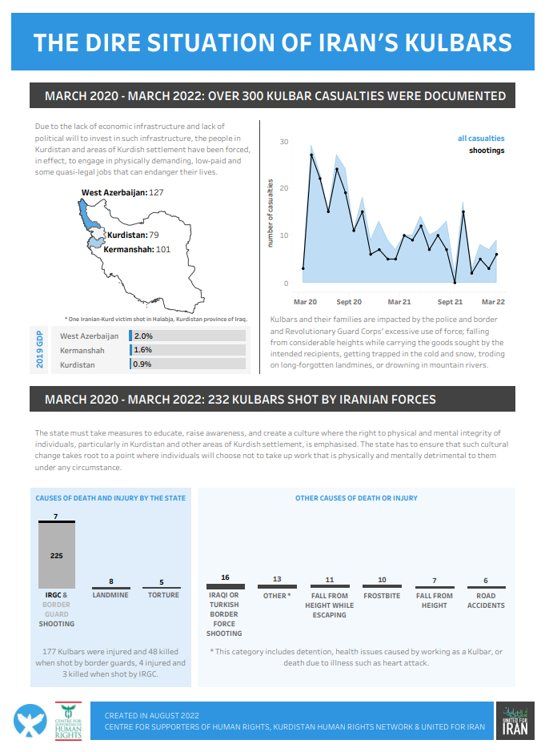

Suggested requests in relation to the Kulbaran:

- Please explain the discrepancy in per capita state funding not made by bodies under the control of the Revolutionary Guards to Kurdistan and other areas of Sunni, Yarsani and Shia Kurdish settlement in respect to health, education and infrastructure, in comparison to Shi’a Persian regions and how such allocations are in keeping with the provisions of the treaty;
- Please provide, by making available to the public, disaggregated details of the health, education and employment support provided to the population of Kurdistan and other areas of Kurdish settlement, with comparative statistics for Khuzestan, West Azerbaijan and Isfahan provinces, as well as other provinces, on the basis that such data can be collated, and explain that data in terms of the obligations under the treaty;
- Please explain and produce evidence of the guidance and operational procedures provided to IRGC, police and border guards in relation to engagement with border couriers, be they Kurdish Kulbaran or Baluchi Sukhtbaran, those, overwhelmingly Baluchi, who transport (-bar) forms of fuels (sukht-).
- Please provide disaggregated details of all deaths of Kulbaran, both registered as well as those reported but not confirmed by the GoI; their location and in which instances did the authorities conduct autopsies;
- Please provide specific and disaggregated details of the compensation delivered to families of those Kulbaran wrongly killed by the authorities; and
- Please provide details of all disciplinary proceedings brought against members of the security services in respect to the wrongful shooting of Kulbaran or other instances of excessive use of forces; if there were not any such cases, please explain why;
- Please provide the Committee with a date when they will invite to Kurdistan and areas of Kurdish settlement both the Special Rapporteurs on minority issues and the country rapporteur on Iran in order to assess the plight of the Kulbaran;
- Please provide disaggregated data and timeframe on specific investments, including infrastructural, in Kurdistan and other areas of Kurdish settlement that are not part of any IRGC or foundational (bonyad) investment and provide to the Committee a detailed explanation on how such investment will create safe and permanent jobs to ensure that the typical demographic currently engaged as Kulbaran will not have to turn to such work in the future; and
- Please provide disaggregated data and timeframe of ongoing measures taken to educate, raise awareness, and create a culture where the right to physical and mental integrity of individuals, particularly in Kurdistan and other areas of Kurdish settlement, is emphasised. Please also provide to the Committee a detailed explanation of how such culture change is taking root where individuals will choose not to take up work that is physically and mentally detrimental to them under any circumstance.

LAWYERS AND THE ADMINISTRATION OF JUSTICE

5.1 - Treaty bodies, Special Procedures and human rights organisations have documented, for decades, measures taken by the GoI against human rights defenders as well as lawyers, in contravention to the provisions of the treaty. Co-authoring organisation, the Centre for Supporters of Human Rights has documented instances of such measures. Despite international expressions of concern and appeals to the GoI to amend laws and change practices, these human rights violations continue. Setting aside facts relating to well-known cases such as Nasrin Sotoudeh and others, as well as the arbitrary detention of Mohammad Najafi - and the range of lawyers facing restriction, harassment or imprisonment, cited in a March 2022 statement - the following addresses aspects of these matters.

5.2 - Lawyers in Iran are systematically pressured and harassed in various ways. One issue restricting lawyers in the field of defence is the establishment of rules and regulations that deprive them of the freedom to defend their clients sufficiently and adequately. Lawyers who undertake cases despite such restrictions, are often threatened, intimidated, and ultimately imprisoned. Bureaucratic requirements, and even reprisals against lawyers (usually depending on the nature of their case) often make it extremely difficult for legal professionals to supply their clients access to adequate defence, and thereby restricts the ability of defendants to receive and access a fair trial.

Administration of Justice

5.3 - The following rules and regulations are established restrictions that violate the independence of lawyers and judges and, through their work, leave them vulnerable to charges such as “conspiracy against national security”, “propaganda activities against the Islamic Republic of Iran” and “cooperation with hostile states”. The following are examples of such provisions, but restrictive measures on justice procedures are not limited to these articles:

- The Islamic Republic of Iran’s Code of Criminal Procedure: Article 191 permits investigators at his/her own discretion, to prohibit a lawyer from accessing the contents of their client's file due to security reasons. It should be noted that ‘security reasons’ are loosely defined and applied. Article 351 strips lawyers of the right to obtain copies of all documents pertained to the case, contrary to the standards of a fair trial and the freedom of lawyers to defend. Articles 346, 385 and 297 provide imitations on the number of lawyers that can be assigned to a case to two or three, depending on the type of case, court and number of judges.
- The Executive By-law of the Prisons Organization and the Preventive and Corrective Measures of the Country approved in 2021: Note 1 to Article 216 requires attorneys to seek the approval of a judicial authority to meet with a client sentenced to imprisonment or for a security offense, as well as any client in custody who is still on charge. In addition to these laws and regulations, directives are sometimes issued by judicial and prison officials that – despite lawyers’ efforts to invalidate the directives through legal means – forces lawyers to face further unnecessary administrative hassle and unusual hurdles to be able to access their case and to meet with their clients.

5.4 - Amongst challenges relating to the administration of justice, lawyers from religious and ethnic minorities face additional challenges, including in the administration of justice faced by their clients.

5.5 - In a 9 August 2022 conversation with Minority Rights Group International, and by way of a submission to the co-authoring organisations, Azerbaijani Turkic lawyer Musa Berzin, now based outside of Iran informed us that:

- While court procedure is in Persian pursuant to Article 15 of the Constitution, he had clients who were not able to speak Persian adequately and that despite the provision in the Code of Criminal Procedure for a translator, courts in areas of Azerbaijani Turkic settlement do not, in practice, provide translators. Musa Berzin cited the 2011 stoning case of Sakineh Ashtiani, who did not understand the legal proceedings she faced.
- The frequent use of vaguely worded, security-based criminal charges in criminal cases that come before branches of the Revolutionary Court has resulted in decades of intimidation towards Azerbaijani Turkic lawyers working in the field of human rights where their collective identity may have formed a part of the case against the accused: Musa Berzin cited his own case and that of Naghi Mahmoudi, Abbas Jamali, Javid Houtan-Kian or Saleh Kamrani, all Iranian Azerbaijani Turkic lawyers whom the GoI targeted and most of whom have now fled Iran. Musa Berzin stated that this pattern can be discerned with respect to other minorities’ lawyers.

5.6 - Musa Berzin told our organisations about other practices in the administration of justice that undermine the right to a fair trial. They are practices he was aware of from cases in East Azerbaijan province. While not targeting the minority itself, they nevertheless undermine the provision guaranteed in the treaty. These included:

- The lack of adequate provision of legal advice (to the general public), including in respect to advice centres, including where this is in or near courts;
- The lack and oftentimes absence of provision of legal advice to those held in pre-trial detention:

“Many prisoners are usually people who neither have legal knowledge nor the possibility to use the services of a lawyer. For this reason, the existence of a legal advisor [...] is of vital importance. Unfortunately, in the prisons [where pre-trial detention often occurs] located in Azerbaijan, very limited legal counselling services are provided, so the vast majority of prisoners are deprived of these services. Even some prisoners are willing to accept some of the sometimes illegal demands of the prison authorities in order to be able to talk to a counsellor and get advice.”

- The lack and oftentimes the absence of adequate time, access to case material; the accused and/or witnesses in advance of trial; and that
- Judges or prosecutors prevent the accused from having any lawyer, let alone a lawyer of the accused’s choosing, asserting to the accused that if they obtain a lawyer, it will have negative consequences. Musa Berzin stated:

“In some cases, it is really like this. Some judges of the Revolutionary Court have entered into a kind of hostility with some lawyers who specialise in security cases and [who] are not aligned with the government. For this reason, in the cases that these lawyers enter, they try to be as strict as possible. In some cases, it has been reported that the judge has told the defendant to fire a certain lawyer or he will face the heaviest possible punishment. In such a situation, the lawyers also refuse to engage with the cases [...]”

5.7 - Paragraphs 73-87 of the state party’s 23 August 2021 report, on Article 14 of the treaty, sets out legal assertions of the rights guaranteed, but ignores the tens of cases raised by human rights organisations, including the matters set out above by Musa Berzin. Notably, they do not address the basis of charges - often vaguely termed provisions linked to national security and the characteristics associated with trial before a branch of the Revolutionary Court.

5.8 - The GoI completely omitted Article 14.3f, on the free assistance of translation.

Persecution of Lawyers and their Clients

5.9 - In addition to restrictions on accessing their clients and meeting the conditions of a fair trial, lawyers are increasingly threatened and arrested.

5.10 - The Shiraz Public Prosecutor and Revolutionary Court has issued warrants for lawyers representing human rights cases, including four lawyers who at time of writing are being prosecuted on charges of conspiracy against national security, propaganda activities against the Islamic Republic of Iran and cooperation with hostile states. One of these lawyers explained that he believed that the charges arose as a result of media interviews, taking part in law-related seminars outside the country that addressed issues relating to women and children, and promotion of legal reform in relation to this area of law, including by way of communication with the president’s office, parliamentarians and other officials. In, on 21 May 2022, approximately 400 Iranian lawyers signed a statement expressing their deep concern over the “unlawful actions of security and judicial institutions” and the issuance of the summons against the four Shirazi lawyers.

5.11 - During the pandemic, six prominent human rights lawyers and activists had reportedly arranged to file a complaint against the Leader, Ali Khamenei; the National Task Force Against Coronavirus; the Minister of Health; and other officials responsible for management of the COVID-19 pandemic for the lack of government transparency and accountability in dealing with Covid-19 crisis. On August 14th, these lawyers and activists were arrested. One of the charges against the aforementioned lawyers and activists is managing and membership in dissident groups, which can be construed to be referencing the formation of a WhatsApp and Clubhouse group to investigate the death of Iranian citizens due to Covid-19. One of the lawyers representing the case asserts that the Clubhouse of these activists had been illegally tapped and the issues raised in it are being used selectively to file a case against these members. In April 2022, Branch 29 of Tehran’s Revolutionary Court tried the five on charges that included ‘assembly and collusion to act against national security’.

5.12 - Over the years, restrictions and threats against lawyers in Iran have caused many in the profession to avoid defending the people that need it most, including minorities and other marginalised defendants as these are often the most politicised cases.

5.13 - In a conversation on 11 August 2022, Kurdish lawyer and human rights activist Hossein Ahmadi Niyaz - who has lived in the Netherlands for about four years - told MRG that the GoI targeted and persecuted him for his legal defence of clients from unrecognised religious minorities, including Baha’is, Yarsans, converts to Christianity, and members of the Kurdish ethno-linguistic and religious minority, including security-related, death penalty cases.

5.14 - Evidence of a systematically unfair administration of justice in respect to cases of Kurds is reflected in the outcomes of the cases taken on by Hossein Ahmadi Niyazi. MRG and others likewise reflected this assessment in a 3 February 2021 statement and appeal co-signed by MRG and 35 other human rights organisations. The statement drew attention to the arrest - from 6 January 2021 - of:

“[...] at least 96 individuals (88 men and 8 women) from Iran’s Kurdish minority, including civil society activists, labour rights activists, environmentalists, writers, university students and formerly imprisoned political activists as well as individuals with no known history of activism, have been arrested by the intelligence unit of Iran’s Revolutionary Guards or ministry of intelligence agents, at times in a violent manner. [...]”
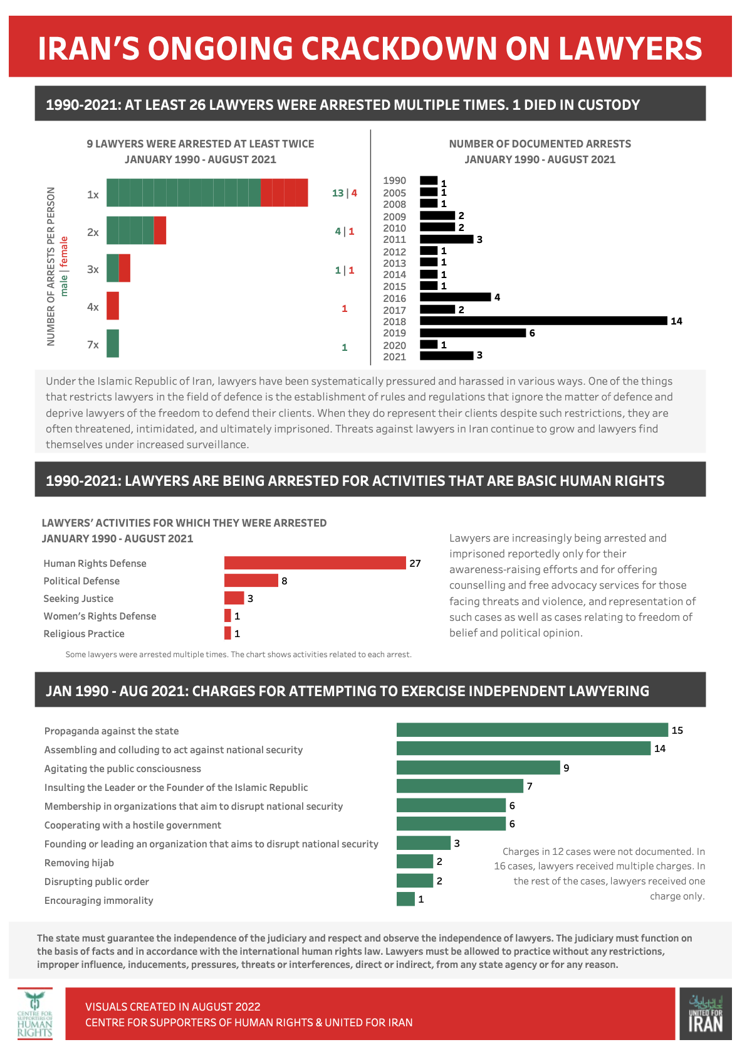
Suggested requests and questions in relation to the administration of justice:

- Please provide disaggregated data on the cases in which the GoI provided translation and the criteria for the provision of such services, including in reference to the nature of the cases. For example, in respect to cases against Kurds, Azerbaijani Turkic-speaking and Baluchi Iranians facing security-related charges, please provide independent evidence of competence in Persian prior to trial;
- In respect to paragraph 77 of the state party’s report, on access to a lawyer, please provide examples in which those facing trial were charged with security-related provisions and were from one of Iran’s ethnic or religious minorities, including those not cited in the Core Document; and
- Why does the government appear to serially target lawyers in areas of ethnic and religious regions and cases relating to such peoples, and please explain the role of the IRGC and Office of the Supreme Leader (Bayt-e Rahbari) in such cases.

This text uses hyperlinks to the sources that informed the content of this text. The links are, in the main, to sources in Persian and English. While we have not provided translations to texts or sources, the Minority Rights Group is happy to do so on behalf of the sponsoring organisations.
Committee on the Elimination of Racial Discrimination, Concluding Observations, Islamic Republic of Iran, CERD/C/IRN/CO/18-19, para. 23 (20 Sept 2010); Committee on the Rights of the Child, Concluding Observations, Islamic Republic of Iran, CRC/C/IRN/CO/3-4, para. 99 (14 March 2016)
For more detailed information on the Kulbaran, and smugglers of the Baluchi community of Iran, see the Minority Rights Group and Ceasefire Centre for Civilian Rights’ June 2020 report In the Name of Security - Human rights violations under Iran’s national security laws, at: https://minorityrights.org/wp-content/uploads/2020/06/In-the-Name-of-Security_Iran_EN_June20.pdf (accessed 7 August 2022)
Of the 46 reportedly killed in 2021, the KHRN also reported that five were killed in avalanches; three as a result of frostbite; and a further three following falls in mountainous areas; three due to heart failure, linked to the strenuous nature of the activity; that one drowned and that nine died in road traffic incidents.
The submission by All Human Rights for All in Iran, Association for Human Rights in Kurdistan – Geneva (KMMK-G), Association for the Human Rights Of The Azerbaijani People In Iran (AHRAZ), Iran Human Rights Documentation Center (IHRDC), OutRight Action International, Siamak Pourzand Foundation, Small Media and Impact Iran addresses: discrimination and violence based on gender, religion or belief, ethnicity, language, sexual orientation, and gender identity.
Musa Berzin’s submission, in Persian, followed an interview in, mainly, (Istanbul) Turkish, is held by Minority Rights Group International. The organisation can provide it on request.

