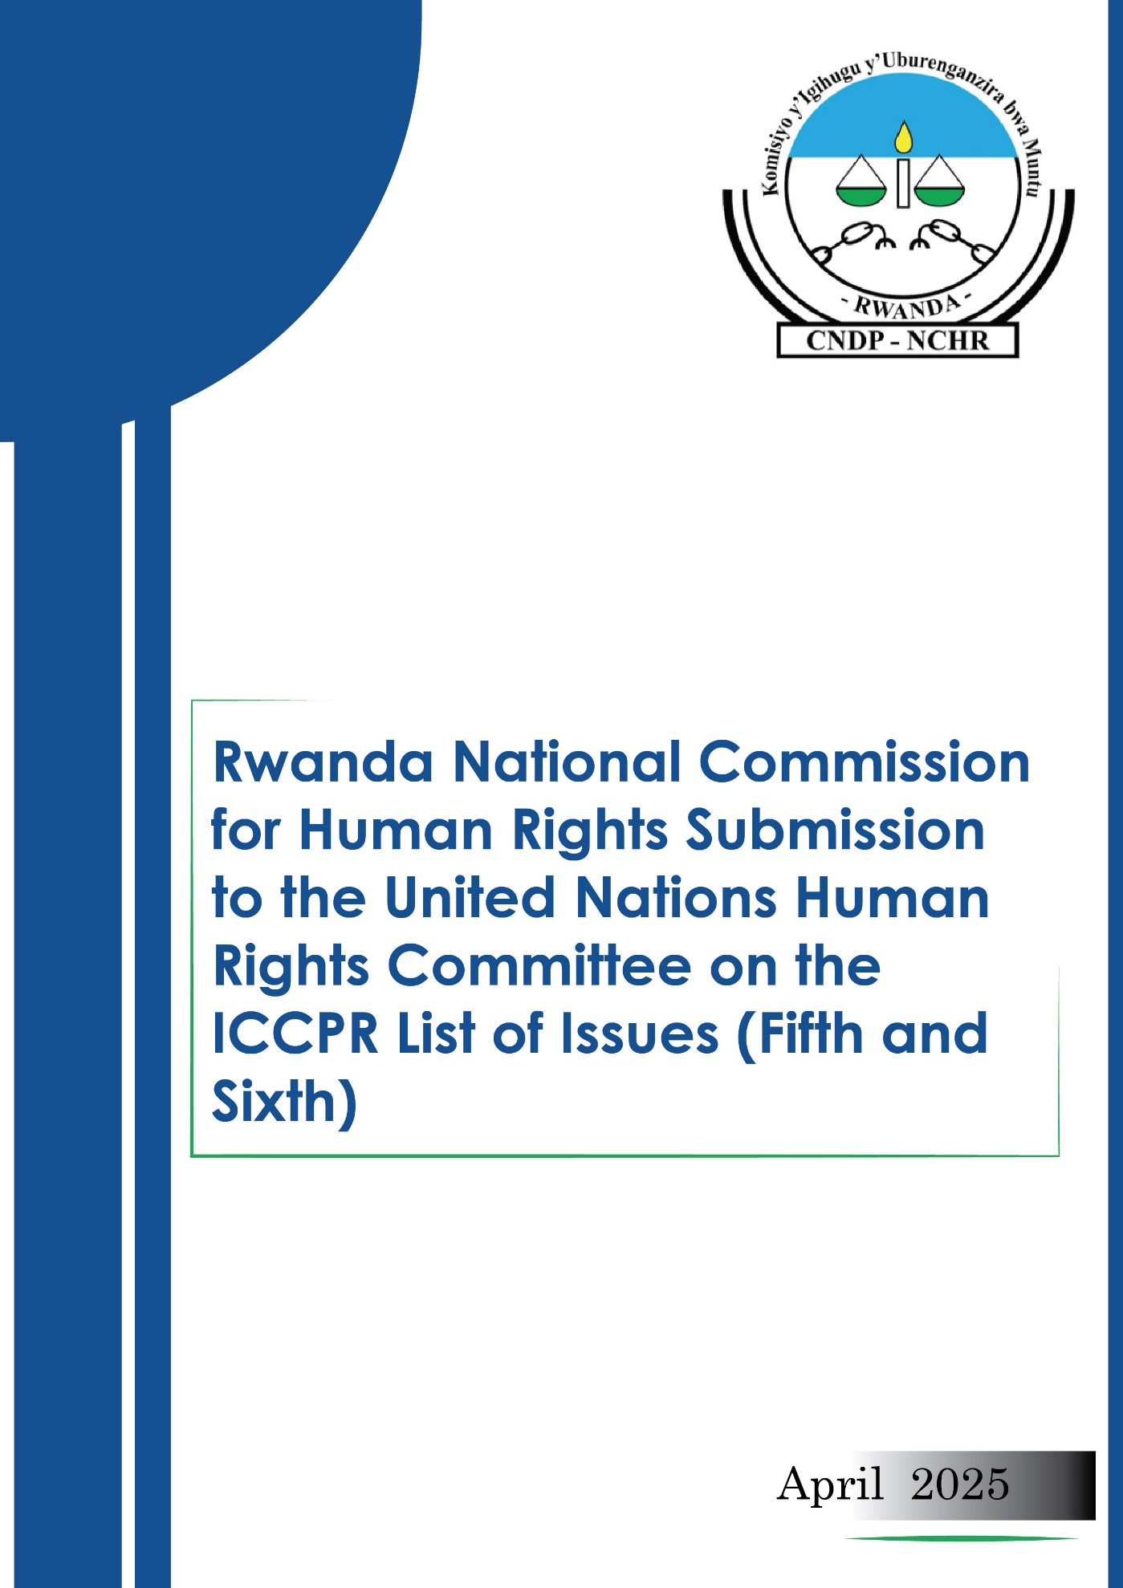Submissions of the Rwanda National Commission for Human Rights to the United Nations Human Rights Committee
144th Session of the Human Rights Committee on Civil and Political Rights
- Introduction
- The RwandaNational Commission for Human Rights (NCHR) is a constitutional and independent institution, established in 1999, by Law n° 19/2013 of 25/03/2013 as revised in 2018, and has the core mandate of promoting and protecting human rights.
- This report is submitted to inform the Human Rights Committee's preparation of the List of Issues Prior to Reporting (LOIPR) for Rwanda's upcoming periodic review under the International Covenant on Civil and Political Rights (ICCPR).
- Rwanda acceded to the International Covenant on Civil and Political Rights (ICCPR) on 16 April 1975. The Covenant entered into force in Rwanda on 23 March 1976, in accordance with Article 27. It was incorporated into the national legal framework through Decree-Law No. 8/75 of 12 February 1975, as published in the Official Gazette No. 5 of 1st March 1975.
- Given their foundational nature, civil and political rights, protected under the ICCPR are often referred to as first-generation rights, forming the basis for the protection of human dignity and the functioning of a just and democratic society.
- By ratifying the ICCPR, Rwanda has accepted all obligations arising from the Covenant, including the duty to respect, protect, and fulfill civil and political rights. In line with these commitments, Rwanda has undertaken to adopt legislative, policy, and institutional measures aimed at safeguarding fundamental freedoms and ensuring the effective enjoyment of rights such as the right to life, liberty, security, fair trial, and freedom of expression. These efforts reflect the State’s dedication to upholding the principles and spirit of the Covenant in its national legal and governance frameworks.

- General information

- Following the amendment made in 2023, the Constitution of the Republic of Rwanda has kept the hierarchy of laws as it was. Thus, the ICCPR - like other international treaties ratified by Rwanda - comes after the Constitution and the Organic Laws.The organic law deals with constitutional matters that may arise after the adoption of the Constitution.
- Rwanda being a monist state, the ratification of the international treaty does not require the adoption of any specific law to incorporate the rights enshrined therein. Indeed, “upon publication of a Presidential Order ratifying an international treaty or agreement in the Official Gazette of the Republic of Rwanda, the international treaty or agreement has the force of law as national legislation in accordance with the hierarchy of laws provided for under Paragraph (1) of Article 95 of this Constitution”.

- Mandate and independence of the National Commission for Human Rights (NCHR)
- The NCHR has a three main mandate, namely the promotion of human rights, the protection of human rights and the prevention of torture as the National Preventive Mechanism (NPM) . The ICCPR provides a critical legal foundation for the protection of human rights and the prevention of torture, with Article 7 explicitly prohibiting torture and cruel, inhuman, or degrading treatment or punishment. This is reinforced by related provisions, such as the right to liberty and security of person (Article 9), the human treatment of persons deprived of liberty (Article 10), and the right to a fair trial (Article 14). In line with these international obligations, the Rwanda National Commission for Human Rights (NCHR), plays a central role in monitoring compliance with these standards. The Commission regularly inspects detention facilities, investigates allegations of torture and ill-treatment, and advocates for accountability. The NCHR submits its reports to the Parliament, which highlight both progress and areas requiring attention in ensuring that Rwanda fulfills its commitments under the ICCPR.
National Preventive Mechanism
- In accordance with the Paris Principles and its designation as Rwanda’s National Preventive Mechanism (NPM) under the Optional Protocol to the Convention against Torture (OPCAT), the National Commission for Human Rights (NCHR) carries out its mandate with full independence. It examines and investigates allegations of human rights violations, with particular attention to the prevention of torture and ill-treatment in places of detention. Through its annual reports submitted to Parliament, the Commission provides detailed findings and forwards concrete recommendations to relevant state institutions. Each report includes a dedicated chapter tracking the implementation of these recommendations, thereby reinforcing state accountability and the protection of human dignity in line with Rwanda’s international obligations, including under the ICCPR.

- Furthermore, Article 5 of the aforementioned law defines the role of the NCHR in Human Rights promotion, including educating the public on human rights, proposing views on laws and draft laws to ensure that they are consistent with human rights principles, urging relevant institutions to submit reports on treaties on time, and collaborating with international (including Office of the United Nations High Commissioner for Human Rights [OHCHR]) and local human rights organizations.
- In line with Article 6 of the ICCPR, which guarantees the inherent right to life and obliges States to protect this right by law, the Rwanda National Commission for Human Rights (NCHR) is entrusted with protection responsibilities for vulnerable groups. These include children, women, persons with disabilities, people living with HIV/AIDS, refugees, migrant workers and their families, as well as the elderly. The right to life under the ICCPR encompasses not only protection from arbitrary deprivation of life but also the creation of conditions that uphold dignity and security. To support these responsibilities, the Government of Rwanda allocates a substantial budget to the Commission annually. Notably, this budget increased by 31.04% between the 2021–2022 and 2023–2024 fiscal years, demonstrating the State’s commitment to strengthening the NCHR’s capacity to carry out its mandate in line with its international obligations.
- Human rights concerns and recommendations

- Overcrowding and conditions in correctional facilities: Rwanda has made commendable legal and institutional efforts to prevent torture and uphold the dignity of individuals in detention. Article 14(2) of the Constitution expressly prohibits torture, and this is reinforced by Law No. 19/2013 (as amended). At the international level, Rwanda ratified the UN Convention Against Torture in 2008 and the Optional Protocol to the Convention Against Torture (OPCAT) in 2014. Under OPCAT, the National Commission for Human Rights serves as the designated National Preventive Mechanism (NPM), empowered to regularly monitor places of detention and prevent torture and other ill-treatment.
- When the Commission was explicitly designed as the NPM, the Commission undertook monitoring activities, visiting 14 correctional facilities, 72 Rwanda Investigation Bureau (RIB) custodies, 28 transit centres, and 3 rehabilitation centres.
- The Commission commends the continuous efforts made by the Government of Rwanda in improving the conditions in detention facilities. We have noted positive steps that have been taken in renovations and expansions of some detentions facilities such as, Musanze, Gicumbi, and Muhanga, that have contributed to a reduction in overcrowding, lowering the national occupancy rate from 140.7% to 134.3% in 2023-to 2024, and as of the recent assessment of early this year September, we noted that inmate population had decreased from 89,550 in 2023 to 81,247 in early 2025, improving the national occupancy rate to 121.8%.
- However, the Commission still has concerns as the rate of overcrowding is still above 100%. This overcrowding has serious human rights implications. Living conditions vary significantly between facilities in particular for prisons that have old buildings such as Rusizi and Bugesera, Muhanga where you find that their conditions are inadequate, (not enough toilets, lack of clean water, too many people in the room and lack of separate bedding for every detainee…)
- In terms of inclusivity, only the Huye and Nyanza facilities are equipped with disability-friendly bathrooms. It is recommended to have consideration for detainees with special needs across the system.
- To comply with Article 7 of the ICCPR and improve overall conditions of detention, the National Commission for Human Rights recommends the following:

- Intensify efforts to address overcrowding in correctional facilities.
- judicial proceedings to minimize prolonged pretrial detentions.
- Promoting and scaling up the use of non-custodial measures, such as community service, conditional release, and house arrest, especially for minor offenses.
- Institutionalizing provisional release programs at least twice a year, in line with established legal frameworks.
- Accelerate the renovation and expansion of old and overcrowded detention facilities, particularly in Rusizi, Bugesera, and Muhanga, to improve infrastructure and ensure adequate space and sanitation for all detainees.
- Enhance living conditions across all facilities by ensuring access to clean, sufficient bedding, in full alignment with the standards set in the Nelson Mandela Rules.
- Renovating kitchen facilities and ensuring proper food storage and preparation conditions.
- Upgrading toilet and bathroom facilities to guarantee privacy and dignity, especially for women and persons with disabilities.
- Ensure accessibility for persons with disabilities by installing inclusive facilities in all prisons, not just in Huye and Nyanza, to fulfill the obligation of respect of vulnerable detainees’ rights.
- Enhance water and sanitation services across all detention facilities with known shortages, such as Muhanga, to protect the health of inmates.
- Improve in infrastructure, staff training, medical care, and rehabilitation programs.

- Pretrial Detention and the Right to Liberty and Security (Article 9 of the ICCPR): Article 9 of the International Covenant on Civil and Political Rights (ICCPR) guarantees the right to liberty and security of person and states that anyone arrested or detained on a criminal charge shall be brought promptly before a judge and shall be entitled to trial within a reasonable time or release.
- The Rwanda National Commission for Human Rights (NCHR) commends the Government of Rwanda for ongoing efforts to strengthen the administration of justice and to protect the rights of individuals deprived of liberty.
- Notable progress includes the implementation of the Integrated Electronic Case Management System (IECMS), which has improved the efficiency and transparency of judicial processes, and enhanced coordination across justice sector institutions. Additionally, the expansion of legal aid services and the creation of specialized prosecution units have played an important role in promoting access to justice, particularly for vulnerable and marginalized groups.
- However, despite these commendable developments, the NCHR remains concerned about challenges related to the use and management of pretrial detention. The Commission has observed that pretrial detention is still frequently applied as a default measure, even in cases where alternatives such as bail would be appropriate. This practice risks infringing on the right to liberty and undermining the presumption of innocence, as guaranteed under Article 14 of the ICCPR.

- Furthermore, the Commission’s monitoring has revealed that some individuals remain in pretrial detention beyond the legal time limits provided for by the Rwandan law. These delays are often caused by prolonged investigations, a shortage of judicial officers, and logistical constraints. Such extended detention periods without timely judicial review may lead to arbitrary detention, in violation of Article 9 of the ICCPR. The Commission has also documented cases where detainees face obstacles in accessing legal assistance at early stages of their detention, limiting their ability to challenge the lawfulness of their detention and exercise their right to a fair trial. These issues tend to disproportionately affect indigent individuals, young people, and those living in remote areas who often lack the means or awareness to advocate for their rights effectively.

- In light of these concerns, the NCHR recommends that the Government of Rwanda intensifies judicial training on the appropriate use of pretrial detention, establish clear procedural safeguards, ensure effective implementation of alternatives to detention, expand the reach of legal aid services nationwide, and strengthen oversight mechanisms to prevent the excessive or unlawful use of pretrial detention. These measures are critical to ensuring full compliance with the ICCPR and to upholding the rights and dignity of all persons within Rwanda’s justice system.
- Violence against women and children, The impact of gender-based violence on the rights of pregnant teenagers: During the reporting year 2023/2024, the Rwanda National Commission for Human Rights conducted research to assess the impact of gender-based violence (GBV) on the rights of pregnant teenagers, with a particular focus on their right to protection, access to justice, education, health, and reparations. The findings revealed gaps that result in the violation of multiple rights enshrined under the ICCPR, including the right to non-discrimination (Article 2), the right to an effective remedy (Article 2(3)), the right to liberty and security of person (Article 9), the right to be treated with humanity and respect (Article 10), and the right to equality before the law (Article 26).
- The study established that a significant proportion of pregnant teens were victims of sexual abuse, yet most cases remained unreported due to fear, social stigma, lack of awareness, or family pressure. Despite existing legal frameworks and institutional mechanisms, the low rate of access to legal aid and the inadequate follow-up on justice services demonstrate a gap in the realization of their right to an effective remedy and access to justice. Furthermore, the study highlighted the adverse effects of early pregnancy on the right to education, health, and an adequate standard of living, with a high dropout rate among pregnant teens and persistent economic vulnerability post-delivery.

- The Commission recommends the government the following:
- Strengthen legal aid mechanisms to ensure that pregnant teenage victims of gender-based violence (GBV) can access timely and effective legal assistance and remedies, in line with Article 2(3) of the ICCPR.
- Enhance community education and awareness on reproductive rights, GBV prevention, and available support services, especially targeting adolescents, families, and local leaders.
- Implement targeted reintegration programs to enable pregnant teenagers to resume their education and benefit from vocational training and income-generating activities.
- Ensure comprehensive healthcare for pregnant teenagers and their babies beyond childbirth, including mental health support and sustained access to health insurance.
- Monitor the enforcement of laws against sexual violence and child abuse, and ensure that perpetrators are held accountable to prevent impunity.
- Strengthen coordination among service providers (health, justice, education, social welfare) to provide holistic and survivor-centered support to affected teens.
The Commission urges the Government of Rwanda to reinforce these measures to fulfill its obligations under the ICCPR and other international human rights instruments, and to protect the dignity and rights of all girls and young women exposed to GBV.
- Freedom of peaceful assembly and association (arts. 19 and 21-22): In accordance with Articles 5(4) and 6 of the Law governing the National Commission for Human Rights (NCHR), the Commission has the mandate to provide views on existing or draft laws and regulations to ensure their compliance with international human rights standards.

- As part of this mandate, the Commission identifies provisions in laws and regulations that may hinder the respect of human rights and submits recommendations to relevant national authorities. It also advises to Parliament on draft legislation, contributing to the alignment of domestic laws with Rwanda’s international human rights obligations.
- One of the key areas of the Commission’s recent engagement has been the review of the Law No. 04/2012 of 17/02/2012 governing the organization and functioning of national non-governmental organizations (NGOs). This law was revised in 2024, and during the revision process, the Commission submitted its views to ensure that the rights to freedom of peaceful assembly and association, as protected under Articles 21 and 22 of the ICCPR, are fully respected.
- In particular, the Commission recommended the inclusion of a provision allowing NGOs whose registration applications have been denied to appeal the decision. This would enable such organizations to have an opportunity to be heard and to seek redress, thereby reinforcing not only the right to freedom of association but also the right to a fair hearing and access to justice, as protected under the ICCPR.

- Additionally, the Commission encouraged the State to continue fostering an enabling environment for civil society by safeguarding the operational independence of non-governmental organizations (NGOs). In this regard, the Commission emphasized the importance of allowing NGOs to manage their own assets and to exercise autonomy in appointing or removing members of their leadership. Preserving such independence is key to ensuring that NGOs can effectively contribute to national development and the promotion of human rights, in line with Rwanda’s international commitments, including those under the ICCPR.
- Conclusion
The Rwanda National Commission for Human Rights (NCHR) reaffirms the country’s unwavering commitment to the principles and obligations enshrined in the ICCPR, as demonstrated through continuous legislative, policy, and institutional efforts to promote, protect, and fulfill civil and political rights. While notable progress has been made, especially in justice sector reforms, legal aid expansion, the prevention of torture, and the protection of vulnerable groups, challenges still exist particularly in the areas of detention conditions, pretrial practices, and the protection of women and children against gender-based violence.
The NCHR underscores the urgent need for continued reforms to address overcrowding in correctional facilities, ensure the appropriate use of non-custodial measures, uphold the rights of detainees and pretrial detainees, and respond comprehensively to gender-based violence, especially for pregnant teenagers.
In submitting this report, the Commission calls upon the Human Rights Committee to consider these observations and recommendations as it prepares the List of Issues for Rwanda’s review under the ICCPR.

Status of the Ratification of International and Regional Human Rights Instruments by Rwanda Fourth Edition Kigali, May 2023 at https://www.cndp.org.rw/index.php?eID=dumpFile&t=f&f=69009&token=2a3605de7eef7ffb34dd35f12eab42dcff185050 , p 7
Law n° 19/2013 of 25/03/2013 modified by Law n° 61/2018 of 24/08/2018 determining missions, organization and functioning of the National Commission for Human Rights, Article 4
https://www.cndp.org.rw/index.php?eID=dumpFile&t=f&f=118111&token=54037038f4141ec93ce58fbb21a76ed53b026af1 p12
National Commission for Human Rights, Annual Report 2022/2023, September 2023, at https://www.cndp.org.rw/index.php?eID=dumpFile&t=f&f=118111&token=54037038f4141ec93ce58fbb21a76ed53b026af1 p. 108
National Commission for Human Rights, Annual Report 2022/2023, September 2023, at https://www.cndp.org.rw/index.php?eID=dumpFile&t=f&f=118111&token=54037038f4141ec93ce58fbb21a76ed53b026af1 p. 25
Idem.P27
Idem.P44-45
National Commission for Human Rights, Annual Report 2022/2023, September 2023, at https://www.cndp.org.rw/index.php?eID=dumpFile&t=f&f=118111&token=54037038f4141ec93ce58fbb21a76ed53b026af1 p. 94-98
National Commission for Human Rights, Annual Report 2022/2023, September 2023, at https://www.cndp.org.rw/index.php?eID=dumpFile&t=f&f=118111&token=54037038f4141ec93ce58fbb21a76ed53b026af1 p. 86-88
The Constitution of the Republic of Rwanda, Article 95.
Idem, Article 169.
Law n° 19/2013 of 25/03/2013 modified by Law n° 61/2018 of 24/08/2018 determining missions, organization and functioning of the National Commission for Human Rights, Article 5.
Idem, Article 6.
Id., Article 6 bis.

