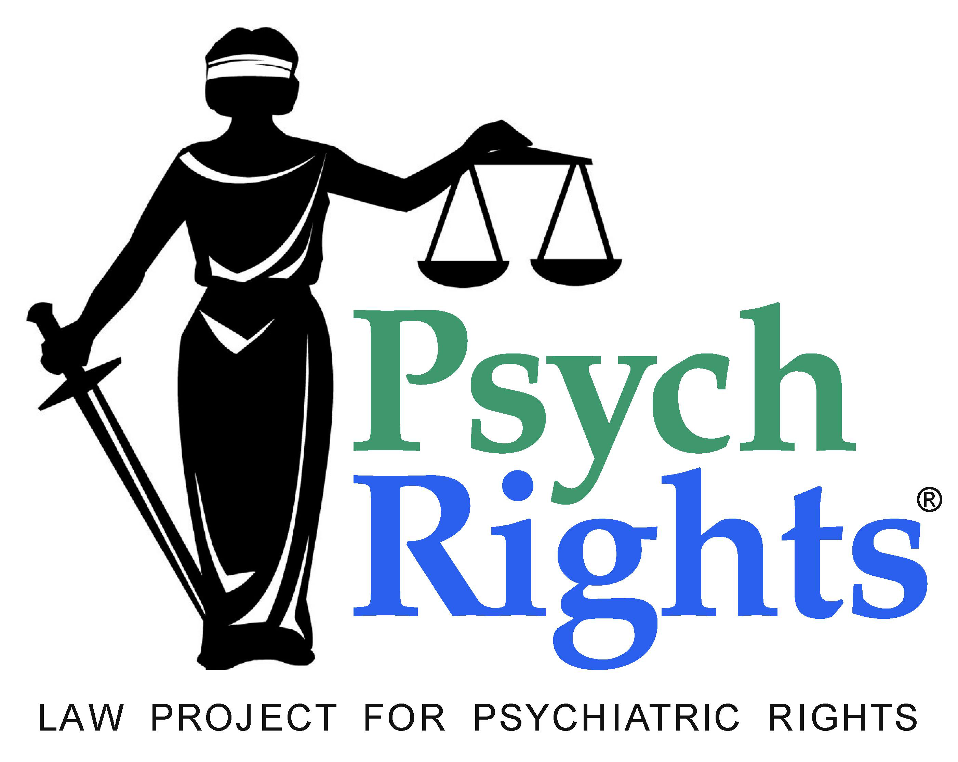

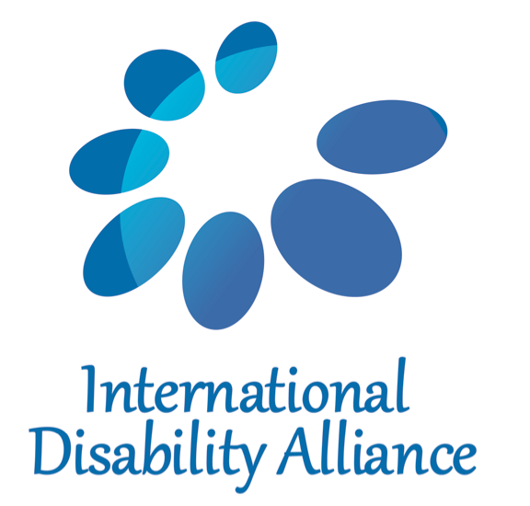


Repeal Mental Health Laws
Documenting and challenging forced psychiatric treatment

Joint Submission to Human Rights Committee for its review of the United States in October 2013 on nonconsensual psychiatric medication: Executive Summary

This report aims to provide experiential and research-based evidence for the harms done by nonconsensual psychiatric medication, and to urge the Committee to find that this practice violates Article 7 of the Covenant.

The practice of nonconsensual psychiatric medication is based on prejudice and faulty science. Prevailing narratives about "mental illness" in the U.S. are rigidly biomedical, locating the "mental illness" in the individual's brain, and the "underlying causes" in the individual's genes. The biopsychiatric narrative requires us to see people experiencing unusual mental phenomena or extreme distress as biologically defective and incapable of exercising agency, and this is both inaccurate and disabling.

Neuroleptic drugs, also called “antipsychotics,” are the class of medications most often administered without consent in psychiatric institutions. Both scientific research and subjective reports reveal the infliction of severe harm. These drugs, which “cause trembling, shivering and contractions, but mainly make the subject apathetic and dull his/her intelligence,” have been acknowledged since 1986 as a means of physical torture. The Committee on the Rights of Persons with Disabilities identifies forced drugging as a human rights violation and form of torture, and the Special Rapporteur on Torture calls for “an absolute ban on all forced and non-consensual medical interventions” in mental health settings, including the non-consensual use of “mind-altering drugs” as well as psychosurgery, electroshock, seclusion or any other restraints, for long- and short-term application.

Neuroleptic medications are known and established to cause tangible medical harm.
This harm is significant, reinforcing the Special Rapporteur's concerns that forceful use of such drugs, or their use over a person's objections, amounts to torture or ill-treatment. These harms include: Dysphoria, Tardive Dyskinesia (TD), Akathisia, Drug-Induced Parkinsonism, Dystonia, Adverse Cardiac Effects, Autonomic Side Effects, Metabolic Syndrome, and, rarely, Neuroleptic Malignant Syndrome (NMS). Additionally, there is concern that neuroleptic medication is at least partially implicated in a well-established 13-30 year loss of life for individuals with psychiatric disabilities. Lastly, research suggests that administration of neuroleptic medication causes permanent structural changes in the brain.

Neuroleptic medication antagonizes dopamine receptors in the brain, along with a variety of other actions that vary from drug to drug, which is simultaneously the source of its sometimes-desired effects and its significant adverse effects. Examples of harm reported by survivors include:

Severely restricted communicative skills (e.g. I could comprehend everything, but Zyprexa is known to cause disturbances in the area of the brain which controls speech in humans). As a result I went from an extremely outgoing personality brimming with thought and interactions...to an almost invisable lump of, well...who knows what?! Not being able to coordinate speech and thought meant the whole process from listening, reasoning and speaking out with own opinions became a two or three minute process. Of course, by the time I was finally able to speak...the conversation had moved on. The longer I was on the drug; the more effort communication became; until I just sank into a pessimistic fog and I withdrew from my family and friends.

I spent several months taking a very powerful ‘anti-psychotic’ tranquilizer drug called Navane, used to treat schizophrenia. It completely changed my personality and denied me the most basic sense of who I was; it made me stupider, slower, fatter, and also, because of the side effects, at times more desperate and suicidal. At one residential facility I was at, a man had killed himself right before I arrived. A patient who was his friend told me why: he was having severe side effects from his meds and no one was listening to him. The meds were why he jumped off the roof and killed himself, not mental illness. When I was on medication it was impossible to know how much of my pain was the medication, not the problems I had to begin with.

I have photos of that time, and the look in my eyes is totally different, not me, a different person. I was basically a zombie, but I was being docile so they considered it recovery. Today I worry that I might have some lingering side effects from the Navane and other drugs I took, including twitching in my body, memory disturbances, and worsened panic. There could be other long term damage that I may never be able to sort out and recognize.

I will always remember, too, the words “chemical lobotomy”. The effect of the drug Largactil (chlorpromazine), which I trustfully swallowed when I knew nothing about neuroleptics. I remember sleeping for hours, feeling like a zombie and having difficulty in getting up from a chair, and the intense pain in my joints. Even before I read the words “chemical lobotomy”, I knew that these drugs could not be good for me.

My son was first given Risperdal when he was seven years old in 1995 to “treat” his aggression. The betrayal of trust I felt when I learned about what this class of drug does to the human body is overwhelming.[…] He has suffered from akathesia and tardive dyskinesia since he was 13 years old. […]

According to the UN Special Rapporteur on Torture, inadequate weight is given to the views of children with disabilities in health-care settings in relation to forced medical interventions. Children have no opportunity to give meaningful informed consent prior to receiving psychiatric medications, and children who have been removed from their families and placed in foster care are particularly vulnerable to all forms of violence, abuse and exploitation including forced medication.

Federal, state, and local governments are involved in administering psychiatric medications to children via the medical system and foster care systems, providing significant financial profit for foster parents, drug companies, and doctors. Despite the acknowledgement that children’s problems are primarily due to poverty and family problems, prescriptions for neuroleptics have increased fivefold in children ages 2-17 receiving Medicaid services, the government-funded health insurance for low-income families. A similar increase was found in the rate of prescription of neuroleptics to all children, from the 1990s through the 2000s. The extent and consequences of prescribing to children are shown in the death of four year old Rebecca Riley died after having taken Seroquel, Zyprexa (both neuroleptics), and two other psychiatric drugs since the age of two.

In the United States, 26% of older adults housed in long term congregate care facilities (“nursing homes”) receive antipsychotic (neuroleptic) medications; among those diagnosed with dementia the rate is 40%. The drugs are also doled out to older people living in the community who need extra support. In 2011, the Inspector General of the Department of Health and Human Services Daniel Levinson noted that such drugs — which include Risperdal, Zyprexa, Seroquel, Abilify and Geodon — are “potentially lethal” to many of the patients getting them and that some drug manufacturers illegally marketed their medicines for these uses “putting profits before safety.” The drugs are typically used to control behavior that is annoying or troublesome to staff or other residents, and without seeking or obtaining the individual’s free and informed consent; often there is no discussion of the medication with the individual and his or her family. The effects of these drugs, including extreme fatigue, apathy, confusion and distress and personality changes, are dismissed as symptoms of dementia or mental illness.

[On the use of neuroleptics on older people]: Jerome Avorn, director of the program for the Analysis of Clinical Strategies at Harvard: "Drugs do work. They do quiet them down. So does a lead pipe to the head." Larry Hodge, administrator at the Life Care Center in Tennessee: "Too often they were so zonked out during their meals that their heads were in the mashed potatoes."

Wilda Henry told The Arizona Republic that her 83-year-old mother became "a vegetable" five weeks after taking Haldol. Her moter was “left her mother babbling, drooling, shaking, and unable to control her bowel functions“

Anise Debose of Washington, D.C., said her 76-year-old father entered a nursing home as an active, talkative person.Four days later, after taking Mellaril and four other drugs, "He was restrained to a chair as rigid as a board when I saw him. His head was thrown back and his mouth was limply hanging down. Both eyes were closed. The impression all of us had was that he was dead."

Nonconsensual medication takes place in “special needs units” of prisons where people diagnosed with a mental health condition are segregated from the general prison population. These units are notoriously abusive and practice restraint and solitary confinement as well as nonconsensual medication, as shown in descriptions by former prisoners.

They have a prison inside the prison and I was there too; it's called SHU or "Security Housing Unit." I was diagnosed as schizophrenic, and because of this diagnosis I was made to be in the isolation unit, in a one-person cell. Being diagnosed as schizophrenic was a way the criminal system controlled me with medication.

Looking back I don't think I was out of my mind, I was acting like that in the environment I was in, in isolation. Isolation is no good for any human being, not being by yourself without anything. I don’t know if there was a bible in there - if not for my spirituality I don’t know what would have happened. That man saw something in me. He gave other people medication but he didn't give me medication, he gave me candy. I'm not on drugs today and he played a major part in that.

The two (2) forced medication chairs are located in a room in one of the prison’s “special needs units” called #1-EE which is located in the south compound section of the prison here at Trenton State Prison (TSP). The chairs are situated side-by-side. The chair is designed to restrain a prisoner(s) from being able to move his or her arms, legs or mid-section of their bodies…. In some cases a gag made of white cloth is placed over the prisoner’s mouth underneath the black head net to prevent the prisoner(s) from spitting – or verbalizing his/her protest over being forced medicated!

Once a prisoner(s) is secured in the chair, a nurse injects the prisoner with some kind of psychotropic drug intravenously. The attending nurse is suppose to test the prisoner’s heart rate and blood pressure every fifteen (15) or twenty (20) minutes in the event the prisoner might possibly go into cardiac arrest from the forced ingestion of the psychotropic drug.

Survivors speak out on court-ordered medication:

Outpatient commitment is hell because once they've got you in the system they don't let you go. If you get outpatient committed too many times – They outpatient commit people who they call noncompliant. You can't even say to them “I don't want to take this drug for the rest of my life” because you're called noncompliant.

I have been repeatedly involuntarily hospitalized and court-ordered to psychiatric involuntary medication “treatment” in the United States approximately once a year ever since April of 2000 even though mental health courts have consistently found me to not present a “danger to self” or “danger to others” and merely be “persistently and/or acutely disabled.” … Many times I have often also been involuntarily medicated in psychiatric hospitals when no court orders have been in effect even though I never presented any realistic danger to anyone at any time, though hospitals at times used inflammatory language in attempt to justify their use of involuntary medication on me, such as referring to my arguing as being “combative” or merely checking boxes of “threat to self” and “threat to others” without providing any additional justification, especially since there was not any except for my trying to verbally assert grievances with the hospital staff. When I was in the state of Minnesota, the hospital staff placed me on an “emergency hold” even no “emergency” existed involving me and used that as justification to medicate me daily during my two weeks of being involuntarily hospitalized there. Throughout my thirteen years of being involuntary medicated, I have suffered numerous adverse effects including sleeping excessively, significant weight gain, the locking of my jaw, involuntary eye closures, stiffness of my right arm at a right angle, facial tardive dyskinesia, and akathisia with my legs involuntarily moving back and forth.

MindFreedom International receives many phone calls from individuals seeking help to stop forced mental health treatments. MindFreedom has issued human rights alerts to mobilize public response.

In 2013, an Action Alert was issued to Free Alison Hymes. Alison Hymes is confined to Western State Hospital in Stanton, Virginia. She's receiving shots of prolixin every two weeks against her will as a daily dose of anti-convulsion drug, Lamictal. Alison Hymes was the recipient of a kidney transplant following poisoning with psychiatric drugs after a previous incident of psychiatric malpractice. Alison Hymes is still in the psychiatric hospital and wants to get out, live in her own home and community.

The United States in its answer to Question 15 cited constitutional safeguards, the federal Protection and Advocacy for Persons with Mental Illness Program (PAIMI), and regulations on the use of seclusion and restraint. The constitutional standards and regulations cited perpetuate rather than eliminating nonconsensual medication of people who have been given psychiatric diagnoses, including the use of psychotropic drugs as a form of chemical restraint. The PAIMI program is overburdened and is an ineffective remedy so long as federal and state legal standards permit nonconsensual medication, civil commitment and other coercive practices in the mental health system.

We urge the Committee to adopt the following Concluding Observations with respect to Question 15:

The Committee notes with concern that the United States permits nonconsensual medication of adults and children who have been given a psychiatric diagnosis, both within psychiatric institutions, in the community (as “outpatient commitment”) and in situations of particular vulnerability such as foster care, jails and prisons, and services for older persons. Existing laws and regulations, including the standards applied under the federal Constitution, are insufficient to establish a requirement of free and informed consent of the person concerned with respect to all psychiatric medication and other mental health services.

It is questionable whether fully free and informed consent to psychiatric drugs is possible under the prevailing circumstances. Psychiatric drugs are not subjected to proper testing to establish safety and efficacy, are often used in untested combinations, and are prescribed pursuant to diagnostic classifications that are acknowledged to be invalid.

Nonconsensual medication with psychiatric drugs of a variety of classes including neuroleptics causes serious adverse effects including neuroleptic dysphoria, akathisia, tardive dyskinesia, metabolic syndrome, cardiac problems and physical changes to the brain, and inflicts physical suffering and mental anguish.

The Committee recommends comprehensive reform of federal and state laws and practices to:

- eliminate nonconsensual medication and other acts of coercion in mental health services, wherever they are provided;
- raise awareness of the harm done by neuroleptics and other psychiatric drugs;
- ensure that all instances of nonconsensual medication and other acts of coercion in mental health services are reported and investigated as acts of abuse and that individuals so victimized are afforded effective remedy and reparation; and
- channel resources into alternatives to the medical model of mental health.

See Annex III of main report for information about submitting organizations. Main contact for the report is Tina Minkowitz, tminkowitz@earthlink.net.
Special Rapporteur on Torture, E/CN.4/1986/15, paras 118, 119.
See e.g. CRPD/C/PER/CO/1 para 30.
A/HRC/22/53, para 89(b).
Méndez, Juan. Statement of the Special Rapporteur On Torture, 22nd session of the Human Rights Council. 4 Mar. 2013. Pg 4-7.
Miller, R. “Mechanisms of Action of Antipsychotic Drugs of Different Classes, Refractoriness to Therapeutic Effects of Classical Neuroleptics, and Individual Variation in Sensitivity to their Actions” Curr Neuropharmacol. 2009 December; 7(4): 302–314. doi: 10.2174/157015909790031229 PMCID: PMC2811864 <http://www.ncbi.nlm.nih.gov/pmc/articles/PMC2811864/>
A/63/175 (28 July 2008) para 57.
Woodward, Paul (2013). Abuse of psychiatry in U.S. far more extensive than occurred in Soviet Union. Retrieved from http://www.eurasiareview.com/13052013-abuse-of-psychiatry-in-us-far-more-extensive-than-occured-in-soviet-union-oped/
Mark Olfson, Carlos Blanco, Shang-Min Liu, Shuai Wang, Christoph U. Correll. National Trends in the Office-Based Treatment of Children, Adolescents, and Adults With Antipsychotics. Arch Gen Psychiatry. 2012;69(12):1247-1256. doi:10.1001/archgenpsychiatry.2012.647.
http://gaia-health.com/gaia-blog/2012-08-18/how-do-these-people-sleep-she-was-4-and-shes-dead-by-psychiatry/
http://www.theconsumervoice.org/advocate/antipsychotic-drugs.
http://www.fda.gov/Drugs/DrugSafety/PostmarketDrugSafetyInformationforPatientsandProviders/DrugSafetyInformationforHeathcareProfessionals/PublicHealthAdvisories/ucm053171.htm
See Patricia Bauerle’s affidavit, Annex II.
CCPR/C/USA/Q.4/Add.1, paras 72-73.

