BELIZE
NGO assessment of the follow-up actions of the State party in implementing
UN Human Rights Committee’s recommendations
As of 3 November 2020
BELIZE LGBT+ Organizations (NGOs)

Contact Details:
- Promoting Empowerment Through Awareness for LesBi women (PETAL), +(501) 607-4865, petalbze@gmail.com
- United Belize Advocacy Movement (UniBAM), +(501) 673-5641, unibambusiness@gmail.com
- Belize Youth Empowerment For Change (BYEC), (501) 615- 5017, bzeyec.org@gmail.com

This assessment form was developed with the support of the International Lesbian, Gay, Bisexual, Trans and Intersex Association (ILGA) to facilitate civil society assessment of the implementation of follow-up recommendations by the State party and more effectively contribute to the Committee’s follow-up procedure.

INTRODUCTION
The initial report of Belize on the State's compliance with the International Covenant on Civil and Political Rights (ICCPR) was examined by the United Nations Human Rights Committee (the Committee) in October 2018. As a result of the review, the Committee adopted the Concluding observations CCPR/C/BLZ/CO/1/Add.1 which include a set of recommendations to the State party.
Paragraph 48 of the Concluding observations states that “In accordance with rule 71, paragraph 5, of the Committee’s rules of procedure, the State party is requested to provide, by 2 November 2020, information on the implementation of the recommendations made by the Committee in paragraphs 15 (discrimination based on sexual orientation and gender identity), 25 (duty to protect the right to life) and 42 (refugees, asylum seekers and migrants) above.”
The purpose of this report is to contribute to the Committee's evaluation by providing the perspective of civil society organizations on the measures taken by the State to implement the recommendations on discrimination based on sexual orientation and gender identity selected for the follow-up procedure.
Submitted by:
o Promoting Empowerment Through Awareness for LesBi women (PETAL), +(501) 607-4865, petalbze@gmail.com
o United Belize Advocacy Movement (UniBAM), +(501) 673-5641
o Belize Youth Empowerment For Change (BYEC) +(501) 615-5017

With the support of the International Lesbian, Gay, Bisexual, Trans and Intersex Association (ILGA World)

Discrimination based on sexual orientation and gender identity
Para 14. The Committee welcomes the Supreme Court’s decision in Caleb Orozco v. The Attorney General of Belize et al. (2016), in which the Court recognized the unconstitutionality and discriminatory character of section 53 of the Criminal Code with regard to its criminalization of same-sex sexual conduct between consenting adults. It remains concerned, however, at credible allegations that lesbian, gay, bisexual, transgender and intersex individuals are stigmatized and are subject to de facto discrimination in the enjoyment of a range of rights on the basis of their sexual orientation and/or gender identity. The Committee is specifically concerned at reports of: (a) hate speech in media targeting lesbian, gay, bisexual, transgender and intersex individuals, with total impunity; and (b) violence, harassment and police abuse of authority experienced by lesbian, gay, bisexual, transgender and intersex individuals, a state of affairs that is exacerbated by the lack of effective investigations into such allegations and their lack of documentation in relevant databases (arts. 2, 7, 9, 20 and 26).

Recommendation of the HR Committee in para 15 | Action taken by the State | Measures needed additionally / Other comments
15. The State party should: (a) repeal section 53 of the Criminal Code and decriminalize same-sex sexual conduct between consenting adults; | The Government tried to appeal the decision of the Supreme Court. However, the Court of Appeal upheld the decision of the Supreme Court.  The Criminal Code has not been amended yet.  The State has taken no action. | The amendments to Section 53 of the Belize Criminal Code and Section 16(3) of the Belize Constitution need to be passed
Case: In 2010 Mr. Caleb Orozco of United Belize Advocacy Movement (UniBAM) brought a lawsuit against the Government of Belize, claiming that Section 53 of the Belize Criminal Code, which purported to criminalize private consensual homosexual conduct, violated several of his constitutional rights. On August 10, 2016, Honourable Chief Justice of Belize, Kenneth Benjamin ruled in favour of Mr. Orzco, finding that Section 53 of the Criminal Code breached several of Orozco’s constitutional rights including (Section 3) to dignity, (Section 6) right to equality before the law, (Section 12) freedom of expression, (Section 14) privacy and (Section 16) non-discrimination on the grounds of sex. Chief Justice Benjamin held that Section 53 of the Criminal Code should be read down to exclude consenting same sex intimacy in private. Section 53 of the Criminal Code would be revised to disregard penalty of sexual acts between two consenting adults of the same gender. The court extended its positive human ruling to declare the definition of “sex” in Section 16 (3) of the Constitution, outlining anti-discrimination, and including sexual orientation.
Developments after the Committee’s review: In October 2018, the Government of Belize appealed against the findings on Sections 12 and Section 16. On 30 December 2019, the Court of Appeal issued its judgment on the limited appeal, upholding the judgment of the Supreme Court. The Court of Appeal upheld the reasoning of Chief Justice Benjamin in the Supreme Court that non-discrimination on the grounds of “sex” under Sections 3 and 16 of the Constitution encompasses sexual orientation.

The State party should (b) explicitly reject any form of social stigmatization, discrimination and violence against persons based on their sexual orientation or gender identity and undertake to combat hate speech by public or private persons targeting lesbian, gay, bisexual, transgender and intersex individuals | The State indicated it was Investigating the situation.  The State has taken some measures, but additional information/measures remain necessary | - The State, with the support of the Media, use situations such as this experience to provide public awareness education promoting the Constitutional rights of all residents in Belize to deter discrimination.  - Information shared from the results of the investigation into the case of excessive force against a young police officer who was the victim of homophobic slurs by a crowd of passengers on a ferry boat.
Case : On a public transportation a Police Officer was subjected to homophobic comments which led to a brawl and eventual engagement by fellow law enforcement officers.

One Sunday afternoon, on board a water taxi loaded with passengers returning to the city from the popular Lobster Fest held in Caye Caulker, homophobic insults were hurled at a young police officer. A brawl became violent and the young police officer was removed from the water taxi and subdued by another officer as he fell unconscious.
A cell phone video showing a police officer in a rear naked choke hold and a boat filled with passengers, laughing and hurling homophobic comments at a young police officer went viral along with a video taken prior to the arrest of the young officer. The video showed a violent brawl inside a San Pedro Belize Express water taxi a few minutes before the vessel departed Caye Caulker Village.

The physical confrontation was between the young police officer and a couple of women over available seating on the boat, but a crowd of passengers hurled homophobic remarks. The police department spokesperson said they would be investigating whether excessive force was used to restrain the young police officer who was the victim of homophobic insults.

In anticipation of the Shadow Report a brief survey asked general awareness questions of stakeholders. Of 26 LGBT+ related civil society and government agency survey respondents a majority, 38.5%, indicated that government, its agencies and personnel had failed to support the LGBT+ community fighting hate speech, facilitate access to justice by victims of harassment or violence or police abuse, strengthening trust between government and LGBT+ people and increase financial or human resources of complaints receiving bodies. Over one third of respondents, 34.6%, indicated that they did not know whether government, its agencies or personnel had provided support in any of the seven areas.

Only one of 26 LGBT+ related civil society and government agency survey respondents felt that the Government of Belize, its agencies and personnel had explicitly rejected, in the assessment period, any form of social stigmatization, discrimination and violence against persons based on their sexual orientation or gender identity and undertake to combat hate speech by public or private persons targeting lesbian, gay, bisexual, transgender and intersex individuals. Over 80% of respondents said the government, its agencies and personnel either did none of the explicit conduct (46.2%) or they were unaware of any action (34.6%).

The State party should (c) remove any barriers to the enjoyment of rights by lesbian, gay, bisexual, transgender and intersex individuals | The State has taken no action. | Increased information creating awareness of government, its agencies and personnel support of LGBT+ people in identified areas.
The State party should (d) facilitate access to justice by victims of harassment, violence and police abuses, including by strengthening trust between lesbian, gay, bisexual, transgender and intersex individuals and State authorities and increasing the financial and human resources of complaint-receiving bodies such as the Professional Standards Branch | Commissioner of Police public response adds to the public stigmatization and discrimination of persons due to their SOGIE and socio-economic status in zeal to remove blame from the police department.  According to the Deputy Commander of Policy and Planning in the Police Force, the policy document – Police Interaction Policy with LGBT – a manual was approved inclusive of the interaction policy in 2020.  The State has taken some measures, but additional information/measures remain necessary | Commissioner of Police, the Police Department and other public sector organizations and personnel reflect the role of the state and impact on the responsibilities in the discharge of their duties to adhere to the rights of citizens regardless of their SOGIE and socio-economic status.
Case:
The media reporting on the story of the death of a young Belizean male headlined the story “Gay Man Dies, Family Says Police Abuse Played A Role”

The family of a 25-year-old male pointed fingers at the police for allegedly playing a role in his death. Before his demise he posted comments on social media that, about two weeks prior to his death, he was badly beaten by the police while he was in their custody April 5, 2020 for breaking the COVID-19 curfew requiring all residents to stay off the streets after eight o’clock at night. Shortly after being released from custody, friends and relative noticed that his left jaw had massive swelling that resulted in medical distress which, compounded with other severe health issues, created complications that led to his death.

While in detention, one police officer allegedly recorded a video portraying him as a ‘homeless degenerate.’ The young man, in his social media post, claimed that as a result that video that was shared on Facebook he became the victim of public humiliation through teasing. He publicly demanded that ‘those who found his misery amusing to leave him alone’.

In February 2019 a Stakeholders Meeting was held between LGBT organizations and the Commissioner of Police to discuss issues related to community policing and the rule of law in relation to the treatment of members of the LGBT community. The meeting also explored the possibility of a working relationship between the organizations and the Belize Police Department. Following this meeting, a policy document - LGBT police interaction - was drafted and submitted for consideration, approval and use by the police department.

The State party should (e) ensure the investigation, prosecution and punishment of any act of violence motivated by the victim’s sexual orientation or gender identity and ensure the systematic collection of data about such acts. | The State has taken some measures, but additional information/measures remain necessary | Increased information needed, creating awareness of government, its agencies and personnel support of LGBT+ people  Collecting data on what type of training programmes exist for police officers and related State personnel and how such training is implemented, including with participation of LGBTI organizations, on how to investigate properly anti-LGBTI cases?  Collecting data on cases of violence and discrimination against LGBTI people?  Challenge the constitutionality of existing laws
Over 80% of respondents said the government, its agencies and personnel either did not know (34.6%) or that the government, its agencies or personnel had not (46.2%) investigated, prosecuted or punished any act of violence motivated by the victim’s sexual orientation or gender identity or that there was systematic and continuous collection of data about acts of violence. Only one respondent affirmed that government, its agencies and personnel had investigated, prosecuted or punished any act of violence motivated by the victim’s SOGIE and had continuous collection of data about acts of violence.

According to the Commissioner of Police and the Chief Magistrate the ‘upholders of the law will therefore act in accordance with the law. This means that the domestic violence unit and the systems in place can only be afforded to what the law defines as couples. Same sex couples will be offered services. However, it will be dealt with as assault or the appropriate charge base on the impact or effects as outlined in the laws of Belize.

About the Organizations
PETAL- Promoting Empowerment Through Awareness for Lesbian and Bisexual Women (PETAL) was officially incorporated on December 29, 2015 as a not-for-profit, non-governmental organization. PETAL’s work, however, has spanned six years beginning in 2011 with several events held called “Conversations” that have brought women together to discuss issues that impact them. PETAL’s aim, like its name stipulates, is to empower women – particularly lesbian and bisexual women – by increasing their knowledge of a wide cross section of issues that impact them, directly or indirectly. For this reason, our activities ensure that accurate and relevant information is available and provided to anyone who attends our events.

UniBAM- United Belize Advocacy Movement is a non‐governmental organization that has been created in May 4th, 2006. It’s the oldest, and only LGBT policy and advocacy organization in the country. UniBAm focuses on using rights‐based approaches to reduce stigma and discrimination. Its focus is litigation, legal research impacting LGBT Belizeans, health and policy advocacy and managing a Human Rights Observatory which is supported by a lawyer.

BYEC- Belize Youth Empowerment For Change is a youth-led organization that works to empower young people to lead productive lives with LGBT youth as a focus, BYEC aims to reduce violence and discrimination across Belize.

ANNEX A FINDINGS FROM A BRIEF AWARENESS SURVEY

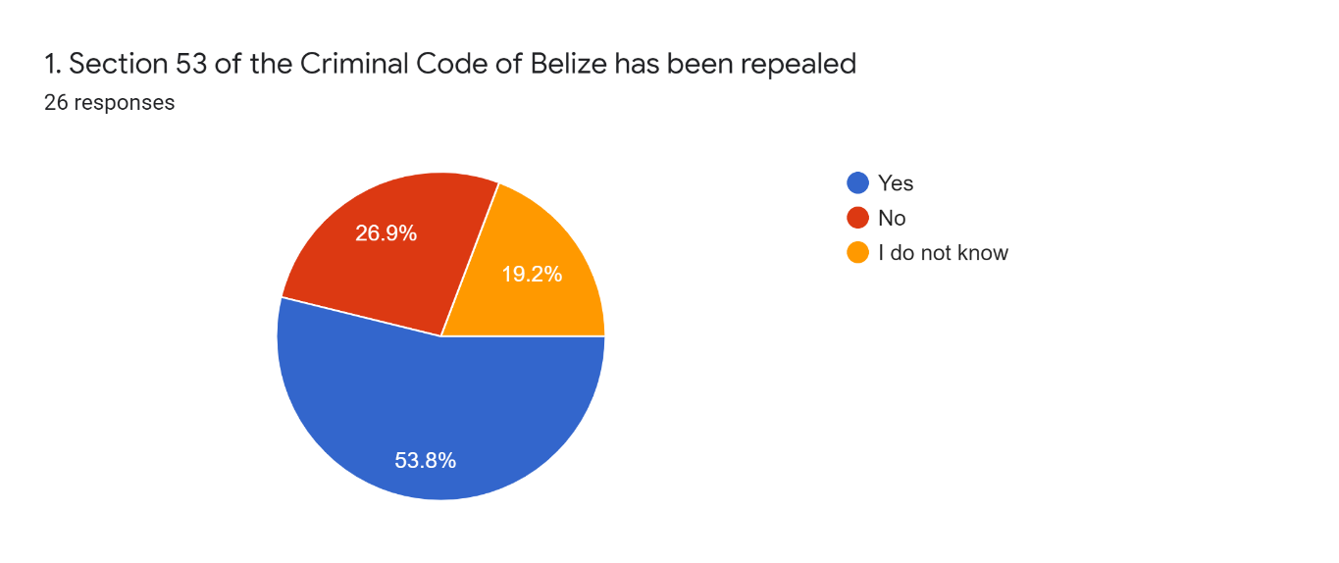

While more than half of the respondents knew that Section 53 of the Belize Criminal Code had been repealed, a high percentage, 46.1%, of participants did not know or responded ‘no’ to the repeal of Section 53. It is possible that the technical language used was not understood by some respondents and could have influenced how they responded.
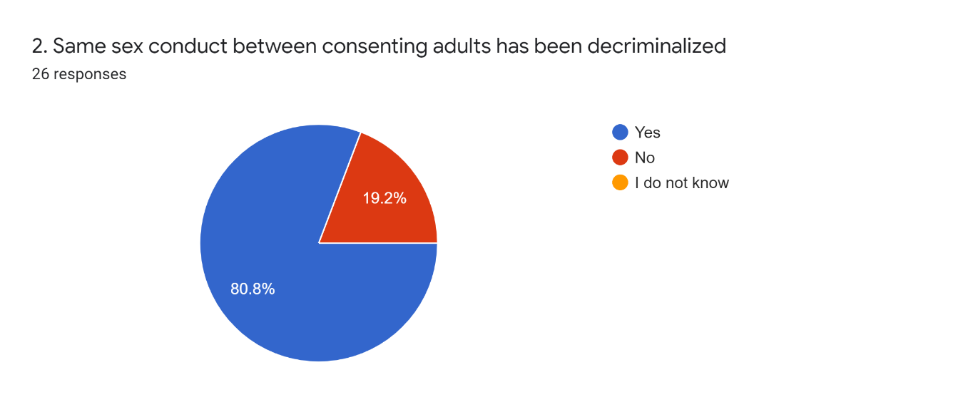

More than four years after the decriminalization of same sexual conduct between consenting adults and almost one year since the Court Appeal upheld specific contested elements one of five respondents, 19.2%, indicated ‘no’ to the decriminalization of same sex conduct between consenting adults. The respondents are from organizations that deal directly with the LGBT+ community so the lack of knowledge may be higher in the general population. Some advocacy work needs to be done to increase the level of awareness among the LGBT+ related organizations.

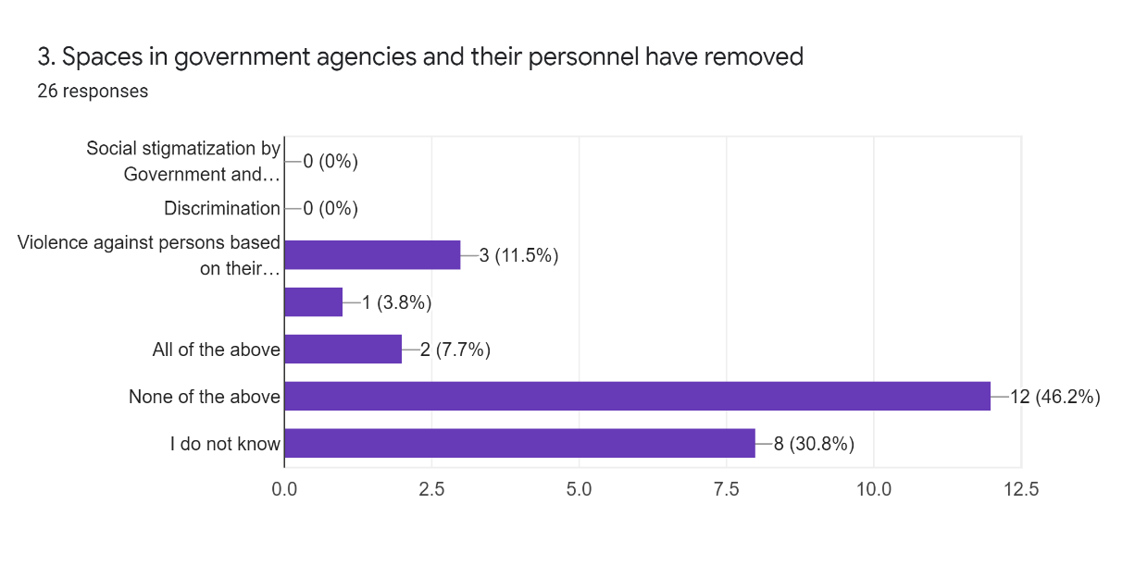
A large majority of respondents, 46.2%, indicated that government agencies and their personnel had not adequately supported the LGBT+ community in any of four defined factors (social stigmatization, discrimination, violence against persons and barriers to rights). A critical mass of respondents, 30.8%, responded that they did not know. Eleven point five percent, 3 respondents, indicated spaces in government agencies had removed violence against persons based on their sexual orientation or gender identity, while 7.7%, two respondents, indicated all four identified factors identified (social stigmatization, discrimination, violence against persons, and barriers to enjoyment of rights). One respondent, 3.8%, indicated there was removal of barriers to enjoyment of rights by LGBT+ persons in spaces by government agencies and personnel.
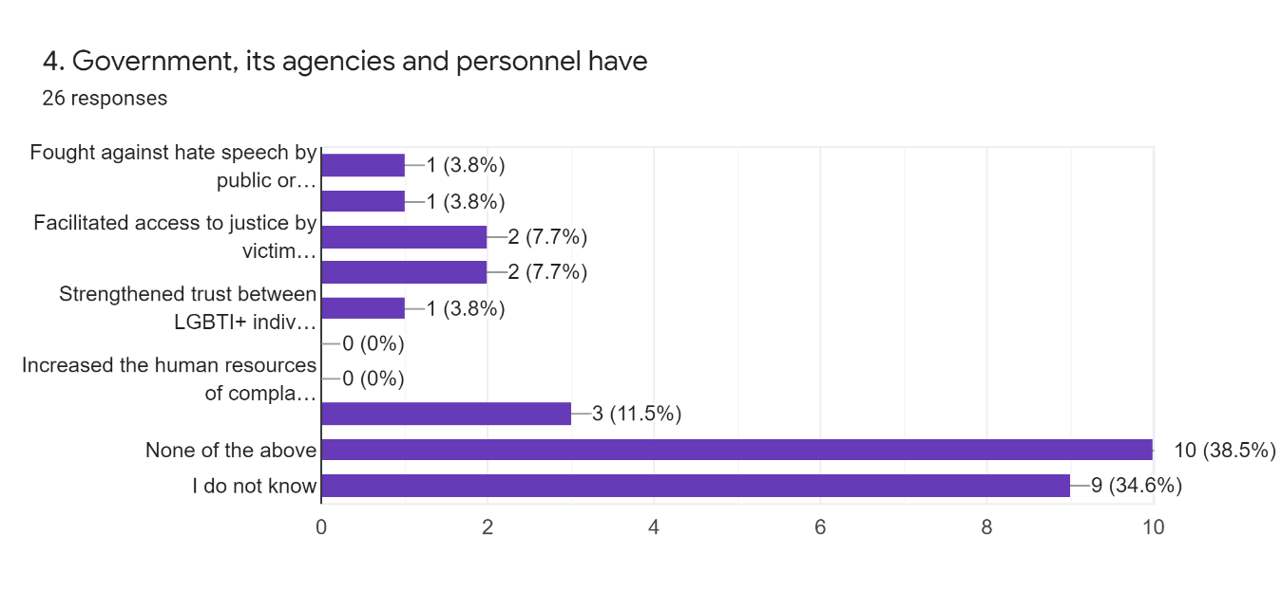

A majority of respondents, 38.5%, indicated that government agencies and their personnel had failed to support the LGBT+ community in any of seven defined factors (fight hate speech, facilitate access to justice by victims of harassment or violence or police abuse, strengthen trust between government and LGBT+ people, increase financial or human resources of complaints receiving bodies). Over one third of respondents, 34.6%, indicated that they did not know whether government, its agencies or personnel had complied with any of the seven factors. Eleven point five percent, 3 respondents, indicated spaces in government agencies had increased human resources of complaints’ mechanisms, while 7.7%, two respondents, indicated both facilitation of access to justice for victims of violence and police abuse. For each of three factors one respondent, 3.8%, affirmed that government, its agencies and personnel had a) fought against hate speech, b) facilitated access to justice by victims of harassment, and c) all seven defined factors.

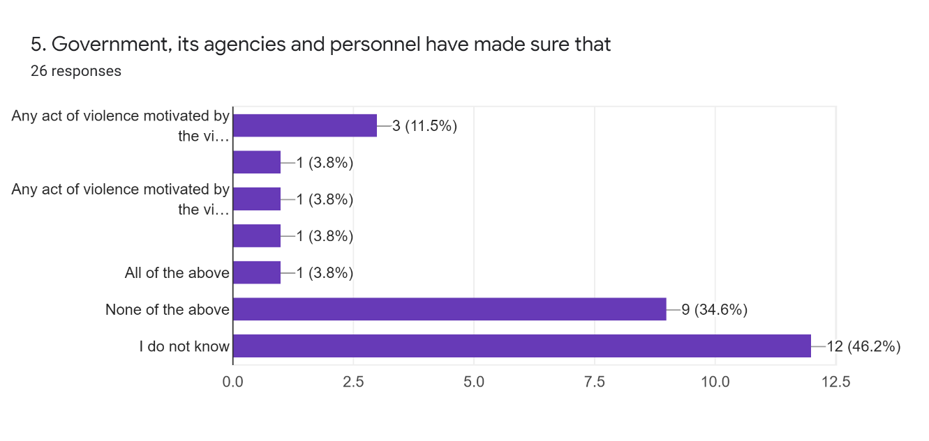

A large majority of respondents, 46.2%, indicated that they did not know if the government, its agencies or personnel had any act of violence motivated by the victim’s sexual orientation or gender identity was a) investigated, b) prosecuted or c)punished or d) that there is systematic and continuous collection of data about acts of violence. Over one third of respondents, 34.6%, indicated none of these four factors were being ensured by government, its agencies or personnel. Eleven point five percent, 3 respondents, indicated that government, its agencies and personnel made sure that any act of violence motivated by the victim’s sexual orientation or gender identity was investigated. One respondent, 3.8%, affirmed that government, its agencies and personnel had made sure a) all of the four factors defined were addressed, or any act of violence motivated by the victim’s SOGIE was b) prosecuted or c) punished and d) that there is systematic and continuous collection of data about acts of violence.

6. Other comment (optional)
Five of 26 respondents gave comments as listed below. Of these, 3 indicated needing to learn more about the issues identified in the questions. One person challenged the implementation of this survey and another commented on work that has been done but does not appear to have benefited in any significant way.
- I thought I would be able to answer these questions. Proves that I am not as knowledgeable as I thought I was on these issues.
- Where is this going
- There is a lot to learn about these issues
- There has been advocacy even by individuals who work for government agencies, but these have not resulted in tangible change.
- I would like to learn more.

Conclusion: Twenty-six survey responses from six (6) civil society organizations and two (2) government agencies suggest a need for increased information creating awareness of government, its agencies and personnel support of LGBT+ people in specified areas identified by the UNOHR in response to Belize’s 2018 Report on Human Rights. The survey data are reflective of comments shared by several respondents of a need for them to learn more about issues identified in the questions.

Concluding observations of the Human Rights Committee on the initial report of Belize are available here: https://bit.ly/2XC3uyj
https://www.sanpedrosun.com/community-and-society/2016/08/12/supreme-court-of-belize-rules-section-53-unconstitutional/
https://lovefm.com/section-53-argued-court-appeal/
https://www.commonwealthlawyers.com/the-americas/orozco-v-attorney-general-of-belize-belize-court-of-appeal-29-october-2018/
https://edition.channel5belize.com/archives/196145
https://edition.channel5belize.com/archives/187308
https://equal-eyes.org/database/2019/7/3/belize-special-envoy-calls-on-police-department-to-provide-training-for-security-of-lgbt-community
See findings of the brief survey in Annex A
https://edition.channel5belize.com/archives/201748
Media headlining of story at http://7newsbelize.com/sstory.php?nid=52841 on September 30, 2020
https://www.unaids.org/en/resources/presscentre/featurestories/2020/may/20200529_caribbean_homophobia_bullying
Minutes of the Stakeholder’s meeting of February 5, 2019
Minutes of Stakeholders’ Meeting of February 5, 2019
Personal Communication between PETAL Founder/President and Chief Magistrate Monday September 14, 2020

