2024
Labour Challenges in Azerbaijan:
Child Labour, Gender Pay Gap, and Employment Conditions

Alternative (shadow) Report to the Committee on Economic, Social and Cultural Rights (CESCR)

Labour Challenges in Azerbaijan:
Child Labour, Gender Pay Gap, and Employment Conditions

Prepared by
Fariz Namazli
Fariz Namazli, is a human rights attorney, engaged in strategic court litigation, women's rights, property rights protection, right to liberty and etc. He has extensive experience in filing more than 100 individual complaints with the European Court of Human Rights and the UN Human Rights Committee.

Contact: Fariz NAMAZLİ,
Tel: +994 (50) 292 86 24
Email: fmnamazov@gmail.com

2024
Table of Contents
- CHİLD LABOUR 3
- Information of international organizations in the field of child labour in Azerbaijan 3
- Information of national institutions about child labour in Azerbaijan and their activities 4
- Problems and Recommendations 10

- GENDER PAY GAP 11
- Backround 11
- The Problem and Its Underlying Causes 11
- Public Policy and Labour Legislation Impact on Gender Pay Gap 13
- Solutions to the Problem 15

- EMPLOYMENT AND UNEMPLOYMENT 17
- Minimum Wage 17
- Unemployment 21
- Right to Just and Favourable Conditions of Work 25

CHİLD LABOUR
- Information of international organizations in the field of child labour in Azerbaijan
Child labour continues to be a pressing issue in Azerbaijan, as evidenced by various local and international reports. The 2021 "End of Childhood" index by Save the Children placed Azerbaijan 93rd out of 186 countries, indicating a significant prevalence of child labour, with 6.5% of children aged 5-17 engaged in such activities from 2015 to 2020. Furthermore, Azerbaijan was ranked 130th in Humanium's Child Rights Realization Index out of 196 countries, highlighting deficiencies in upholding children's rights.
US Bureau of Labour Affairs and International Labour Organization Insights
In 2022, the US Bureau of Labour Statistics reported that 4.5% of Azerbaijani children aged 5-14 were involved in child labour. Notably, this statistic does not represent the full spectrum of child labour as it only captures the 5-14 age group. Among these, a significant majority (91.9%) were engaged in agricultural labour, with the remainder in services (7.2%) and industry (0.8%). This data underscores the prevalence of child labour in rural areas, predominantly due to agricultural dependence, which often leads families to involve their children in farming to secure their livelihood. 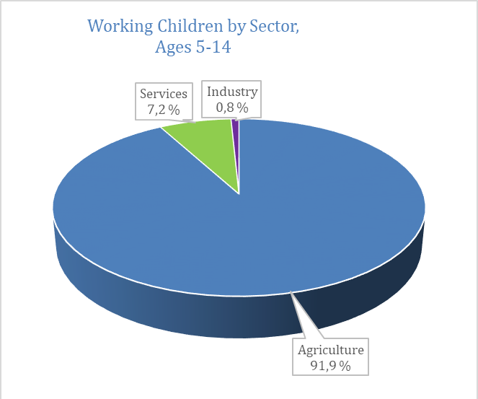 Graphic 1. Table 1.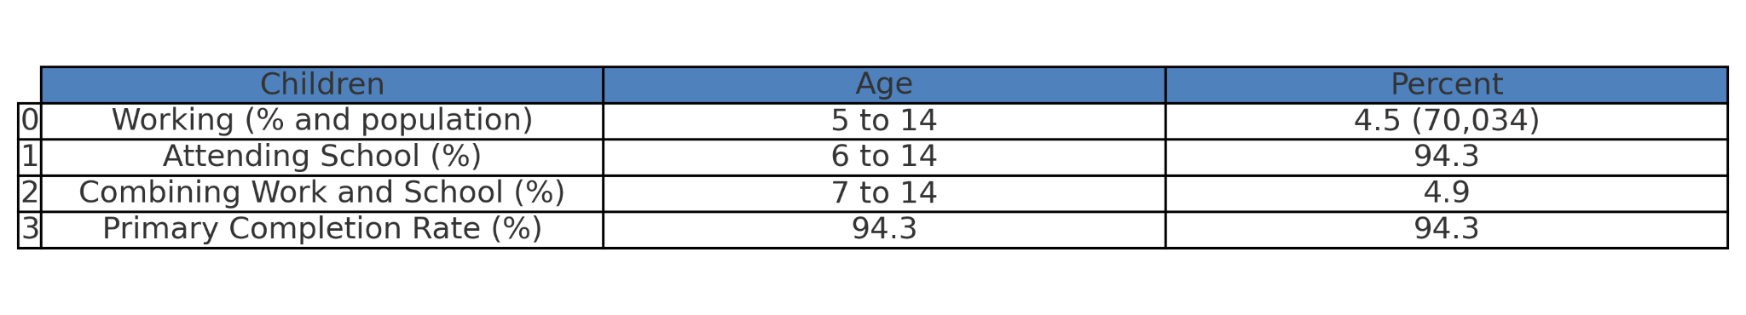
International Labour Organization
Furthermore, the International Labour Organization in 2021 estimated that around 38,000 children in Azerbaijan were engaged in hazardous occupations, particularly in agriculture and other physically demanding jobs.
- Information of national institutions about child labour in Azerbaijan and their activities
Azerbaijan has committed to international standards by ratifying key conventions against child labour, reflecting its dedication to safeguarding children's rights. The national constitution explicitly prohibits all forms of forced labour, including child labour, affirming the legal minimum age for employment as 15, with stringent conditions for hazardous work to protect the younger population. This legislative framework is further strengthened by specific provisions within the Labour Code that hold employers accountable for any violations against employing minors under the stipulated age, necessitating consent from legal guardians for workers aged 15 to 18.
1. Main Department of Combating Human Trafficking of the Ministry of Internal Affairs
The extent of child labour in Azerbaijan is substantial, yet precise statistics are hard to come by. The National Anti-Trafficking Coordinator's reports have recorded a considerable number of children involved in street work, begging, and exploitation over the last ten years.
Graphic 2.
It is important to note that the statistics shown in the aforementioned graph only account for children disconnected from family, educational, and social environments, specifically those begging or working on the streets. These figures do not encompass all children subjected to forced labour.
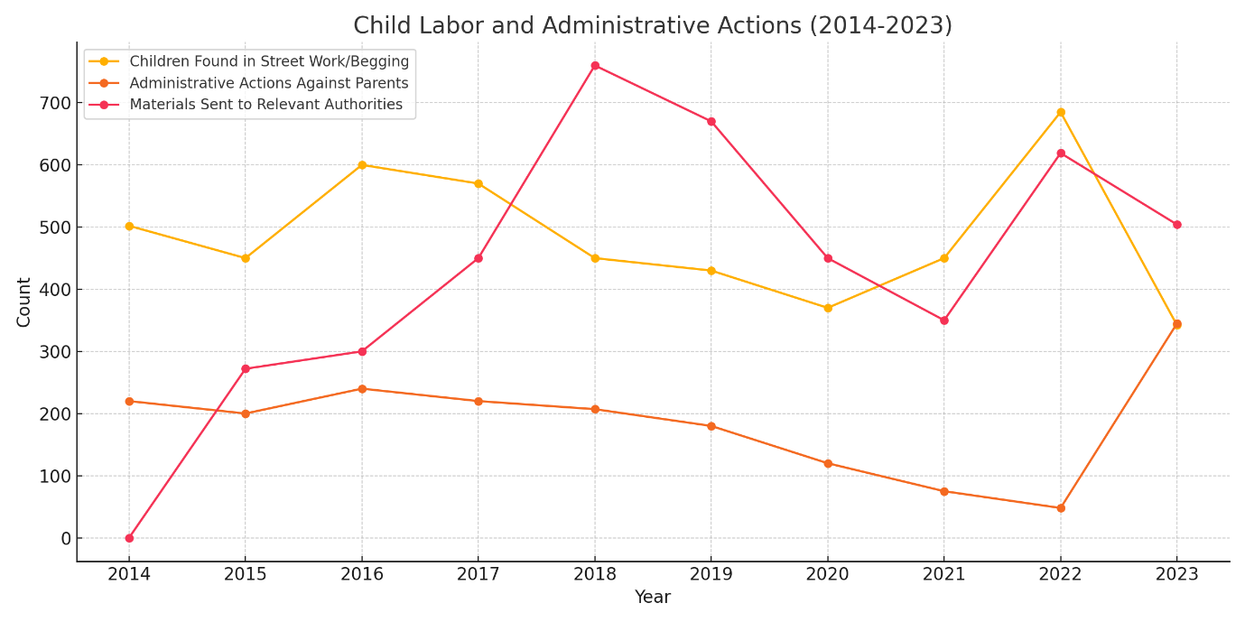
Graphic 3.
Over the past decade, the number of children found in street work and begging has fluctuated significantly, with peaks in 2016 and 2022 (Graphic 2), suggesting that efforts to address child labour have been inconsistent, often driven by periodic enforcement campaigns rather than sustained reductions. This inconsistency indicates that socio-economic pressures and enforcement vigor vary over time. Additionally, while the number of materials sent to relevant authorities increased, this did not lead to a corresponding decrease in child labour cases, revealing gaps in follow-up and enforcement efficacy.
The National Coordinator’s annual reports on combating human trafficking often classified children in street labour and begging as not victims of forced labour, leading to administrative rather than criminal penalties for parents. This approach aligns with the administrative legal framework rather than imposing stricter criminal sanctions, potentially allowing such violations to persist. According to the International Labour Organization (ILO), child begging should be considered a form of forced labour, warranting more severe penalties. The administrative handling of these cases suggests a need for a more robust legal framework and stricter penalties to effectively deter child labour.
In Azerbaijan, these cases are often treated as family issues by the police rather than labour violations, leading to referrals to the Commission on Juvenile Issues and Protection of Minors' Rights for service coordination instead of criminal investigation. Furthermore, child labour enforcement is heavily concentrated in Baku, with few investigations in other regions. Consequently, only about half of the parents are administratively penalized compared to the number of detected child labour cases, as shown in the graph.
To effectively combat child labour, it is essential to tighten legislation and ensure systematic enforcement of penalties. While criminal measures may not always be appropriate, consistent application of administrative punishments, monitoring of children's future well-being, and rigorous control measures are crucial.
Moreover, there are children involved in child labour who remain unregistered. For example, in 2021 and 2022, 972 and 926 previously undocumented children were identified and registered, respectively. Thus, it is crucial that the development of state policies on child labour prevention consider all children potentially at risk of exploitation in Azerbaijan.
2. Ministry of Labour and Social Protection of the Population (State Labour Inspection Service)
Despite these robust legal provisions, practical challenges persist, particularly due to a moratorium on labour inspections that critically restricts proactive enforcement measures. This moratorium has notably diminished the capacity of the State Labour Inspection Service, limiting it predominantly to desk reviews rather than on-site inspections, thus weakening the enforcement of child labour laws.
Also, under Article 192.8 of the Republic of Azerbaijan's Code of Administrative Offenses, officials are fined between 1,000 and 1,500 manats, while legal entities face fines ranging from 3,000 to 5,000 manats for employing individuals under the age of 15. Despite these punitive measures, the primary challenge in combating child labour lies in detecting such violations. The State Labour Inspection Service, functioning under the Ministry of Labour and Social Protection of the Population, is the designated authority for preventing child labour and implementing administrative measures in this regard. However, there is a notable lack of official statistics reflecting the administrative actions undertaken in this domain. According to the 2021 report from the Department of Labour Policy of the Ministry of Labour and Social Protection of the Population, only four cases of child labour involving individuals under 15 were identified, with corresponding fines imposed on the responsible officials and entities. This low number of cases highlights the inadequate enforcement measures in this area.
Detection of children involved in forced labour - Labour Relations Monitoring Center of the State Labour Inspection Service under the Ministry of Labour and Social Protection of the Population and the State Agency for Service to Citizens and Social Innovation under the President of the Republic of Azerbaijan to detect children involved in labour under the age of majority in violation of the requirements of labour legislation strengthening control over the implementation of legislation by; for this purpose, periodic monitoring can be carried out in the regional departments of the Inspectorate, and children involved in forced labour can be detected, and measures can be taken against those who involve them in accordance with the law. At the same time, monitoring of the Labour Relations Monitoring Center in the non-construction field and in regions other than Baku can be ensured.
The State Labour Inspection Service (SLIS) is tasked with enforcing labour laws concerning child labour in Azerbaijan. However, a moratorium on labour inspections significantly hampers its capacity to conduct proactive checks, leading predominantly to desk reviews rather than on-site investigations. In 2021, this limitation was evident as only four cases of illegal child employment under 15 were officially documented, indicating a deficiency in monitoring and enforcement efforts.
To address these challenges, it is recommended that Azerbaijan resume routine and targeted labour inspections, expand the labour inspector workforce to ensure comprehensive coverage, and strengthen the coordination among various state bodies to effectively combat child labour. Additionally, the government should prioritize data collection and the development of policies tailored to the most hazardous forms of child labour, particularly in agriculture, while ensuring equitable education access for all children, including those from marginalized groups.
3. Ministry of Science and Education
Furthermore, Article 181.0.1 of the Code of Administrative Offenses stipulates fines for individuals (100 manats), officials (300 manats), and legal entities (5,000 manats) for depriving someone of education at any stage, level, or form. Despite this, a significant gap in education persists: in 2010, 170,000 students enrolled in the first grade of secondary schools, but only 85,000 students graduated in the 2021-2022 academic year, indicating that nearly half of the children were excluded from various levels of education. However, data on how many individuals, legal, or official entities have been held accountable for this widespread educational neglect is unavailable.
Moreover, educational compliance is also a concern, with substantial discrepancies observed in school attendance and dropout rates, indicating a failure to fully integrate children into the educational system. The lack of comprehensive data and weak inter-agency coordination further complicates the landscape, making it difficult to enforce laws effectively and protect children from labour exploitation.
4. State Committee on Family, Women and Children's Problems
Article 181.0.3 of the Code of Administrative Offenses targets the unauthorized involvement of students in activities unrelated to their education. This legislation imposes fines of 100 manats for individuals, 300 manats for officials, and 5,000 manats for legal entities involved in such practices. The enforcement of this article aims to prevent the diversion of children from educational pursuits to non-educational activities that may undermine their academic and personal development.
The State Committee on Family, Women, and Children's Problems is tasked with enforcing this provision. According to a presidential decree, the Committee's senior officials, including the Chair, deputies, and regional leaders, are authorized to draft protocols for violations, ensuring that children are not inappropriately engaged in activities outside their educational responsibilities.
In response to our request for official statistics on the number of persons brought to administrative responsibility under Article 181.0.3 of the Code of Administrative Offenses (involving students in non-educational activities), the State Committee for Family, Women, and Children's Problems reported that no cases had been registered for this violation.
Overall, while Azerbaijan has established a solid legal framework to combat child labour, the implementation gaps, particularly in enforcement and inter-agency collabouration, pose significant barriers to eradicating child labour. Addressing these challenges requires a multifaceted approach that includes strengthening enforcement mechanisms, enhancing regulatory frameworks, and improving coordination among all stakeholders involved in child protection.

Table 2.
Violation | Responsible Institution | Relevant Article | Penalties | Information Request Findings
Employment of Minors | Ministry of Labour and Social Protection of the Population (State Labour Inspection Service) | Article 192.8 | - Fines for officials: 1000-1500 AZN  - Fines for legal entities: 3000-5000 AZN | - Despite repeated requests, no official statistics provided for the last five years  - Media reported 4 cases in 2021.
Educational Deprivation | Ministry of Science and Education | Article 181.0.1 | - Fines for individuals: 100 AZN  - Fines for officials: 300 AZN  - Fines for legal entities: 5000 AZN | - No response to information requests regarding the number of administrative actions taken  - Significant drop in school enrollment observed.
Involvement in Non-Educational Activities | State Committee on Family, Women, and Children’s Affairs | Article 181.0.3 | - Fines for individuals: 100 AZN  - Fines for officials: 300 AZN  - Fines for legal entities: 5000 AZN | - Official response indicated no cases recorded in the last five years.

- Problems and Recommendations
Problem | Recommendation
Incomplete Coverage of Compulsory Education | - Identify and involve absent children in education; register undocumented children  - Expedite identity documentation for children in shelters.  - Ensure education access for undocumented children.
Lack of Job Opportunities for Adults | - Create jobs matching rural skills.  - Involve unemployed persons in training.  - Raise awareness about state employment policies.
Weakness in Child Labour Prevention Education | - Hold information sessions for students.  - Prepare and distribute informational booklets.  - Educate employers on penal measures related to child labour.
Gaps in Coordination of State Bodies | - Ensure effective coordination among state institutions.  - Empower coordinating bodies to investigate and combat child labour.  - Increase referral coordination between ministries.
Detection of Children in Forced Labour | - Strengthen control over labour legislation.  - Conduct periodic monitoring  - Take legal action against those involving children in forced labour.  - Screen for forced labour indicators in child begging.  - Increase law enforcement investigations outside Baku.  - Ensure referral to social services to prevent recurrence.
Enforcement Challenges | - Resume routine, targeted, and unannounced labour inspections.  - Increase the number of labour inspectors.
Government Policy Gaps | - Adopt policies addressing worst forms of child labour.  - Revise policies on priority crops to prevent child labour in agriculture.
Social Program Shortcomings | - Collect and publish data on child labour.  - Ensure education access for marginalized and disabled children.  - Publish activities of social programs.  - Provide consistent funding for NGO-run shelters.

B. GENDER PAY GAP
- Background
The persistent gender wage gap, marked by a significant earnings disparity between men and women, remains a substantial obstacle to gender equality worldwide, with industrialized countries, including Azerbaijan, particularly affected. Despite Azerbaijan's Labour Code, especially Article 16.1, explicitly banning gender-based or unrelated job performance discrimination and striving for equal privileges, concessions, and rights, the reality remains stark. In 2022, women globally earned approximately 17% less than men, a disparity even more pronounced in Azerbaijan where women's earnings are only 65.8% of men's average monthly salary. This situation has prompted the "Socio-economic Development Strategy of the Republic of Azerbaijan for 2022-2026" to target an increase in this ratio to 80% by 2026, highlighting the critical need to identify and address the underlying causes of this wage gap.
- The Problem and Its Underlying Causes
The gender pay gap represents a complex and significant indicator of gender inequality, impacted by legal, economic, and social dynamics. This gap is especially significant in countries where female employment is low and manifests in two primary forms: unequal pay for the same work and broader wage disparities across different sectors due to various factors.
Underrepresentation of Women in Leadership and Politics
Women's presence in executive and governmental roles is notably scarce. In both the private sector and government institutions, female leadership is rare. When women are appointed to leadership positions in Azerbaijan, they are predominantly assigned to agencies dealing with family, children, and women's issues, reflecting traditional gender roles.
In Azerbaijani politics, women's underrepresentation is evident. According to the State Statistics Committee (SSC) for 2023, only 22 women serve as deputies in the Parliament, constituting 18.6 % of all deputies. There are only two female committee chairpersons, none in commission chair roles. The committees chaired by women are those of Family, Women and Children Affairs, and Culture. Out of 59 officially registered political parties in Azerbaijan, merely two are led by women.
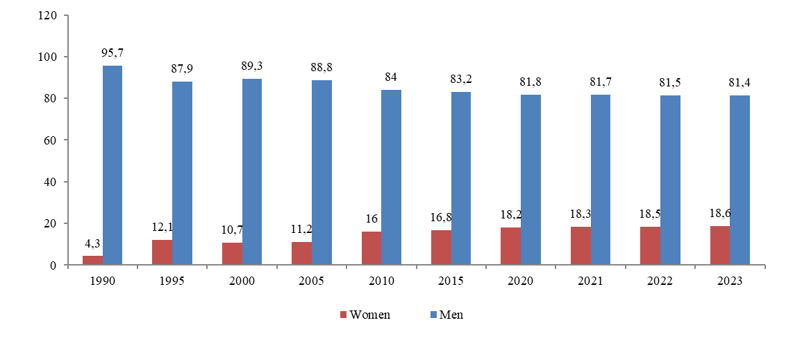
Graphic 4. Gender distribution of those elected to Parliament in 2023
Women's Concentration in Low-Wage Sectors
Approximately 24% of the gender pay gap can be attributed to women's overrepresentation in relatively lower-paying sectors such as social care, health, and education. This trend is largely driven by societal gender stereotypes, which significantly influence women's educational and professional choices.
Increased Burden of Domestic Responsibilities
The uneven distribution of domestic tasks, including childcare and housework, severely impacts women's career trajectories and earnings. Women in Azerbaijan, for example, spend three times more on unpaid work compared to men, limiting their time for paid employment and professional development. This imbalance not only reinforces traditional gender roles but also restricts women to part-time or lower-paid jobs, further widening the pay gap.
Interruptions in Career Paths
Women often face breaks in their careers due to childbirth and caregiving responsibilities, influenced by traditional gender roles. These interruptions diminish their career progression and seniority, while employer biases against hiring women due to these potential breaks exacerbate the problem. The exclusive provision of paid maternity leave, without corresponding paternity leave, reinforces this disparity.
Narrowing the gender pay gap fosters greater gender equality, reduces poverty, and strengthens the economy. Increased female participation in the labour market and reduced wage differentials would expand the tax base and alleviate the burden on social security systems. Estimates suggest that reducing the gender pay gap by one percentage point could boost the gross domestic product by 0.1%.
- Public Policy and Labour Legislation Impact on Gender Pay Gap
The Labour Code of the Republic of Azerbaijan is the primary legal framework governing labour relations, mandating equal working conditions for employees of the same role, irrespective of gender. Article 16 explicitly prohibits any form of discrimination based on gender, service position, or factors unrelated to work performance. Employers or individuals who engage in discriminatory practices are held accountable under the law, with affected employees entitled to seek judicial restoration of their rights.
The Criminal Code and the Code of Administrative Offenses address discrimination in labour relations, yet they lack specific norms for wage discrimination based on gender. Similarly, while the Law "On Guarantees of Gender Equality" prohibits different job requirements for men and women, this is often overlooked in practice, and no specific penalties are enforced for such violations. Discriminatory terminations due to pregnancy or caregiving for a child under three are criminalized.
Significant progress was made in 2022 when, following international recommendations, prohibitions on women working in 674 specific roles across various sectors were lifted. Now, only pregnant women or those with children under one year are restricted from certain jobs, a significant reduction from previous limitations.
Data from the SSC in 2021 shows women's average monthly nominal salary at 64.8% of men's. The largest wage gaps are in professional, scientific and technical activities, financial and insurance activities, and the manufacturing industry, with men's salaries sometimes more than double that of women. However, women are predominantly found in health and social services, education, and arts and entertainment.
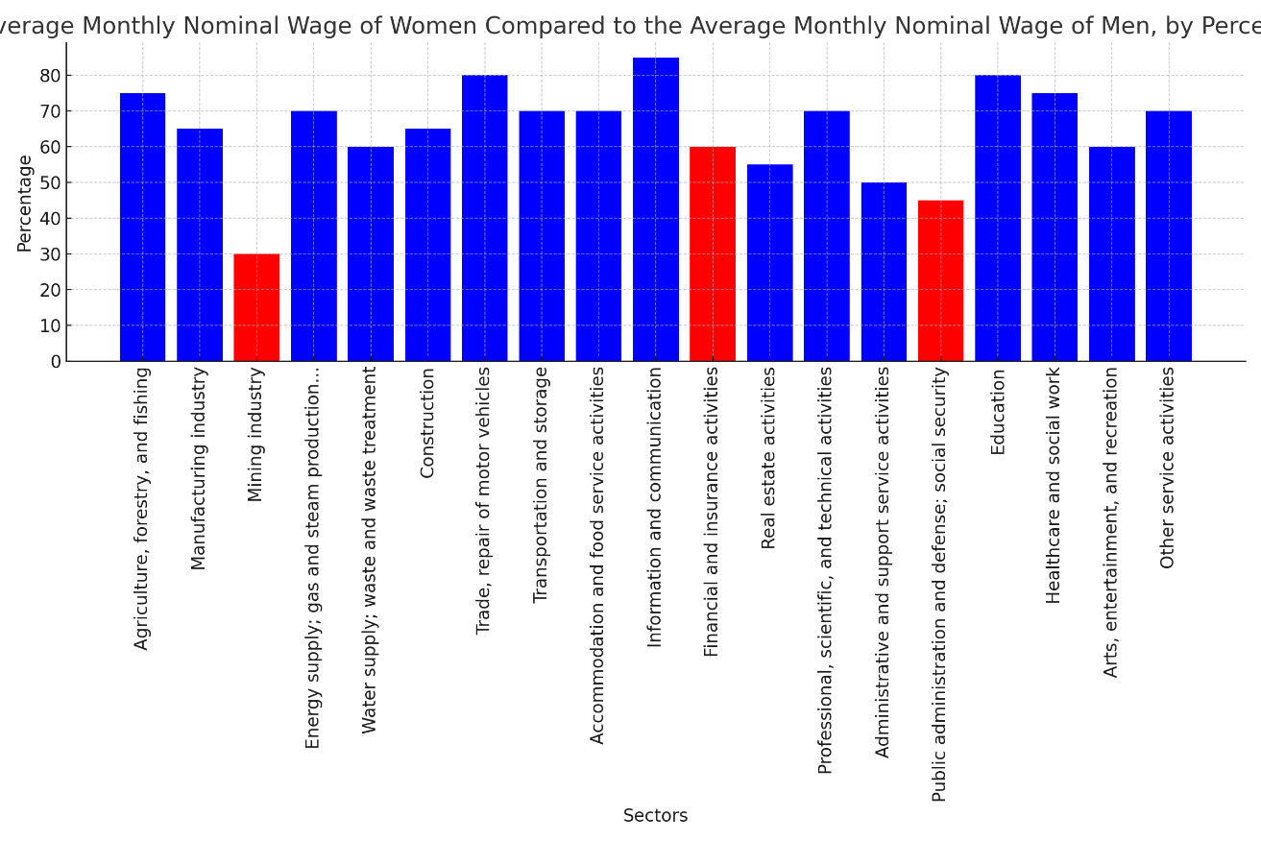
Graphic 5. Average Monthly Nominal Wage of Women Compared to the Average Monthly Nominal Wage of Men, by Percentage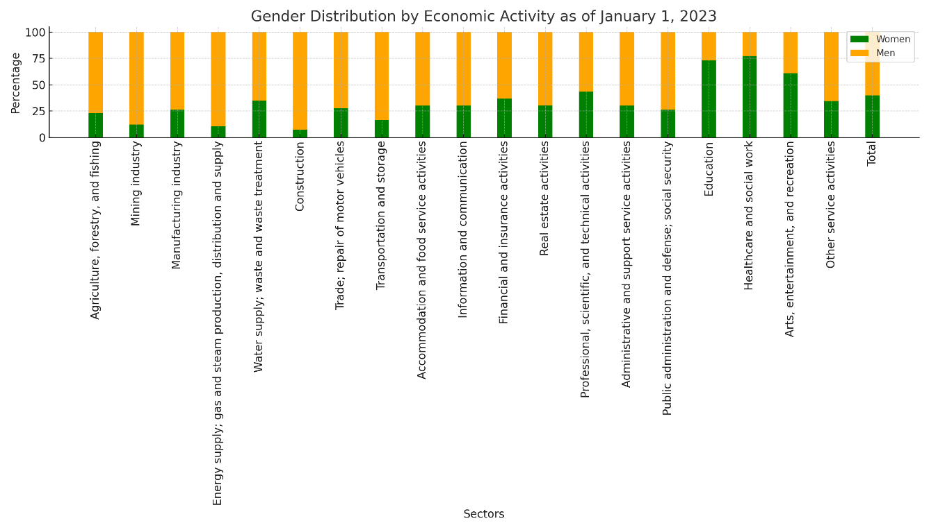
Graphic 6.Gender Distribution by Economic Activity as of January 1, 2023
The socio-economic development strategy for 2022-2026 aims to boost women's economic participation and reduce the wage gap, targeting an increase in women's average monthly salary to 80% of men's by 2026. However, the law "On Commercial Secrets" complicates identifying gender-based discrimination by treating salary details as confidential, thereby keeping potential cases hidden.
Women receive 126 days of paid maternity leave, and one parent or family member is entitled to partially paid leave for childcare until the child turns three. However, men's paternity leave of up to 14 days is unpaid, discouraging its use and placing more caregiving responsibility on mothers.
- Solutions to the Problem
To effectively address the gender pay gap in Azerbaijan, drawing from successful foreign practices and the analysis of the International Labour Organization, a multi-faceted approach is essential. Here is a systematic and innovative set of recommendations for the government:
Recommendation | Details | Rationale
Implement Regular Wage Transparency Reports | Mandate employers to submit detailed reports on male and female employee pay, including performance metrics. | Promotes open discussions on pay equity and compels employers to adopt fair pay policies.
Enforce Comprehensive Wage Audits | Require regular, thorough wage audits based on company size, analyzing pay disparities by job function, gender, and seniority. | Identifies systemic pay issues and ensures targeted interventions.
Revise the Law "On Commercial Secrets" | Update the law to exclude salary information from being classified as a commercial secret. Amend the Labour Code to invalidate confidentiality clauses on salaries in employment contracts. | Enhances salary transparency and empowers employees to negotiate fair compensation.
Develop a Digital Platform for Salary Transparency | Launch a user-friendly state-supported online platform for employers to submit wage transparency reports. | Facilitates compliance, reduces administrative burdens, and aids in preparing and submitting reports.
Introduce Paid Paternity Leave | Establish paid paternity leave to encourage fathers to participate in caregiving. | Reduces career interruptions for women and promotes shared parental responsibilities.
Set Gender Quotas in Leadership and Politics | Implement quotas for women in key decision-making positions and political party candidate lists. | Ensures gender diversity in leadership and decision-making roles.
Legal Penalties for Non-Compliance | Establish strict penalties for failing to meet gender pay equity standards and discriminatory practices in hiring and wage determination. | Enforces compliance with gender pay equity and deters discriminatory practices.
Guarantee Employee Access to Wage Information | Ensure employees can access comprehensive salary structure information directly or through representative bodies. | Empowers employees to understand and negotiate their pay, particularly in non-unionized settings.

By adopting these recommendations, Azerbaijan can make significant strides toward closing the gender pay gap, fostering a more equitable labour market, and promoting overall economic growth and social justice.

C. EMPLOYMENT AND UNEMPLOYMENT
- Minimum Wage
The Universal Declaration of Human Rights, adopted by the United Nations in 1948, states that "Everyone who works has the right to just and favourable remuneration ensuring for himself and his family an existence worthy of human dignity, and supplemented, if necessary, by other means of social protection." According to the International Covenant on Economic, Social and Cultural Rights, prepared by the UN, everyone is entitled to remuneration that provides at least the minimum wage set by the state for their work, without any discrimination.
According to the law on the minimum living wage, the need criterion is established to determine targeted state social assistance, based on the minimum living wage for the main socio-demographic groups of the population. The minimum subsistence level is a social norm comprising the value of the minimum consumption basket and mandatory payments. Consequently, one of the main factors influencing the formation of social benefits, the need criterion, and therefore the minimum wage, is the consumer basket. This law defines the consumer basket as a set of food, non-food goods, and services necessary for a minimum level of human health and life activity, determined based on scientific standards. The consumer basket includes a minimum set of food products, non-food goods (such as clothing, footwear, and stationery), and services (including utilities, transportation, communication, household, educational, cultural, and recreational services).
The main criticism of the consumer basket concerns its composition. For instance, in the Cabinet of Ministers' decision, the fee for internet services is calculated based on 1 hour per day per family, or the wear period for coat-type outerwear for the working population is 8 years, and for shoes, it is 3.5 years. Additionally, although the minimum living wage is reviewed annually in parliament within the framework of the budget envelope, legislation stipulates that the consumer basket be reviewed every three years. This timeframe prevents timely adjustments to reflect current consumer behavior and demands.
There are also issues related to the scope of the minimum consumption basket in Azerbaijan. Beyond food and housing needs, the International Labour Organization considers it essential to include healthcare, children's education expenses, and other necessary costs for participating in public life when determining the need criterion. However, the consumer basket in Azerbaijan does not account for these types of services.
Another significant point regarding the minimum and average monthly wages is that when Azerbaijan joined the European Social Charter in 2004, it committed to raising the minimum wage to 60% of the average monthly wage. According to Clause 7.3 of the "Azerbaijan 2020: A Vision of the Future" Development Concept, as per the Presidential Decree dated December 29, 2012, on improving the social protection system:
"In order to ensure a decent standard of living for working citizens, depending on economic development, measures will be taken to gradually align the minimum wage with the minimum living standards and achieve 60% of the average monthly wage established in European countries. Efforts will continue to increase the share of wages in the total income of the population and implement relevant measures in the field of social protection to reduce income inequality. Efforts will also be intensified to ensure safe and healthy working conditions for employees, and a State Program on labour protection and improvement of working conditions will be prepared."
Examining the ratio of the minimum wage to the average monthly wage from 2014 to 2024 shows that despite more than four years having passed since the target was set, it has not yet been reached.
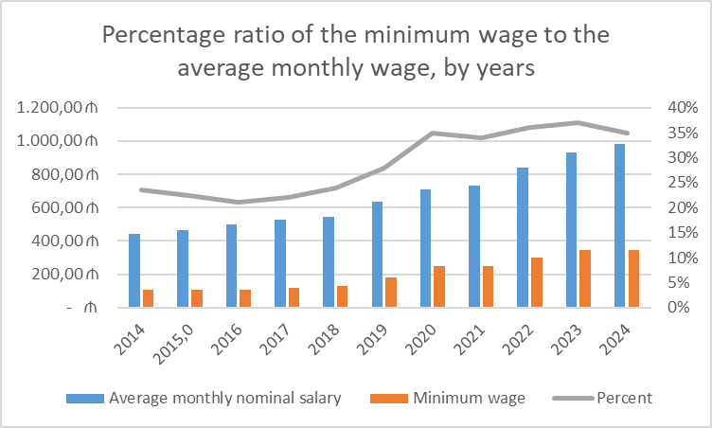
Graphic 7.
As of January 1, 2024, preliminary data indicates that the number of salaried workers in the national economy was 1,741.8 thousand, of which 899.1 thousand were employed in the state sector, and 842.7 thousand in the non-state sector.
In 2021, the Ministry of Labour and Social Protection of the Population announced the median salary for the first time, which was 343 manats in Azerbaijan. This means that the monthly salary of 850,000 out of 1.7 million wage earners in Azerbaijan is less than 343 manats. Additionally, this shows that the median wage in the country is only 48% of the average monthly wage, indicating that the average monthly wage is twice the median wage. This disparity is a clear indicator of significant income inequality in the country.
According to the Ministry of Labour and Social Protection of the Population, the median salary for 2023 was 478 manats, which is about 51% of the average monthly salary. Notably, according to OECD (Organization for Economic Cooperation and Development) statistics, the difference between median and average salaries in developed and several Eastern European countries typically ranges from 10-25%. In Azerbaijan, however, this indicator is more than double, highlighting a pronounced income disparity.
Recommendation | Details | Rationale
1. Revise the Consumer Basket Composition | Conduct a comprehensive review and update of the consumer basket to reflect current living standards and consumption patterns. | Ensures the consumer basket accurately represents the minimum requirements for a decent living standard.
2. Increase Frequency of Consumer Basket Reviews | Amend legislation to mandate annual reviews of the consumer basket. | Allows for prompt adjustments in response to changes in consumer behavior, inflation, and economic conditions.
3. Expand the Scope of the Minimum Consumption Basket | Integrate additional essential services, such as healthcare, education expenses, and participation in public life. | Accounts for critical expenses necessary for a decent standard of living and societal participation.
4. Align Minimum Wage with Living Standards | Implement measures to gradually increase the minimum wage to meet or exceed minimum living standards, aiming for 60% of the average monthly wage. | Reduces income inequality and ensures the minimum wage provides a sufficient standard of living.
5. Regularly Monitor and Adjust Minimum Wage | Establish a mechanism for the annual adjustment of the minimum wage based on inflation rates, economic growth, and changes in the cost of living. | Maintains the purchasing power of the minimum wage, protecting workers from inflation.
6. Address Income Inequality through Progressive Wage Policies | Develop policies such as progressive taxation and targeted social benefits for low-income earners. | Helps redistribute income more equitably and supports those with lower earnings.
7. Enhance Transparency and Data Collection | Improve the collection, analysis, and publication of wage data, including reports on median and average wages by sector and demographic group. | Provides a clearer picture of wage distribution and aids in designing effective wage policies.
8. Strengthen Social Dialogue and Worker Representation | Promote engagement between the government, employers, and workers' representatives in setting and reviewing wage policies. | Ensures that the needs and perspectives of all stakeholders are considered in wage policy decisions.

- Unemployment
According to the International Labour Organization (ILO) methodology, there are currently about 300,000 unemployed people in Azerbaijan. The unemployment insurance system faces several challenges, one of which is the significant disparity between the income and expenses of the Unemployment Insurance Fund. The Fund is financed through contributions from wages of citizens employed under official contracts (0.5 percent from employees and 0.5 percent from employers). There is a clear need to adapt the legislation to the current situation to better manage surplus funds and enhance the social welfare of the unemployed.
The Accounts Chamber's opinion on the draft law "On the 2021 Budget of the Unemployment Insurance Fund" highlighted that in 2019, the Fund's income was 12.6 million manats, while the unemployment insurance payments amounted to 2.268 million manats. In 2020, although the Fund's projected income increased to 15.1 million manats, the insurance payments were only 1.65 million manats, despite a planned expenditure of 10 million manats for this purpose.
1. Basis of Employee Dismissal: According to the law, individuals eligible for insurance payments include those whose employment is terminated due to the closure of the enterprise, layoffs, or the expiration of a fixed-term contract. This creates several issues. For instance, if a person is subjected to sexual harassment and resigns, they are not eligible for insurance payments because they left voluntarily. Similarly, employees who move to a new residence, leave work to continue their education, or resign for other personal reasons are also deprived of this right.
2. Lack of Information and Accessibility: Many citizens are unaware of unemployment insurance or are unable to access it due to a lack of internet and electronic systems. This lack of awareness and accessibility results in a significant difference between the income and expenses of the Unemployment Insurance Fund and a large number of people not registering as unemployed, leading to inaccurate unemployment statistics.
3. Legal Limitations: The legal restrictions increase the budget of the Unemployment Insurance Fund but prevent the effective allocation of these funds to the unemployed, contributing to poverty. As noted in the "State Program for Poverty Reduction and Sustainable Development in the Republic of Azerbaijan (2006-2015)," a portion of the population's poverty is linked to unresolved unemployment issues. Subsequent orders have addressed this, but accountability and transparency in reporting remain crucial. Disclosing the results of such reports is vital for societal and state development and for reducing unemployment and poverty levels.
Recommendation | Details | Rationale
1. Intensify Efforts to Reduce Unemployment and Underemployment | The government must implement targeted strategies to address unemployment and underemployment. This should focus on groups most affected, including women, young people, persons with disabilities, and internally displaced persons (IDPs). These strategies have to be tailored to the specific needs of these groups. | Addressing unemployment and underemployment in these vulnerable groups is crucial for improving overall employment rates and social welfare.
2. Enhance Vocational and Technical Training | Vocational and technical training programs should be developed and expanded to equip individuals with skills relevant to the current labour market demands. This must be done in collabouration with industries to identify key skills gaps and design training modules accordingly. | Ensures that the workforce possesses the necessary skills for employment, reducing unemployment and underemployment.
3. Improve Data Collection Systems | The system for collecting disaggregated employment data, including gender, age, disability status, and IDP status, must be strengthened and modernized. This should be achieved by implementing advanced data collection technologies and methodologies. Data must be updated and detailed in periodic reports. | Accurate, detailed data is essential for informed policy-making and effective monitoring of employment trends and issues.
4. Adapt Legislation to Improve Unemployment Insurance Fund Management | Legislation must be revised to align with current economic conditions, focusing on better management of surplus funds and enhancing social welfare for the unemployed. | Effective management of the Unemployment Insurance Fund will improve financial stability and provide better support for the unemployed.
5. Expand Eligibility for Unemployment Insurance | Eligibility criteria for unemployment insurance should be modified to include those who resign due to sexual harassment, relocation, education, or other personal reasons. This must be achieved by broadening the definition of acceptable resignation circumstances. | Expanding eligibility ensures broader support for unemployed individuals facing various circumstances, contributing to reduced poverty.
6. Increase Awareness and Accessibility of Unemployment Insurance | Public awareness campaigns must be implemented, and electronic systems should be enhanced to make information on unemployment insurance more accessible, especially to those lacking internet access. This should be done through a mix of traditional media and digital platforms. | Improved awareness and accessibility will encourage more people to register as unemployed, leading to accurate unemployment statistics and better fund utilization.
7. Address Legal Limitations to Fund Allocation | Legal restrictions that prevent effective allocation of the Unemployment Insurance Fund to the unemployed should be reformed. This must be done by revising the regulations to allow for more flexible use of the funds to provide adequate support and reduce poverty. | Effective allocation of funds will enhance support for unemployed individuals and contribute to poverty reduction.
8. Improve Transparency and Accountability in Reporting | Transparency and accountability in the reporting of unemployment and fund management must be enhanced. This should be achieved by regularly disclosing detailed results of reports to the public and stakeholders. | Transparency in reporting builds trust and ensures that funds are used effectively to address unemployment and poverty issues.

- Right to Just and Favourable Conditions of Work
From 2010 to 2022, there have been significant shifts in workplace conditions across various sectors. Starting with sanitation, the industry sector has seen a steady improvement. Back in 2010, there were 23,690 workers enduring unsanitary conditions. By 2022, this number had decreased to 15,879, indicating a positive trend towards better workplace hygiene. The transport and storage sector also followed this positive trajectory, with numbers dropping from 7,323 to 4,031 over the same period. This suggests efforts to improve sanitation have been somewhat effective in these sectors.
However, the construction sector tells a different story. While there was a notable drop in workers exposed to unsanitary conditions in 2020, the numbers surged again, peaking at 4,188 in 2022. This fluctuation points to inconsistent improvements, with some years showing better outcomes than others. In the information and communication sector, the situation remains relatively stable, albeit with a slight decline overall, suggesting that while improvements have been made, they haven't been as dramatic.
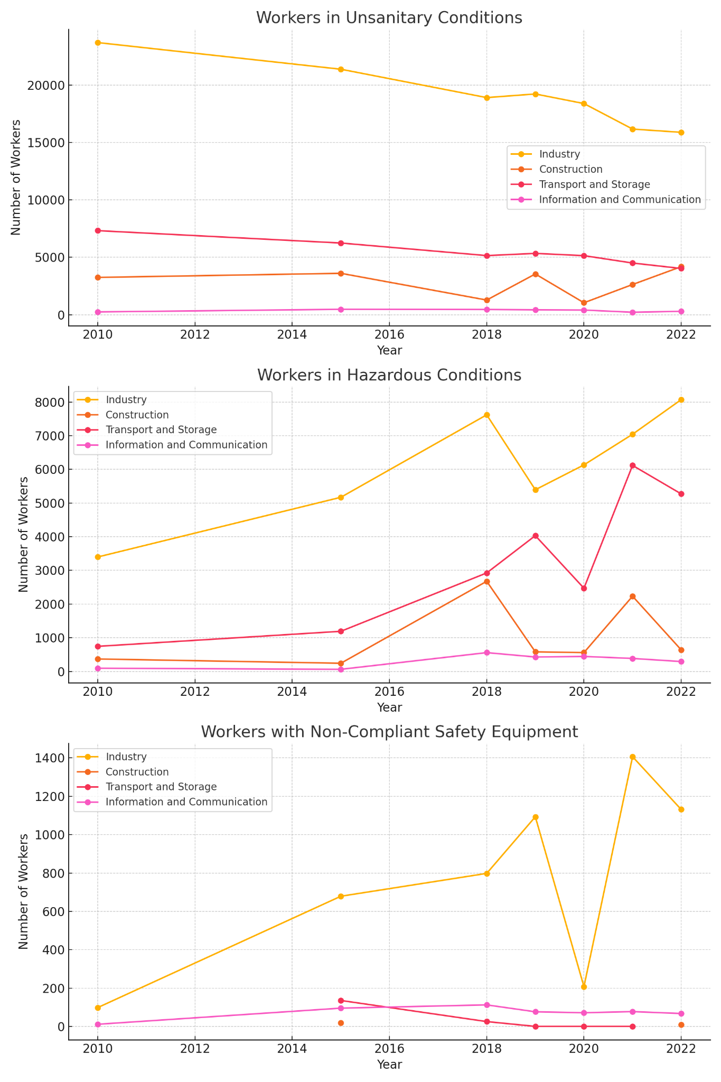Graphic 8.
Turning to hazardous working conditions, the data reveals some concerning trends. In the industry sector, the number of workers in hazardous conditions has more than doubled, increasing from 3,398 in 2010 to 8,071 in 2022. This significant rise highlights a growing issue that needs urgent attention. Similarly, the transport and storage sector has seen an increase in hazardous conditions, with numbers rising from 744 to 5,272 over the years. These trends suggest that despite advances in other areas, the risk of hazardous work environments is becoming more pronounced.
Graphic 9.
In the construction sector, there have been some dramatic fluctuations. The number of workers in hazardous conditions spiked significantly in 2018 and again in 2021, reaching as high as 2,676 and 2,233 respectively. Although there was a decline in 2022, the overall trend suggests that hazardous conditions remain a persistent challenge. The information and communication sector has also seen an increase, though the numbers are smaller, rising from 94 in 2010 to 293 in 2022.
Lastly, examining the use of non-compliant safety equipment, the industry sector again shows an increasing trend. The number of workers using such equipment rose from 99 in 2010 to 1,131 in 2022, peaking at 1,406 in 2021. This increase highlights ongoing issues with safety compliance. Data for the construction and transport sectors is less consistent, but the overall picture suggests that these sectors also face challenges in ensuring safety equipment compliance. The information and communication sector saw numbers peak in 2018 at 113 but then decline to 68 in 2022, indicating some improvement.
Graphic 10.
Despite the approval of the Statute of the State Labour Protection Fund by Resolution No. 423 of the Cabinet of Ministers of the Republic of Azerbaijan, dated September 27, 2019, there is no information about the activities of the fund available either in the media or on the website of the Ministry of Labour and Social Protection of the Population. According to Article 1.2 of that Regulation, the purpose of the fund is to provide material and technical support for labour protection measures implemented in accordance with the unified state policy on labour protection in the country. The fund's resources are to be used in the following areas:
1. Financing scientific research on labour protection;
2. Training labour protection specialists;
3. Preparing labour protection norms, standards, and rules;
4. Conducting propaganda and educational activities in the field of labour protection;
5. Creating and developing the material and technical base of state bodies operating in the field of labour protection (including the purchase, major and current repair of technological facilities, devices, equipment, vehicles, intangible assets, goods, and supplies);
6. Organizing and implementing control and monitoring in the field of labour protection;
7. Providing collective or individual remuneration to employees within the ministry system;
8. Preparing and implementing state and regional programs in the fields of labour relations, employment, social protection, and security.
In summary, while there have been notable improvements in workplace sanitation, particularly in the industry and transport sectors, the rising numbers of workers in hazardous conditions and those using non-compliant safety equipment across several sectors highlight areas that require urgent and sustained intervention. These trends underscore the need for ongoing efforts to improve workplace safety and hygiene to protect workers' health and well-being.
Recommendation | Details | Rationale
1. Enhance Labour Protection Fund Transparency | The activities of the State Labour Protection Fund must be made publicly available on the Ministry of Labour and Social Protection of the Population’s website and in the media. It should be done by regularly updating the public on the fund's initiatives, expenditures, and results. | Transparency in the fund's activities will build public trust and ensure accountability in the use of resources for labour protection measures.
2. Improve Work Conditions | Fair and favorable working conditions without discrimination must be ensured. This should be achieved by implementing strict enforcement of labour standards and regulations across all sectors. | Protecting workers from occupational injuries, accidents, exploitation, and abuse is essential for their safety and well-being.
3. Strengthen Labour Inspection Mechanisms | Labour inspections must be reactivated to enforce employment standards. It should be done by establishing a robust inspection framework to monitor compliance effectively. | Reactivating labour inspections will help enforce employment standards and improve workplace safety and hygiene.
4. Provide Effective Remedies for Labour Rights Violations | Access to effective remedies for labour rights violations must be provided, including compensation and guarantees of non-repetition. This should be done by establishing clear procedures for reporting violations and obtaining redress. | Ensuring remedies for labour rights violations will uphold workers' rights and deter future violations.
5. Address Hazardous Working Conditions | Urgent measures must be taken to reduce hazardous working conditions, especially in the industry, transport, and construction sectors. This should be done by enforcing stricter safety regulations and conducting regular safety audits. | Reducing hazardous conditions will protect workers' health and safety, preventing accidents and long-term health issues.
6. Ensure Compliance with Safety Equipment Standards | Compliance with safety equipment standards must be enforced. This should be achieved by monitoring the availability and proper use of safety equipment in all sectors, particularly where non-compliance is high. | Proper use of safety equipment is crucial for minimizing risks and ensuring workplace safety.
7. Expand Training for Labour Protection Specialists | Training programs for labour protection specialists should be expanded. This should be done by increasing funding and resources for training initiatives to equip specialists with the latest knowledge and skills. | Well-trained labour protection specialists are essential for effective implementation and oversight of labour protection measures.
8. Update and Implement Labour Protection Norms and Standards | Labour protection norms, standards, and rules must be regularly updated and effectively implemented. This should be done in line with international best practices and emerging trends in workplace safety. | Updating and implementing labour protection standards will ensure they remain relevant and effective in safeguarding workers.
9. Conduct Propaganda and Educational Activities | Propaganda and educational activities in the field of labour protection should be conducted. This must be done by raising awareness among employers and workers about labour rights and safety practices through workshops, campaigns, and training sessions. | Education and awareness are key to promoting a culture of safety and compliance in the workplace.
10. Develop State and Regional Programs for Labour Relations and Safety | State and regional programs focusing on labour relations, employment, social protection, and security must be prepared and implemented. This should be done by developing comprehensive strategies that address local labour market needs and safety challenges. | Comprehensive programs will address the diverse needs and challenges of different regions, promoting equitable and effective labour protection.

Save the Children “GLOBAL CHILDHOOD REPORT”, 2021, p. 3, https://www.savethechildren.org/content/dam/usa/reports/advocacy/2021-global-childhood-report.pdf?vanityurl=endofchildhood.
Humanium, “Ranking of countries according to their respect for the Rights of the Child “, https://www.humanium.org/en/rcri-world-ranking-by-countries/ .
US Bureau of Labor Affairs and International Labor Organization, 2022 Findings on the Worst Forms of Child Labor: Azerbaijan, https://www.dol.gov/sites/dolgov/files/ILAB/child_labor_reports/tda2022/Azerbaijan.pdf
International Labor Organization, 2021 report.
Constitution of the Republic of Azerbaijan, Article 17, https://www.e-qanun.az/framework/897
Labor Code of the Republic of Azerbaijan, article 12, https://www.eqanun.az/framework/46943.
The National Anti-Trafficking Coordinator's reports, for 2013-2023, https://insanalveri.gov.az/.
C029 - Forced Labour Convention, 1930 (No. 29), Art. 2, https://normlex.ilo.org/dyn/normlex/en/f?p=NORMLEXPUB:12100:0::NO::P12100_ILO_CODE:C029
Global Estimates of Modern Slavery 2022] (https://www.ilo.org/global/publications/books/WCMS_854733/lang--en/index.htm), ILO Child Labour Guidance](https://www.ilo.org/global/topics/child-labour/lang--en/index.htm)
“Children in Azerbaijan last year: those involved in begging, those without documents - NUMBERS" (Oxu.az, 28.04.2022), https://oxu.az/society/597744; “926 children without birth documents were found in previous years” (Apa.az, 08.05.2023), https://apa.az/az/social/evvelki-illerde-dogulmus-senedleri-olmayan-926-usaq-askarlanib-763523.
2022 Findings on the Worst Forms of Child Labor: Azerbaijan, p. 1, https://www.dol.gov/sites/dolgov/files/ILAB/child_labor_reports/tda2022/Azerbaijan.pdf.
Azərbaycan Respublikası İnzibati Xətalar Məcəlləsi, maddə 192.8, https://www.eqanun.az/framework/46960.
Biznes qurumları insan alveri cinayətinin subyekti kimi, https://socialrights.net/?p=3342
Code of Administrative Offenses of the Republic of Azerbaijan, article 181.0.1, https://www.eqanun.az/framework/46960.
S. Jahangirli, S. Askerov, LET OUR CHILDREN GET KNOWLEDGE, NOT MONEY: CHILD LABOR PROBLEM IN AZERBAIJAN POLICY DOCUMENT - 2023, page 11.
2022 Findings on the Worst Forms of Child Labor: Azerbaijan, p. 1, https://www.dol.gov/sites/dolgov/files/ILAB/child_labor_reports/tda2022/Azerbaijan.pdf.
Labor Code of the Republic of Azerbaijan, https://e-ganun.az/framework/46943
Forbes, "Gender Pay Gap Statistics In 2023", See: Harvard Business Review, https://www.forbes.com/advisor/business/gender-pay-gap-statistics/#sources_section.
Socio-economic development strategy in the Republic of Azerbaijan in 2022-2026, https://e-ganun.az/framework/50013.
Ibid.
State Statistics Committee, Gender distribution of those elected to Parliament, 2023, https://www.stat.gov.az/source/gender/
S. Yusifov, Sh. Abbasova, and Z. Babayeva, 'Different Prices for the Same Work: Ways to Eliminate the Gender Wage Difference in Azerbaijan,' 2023.
Ibid.
European Parliament, “Understanding the gender pay gap: definition and causes”, https://www.europarl.europa.eu/news/en/headlines/society/20200109STO69925/understanding-the-gender-pay-gap-definition-and-causes.
Law of the Republic of Azerbaijan on guarantees of gender (men and women) equality, https://e-qanun.az/framework/12424
World Bank, “Lifting Barriers to Women Employment Will Benefit Everyone in Azerbaijan”, https://www.worldbank.org/en/news/opinion/2023/03/08/lifting-barriers-to-women-employment-will-benefit-everyone-in-azerbaijan.
"List of productions, professions (positions) with harmful and difficult working conditions, as well as underground works, in which the employment of pregnant women or women with children under one year of age is prohibited" and "Prohibition of contact with pregnant women or women with children under one year of age in workplaces" No. 170 of the Cabinet of Ministers of the Republic of Azerbaijan, dated October 18, 1999, has been canceled, https://e-qanun.az/framework/54303
Socio-economic development strategy in the Republic of Azerbaijan in 2022-2026, https://e-ganun.az/framework/50013.
State Statistics Committee, "Distribution of salaried workers by types of economic activity as of January 1, 2023"
S. Yusifov, Sh. Abbasova, and Z. Babayeva, 'Different Prices for the Same Work: Ways to Eliminate the Gender Wage Difference in Azerbaijan,' 2023, See: Socio-economic development strategy in the Republic of Azerbaijan in 2022-2026,
Ibid. See: AR Law on Commercial Secrets, Art. 4.1.6, https://e-ganun.az/framework/2861.
UN, Universal Declaration of Human Rights, Art. 23.3, https://www.un.org/en/about-us/universal-declaration-of-human-rights
International Covenant on Economic, Social and Cultural Rights, 16.12.1966, Art 7., https://www.ohchr.org/en/instruments-mechanisms/instruments/international-covenant-economic-social-and-cultural-rights
AR Law on minimum living wage, art. 1.0.9, https://e-qanun.az/framework/5518
Ibid. art 1.0.1
Resolution of the Cabinet of Ministers of the Republic of Azerbaijan on approval of the composition of the minimum consumption basket in the Republic of Azerbaijan, https://e-qanun.az/framework/10061
F. Mehralizade, "Minimum wage and wage labor in Azerbaijan", 09.03.2021, p. 4, https://bakuresearchinstitute.org/the-minimum-wage-and-wage-labor-in-azerbaijan/?print=pdf
Resolution of the Cabinet of Ministers of the Republic of Azerbaijan on approval of the composition of the minimum consumption basket in the Republic of Azerbaijan,
F. Mehralizade, "Minimum wage and wage labor in Azerbaijan"
https://openazerbaijan.org/blog/az-rbaycan-n-ehtiyac-meyar/
F. Mehralizade, "Minimum wage and wage labor in Azerbaijan"
Voice of America, Expert: 'The minimum wage in Azerbaijan is the same as in Afghanistan', 26.11.2017, https://www.amerikaninsesi.org/a/ekspertler-azerbaycanda-minimum-emek-haqqi/4179953.html
Decree of the President of the Republic of Azerbaijan on the approval of the "Azerbaijan 2020: vision of the future" Development Concept, https://e-qanun.az/framework/25029
State Statistics Committee, on the number of people working in the economy and wages, 05.02.2024, https://stat.gov.az/news/index.php?lang=az&id=5774
State Statistics Committee, on the number of people working in the economy and wages, 09.02.2021, https://www.stat.gov.az/news/index.php?id=4803
F. Mehralizade, "Minimum wage and wage labor in Azerbaijan"
Turan.az, "The median salary in Azerbaijan increased by 12.7%", 01.11.2023, https://turan.az/az/iqtisadiyyat/azerbaycanda-median-emek-haqqi-127-artib-770982
Qafqazinfo, "Half of them receive a salary of 343 manats or less", 16.02.2021, https://qafqazinfo.az/news/detail/onlarin-yarisi-343-manat-ve-ondan-asagi-maas-alir-314960
Musavat, "The latest statistics on unemployment - 300 thousand or not...", 24.05.2023, https://www.musavat.com/news/issizkle-bagli-son-statistika-300-min-yoxsa_979481.html
F. Aghayeva, A. Iskenderzade, K. Salmanov, "Comparative analysis of the unemployment insurance system in Azerbaijan with other Eastern Partnership countries", 2023
Law of the Republic of Azerbaijan "On Unemployment Insurance" (June 30, 2017) Articles 1.1 and 2.0.1 https://e-qanun.az/framework/36310 Article 13 of the Law of the Republic of Azerbaijan "On Unemployment Insurance" (June 30, 2017) https://e-qanun.az/framework/36310
Ibid.
Decree of the President of the Republic of Azerbaijan on the preparation of the "State Program for Poverty Reduction and Sustainable Development in the Republic of Azerbaijan in 2006-2015" (June 20, 2005), https://e-ganun.az/framework/9982
The decision of the Cabinet of Ministers of AR on the establishment of the State Labor Protection Fund and approval of its Statute, https://e-qanun.az/framework/43350

