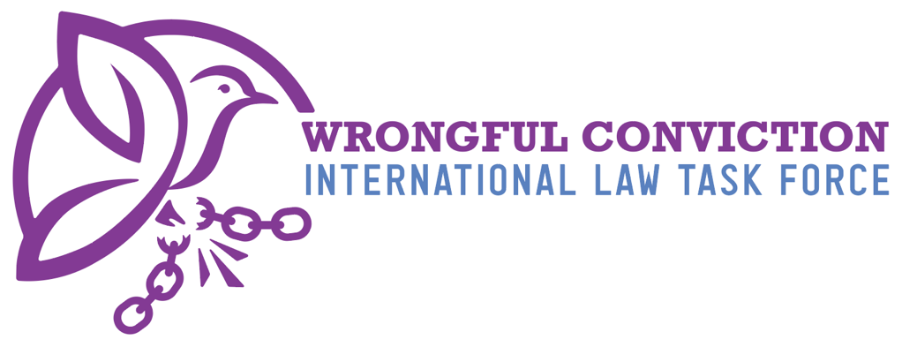

Concerning Guinea Bissau, presented to the
United Nations Human Rights Committee
Submitted on May 26, 2025.

- Authors
The Wrongful Conviction International Law Task Force (WCILTF) is a global coalition of law professors, attorneys and activists working together to fill the “Innocence Gap” in international law. The WCILTF is supported by a pro bono legal team at the international law firm Proskauer Rose (www.proskauer.com/) located in New York City.
In the past twenty-five years, wrongful conviction of the innocent has emerged as a major problem in criminal justice systems around the world. Research indicates that the problem has always existed but has only come to light in recent decades due to forensic advancements allowing for post-conviction DNA testing of crime scene evidence. Wrongful convictions occur because of human limitations in investigation and evidence collection, such as memory weaknesses and malleability (leading to misidentifications by eyewitnesses), unreliable or faulty forensic evidence, false confessions, confirmation bias or tunnel vision on behalf of investigators, inadequate defense lawyering, and many other human problems. Thus, wrongful convictions exist in all legal systems around the world, as all nations use the same types of evidence and investigation techniques regardless of the precise legal procedures employed in their courtrooms.
NGOs called “Innocence Projects” have sprung up around the globe to combat this problem, and now entire networks of innocence projects exist in Asia, Europe, North America and South America. Innocence Projects are often housed at law schools and are operated by law professors and law students. In one member state, for example, more than 3,000 innocent people have been released from prison in recent years due to the work of NGOs like Innocence Projects. Exonerations of the innocent have occurred across the globe in the past three decades.
For a brief video overview of the global problem of wrongful convictions, and the efforts of Innocence Projects to combat the problem, please view: https://youtu.be/jMATkuFaRU8?si=fO0wXGhPr-oCyhBA
As the innocence movement has developed a global presence in recent years, it has become apparent to legal scholars that an “Innocence Gap” exists in international law. The WCILTF formed to combat this problem and help fill the Innocence Gap. The WCILTF is comprised of more than twenty-five law professors and Innocence Project leaders from across Asia, Europe, North America and South America.

- Filling the Innocence Gap
Due to the relatively recent discovery of wrongful convictions, international law covenants and treaties predate awareness of this problem and thus do not speak directly to issue. In recent years, however, the United Nations Human Rights Committee (HRC) has identified key rights to the benefit of incarcerated person claiming innocence to be derived from the right to a fair trial and other existing rights. For example, in Abdiev v. Kazakhstan, 2023, the HRC stated that the right of incarcerated persons to re-open a criminal case in order to present new evidence of innocence after conviction and appeal have concluded, in order to achieve exoneration and freedom, is essential to the right to a fair trial under Article 14(1) of the ICCPR. Similarly, on October 3, 2023, in Concluding Observations on the Fifth Periodic Report of the Republic of Korea, the HRC observed that South Korea should “provide adequate legal and financial assistance to enable individuals sentenced to death to re-examine convictions on the basis of newly discovered evidence, including new DNA evidence.” Likewise, on July 25, 2024, in Concluding Observations on the Second Periodic Report of Maldives, the HRC expressed concern “about the lack of information on the existence of a procedure enabling individuals sentenced to death to seek a review of their convictions and sentences based on newly discovered evidence of their innocence, including new DNA evidence, and, if wrongfully convicted, to provide them with compensation.” The HRC recommended that Maldives take all necessary measures to ensure that “death sentence can be reviewed based on newly discovered evidence of their innocence, including new DNA evidence, adequate legal and financial assistance is provided to enable this review and, if wrongfully convicted, individuals have access to effective remedies, including compensation” para. 28(e). See Brandon Garrett, Laurence Helfer and Jayne Huckerby, Closing International Law’s Innocence Gap, S. Cal. L. Rev. 95 (2021), available at: https://papers.ssrn.com/sol3/papers.cfm?abstract_id=3803518#

- Rights of Innocent Incarcerated Persons in Guinea Bissau
Based on the research of the WCILTF, it is our belief that Guinea Bissau does not have laws establishing rights for innocent incarcerated persons and lacks a legal mechanism for exoneration of the wrongfully convicted.
Guinea Bissau’s constitution and law does provide from some protections against wrongful conviction. For example, the law provides that a defendant has a right to counsel and a right to a fair and public trial. Additionally, Article 41, Paragraph 6 of the constitution provides that a defendant who has been unlawfully convicted can have the conviction reviewed and obtain compensation. However, the structure of the legal system, the state of the government, and the economics of the country prevent consistent implementation of these rights.

Lack of Judiciary Independence
While the constitution calls for an independent judiciary, WCILTF’s research shows that the judiciary, the prosecution, and the police are subject to political manipulation, bribery, and corruption. Research shows that judges often work in tandem with the police or politicians. There is no independent police oversight in Guinea Bissau. Prosecutors’ work is rarely reviewed, and they are also subject to political interference, with prosecutors sometimes removed from office if they do not comply with the desires of those in authority. This lack of independence from political influence means that criminal investigations and trials often are unfair and may be politically motivated.
Lack of Access to and Funding for the Legal System
Article 32 of Guinea Bissau’s constitution states that all citizens shall have the right to access the courts to seek redress for violations of their rights. However, in reality, most of the population lacks access to the legal system. Some parts of the country do not have a courthouse, there may not be any police officers, and many remote areas of the country do not have access to lawyers.
Guinea Bissau does not have an adequate budget to fund the legal system’s proper functioning. Outside of the capital, Bissau, much of the country does not have access to courts, police, or lawyers. Some regions of the country do not have an accessible courthouse. The judicial police force is responsible for assisting in criminal investigations and has national jurisdiction; however, they only have a single unit located in the country’s capital. Many remote areas of the country do not have access to lawyers.
Given the lack of funding, Guinea Bissau does not have access to scientific and forensic evidence. The country does not have the capabilities for DNA testing and does not have a forensic laboratory or a forensic institute. As such, there are no laws requiring preservation of biological evidence. As a result, investigations and convictions rely largely on witness-based evidence. Despite the country’s reliance on witness-based evidence, WCILTF could not identify any procedures directing the police on proper procedure regarding eyewitness identification or interview processes.
Additionally, WCILTF’s research suggests that Guinea Bissau does not have a law providing access to information or records. Research suggests that records are closed and citizens do not have a legal mechanism to request records.
Conclusion
In conclusion, the WCILTF was unable to identify any working mechanism in Guinea Bissau that allows for innocent incarcerated persons to achieve exoneration and freedom. Our research did not indicate that any person in Guinea Bissau has been exonerated due to wrongful conviction.

This document created by the following members of the WCILTF:
Name, title, email address of the individuals and Proskauer attorneys who worked on this
To contact the WCILTF generally, please email:
Prof. dr. mr. G.J. Alexander Knoops. Professor Mark Godsey
Advocaat/Attorney at law University of Cincinnati College of Law
Professor Politics of International Law Director, Ohio Innocence Project
alex@knoopsadvocaten.nl markgodsey@gmail.com

