KOREA FALUN DAFA ASSOCIATION

International Covenant on Civil and Political Rights
Submission to the UN Human Rights Committee’s 139th Session (October 2023)

SOUTH KOREA
Violation of Shen Yun Performing Arts’ Freedom of Expression
This briefing details the violation of artistic freedoms in South Korea due to the influence of the People’s Republic of China’s censorship. Shen Yun Performing Arts first travelled to Korea in 2007, and nearly every year since the national government of Korea and local officials have permitted or even been complicit in PRC-led censorship, resulting in many theatres’ refusal to rent their venues to Shen Yun. In doing so, Korea has violated the freedom of expression (Covenant Article 19) and is, furthermore, contributing to the PRC’s gross human rights abuses and religious persecution of Falun Dafa practitioners (Covenant Article 18). We hope the Human Rights Committee will:
- Examine these violations of artistic freedom in Korea that are taking place under the influence of a foreign regime.
- Raise the above issue to Korea’s representatives in the 139th session, in particular asking what response has been made by Korea’s Ministry of Foreign Affairs to PRC censorship in Korea, and what is the guideline of the Ministry of Culture, Sports and Tourism to the national and public theatres facing such transnational pressure.
- Recommend, in its sixth state party report concluding observations, that any foreign censorship within the jurisdiction of Korea be denounced and rejected.

Established in 2001, the Korea Falun Dafa Association is a volunteer-based nongovernmental organization committed to raising awareness about the ongoing persecution of Falun Dafa practitioners in China. To fulfil this mission, it organises parades, painting exhibitions, and other community activities. Starting in 2007, the Korea Falun Dafa Association also began serving as the hosting organizer for Shen Yun Performing Arts’ annual shows in Korea.
Renaissance tower #808, 14 Mallijae-ro, Mapo-gu, Seoul, Korea
Tel: 82-10-8742-1510 e-mail: ohsyz0860@gmail.​com ​Secretary-General: Seyeol Oh
www.falundafa.or.kr
- Background
  - Shen Yun: Based in New York, Shen Yun was established by practitioners of Falun Dafa (also called Falun Gong) in 2006. The company’s mission is to revive five thousand years of Chinese civilisation. This ancient culture, which traditionally was said to be divinely inspired, has been almost entirely wiped out under decades of communist rule. Shen Yun’s performance consists mostly of classical Chinese dance and music. Alongside dances portraying stories from dynasties and heroes of the past, some of the show’s pieces also depict the story of what Falun Gong practitioners face in China today.
  - PRC persecution of Falun Dafa in China: On 20 July 1999, the Chinese Communist Party (CCP) launched a persecution campaign aimed at practitioners of Falun Dafa, a meditation discipline based on the principles of “Truth, Compassion, Forbearance.” Millions of Falun Dafa practitioners in China have been fired from their jobs, expelled from school, jailed, tortured, or killed simply for practicing Falun Dafa. Soon, these people became the main targets of state-sanctioned forced organ harvesting and have been killed in order to extract their vital organs, which are used to fuel a booming organ transplantation business in China. In March 2020, The China Tribunal, an independent tribunal chaired by Sir Geoffrey Nice KC (who was a prosecutor at the trial of Slobodan Milošević in the International Criminal Tribunal for the Former Yugoslavia), concluded that the crime of state-sanctioned forced organ harvesting has been committed for years throughout China on a significant scale, and that Falun Dafa practitioners have been the main source of organ supply. On 14 June 2021, UN human rights experts publicly stated that they were extremely alarmed by reports of organ harvesting targeting minorities, including Falun Gong practitioners, Uyghurs, Tibetans, Muslims, and Christians in detention in China.
  - PRC transnational persecution of Falun Dafa: While Falun Dafa practitioners in China continue to face horrific abuse, the PRC has also extended its persecution outside of China. The primary aim of the overseas harassment is to prevent Falun Dafa practitioners from revealing the tragic reality of the persecution to the world. But that is not the only reason. The Chinese Communist Party (CCP) is also trying to manipulate the international community’s opinion of Falun Gong. According to Chen Yonglin, a former Chinese diplomat who defected to Australia, “The war of the Falun Gong was extended abroad in 2000. In each Chinese diplomatic mission, there had to be at least one official responsible for the Falun Gong issue.” Chen confirmed that the system of intelligence gathering on Falun Gong in Australia relied on some 1,000 agents and informers. Surveillance and repression against Falun Gong practitioners is accompanied by significant propaganda efforts aimed at foreign governments, elected officials, media, and universities to convince them of both the legitimacy of Chinese actions and the purported harmfulness of Falun Gong.
  - PRC interference with Shen Yun: The extension of the persecution of Falun Dafa overseas includes harassing Shen Yun. Chinese embassies and consulates in the over 20 countries where Shen Yun performs have tried to sabotage Shen Yun shows, block advertising, and intimidate the artists. The PRC operates both directly, through its consular officials, and indirectly through Chinese business associations, Chinese student associations, and Confucius Institutes to try to pressure theatres to not to rent to Shen Yun or cancel existing contracts and even sold-out performances. Over 80 incidents have been documented—ranging from threatening theatres and elected officials to online hacking of ticket offices and slashing the tires of Shen Yun buses. In January 2023, for instance, prior to Shen Yun’s performances at the National Theatre in Santo Domingo, Dominican Republic, the Chinese Embassy in the country pressured local media to not cover the performances, contacted the theatre manager and the Ministry of Culture asking them to cancel the shows, and repeatedly visited the Dominican President Luis Abinader asking him to personally intervene and stop the performances. The president refused to do so, and the director of the National Theatre not only honoured the contract, but also publically supported Shen Yun. In a media interview after watching the show he said, “The National Theatre will be always open to anyone who comes with art, to tell the truth.” Similarly, three Senators and two deputies of the Congress of the Dominican Republic sent Shen Yun welcome letters, and the Governor of Santiago delivered a welcome letter to Shen Yun. This is but one recent example of many similar ones around the world.

- Violation of Freedom of Expression (Article 19)
  - PRC censorship effective in Korea: Most of the sabotage attempts in Europe, North America, and Australia have been futile, but South Korea has been susceptible to them. Indeed, they have led to cancellations and near-cancellations in South Korea in the past. In 2016, in particular, the Korea Broadcasting System illegally cancelled the venue rental contract with Shen Yun after threats from Beijing. Even more disheartening was that the Court of Korea approved the PRC censorship and threats to the theater, abandoning both the protection of the artistic freedom that Koreans should enjoy and the contractual rights of Shen Yun. Two days before the first show, Seoul Southern District Court issued a last-minute ruling that approved KBS’s contract cancellation, which was made right after receiving the PRC embassy’s letter of warning. The court that issued this decision was the very same one that had ruled two weeks earlier in favour of the Shen Yun performance, despite already hearing arguments drawn from Chinese Embassy communications. The Diplomat commented as follows: “The last-minute ‘flip flop’ raises the question of what changed in the interim and who intervened to alter the final ruling. Whether it was higher-level input from Chinese diplomats or from South Korea’s own executive branch, such pressures infringe on judicial independence and ultimately hurt South Korean democracy and rule of law.” It also pointed out that the decision provided unusually explicit insight into the financial leverage that may have been employed by the Chinese Embassy to incentivize this obstruction of a performing arts event outside China. Worse yet, even the National Human Rights Commission of the Republic of Korea made a decision in favour of KBS. The Commission dismissed the petition for Shen Yun out of consideration for the PRC’s position against Falun Dafa, the very group it is persecuting. The decision determined that the “political and religious neutrality of KBS” regarding PRC interests, which it viewed as a public interest, outweighs damage to Shen Yun, which it counted as a mere private interest. One additional factor used to justify KBS’s illegal contract cancellation on grounds of religious neutrality was a boycott of Shen Yun by a “Christian” organization”, whose leader is well known as a pro-CCP activist who has for years advocated in support of CCP persecutory policies towards Falun Gong practitioners, Uyghurs, and other religious minority groups.
  - PRC openly admits to transnational operations; Korean officials complicit: The Monthly Chosun, a major Korean news magazines, recently published an in-depth report on the PRC’s attempts to interfere with Shen Yun’s performances. According to the report, a representative from the Chinese Embassy in South Korea told the reporter, “We do not agree that interfering with Shen Yun performances is disrupting South Korea’s sovereignty. We will continue to follow the Chinese Embassy directive and reject Falun Dafa practitioners’ requests to rent theatres in South Korea.” In 2022, with the exception of the National Theatre, all 13 theatres run by local Korean governments that were approached refused to rent their venues to Shen Yun.
  - Conclusion: The national government of Korea and local officials have silently allowed or even actively participated PRC censorship in clear violation of Korea’s freedom of expression. Due to the PRC’s transnational censorship and influence, for over 17 years many Korean theatres run or supervised by central or local governments have refused to rent their venues to Shen Yun—this even as prestigious venues around the world continue to host sold-out Shen Yun performances every year. This is a violation of basic human rights and freedoms, is unlawful and unjustifiable. It is the kind of behaviour one has grown to expect inside the PRC, now exported to South Korea.

- Violation of religious freedom (Art. 18)
  - Further, by following the PRC’s lead and censoring Shen Yun, the Korean government is contributing to the PRC’s persecution of Falun Dafa of China, which is a gross violation of other human rights, notably religious freedom.

* Attached (English-translated reference)
- Monthly Chosun (August 2023), Chinese Embassy pressures all sides to prevent Falun Gong-related performances (translated by the Korean Falun Dafa Association)

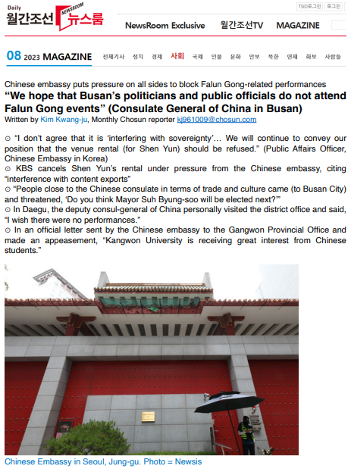
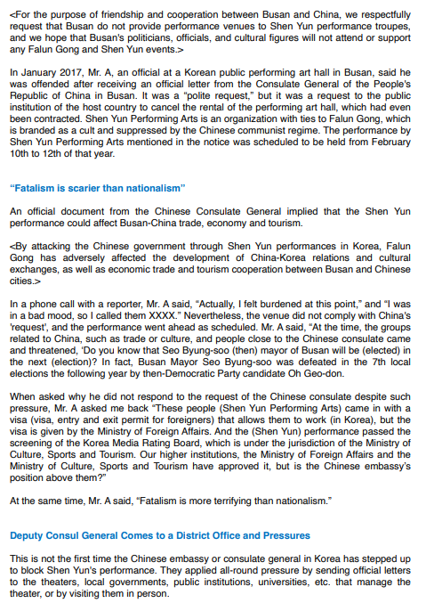
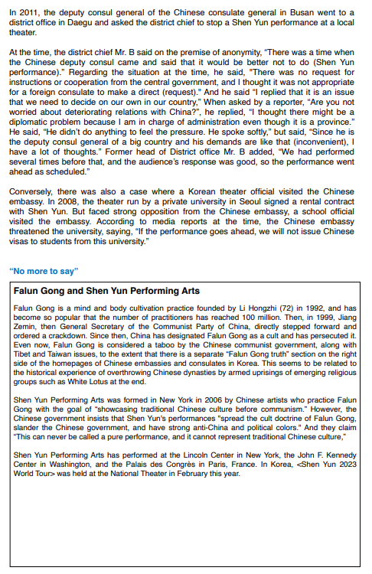
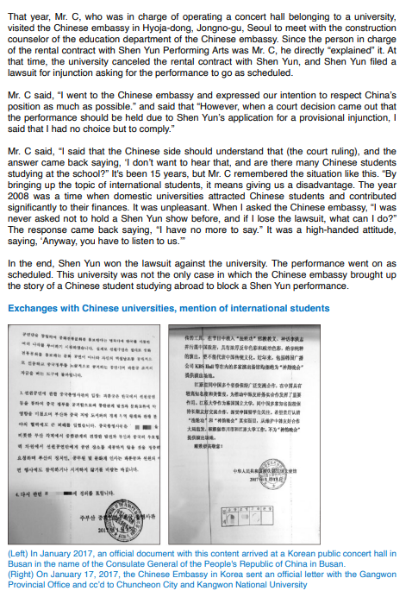
`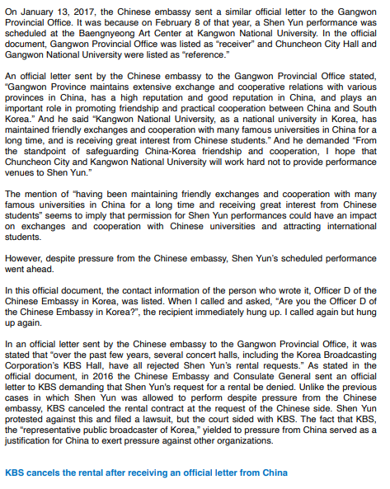

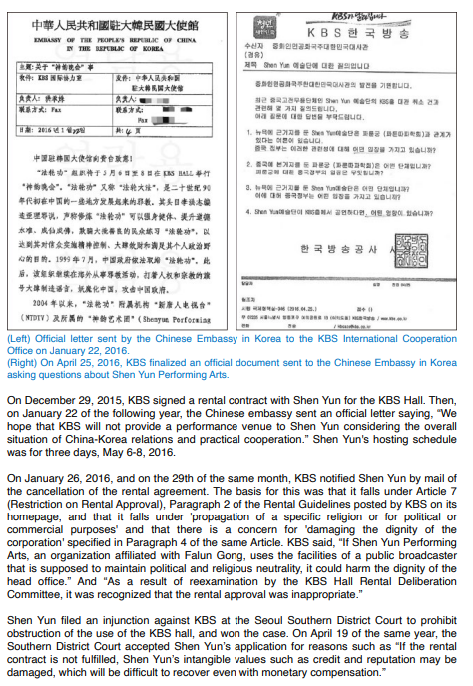
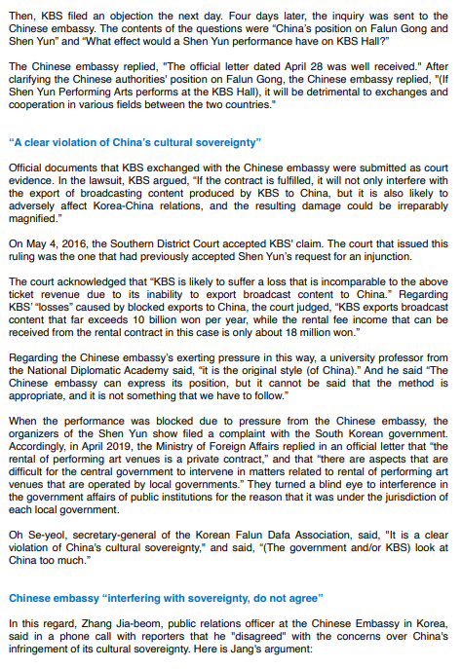
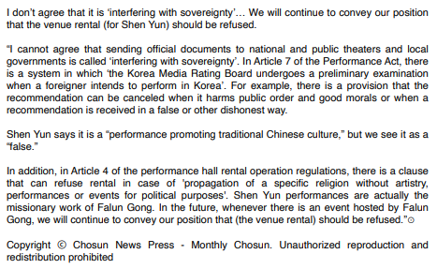

Shenyun.org
Falun Dafa Infocenter website: https://faluninfo.net/violent-suppression-of-100-million-people/.
Final judgement (1 March 2020): https://chinatribunal.com/final-judgment/
UN OHCHR Press release (14 June 2021), “China: UN human rights experts alarmed by ‘organ harvesting’ allegations” https://www.ohchr.org/en/press-releases/2021/06/china-un-human-rights-experts-alarmed-organ-harvesting-allegations
Chinese Influence Operations (October 2021.) published by IRSEM(L’Institut de Recherche Stratégique de l’École Militaire), p. 79 Full text: https://www.irsem.fr/report.html
Ibid. p. 80.
https://www.shenyun.org/spirituality/challenges-we-face
List of the incidents & Evidence: http://leeshailemish.com/on-shen-yun/whos-afraid-of-shen-yun/
Statement published on the Chinese Embassy’s website: http://do.china-embassy.gov.cn/esp/xwdt/202301/t20230131_11016668.htm
The Epoch Times (3 February 2023), “Shen Yun Shows Virtues, Beauty, ‘The World Needs a Lot of That’ Says Eduardo Brito National Theater Director” https://www.theepochtimes.com/shenyun/shen-yun-shows-virtues-beauty-the-world-needs-a-lot-of-that-says-eduardo-brito-national-theater-director-5031939
The Epoch Times (3 February 2023), “Funcionarios de República Dominicana dan la bienvenida a Shen Yun al país Fuente: The Epoch Times en español” https://es-mb.theepochtimes.com/funcionarios-de-republica-dominicana-dan-la-bienvenida-a-shen-yun-al-pais_1095131.html
The Epoch Times (6 February 2023), “Gobernadora de Santiago da la bienvenida a Shen Yun: “¡Te transporta a otra dimensión!” Fuente: The Epoch Times en español” https://es-mb.theepochtimes.com/gobernadora-de-santiago-da-la-bienvenida-a-shen-yun-te-transporta-a-otra-dimension_1096292.html
Seoul Southern District Court Decision No. 2016 Kahap 71 rendered on 4 May 2016
The Diplomat, The Long Arm of Chinese Censorship Reaches South Korea (9 May 2016) https://thediplomat.com/2016/05/the-long-arm-of-chinese-censorship-reaches-south-korea/
NHRC’s decision on the case No. 16-Jinjeong-0057200 (20 April 2016)
Bitter Winter, ‘Ms. O Again! She Insults Islam, Uyghurs, Refugees… and Bitter Winter’, 7 August 2019 https://bitterwinter.org/ms-o-insults-islam-uyghurs-refugees-and-bitter-winter/
The Epoch times, ‘In the name of Christianity, a Korean organization takes part in CCP’s censorship in Korea’, 8 September 2023 http://kr.theepochtimes.com/국내-종교단체-기독교-빙자해-중공의-문화주권침해_660007.html
Monthly Chosun(August 2023), ‘Chinese Embassy pressures all sides to prevent Falun Gong-related performances’ http://m.monthly.chosun.com/client/news/viw.asp?ctcd=C&nNewsNumb=202308100025

