BRIEFING ON KAZAKHSTAN FOR THE COMMITTEE AGAINST TORTURE, SESSION 76 – April/May 2023
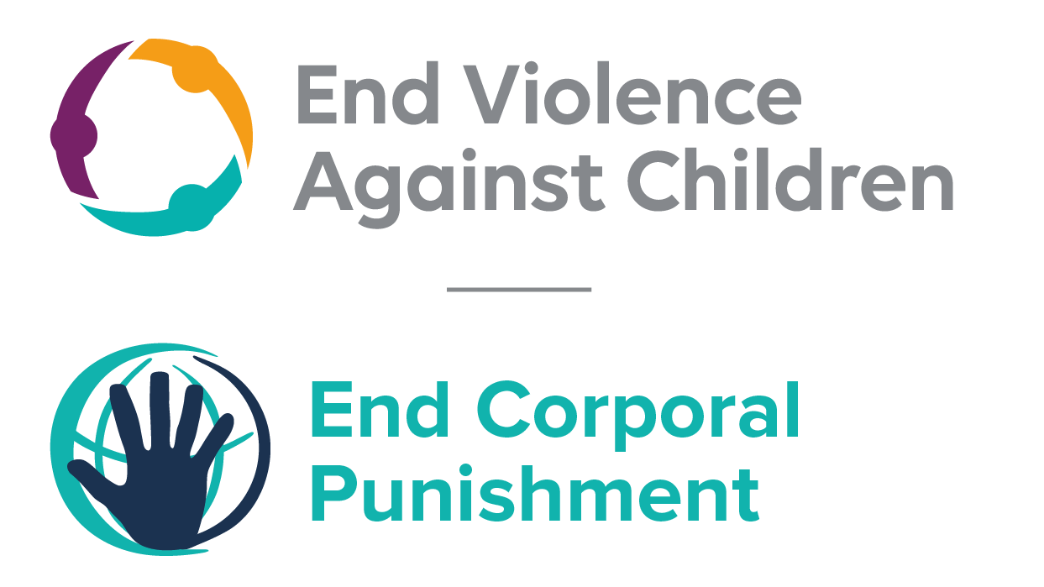
The Global Partnership to End Violence Against Children
March 2023

This briefing describes the legality of corporal punishment of children in Kazakhstan. In light of the obligation under international human rights law to prohibit all corporal punishment of children, the recommendation of the UN Secretary General’s Study on Violence against Children, the repeated recommendations to prohibit all corporal punishment made to Kazakhstan by the Committee on the Rights and other human rights treaty bodies, and considering the global commitment to ending all violence against children in the context of the 2030 Agenda for Sustainable Development, we hope the Committee will:
• in its concluding observations on the second report of Kazakhstan, recommend that legislation is immediately enacted to explicitly prohibit corporal punishment of children in all settings including the home, and to repeal all legal defences for its use.

Summary of necessary legal reform to achieve full prohibition
Prohibition is still to be achieved in the home, alternative care settings and day care.
There is no confirmation in law of a “right” of parents to punish their children, but there is no explicit prohibition of all forms of corporal punishment in childrearing. The near universal acceptance of corporal punishment in “disciplining” children necessitates a clear statement in law that all corporal punishment, without exception, is prohibited.
Alternative care settings – Corporal punishment should be prohibited in all alternative care settings, without exception.
Day care – Corporal punishment should be prohibited in all early childhood care (including crèches, family centres) and all day care for older children (including day centres, after-school childcare, childminding, etc.), without exception.

- The report of Kazakhstan to the Committee Against Torture

  - The fourth report of Kazakhstan states that article 17 of the Constitution establishes that human dignity is inviolable and that no one may be subjected to torture, violence or other cruel or degrading treatment or punishment. However, the report does not refer to prohibition of corporal punishment of children in all settings.

- Current legality of corporal punishment in Kazakhstan

  - Home: Corporal punishment is lawful in the home. The Government reported to the UN Committee on the Rights of the Child in 2003 that all violence and corporal punishment is prohibited. However, while there is no confirmation in law of a “right” of parents to punish their children, there is no explicit prohibition of all forms of corporal punishment in childrearing. Article 60 of the Marriage and Family Code 2011 states that the child “has the right to be educated by the parents, ensuring its interests, full development and respect for human dignity” (unofficial translation). Article 72 states that in the exercise of parental rights, parents “do not have the right to harm the physical and mental health or moral development of the child” and that “methods of education must exclude neglectful, cruel, brutal or degrading treatment or abuse, humiliation or exploitation”. But it does not explicitly prohibit all corporal punishment, however light.

  - The Law on the Rights of the Child 2002 confirms the child’s right to respect for human dignity the state’s obligation to protect the child from physical and mental abuse and cruel, inhuman or degrading treatment (art. 10) and confirms parents’ duty to educate and care for children (art. 24) but does not explicitly prohibit all corporal punishment. Similarly, there is no prohibition of all corporal punishment in childrearing in the Law on Prevention of Domestic Violence 2009 (amended 2014): it defines domestic violence as “an intentional illegal act (action or failure to act) by one person in the sphere of the family and household relations concerning another (others) causing or containing threat of causing of physical and (or) mental suffering” (art. 1(3)) and states that this can take the form of, among other things, physical abuse, defined as “intentional harm to health by use of force and causing of physical pain” (art 4(2)). Neither the Criminal and Executive Code 2014 nor the Code on Administrative Offences 2014 prohibits all corporal punishment in childrearing.

  - In 2020, the Government supported a UPR recommendation to explicitly prohibit corporal punishment of children.

  - Alternative care settings: Corporal punishment is prohibited in some but not all alternative care settings. The Law on Children’s Villages of Family Type and Youth Homes 2000 states in article 5 that in children’s villages, children have the right to respect for their human dignity and article 18 states that the mother tutor “may not harm the physical and mental health of children” and “methods of education must not include neglectful, cruel or degrading treatment, or insulting the honour and dignity of the child”. This appears to be interpreted as prohibiting all corporal punishment (unconfirmed). In reporting to the Committee on the Rights of the Child in 2014, the Government stated that pursuant to Order No. 10 of 31 March 2005 of the Procurator-General’s Office, children’s homes must be inspected at least once every six months with a view to preventing corporal punishment.

  - There is no explicit prohibition in other care settings, where children are protected from some but not all corporal punishment under article 10 of the Law on the Rights of the Child 2002 (see under “Home”).

  - Day care: Corporal punishment is considered unlawful in the provision of preschool education and training under the Law on Education 2007, which prohibits physical and mental violence (art. 28(4)) and protects pupils’ right to respect for their honour and dignity (arts. 47(11) and 51(3)) (see under “Schools”), but it is not explicitly prohibited.

  - There is no explicit prohibition of corporal punishment in other early childhood care (crèches, family centres, etc) and day care for older children (day centres, childminding, etc): in these settings children are protected from some but not all corporal punishment under article 10 of the Law on the Rights of the Child 2002 (see under “Home”).

  - Schools: Corporal punishment is considered unlawful in schools, and in 2001 the Government reported to the UN Committee on the Rights of the Child that the use of threats or corporal punishment is forbidden in educational organisations and the Government similarly reported in 2014 that corporal punishment is prohibited in educational institutions but there appears to be no explicit prohibition. The Law on Education 2007 prohibits physical and mental violence (art. 28(4), unofficial translation): “Training and educational process is carried out on the basis of mutual respect for the human dignity of pupils, students, teachers. The use of physical, moral and mental violence against students and pupils is not allowed.” Article 47(11) states that pupils and students have a right to respect for their human dignity, and article 51(3) states that teachers must “respect the honour and dignity of pupils, students and their parents”. Article 10 of the Law on the Rights of the Child 2002 (see under “Home”) also applies.

  - Penal institutions: Corporal punishment is unlawful as a disciplinary measure in penal institutions. There is no provision for corporal punishment among the permitted disciplinary measures in the Criminal and Executive Code 2014 and in the Law “On Prevention of Juvenile Delinquency, Child Neglect and Abandonment” (art. 22-8). The latter states in article 23: “Bodies and agencies of the system of preventing crime or neglect of minors, within their jurisdiction, must ensure that the rights and legitimate interests of minors are respected, protecting them against all forms of discrimination, physical or mental violence, injury, abuse, sexual and other exploitation.” The Criminal and Executive Code 2014 states that convicted persons have the right to “recognition of their human dignity and protection from torture, violence and other cruel, inhuman and degrading punishment” (art. 10, unofficial translation). Article 154 of the Code sets out permitted disciplinary measures in detention, which include warning, reprimand, strong reprimand and placement in an isolation cell.

  - Disciplinary measures in Kazakhstan’s eight Special Schools are also governed by the Order of the Kazakhstan Minister for Education and Science “On Approval of the Regulation on Educational Institutions with Special Detention Regime”. Article 46 permits only warning, reprimand, discussion at a general meeting and extraordinary duties, stating that “application of penalties not covered by these Regulations is prohibited”.

  - Sentence for crime: Corporal punishment is unlawful as a sentence for crime. There is no provision for judicial corporal punishment in the Criminal and Executive Code 2014.

Recommendations by human rights treaty bodies and during the UPR

  - CRC: On three occasions, the Committee on the Rights of the Child has recommended to Kazakhstan that legislation be enacted to explicitly prohibit corporal punishment in all settings: in its concluding observations on the state party’s initial report in 2003, on the state party’s second-third report in 2007, and on the state party’s fourth report in 2015.

  - HRC: The Human Rights Committee recommended that Kazakhstan put an end to corporal punishment in all settings and encourage non-violent forms of discipline- in its concluding observations on the state party’s initial report in 2011.

  - UPR: At the third cycle of the Universal Periodic Review of Kazakhstan in 2019, a recommendation to prohibit corporal punishment of children was made and later supported by the Government.

17 January 2022, CAT/C/KAZ/4, Fourth periodic report submitted by Kazakhstan under article 19 of the Convention, due in 2018, para. 91
24 July 2003, CRC/C/SR. 886, Summary record of 886th meeting, para. 15
20 December 2019, A/HRC/43/10, Report of the Working Group, para. 139(226); 26 February 2020, A/HRC/43/10/Add.1, Report of the Working Group: Addendum
15 January 2014, CRC/C/KAZ/4, Fourth state party report, para. 169
24 September 2002, CRC/C/41/Add.213, Initial state party report, para. 89
15 January 2014, CRC/C/KAZ/4, Fourth state party report, para. 174
Penal Reform International (2015), Voice of the child: Findings from a survey of children detained in closed institutions in Kazakhstan, Kyrgyzstan and Tajikistan, p. 15
Article 46 quoted in Penal Reform International (2015), Voice of the child: Findings from a survey of children detained in closed institutions in Kazakhstan, Kyrgyzstan and Tajikistan, p. 15
10 July 2003, CRC/C/15/Add.213, Concluding observations on initial report, paras. 37 and 39
19 June 2007, CRC/C/KAZ/CO/3, Concluding observations on second/third report paras. 36 and 37
2 October 2015, CRC/C/KAZ/CO/4 Advance Unedited Version, Concluding observations on fourth report, paras. 28 and 29
19 August 2011, CCPR/C/KAZ/CO/1, Concluding observations on initial report, para. 15
20 December 2019, A/HRC/43/10, Report of the Working Group, para. 139(226)
26 February 2020, A/HRC/43/10/Add.1, Report of the Working Group: Addendum

