European Union Agency for Fundamental Rights, selection of rights of the child passages from published reports related to Austria
fra.europa.eu

9 April 2019, Vienna

Contents
1. Data Explorers and tools 2
1. 1 Violence against women: an EU-wide survey (2014) 2
1.2 EU-LGBT survey (2012) 3
2. Annual reports 5
2.1 Fundamental Rights Report 2018 Report 5
2.2 Fundamental Rights Report 2017 Report 6
3 Thematic reports 7
3.1 Combating child poverty: an issue of fundamental rights (2018) 7
3.2 European legal and policy framework on immigration detention of children (2017) 10
3.3 Migration: Key fundamental rights concerns – Quarterly bulletin 1 (2018) 11
3.4 Violence against children with disabilities: legislation, policies and programmes in the EU (2015) 12
3.5 Violence against women: an EU-wide survey (2014) 13
3.6 EU LGBT Survey – European Union lesbian, gay, bisexual and transgender survey (2012) 16
3.7 Second European Union Minorities and Discrimination Survey (2016) 17
3.8 Being black in the EU (2018) 17
3.9 Mapping of minimum age requirements (2017 – 2018) 18

- Data Explorers and tools

1. 1 Violence against women: an EU-wide survey (2014)
The survey includes extensive information regarding Malta, these excerpts are just a selection. Violence against women: an EU-wide survey data explorer: http://fra.europa.eu/en/publications-and-resources/data-and-maps/survey-data-explorer-violence-against-women-survey
In Austria – Women who have experienced physical, sexual or psychological violence before the age of 15
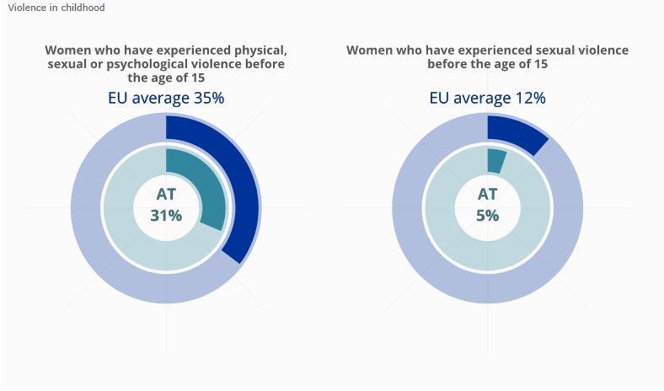
In the EU – Experiencing physical, sexual or psychological violence before the age of 15 by an adult perpetrator

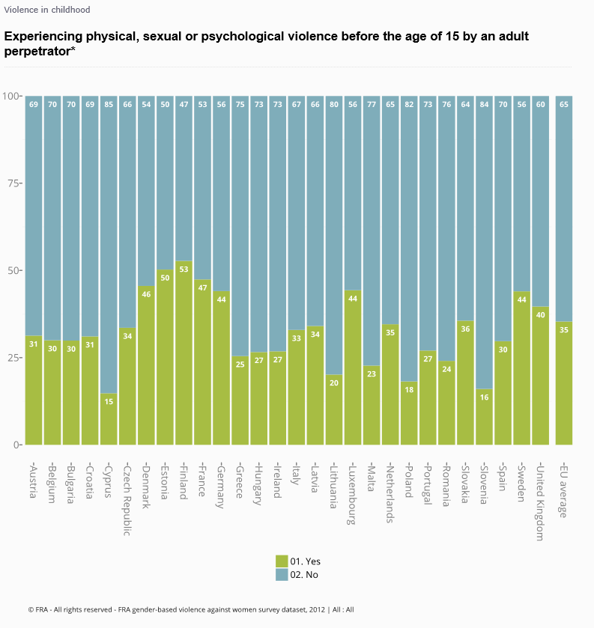

1.2 EU-LGBT survey (2012)
The survey includes extensive information regarding Austria, these excerpts are just a selection. EU LGBT survey data explorer: http://fra.europa.eu/en/publications-and-resources/data-and-maps/survey-data-explorer-lgbt-survey-2012
In Austria – During your schooling before the age of 18, did you hide or disguise that you were L, G, B or T at school?
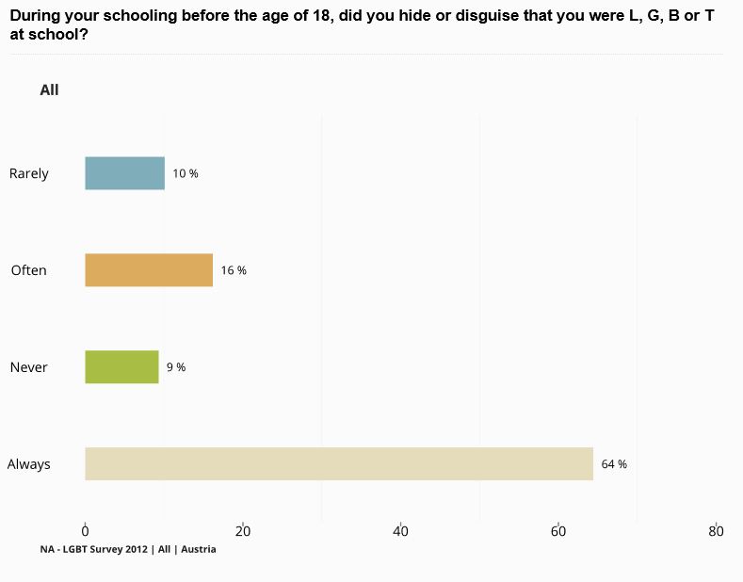
In the EU – During your schooling before the age of 18, did you experience negative comments or conduct at school because of you being L, G, B or T?
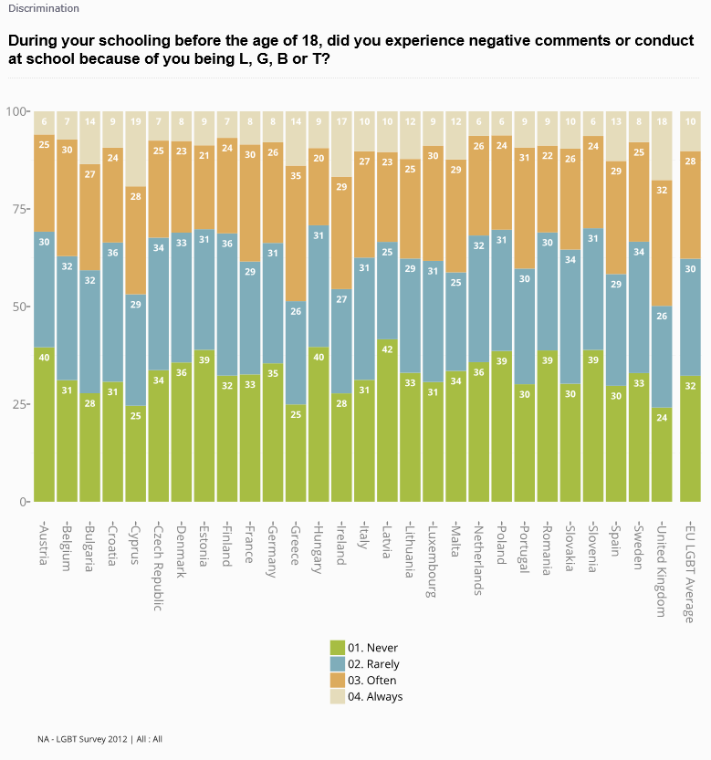
- Annual reports

  - Fundamental Rights Report 2018 Report
For more detailed information: https://fra.europa.eu/en/publications-and-resources/publications/annual-reports/fundamental-rights-2018#child-rights
Tackling child poverty and social exclusion
“Promising practice: Providing support to families at risk of homelessness in Austria
In Austria, there are a number of support services for people at risk of or in homelessness. They range from consulting, prevention of eviction, help in finding a new home, emergency shelter, day-centres, temporary apartments and assisted living.
During 2017, in seven out of the nine Austrian regions – Burgenland and Carinthia being the exceptions – social organisations provided a dedicated service for the prevention of eviction. People who have difficulties with paying the rent or are at risk of eviction for other reasons can get advice and counselling on how to proceed. There are also specialised services for specific groups, such as women with children and pregnant women. “(p.181)
Protecting children in migration remains a daunting challenge
“Given the temporary reintroduction of border controls, the EU–Turkey statement and changing migration routes, there were drastically fewer applications in some Member States, such as Austria, Bulgaria and Germany.” (p. 181 -182)
  - Fundamental Rights Report 2017 Report
For more detailed information: http://fra.europa.eu/en/publications-and-resources/publications/annual-reports/fundamental-rights-2017#child-rights
Child poverty rate improves marginally
“In seven countries, the proportions of children at risk of poverty or social exclusion increased by 2–12 percentage points over time: Austria, Cyprus, France, Greece, Italy, Malta and Spain. In Greece, the increase over the 10-year period in question was around 12 percentage points. In most cases, this was not a continuous process. In Austria, for example, the rate remained at the same level after an initial increase, while Cyprus experienced a strong increase only during the second half of the period.” (p. 176)
(p. 176)
Protecting rights of children accused or suspected of crimes
“All 10 Member States with child-related CSRs in 2015 responded with child-related initiatives in their 2016 NRPs. For example, Austria received two CSRs on child-care services and inclusive education in 2015.15 Its 2016 NRP elaborates in detail all the measures taken in this field – ranging from labour law reforms to family allowance increases – and provides specific budget figures.” (p. 177)
“An amendment to the Austrian Juvenile Court Act54 entered into force on 1 January 2016, establishing that pre-trial detention for child offenders is to be used only in exceptional cases, and is no longer permissible for children suspected of having committed a criminal offence punishable with a fine or imprisonment of up to one year; measures are also in place to encourage replacing pre-trial detention with less severe measures.” (p. 180)
Protecting unaccompanied children poses tremendous challenge
“In the 12 countries that provide foster care, practices are either diverse or uniform. Having diverse practices means that they may vary at regional, local or municipal level, because they are not harmonised nationally. This is the case in Austria, Belgium, Denmark, Estonia, France, Germany and Poland. Specifically, eight out of nine regions in Austria allow the placing of unaccompanied children in foster families, but in practice foster care works only in some cities. For example, in Vienna, the Fonds Social Vienna, the Vienna City Department for Youths and Family, and SOS Children’s Villages launched a joint project to create the possibility for families to host unaccompanied children older than 14, in addition to foster care families for children up to the age of 14. By September 2016, almost 130 children had been placed in foster families in Austria.” (p. 185)
“Under the Rights, Equality and Citizenship Programme, the EU co-funded a follow-up action project whereby Nidos (the Netherlands), in cooperation with Minor N’dako (Belgium), Jugendhilfe Süd Niedersachsen (Germany), OPU (Czech Republic), the Danish Red Cross and KIJA (Austria), has developed a training programme with supportive and online materials for professionals working with host families who take care of unaccompanied children. The training consists of different modules on recruitment, screening, matching and guidance of the host families. The project runs from 2015 to 2017.” (p. 185)

- Thematic reports

Combating child poverty: an issue of fundamental rights (2018)
For more detailed information: https://fra.europa.eu/en/publication/2018/child-poverty
“The figure shows that rates vary substantially among the various migrant backgrounds and Member States. For example, 38 % of children of Turkish origin (immigrants or children of descendants of immigrants) living in Denmark are at risk of poverty, compared with 14.5 % of children of the general population.20
20 Eurostat, European Union Statistics on Income and Living Conditions (EU-SILC), Indicator ‘People at risk of poverty or social exclusion by age and sex’ [ilc_peps01], for 2014, accessed on 7th June 2018. However, the risk for the same population is 86 % in Austria, compared with 23.3 % among the general population.21
The differences between Member States are not as great for children of Sub-Saharan African origin (immigrants or children of descendants of immigrants): they range from 61 % at risk of poverty in Germany and Finland, to 86 % in Austria.” (p. 20)
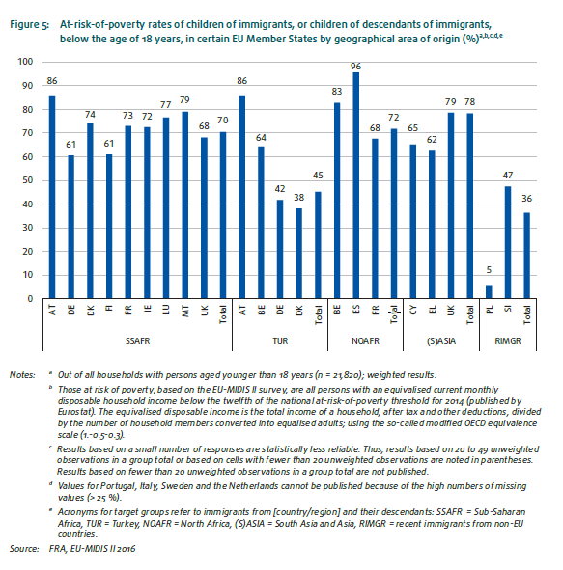
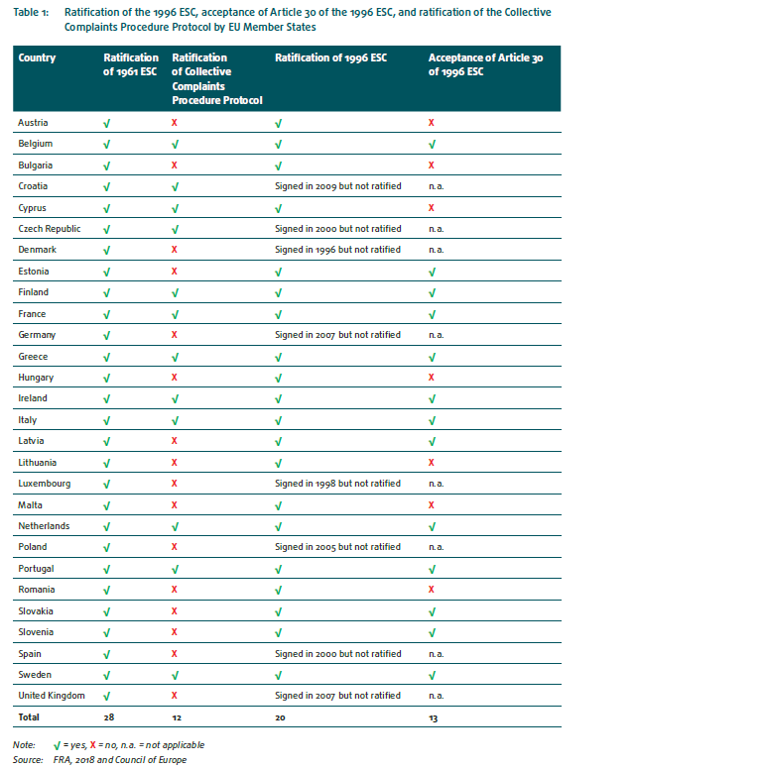(p.26)
“It also shows that, while flexible arrangements and part-time work are common in some Member States (Austria, Belgium, Germany, the Netherlands, the United Kingdom and Sweden), these arrangements are still associated with lower pay, fewer promotion opportunities and reduced pension entitlements, resulting in a higher risk of poverty and fewer unemployment entitlements. In addition, women are more likely than men to opt for flexible arrangements to take care of children.” (p. 31)
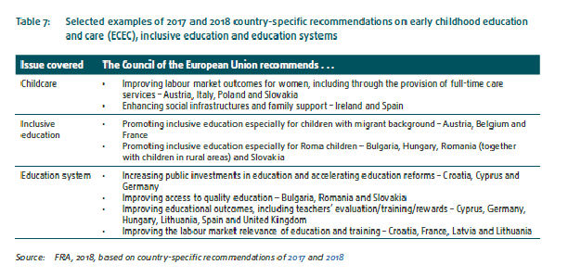(p.43)

3.2 European legal and policy framework on immigration detention of children (2017)
For more detailed information: https://fra.europa.eu/en/publication/2017/child-migrant-detention
“In some Member States, in which detention of unaccompanied children is allowed, it rarely happens in practice, for example in Cyprus.104 Others, such as Austria, Finland or Hungary, do not permit detention below a certain age.”(p.37)
“In Austria120 and Latvia, unaccompanied children below the age of 14 years may not be taken into detention pending removal. In Austria, the law stipulates that children below 16 years old must be kept in alternatives to detention, unless certain facts justify the assumption that the purpose of migration detention may not be achieved by this alternative.”(p.39)
“The situation is different for immigration detention. Justified by the principle of family unity, most EU Member States do not exclude the possibility that children may accompany the parents in detention, regardless of the age of the child. For example, in Austria, foreigners who are detained pending removal may be accompanied by the minors under their guardianship, although only if the accommodation is child-friendly.” (p. 55)
“At least four EU Member States have shorter detention ceilings for unaccompanied children. In Austria, unaccompanied children aged 14–18 can be detained pending return for a maximum of two months.” (p. 60)
“EU Member States have implemented different time limits to review immigration detention orders. In Austria, for example, in the context of asylum procedures, the Federal Office for Immigration and Asylum reviews a detention order every four weeks.” (p. 61)
“(…) in Austria, a legal adviser must advise and support a detained person, who may be a child.261 The adviser is entitled to participate at all stages of proceedings.” (p.68)
“Additional challenges emerge when EU Member States employ private security companies in the facilities that they consider specialised. In Austria, the Ministry of the Interior has contracted the private security company G4S to provide services in the Vordernberg detention facility. The Austrian Ombudsman Board has criticised the move.” (p. 81)
“In Austria, public health officers (Amtsärzte) providing healthcare in detention facilities; if detainees choose to also consult a doctor of their own choice, they must cover the costs and the consultation must take place in the detention room.” (p. 86)
  - Migration: Key fundamental rights concerns – Quarterly bulletin 1 (2018)

FRA has been regularly collecting data on migration and is publishing periodic updates on migration-related fundamental rights concerns. This report is only one of them, some focus on more specifically on children such as separated children arriving to the EU or the access to education for migrants and asylum seekers.

For more detailed information: https://fra.europa.eu/en/publication/2019/migration-key-fundamental-rights-concerns-quarterly-bulletin-1

“Austria presented a legislative proposal to significantly cut social welfare benefits. The law, once in force, will particularly affect refugees and beneficiaries of subsidiary protection who do not speak sufficient German, as the benefit will depend on a person’s employability. Employability is assumed if a person can prove at least language level B1 (German) or C1 (English), has completed vocational qualification measures, and has completed a ‘values and orientation’ course. According to a press release of UNHCR, with this new law, refugees and beneficiaries of subsidiary protection will risk to fall below the poverty line in Austria.” (p.3)

“Austria, Denmark, France, Germany, and Sweden prolonged internal border controls in the Schengen area. Poland reintroduced controls at all internal borders from 22 November 2018 to 16 December 2018 – for the global climate conference.
The number of smugglers detected at the internal borders of Austria remained low, according to several governmental responses to parliamentary questions. For example, during random checks at 32 border crossings with Slovenia, 19 human smugglers were detected between January 2017 and September in 2018.” (p. 11)

“In Austria, the court of second instance overturned 43 % of the decisions issued by the Federal Office for Immigration and Asylum between February 2017 and July 2018, according to a response to a parliamentary question.” (p.12)

“The situation of vulnerable asylum seekers in Austria has not improved. There are still no specific procedures in place to identify vulnerable persons and no specialised care facilities and support services for victims of torture and/or trauma. General psychological care, however, is provided in all accommodations, according to the Federal Ministry of the Interior.”(p. 16)
“The Governor of Lower Austria closed a special centre for “suspicious, notoriously trouble-making“ unaccompanied children following a report by the Lower Austria Ombudsoffice for Children and Youth, criticising the poor hygienic conditions; the fence with barbed wire surrounding the accommodation; children being allowed to leave only for limited time periods and only if accompanied by security guards; as well as the lack of daily activities and adequate care.” (p.17)
“As of 1 December 2018, 497 missing children with non-EU-citizenship were registered in SIS II in Austria, and as of 1 January 2019, this number was 452, according to the Federal Ministry of the Interior.” (p. 20)
“In Austria, the intended forced removal – at five o’clock in the morning – of a well-integrated family in Vorarlberg, including a three-year-old child and a pregnant woman, sparked a political debate, die Presse reported. The removal could not take place as it led to medical complications for the pregnant woman, who had to be brought to a hospital. The case prompted governors of the provinces of Vorarlberg and Carinthia to demand having a say in return decisions and the right to stay for humanitarian reasons, which the Minister of the Interior refused to grant. Following a parliamentary inquiry into the incident, the Federal Minister of the Interior stated that the best interests of the child have to be in the foreground for all measures concerning children and that removals of families are only conducted by specialised officers in civilian clothing, and in the presence of female officers.” (p.24)
“In a preliminary ruling initiated by the Regional Administrative Court of Upper Austria, the CJEU ruled that EU law precludes national legislation from granting fewer social benefits to refugees with a temporary right of residence than to nationals or refugees with a permanent right of residence.” (p.25)
  - Violence against children with disabilities: legislation, policies and programmes in the EU (2015)
For more detailed information: https://fra.europa.eu/en/publication/2015/children-disabilities-violence
“In Austria, crimes committed against children with disabilities (for example, abuse or neglect, severe violence, sexual abuse, incitement on the basis of disability) are dealt with in the criminal code81 under provisions relating to crimes committed against children or against “defenceless or psychologically impaired persons”. For some of these crimes, disability is an aggravating circumstance. It was only in 2013 that Austria abolished lighter sentences for crimes involving victims who are defenceless or “psychologically impaired”.” (p. 39)
“Some EU Member States include a victim’s disability as a ground for criminalising a hate crime. As of October 2014, 13 EU Member States explicitly recognise, in one form or another, a disability-bias motivation in their criminal laws: Austria, Belgium, Croatia, Finland, France, Greece, Hungary, Lithuania, the Netherlands, Romania, Slovenia, Spain, and the United Kingdom. This applies equally to adults and children. Only a few clearly separate the hate motivation from the basic offence by using enhanced penalties to stress the severity of bias-related offences. Most define bias motivation as an aggravating circumstance. The practice of imposing enhanced penalties stresses the severity of bias-related offences, and clearly separates the hate motivation from the basic offence.” (p. 40)
“Some EU Member States – such as Austria,136 the Czech Republic,137 Germany, Slovenia and Spain138 – have disability policies or action plans that set out specific objectives or measures aiming to prevent violence against persons with disabilities. These policies include specific references to children with disabilities and some, like Austria, refer to girls with disabilities. Most of these objectives revolve around raising awareness about violence against children and focus to a great extent on sexual violence.” (p. 45)
“Respondents also discussed the traditional mind-set of society, which largely still takes the medical approach to disability. This approach is based on pity and charity, and sees people with disabilities as victims of their impairment who should be ‘cured’ and looked after.
“[A] young man told me that he was shopping […] with his mother and there was a shop with a step and he couldn’t go inside […] so he sat outside waiting in his wheelchair and he couldn’t even look that quickly as someone already gave money to him. And I think that this welfare-attitude is also already related, unconsciously, with a hostile attitude.” “
(Independent monitoring body of the CRPD representative, Austria) (p. 63)
“Some respondents, notably in Austria, Italy and the Netherlands, discussed taboos regarding certain types of disabilities and isolation due to disability being connected to shame. A public authority representative tasked with including children with disabilities in mainstream schools highlighted the need to address different perceptions of gender roles, and noted that migrant mothers of children with disabilities may be blamed for their child’s disability, which reduces their ability to seek help.” (p.83)
“Research based on focus group discussions and in-depth interviews with women with disabilities in Austria, Germany, Iceland and the United Kingdom reveals that many women, especially those with intellectual disabilities and sensory impairments, were exposed to bullying in schools and residential care homes during childhood. Furthermore, women with disabilities often experience psychological violence from their parents during childhood, which increases the risk of violence later in life.” (p.85)
“Aside from formalised cooperation efforts between different actors, respondents – in Austria, Bulgaria, Croatia, the Czech Republic, Italy, Lithuania, Slovenia and Sweden, for example – raised concerns about the lack of coordination and cooperation among different institutions and bodies involved in child protection.(…) Finally, respondents from Austria and Lithuania also identified data protection regulations as hampering effective multiagency collaboration. In Austria, for instance, once the public hospital’s children’s protection group forwards information to the youth-welfare authorities, it cannot be informed about further proceedings or have access to further information. Likewise, confidentiality rules impede the transmission of information about children, meaning institutions are not aware of the type of services an individual may have received in another setting.” (p.100 -101)
“Respondents – notably in Lithuania and Austria – also indicated that the inaccessibility of support services is exacerbated in rural areas.” (p.106)

3.5 Violence against women: an EU-wide survey (2014)
For more detailed information: https://fra.europa.eu/en/publication/2014/violence-against-women-eu-wide-survey-main-results-report and https://fra.europa.eu/en/publications-and-resources/data-and-maps/survey-data-explorer-violence-against-women-survey
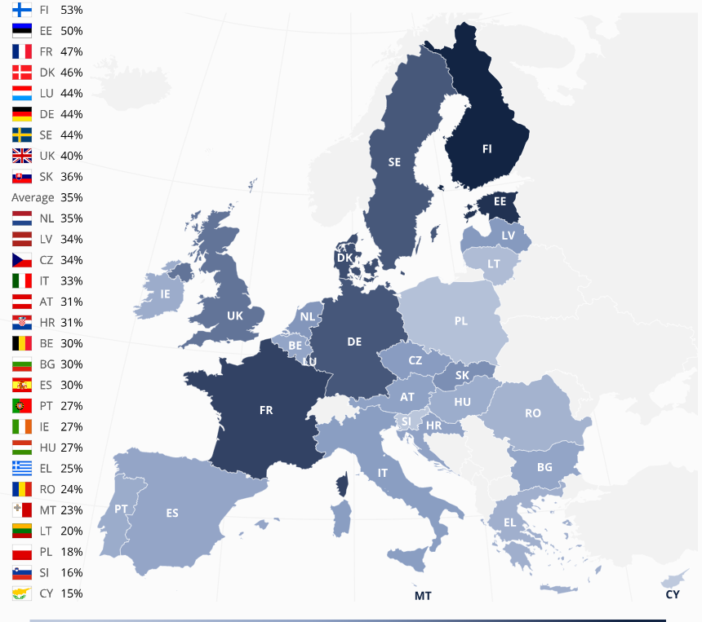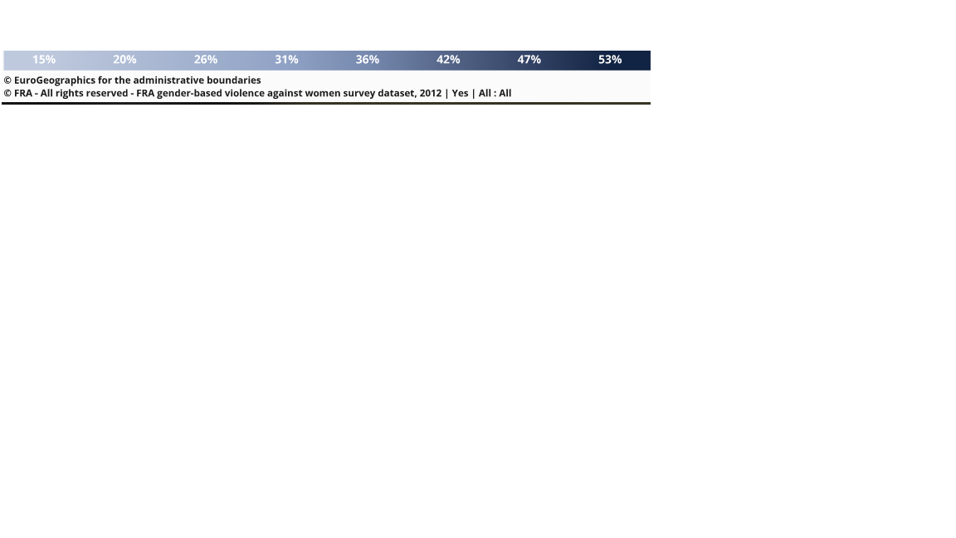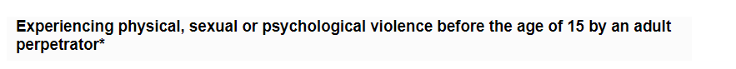

“The comparative five-country study showed that Sweden, the first country in the world to introduce legal measures to fully protect children from violence, had the lowest proportion of supportive attitudes towards all forms of corporal punishment. Austria showed higher support rates, similar to attitudes in Germany. Austria prohibited corporal punishment against children in 1989, whereas Germany fully banned it only in 2000. The introduction of the law in Austria was not accompanied by a nationwide information campaign as in Germany. At the time of the comparative five-country study in 2007, Spain had not fully abolished corporal punishment but had made efforts through campaigns to raise public awareness about the consequences of violence in child rearing. In France, corporal punishment was neither forbidden nor a subject of public discussion at the time of the study. In both countries, attitudes towards corporal punishment were more supportive than in Austria, Germany or Sweden. However, the difference between France and Spain was still significant, confirming that awareness campaigns are similar in importance to the introduction of legislation itself.” (p. 126)
Relationship between violence in childhood and later experiences
„Austria, for example, is one of the countries with the lowest prevalence rates of physical and/ or sexual violence after the age of 15, whereas physical and sexual violence women experienced in childhood in Austria is just below the EU-28 average.” (p. 132)
“Moreover, the relationship between the perceived level of intimate partner victimisation in respondent’s close environments and the disclosed level of experienced violence is stronger in EU Member States with lower overall prevalence (such as Bulgaria, Hungary and Austria) than in those with higher rates (such as Finland, France, Lithuania and Sweden). This may mean that in those countries violence against women is more strongly perceived to be a private matter, and/or that
levels of violence are in fact lower.” (p. 157)
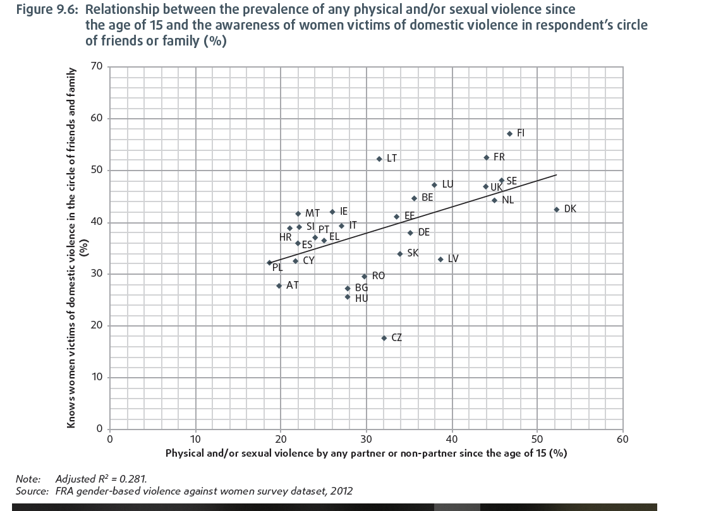
“In contrast, only one in five women in Austria (20 %) and Germany (23 %), and about one in four women in the
Czech Republic and in Denmark (both 26 %), have recently seen or heard any campaigns addressing violence against women.” (p. 161)

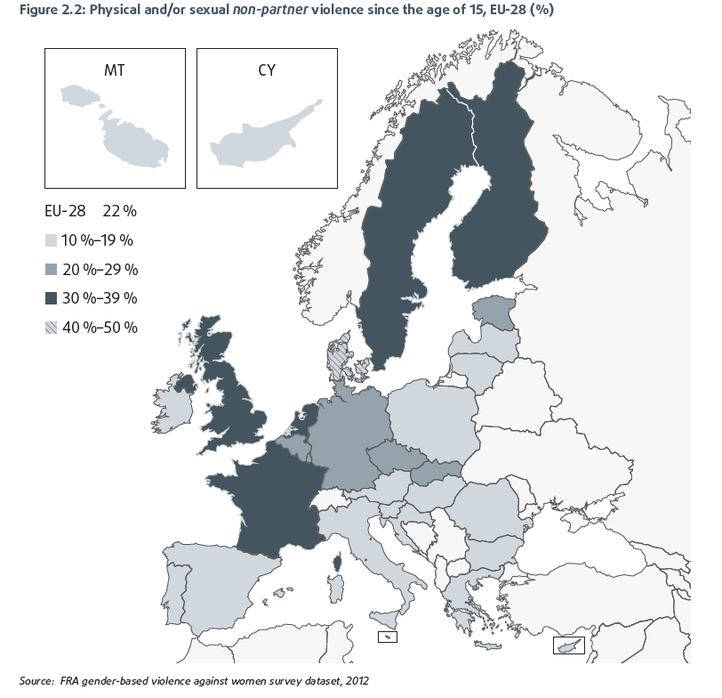

3.6 EU LGBT Survey – European Union lesbian, gay, bisexual and transgender survey (2012)
For more detailed information: https://fra.europa.eu/en/publication/2014/eu-lgbt-survey-european-union-lesbian-gay-bisexual-and-transgender-survey-main
“Overall, one in eight respondents lives with a child under the age of 18. Gay men are less than half as likely as any of the other LGBT groups to have a child living in their household. The proportion of survey participants living in a household with at least one child under the age of 18 ranges from 17 % in the Czech Republic, Ireland, Malta and Slovakia to 9 % in Austria, Germany, Greece and the Netherlands.” (p. 136)
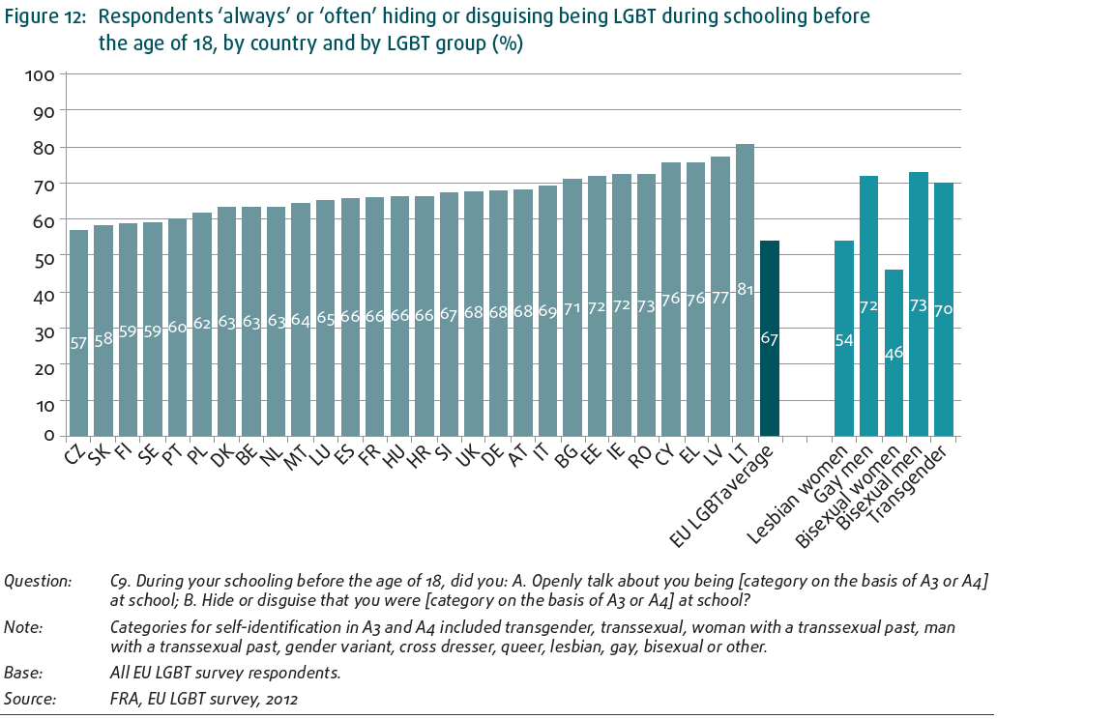

3.7 Second European Union Minorities and Discrimination Survey (2016)
For more detailed information: https://fra.europa.eu/en/publication/2017/eumidis-ii-main-results
“For example, among respondents with Turkish background, the difference between the first and second generations in Austria – in terms of having completed at least upper secondary education – is 41 percentage points (36 % for first- and 77 % for second-generation respondents).” (p. 90)
“Among respondents who are immigrants or descendants of immigrants, 7 % have a wife, husband or children living outside the country in which they live. The percentage of those with family outside the country is higher among groups with recent immigration histories, particularly among immigrants from South Asia in Greece (44 %) and immigrants from Asia in Cyprus (29 %). Among recent immigrants in Slovenia, one in five has family outside the country (21 %). The same rate can be found among immigrants from Sub- Saharan Africa in several countries, including Italy, Luxembourg, Malta and Austria (19–20 %).” (p. 86)
  - Being black in the EU (2018)
For more detailed information: https://fra.europa.eu/en/publication/2018/eumidis-ii-being-black
“Parents in Finland (45 %), Austria (42 %) and Germany (41 %) reported the highest levels of racist harassment and racial discrimination experienced by their children at school.” (p. 48)
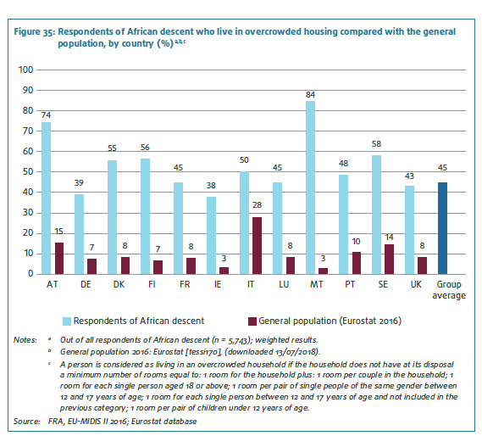

3.9 Mapping of minimum age requirements (2017 – 2018)
In 2017, FRA is mapped national laws across EU governing age requirements linked to the child rights of protection and participation. The Convention on the rights of the Child requires States to take children's views into consideration on matters which concern them in accordance with their age and maturity. However, FRA research has shown that the way children are recognised as rights holders differs across the EU. Age requirements can also be arbitrary and inconsistent, potentially limiting child rights
The areas covered in this mapping exercise are: the legal definition of a child; political participation; social rights and welfare; education; health and medical treatment; employment; child care and child protection; access to justice (including juvenile justice); children in the digital world; asylum and migration.
For more detailed information: https://fra.europa.eu/en/publications-and-resources/data-and-maps/minag?mdq1=theme&mdq2=3509 and https://fra.europa.eu/en/publication/2017/mapping-minimum-age-requirements-concerning-rights-child-eu
As a matter of example, please find some extracts of this mapping concerning the age requirements in Austria in the area of asylum and migration:


