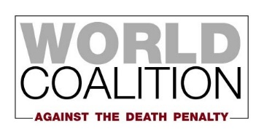
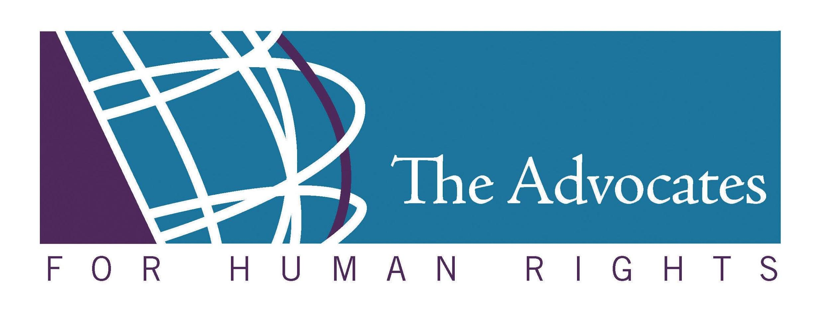

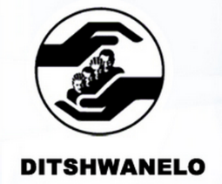

Botswana’s Compliance with the International Covenant on Civil and Political Rights:
The Death Penalty

Submitted by DITSHWANELO – The Botswana Centre for Human Rights,
The International Federation for Human Rights (FIDH),
The Advocates for Human Rights, and
The World Coalition Against the Death Penalty

for the 133rd Session of the Human Rights Committee
11 October 2021 – 5 November 2021

Submitted 4 October 2021

DITSHWANELO – The Botswana Centre for Human Rights was established in 1993 and since then has remained the only organisation in Botswana dealing with varied aspects of human rights. We work to advocate for changes in laws, policies and practices, and to raise public awareness of rights and responsibilities.
The International Federation for Human Rights (FIDH) is an international human rights NGO that unites 192 member organizations from 117 countries. Since its foundation in 1922, FIDH has been defending all civil, political, economic, social, and cultural rights set out in the Universal Declaration of Human Rights (UDHR).
The Advocates for Human Rights (The Advocates) is a volunteer-based nongovernmental organization committed to the impartial promotion and protection of international human rights standards and the rule of law. Established in 1983, The Advocates conducts a range of programs to promote human rights in the United States and around the world, including monitoring and fact finding, direct legal representation, education and training, and publications.
The World Coalition Against the Death Penalty, an alliance of more than 160 NGOs, bar associations, local authorities and unions, was created in 2002. The aim of the World Coalition is to strengthen the international dimension of the fight against the death penalty. Its ultimate objective is to obtain the universal abolition of the death penalty.
Botswana fails to uphold its obligation under the International Covenant on Civil and Political Rights

- In addition to the figures provided by the State of Botswana in paragraph 73 of its second periodic report, at least seven men were executed between January 2018 and September 2021. Mr Mooketsi Kgosibodiba, who had been sentenced to death by the Francistown High Court on 14 December 2017, was executed on 2 December 2019 at the Gaborone Central Prison. The execution of Mr Mmika Michael Mpe, who had been sentenced to death by the High Court of Botswana on 18 May 2018, took place on 21 February 2021 at the Gaborone Central Prison. Mr Moabi Seabelo Mabiletsa and Mr Matshidiso Tshidi Boikanyo, whose sentence to death had been handed down by the High Court of Botswana on 1 December 2017, were executed on 28 March 2020 at the Gaborone Central Prison. Mr Wedu Mosalagae, sentenced to death by the Francistown High Court on 8 August 2019, and Mr Kutlo Setima, sentenced to death by the Lobatse High Court on 24 May 2019, were executed on 8 February 2021 at the Gaborone Central Prison . The execution of Mr Phemelo Botogeleng, who had been sentenced to death by the Francistown High Court on 28 July 2020, was carried out on 11 June 2021 at the Gaborone Central Prison.

- In paragraph 68 of its second periodic report, the State of Botswana understates the brutality of the executions in the country. The executions by hanging are carried out in total secrecy. The authorities constantly fail to give prisoners sufficient notice about the death warrant and the date and time of execution. It was also mentioned that method of carrying out the death penalty is done with care to preserve the dignity of the prisoner. The truth is as long as the death penalty is involved, dignity cannot be preserved.

- The Advisory Committee on the Prerogative of Mercy lacks independence and transparency. According to the Section 54 of the Constitution, it consists of the Vice-President, or a Minister appointed by the President, the Attorney General and a person qualified to practise in Botswana as a medical practitioner, appointed by the President. The fact that the Attorney General is a member of this Advisory Committee creates a conflict of interest. Furthermore, the Advisory Committee can act with one of its members absent and the proceedings are not invalidated by the presence or participation of a non-member. The Constitution also provides for the Advisory Committee to regulate its own procedure which contributes to the opaqueness of the process. The criteria for the procedures are not clear. There is a lack of transparency.

- The lack of transparency in the clemency process and the functioning of the Advisory Committee was brought before the Court of Appeal in 2016 in the case of Patrick Gabaakanye who was sentenced to death. The Court of Appeal held in its 21 April 2016 Judgment that less than six weeks preparation time for pro deo counsel for the preparation of a clemency petition would not allow the exercise of the accused persons’ constitutional right to clemency. Although this judgment of the Court of appeal was a positive step in relation to the clemency process, the Advisory Committee failed to adhere to this ruling and did not provide sufficient time for the Patrick Gabaakanye’s counsel to prepare the application. Patrick Gabaakanye was eventually executed on 25 May 2016. There is no criteria for determining success or failure of applications.

- As explained in paragraph 74 of the second periodic report, the Botswana authorities fail to return the bodies of executed persons to their families. Burial of the executed persons on the prison ground does not allow for their families to hold private burials and to visit the graveyard. This practice does not allow respect to the Setswana culture, in which burials involve a mourning period, visits of relatives and acquaintances to pay condolences, a dignified funeral and a grave that can be visited by the loved ones. In 2013 at the second cycle of its Universal Periodic Review (UPR) process, the government of Botswana accepted the recommendation to inform family members of the accused of the execution before it was carried out. There has been no implementation regarding that.

- In addition, no prior information is given to the families, relatives, and lawyers of the inmates on death row. Therefore, the prisoners’ family members, relatives and lawyers are not able to visit the prisoner for a last time.

- In paragraph 76 of its Second Periodic Report, Botswana acknowledged the need for another public opinion survey on the death penalty following the one conducted in 1997. During the Universal Periodic Review in 2013, Botswana accepted a recommendation to carry out public debates on the death penalty. The Human Rights Unit established in 2019 under the Ministry of Presidential Affairs, Governance and Public Administration was to draft and implement a plan to hold the public debates. To date, there has been no implementation.

/END

DITSHWANELO Press Statement on the Execution of Mr Mooketsi Kgosibodiba, https://www.facebook.com/ditshwanelobotswana/posts/1274043332804456
DITSHWANELO Press Statement on the Execution of Mr Mmika Michael Mpe, https://www.facebook.com/page/351655181709947/search/?q=mmika
DITSHWANELO Press Statement on the Execution of Mr Moabi Seabelo Mabiletsa and Mr Matshidiso Tshidi Boikanyo, https://www.facebook.com/ditshwanelobotswana/posts/1404102769798511
Ditshwanelo Press Statement on the Execution of Mr Wedu Mosalagae and Mr Kutlo Setima, https://www.facebook.com/ditshwanelobotswana/posts/1804741939734590
DITSHWANELO Press Statement on the Execution of Mr Phemelo Botogeleng, https://www.facebook.com/ditshwanelobotswana/posts/1902503749958408
Botswana continues with cruel and regressive execution, https://www.fidh.org/en/issues/death-penalty/botswana-continues-with-cruel-and-regressive-execution
Section 54.1, Constitution of Botswana, https://www.parliament.gov.bw/images/constitution.pdf
Dr Elizabeth Macharia-Mokobi, “The Death Penalty in Botswana: Time for a Re-Think”, p.71, https://www.southernafricalitigationcentre.org/wp-content/uploads/2017/08/GOAL-16-Book-Mokobi.pdf
Section 54.4, Constitution of Botswana, https://www.parliament.gov.bw/images/constitution.pdf
Section 54.5, Constitution of Botswana, https://www.parliament.gov.bw/images/constitution.pdf
DITSHWANELO, Press statement on the execution of Mr Patrick Gabaakanye, https://www.facebook.com/ditshwanelobotswana/posts/492608097614654
DITSHWANELO, Press statement on the execution of Mr Patrick Gabaakanye, https://www.facebook.com/ditshwanelobotswana/posts/492608097614654
DITSHWANELO, Press statement on the execution of Mr Patrick Gabaakanye, https://www.facebook.com/ditshwanelobotswana/posts/492608097614654
DITSHWANELO Press statement on recent comments made by the Minister of Defense, Justice and Security, https://www.facebook.com/ditshwanelobotswana/posts/621045478104248
DITSHWANELO Press statement on recent comments made by the Minister of Defense, Justice and Security, https://www.facebook.com/ditshwanelobotswana/posts/621045478104248
Botswana continues with cruel and regressive execution, https://www.fidh.org/en/issues/death-penalty/botswana-continues-with-cruel-and-regressive-execution

