CESCR - International Covenant on Economic, Social, and Cultural Rights

77 Session (10 Feb 2025 - 28 Feb 2025)

Review of the “United Kingdom of Great Britain and Northern Ireland”

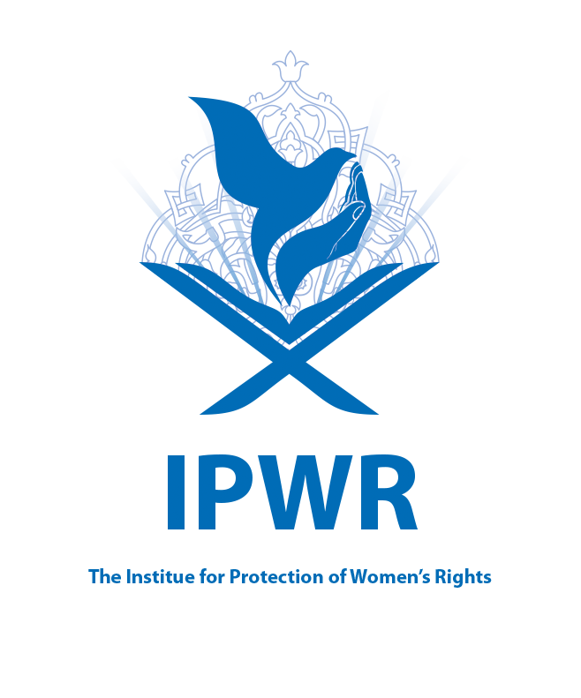
IPWR Report: Gender discrimination in the workplace in the UK
E-mail: info@womenrightful.com

Gender discrimination in the workplace in the UK
Gender inequality remains a pervasive issue across all levels of business and throughout various industries. Even in contemporary workplaces, workplace sexism creates significant barriers to women's success, manifesting in several ways, including unequal pay for equal work, entrenched gender stereotypes, and reduced opportunities for promotions and career advancement. In this report, the IPWR Institute delves into the complexities of gender inequality within the workplace, focusing on the situation in the United Kingdom.
The UK government has asserted that the Equality Act provides essential legal protections against sexual harassment and discrimination in the workplace. This legislation is intended to safeguard individuals from unfair treatment based on gender and to foster a more equitable work environment. However, despite these legal frameworks, numerous reports and high-profile revelations over the past few years suggest that workplace sexism and gender-based discrimination continue to be significant issues. Many women still face challenges undermining their professional growth, highlighting a need for ongoing efforts to address these systemic inequities and ensure a truly inclusive workplace for all employees.
The gender pay gap: The gender pay gap refers to the measurable disparity between the average earnings of men and women within a given organization or the labor market as a whole. In the UK, the legislation mandates that men and women receive equal pay for equal work. This legal framework stipulates that an employee must not be compensated less than a colleague of the opposite sex who is engaged in the same job or in a role deemed of equal value within the same organization. Nevertheless, there are exceptions to this regulation; differences in pay are permissible, provided they are justified by reasons unrelated to the employee's sex.
According to data from the Office for National Statistics (ONS), as of April 2024, the median hourly wage for full-time female employees was 7.0% lower than that of their male counterparts. In contrast, for part-time workers, women earned an average of 3.0% more per hour than men, excluding overtime pay. Despite this seemingly favorable figure for part-time women, the larger context reveals that a significant portion of the female workforce is engaged in part-time employment, which generally comes with lower hourly wages. Consequently, when examining median pay across all employment types, women earned a startling 13.1% less than men.
Because more women are employed part-time, and part-time workers tend to earn less per hour, the gender pay gap for all employees is considerably more significant than the full-time and part-time gaps. Median pay for all employees was 13.1% less for women than for men in April 2024.
Since 2017/18, public and private sector employers with 250 or more employees have been required to publish data on the gender pay gap within their organization. The requirements only apply to businesses with at least 250 employees, although some smaller employers have reported their gender pay gap voluntarily. At the start of 2024, UK businesses and other organizations with at least 250 employees accounted for 17.8 million employee jobs. This represented around 50% of all employee jobs in the UK.
The gender pay gap figures reveal a stark contrast between sectors. In April 2024, the public sector reported a gender pay gap of 10.0% for full-time employees, whereas the private sector exhibited a more pronounced gap of 12.5%. These percentages are higher than the overall gender pay gap of 7.0% for all full-time workers, which can be attributed to the more significant proportion of women in the public sector and the generally higher pay scales in this field.
Persistent inequalities in the labor market’s three main components – employment opportunities, working hours, and hourly wage rates – continue to be significant. Notably, the disparities in earnings grow considerably after the birth of children. The noticeable gaps around childbirth underscore the impact of unpaid care work, which plays a critical role in shaping labor market inequalities.
Women are paid less, earning 85 pence for every pound a man earns. They also bear disproportionate responsibility for unpaid care and domestic work, carrying out, on average, 60% more unpaid work than men per week. If this was assigned a monetary value, one study has suggested that it would be between 10 and 39% of GDP. This is a key driver of women’s inequality at work. Over two million women, 14% of all women in the UK, are paid less than the real living wage (vs. nine% of men). The research found that nearly 60% of women with caring responsibilities said this prevented them from getting a new job or promotion, trapping women in low-paid and low-valued jobs.
An alarming statistic reveals that over two million women in the UK, amounting to 14% of all working women, receive less than the real living wage, compared to 9% of men in similar situations. Furthermore, research findings indicate that approximately 60% of women with caregiving responsibilities reported that these obligations had hindered their ability to secure new employment or promotions, effectively trapping them in low-paying and undervalued positions. This compounding set of challenges continues to perpetuate the cycle of gender inequality in the workforce.

Bullying and sexual harassment: Bullying and harassment encompass behaviors that create a hostile or intimidating environment for individuals, often leading them to feel marginalized or unsafe. According to the Equality Act of 2010, harassment is classified as unlawful conduct. Such behaviors can take various forms, including but not limited to spreading malicious rumors, engaging in discriminatory treatment, consistently undermining an individual's confidence, and obstructing access to training or promotion opportunities that they rightfully deserve. The consequences of bullying and harassment pose significant health and safety risks, with surveys indicating that over a third of employees in the UK have experienced bullying within their workplace.
Workplace bullying is often characterized by its subtlety, making it particularly challenging to identify and prove. Those engaging in bullying may wield power over their victims, leading to a culture where unfair treatment goes unreported due to fears of retaliation or negative consequences for the victim. This creates a cycle that perpetuates a toxic work environment.
Sexual harassment is a particularly insidious form of violence predominantly directed toward women and remains alarmingly prevalent within UK workplaces. Overall, 29% of those in employment experienced some form of sexual harassment in their workplace or work-related environment in 2023. Unwelcome sexual jokes and unwelcome staring were the most common forms of sexual harassment experienced in the workplace (by 15% and 10% of those in work respectively), 9 of the 15 sexual harassment behaviors were experienced by at least one in twenty (5%) in the workplace in 2023.
Of women, 81% reported being harassed by a man/man compared to 46% of men. One in ten (10%) women reported being harassed by another woman, whilst more than a third of men (35%) reported being harassed by another man. In terms of the location of workplace sexual harassment, 20% of those in employment experienced sexual harassment at their physical place of work (for example, in the office). Sexual harassment when socializing with colleagues outside the workplace was the second most likely setting for sexual harassment in a work-related environment (13%), followed by visits to clients or customers (9%).
Research conducted by the Trades Union Congress (TUC) reveals that more than 50% of all women have encountered some form of sexual harassment at work. The situation is even more concerning among younger demographics, with nearly two-thirds (63%) of women aged 18 to 24 reporting experiences of harassment. The ramifications of such actions extend beyond the workplace; for instance, data indicates that over 20% of employed women take time off each year due to domestic abuse, and 2% experience job loss directly related to this violence.
In a tragic reflection of this issue, reports from 2016 indicate that four women were murdered by male perpetrators at or near their workplace. These incidents underline the gravity of the threats women face not only in their personal lives but also within their professional environments.
Furthermore, the pervading issues of harassment and discrimination are compounded by the realities of domestic abuse occurring in the home. Shockingly, 52% of women have reported experiencing bullying and harassment in their workplaces, yet the rate of reporting these incidents remains markedly low. The ongoing cost-of-living crisis has further exacerbated this situation, as financial pressures increasingly compel women to stay in abusive relationships. The prevalence of such abuses has escalated during the pandemic, highlighting a growing need for supportive measures and resources aimed at addressing these critical workplace and domestic issues.
Women-led businesses: Women-led businesses are defined as those majority-led by women, controlled by a single woman, or have a management team of which a majority are women. In 2022, 18% of SME employers were women-led. This was a one percentage point decrease in 2021. There were fewer women-led medium-sized businesses (14%) than small and micro businesses (18% for both).
Women are underrepresented in senior positions, making up around 30% of senior management roles. Only 6% of the CEOs of FTSE 100 companies are women, and none of these are from ethnically diverse backgrounds. This is perhaps unsurprising given that one in three women from ethnically diverse backgrounds say they have been unfairly passed over for or denied a promotion at work, with 27% believing their manager was actively blocking this.
In 2022, 18% of small and medium-sized enterprises (SME) employers were led by women (meaning that they were either led by one woman or by a management team that is majority female), according to the Government’s annual Small Business Survey. 26 This is a one percentage point fall compared to 2021, similar to figures since 2015.
Only one in ten of the UK’s top businesses have a woman as chief executive. Several factors explain this imbalance, from discrimination and a lack of networks to low confidence and the ‘motherhood penalty.’ Investment in childcare and more diverse boards could help to close the corporate gender gap.
Women account for 49% of the employment of people over 16 years old in the UK. Yet of the one hundred chief executive officers (CEOs) currently heading the country’s most prominent public companies by market capitalization (the FTSE 100), only ten are women.
Recommendations
Under the Equality Act 2010, it is mandated that men and women must receive equal pay for “equal work.” This encompasses various categories of work as defined by the Equal Pay Act, including jobs that are the same, similar, equivalent, or of equal value in terms of skill, effort, responsibility, and working conditions. The Act aims to eliminate gender-based pay disparities and ensure that all individuals, regardless of gender, are compensated fairly for their contributions in the workplace.
In addition to pay equity, the Equality Act 2010 addresses the issue of bullying and harassment within professional environments. Such behaviors, which can create a hostile atmosphere and leave individuals feeling intimidated, threatened, or offended, are deemed unlawful. This includes not only direct harassment but also any conduct that contributes to a toxic work culture.
Given the importance of these provisions in promoting a fair and respectful workplace for all individuals, we strongly urge the UK government to actively monitor and enforce the implementation of the provisions outlined in this Act. Mechanisms must be in place to ensure compliance and to support individuals who may face unequal treatment or harassment in their work environments.
We urge the UK government to actively promote the inclusion of more women in senior leadership positions across various sectors. This could involve implementing changes to hiring laws and practices to facilitate greater gender diversity in leadership roles. By creating clear guidelines and incentives for organizations to prioritize female candidates for senior positions, the government can help break down the barriers that have historically limited women's advancement in the workplace. Such initiatives would not only foster a more equitable environment but also enhance decision-making processes and drive innovation, ultimately benefiting society and the economy as a whole.
Recalling in this regard Human Rights Council resolution 41/14 of 11 July 2019 on equal pay, we also invite the United Nations Entity for Gender Equality and the Empowerment of Women (UN-Women) and the International Labor Organization, within their respective mandates and existing resources, in collaboration with all relevant organizations already involved in the promotion of equal pay for work of equal value, to work together to facilitate the observance of International Equal.

https://researchbriefings.files.parliament.uk/documents/SN07068/SN07068.pdf
https://commonslibrary.parliament.uk/research-briefings/sn07068/
https://researchbriefings.files.parliament.uk/documents/SN07068/SN07068.pdf
https://www.ons.gov.uk/employmentandlabourmarket/peopleinwork/earningsandworkinghours/bulletins/genderpaygapinthe uk/2024
https://www.ons.gov.uk/employmentandlabourmarket/peopleinwork/earningsandworkinghours/bulletins/genderpaygapintheuk/2022
https://www.ons.gov.uk/employmentandlabourmarket/peopleinwork/earningsandworkinghours/articles/womenshouldertheresponsibilityofunpaidwork/2016-11-10
https://www.bitc.org.uk/blog/why-is-workplace-gender-equality-still-relevant-in-2023/
https://www.livingwage.org.uk/news/over-2-million-women-uk-earn-below-real-living-wage#:~:text=OVER%202%20MILLION%20WOMEN%20IN%20THE%20UK%20EARN%20BELOW%20THE%20REAL%20LIVING%20WAGE,-09%20Mar%202023&text=New%20research%20from%20the%20Living,of%2Dliving%20crisis%20than%20men.&text=The%20real%20Living%20Wage%20is,of%20%C2%A311.95%20in%20London.
https://www.smeloans.co.uk/blog/bullying-in-the-workplace-statistics-uk/
https://assets.publishing.service.gov.uk/media/60f03e068fa8f50c77458285/2021-07-12_Sexual_Harassment_Report_FINAL.pdf
https://www.npr.org/sections/thetwo-way/2018/02/21/587671849/a-new-survey-finds-eighty-percent-of-women-have-experienced-sexual-harassment
https://www.sciencedirect.com/science/article/pii/S2405844023083044
https://www.tuc.org.uk/news/nearly-two-three-young-women-have-experienced-sexual-harassment-work-tuc-survey-reveals
https://assets.publishing.service.gov.uk/media/60f03e068fa8f50c77458285/2021-07-12_Sexual_Harassment_Report_FINAL.pdf
https://pmc.ncbi.nlm.nih.gov/articles/PMC4676385/
https://www.femicidecensus.org/wp-content/uploads/2020/02/Femicide-Census-of-2016.pdf
https://www.unison.org.uk/content/uploads/2020/02/589_sexual-harassment-guide-Oct24.pdf
https://assets.publishing.service.gov.uk/media/64e88c0d691aa3000da56df2/LSBS_2022_SME_Employers.pdf
https://www.linkedin.com/pulse/women-make-up-only-30-uk-leadership-roles-why-female-still-morrin
https://www.fawcettsociety.org.uk/Handlers/Download.ashx?IDMF=72040c36-8cd6-4ae3-93f3-e2ad63a4b4b0
https://www.gov.uk/government/statistics/small-business-survey-2022-businesses-with-employees
https://www.economicsobservatory.com/why-are-there-so-few-women-leading-the-uks-biggest-companies#:~:text=Only%20one%20in%20ten%20of,close%20the%20corporate%20gender%20gap.

