CONTRIBUTION TO THE LIST OF ISSUES TO BE COMPILED BY THE COMMITTEE ON THE CONVENTION ON THE ELIMINATION OF DISCRIMINATION AGAINST ALL WOMEN (CEDAW)

STATE PARTY:
MALAYSIA

Lesbian, bisexual, queer, transgender and intersex (LBQTI) women

JANUARY 2023

by
Justice for Sisters, Legal Dignity, Jejaka, PLUHO, Queer Lapis & Kemban Kolektif

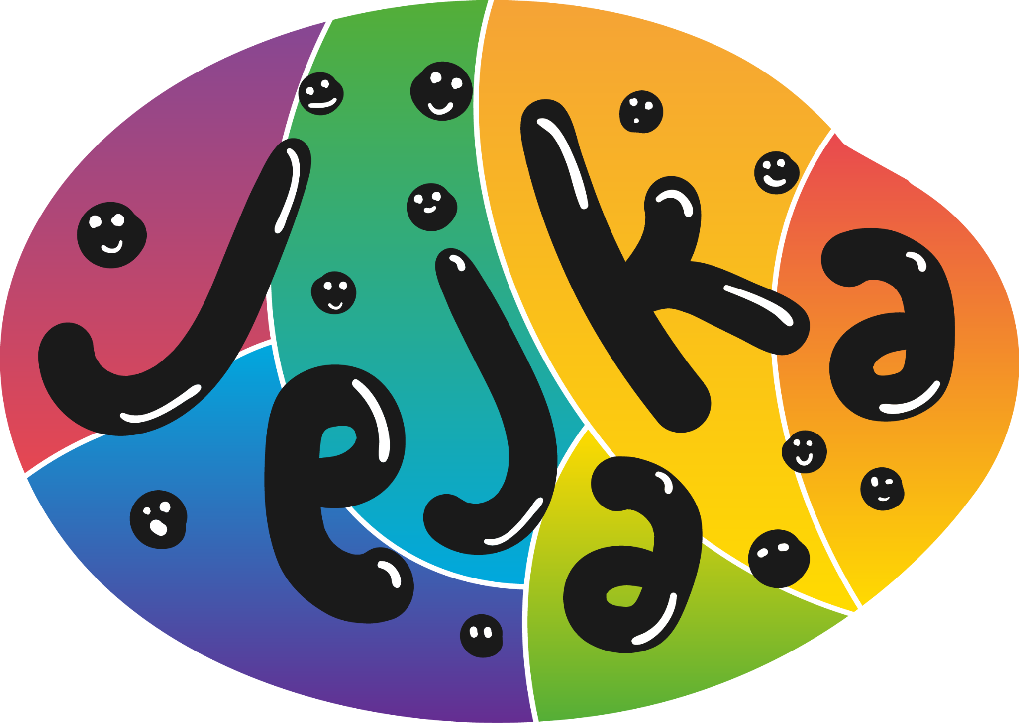
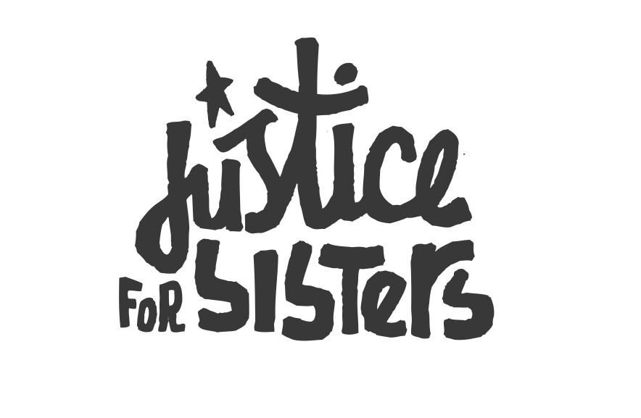
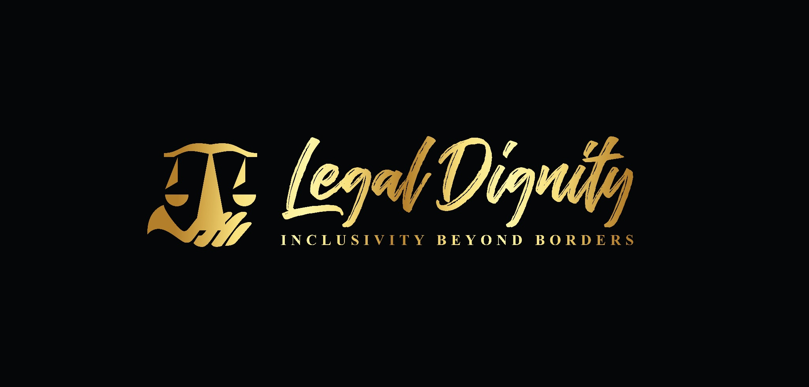

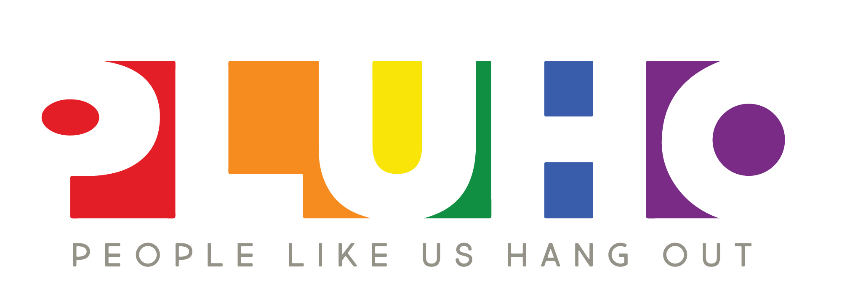

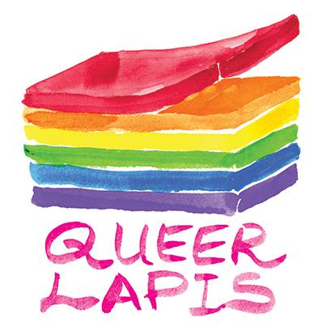

For more information, please kindly contact thilaga sulathireh at justiceforsisters@protonmail.com

Table of contents

Item | Page
Executive summary | 3
Article 1: Definition of discrimination | 4
Article 2, 3 & 15: Equality & Non-discrimination | 5
Favourable legal developments on criminalization | 5
Criminalisation of LBT women | 6
Legal gender recognition | 7
State-funded anti-LGBT activities | 8
Article 5: Stereotypes | 10
Article 7: Political and public life | 11
Right to vote | 11
Barriers to public and political participation | 11
Freedom of assembly | 12
Article 10: Education | 13
Article 11: Employment | 14
Pre-employment discrimination | 14
Employment discrimination | 15
Article 12: Health | 16
General Recommendation 19: Violence against Women | 17
General Recommendation 33: Access to Justice | 18

Executive summary
Lesbian, bisexual, queer, and trans (LBQT) women in Malaysia face widening inequalities due to increasing criminalisation, state-funded rehabilitation or conversion practices, and discrimination. While intersex women are seemingly accepted by state religious institutions, they are heavily pathologized in state health guidelines.

The state, namely the Prime Minister’s Department (Religious Affairs) and JAKIM is instrumental in the increasing hostility against LGBT people. In the last 5 years, 8 new anti-LGBT state syariah laws have been introduced along with several amendments to existing anti-LGBT laws. The state-rehabilitation programmes were expanded to regional activities. At least 5 LGBT people were subjected to judicial caning. Of which, 2 are women. LGBT contents were banned or subjected to investigations.

While the Malaysian Courts have made favourable decisions, state agencies have appealed them, resulting in the decisions being overturned. In the Federal Court decision, which found Selangor’s Section 28 (sex against the order of nature) unconstitutional, the state does not have an appeal avenue. The court’s decision has yet to be integrated into state legislative processes. Instead, new anti-LGBT inconsistent with the decision have been introduced.

Yet, the state report notes “113. Malaysia maintains the principle of gender equality and non-discrimination against women as articulated in the Federal Constitution and as reported in the previous periodic reports”

In the 2018 CEDAW review, Malaysia received the following concluding observations, all of which have not been implemented.

36 (e) Adopt anti-bullying policies based on alternative strategies, such as counselling services and positive discipline, and undertake awareness-raising measures to foster equal rights for lesbian, bisexual, transgender and intersex students.

48. The State party undertake awareness-raising measures to eliminate discrimination and negative stereotypes against lesbian, bisexual and transgender women, and intersex persons.

(a) Amend all laws that discriminate against lesbian, bisexual and transgender women, and intersex persons, including the provisions of the Penal Code and Syariah laws that criminalise same-sex relations between women and cross-dressing;
(b) Apply a policy of zero tolerance with regard to discrimination and violence against lesbian, bisexual and transgender women and intersex persons, including by prosecuting and adequately punishing perpetrators:
(c) Expedite measures to discontinue all policies and activities aimed at “correcting” or “rehabilitating” lesbian, bisexual and transgender women, and intersex persons.
Article 1: Definition of discrimination
1.1 Sex and gender are used interchangeably, as they are not clearly defined in laws and the Federal Constitution. The narrow and binary definition of women is underscored by a lack of understanding of sex, gender, and intersectionality; patriarchal religious interpretations; and the criminalisation and pathologisation of LGBT people. This forms the state’s gender ideology.

1.2 The 2017 Guideline on the Management of Problems Related to Gender and Health notes “in the context of the Constitution and Malaysian laws sex or gender refers to biological status male or female, which includes physical traits such as chromosome, sex, gonad, sex hormones, internal reproductive structure and external genitalia.” Further, the guideline medicalises and pathologises LGBT people as having ‘gender confusion’ due to sexual violence, lack of love, absent parents, among other widely debunked pseudo-scientific myths.

1.3 The Prime Minister’s Department (Religious Affairs) and JAKIM, which oversees most of the LGBT-related programmes, adopts an ‘acceptance with exception’ approach in relation to LGBT persons. JAKIM does not agree with LGBT acts; however, it believes LGBT persons have a right to be guided and advised to the right path. To that end, JAKIM promotes and has introduced various forms of LGBT rehabilitation practices, including camps; Islamic psycho-spiritual treatment; and using religious guilt, shame, and peer-pressure to ‘rehabilitate’ or ‘return LGBT people to the right path’, among others.

Critical questions

Q1. How does the State plan to integrate an intersectional lens, as recommended in General Recommendation 28, in defining and addressing discrimination?

Q2. How does the state plan to ensure an evidence and rights-based approach in relation to LBTI persons? For example, by adopting scientific medical evidence as well as non-patriarchal and inclusive religious interpretations on sexual orientation, gender identity, gender expression and sex characteristics (SOGIESC) or engaging inclusive religious actors?

Article 2, 3 & 15: Equality & Non-discrimination

Favourable legal developments on criminalization

2.1 In the 2020 constitutional review of Section 28 of the Selangor Syariah Criminal Offences, which criminalises sex against the order of nature, the Federal Court found the state law unconstitutional due inconsistencies with the Federal and state governments’ legislative jurisdictions, as outlined in the Federal and State lists of the Constitution.
The State List, while allows states to enact laws on ‘precepts of Islam,’ they are bound by the preclusion clause, which stipulates that states cannot enact laws on matters included under the Federal List. The Federal Court noted “… it can be postulated that having regard to the preclusion clause in item 1 of the State List, when the two Legislatures (Federal and State) legislate a law concerning the subject-matter of criminal law, and the two laws touch on the same matter, the said laws cannot co-exist even if the said law is said to be against the precepts of Islam.”

2.2 In 2014, the Court of Appeal declared Negeri Sembilan’s Section 66 unconstitutional on the grounds that it violated Articles 5, 8, 9, and 10 of the Federal Constitution. However, in 2015, the Federal Court set aside the decisions by the High Court and Court of Appeal citing procedural error by the applicants in filing of their petition to the High Court instead of the Federal Court. However, in 2019, in the case of Alma Nudo Atenza vs PP & Another Appeal, the Federal Court opined that the filing procedure was indeed correct. Subsequently, the applicants filed another petition to review the decision based on the Alma Nudo decision, albeit unsuccessfully. Nonetheless, the merits of the Court of Appeal decision still stand.

2.3 The legal challenge resulted in reduced official arrests and a change of laws used in trans women related cases. Nonetheless, surveillance, raids, harassment, and intimidation of LBT women continues. Trans women in service and other visible employment sectors are more vulnerable to harassment and arbitrary arrests by state actors. Gendered, broad, and vague laws—e.g., insulting Islam, encouraging vice, and failure to perform Friday prayers, under the state syariah criminal laws—have been used instead against trans women to reinforce gender binary constructs.

2.4. Despite the favourable legal developments, court decisions have yet to be integrated into LGBT and/or syariah legal reforms. Instead, state governments have introduced new anti-LGBT state syariah laws or harsher amendments to existing anti-LGBT laws. Following the Federal Court decision on Section 66, the Negeri Sembilan state assembly amended Section 66 by adding ‘immoral purposes’ to wears a woman's attire and increased its punishment. It also introduced Section 66A, which criminalizes a female person posing as a man.
Kelantan’s new syariah criminal offences enactment, which took effect following the Section 28 Federal Court decision, introduced ‘attempt to liwat and musahaqah’ and a female person posing as a man. Terengganu introduced similar provisions in 2022. Kelantan also amended the ‘male person posing as a woman section’ to penalize wearing female attire in private and public spheres.

Criminalisation of LBT women

2.4 LBT women face increasing criminalisation. Between 2019 and 2022, 8 new anti-LGBT state Syariah laws were introduced in three states, bringing it to a total of 55 anti-LGBT state syariah laws. The new laws include a female person posing as a man (3), attempt to musahaqah or sexual relations between women (2), attempt to liwat or anal sex or sexual relations between men (2), and changing gender (1).

2.5 The following laws, fatwa and regulations penalise LGBT people:
- Sections 377 A & B of the Penal Code that criminalise carnal intercourse between consenting adults of any gender carry mandatory whipping and a maximum 20 years of imprisonment. State actors use Section 377 to reinforce the notion that LGBT people are inconsistent with religion, law, and culture, despite it being a British colonial legacy. Section 377D, which penalizes gross indecency, has been used in cases of political extortions based on actual or perceived sexual orientation.
- State Syariah laws criminalise musahaqah (13 states), attempt of musahaqah (2), liwat (11), attempt to liwat (3), male person posing as a woman (14), female person posing as a man (6), sex against the order of nature (4), sexual relations between persons of the same gender (1), and changing gender (1).

- At least 10 fatwas declare trans people as haram (illegal), impacting legal gender recognition and availability of trans-specific healthcare for all persons regardless of religion. Other LGBT-related fatwas restrict freedom of assembly and criminalise support for LGBT people.
- In 2021, Perlis introduced a guide on interaction with Mukhannath, a classical Arabic umbrella term for trans and gender-diverse people. It has no legal effect, but it prohibits, among others, entry into mosques in the state of ‘gender confusion’ and performing hajj and umrah (pilgrimage). It was welcomed by the Penang Mufti and the Deputy Minister of Religious Affairs.
- Film censorship guidelines prohibit the depiction of LGBT people.

2.6 Between January and February 2022 alone, 5 musahaqah cases and an arrest of a trans person were reported in Kelantan. In 2018 and 2019, at least six people were subjected to caning for attempting to musahaqah in Terengganu and sex against the order of nature in Selangor; two of them were LBQ women. Statistics of arrests and prosecution are not accessible and readily available.

Legal gender recognition (LGR)

2.7 Trans, intersex, and gender-diverse people lack legal gender recognition (LGR) based on self-determination. LGR based on medical intervention has been rolled back. In 2017, the National Registration Department won an appeal of a progressive High Court decision allowing a trans man to change gendered details in his identification cards (IC).

2.8 Studies show a causal link between the lack of LGR and poorer quality of life due to increased discrimination and gender dysphoria.

- An APTN research shows that, in Malaysia, trans applicants were 50% less likely than cis applicants to get a positive response from a prospective employer and 32.9% less likely to be invited to an interview. Some employers demand that transgender employees present themselves based on the gender on their IC.

- Increased vulnerability to doxing, especially the dissemination of their legal documents online to ‘out’ them. In 2020, the Mufti of the Federal Territory obtained a trans woman’s details as per her birth certificate without her consent and disclosed it publicly. Subsequently, media outlets misgendered her. While Section 8 of the Personal Data Protection Act 2010 prohibits the sharing of personal data, the state is exempted.

- Humiliating and degrading treatment during raids and arrests, as trans women are called by name as per IC, forcibly segregated and subjected to procedures based on gender marker on their IC, including body searches, inspections, and urine tests.

- Increased vulnerability to sexual violence in prisons and lockups as assignment of lockups and prisons is based on gender markers on IC.

2.9 SUHAKAM’s initiative to moot a LGR feasibility study in 2021 was met with resistance from the then-Minister of Religious Affairs, among others. He stated that trans people are inconsistent with nature, religion, customs, and culture, and will not be recognised in Malaysia consistent with the Cairo Declaration, which prohibits ‘practices that are against Islamic Syariah.’

State-funded anti-LGBT activities

2.10 The state’s LGBT rehabilitation efforts consist of:
1) Establishment of a task force and action plan to address LGBT issues.
The JAKIM Social Action Plan (PTSI JAKIM) 2019-2025 aims to address a range of ‘social ills among Muslim societies, including ‘deviant lifestyle.’ (read LGBT people or issues).

2) Implementation of support and guidance programmes
According to JAKIM, 1,769 people have participated in state-organised rehabilitation activities, through which 12 ex-LGBT groups have been established. Nine activities were held under JAKIM’s ‘treatment and rehabilitation programmes’ on ‘gender confusion’ in 2019, of which five targeted LGBT people, including one in a women’s prison. In 2021, JAKIM organised a Nusantara Religious Camp with LGBT persons from Malaysia, Indonesia, Thailand, and Singapore.

3) Establishment of support services
JAKIM’s Community Family and Social Services Center (PKKSK) provides counselling and Islamic Psychotherapy, including for LGBT persons.
4) Development of resources
In 2022, JAKIM launched a rehabilitation manual for lesbian and gay persons (Manual Komuniti Hijrah Lesbian dan Gay). It features among others, understanding your own fitrah (nature); an Islamic perspective on lesbian and gay; and Islamic psychotherapy, including prayer and zikir therapy; to help lesbian and gay persons, especially Muslims, to lead a better life aligned with Islamic principles.

2.11 The state’s ‘Islamic psychospiritual’ approach employs a combination of shame, religious guilt, incentives, pseudo-science, peer pressure, and the weaponisation of sex work and HIV to reinforce the notion of sin. Some key manifestations include:
- ‘Voluntary’ camps that offer religious and HIV awareness together with conditional economic support
- Asnaf al-riqab zakat (Islamic alms) supports the cost of rehabilitation, including rental and relocation support to start a new life, medical support, and start-up funds for businesses. for LGBT people seeking to ‘change’ themselves. In 2019, 497 LGBT people reportedly have ‘returned to the right path’ through the support of the Selangor Zakat funds.
- A university hospital reportedly sponsored medical intervention for 20 trans people to de-transition. Financial incentives are also provided to discourage them from returning to their ‘old self’.

2.12 In the absence of state measures to address marginalisation and criminalisation of LBT women, some are more inclined to suppress their SOGIE to seek acceptance and survive, including secure employment opportunities. Elderly, PLHIV, Muslim LBT women, and those from lower economic background are vulnerable to SOGIE-change efforts through conditional welfare aid that imposes suppression of SOGIE.

Critical questions

Q3. What measures has the State taken to implement the CEDAW Committee’s concluding observation 48 (a), (b) and (c)?

Q4. How does the state plan to address resistance to human rights of LBT persons by some state agencies?

Q5. How does the state view the role of discriminatory laws and policies in the continuation of discrimination and marginalisation of LBTI women? How does the state plan to use progressive Court decisions to reduce inequalities against LBT persons?

Q6. When does State plan to institute legal gender recognition, given the far-reaching impacts of lack of LGR for trans and gender-diverse persons?

Article 5: Stereotypes
5.1. The state’s promotion of gender ideology, underscored by the exclusion, criminalisation, and pathologisation of LBTI women, has intensified over the past 5 years. JAKIM’s annual publications promote the harmful notion that LGBT people can be changed, and that LGBT people’s sexual orientation and gender identity are caused by widely debunked harmful myths. In 2022, JAKIM published a rehabilitation manual for lesbian and gay persons. Among others, it promotes Islamic psychotherapy, including prayer and zikir therapy, to ‘help’ Muslim lesbian and gay persons lead a better life aligned with Islamic principles.

5.2. LGBT people are perceived and portrayed as ‘sinners’, including descriptions by some media outlets like ‘komuniti songsang’ or ‘deviant community.’

5.3. Between 2020 and 2022, at least 3 LGBT-related books have been banned under the Printing Presses and Publications Act for being ’detrimental to public order, morals and public interest’. The same year, the Home Ministry appealed a book ban lifted by the High Court. The same year, two celebrities were charged under the Communications and Multimedia Act (CMA) for sharing on social media platforms their music videos featuring gender-diverse and drag performers. Meanwhile, 2 films were banned due to LGBT content. The then-Deputy Minister of Communications and Multimedia reportedly said that the Ministry and JAKIM will “prevent the spread of LGBT culture in Malaysia” and take “severe action against individuals found promoting such elements.”

Critical questions

Q7. Given that LGBT rehabilitation are harmful and unscientific, what are the state’s plans to adopt an evidence and rights-based approach towards reducing harmful stereotypes against LBTI women? How does the state see the correlation between criminalisation and discrimination with LBTI persons’ so-called or perceived willingness to suppress their SOGIE?

Q8. What are the state’s plans to ensure SOGIESC-affirming content and expressions are not prohibited or viewed as a ‘promotion of LGBT lifestyle’ or threat?

Article 7: Political and public life

Right to vote

7.1 The lack of LGR for trans and gender-diverse people negatively impacts their participation in elections and politics. They are inevitably subjected to misgendering, being outed, or having their gender identity disclosed to the election officers and others at the polling centre, as the electoral rolls reflect name and gender marker IC.

7.2 In the last two elections, those whose appearance differs from the photo on their IC, including trans and gender-diverse persons, are required to complete Form 11 to verify their identity. Anecdotal evidence shows Form 11 is not applied consistently for all trans and gender-diverse persons: some reportedly were required to complete Form 11, and some reported microaggressions from election officers.

Barriers to public and political participation
7.3 Election hate speech monitoring found offensive speech related to gender and sexual orientation was 3 times higher than religion- and race-related offensive speech. A survey with 220 LGBT people found 55% and 53% faced increased stress due to media sensationalism and online hate speech, respectively. Meanwhile, 39% experienced discrimination.
7.4 Political LGBTphobia is high, evidenced by outing of politicians based on perceived sexual orientation, leaked sex videos, name-calling, LGBT scapegoating, among others. While Section 4A of the Election Offences Act prohibits promotion of ill-will or hostility, it has not been applied against promotion hostility against LGBT persons. Political parties subjected to LGBTphobia, aggressively and pre-emptively disassociate themselves from LGBT-related issues, exacerbating LGBT exclusion.
7.5 LBT human rights defenders (HRD) report increasing apathy and dismissal by government actors citing “sensitivity” in response to discrimination against LBTI women.
7.6 State-linked ex-LGBT groups are pitted against LBT HRD to reinforce the ‘legitimacy’ and ‘efficacy’ of the state’s harmful ‘rehabilitation’ programmes and deter representation of LBTI women in government processes. In 2019, a trans woman HRD faced public backlash following her appointment as a civil society representative to a civil society-state HIV oversight mechanism. This included public pressure to review and replace her with an ex-transgender person. She was subjected to death threats and doxing, where her personal information and pre-transition photos were disseminated without her consent. While the Ministry of Health maintained her representation, the backlash was not addressed.
7.6 Advocacy efforts and criticism against the state’s LGBT ‘rehabilitation’ and other harmful programmes are met with punitive measures, including police reports against HRD by JAKIM.
Freedom of assembly

7.3. Between 2019 and 2022, at least five LGBT-related events were reportedly intimidated, raided, or disrupted by the police and/or the state Islamic departments. A venue that hosted an LGBT social event was notified by the police to expect raids should they continue to host the event. The Women’s March 2019 organisers were investigated under the Sedition Act and the Peaceful Assembly Act due to LGBT visibility and inclusion; the charges were later dropped. In most of these incidents, trans women were targeted by the police and state Islamic departments, with Muslims being subjected to investigation under state syariah laws.

Critical questions

Q9. What are the state’s plans to reduce LGBTphobia or LGBT prejudice, particularly during elections? How does it plan to enforce Election Offences Act in relation to hostility towards LBT women?

Q10. How does the state plan to shift its punitive approach against LBT human rights defenders, representation, and visibility in line with international human rights law?

Article 10: Education

10.1 The Ministry of Education’s Circular No 7/2003 Power of Teachers to Cane and the Federal Territory Education Department’s discipline rule book for secondary school students impose corporal punishment for homosexuality and ‘gender confusion’, so-called serious offences. The latter allows stern warning, expulsion, caning, suspension, fine, and being charged in court against students because of their SOGIE.

10.2 The Form 2 reproductive and sexual health education guidance SOGI as a form of confusion or disorder and being inconsistent with religion and culture.

10.3 Research shows LBQ girls and gender-diverse persons face ‘outing’ and microaggressions by peers and teachers; religious interventions to correct their sexual orientation; and religious condemnation of LGBT people in classes. In most cases, they lack support at home and in school.

10.4 A SUHAKAM study with trans people found name-calling, physical violence, and sexual harassment as pervasive forms of discrimination faced by transgender students in school, resulting in stress, depression, loss of interest, and suicidal attempts. It concludes that the educational system lacks any redress mechanism that transgender children trust to discuss the unique challenges they face.

Critical questions
Q11. How does the State plan to implement recommendations in SUHAKAM’s transgender study?
Q12. What is the State’s plan to implement the CO 36 (e)?

Article 11: Employment

11.1 Criminalization and intersectional discrimination limit LBT women’s employment options, resulting in missed opportunities for self-development and growth. A queer woman explained that the combination of sexism and LGBTphobia limited her employment options.
“At my previous job, they have misogynistic jokes, and I feel like I have to keep it to myself because they are of higher rank than me. … it actually is very difficult. So ya, there are two things, one I get anxiety about being queer as a government staff and two trying to be cool about these people passing remarks, you have this locker room kinda thing, it’s really frustrating, and it does affect my choice of jobs in life.”
11.2 Consequently, due to economic desperation, LBT women take any available jobs or are left with sex work as their option, where they face increased vulnerability to arrest due to its criminalisation.
Pre-employment discrimination

11.2 A study shows trans applicants were less likely than cisgender applicants to receive a positive response, which includes being invited to contact the employer, being asked for more information, or being invited to attend an interview. The report shows cisgender applicants were 66.1% more likely to be invited to an interview than trans women applicants in Malaysia. The report notes that “the discrimination experienced by trans women was particularly severe” due to the disproportionate rejections that trans women face compared to cisgender women.

11.3 The SUHAKAM study also highlights similar trends. 58 of 100 respondents (58%) were denied employment or have had their applications rejected. 57% said interviewers questioned or made comments regarding their gender identity. This includes cutting their hair, comments about their attire and their gender expression, negative assumptions about their qualification, etc.
11.4 Reports show that denial of employment intersect with discrimination based on religion, HIV status, among others. A trans woman was denied employment at a Muslim women hair salon on the grounds of religion and gender. The ‘women’ only policy often underscored by misunderstanding of trans women’s gender identity, arbitrary regulation of interactions between any gender, etc.
11.5 Reports identify the negative impact of lack of legal gender recognition on employment discrimination. Trans women who change their gender expression to appear masculine-presenting to secure jobs also face discrimination and rejection for being gender-non-conforming. Some are only allowed to use gendered workplace spaces as per gender on their IC.

Employment discrimination
11.6 The SUHAKAM report cites various forms of workplace discrimination against trans women, including:
- subjected to intrusive questions by their colleagues (53%),
- spread of gossip and rumours (51%),
- name-calling (48%),
- sexual harassment by colleagues (27%) and customers (25%).
11.7 The report documents the following impact of workplace discrimination:
- 61% felt stress, anxiety, and isolation
- 45% were demotivated
- 43% experienced depression
- 15% had suicidal thoughts
- 8% had attempted suicide
- 37% resigned and sought new employment opportunities.
Critical question

Q13. How does the State plan to address pre-employment and intersectional workplace discrimination LBT women face?

Article 12: Health

12.1 The Ministry of Health’s 2017 guideline to manage ‘gender confusion’ in health clinics recommends medical examinations, a chromosome test and counselling with state agencies, counsellors, and religious institutions, among others for those seeking support for gender-related issues. Intersex babies are medicalized and described as ‘ambiguous’.
The 2019 Paediatric Protocols recommends gender assignment and sex rearing for intersex babies based on ‘most probable adult gender identity and potential for adult function’ and medical and non-medical measures to reinforce the assigned gender. They unnecessarily medicalise LBTI persons, violate bodily autonomy and integrity, and are not based on latest scientific and human rights standards.

12.2. A medical university’s Gender Dysphoria Flagship programme aims to ‘save’ LGBT people. A university-linked hospital has reportedly sponsored medical interventions for 20 trans people to de-transition and provided financial incentives to discourage them from returning to their ‘old self’.

12.3 The weaponisation of HIV increases discrimination and threatens LBT women’s access to healthcare. State actors raise panic by exploiting statistics on the prevalence of HIV among LGBT people, while promoting harmful and counterproductive HIV interventions, such as LGBT rehabilitation and other SOGIE-change efforts. A study shows 42% of 436 physicians in Kuala Lumpur showed stigma-related constructs towards transgender people.

Critical questions
Q14. How does the state plan to adopt a more evidence- and rights-based approach in relation to LBTI women’s health issues?

General Recommendation 19: Violence against Women

GR19.1 LBT women face multiple foms of discrimination and violence, by state and non-state actors, including family members.
- Online gender-based violence, including doxing, catfishing, and blackmail. Consequently, many opt to self-censor themselves to avoid discrimination.
- Trans and gender-diverse people, especially sex workers are vulnerable to hate crimes and murder. The Suhakam study found 28 trans respondents who were sex workers experienced violence from clients/customers, 25 from authorities and 29 from members of the public.
- Sexual harassment and violence in public places and transportation;
- Domestic violence, including surveillance by family members; forced marriages; emotional and financial withdrawal; disownment; forcibly or pressuring LGBTQ family members to SOGIE-change efforts or conversion practices; and violence. In some cases, the violence results in discontinued education, loss of home or shelter, long-term effects on their safety and wellbeing.

GR19.2 A report shows 20% of the respondents noted increased anti-LGBT conversations at home, in family chat groups, or among family members because of increased anti-LGBT narratives.

GR19.3 Reports show low access to justice and a causal link with criminalisation. Muslim queer women facing forced marriage and domestic violence by family members are unable to seek redress due to fear of legal repercussions.

Critical question

Q15. How does the State plan to reduce violence against LBT women and promote redress mechanisms, including the Domestic Violence Act among LBT women?

General Recommendation 33: Access to Justice

Access to redress

GR33.1 A survey shows only 17% of 220 respondents stated that they are very comfortable reporting cases of discrimination and violence to government agencies. Meanwhile, 59% were uncomfortable citing:
- Lack of trust that the case would be taken seriously (73%)
- Fear of exacerbating the situation, including additional discrimination (34%)
- Fear of being outed (28%)
- Lack of knowledge and information on the reporting process (31%)
- Fear of media sensationalism (31%).

Discrimination by the police

GR33.2. Research shows that trans women experience name-calling and humiliating treatment, microaggressions, victim-blaming, and a lack of urgency in handling their cases when seeking redress from the police. During raids, arrests, and detention, they are subjected to procedures, treatment, and assignment of facilities based on their gender marker on legal documents, although discretion is made in the context of lock-up and for trans women based on medical transition.

GR33.3 Police use non-human rights language and discriminatory terms to describe LBT women when sharing information with the media and the public regarding hate crimes and violence involving trans women.

Discrimination by the state Islamic departments
GR33.4. LBT women experience the following violations during raids, arrests, detention, and prosecution by the state Islamic departments, including
- Being subjected to irrelevant and degrading questions during the statement-taking process
- Inclusion of media in raids leading to humiliating and degrading treatment, loss of employment, strain on relationships with family members, and violence by family members, among others
- Unreasonable bail conditions by judges resulting in being forced to serve prison sentence or continued detainment. For example, in some monitored cases, judges have set that only family members, or government officers of a certain grade residing in a specific state can be bailors
- Bias by syariah justice actors is high. In the Terengganu caning case, a judge was quoted as saying, “Caning in sharia is not to injure, torture, and punish offenders. Hopefully this punishment will serve as a lesson and reminder to all Muslims and give an idea of how sharia punishment is a punishment in the form of education and not to torture" In the section 28 case, the judge meted out prison sentences as a preventative measure to rehabilitate and isolate those prosecuted from “others and their environment” (read: other LGBTQ people). The judge also said that as people like them are difficult to control, thus they must be segregated. Similar bias is found against sex workers.
- In several cases monitored by Justice for Sisters in syariah courts Selangor, bureaucracy and inefficiencies have led to victimisation. For example, delays in making bail fees due to the distance of the bank from the court have led to unnecessary detention.
Access to data

GR33.5. Current data is based on community data gathering, giving rise to two main issues in relation to access to data:
- Lack of access to statistics in relation to cases of arrests, namely under state Syariah criminal offences enactments; and
- Lack of gender-disaggregated data and analysis of crimes against LBTI persons prevents insights into trends of violence and increased vulnerability, as well as development of effective responses to violence against LGBTIQ persons.

Critical question

Q16. How does the State plan to reduce discrimination and trust deficit in police to ensure access to justice? Does the State learn from and adopt good practices in the region, for example, by introducing a standard operating procedure in interacting with LBTI persons, sensitisation training, and introduction of LGBTI police desks?

In Malaysia’s gender binary context, gendered laws and laws targeting men are applied against trans women, vice versa, thus ‘LGBT’ will also be used, where relevant
The Department of Islamic Development Malaysia (JAKIM), federal agency that administers Islamic affairs. https://www.islam.gov.my/ms/
1) The Negeri Sembilan state government appealed the Court of Appeal decision that found Section 66 (male person posing as a woman) of the state syariah criminal offences enactment unconstitutional. 2) National Registration Department (NRD) appealed a progressive High Court decision allowing change of gendered details in a trans man’s legal documents 3) Home Ministry is currently appealing its ban on ‘Gay is Okay: A Christian Perspective’ quashed by the Kuala Lumpur High Court
Ministry of Health (2017). Garispanduan Pengendalian Masalah Kesihatan Gender di Klinik Kesihatan. https://www.researchgate.net/publication/314228943_GARISPANDUAN_PENGENDALIAN_MASALAH_KESIHATAN_GENDER_DI_KLINIK_KESIHATAN
Harian Metro. (2021). Jakim santuni golongan LGBT. https://www.hmetro.com.my/utama/2021/05/706415/jakim-santuni-golongan-lgbt
Wan Yusoff, W.F.Z. et al. (2019). A Literature Review of Psycho-spiritual Therapy Using Al-Quran and Hadith in Recovering Transgender. Proceedings of the 6th International Conference on Quran as Foundation of Civilisation (SWAT 2019), FPQS, Universiti Sains Islam Malaysia, Paper No. BI020. https://oarep.usim.edu.my/jspui/bitstream/123456789/12042/4/4.%20SWAT%20PAPER%20PROCEEDINGS%20A%20Literature%20review%20of%20Psycho%20spiritual%20Therapy%20Using%20Al%20Quran%20and%20Hadith%20in%20Recovering%20Transgender.pdf
Any male person who, in any public place wears a woman attire and poses as a woman shall be guilty of an offence and shall be liable on conviction to a fine not exceeding one thousand ringgit or to imprisonment for a term not exceeding six months or to both.
Fundamental liberties, equality and non-discrimination, freedom of movement and freedom of expression
"[59] The decision in Titular Roman Catholic Archbishop of Kuala Lumpur (supra) was followed in State Government of Negeri Sembilan & Ors v. Muhammad Juzaili Mohd Khamis & Ors [2015] 8 CLJ 975; [2015] 6 MLJ 736, where the validity of a State Enactment was challenged on the ground that it offended the fundamental liberties in arts. 5, 8, 9 and 10 of the FC. Similarly, the Federal Court held that the challenge could only be made via the specific procedure provided for under art. 4(3) and (4) of the FC. [60] These two cases suggest that a challenge to the constitutionality or validity of a law on any ground comes within the ambit of art. 4(3) and (4). With respect, we are of the view that the wide interpretation adopted is contrary to the clear wordings of the aforesaid articles and is not supported by any consistent line of authorities. (See: Ah Thian (supra), Gerald Fernandez v. Attorney-General, Malaysia [1970] 1 LNS 27; … We are therefore not inclined to follow these two cases. In our view, they were decided per incuriam."
Monitoring Report: LGBTIQ+ Rights in Malaysia (2020) https://arrow.org.my/wp-content/uploads/2021/01/LGBTIQ-Rights-in-Malaysia-.pdf
Malay Mail. (2021). Selangor Islamic enforcers probed for violence against Nur Sajat in arrest for ‘insulting Islam’. https://www.malaymail.com/news/malaysia/2021/01/13/selangor-islamic-enforcers-probed-for-violence-against-nur-sajat-in-arrest/1940004
Harian Metro. (2020). Padah berlagak wanita [METROTV]. https://www.hmetro.com.my/mutakhir/2020/10/635430/padah-berlagak-wanita-metrotv
Harian Metro. (2019). Mak nyah tak solat Jumaat didenda. https://www.hmetro.com.my/mutakhir/2019/08/490797/mak-nyah-tak-solat-jumaat-didenda
Negeri Sembilan, Kelantan and Terengganu
Penal Code Act 574 https://www.ilo.org/dyn/natlex/docs/ELECTRONIC/61339/117909/F1085941047/MYS61339%202015.pdf
Daud. R (2022) LGBT bertentangan dengan budaya Malaysia, undang-undang negara - Idris https://www.astroawani.com/berita-malaysia/lgbt-bertentangan-dengan-budaya-malaysia-undangundang-negara-idris-350982
Zainul. E. (2020) No prosecution — AG https://www.theedgemarkets.com/article/no-prosecution-%E2%80%94-ag
The Law of Interacting With Mukhannath (Pondan / Mak Nyah / Old Man / Pengkid / Tomboy / Transgender) (2021) https://muftiperlis.gov.my/index.php/himpunan-fatwa-negeri/575-hukum-berinteraksi-dengan-mukhannath-pondan-mak-nyah-bapuk-pengkid-tomboi-taransgender
Guidelines on Film Censorship. (2010). http://lpf.moha.gov.my/lpf/images/Perundangan/GARIS_PANDUAN_PENAPISAN_FILEM(1).pdf
Palansamy, Y. (2018). Terengganu duo publicly caned six times over lesbian sex attempt (VIDEO). https://www.malaymail.com/news/malaysia/2018/09/03/terengganu-duo-publicly-caned-six-times-over-lesbian-sex-attempt/1668766
Amnesty International. (2019). Malaysia: Caning of four men is a terrible warning to LGBTI people, while more await trial. https://www.amnesty.org/en/latest/press-release/2019/11/malaysia-caning-of-four-men-is-a-terrible-warning-to-lgbti-people-while-more-await-trial
Jalil, M. A (2017) NRD wins appeal bid to stop transgender from changing IC details https://www.malaymail.com/news/malaysia/2017/01/05/nrd-wins-appeal-bid-to-stop-transgender-from-changing-ic-details/1286225
Denied Work: An audit of employment discrimination on the basis of gender identity in Asia. Bangkok: APTN and UNDP (2018)
Justice for Sisters. (2021). Freedom of Expression and Transgender Women in Malaysia: A study on the relationship of freedom of expression and gender identity. https://static1.squarespace.com/static/5e2fb70868966a1c84c7e258/t/6156fb9848b86e3bf6013ad3/1633090508281/Empower_JFS_FOEGI_Report.pdf
'It's Muhammad Sajjad' (2020) https://www.nst.com.my/news/nation/2020/02/562688/its-muhammad-sajjad.
Husain, N.H. and Hairom, H. (2021). Malaysia kekal pendirian tak iktiraf gender ketiga. https://www.sinarharian.com.my/article/165716/BERITA/Nasional/Malaysia-kekal-pendirian-tak-iktiraf-gender-ketiga
Notice Of Non-Oral Questions of The House of People Third Meeting, Third Term Fourteenth Parliament (2020) https://pardocs.sinarproject.org/documents/2020-november-december-parliamentary-session/written-replies-soalan-bertulis/20201207-p14m3p2-soalan-bukanlisan-148.pdf
Berita Harian. (2022). Isu LGBT kian membimbangkan - Idris. https://www.bharian.com.my/berita/nasional/2022/03/932365/isu-lgbt-kian-membimbangkan-idris
Notice Of Non-Oral Questions of The House of People Third Meeting, Third Term Fourteenth Parliament (2020)
“I Don’t Want to Change Myself” Anti-LGBT Conversion Practices, Discrimination, and Violence in Malaysia (2022) https://www.hrw.org/report/2022/08/10/i-dont-want-change-myself/anti-lgbt-conversion-practices-discrimination-and
Unpublished report, Justice for Sisters
Persons seeking to liberate themselves from the shackles of slavery, lust, or social ills
Mohd Zakaria, M. Z. I. (2019). Pemberian Zakat Terhadap Golongan LGBT Menurut Fatwa Selangor (Analisis Tinjauan Maqasid Syariah).
Abd Malik, M. (2018). Zakat untuk LGBT [METROTV]. Harian Metro.
Tahir, M. I. I. (2020). 497 LGBT insaf dipulihkan MAIS.
Universiti Sains Malaysia et al. (2022). Promoting Sexual Wellbeing: Conversations on Different Perspectives (e-book). The 16th Congress of Asia-Oceania Federation for Sexology (AOFS). https://designrr.s3.amazonaws.com/nazirah7606_at_gmail.com_154541/nazirah7606gmailcom_EbookAOFSConference20221660808504.pdf
Justice for Sisters. (2021). Freedom of Expression and Transgender Women in Malaysia: A study on the relationship of freedom of expression and gender identity.
Sinar Harian Must Reconsider Its ‘prep Buat Komuniti Songsang Lega @ Bencana’? Episode In Order to Prevent Misinformation & Stigma Against LGBT People (2022) https://justiceforsisters.wordpress.com/2022/12/16/sinar-harian-must-reconsider-its-prep-buat-komuniti-songsang-lega-bencana-episode-in-order-to-prevent-misinformation-stigma-against-lgbt-people/
'Gay Is Okay!' Book By Local Author Is No Longer Banned in Malaysia After Judicial Review (2022) https://says.com/my/news/gay-is-okay-book-no-longer-banned-in-malaysia-after-judicial-review
KDN bans 3 publications (2022) https://themalaysianreserve.com/2022/11/08/kdn-bans-three-publications/
Court quashes Home Ministry’s ban on ‘Gay Is OK!’ book (2022) https://www.malaymail.com/news/malaysia/2022/02/22/court-quashes-home-ministrys-ban-on-gay-is-ok-book/2043145
Aliff Syukri claims trial to uploading offensive social media content (2022) https://www.malaymail.com/news/malaysia/2022/10/13/aliff-syukri-claims-trial-to-uploading-offensive-social-media-content/33379
Cosmetics tycoon Vida pleads not guilty to uploading offensive video (2022) https://www.malaymail.com/news/malaysia/2022/11/08/cosmetics-tycoon-vida-pleads-not-guilty-to-uploading-offensive-video/38277
Rocketman was censored in 2019, Disney’s Thor and Lightyear were banned in 2022
Malaysia to ban more LGBT movies (2022) https://www.thevibes.com/articles/culture/68326/malaysia-to-man-more-lgbt-movies
The Star. (2018). EC: Transgenders can vote too. https://www.thestar.com.my/news/nation/2018/03/31/ec-transgenders-can-vote-too-they-have-to-fill-in-and-sign-a-form-to-confirm-their-identity-before-c
Center for independent Journalism (CIJ) (2022) https://cijmalaysia.net/
https://www.queerlapis.com/wp-content/uploads/2021/12/311221-Survey-findings_Impact-of-Covid-19-and-anti-LGBT-narratives-on-LGBT-persons-in-Malaysia.pdf, page 23 – 25
Preliminary Analysis: LGBTphobia In Malaysia 15th General Elections (GE15) (2022) https://justiceforsisters.wordpress.com/2022/11/19/preliminary-analysis-lgbtphobia-in-malaysia-15th-general-elections-ge15/
Apply Standing Orders Towards Offensive Speech Against LGBT People (2019) https://justiceforsisters.wordpress.com/2019/03/19/apply-standing-orders-towards-offensive-speech-against-lgbt-people/
Election Offences Act 1954 https://www.parlimen.gov.my/images/webuser/jkuasa/memorandom/BERSIH%202.0/Election%20Offences%20Act%201954.pdf
Monitoring Report: LGBTIQ+ Rights in Malaysia (2020)
Pelantikan ratu transgender dalam CCM langgar undang-undang negara (2019) https://azmanamericana.blogspot.com/2019/07/pelantikan-ratu-transgender-dalam-ccm.html
https://bn3.cari.com.my/forum.php?mod=viewthread&tid=1166171
Dr Lee: Rania's appointment follows procedure, CCM has been around since 2009 (2019) https://www.nst.com.my/news/nation/2019/07/502966/dr-lee-ranias-appointment-follows-procedure-ccm-has-been-around-2009
JAKIM lodges police report against Twitter account owner regarding Mukhayyam programme. (2020) https://www.thesundaily.my/local/jakim-lodges-police-report-against-twitter-account-owner-regarding-mukhayyam-programme-BK3286715
1) An LGBT club was raided in 2018, 2) A trans women attended birthday party attended in Kedah was disrupted in 2020, 3) REXKL raid in October 2022, 4) A venue was cautioned by the police of prospective raids should they continue to host LGBT events, 5) An LGBT venue faced surveillance and harassment by police.
Surat Pekeliling Ikhtisas bil. 7/2003: Kuasa Guru Merotan Murid. https://www.moe.gov.my/pekeliling/1970-surat-pekeliling-ikhtisas-bilangan-7-tahun-2003-kuasa-guru-merotan-murid/file
KSSM Komponen Pendidikan Jasmani Tingkatan 2. (2022). https://anyflip.com/pvoey/wgzk/basic/51-100, pp. 99.
Status Report on Child Rights in Malaysia 2019 (2020) https://wao.org.my/wp-content/uploads/2020/11/CRCM-STATUS-REPORT-2019-FINAL.pdf.
SUHAKAM. (2019). Study on discrimination against transgender persons based in Kuala Lumpur and Selangor.
Monitoring Report: LGBTIQ+ Rights in Malaysia (2020)
Justice for Sisters, (2021, July)
Winter et al, (2018), Denied Work
Monitoring Report: LGBTIQ+ Rights in Malaysia (2020)
Freedom of Expression and Transgender Women in Malaysia (2021)
Ibid.
http://irep.iium.edu.my/55219/1/BOOK_GENDER IDENTITY DISORDER_LAYOUT_FA2pdf.pdf
Paediatric Protocols for Malaysian Hospitals 4th Edition (2019) https://mpaeds.my/wp-content/uploads/2019/09/Paediatric_Protocols_4th_Edition_(MPA%20Version)_2nd_Print_Aug_2019.pdf, page 322-323
Yusof, D. (2022) KOM to continue with “Gender Dysphoria 2.0” https://news.iium.edu.my/?p=142015
Universiti Sains Malaysia et al. (2022)
Vijay, A. et al., 2018, Factors Associated with Medical Doctors’ Intentions to Discriminate Against Transgender Patients in Kuala Lumpur, Malaysia. https://www.ncbi.nlm.nih.gov/pmc/articles/PMC5770086/
Monitoring Report: LGBTIQ+ Rights in Malaysia (2020)
Justice for Sisters, (2021)
Justice for Sisters, Diversity Malaysia, et. al. (2021). Survey findings: Impact of Covid-19 & anti-LGBT narratives on LGBTQ+ persons in Malaysia. https://www.queerlapis.com/wp-content/uploads/2021/12/311221-Survey-findings_Impact-of-Covid-19-and-anti-LGBT-narratives-on-LGBT-persons-in-Malaysia.pdf
SUHAKAM. (2019).
Justice for Sisters, (2021)
Monitoring Report: LGBTIQ+ Rights in Malaysia
Justice for Sisters, Diversity Malaysia, et al. (2021, Dec).
Monitoring Report: LGBTIQ+ Rights in Malaysia
ibid.
Have you ever had unnatural sex?” Activist slams JAWI for asking ridiculous questions during RexKL raid (2022) https://www.malaysiatrend.com/2022/11/03/have-you-ever-had-unnatural-sex-activist-slams-jawi-for-asking-ridiculous-questions-during-rexkl-raid/
Human Rights Watch (2014)"I’m Scared to Be a Woman" Human Rights Abuses Against Transgender People in Malaysia https://www.hrw.org/report/2014/09/24/im-scared-be-woman/human-rights-abuses-against-transgender-people-malaysia
Zurairi A. R (2014) With shaved heads, Negri Sembilan transgender women opt for jail https://www.malaymail.com/news/malaysia/2014/06/11/with-shaved-heads-negri-sembilan-transgender-women-opt-for-jail/685521
The judge allowed only family members to be bailors in the 2014 prosecution of trans women. The same happened in a sex worker case in Terengganu
In Nur Sajat’s insulting Islam case for wearing women’s attire, only a government employee of a certain grade could be her bailor. The same was imposed in the Section 28 case. Both cases took place in Selangor
Lagi Hukuman Sebat Jenayah Syariah Terengganu. (2018). https://www.trdi.my/lagi-hukuman-sebat-jenayah-syariah-terengganu
Kes lesbian: Jangan hina, aibkan pesalah - Hakim Syarie (2018). https://www.astroawani.com/berita-malaysia/kes-lesbian-jangan-hina-aibkan-pesalah-hakim-syarie-184618
Queer Lapis (2019) Conviction for Attempts of Sex Acts Points to Increasing Hostility Towards LGBTQ Persons In Malaysia https://www.queerlapis.com/conviction-for-attempts-of-sex-acts-points-to-increasing-hostility-towards-lgbtq-persons-in-malaysia/
Queer Lapis (2019) 11 men charged for attempting sex: what you need to know https://www.queerlapis.com/11-men-case-intro/
Single mother sentenced to 6 months in prison and 6 strokes of the rotan for doing sex work (2018) https://www.nswp.org/news/single-mother-sentenced-6-months-prison-and-6-strokes-the-rotan-doing-sex-work
Queer Lapis (2019) 11 men charged for attempting sex: what you need to know

