

REPUBLIC OF MOLDOVA

ISSUES RELATED TO MENTAL HEALTH AND INADEQUATE HEALTHCARE FOR DISABLED INMATES IN PRISONS

SUGGESTED LIST OF ISSUES PRIOR TO REPORTING
Individual Submission to the UN COMMITTEE ON THE RIGHTS OF PERSONS WITH DISABILITIES
19th Pre-sessional Working Group-PSWG (25 – 28 March 2024)

Submitted on: 25 January 2024
Authors of the individual submission:

Promo-LEX
The “Promo-LEX” Association is a civil society organization with special consultative status with the UN (ECOSOC) based in Chisinau, whose purpose is to advance democracy in the Republic of Moldova through promoting and defending human rights and monitoring democratic processes. Promo-LEX was founded in 2002 and is based in Chisinau. Promo-LEX works through the Human Rights Program and the Monitoring Democratic Processes Program.

Contents
A. INTRODUCTION 3
B. EXECUTIVE SUMMARY 6
C. THE EMERGING ISSUES 6
I. EMERGING ISSUE: ASSESSING DISABILITY SUPPORT AND MENTAL HEALTH CONDITIONS AMONG INMATES IN MOLDOVA’S PENITENTIARY SYSTEM 7
a) Overview of Detainees with Officially Recognized Disabilities 7
b) The high incidence of Mental and Behavioral Disorders Among Detainees 7
c) The high incidence of Self-Harm, Suicide Attempts, and Suicides in Detention 10
d) Inadequate Assessment Mechanisms for Detainees with Mental and Behavioral Disorder Needs 11
II. EMERGING ISSUE: STRUCTURAL CHALLENGES IN PRISON HEALTHCARE: SYSTEMIC ORGANIZATIONAL LAPSES 14
a) Accreditation of Medical Units in Prisons: Standards vs. Reality 14
b) The Lack of a Response to the Problem of Under-staffing of Healthcare Professionals 16
c) Budgetary and Financial Restrictions 17
d) The lack of a Methodology in Determining the Need for Medical Services in the Prison System. 18
III. EMERGING ISSUE: CHALLENGES ARISING FROM THE STATUS OF HEALTH PROFESSIONAL AND THIR INTEGRETION INTO THE PRISON ADMINISTRATION SYSTEM 19
a) Double Loyalty of Medical Staff in Penitentiaries 19
b) Ethical and Confidentiality Concerns 19
IV. EMERGING ISSUE: BREAKING WITH INCONSISTENT AND FRAGMENTARY PRISON HEALTH POLICIES 20
D. SUGGESTED QUESTIONS FOR THE GOVERNMENT: 21
E. SUGGESTED RECOMMENDATIONS FOR THE GOVERNMENT ON MEDICAL SERVICES IN THE PENITENTIARY SYSTEM 22

- INTRODUCTION

- The UN Committee on the Rights of Persons with Disabilities (hereinafter referred to as ”the Committee”) will adopt its List of Issues prior to reporting (hereinafter referred to as ”LoiPR”) concerning the Republic of Moldova during its 19th Pre-sessional Working Group (PSWG), to be held from March 25 to 28, 2024. This event is part of the process of reviewing the combined second and third periodic reports of the State party.
- This alternative report is submitted by the Promo-LEX Association (hereinafter “Promo-LEX”). It aims to provide a review of the main obstacles in implementing the Republic of Moldova’s obligations under the International Convention on the Rights of Persons with Disabilities (hereinafter, “the Covenant”). It specifically addresses issues related to mental health care in prisons, analyzing how Moldova fulfills its obligations in this area. The report seeks to highlight the key hurdles in providing adequate mental health services within the prison system, thereby contributing to a better understanding of the gaps and needs in this critical sector.
- The assessment was meticulously carried out through comprehensive research, entailing an in-depth examination of the legal framework. It involved analyzing official statistics obtained from public sources, complemented by data gathered through formal requests for access to public information. The Promo-LEX Association submitted these requests to the Ministry of Justice and the National Prison Administration in December 2023. The process ensured a robust and thorough collection and documentation of relevant data.
- Reference is made in particular to Moldova’s obligations pursuant to Articles 15, 17 and 25 of the Covenant. For each subject covered concrete questions and recommendation for the LoiPR are suggested.
- The UN Committee on the Rights of Persons with Disabilities (CRPD Committee), which is responsible for monitoring state compliance with the International Convention on the Rights of Persons with Disabilities, emphasizes a specific right to health provision. This provision is integral to addressing issues of prohibition of torture (Article 15), protecting the integrity of the person (Article 17), and health in detention, which can be evaluated under the right to health (Article 25). This interpretation underlines the importance of health care, including mental health, for persons with disabilities in detention settings, ensuring their protection and well-being under these critical articles of the Convention.
- In the final observations regarding the initial report of the Republic of Moldova, the Committee on the Rights of Persons with Disabilities (CRPD) did not specifically address the medical assistance for detainees with mental and intellectual disabilities. This particular aspect, critical to the well-being of a vulnerable prison group, was not a detailed part of the Committee's evaluation in their review of Moldova's compliance with the International Convention on the Rights of Persons with Disabilities. This points to an area that could benefit from more thorough exploration and emphasis in subsequent reports and reviews.

Key Recommendations from International and National Human Rights Institutions

- The health care services in prisons have been constantly in the sight of national, regional, and international human rights mechanisms. Recommendations on improving access of inmates to medical, mental health, and psychosocial services were addressed previously to the Government during the second and third UPR cycles, by the EU bodies, the CPT, as well as by the UN Committee against Torture, by the National Preventive Mechanism and the People's Advocate. In recent months, the issue of prison medicine has once again come under the scrutiny of the relevant international and national bodies.

Recommendations made by the States during the Third UPR cycle (2021):

- Improve access to inclusive medical psychosocial and mental health services for all persons in detention, especially for those belonging to vulnerable groups (127.98 Austria); Accelerate reforms to tackle the issues of overcrowding, adequate sanitation and access to health care in prisons and detention centers (127.97 Czechia).

The UN Committee against Torture (CAT)
- The Committee was concerned about reports that health care in penitentiary facilities is insufficient, that unqualified staff provide medical services to inmates, that inmates are not permitted to obtain private medical assistance or referred to outside specialists when necessary, that the needs of inmates with disabilities and those who require mental health and psychosocial services cannot be adequately accommodated. The Committee was also concerned at reports concerning particularly poor material conditions, the inadequate quality of medical services, and disciplinary sanctions against patients at the penitentiary hospital (Penitentiary No. 16), and at the fact that medical staff in the penitentiary system are not independent of the prison management (arts. 2, 10 and 11 of the UN Convention against Torture). The Committee recommended the State party to:
- transfer responsibility for penitentiary medical units from the Department of Penitentiary Institutions to the Ministry of Health, Labour and Social Protection; ensure that the penitentiary hospital is affiliated with the Ministry of Health;
- intensify its efforts to improve health care in penitentiary facilities, including by hiring adequate numbers of qualified medical staff and providing them with training on the Istanbul Protocol;
- establish and ensure the implementation of rules to facilitate requests from inmates for private medical assistance and referrals to outside specialist services and to accommodate the needs of inmates with disabilities in the penitentiary environment;
- take measures to ensure individualized treatment plans and medicines for psychoneurological patients, including anti-psychotic drugs.
UN Human Rights Committee (UN CCPR).¹⁷

- The UN Human Rights Committee, in its session in July 2023, expressed concerns regarding medical services in Moldovan penitentiaries. They requested clarifications on staff shortages, especially in medical roles, and the overall quality of medical care in detention facilities. Concerns included the use of unqualified staff for providing medical services, restricted access to private medical care and external specialists, and insufficient care for inmates with disabilities or mental health needs in the penitentiary system. The Committee also highlighted issues with the quality of medical services at Penitentiary No. 16 and raised concerns about the independence of medical staff from prison administration.

Council of Europe’s human rights mechanisms (ECtHR and Committee of Ministers)
- The European Court of Human Rights (ECtHR) case of Cosovan v. Moldova, ruled on March 22, 2022, highlighted systemic and structural issues in medical care within Moldovan prisons.
- These longstanding problems, underscored by numerous recommendations from human rights bodies, led the ECtHR to call for urgent measures to address these critical issues. Subsequently, on September 22, 2022, the Committee of Ministers decided to supervise the execution of this judgment separately from those concerning the material condition of detention under an enhanced procedure, focusing on the systemic and structural challenges in prison medical care. This includes issues like lack of accreditation for prison hospitals, absence of medical specialists, logistical and financial difficulties in transferring detainees to civilian hospitals, detainees' exclusion from the general medical insurance scheme, and the problematic subordination of prison doctors to penitentiary administration.
- During its meeting in December 2023, the Committee of Ministers of the Council of Europe urged the Moldovan government to address healthcare issues in prisons. Key points included the need for a more proactive approach in national health policies, transferring prison medical services to the Ministry of Health's supervision, and accrediting the Prison hospital no.16. There were significant concerns over an 18% budget reduction for external medical services from 2021 to 2023, highlighting the need for clear explanations from authorities on budget management. The Committee also emphasized addressing staff shortages and ensuring the independence and effectiveness of the Quality Council in overseeing medical services. Concerns were also raised about staff shortages, the independence of the National Administration of Penitentiaries (hereinafter referred to as NAP) Quality Council for medical services , and effective implementation of proposed measures.

Moldovan Council of Prevention of Torture (CpPT)
- Serious problems were found by the Council for the Prevention of Torture Moldova (CpPT) together with health experts in July 2019. The CpPT confirmed these severe findings in 2022 following the monitoring visit carried out at Penitentiary no. 16-Pruncul:
- Penitentiary no. 16 - Pruncul. It does not have a health authorization and is not accredited as a medical institution. As a result, the provision of medical services for detainees in this institution is outside the legal provisions in force.
- The most common illnesses encountered in detainees are mental and behavioral disorders. The CpPT is concerned about the high rate of suicides, which is the most common cause of death among detainees, after cardiovascular disease.
- The CpPT is concerned about the lack of psychiatrists and the mental health strategy in the penitentiary system. Prison environment requires complex medical and psychological interventions to rule out suffering of the ill prisoners, as well as to ensure the authorities' compliance with their positive obligation to provide the persons in detention with medical monitoring and the prescribed treatment.
- The health care provided does not meet the quality standards. The quality of the medical services provided in the penitentiary hospital is not systematically verified by the competent institutions subordinated to the Ministry of Health.
- Detainees' right to health is violated due to inadequate treatment, lack of medical staff, and non-compliance with national treatment protocols and standards.

- EXECUTIVE SUMMARY

- The Republic of Moldova's prison system faces significant challenges, including severe overcrowding, under-resourcing, and management difficulties. These challenges strain the system and impede the safeguarding of human rights within these facilities. The insights offered in this report reflect a broader struggle many national prison systems face under growing pressure.
- The document "Issues Related to Mental Health and Inadequate Healthcare for Disabled Inmates in Prisons," submitted by Promo-LEX to the UN Committee on the Rights of Persons with Disabilities, provides an in-depth analysis of the mental health and healthcare challenges faced by inmates in the Moldovan penitentiary system. The report highlights the prevalence of mental and behavioral disorders among inmates, inadequate assessment mechanisms, and structural challenges in prison healthcare. It underscores the need for reforms aligning with the CRPD standards, emphasizing the importance of accessible mental health services, professional training, and mechanisms to report abuses. The high incidence of self-harm, suicide attempts, and suicides in detention settings are presented as critical issues, demonstrating the urgent need for improved mental health care and better resource allocation in prisons.
- The report also delves into the lack of specialized staff, which exacerbates the challenges of providing proper mental health care. The limited availability of psychiatric services and the reliance on external healthcare facilities are highlighted as major concerns. Furthermore, the document underscores the need for systemic changes, including policy reforms and increased funding, to address these critical issues effectively. The overall emphasis is on creating a more humane and rights-respecting prison environment, aligning with international human rights standards.
- To enhance understanding of the medical services functioning within the Moldovan penitentiary system, please see for more details the Communication from NGOs (Promo-LEX and European Prison Litigation Network) and an NHRI (The People's Advocate Office), dated 24/10/2023. This communication concerns Cosovan v. the Republic of Moldova (Application No. 13472/18) and is addressed to the Committee of Ministers of the Council of Europe. This addition aims to highlight systemic issues and the need for reforms in prison healthcare, emphasizing the alignment with international human rights standards.

- THE EMERGING ISSUES
Relevant CRPD Articles: Article 15 (prohibition of torture), Article 17 (protecting the integrity of the person), Article 25 (the right to health)
- In the context of the CRPD, Articles 15, 17, and 25 hold particular significance for mental health care in penitentiary institutions. Article 15, prohibiting torture, demands that detainees with disabilities are protected from inhumane treatment, including negligent healthcare practices. Article 17, concerning the integrity of the person, underscores the need to respect the physical and mental integrity of detainees with disabilities, ensuring their healthcare needs are adequately met. Article 25, focusing on the right to health, mandates that detainees have access to the highest standard of health care, including mental health services. These articles collectively affirm that state parties are obliged to provide comprehensive and accessible healthcare to all detainees, particularly those with disabilities, ensuring their rights are respected and upheld within the detention system. The failure to develop effective healthcare mechanisms in prisons not only compromises the health of detainees but also represents a breach of their fundamental human rights. This connection underscores the necessity for countries to implement robust healthcare systems in prisons, ensuring the rights of all detainees, especially those with disabilities, are respected and protected.

- EMERGING ISSUE: ASSESSING DISABILITY SUPPORT AND MENTAL HEALTH CONDITIONS AMONG INMATES IN MOLDOVA’S PENITENTIARY SYSTEM

- Overview of Detainees with Officially Recognized Disabilities

- In response to a request from Promo-LEX, the National Administration of Penitentiaries provided detailed on 19 January 2024 information regarding the situation of persons with disabilities in the Moldovan penitentiary system, organized as follows:
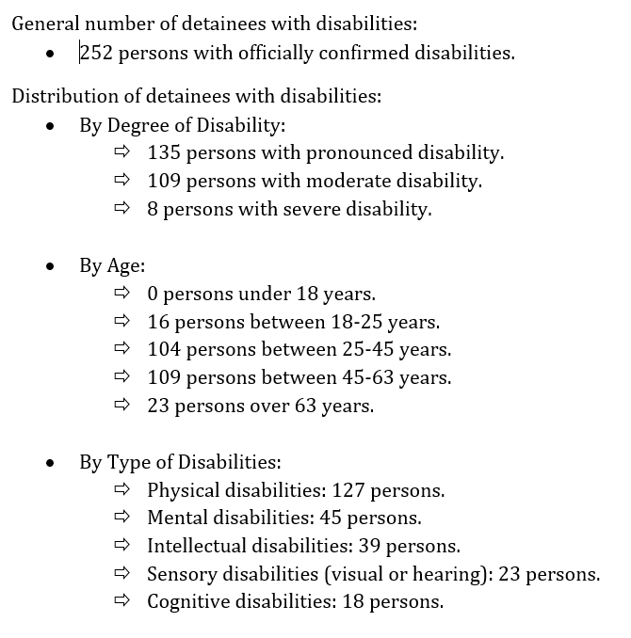

- Currently, in the Moldovan penitentiary system, 16 detainees are undergoing the process of assessment to determine their level of disability.

- The high incidence of Mental and Behavioral Disorders Among Detainees

- According to information provided by the Medical Directorate of the National Administration of Penitentiaries (hereinafter referred to as NAP), mental disorders rank first or second in morbidity structure, with an average of 3,000 diagnoses recorded annually. This figure should be assessed in relation to the total number of individuals held in detention in 2022 – 6,084 persons.
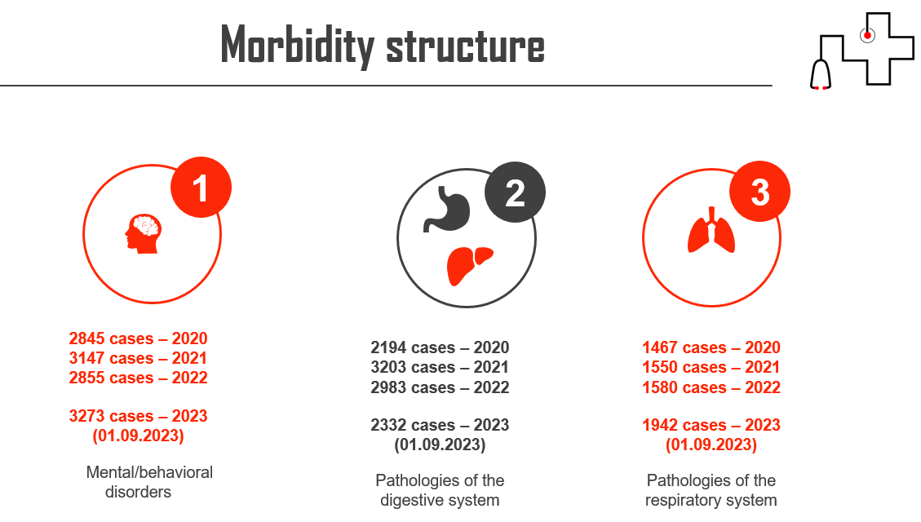
- Despite that the prison system offers outpatient services within the medical units of each penitentiary, inpatient medical services in Penitentiary No. 16, and external medical services under contracts, provided by the IMSP Clinical Psychiatry Hospital (refer to the sum of services contracted by the Ministry of Justice in the paragraph 65 of this report) and IMSP Psychiatry Hospital Bălți, there are substantial gaps in the approach and treatment of detainees. For example, the psycho-neurology section of Penitentiary hospital No. 16 – has a treatment capacity for only 36 patients, under the care of a single psychiatrist. Furthermore, several medical units in penitentiaries are facing a staff shortage, with multiple vacant psychiatrist positions. It is important to note that, thanks to the support provided by the Council of Europe, the NAP has developed a Strategy for assisting individuals with mental disabilities. However, the strategy was not approved due to its format not aligning with the policy document templates adopted by a government decision.

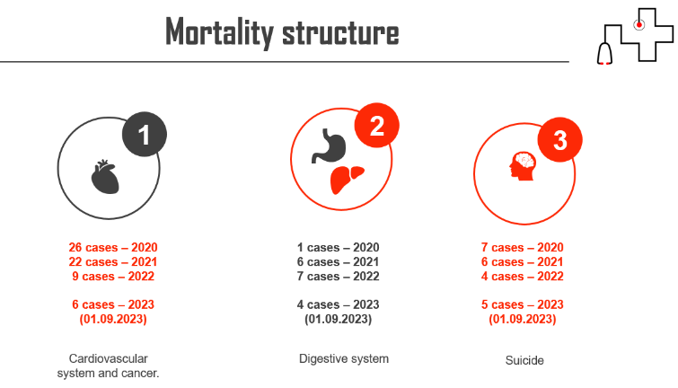

- The NAP provided detailed information about the situation of prisoners with mental and behavioral disorders in the Moldovan penitentiary system in response to the request from Promo-LEX. These data reveal the prevalence of various mental and behavioral disorders among prisoners, providing a perspective on the state of mental health in the penitentiary system of the Republic of Moldova.
Disaggregated statistical data for the year 2022:

In 2022, there were recorded:
- 2748 cases of mental and behavioral disorders in adults, of which 13 cases were minors (0-17 years old).
The most common types of mental and behavioral disorders:
- Organic mental disorders, including symptomatic disorders:
- Total: 936 diagnoses (1 minor).
- Schizophrenia and schizoid disorders:
- Total: 110 diagnoses (adults only).
- Mood (affective) disorders:
- Total: 301 diagnoses (2 minors), decreased to 172 diagnoses (2 minors).
- Neurotic, stress-related and somatoform disorders:
- Total: 551 diagnoses (adults only).
- Behavioral syndromes associated with physiological disturbances and physical factors:
- Total: 78 diagnoses (adults only).
- Personality disorders:
- Total: 648 diagnoses (7 minors).
- Mental retardation:
- Total: 113 diagnoses (3 minors).
- Disorders of psychological development:
- Total: 11 diagnoses, decreased to 6 (adults only).

Sex-disaggregated data:
- Women accounted for - 123 cases during the year.

- The data presented by the NAP indicate the following serious issues in the system::
- Prevalence of mental and behavioral disorders: there is a significant presence of mental and behavioral disorders among prisoners in the Republic of Moldova. Notably, the prevalence of organic mental disorders, mood (affective) disorders, and neurotic disorders highlights the need for adapted mental health services in detention environments. The total number of cases recorded in 2022 (2748 cases at the beginning of the year, decreasing to 1990 by the end) suggests that mental health needs are an essential aspect of the penitentiary system.
- Lack of resources and infrastructure in the penitentiary medical service: The limited treatment capacity in the psycho-neurology department of Penitentiary No. 16 and the insufficient number of psychiatrists in the medical units of the prisons indicate an undersized medical infrastructure to cope with the needs of the imprisoned population. This is a significant issue, considering the severity and complexity of cases of mental and behavioral disorders.
- Insufficient budget allocations: The relatively low expenditures for external medical services, such as those of the IMSP Clinical Psychiatric Hospital (14,408.7 lei in 2021 and 21,517 lei in 2022), reflect an insufficient budget allocation for the specialized medical care needed by prisoners with mental disorders (see details in para. 65 below).
- The need for improvement in mental health services: The data indicates an urgent need to improve mental health services in prisons by increasing treatment capacity, providing more significant budget allocations for specialized medical services, and hiring a sufficient number of mental health specialists. The lack of specialized medical staff and vacant psychiatrist positions in several medical departments of the penitentiaries highlight a systemic problem in terms of human resources, affecting the system's ability to provide adequate care to prisoners with specific mental health needs.
- In prisons, all inmates face significant challenges, but those with mental or behavioral disabilities may encounter even more serious difficulties and barriers. These include limited access to support and services, adapting to the extraordinary stresses of incarceration, and adhering to the rules governing every aspect of their lives, particularly in an environment dominated by the criminal subculture, a phenomenon repeatedly highlighted by the Council of Europe's Committee for the Prevention of Torture (CPT).
- Furthermore, inmates with disabilities are often seen as ”easy targets” or ”weak,” exposing them to a wide range of abuses, including intimidation, harassment, and verbal, physical, and sexual violence from other inmates and staff. This can lead to increased vulnerability to the criminal subculture in prisons, where a hierarchy based on strength and intimidation prevails. In the penitentiary system dominated by the criminal subculture, a code of silence predominates, and victims often do not report abuses due to fear of reprisals.
- In conclusion, the current situation of mental health services in the Moldovan penitentiary system is marked by significant constraints in terms of both human and financial resources. This severely affects the system's ability to provide adequate care to inmates with mental and behavioral disorders, highlighting the critical need for reforms and improvements in this sector. In this context, penitentiary systems must develop and implement effective strategies to protect inmates with mental and behavioral disabilities. This requires a multidisciplinary approach that includes training custodial staff in the field of disabilities and mental health, improving access to support and mental health services, and ensuring mechanisms for reporting abuses that protect victims from retaliation.

- The high incidence of Self-Harm, Suicide Attempts, and Suicides in Detention

- The statistical data provided by the NAP underscores the severity of mental health issues in the penitentiary system and the critical need to address these issues through improved mental health services, adequate staff training, and the creation of a more supportive and safe environment for inmates. The analysis of data from the table regarding cases of self-harm, suicide attempts, and suicides in the Moldovan penitentiary system for the year 2022 and the first 9 months of 2023 indicates a deeply concerning situation. The high numbers of these incidents highlight a serious crisis in the mental health of inmates, requiring immediate attention.
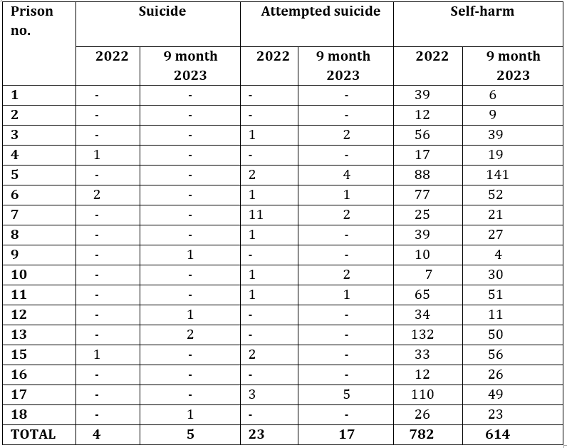
- The high number of cases of self-harm and suicides reflects alarming levels of stress and despair among inmates, suggesting an urgent need for psycho-social and psychiatric intervention. These figures indicate the insufficiency of mental health resources and services available in prisons to address and prevent such incidents. The situation demonstrates a lack of emotional support and adequate monitoring of inmates at high risk of self-destructive behaviors.
- The current situation in Moldova's prisons requires a serious and immediate review of how inmates' mental health is managed. There is an urgent need to align with the international standards of the CRPD, which emphasize the importance of equal access to health, including mental health. The high number of cases of self-harm, suicide attempts, and suicides reflects a violation of these fundamental rights within the penitentiary system. The implementation of adequate mental health programs is essential, including access to counseling, therapy, and psychiatric treatment, as well as training for prison staff to recognize and appropriately respond to the mental health needs of inmates. This would ensure the respect of the fundamental rights of inmates with disabilities, thereby reducing the number of self-destructive incidents and improving the overall conditions in prisons.

- Inadequate Assessment Mechanisms for Detainees with Mental and Behavioral Disorder Needs

- The Promo-LEX Association requested the NAP to inform us about the existence of a standardized process or a specific mechanism aimed at identifying and assessing the special needs of inmates with various types of disabilities, including those that are not strictly locomotor – whether physical, mental, intellectual, sensory, or combinations thereof. We also asked for details about this mechanism's functioning and practical application. In their response, the NAP provided a general description, mentioning that necessary measures are undertaken to assess the needs of inmates upon their arrival at the penitentiary institutions. These measures include a general clinical and paraclinical examination process, according to the Regulation on providing medical care to persons detained in prisons, approved by the Minister of Justice No. 343 of 29.12.2022 and in force from 02.02.2023. While the NAP acknowledges the necessity to assess the needs of inmates with disabilities, their approach lacks specificity and tailoring to the diverse requirements of this population, particularly those with mental and behavioral disorders.
- Generalized approach vs. specific needs: The NAP's response illustrates a generalized approach to inmate assessment. While it is commendable that a clinical and paraclinical examination process exists, such a broad method fails to consider the unique and multifaceted needs of inmates with different types of disabilities, especially mental and behavioral disorders. These disorders require a more nuanced and individualized assessment.
- Inadequacy of existing documents: The mention of an Individual Resocialization Plan and an Individual Identification Record does not sufficiently address the gap. These documents, as stated, focus on the resocialization of convicts in general and do not cater specifically to the unique challenges faced by inmates with disabilities. This is a significant oversight as inmates with mental and behavioral disorders often require specialized care and interventions that differ from the general prison population. The reference to Order No. 9 of 05.01.2023, while potentially useful, appears to offer only a general overview rather than concrete steps or procedures tailored for inmates with mental and behavioral disorders. The order covers general aspects and criteria related to disability and living conditions but lacks depth in addressing the complex requirements of inmates suffering from these disorders.
- Lack of specific mechanisms for mental and behavioral disorders: The response from the NAP lacks a clear and detailed mechanism for assessing and meeting the needs of inmates with mental and behavioral disorders. This is a critical issue as these inmates are likely to be more vulnerable and may have different needs compared to other inmates with physical or sensory disabilities. The absence of a detailed and precise framework for assessing and catering to the needs of inmates with mental and behavioral disorders indicates a gap in the prison system's ability to provide adequate care. There is an urgent need for the development of standardized, detailed, and practical mechanisms that can identify, evaluate, and address the specific needs of these inmates.
- In conclusion, while there are some measures in place for assessing the needs of inmates with disabilities, the current system is inadequately equipped to specifically address the needs of those with mental and behavioral disorders. There is a critical need for developing a more detailed, specialized, and practical framework that can adequately cater to the complex requirements of this vulnerable group within the penitentiary system.

- Inadequate Adaptation of Prison Spaces for Detainees with Various Types of Disabilities or Impairments

- Although the Promo-LEX Association requested detailed information regarding adapting penitentiary spaces and facilities to meet the specific needs of inmates with various types of disabilities, the NAP provided only general information. This indicates that some accommodation measures have been undertaken in prisons No. 7-Rusca, No. 13-Chisinau, No. 16-Pruncul, No. 17-Rezina, and No. 18-Brănești, such as installing ramps and support bars. However, the NAP did not provide specific data on how the facilities have been adjusted for each type of disability identified in their statistics. From this lack of disaggregated information, it can be deduced that penitentiary spaces are not sufficiently adapted to adequately meet the needs of all inmates with disabilities, considering the diversity of types of disabilities encountered in detention. This situation raises serious questions about the compliance of the Moldovan penitentiary system with CRPD standards.
- In the same vein, the NAP mentioned that inmates with disabilities or impairments are placed in detention spaces close to medical units or in areas that facilitate movement and access to walking courtyards. Although placing inmates with disabilities near medical units or areas with improved accessibility may be helpful, it does not guarantee equal access and full integration into all penitentiary activities, as required by the CRPD.
- However, some necessary adaptation measures are challenging to implement due to the limitations of penitentiary institutions' architectural infrastructure. Moreover, due to budgetary restrictions for 2023, most penitentiary institutions have only planned adaptation works without being able to execute them effectively. The lack of financial funds for 2023 has postponed planned adaptation works, suggesting a delay in improving conditions for inmates with disabilities. It may indicate a lack of priority for the needs of this vulnerable group.

Issues associated with employing inmates as personal assistants

- To meet the needs of persons with disabilities in the penitentiary system, the National Administration of Penitentiaries of Moldova, according to NAP Order No. 58 of 29.01.2020, initiated the creation of personal assistant roles filled by inmates. These assistants are intended to support inmates with health issues, including those with physical, mental, intellectual, sensory, or combinations of these disabilities, being remunerated according to Government Decision No. 152/2004.
- This measure raises serious concerns about the quality of care provided, considering the lack of professional training and potential conflicts of interest. Moreover, this arrangement could exacerbate the problem of abuse within the deeply ingrained criminal subculture in Moldovan prisons, a phenomenon repeatedly highlighted by the Council of Europe's Committee for the Prevention of Torture (CPT) and other institutions. Inmates selected to serve in these roles could wield undue power over other inmates, especially in a context where the criminal subculture is predominant. This could lead to situations where the needs of inmates with disabilities are not properly met and where their rights might be violated. They are employing inmates as personal assistants in Moldovan prisons, which, while seemingly a practical solution, creates more problems than it solves. This arrangement not only questions the quality of care provided but, in the context of a robust penitentiary subculture, increases the risk of abuse and exploitation of vulnerable inmates. Moldova must rethink this strategy and seek alternatives that align with CRPD standards, thereby ensuring a safe and respectful environment for all inmates, especially those with disabilities.

Lack of specific legal framework for adapting prisons to the needs of inmates with disabilities

- In the context of the data provided above and in an attempt to better understand how the penitentiary system in the Republic of Moldova responds to the needs of inmates with disabilities, the Promo-LEX Association addressed a specific question to the NAP. We requested clarifications on the existence of a legal framework, normative acts, or sets of standardized procedures dedicated to adapting and improving the infrastructure and services of penitentiaries to align them with the special needs of inmates with disabilities. We also asked for concrete details about this framework, including copies of the relevant normative acts, in case they are not publicly available.
- In its response, the NAP referred to a general normative framework, which includes provisions for the separate detention of convicts in prisons and, respectively, in pre-trial detention centers, according to Article 205 and Article 309 of the Execution Code. Furthermore, the NAP mentioned that, according to paragraph (2) of Article 205 of the Execution Code, the prison administration may apply other criteria for separate detention, and according to the Status of Execution of Sentence by Convicts, the allocation of inmates takes into account the characteristics of each individual, including disabilities and deficiencies. However, the NAP emphasized that the Status of Execution of Sentence by Convicts is the only normative act that establishes the method of allocation of inmates without specifying details about the process of accommodation and improvement of infrastructure for inmates with disabilities. Furthermore, it should be noted that on March 22, 2023, the Director of the NAP issued Order No. 149/2023. This order primarily focuses on the uniform distribution of inmates and the delineation of auxiliary spaces in prisons rather than being specifically dedicated to the adaptation and enhancement of penitentiary infrastructure and services to cater to the unique needs of inmates with disabilities.
- Based on the analyzed information, the imperative need to establish a clear legal framework and standardized procedures specifically guiding the adaptation of penitentiary infrastructure to the needs of inmates with various forms of disabilities becomes evident. The lack of standardized procedures suggests insufficient understanding and priority given to these needs within the Moldovan penitentiary system. This gap indicates a possible non-compliance of the Moldovan prison system with the standards set by the CRPD, especially in terms of accessibility and providing an appropriate environment for inmates with disabilities. Therefore, the NAP and other relevant entities need to develop and implement more detailed and effective policies and procedures focused on meeting the specific needs of inmates with disabilities, thereby ensuring fair and respectful treatment by the international commitments of the Republic of Moldova in line with the CRPD.

- The Struggle for Dental Prosthetic Access in Prisons

- The reduction or loss of chewing capacity due to partial or complete tooth loss constitutes a temporary disability that can be prevented or improved through proper dental prosthetics. Reduced consumption of chewable foods can lead to malnutrition, affecting overall health and exacerbating other medical conditions. This problem is compounded in the prison context by the lack of a specific diet for inmates who cannot chew efficiently, affecting their nutrition and their swallowing. This can lead to gastric issues and weight loss due to inadequate or insufficient nutrition.
- Monitoring of the prison system conducted by the Promo-LEX Association has highlighted the serious issue of limited access to dental prosthetic services. One inmate, left with only three teeth, faced significant difficulties in chewing and speaking. Despite repeated requests for dental prosthetic services, the inmate received refusals and was informed that he had to bear the cost. Limited job opportunities in prisons made it difficult to accumulate the necessary funds for prostheses. According to official data, only 15% of inmates have been employed in the penitentiary system over the past ten years. As of April 1, 2022, only 974 inmates out of 6,473 were engaged in work.
- Relevant cases in the jurisprudence of the European Court of Human Rights (ECtHR), such as the case of V.D. v. Romania, where the applicant, having serious dental problems and a need for prostheses, could not access them due to a lack of financial resources. This case illustrates that inmates with dental issues are considered vulnerable individuals. In this case, the ECtHR found a violation of Article 3 of the European Convention on Human Rights due to the authorities' inability to provide necessary dental prostheses.
- According to the NAP, no disaggregated data exists on inmates with reduced or lost chewing capacity. Although dental medical assistance is available in prisons, dental prosthetics are not included in the services offered and must be borne by the inmates. This lack of data and the exclusion of dental prosthetics from medical services indicate a possible neglect of the health needs of a vulnerable group of inmates.
- The NAP acknowledges the importance of providing dental prosthetic services to inmates, suggesting legislative amendments to include these services in the free medical assistance provided to inmates. This would align with the Republic of Moldova's international commitments. It is essential to revise primary legislation, such as the Execution Code, to ensure free access to dental prosthetics in detention.

- EMERGING ISSUE: STRUCTURAL CHALLENGES IN PRISON HEALTHCARE: SYSTEMIC ORGANIZATIONAL LAPSES

- Accreditation of Medical Units in Prisons: Standards vs. Reality

- According to the relevant regulations, all hospital services, including medical services in prison system, are subject to health operating authorization. Without it no health care provider can operate. This aspect remains highly problematic.

In the Republic of Moldova, there are two parallel medical systems:
- The public accredited medical system (under the authority of the Ministry of Health)
- The medical services of the penitentiary system (under the authority of the Ministry of Justice).

The medical service of the penitentiary system comprises:
- Outpatient medical assistance:
- 16 outpatient medical units in penitentiaries.
- Inpatient medical assistance:
- Penitentiary No. 16 with the hospital status.

Outpatient medical assistance: medical units within penitentiaries
- While the procedure for health evaluation and accreditation was launched in 2021, the National Prison Administration initiated the evaluation procedure for the purpose of accrediting certain prison medical units only in 2021. This procedure applies to all medical service providers and takes place once every 5 years. To initiate this process, an applicant shall submit a request to the National Agency for Public Health (under the Ministry of Health). The Agency takes a decision on accreditation, conditional accreditation, or non-accreditation and, in case of approval, issues a five-year certificate. After obtaining the accreditation, medical service providers shall undergo continuous annual evaluation, an independent and systematic process of evaluating the compliance of the services provided with the health-care regulatory framework.
- Primary and specialized care is provided by medical departments at each prison level. To date, 14 medical departments have been accredited. Prison No. 6 did not receive accreditation, due to its medical department’s failure to “implement recommendations for elimination of significant problems in the medical care field” (according to the Ministry of Health), neither Medical department of Prison no. 10 (facility for juveniles).
- What is more disturbing is that the Agency was to conduct mandatory annual evaluation of the medical departments and to withdraw the accreditation if the standards were not observed. However, none of the medical units accredited in 2021 have undergone this annual evaluation. According to the Ministry of Health, the evaluation of the medical units accredited in 2021 should have taken place in 2022. The Ministry referred to the COVID-19 pandemic as the reason for the absence of assessment. However, the COVID-19 restrictions during the same period (November 2022), didn’t prevent the NAP to provoke an evaluation to get medical section of Penitentiary No. 4 being accredited.
- Moreover, in the view of the pandemic argument, the Decisions of the National Extraordinary Public Health Commission do not provide for any exemptions. Furthermore, even in 2023, the respective medical units were not re-evaluated, in an apparent breach of the domestic law. In addition, according to audit reports conducted by the NAP Quality Council, significant deficiencies were observed in the work of the accredited medical units, affecting the quality of care.

Inpatient medical assistance: Penitentiary hospital No. 16 - illegal functioning in the absence of sanitary authorization and accreditation

- The relevant regulation does not explicitly specify that Penitentiary No. 16 has the status of a prison hospital, but classifies it as a prison institution. According to Law No. 300/2017, the main function of Penitentiary No. 16 is to ensure temporary detention of all categories of detainees requiring inpatient medical care.
- The right to carry out medical and pharmaceutical activities is reserved for medical service providers who have been evaluated and accredited. However, according to the Ministry of Health, there are no current requests from the Ministry of Justice (through the NAP) for obtaining operating health authorisation for Prison No. 16. The Ministry of Health stated that the head of Penitentiary No. 16 and its superiors are responsible for ensuring the compliance of its work with relevant legal provisions, meaning substantial requirement, as well as fulfillment of evaluation and accreditation standards and the rules for equipping and organising medical assistance, which are mandatory for medical service providers regardless of their type and legal form.
- Similar clarifications were provided by the NAP. According to them, the prison authorities were planning to initiate the process of obtaining health authorisation and accreditation of Prison hospital no.16. The NAP have not specified the relevant timeline, and have not referred to any public policy document in this regard. Additionally, from the information provided, it is evident that such process is extremely costly, and there are well-founded suspicions that it will not be initiated in the near future. According to the NAP, Penitentiary No. 16 received a technical report and cost estimate for the reconstruction of the surgery block in the amount of 232,142.0 lei. Authorities acknowledged that the resources available in the current budget allocated to the prison system are insufficient to support these costs. Furthermore, the NAP mentioned that the application to the ANSP for initiating the obtaining of health authorisation and accreditation will only be possible after completing the reconstruction.
- Penitentiary No. 16, which currently provides unaccredited medical services to patients-detainees and functions without a health permit, operates outside the national legal framework and in breach of the principles of quality and equivalence of medical services in detention. This finding is supported both by the Ministry of Health and by the Council for the Prevention of Torture (CpPT) in the two monitoring reports covering Prison No. 16 (see above para. 9 to 19).

- The Lack of a Response to the Problem of Under-staffing of Healthcare Professionals

Medical staff shortage

- In response to the Promo-LEX Association's inquiry about the medical staff shortage in the prison system (including Penitentiary No.16), the NAP indicated the following needs:

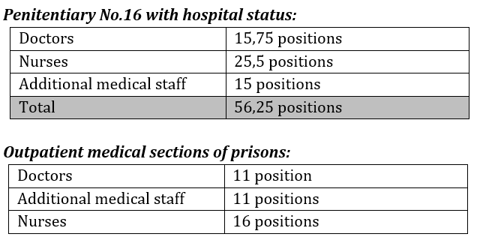
- According to the NAP information there are currently no approved Medical Staff Norms for the prison system, and the Ministry of Health Medical Staff Norms are not applicable. These Norms are a vital element in managing the medicine within the prison system, as it would allow to determine staff needs with reference to the actual workload and tasks complexity. Adopting such a document would bring clarity and unify the requirements related to the medical staff necessary in each prison ward. They would promote transparency and accountability regarding hiring and managing medical staff.

- Budgetary and Financial Restrictions

- Detainees do not benefit from the mandatory public health insurance. Medical care in prisons is financed from the public budget (the budget of the Ministry of Justice and the NAP), as well as from other sources permitted by legislation, such as donations, material aid, or grants. The Ministry of Justice, through the NAP, annually contracts specialized medical services from the public medical system, as the medical service within the penitentiary system does not have the necessary capacities to provide such services.
- According to official data, to ensure qualified medical care for incarcerated persons in 2021, contracts were signed with 19 public medical-sanitary institutions under the Ministry of Health. The total amount of allocated funds for medical services was 3,186,000.00 lei. In 2022 and 2023 contracts were signed with 17 facilities, and the amount of funds was reduced to 2,813,000.00 lei (2022) and 2,597,900.00 lei (2023).
- The table below summarises the information about public and private medical services providers specializing in conditions representing typical causes of mortality and morbidity in prisons, as well as most typical ailments in detention. It contains information about contracts made in 2021-2023 and their amounts.

*At the exchange rate of the National Bank of Moldova
- The table below summarises the information about public and private medical services providers specializing in conditions representing typical causes of mortality and morbidity in prisons, as well as most typical ailments in detention. It contains information about contracts made in 2021-2023 and their amounts.
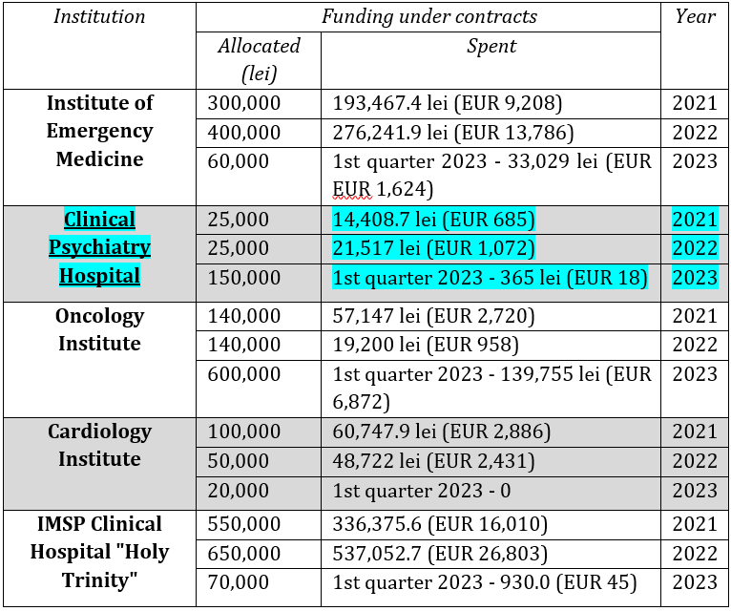

- The lack of a Methodology in Determining the Need for Medical Services in the Prison System.

- Seeking clarification about the contracting process for medical services in the prison system, we requested details about the selection criteria and the methodology for assessing needs, to obtain information about any existing methodology or regulations. We were also interested in whether any analysis or study had been carried out regarding the specific medical needs of the prison system in 2021-2023.
- The authorities' response was straightforward: there are no studies focusing on the medical needs within the prison system. Furthermore, the process of contracting medical providers takes place in the absence of a clear methodology or a regulatory framework. Instead of a structured analysis, authorities use data on medical services from previous years as a reference to estimate future needs. This method, based on estimates and without a clear strategy, indicates an approach that does not efficiently prioritize the actual medical needs of detainees, highlighting the crucial need of rigorous and transparent planning.

Conclusions / observations:
- Decreasing financial allocations: there is a clear trend of diminishing funds allocated for specialized medical services for detainees. We notice a progressive decline in the amounts allocated annually, from 3,186,000 lei in 2021 to 2,597,900 lei in 2023.
- Allocation versus expenses: in all cases, actual expenditures are below the contracted value. This suggests that although funds are allocated for medical services, they are not fully used, and detainees might not receive complete medical services. For instance, for the Emergency Medicine Institute in 2021, out of the allocated sum of 300,000 lei, only 193,467.4 lei were spent. This pattern recurs for most institutions, indicating possible underuse of resources or inadequate planning.
- Lack of clear methodology in contracting external medical services: there are significant variations in the annual contracts with different institutions, exemplified by the contracts with the Emergency Medicine Institute, which increased notably in 2022 but plummeted in 2023. Even though there is an evident need for medical services in the penitentiary system, providers are contracted without a standardized approach or well-defined methodology. This leads to inefficiencies and inappropriate allocation of resources where they are most needed.
- Ambulance service: we note that the average rate for an ambulance service is 808 lei per hour, and the number of requests has increased from 655 in 2021 to 670 in 2022. Nevertheless, the sums allocated for ambulance transport have decreased substantially, potentially indicating underfunding of this crucial service.
- Lack of obligatory medical insurance: detainees do not benefit from the healthcare insurance system, which is why any additional medical service depend solely on the Ministry of Justice's budget. From interviews with detainees, complaint analysis, and statistical data concerning morbidity and mortality, it is evident that financing is disproportionate to the needs, considering the discrepancies between allocated sums and the actual expenses.
- Need for analysis and studies: the absence of studies analyzing the specific needs of detainees between 2021-2023 suggests a lack of long-term planning. Without such analysis, it is impossible to anticipate and adequately respond to detainees ' medical needs.
- In conclusion, the data analysis points to underfunding and potential inefficiency in administering funds intended for detainees' medical services. This might be one of the substantial reasons for the high morbidity and mortality rates in prisons. From the presented data, it is evident that while the State allocates resources for medical care in prisons, it does not spend them efficiently or in full amount. The lack of proper planning, clear methodology, and analysis identifying the actual needs will exacerbate or maintain this situation.
- EMERGING ISSUE: CHALLENGES ARISING FROM THE STATUS OF HEALTH PROFESSIONAL AND THIR INTEGRETION INTO THE PRISON ADMINISTRATION SYSTEM

- Double Loyalty of Medical Staff in Penitentiaries

- The medical staff of the penitentiary institutions belongs to the prison service, which entails their “double loyalty” when making medical decisions. Such “double loyalty” may be defined as a clinical role conflict between professional duties towards a patient and obligations, explicit or implied, to the interests of a third party (such as an employer, an insurer, or the State). Thus, the priority in making medical decisions lies with the interests of the penitentiary administration and not with the interests of the patient.
- According to the recently adopted regulation on organisation of medical care for detainees: "in cases of major emergencies, admitting sick detainees to a public health institution, on a doctor's recommendation, can be ordered by the Prison Director or the officer on duty. For longer stays, the transfer must subsequently be approved by the NAP’s Director order." This complex bureaucratic procedure poses significant obstacles to providing prompt and efficient care and makes this approach counter-productive and harmful in in practice.
- The medical staff's subordination to prison authorities has direct implications for the quality and objectivity of medical care provided to detainees:
- Contractual relationship: an employment contract directly signed by the doctor of the nurse with the NAP Director create an obvious hierarchical relationship. Being the medical staff's direct employer, the Director has significant control over their decisions and actions.
- Financial implications: dependency on the Prison Director can have serious implications when it comes to financial decisions. For instance, if an external medical service requires funding allocation, the doctor might feel compelled to seek approval, even if they believe the service is essential for the patient. This issue was evident in the Cosovan case, where the applicant faced significant difficulties in accessing specialized services he desperately needed.
- Regulation on medical assistance: the current regulation stipulates that, in major emergency cases, the admission of detainees to a hospital can be ordered by the Prison Director or the Duty Officer. This provision introduces another layer of bureaucracy in the medical decision-making process.

- Ethical and Confidentiality Concerns

- The realm of healthcare is bound by strict ethical considerations and the indispensable right to patient confidentiality. Prisons, however, present a unique set of challenges where these standards might be compromised. Whether due to surveillance, administrative policies, or the mere nature of incarceration, inmates might find their medical confidentiality breached and ethical standards overlooked. This segment aims to shed light on these pressing concerns, emphasizing the importance of upholding the sanctity of medical ethics even within prison walls.
- Ensuring data confidentiality represents a fundamental challenge in penitentiary institutions. According to Law no. 133/2011, medical data or information about health status fall under special categories of personal data. Therefore, the requirements for ensuring the security of personal data established by Government Decision no. 1123/2010 apply. According to Annex no.1, the security of special categories of personal data involves level 2 requirements (N-2) - which, for example, requires the mandatory use of automated means for tracking security incidents of personal data information systems, collecting and analyzing information about these incidents; multifactorial (complex) authentication, which includes passwords and special physical access means with memory or microprocessor cards or passwords and biometric authentication means.
- In practice, institutions do not ensure the protection of documents containing special data. Medical records are stored inadequately: on open shelves, without any restrictions, thus allowing access to non-medical staff. These irregularities, identified by both CpPT in its report and by Promo-LEX during prisons visits in June 2022, were detailed in a report addressed to the authorities. The authorities raised no objections regarding the observations made in the report.
- Moreover, in response to the question whether inmates work as nurses in some prisons, as reported by the CpPT, the National Prison Administration informed us that: "in penitentiary institutions, inmates are employed as disinfectors, also being responsible for carrying out regular cleaning and disinfection in medical units. If inmates are found to be involved in other activities, they are immediately removed."
- EMERGING ISSUE: BREAKING WITH INCONSISTENT AND FRAGMENTARY PRISON HEALTH POLICIES

- The penitentiary health system has long stood at a crossroads. While the nation has experienced reforms and policy adjustments, prisons often remained underserved and overlooked in the broader health policy landscape. The resulting inconsistency in prison health policies not only jeopardizes the well-being of inmates but also poses challenges to the healthcare professionals dedicated to serving this population.
- The prisons, being closed environments, attract a different degree of scrutiny or attention than public health matters in the broader community. This often results in a reactive approach to policy-making rather than a proactive and comprehensive strategy. The key issue from the standpoint of improving medical care for prisoners is the transfer of medicine in prisons under the authority of the Ministry of Health. The UN CAT urged such transfer, and the ECtHR drew all the consequences in Cosovan from the point of view of quality of care. This shift would ensure doctors' independence, a sine qua non for establishing trust between patients and practitioners, and ensure better coordination with civilian hospitals.
- In this respect, the reorganization of the health system was defined as a priority of the Prison System Development Strategy 2016-2020 and the Action Plan for its implementation. However, no essential reforms have been proposed or designed regarding the unification of medical services, as recommended by the UN CAT.
- Currently, no public policy envisages the reform of the medical service in the penitentiary system, especially regarding the transfer of medicine in prison under the Ministry of Health.
- Moreover, national health policies do not provide for any actions concerning medical assistance in penitentiaries. In sum, despite the numerous international recommendations recognizing the need for reform at the national level, concrete steps toward that change have yet to be undertaken.

- SUGGESTED QUESTIONS FOR THE GOVERNMENT:

- How does the Government intend to ensure that the penitentiary infrastructure is adequately adapted to accommodate detainees with various types of disabilities (physical, mental, intellectual, sensory disabilities, or a mix of these conditions)?
- What specific steps are being taken to address the high prevalence of mental and behavioral disorders among detainees in Moldovan prisons?
- Are there any plans to increase the number of qualified mental health professionals and improve the infrastructure within the prison healthcare system?
- How is the Government addressing the shortage of specialized staff, particularly psychiatrists, in the penitentiary system?
- What efforts are being made to provide adequate budget allocations for external medical services, such as those offered by the IMSP Clinical Psychiatry Hospital?
- What strategies are being implemented to improve the overall mental health services in the penitentiary system?
- How does the government plan to provide more effective support and protection for detainees with mental and behavioral disorders against abuse and violence within the prison subculture?
- What steps is the Government taking to develop and implement a standardized process specifically for the identification and assessment of the special needs of detainees with mental, intellectual, sensory, and physical disabilities, including those that are not strictly locomotor?
- Can the Government provide detailed information on how the current general clinical and paraclinical examination process is adapted to meet the specific needs of detainees with various types of disabilities?
- How does the government plan to address the lack of specific focus on inmates with disabilities in the existing Individual Resocialization Plan and the Individual Identification Sheet?
- What measures are being taken to address the lack of detailed policies and effective procedures focused on the specific needs of inmates with disabilities?
- Given the high incidence of self-harm, suicide attempts, and suicides in detention, what specific strategies is the Government implementing to improve mental health care in the penitentiary system?
- How is the Government ensuring that prisoners with disabilities, who are at a higher risk of self-harm and suicide, receive the necessary care and support?
- What measures are being taken to enhance the training of penitentiary staff in identifying and responding to mental health crises among inmates?
- What plans does the Government have to develop a legal framework and standardized procedures that specifically address the needs of inmates with all types of disabilities?
- What are the criteria and process for selecting inmates to serve as personal assistants, and how does the Government ensure they are appropriate for this role?
- What mechanisms are in place to monitor interactions between inmate assistants and inmates with disabilities to ensure their safety and well-being?
- How does the current practice of using inmate personal assistants align with the international human rights standards, and what steps are being taken to improve this alignment?
- What steps is the Government taking to ensure that detainees with reduced or lost mastication capacity have access to necessary dental prosthetics?
- How does the government plan to amend legislation to include dental prosthetics in the free medical services provided to detainees?
- Given the lack of disaggregated data about detainees with reduced or lost mastication capacity, how does the government plan to address this data gap to understand better and meet the healthcare needs of this vulnerable group?

- SUGGESTED RECOMMENDATIONS FOR THE GOVERNMENT ON MEDICAL SERVICES IN THE PENITENTIARY SYSTEM
- Medical service transfer: to develop a concept for reforming medical services in the penitentiary system and to transfer the responsibility for medical care in prisons from the Ministry of Justice to the Ministry of Health.
- Annual and consistent evaluations: conduct continuous annual evaluations of medical departments in accredited prisons by the National Public Health Agency to ensure that medical care standards are observed.
- To ensure that Penitentiary No.16 operates in conformity with the legal and medical framework, including health care regulations,
- Storage space restructuring: Medical records should be kept in secure areas with restricted access, preventing unauthorized access by non-medical staff or inmates.
- Implementing advanced security systems: to implement advanced security systems for medical data protection, including multifactor authentication and automated incident tracking.
- Strict disclosure protocols: to establish strict protocols and rules on access to inmates' medical information
- To develop a standardized methodology for contracting extern medical services.
- Optimizing resource use: to create mechanisms that ensure efficient resource use in the inmate patient's interest and understand why allocated funds are not used to their total capacity.

Submitting organization:
Promo-LEX Association
Contact Persons:
Vadim VIERU
Human Rights Program Director,
Promo-LEX Association, Email: vadim.vieru@promolex.md

Nicoleta HRIPLIVII
Human Rights Lawyer,
Promo-LEX Association, Email: nicoleta.hriplivii@promolex.md

https://promolex.md/?lang=ro
OHCHR, "Universal Periodic Review - Republic of Moldova," accessed January 25, 2024, https://www.ohchr.org/en/hr-bodies/upr/md-index.
EU-Republic of Moldova Association Council, "Recommendation No 1/2022 of 22 August 2022 on the EU-Republic of Moldova Association Agenda [2022/1997]," accessed January 25, 2024, https://eur-lex.europa.eu/legal-content/EN/TXT/?uri=CELEX%3A22022D1997.
European Committee for the Prevention of Torture and Inhuman or Degrading Treatment or Punishment (CPT), "Report to the Government of the Republic of Moldova on the visit to the Republic of Moldova from 28 January to 7 February 2020," accessed January 25, 2024, http://ombudsman.md/wp-content/uploads/2020/10/Raportul-CPT_vizita-2020.pdf; and "Report for the period 5-13 December 2023," accessed January 25, 2024, https://rm.coe.int/1680ac59d8.
UN Committee Against Torture, "Concluding observations on the third periodic report of Republic of Moldova," accessed January 25, 2024, https://tbinternet.ohchr.org/_layouts/15/treatybodyexternal/Download.aspx?symbolno=CAT%2FC%2FMDA%2FCO%2F3&Lang=en.
Ombudsman of the Republic of Moldova, "Report on the monitoring visit to Penitentiary no. 16 – Pruncul on February 22, 2022," accessed January 25, 2024, http://ombudsman.md/wp-content/uploads/2022/04/Raport-CpPT_P16_22.02.2022-FINAL_FINAL_pe-site_expediat-autoritatilor.pdf.
Ombudsman of the Republic of Moldova, "Annual report on human rights compliance," accessed January 25, 2024, http://ombudsman.md/wp-content/uploads/2023/08/Raport-anual-privind-respectarea-drepturilor-omului-EN.pdf.
Office of the High Commissioner for Human Rights (OHCHR), "Universal Periodic Review - Republic of Moldova," accessed January 25, 2024, https://www.ohchr.org/en/hr-bodies/upr/md-index.
United Nations Committee Against Torture, "Concluding Observations on the Third Periodic Report of Republic of Moldova," accessed January 25, 2024, https://tbinternet.ohchr.org/_layouts/15/treatybodyexternal/Download.aspx?symbolno=CAT%2FC%2FMDA%2FCO%2F3&Lang=en.
European Court of Human Rights, "Case of Cosovan v. the Republic of Moldova (Application no. 13472/18)," accessed January 25, 2024, https://hudoc.echr.coe.int/eng?i=001-216352.
Council of Europe Committee of Ministers, "Decision in the Case of Cosovan v. the Republic of Moldova," accessed January 25, 2024, https://hudoc.exec.coe.int/ENG#{%22EXECIdentifier%22:[%22DH-DD(2022)894E%22]}.
Council of Europe Committee of Ministers, "Decision in the Case of Cosovan v. the Republic of Moldova," accessed January 25, 2024, https://hudoc.exec.coe.int/?i=DH-DD(2023)1323E.
Ombudsman of the Republic of Moldova, "Report on the Monitoring Visit Carried Out in Penitentiary No. 16 – Pruncul on July 22-23, 2019," accessed January 25, 2024, http://ombudsman.md/wp-content/uploads/2020/02/P-16-Pruncul.pdf.
Ombudsman of the Republic of Moldova, "Report on the Monitoring Visit Carried Out in Penitentiary No. 16 – Pruncul on February 22, 2022," accessed January 25, 2024, http://ombudsman.md/wp-content/uploads/2022/04/Raport-CpPT_P16_22.02.2022-FINAL_FINAL_pe-site_expediat-autoritatilor.pdf.
Republic of Moldova, "Law No. 552 of 18.10.2001 on Assessment and Accreditation in the Healthcare System, Articles 2 and 11(3) (Amended in 2020)," accessed January 25, 2024, https://www.legis.md/cautare/getResults?doc_id=122910&lang=ro#.
Promo-LEX, European Prison Litigation Network, and The People's Advocate Office, "Communication to the Committee of Ministers of the Council of Europe Dated 24/10/2023," accessed January 25, 2024, https://hudoc.exec.coe.int/?i=DH-DD(2023)1323E.
European Committee for the Prevention of Torture and Inhuman or Degrading Treatment or Punishment (CPT), "Report to the Moldovan Government on the Ad Hoc Visit to the Republic of Moldova from 5 to 13 December 2022," accessed January 25, 2024, https://rm.coe.int/1680ac59d8.
Ministry of Justice, "Order No. 343 of 29-12-2022 on the Regulation Regarding the Organization of Medical Assistance for Prisoners in Penitentiary Institutions," published in the Official Monitor No. 28-30, Article 129, February 2, 2023, accessed January 25, 2024, https://www.legis.md/cautare/getResults?doc_id=135397&lang=ro
European Committee for the Prevention of Torture and Inhuman or Degrading Treatment or Punishment (CPT), "Report to the Moldovan Government on the Ad Hoc Visit to the Republic of Moldova from 5 to 13 December 2022," accessed January 25, 2024, https://rm.coe.int/1680ac59d8
Promo-LEX Association, 'Evaluation of the Mechanism for Preventing and Combating Ill-Treatment in the Penitentiary System of the Republic of Moldova: Choose the Side, Do Not Cross the Line,' accessed January 25, 2024, https://promolex.md/wp-content/uploads/2022/11/Report-Evaluation-of-the-mechanism-for-preventing-and-combating-ill-treatment-in-the-penitentiary-system-of-the-Republic-of-Moldova-.pdf.
Nozomi Okamoto, Nobuko Amano, Tomiyo Nakamura, and Motokazu Yanagi, "Relationship between Tooth Loss, Low Masticatory Ability, and Nutritional Indices in the Elderly: A Cross-Sectional Study," BMC Oral Health 19, no. 110 (2019), accessed January 25, 2024, https://bmcoralhealth.biomedcentral.com/articles/10.1186/s12903-019-0778-5.
Ministry of Justice of the Republic of Moldova, "Analysis of the Impact in the Process of Substantiating the Draft Law for the Modification of Certain Legislative Acts (for Facilitating Employment for Convicts)," accessed January 25, 2024, https://justice.gov.md/sites/default/files/analiza_impactului.pdf
Republic of Moldova, "Section 23/2 § 2 and Annex No. 2 to Law No. 10/2009 On State Public Health," accessed January 25, 2024, https://www.legis.md/cautare/getResults?doc_id=125959&lang=ro
Ministry of Health of the Republic of Moldova, "Reply No 24/3126 of 30 August 2023."
National Administration of Penitentiaries (NAP), "Organizational Structure," accessed January 25, 2024, https://www.anp.gov.md/index.php/structura-anp
Republic of Moldova, "Law No. 552 of 10-18-2001 on Health Assessment and Accreditation," accessed January 25, 2024, https://www.legis.md/cautare/getResults?doc_id=138755&lang=ro
Republic of Moldova, "Article 11 of the Law No. 552 of 10.18.2001 On Health Assessment and Accreditation," accessed January 25, 2024, https://www.legis.md/cautare/getResults?doc_id=138755&lang=ro
Full Accreditation for Penitentiaries Nos. 1 - 3, 5, 7 - 9, 11 - 13, 15, 17, and 18; Prison No.4 Received Full Accreditation Only in 2023
Ministry of Health of the Republic of Moldova, "Response No. 24/3126 of 30 August 2023” Ministry of Health response no.24/3126 of 30 August 2023
Extraordinary National Public Health Commission, "Decisions (2022)," accessed January 25, 2024, https://cancelaria.gov.md/ro/apc/coronavirus
Promo-LEX, European Prison Litigation Network, and The People's Advocate Office, "Communication to the Committee of Ministers of the Council of Europe Dated 24/10/2023," accessed January 25, 2024, https://hudoc.exec.coe.int/?i=DH-DD(2023)1323E.
Government of the Republic of Moldova, "Decision No. 437/2018 on the Organization and Operation of the National Prison Administration," accessed January 25, 2024.
Republic of Moldova, "Law No. 300 of 21.12.2017 On the Penitentiary Administration System," accessed January 25, 2024, https://www.legis.md/cautare/getResults?doc_id=136291&lang=ro
National Council for the Prevention of Torture, "Report (2022), Page 10," accessed January 25, 2024, http://ombudsman.md/wp-content/uploads/2022/04/Raport-CpPT_P16_22.02.2022-FINAL_FINAL_pe-site_expediat-autoritatilor.pdf
Ministry of Health of the Republic of Moldova, "Sanitary Regulation on Hygiene Conditions for Medical-Sanitary Institutions (Government Decision No. 693/2010)."
National Administration of Penitentiaries, "Answer No. 8-2076 of 21 July 2023."
National Administration of Penitentiaries (NAP), "Response No. 8-2076 of July 21, 2023."
Promo-LEX, "Monitoring Report 2: Managing the COVID-19 Pandemic in the Prison Administration System," accessed January 25, 2024, https://promolex.md/wp-content/uploads/2022/04/RAPORT-DE-MONITORIZARE-2-Gestionarea-pandemiei-de-COVID-19-%C3%AEn-sistemul-administra%C8%9Biei-penitenciare.pdf
National Council for the Prevention of Torture, "Report (2022), Page 10," accessed January 25, 2024, http://ombudsman.md/wp-content/uploads/2022/04/Raport-CpPT_P16_22.02.2022-FINAL_FINAL_pe-site_expediat-autoritatilor.pdf
Republic of Moldova, "Law No. 133 of 08/07/2011 on Personal Data Protection," accessed January 25, 2024, https://www.legis.md/cautare/getResults?doc_id=136439&lang=ro#
Republic of Moldova, "Government Decision No. 1123 of 14/12/2010 on the Approval of the Requirements for Ensuring the Security of Personal Data When Processing Personal Data within Personal Data Information Systems," accessed January 25, 2024, https://www.legis.md/cautare/getResults?doc_id=16012&lang=ro
National Council for the Prevention of Torture, "Report on the Monitoring Visit to Penitentiary No. 16 – Pruncul, July 22-23, 2019 (Page 19)," accessed January 25, 2024, http://ombudsman.md/wp-content/uploads/2020/02/P-16-Pruncul.pdf
Promo-LEX, "Report on the Evaluation of the Mechanism to Prevent and Combat Ill-Treatment in the Penitentiary System of the Republic of Moldova (2022)," accessed January 25, 2024, https://promolex.md/wp-content/uploads/2022/11/Raport-Evaluarea-Mecanismului-de-Prevenire-%C8%99i-Combatere-a-Relelor-Tratamente-%C3%AEn-Sistemul-Penitenciar-din-Republica-Moldova-1.pdf
National Council for the Prevention of Torture, "Report on the Monitoring Visit Carried Out in Penitentiary No. 16 – Pruncul on July 22-23, 2019 (Page 19)," accessed January 25, 2024, http://ombudsman.md/wp-content/uploads/2020/02/P-16-Pruncul.pdf
United Nations Human Rights Office of the High Commissioner, "Concluding Observations on the Third Periodic Report of the Republic of Moldova: §10," accessed January 25, 2024, http://tbinternet.ohchr.org/_layouts/treatybodyexternal/Download.aspx?symbolno=CAT%2fC%2fMDA%2fCO%2f3&Lang=en
Government of the Republic of Moldova, Government Decision No. 886/2007 on the Approval of the National Health Policy; No. 452/2016 on the Approval of the Strategy for the Development of Human Resources in the Health System for 2016-2025; the 2030 Sustainable Development Agenda in the Context of the Republic of Moldova; the National Strategy for the Prevention and Control of Non-Communicable Diseases for 2012-2020.

