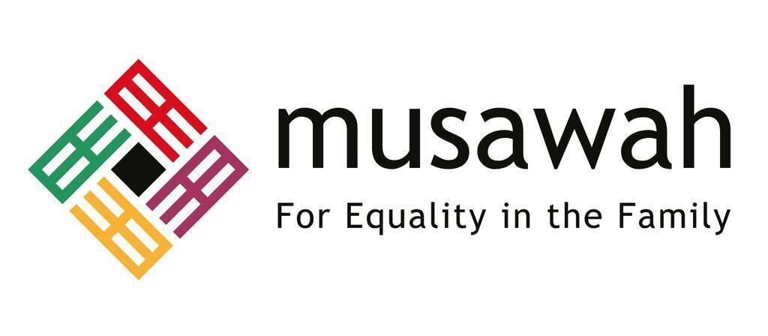

THEMATIC REPORT ON MUSLIM FAMILY LAW AND
MUSLIM WOMEN’S RIGHTS IN
THE PHILIPPINES

86th CEDAW Session
Geneva, Switzerland
OCTOBER 2023

Musawah
15 Jalan Limau Purut, Bangsar Park, 59000 Kuala Lumpur, Malaysia
Tel: +603 2083 0202 Fax: +603 2202 0303
Email: musawah@musawah.org
Website: www.musawah.org

Table of Contents

A. INTRODUCTION 3
B. BACKGROUND, LEGAL FRAMEWORK AND CONTEXT 3
C. KEY ISSUES AND RECOMMENDATIONS 4
1. Spousal Inequality 4
2. Polygamy 6
3. Divorce Rights 7
4. Child and Forced Marriages 9

A. INTRODUCTION
Musawah, the global movement for equality and justice in the Muslim family, submits this Thematic Report on concerns related to Muslim women’s legal equality in personal status matters and child marriage for consideration by the CEDAW Committee in its review of the Government of the Philippines, reporting before the 86th Session of the CEDAW Committee in October 2023. This is the CEDAW Committee’s ninth periodic engagement with the Philippines. Its last full review was in 2016. The Philippines ratified the CEDAW in Aug 1981 with no reservations.
Despite the Philippines’s noteworthy lack of reservations and relative high rank in the global indicators of equality, Musawah remains concerned by its continued non-implementation of the Convention in the context of marriage and family rights of Muslim women. This report highlights key legal inequalities that Muslim women face in the Philippines in the personal status sphere and their resulting negative impact on women and girls, along with recommendations to address gaps. We encourage the Philippines government to continue its efforts in eliminating discrimination against women.

We hope that the CEDAW Committee will utilize this report as a key resource during its constructive engagement with the State Party and use the recommendations to identify follow-up issues in its Concluding Observations.

B. BACKGROUND, LEGAL FRAMEWORK AND CONTEXT

The Philippines, located in Southeast Asia, is a diverse nation with a population of approximately 113 million people as of the last knowledge update in September 2021. The country is predominantly Christian, with Islam being the second-largest religion. The Muslim population in the Philippines, primarily concentrated in Mindanao and the Bangsamoro Autonomous Region in Muslim Mindanao (BARMM),, comprises around 6% of the total population.

The Philippines is a secular state and all laws are made to conform to the 1987 Constitution that contains a gender equality provision. However, a Code of Muslim Personal Laws (CMPL) was enacted in 1977 in order to appease the Muslim separatists. By doing so, the government of the Philippines legitimized traditions and practices that limit the rights of women in contrast to the constitution of the Philippines.

The BARMM consists of five predominantly Muslim provinces. It is the only region in the Philippines that has its own government. Most Muslim Filipinos practice Sunni Islam according to the Shafi'i school, and a small minority of Shia Muslims live in the region, mostly in the provinces of Lanao del Sur and Zamboanga del Sur in Mindanao. An increasing number of Muslims are migrating to the urban centers of Manila, Baguio, Dumaguete, Cagayan de Oro, Iligan, Cotabato, and Davao. With a poverty incidence rate of 63 percent, BARMM is one of the poorest regions in the country.

The Shari’ah Court System of the Philippines is composed of 5 Shari’ah District Courts, and 51 Shari’ah Circuit Courts (only 25 of which have been established) and Shari’ah Appellate Courts. There is also a jurisconsult in Islamic Law to assist the Supreme Court in cases involving the implementation and/or interpretation of the CMPL. Under Article IX, Section 2 RA 6734, a Shari’ah appellate court is to be established with one presiding justice and two associate justices. To date, the appellate court has not been established.

Shari’ah courts handle only cases relating to personal status laws affecting family relations and property. Shari’ah does not apply in criminal matters and applies only to Muslims. The state court system hears cases involving Muslims and non-Muslims, and national laws apply in those cases.

Litigation process in the Shari’ah courts is similar to the procedure in civil courts, as outlined by the Revised Rules of Court. Issues impacting access to justice for Muslims in the Philippines include the lack of operational Shari’ah Courts, an absence of Shari’ah courts outside the island of Mindanao, a low caseload and low rate of disposition, limited jurisdiction of the courts, and lack of capacity of Shari’ah counselors.

C. KEY ISSUES AND RECOMMENDATIONS

Spousal Inequality Articles 2, 16

Although Article 15 of the Constitution of the Philippines states that women and men are equal before the law, the Code of Muslim Personal Law contains inequalities between men and women in a number of its provisions. Article 35 of the Code of Muslim Personal Law gives the husband the authority to choose the family residence. Article 36, in turn, places the duty on the wife to “manage the affairs of the household”. It further gives authority to the husband to deny permission to his wife to practice a profession or occupation of her choice. The wife also cannot, without the husband’s consent, acquire any property by gratuitous title, except from her relatives within the prohibited degrees in marriage.

The CEDAW Committee, in its previous Concluding Observations as well as its List of Issues, has recommended and requested information about efforts to raise awareness about CEDAW and the Committee’s General Recommendation No. 21 (1994) on Marriage and Family Relations. The Philippines' reply to the List of Issues states that such efforts “could form part of future endeavors of the State through the commissions on IPs and on Muslim Filipinos,” indicating that such efforts have not been prioritized by the State Party so far.

Moreover, the Philippines states in its ninth State Party Report to CEDAW that “the State has instituted measures to ensure equal rights, opportunities, and protection of women especially those belonging to vulnerable groups. The 2017-2022 Strategic Plan of Inter-Agency Council on Violence Against Women and their Children (IACVAWC) has prioritized the issue of limited delivery of advocacy programs to reach women in the marginalized sectors, including…Muslim women...” Additionally, the SDG Watch by the Philippine Statistics Authority (last updated in December 2022) claims that the Philippines satisfies the requirement of indicator 5.1.1 on legal frameworks to enforce non-discrimination on the basis of sex.

However, the Philippines has failed to addressed the concern of Muslim women who continue to suffer due to inequality in family laws outlined in the Code of Muslim Personal Law, and this has also not been reflected in the Philippines’ SDG reporting as well.

Musawah Justification for Reform: Challenging the husband’s right to authority

The concept of male authority (qiwamah) over women plays a central role in institutionalising, justifying, and sustaining a patriarchal model of families in Muslim contexts; and it justifies and perpetuates numerous specific discriminatory provisions and practices, including key critical issues examined in this report. There is a disconnect between this discriminatory legal framework and women’s lived realities and family life today.

Musawah asserts that several verses in the Qur’an that dwell on the values of love, compassion, closeness, and protection between men and women and the general principles of equality and justice should form the basis of marriage and family in Islam. Repealing the codification of unequal and discriminatory rights and responsibilities within the marriage is not against Islam—it is in fact consistent with Qur’anic principles of justice (‘adl), equality (musawah), dignity (karamah), and love and compassion (mawaddah wa rahmah).

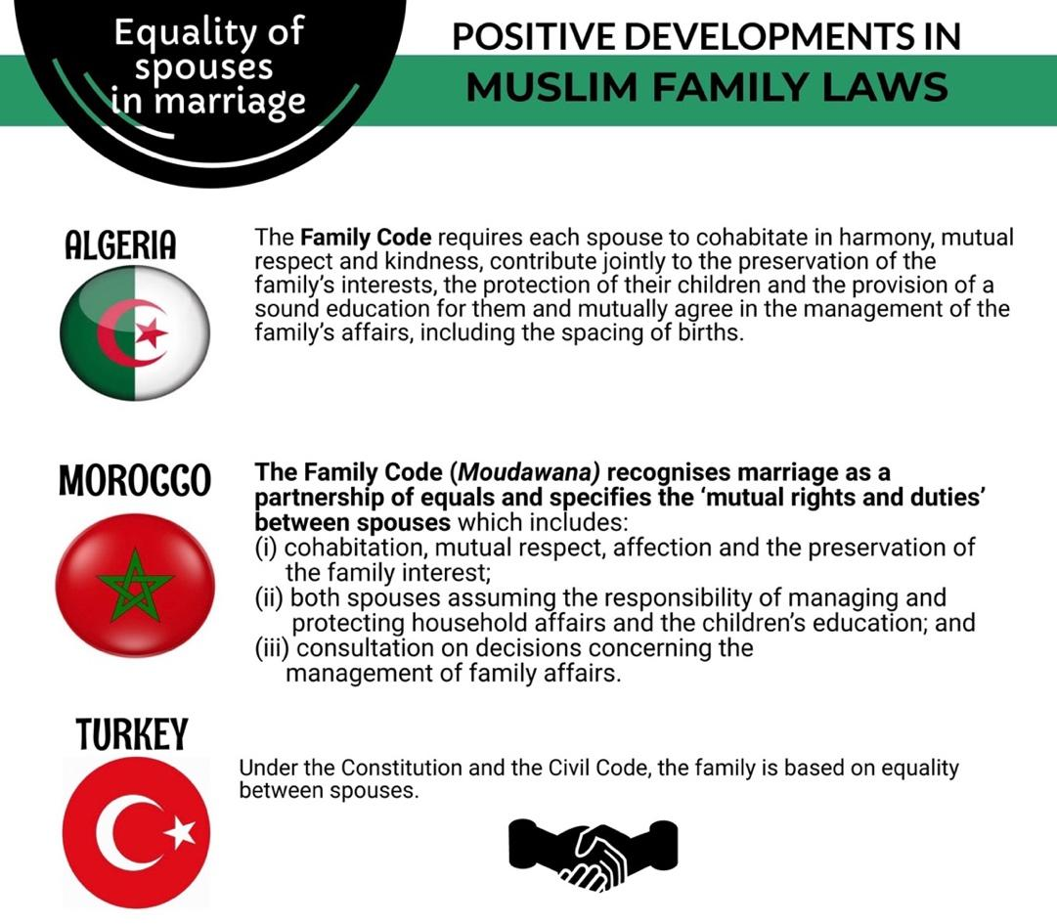

RECOMMENDATIONS
We recommend the CEDAW Committee urge the State party to:

- Amend the Code of Muslim Personal Law to grant and ensure spousal equality between men and women in all their spousal and personal rights in accordance with the Philippines’s own Constitution and international human rights obligations.

- Prioritize compliance with the CEDAW Committee’s previous Concluding Observations to “intensify its efforts to raise awareness about the Convention among Muslim communities, including women, men and traditional and religious leaders, in particular by disseminating information on good practices of other Muslim countries with regard to the application of sharia in line with the Convention”

- In accordance with the CEDAW Committee’s previous Concluding Observations, ensure the “full participation of women in decision-making and legislative processes at the national, local and community levels, including in the codification and interpretation of religious norms or customs on marriage and family relations”.

Polygamy Article 16

Article 27 of the CMPL allows Muslim men to marry up to four wives. Although the Article states that he can only take another wife in ‘exceptional cases’, provided that he can ‘deal with them with equal companionship and just treatment as enjoined by Islamic law’, there is no explanation of these conditions in detail. The law does not delineate or expand upon the exceptional circumstances in which polygamous marriages may be allowed to be contracted. There is also no provision that requires the consent of the first wife or the consent of the State to ensure the first wife’s protection of her rights.

The CEDAW Committee has raised concerns about the permissibility of polygamy for Muslims in the Philippines, both in its previous Concluding Observations as well as in its List of Issues to the State Party.

In some indigenous communities, polygamy and abduction for forced cohabitation are still practiced.

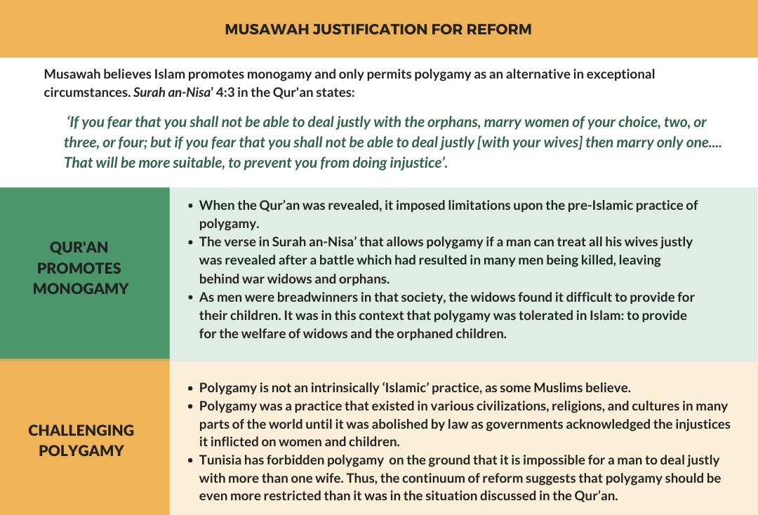

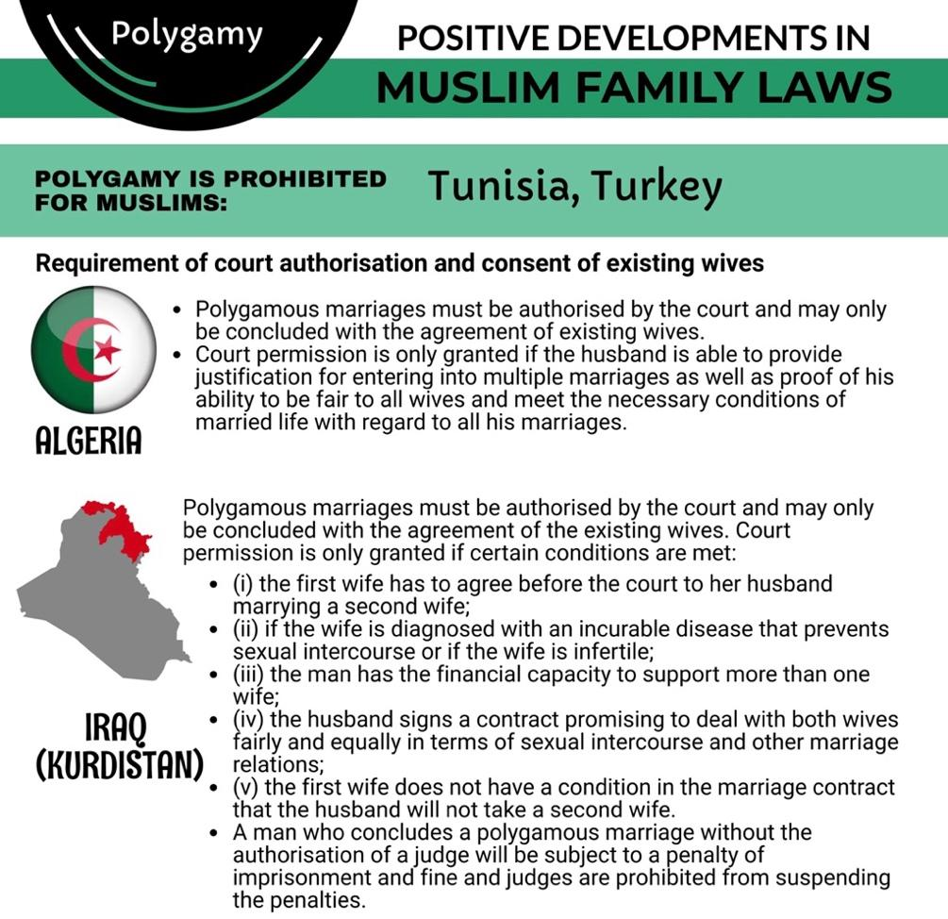

RECOMMENDATIONS
We recommend the CEDAW Committee urge the State party to:

- Harmonize the Code of Muslim Personal Law with the Constitution of the Philippines by explicitly discouraging polygamy with a view to prohibiting it in consultation with local women’s rights organizations and, in particular, Muslim women’s groups.

- Amend the Code of Muslim Personal Law to make provision for prenuptial agreements, in order for the husband and wife to decide whether a subsequent marriage may be contracted by the husband, and giving the option of divorce to the wife.

Divorce Rights Article 16

There is no absolute divorce or no-fault divorce in the Philippines. There is only annulment of marriage under Art. 36 of the Family Code. Cases for annulment of marriage are costly and inaccessible to poor women and court decisions nullifying marriages are difficult to obtain because of varying judicial interpretations.

The only women who can legally obtain a divorce in the Philippines are Muslim women. However, even Filipino-Muslim women face barriers that men do not face when seeking divorce. The law followed in Mindanao states that men can initiate divorce by pronouncing “I divorce you” to their wife. Meanwhile, women must follow a waiting period, and will only be granted said divorce if they can prove that their husband failed to provide for their basic needs, such as food or shelter, or if the couple had no sexual relations for two months. However, even Filipino-Muslim women cannot obtain divorce in the absence of these grounds.

Women are the primary victims of the illegality of divorce because of the lack of protections granted to them in the patriarchal legal and societal system of the Philippines. Even though women make up about 49.4% of the population in the Philippines, they only make up 34% of the workforce. Filipinas are rarely the main financial providers for their families, and since annulments do not grant protections for women or their children, many of them are stuck in marriages to guarantee their livelihoods. A specialized family law attorney in the Philippines states that women are afraid to separate from their husbands, especially if they have children who still rely financially on them.

In 2016, the CEDAW Committee, in its Concluding Observations, recommended the State Party to harmonize the laws on marriage and family relations with the Convention and the Magna Carta of Women, particularly by “expediting the adoption of the long-pending divorce bill”. The State Party has reported, in its Reply to the CEDAW Committee’s List of Issues, that the “Divorce bill has been part of the WPLA since the 17th Congress. In the 18th Congress, three bills were filed in the House of Representatives and two in the Senate, on Divorce."

However, the divorce bill has not been adopted till date.
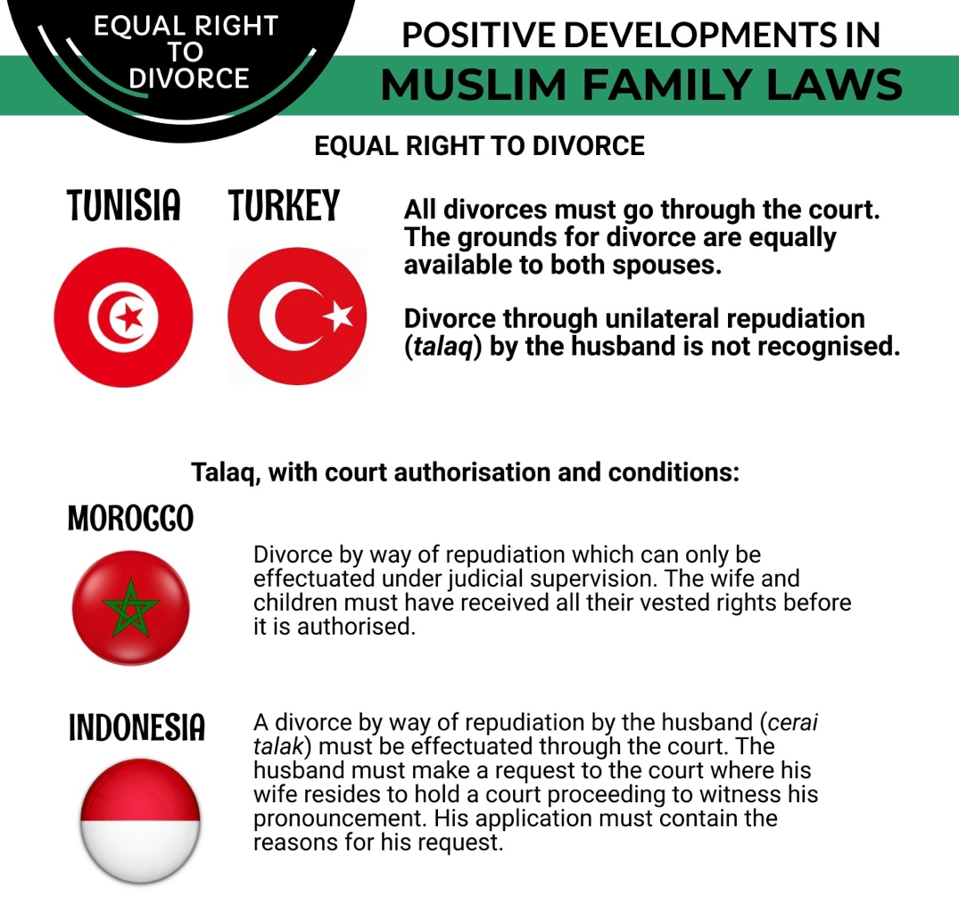

RECOMMENDATIONS
We recommend the CEDAW Committee urge the State party to:

- Enact the divorce bill allowing the dissolution of marriage through no-fault divorce for both Muslims and people from other religious backgrounds, and include provisions in the bill for the division of assets, and financial support for the children of divorced parents.

Child and Forced Marriages Article 16

In January 2022, a law prohibiting child marriage took effect in the Philippines. The law introduces penalties for those that facilitate, participate, and officiate the marriage of children under the age of 18. It also calls for the development and implementation of policies to ensure access to education, economic support, and other social measures and interventions to discourage the practice. Under the Code of Muslim Personal Laws, Filipino Muslims were allowed to get married as minors, while non-Muslims in the country are permitted by the Family Code to marry only after reaching the age of 18. Section 13 of the new law prohibiting child marriages states that decrees that are inconsistent with it are repealed or modified. Lawmakers and advocates fought a long battle for the ban to protect Muslim women and girls from the practice.

However, the Philippines has yet to see the full implementation of the law and its impact on the health and lives of children. The law also does not necessarily mean the practice will be eradicated right away. Cultural and socio-economic conditions prevail that make these possible.

In the Bangsamoro Autonomous Region in Muslim Mindanao (BARMM), adolescent girls have had to undergo the now-illegal practice of child marriage because of family, community, and environmental pressures, a study released in March 2022 found. Plan International, the Women’s Refugee Commission, and Transforming Fragilities stated in their study that child marriage in BARMM is rooted in gender and socio-economic equality, limiting young girls’ freedoms to make their own life decisions. The study found that child marriage comes from a number of cultural factors, such as a prevailing patriarchal system, as well as unaddressed socio-economic problems. These include:

- Differing interpretations of Islamic beliefs around child marriage
- Conflict or disaster-related displacement
- Limited decision-making power among adolescent girls
- Self-sacrifice and sense of duty
- Controlling adolescent sexuality to protect family honor
- Poverty and lack of access to stable income-generating activities
- Lack of access to quality education
- Enabling legal environment

The study also found that married and unmarried young women were not familiar with existing national laws or guidelines that discouraged the practice. This led them to believe child marriage was common and acceptable, even if it meant marrying a perpetrator of sexual violence. Muslim families were also found to be interpreting Islamic beliefs differently when it came to the acceptance of child marriage. “Data showed contradictory community perceptions; among some community members child marriage was desired, while among others it was stigmatized,” the study read.

The child marriage ban was a long-awaited victory for young women and girls forced into the practice, but the law may turn out ineffective if it is not implemented.

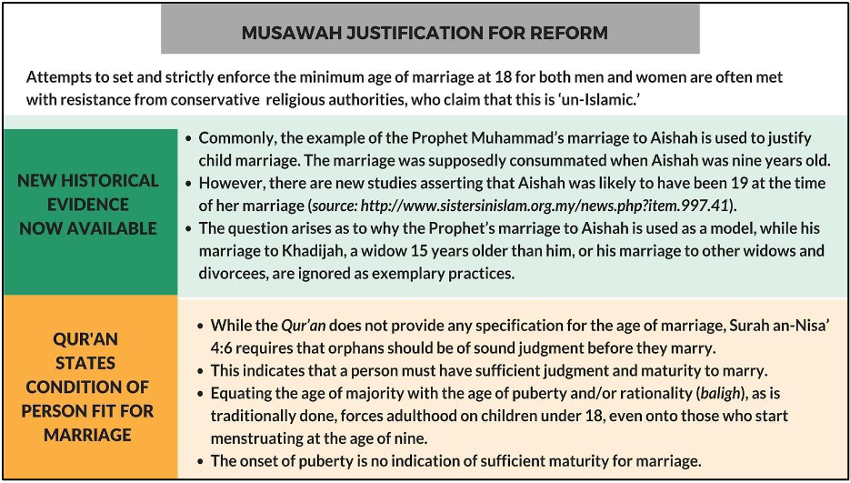

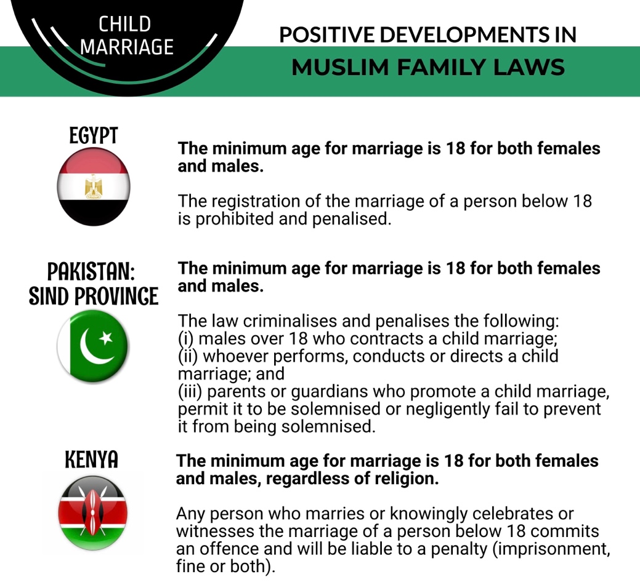

RECOMMENDATIONS
We recommend the CEDAW Committee urge the State party to:

- Ensure that the government sectors, regional government agencies and local government units allocate resources to strengthen the accountability mechanisms for the law prohibiting child marriage, and ensure its proper dissemination and implementation within their communities.

- Formulate an urgent, coordinated and multi-stakeholder community-led approach to address the drivers of child marriage including through targeted programs, parenting interventions, curriculum inclusions and specialized trainings, involving government actors such as the BARMM’s ministries of education, health, social services and development, and through extensive engagement with religious leaders, men, and women in Muslim communities.

ARMM (Autonomous Region in Muslim Mindanao) was succeeded by BARMM which was formally established in 2019 as part of a peace agreement to end nearly five decades of conflict between the Philippine government and Moro secessionists. The BARMM is a Muslim-led autonomous region established by the central government in 2019, with jurisdiction over five provinces and three major noncontiguous cities. The Bangsamoro Organic Law provides the framework for the transition to greater autonomy for the area’s majority Muslim population; the transition completion date is set for 2025.
Approximately 6 percent of the population is Muslim, according to the PSA, while the National Commission for Muslim Filipinos (NCMF) estimates 10 to 11 percent. See 2022 Report on International Religious Freedom: Philippines, Office of International Religious Freedom, US Department of State, https://www.state.gov/reports/2022-report-on-international-religious-freedom/philippines/#:~:text=Approximately%206%20percent%20of%20the,estimates%2010%20to%2011%20percent.
The Philippines government had intended the Code of Muslim Personal Laws (CMPL) to uphold “customs, traditions, beliefs, and interests of the national cultural communities in the formulation and implementation of state policies” (Sec.11, Art. XV Philippine Constitution 1986). http://berkleycenter.georgetown.edu/posts/paradise-lies-at-the-feet-of-the-mother-muslim-women-s-rights-gender-roles-and-philippine-laws
2022 Report on International Religious Freedom: Philippines, Office of International Religious Freedom, US Department of State, https://www.state.gov/reports/2022-report-on-international-religious-freedom/philippines/#:~:text=Approximately%206%20percent%20of%20the,estimates%2010%20to%2011%20percent.
Bangsamoro Autonomous Region in Muslim Mindanao (BARMM), UNFPA Philippines, https://philippines.unfpa.org/en/node/15306
2022 Report on International Religious Freedom: Philippines, Office of International Religious Freedom, US Department of State, https://www.state.gov/reports/2022-report-on-international-religious-freedom/philippines/#:~:text=Approximately%206%20percent%20of%20the,estimates%2010%20to%2011%20percent.
Presidential Decree No. 1083, Code of Muslim Personal Laws, Philippines, https://lawphil.net/statutes/presdecs/pd1977/pd_1083_1977.html
SDG Watch (2022), Goal 5: Gender Equality, Philippines Statistics Authority, https://psa.gov.ph/sdg/Philippines/baselinedata/gender_equality
EnGender NGO CEDAW Shadow Report 2022, para 42.
Ilona Barrero (2023). Divorce Prohibition in the Philippines: A System Serving the Patriarchy. Gender in Geopolitics Institute. https://igg-geo.org/?p=13576&lang=en
Lynzy Billing (2018). In Philippines, Where Divorce is Illegal, Women Pay the price. The New Humanitarian. https://deeply.thenewhumanitarian.org/womensadvancement/articles/2018/02/22/in-philippines-where-divorce-is-illegal-women-pay-the-price
Ilona Barrero (2023). Divorce Prohibition in the Philippines: A System Serving the Patriarchy. Gender in Geopolitics Institute. https://igg-geo.org/?p=13576&lang=en
Ibid. The article states: “In early 2020, a House committee in the Philippine legislature unanimously approved House bills 100, 838, and 2263; three measures seeking to legalize divorce in the country. The bills would have also made separations much more accessible, getting rid of requirements like inability to bear children and psychological incapacity. In 2021, these bills passed the House of Representatives’ final reading, but ended up being voted down by the Senate, facing strong opposition from Catholic coalitions. This seems to be the constant battle for most Filipinos who advocate for divorce: the strong presence and influence of the Catholic church on government affairs stops progressive bills from passing in the Senate, the upper house of the legislature. Three out of five Filipinos want divorce to be legalized and in March of 2023 another bill seeking to legalize divorce was approved by a panel of representatives in the House. The House Committee on Population and Family Relations passed the substitute bill, and now it needs to be approved by the House before making it to the Senate again. While support is still being garnered for this bill, legislators are confident that this bill has a real chance of passing. However, even though Filipinos are hopeful, the bill has a long way to go before becoming law, and most importantly, actually being enforced. The divorce bill must not only allow divorce in circumstances of abuse, but also protect women who are financially vulnerable after separating from their husbands. Fathers and husbands must be held to high child support standards, and their ex-wives should have access to fair asset division, as well as the right to remarry if they wish. Furthermore, policies surrounding divorce should include provisions to aid Filipinas in becoming financially empowered and independent.”
An Act Prohibiting the Practice of Child Marriage and Imposing Penalties for Violations Thereof, Rep. Act No. 11596 (2021).
Michelle Abad (2022), Fast Facts: What causes child marriage in BARMM?, Rappler, https://www.rappler.com/newsbreak/iq/things-to-know-causes-child-marriage-barmm/#:~:text=On%20January%206%2C%20President%20Rodrigo,and%20girls%20from%20the%20practice
Joint Shadow Report submitted to the CEDAW Committee, Supplementary Report for the Adoption of List of Issues 84th Pre-Sessional Working Group, submitted by Center for Reproductive Rights, EnGendeRights, Inc, and 7 other organizations.
Michelle Abad (2022), Fast Facts: What causes child marriage in BARMM?, Rappler, https://www.rappler.com/newsbreak/iq/things-to-know-causes-child-marriage-barmm/#:~:text=On%20January%206%2C%20President%20Rodrigo,and%20girls%20from%20the%20practice
“Our Voices, Our Future: Understanding Risks and Adaptive Capacities to Prevent and Respond to Child Marriage in the BARMM (2022), Plan International, https://plan-international.org/philippines/publications/our-voices-our-future/

